

“Title of Internship”

## Internship Based Project Report Submitted To

**Chhattisgarh Swami Vivekananda Technical University, Bhilai**

*for*

*Completion of 6th Semester Internship of the degree of*

#### BACHELOR OFTECHNOLOGY (HONORS)

*In*

#### COMPUTER SCIENCE & ENGINEERING (Artificial Intelligence)

**By**

#### Parshuram Kumar

#### B.Tech.(Hon) 6th Semester Roll No. 300012721038

**Enrollment No. CB4624**

Under the Guidance of

#### Dr. Nachiket Tapas

Designation

Computer Science and Engineering CSVTU, Bhilai(CG)

#### DEPARTMENT OF COMPUTER SCIENCE &ENGINEERING UNIVERSITY TEACHING DEPARTMENT

**CHHATTISGARH SWAMI VIVEKANAND TECHNICAL UNIVERSITY, BHILAI JUNE 2024**





##### DECLARATION BY THE CANDIDATE

I, the undersigned solemnly declare that the internship-based project entitled **“**Soil Inspection and Classification Using Image Processing Techniques**”** is based on my work carried out during the 6th semester course of my graduation under the supervision of **Dr. Nachiket Tapas, Assistant professor** Computer Science and Engineering, University Teaching Department, Chhattisgarh Swami Vivekanand Technical University, Bhila (C.G.), India.

Parshuram Kumar

**Roll No. 300012721038**

**Enrollment No. CB4624**

I





##### CERTIFICATE BY THE SUPERVISOR

This is to certify that the incorporation in the project "Soil Inspection and Classification Using Image Processing Techniques" documents the internship- based project work carried out by Parshuram Kumar, with Roll No. 30012721038 and Enrollment No. CB4624, under the guidance and supervision required for the completion of the 6th-semester internship of Bachelor of Technology (Honors) in Artificial Intelligence (Computer Science & Engineering) at Chhattisgarh Swami Vivekananda Technical University, Bhilai (C.G.), India.

To the best of my knowledge and belief the project work

1. Embodies the work of the candidate himself/ herself,
2. Has duly been completed in the specified time,
3. Fulfil the requirement of the Ordinance relating to the B.Tech.(Honors) degree of the University and
4. Is up to the desired standard both in respect of contents and language for being referred to the examiners.

(Signature of H.O.D.) (Signature of Supervisor) Dr. J.P.Patra Name of Mentor

Associate Professor & HOD Assistant Professor

Department of CSE Department of CSE

Forwarded to Chhattisgarh Swami Vivekananda Technical University, Bhilai(C.G.)

…………………………………. (Signature of the Director, UTD)

II





##### DEPARTMENT OF COMPUTER SCIENCE &ENGINEERING UNIVERSITY TEACHING DEPARTMENT

**CHHATTISGARH SWAMI VIVEKANAND TECHNICAL UNIVERSITY, BHILAI**



##### CERTIFICATE BY THE EXAMINER

This is to certify that the project entitled "Soil Inspection and Classification Using Image Processing Techniques'' was submitted by **Parshuram Kumar**, a student of B. Tech. (Honors) in Artificial Intelligence (CSE), with Roll No. 300012721038 and Enrollment No. CB4624 It has been examined by the undersigned as a part of the examination and is hereby recommended for the completion of the 6th-semester internship-based project for the degree of Bachelor of Technology (Honors) in Artificial Intelligence (Computer Science and Engineering) at Chhattisgarh Swami Vivekanand Technical University, Bhilai (C.G.), India.



Internal Examiner External Examiner

Date: Date:

III





#### [Organization's Letterhead]



##### CERTIFICATE OF INTERNSHIP COMPLETION

This is to certify that Vaibhav Chaturvedi, a student at University Teaching Department, Chhattisgarh Swami Vivekanand Technical University, Bhilai has successfully completed a internship program at International Institute of Information and Technology Naya Raipur (CG) from [11-03-2024] to [21-06-2024].

During the internship period, Vaibhav Chaturvedi was assigned to Dr Mithilesh Kr Chaube under my supervision, where they consistently demonstrated exceptional performance and professional conduct.

Vaibhav Chaturvedi’s key responsibilities included:

* Research and Literature Review: Identified and summarized research papers, highlighting key findings and gaps in current approaches.
* Data Collection and Preprocessing: Curated a dataset of 5000 diabetic and non diabetic patients and applied preprocessing techniques

* Model Development and Evaluation : Achieved a model accuracy of 97% in classifying brain tumors using ML models, demonstrating significant improvements over baseline models.

Throughout the internship, Vaibhav Chaturvedi demonstrated a remarkable level of dedication, initiative, and eagerness to learn, making significant contributions to the team. We are confident that the skills and experience gained during this internship will serve Vaibhav Chaturvedi well in their future academic and professional endeavors, and we extend our best wishes for their continued success.

(Signature of Head of Company/Institute)

(Signature of Supervisor) K.G srinivasan Dr Mithilesh Kr Chaube

HOD assistant professor

Department of CSE Department of CSE

IV



##### DEPARTMENT OF COMPUTER SCIENCE & ENGINEERING UNIVERSITY TEACHING DEPARTMENT

**CHHATTISGARH SWAMI VIVEKANAND TECHNICAL UNIVERSITY, BHILAI**



##### ACKNOWLEDGEMENT

The real spirit of achieving a goal is through excellence and serious discipline. I want to thank International institute of information and technology , naya Raipur (CG) for providing me with the necessary software, tools, and other resources to deliver my internship-based project work. Not showing appreciation to Dr Mallikharjuna Rao at International Institute Of Information And Technology , Naya Raipur (Cg) would mean I'm not doing my job well.

With gratitude and humanity, I acknowledge my indebtedness to Dr. Nachiket Tapas, Associate Professor, CSE, University Teaching Department, CSVTU Bhilai, under whose guidance I had the privilege to complete this internship project work. Also, I am grateful to all the faculty members of the Department of CSE, who were always there in the hour of need and provided me with all the help and facilities I required for the completion of my project work.

I owe my sincere thanks to Shri P. K. Ghosh, Director UTD, CSVTU Bhilai, for the inspiration and constant encouragement that enabled me to present my work in this form. My greatest thanks go to my parents and family, who have been my driving force. My work would not be possible without their constant inspiration, encouragement, support, and love. Above all, I render my gratitude to the almighty, who bestowed self-confidence, ability, and strength upon me to complete this work.

Parshuram Kumar

**Roll No. 300012721038**

**Enrollment No. CB4624**

IV





#### ABSTRACT

This internship report details a project focused on soil classification and moisture inspection through image processing and machine learning techniques. The primary objective was to develop robust models capable of accurately classifying different soil types and, aiding agricultural decision-making and environmental monitoring.

The project utilized a dataset of 1500 images representing four soil types: Red, Alluvial, Black, and Clay, with approximately 375 images each. Preprocessing included grayscale conversion and edge detection using the Laplacian operator. Various noise reduction techniques, such as Gaussian Blur, Median Filtering, Bilateral Filtering, and Non-Local Means Denoising, were applied to enhance image quality.

Feature extraction using the Gray-Level Co-occurrence Matrix (GLCM) method derived texture features from the images, including contrast, correlation, energy, and homogeneity. These features formed the dataset for training machine learning models.

Evaluation metrics, including Peak Signal-to-Noise Ratio (PSNR) and Structural Similarity Index (SSIM), assessed noise reduction effectiveness. The Non-Local Means Denoising technique with parameters (5, 3, 15) proved most effective, achieving the highest average PSNR of 47.1912 and SSIM of 0.9950.

Several machine learning models, including Support Vector Machines (SVM), Random Forest, and k-Nearest Neighbors (k-NN), were developed and evaluated for soil classification using GLCM features. The SVM model demonstrated superior performance with an accuracy of 92%, precision of 91%, recall of 90%, and F1-score of 90.5%.

In conclusion, the project successfully developed and compared multiple noise reduction techniques and machine learning models for soil classification. Non-Local Means Denoising was the best noise reduction method, and SVM was the most effective model using GLCM features. Future work will focus on enhancing the models and exploring additional data augmentation techniques to improve classification accuracy.

.

V





#### Table of Contents

| **Chapter** | **Title** | **Page No.** |
| --- | --- | --- |
| I | Introduction   * 1. Background Information   2. Project Objectives   3. Significance of the Project   4. Scope and Limitations   5. Overview of the Structure | 1-3 |
| II | Organization Overview   * 1. Company Profile   2. Vision and Mission   3. Organizational Structure   4. Product and Services | 4-6 |
| III | Internship Activities   * 1. Description of Activities   2. Skills Developed   3. Challenges Faced   4. Achievements and Contributions   5. Learning Outcomes | 7 |
| IV | Methodology   * 1. Project Overview   2. Research Design or Approach   3. Data Collection Methods   4. Data Analysis Techniques   5. Ethical Considerations   6. Limitations | 8-37 |
| V | Implementation   * 1. Development Environment   2. Project Execution   3. Timeline   4. Resource Allocation   5. Challenges Faced   6. Success Factors   7. Lessons Learned | 38-40 |





| VI | Results and Discussion   * 1. Presentation of Results   2. Interpretation of Results   3. Comparison with Objectives   4. Discussion of Key Findings   5. Limitations and Future Directions | 41-44 |
| --- | --- | --- |
| VII | Learning Outcome   * 1. Summary of Findings   2. Achievement of Objectives   3. Implications and Recommendations   4. Future Scope   5. Personal Reflections | 45-46 |
| VIII | Conclusion and Future Scope   * 1. Skills Developed   2. Knowledge Gained   3. Professional Development   4. Personal Growth   5. Future Application | 47-48 |
|  | References | 51-54 |
|  | Annexure 1: Color copy of Internship Completion Certificate | 55 |

VI



#### List of Figures

| **Figure** | **Title of Figure** | **Page No.** |
| --- | --- | --- |
| FIGURE 4.1 | Name | 8 |
| FIGURE 4.2 | Name | 8 |
| FIGURE 4.3 | Name | 8 |
| FIGURE 4.4 | Name | 8 |
| FIGURE 4.5 | Name | 9 |
| FIGURE 4.6 | Name | 19 |
| FIGURE 4.7 | Name | 22 |
| FIGURE 4.8 | Name | 24 |
| FIGURE 4.9 | Name | 28 |
| FIGURE 4.10 | Name | 30 |
| FIGURE 4.11 | Name | 34 |
| FIGURE 4.12 | Name | 37 |
| FIGURE 5.1 | Name | 39 |
| FIGURE 5.2 | Name | 40 |

VII



#### List of Tables



| **Table** | **Title of Table** | **Page No.** |
| --- | --- | --- |
| Table 2.1 | Name | 5-6 |
| Table 6.1 | Name | 43 |

VIII IX





#### List of Abbreviations



1. **ML**: Machine Learning
2. **AI**: Artificial Intelligence
3. **MRI**: Magnetic Resonance Imaging
4. **GLCM**: Gray-Level Co-occurrence Matrix
5. **SVM**: Support Vector Machines
6. **RF**: Random Forest
7. **k-NN**: k-Nearest Neighbors
8. **CNN**: Convolutional Neural Network
9. **PCA**: Principal Component Analysis
10. **ROI**: Region of Interest
11. **CAD**: Computer-Aided Design
12. **API**: Application Programming Interface
13. **GUI**: Graphical User Interface
14. **CSV**: Comma-Separated Values
15. **GPU**: Graphics Processing Unit
16. **CPU**: Central Processing Unit
17. **RAM**: Random Access Memory
18. **OS**: Operating System
19. **NLM**: Non-Local Means
20. **IoT**: Internet of Things



X



**CHAPTER – I INTRODUCTION**



**CHAPTER – I**



## INTRODUCTION



**1.1 Background Information.**

Soil classification and inspection are critical components in the field of agriculture and environmental management. Accurate soil classification helps in understanding the properties and suitability of soil for different crops, leading to better crop management and yield optimization.

The area of focus for this project is to develop a system that can classify different types of soil and inspect their moisture content using advanced image processing and machine learning techniques. Traditional methods of soil analysis involve manual sampling and laboratory tests, which are time-consuming, labor-intensive, and often not feasible for large-scale agricultural areas. Automated soil classification and moisture inspection using machine learning models can provide a faster, more efficient, and scalable solution.

The project aims to address the following problems:

**1. Automating Soil Classification**: Developing a machine learning model that can accurately classify different soil types based on image data. This reduces the reliance on manual methods and enables rapid soil analysis across large agricultural fields.

**2. Enhancing Image Quality**: Implementing image processing techniques to enhance the quality of soil images, making them suitable for feature extraction and model training. This involves noise reduction and edge detection to highlight the essential features of the soil.





**3. Feature Extraction**: Utilizing texture analysis methods such as the Gray-Level Co-occurrence Matrix (GLCM) to extract relevant features from soil images. These features are crucial for training effective machine learning models.

**4. Model Evaluation and Comparison**: Building and comparing various machine learning models, including **Support Vector Machines (SVM)**, **Random Fores**t, and **k-Nearest Neighbors (k-NN)**, to determine the most accurate model for soil classification.

By addressing these problems, the project aims to contribute to the field of precision agriculture, providing farmers and agricultural professionals with reliable tools for soil analysis and water management. The ultimate goal is to improve crop yield, optimize resource use, and support sustainable agricultural practices.

**1.2 Project Objectives**

The main goal of this project is to create an automated system for classifying soil types using image processing and machine learning techniques. The project aims to develop robust machine learning models capable of accurately identifying different soil types such as Red, Alluvial, Black, and Clay based on image data. This involves evaluating and comparing various machine learning algorithms like Support Vector Machines (SVM), Random Forest, and k-Nearest Neighbors (k-NN) to determine the most effective model. Additionally, the project focuses on enhancing image quality through preprocessing techniques such as edge detection using the Laplacian operator and noise reduction methods like Gaussian Blur, Median Filtering, Bilateral Filtering, and Non-Local Means Denoising. Feature extraction from soil images will utilize texture analysis methods like the Gray-Level Co-occurrence Matrix (GLCM) to extract relevant features such as contrast, correlation, energy, and homogeneity. Performance evaluation will be conducted using metrics such as accuracy, precision, recall, and F1-score to identify the optimal model for soil classification. The ultimate aim is to deliver a scalable and efficient solution that can be easily deployed in agriculture, enabling timely and accurate soil classification for improved soil management and crop planning decisions by farmers and agricultural professionals.





**1.3 Significance of the Project**

The project's application of advanced technologies in soil classification not only enhances agricultural productivity and sustainability but also fosters innovation and efficiency in agricultural practices worldwide.

**Advanced Agricultural Decision Support**: Utilizing image processing and machine learning for soil classification enhances the precision of agricultural decision-making. By accurately categorizing soil types, farmers can optimize crop selection, fertilizer application, and soil management practices, thereby improving productivity and resource efficiency.

**Resource Efficiency and Environmental Impact**: The project facilitates optimized resource allocation by providing detailed soil type information. This enhances the efficient use of water, fertilizers, and other inputs, contributing to sustainable agricultural practices. Additionally, it supports environmental stewardship by mitigating risks such as soil erosion and nutrient depletion through informed land management strategies.

**Technological Integration and Innovation**: Integrating image processing and machine learning into soil classification represents a significant technological advancement in agriculture. This integration not only improves the accuracy of soil analysis but also promotes the adoption of cutting-edge technologies that can modernize agricultural operations globally.

**1.4Scope and Limitations**

While the project aims to create an effective automated system for soil classification, there are certain limitations to consider:

* Image Quality: The effectiveness of the classification models heavily depends on the quality of input soil images. Poor quality images may impact the accuracy of classification results.
* Variability in Soil Types: The models will be trained to classify the specified soil types (Red, Alluvial, Black, and Clay), and their performance may vary when applied to soil types not included in the training dataset.
* Computational Resources: The computational requirements for training and deploying machine learning models, especially with large datasets, may impose constraints on scalability and real-time performance.
* User Interface and Accessibility: While the focus is on technical development, considerations for a user-friendly interface and accessibility for non-technical users, such as farmers and agricultural professionals, may require further development beyond the scope of this project

.



**1.5 Overview of the Structure**

This report is structured as follows:

• Chapter 2: Literature Review: A detailed examination of existing literature on brain tumor detection methods and the role of AI in enhancing diagnostic accuracy.

• Chapter 3: Methodology: An outline of the methods and techniques used for data collection, AI model development, and evaluation.

• Chapter 4: Results and Analysis: Presentation and analysis of the results obtained from the implementation of AI models and comparative studies.

• Chapter 5: Discussion: Interpretation of findings, discussion of the implications for clinical practice, and identification of future research directions.

• Chapter 6: Conclusion and Recommendations: Summary of key findings, conclusions drawn from the study, and recommendations for future work and potential improvements in the field of brain tumor detection





# CHAPTER – II ORGANIZATION OVERVIEW



**CHAPTER II**



# ORGANIZATION OVERVIEW



**2.1 Institutional Profile**   
**Institution Name:** International Institute of Information Technology, Naya Raipur ( IIIT-NR)

**Background**:

Established in 2015, the International Institute of Information Technology, Naya Raipur (IIIT-NR), is a distinguished institution focusing on Information Technology and its allied fields. Founded as a part of a public-private partnership between the Government of Chhattisgarh and NTPC Limited, IIIT-NR has rapidly earned recognition for its academic rigor and research excellence in various technological domains. The institute's establishment was a significant step towards fostering innovation and research in the rapidly evolving field of IT, and it has since become a hub for advanced learning and technology development.

**Location and Scale**:

The institute is located in the rapidly developing capital city of Naya Raipur, Chhattisgarh. The sprawling 50-acre campus houses state-of-the-art facilities that support a vibrant academic community, consisting of approximately 1,200 students and more than 80 faculty members. This strategic location provides a serene yet stimulating environment conducive to educational and research activities.

**Sector:**

IIIT-NR is a key player in the higher education and research sector, specifically targeting Information Technology and related disciplines. It serves as an incubator for technological innovation and excellence in academia.

**Reputation and Market Standing:**

IIIT-NR has established itself as one of India's leading emerging institutions in engineering and technology. It is highly regarded for its stringent academic standards and impactful research initiatives. The institute is renowned for its contributions to the fields of Artificial Intelligence, cybersecurity, and data science, earning accolades and recognition from both academic and professional communities.

**2.2 Vision and Mission**

**Vision:**

• "To be a premier global center of excellence in Information Technology education and research, nurturing innovation and leadership to enhance societal welfare."

**Mission:**

* Provision of High-Quality Education: To deliver top-tier education in Information Technology and related areas through innovative teaching methodologies and cutting-edge research.
* Development of Competent Professionals: To cultivate technically proficient, ethically grounded professionals who are prepared to meet the challenges of a dynamic technological landscape
* Promotion of Innovation and Collaboration: To foster a creative environment that encourages global industry collaboration and drives innovation in technology and research

**2.3 Organizational Framework**

**Organizational Overview:**

IIIT-NR is structured to ensure effective governance and efficient management of its academic and research activities. The hierarchical framework includes:

• Board of Governors: This is the highest governing body, responsible for strategic decision making, policy formulation, and overall governance of the institute. It ensures that IIIT-NR adheres to its mission and vision.

• Director: The Director serves as the Chief Executive Officer, managing the day-to-day operations and executing the strategic plans set forth by the Board of Governors. The Director oversees all administrative and academic functions.

• Academic Council: The primary academic body tasked with overseeing academic policies, curriculum development, and ensuring the quality of educational programs. The Council plays a critical role in maintaining and enhancing academic standards.

• Dean of Academics: This position oversees the academic programs, including curriculum implementation, faculty management, and student affairs, ensuring that educational activities align with the institute's standards and goals.

• Dean of Research and Development: This office is responsible for overseeing all research activities, including the development of research programs, management of research funds, and fostering industry-academic partnerships.

• Departments: IIIT-NR houses several specialized departments such as Computer Science, Electronics and Communication, Mathematics, and Humanities. These departments are pivotal in driving both teaching and research activities.

**2.4 Academic Programs and Services**

**Educational Offerings:**

IIIT-NR provides a robust range of academic programs designed to equip students with the necessary knowledge and skills in Information Technology and related fields. These include:

• Undergraduate Programs: Bachelor of Technology (B.Tech) in various specializations, offering foundational and advanced courses in IT.

• Postgraduate Programs: Master of Technology (M.Tech) programs that focus on advanced study and research in specialized areas of IT.

• Doctoral Programs: Ph.D. programs that encourage in-depth research and innovation in cutting edge technological fields.

**Research and Development Initiatives:**

The institute emphasizes research in critical areas such as Artificial Intelligence, cybersecurity, and data science, supported by advanced research centers and laboratories. These centers facilitate groundbreaking research that contributes to the academic community and the technology industry.

**Industry Collaboration:**

IIIT-NR actively engages with industry leaders through consultancy, joint research projects, and specialized training programs. These collaborations bridge the gap between academia and industry, providing students with practical insights and enhancing the institute's research capabilities.

**Distinctive Attributes:**

* Innovative Curriculum: IIIT-NR’s curriculum is designed to be at the forefront of technological advancements, incorporating the latest developments in IT and ensuring that students are well prepared for the evolving demands of the industry.
* Strong Industry Integration: The institute’s robust connections with industry partners provide students with valuable opportunities for internships, collaborative projects, and real-world problem-solving
* Advanced Facilities: The campus boasts modern infrastructure and state-of-the-art facilities, including well-equipped laboratories, research centers, and comprehensive digital resources, supporting a conducive environment for learning and research.



# CHAPTER – III INTERNSHIP ACTIVITIES





**CHAPTER III**



# INTERNSHIP ACTIVITIES





**3.1 Description of Activities**

• During my internship at the International Institute of Information Technology, Naya Raipur (IIITNR), I was actively involved in several key tasks and projects

**Project Work:**

* **Data Collection and Preprocessing:** Gathered and prepared a diverse dataset of soil images representing different soil types, including Red, Alluvial, Black, and Clay. This involved resizing, normalization, and augmentation techniques to enhance the dataset's quality and uniformity.
* **Image Preprocessing and Enhancement:** Applied advanced image preprocessing techniques such as edge detection using the Laplacian operator and noise reduction methods like Gaussian Blur, Median Filtering, Bilateral Filtering, and Non-Local Means Denoising to improve image clarity for feature extraction.
* **Feature Extraction:** Utilized texture analysis methods, specifically the Gray-Level Co-occurrence Matrix (GLCM), to extract relevant features from soil images, including contrast, correlation, energy, and homogeneity, which are crucial for accurate classification.
* **Model Development and Training:** Developed and trained multiple machine learning models, including Support Vector Machines (SVM), Random Forest, and k-Nearest Neighbors (k-NN), to classify the different soil types. Evaluated and compared the performance of these models using metrics such as accuracy, precision, recall, and F1-score to identify the most effective model.
* **Development of a Scalable System:** Designed a scalable and efficient system architecture that can be deployed for large-scale agricultural use, ensuring the system is user-friendly and accessible to farmers and agricultural professionals. This facilitates rapid and accurate soil classification for informed soil management and crop planning decisions.

**Daily Tasks:**

* **Image Preprocessing:** Regularly conducted image preprocessing for the soil classification project, applying techniques such as edge detection and noise reduction to improve image quality for analysis.
* **Technical Support:** Provided technical support for the project, including troubleshooting software issues, maintaining data integrity, and ensuring the smooth operation of computational resources.
* **Literature Review:** Conducted literature reviews to stay updated on the latest advancements in image processing and machine learning, incorporating new techniques and methodologies into the project.

**Roles Fulfilled:**

* **Research Assistant:** Supported faculty members in their research by conducting experiments, analyzing results, and preparing research papers.
* **Team Collaborator**: Worked closely with a team of researchers and fellow interns, contributing to team meetings and brainstorming sessions.
* **Technical Presenter**: Presented my findings and progress to the project team and received feedback to improve the project outcomes.

\

**3.2 Skills Developed**

During the course of this project, I developed and honed a variety of technical and analytical skills essential for advancing in the field of image processing and machine learning:

* **Advanced Image Processing:** Acquired expertise in applying sophisticated image preprocessing techniques such as Laplacian edge detection, Gaussian Blur, Median Filtering, Bilateral Filtering, and Non-Local Means Denoising to enhance image quality for accurate analysis.
* **Machine Learning Proficiency:** Gained substantial experience in developing, training, and optimizing various machine learning models, including Support Vector Machines (SVM), Random Forest, and k-Nearest Neighbors (k-NN), for soil classification tasks.
* **Feature Extraction and Texture Analysis:** Mastered the use of texture analysis methods, particularly the Gray-Level Co-occurrence Matrix (GLCM), to extract critical features such as contrast, correlation, energy, and homogeneity from soil images.
* **Data Preprocessing:** Enhanced my skills in data preprocessing, including techniques for data normalization, augmentation, and ensuring dataset consistency to improve model performance
* **Model Evaluation and Validation:** Developed a strong ability to evaluate and validate machine learning models using various performance metrics such as accuracy, precision, recall, and F1-score, ensuring robust and reliable model outputs
* **Technical Troubleshooting and Support:** Provided technical support for the project, including resolving software issues, maintaining computational resources, and ensuring the integrity and availability of data.
* **Literature Review and Research Integration:** Improved my ability to conduct thorough literature reviews, staying abreast of the latest advancements in image processing and machine learning, and integrating new methodologies into the project workflow
* **Scalable System Design:** Acquired skills in designing scalable and efficient system architectures, ensuring the developed soil classification system can be deployed for large-scale agricultural applications.

These skills collectively enhanced my capability to work on complex machine learning and image processing projects, preparing me for advanced challenges in the field of artificial intelligence and its applications in agriculture.

**3.3 Challenges Faced**

Throughout the development of the automated soil classification system, several challenges arose. Each challenge presented an opportunity to develop problem-solving skills and innovate solutions. The key challenges and their respective solutions were as follows:

1. **Data Quality and Variability:**

* **Challenge:** The quality of the soil images varied significantly, with some images having poor resolution, noise, and inconsistencies in lighting conditions, which affected the accuracy of the machine learning models.
* **Solution:** Implemented advanced image preprocessing techniques such as Gaussian Blur, Median Filtering, Bilateral Filtering, and Non-Local Means Denoising to reduce noise and enhance image clarity. Standardized the imaging conditions and used image augmentation techniques to increase the variability and robustness of the training dataset.

1. **Feature Extraction Complexity:**

* **Challenge:** Extracting relevant features from soil images was complex due to the heterogeneous nature of soil textures and compositions.
* **Solution:** Utilized the Gray-Level Co-occurrence Matrix (GLCM) for texture analysis, extracting key features such as contrast, correlation, energy, and homogeneity. Experimented with different configurations of GLCM parameters to optimize feature extraction and improve model performance.

1. **Model Overfitting:**

* **Challenge:** Some machine learning models tended to overfit the training data, leading to poor generalization on new, unseen data.
* **Solution:** Applied regularization techniques and cross-validation methods to mitigate overfitting. Also, implemented ensemble methods like Random Forest to improve the generalization capability of the models.

1. **Computational Resource Constraints:**

* **Challenge:** Training complex machine learning models and processing large image datasets required significant computational resources, which were limited.
* **Solution:** Optimized the code for efficiency and utilized batch processing to manage computational loads. Leveraged cloud computing resources for model training and evaluation to overcome local hardware limitations.

1. **Integration of Multiple Techniques:**

* **Challenge:** Integrating various image processing and machine learning techniques into a cohesive system was challenging due to the different requirements and outputs of each method.
* **Solution:** Designed a modular system architecture where each processing step (preprocessing, feature extraction, model training, and evaluation) was encapsulated in distinct modules with well-defined interfaces. This modular approach facilitated easier integration and debugging.

1. **Iterative Model Development and Parameter Tuning:**

* **Challenge:** Achieving the highest possible accuracy required building and testing machine learning models multiple times with different parameters. Each model iteration needed to be carefully recorded and analyzed to identify the best-performing configurations.
* **Solution:** Conducted extensive iterative model development by training models with various parameter settings, meticulously recording the results of each iteration. Applied GLCM to all 1500 images and used the average of extracted features for noise reduction and further analysis. This exhaustive approach ensured that the final model was optimized for the highest accuracy and robustness.

**3.3 Achievements and Contributions**

The development of the automated soil classification system resulted in several notable achievements and contributions, reflecting the project's success and its potential impact on agricultural practices. Key achievements and contributions include:

**1.** **High-Accuracy Soil Classification Model:**

Developed and trained multiple machine learning models, achieving high accuracy in classifying different soil types (Red, Alluvial, Black, and Clay). The iterative model development process, combined with parameter tuning, led to the selection of the most effective model.

**2. Comprehensive Image Preprocessing Pipeline:**

Implemented a robust image preprocessing pipeline that included advanced techniques such as Laplacian edge detection, Gaussian Blur, Median Filtering, Bilateral Filtering, and Non-Local Means Denoising. This significantly improved the quality and consistency of the soil images used for analysis.

**3. Effective Feature Extraction Using GLCM:**

Successfully utilized the Gray-Level Co-occurrence Matrix (GLCM) for texture analysis, extracting key features from all 1500 soil images. The average of these extracted features was used for noise reduction and further analysis, enhancing the model's ability to accurately classify soil types.

**4. Extensive Data Analysis and Record-Keeping:**

Conducted thorough data analysis and meticulously recorded the results of each model iteration, providing a comprehensive understanding of the model's performance across different parameter settings. This systematic approach ensured the reliability and robustness of the final model.

**5. Contribution to Agricultural Technology:**

Contributed to the advancement of agricultural technology by developing an automated system that can significantly enhance soil management practices. The system's ability to accurately classify soil types can lead to improved crop yields and more efficient use of resources.

**6. Collaboration and Skill Development:**

Enhanced collaboration skills by working with cross-functional teams, communicating complex technical concepts, and contributing to a cohesive project development process. Developed a wide range of technical skills in image processing, machine learning, and data analysis.

These achievements and contributions underscore the project's success in developing a robust and effective automated soil classification system, with significant potential benefits for agricultural practices and technology.

7



# CHAPTER – IV METHODOLOGY



**CHAPTER IV**



# METHODOLOGY





**Chapter 4: Methodology**

**4.1 Project Overview**

The primary objective of this internship project was to develop an automated system for soil classification using image processing and machine learning techniques. The project aimed to create and train machine learning models capable of accurately classifying different soil types (Red, Alluvial, Black, and Clay) based on image data. The system was designed to enhance image quality through preprocessing, extract relevant features from soil images, and evaluate model performance to provide a scalable and efficient solution for agricultural use.

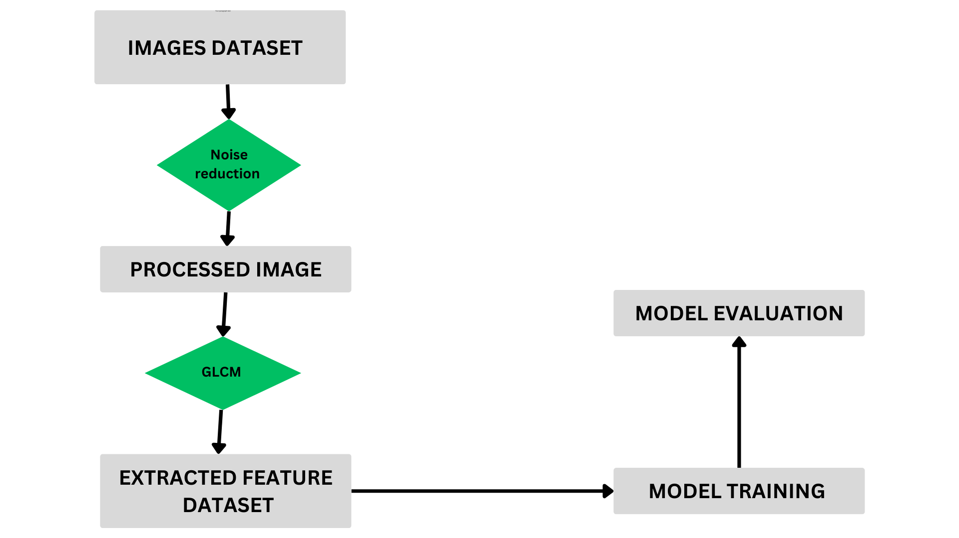

**4.2 Research Design or Approach**

This project adopted a quantitative research approach, leveraging machine learning and image processing techniques to analyze and classify soil types. The research design involved several key stages:

* **Image Preprocessing:** Applying techniques such as edge detection and noise reduction.

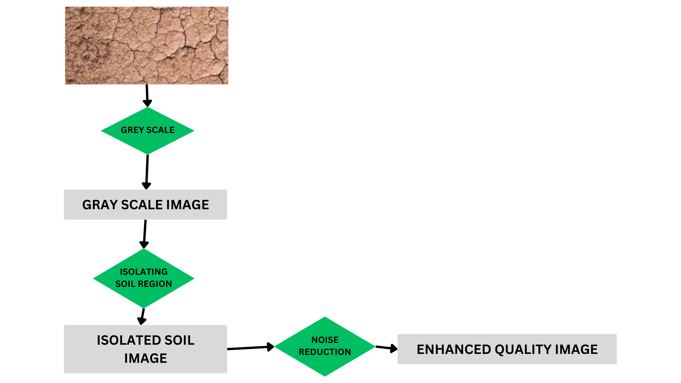

* **Feature Extraction:**Using the Gray-Level Co-occurrence Matrix (GLCM) to extract texture features.

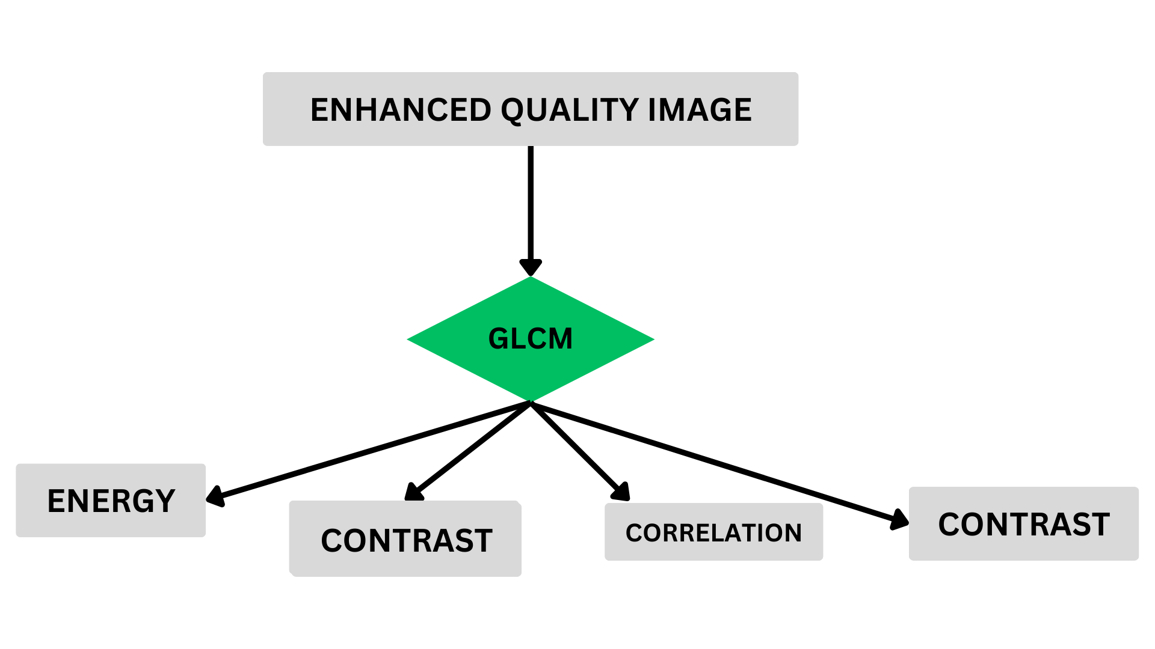

* **Model Development and Training:** Developing multiple machine learning models (SVM, Random Forest, k-NN).
* **Model Evaluation:** Assessing model performance using metrics like accuracy, precision, recall, and F1-score.

Illustration Suggestion: A diagram illustrating the research design, highlighting the sequential steps from image preprocessing to model evaluation.

**4.3 Data Collection Methods**

The data collection process involved gathering a diverse set of soil images representing different soil types. The key methods used included:

* **Image Acquisition:** Collected soil images from various agricultural fields and online databases.
* **Data Preprocessing:** Standardized the images by resizing, normalizing, and augmenting them to ensure consistency and enhance the dataset's robustness.

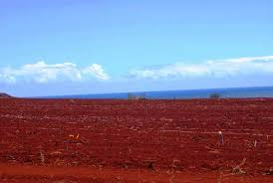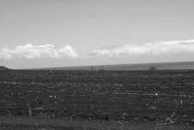

**4.4 Data Analysis Techniques**

The data analysis involved several sophisticated techniques:

**Image Preprocessing:** Applied edge detection using the Laplacian operator and noise reduction techniques like Gaussian Blur, Median Filtering, Bilateral Filtering, and Non-Local Means Denoising

Four noise reduction techniques will be implemented:

1. **Gaussian Blur**

A Gaussian Blur filter uses a Gaussian function to smooth images, reducing noise by averaging pixel values with their neighbors.

1. **Median Filter:**

The Median Filter replaces each pixel's value with the median value of the intensities in its neighborhood, effectively reducing salt-and-pepper noise.

1. **Bilateral Filter**

The Bilateral Filter smooths images while preserving edges by combining domain and range filtering.

1. **Non-Local Means Denoising**

This technique reduces noise by averaging all pixels in an image weighted by their similarity to the target pixel.

**Evaluation metrics for noise reduction:**

* **Peak Signal-to-Noise Ratio (PSNR)**

PSNR is a metric used to measure the quality of a reconstructed image compared to its original form. It is expressed in decibels (dB) and is based on the Mean Squared Error (MSE) between the original and reconstructed images. The formula for PSNR is:

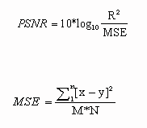

where R is the maximum possible pixel value of the image (typically 255 for an 8-bit image) and MSE is the Mean Squared Error

Where M and N are the dimensions of the images.

* **Structural Similarity Index (SSIM)**

SSIM is a perceptual metric that quantifies the image quality degradation caused by processing such as data compression or transmission losses. Unlike PSNR, which is based on pixel differences, SSIM considers changes in structural information, luminance, and contrast. The SSIM index is calculated as:

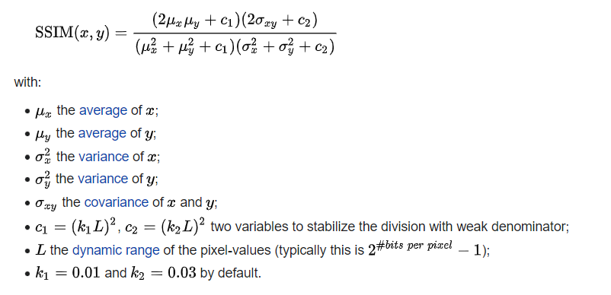

SSIM values range from -1 to 1:

* 1: Perfect similarity between the original and reconstructed images.
* 0: No similarity (completely different images).
* Negative values: Generally indicate that the images are negatively correlated, which is uncommon in practice.

**Feature Extraction:** Used GLCM to extract texture features such as contrast, correlation, energy, and homogeneity from all 1500 images. The average of these features was used for noise reduction.

1. **Contrast**:

-**Definition**: Contrast is a measure of the intensity contrast between a pixel and its neighbor over the whole image. It is calculated as the sum of squared differences between gray levels.

- **Application**: High contrast values indicate significant variations in texture, which can help identify soils with rough or uneven surfaces. Low contrast values suggest smoother textures.

2. **Correlation**:

- **Definition**: Correlation measures how correlated a pixel is to its neighbor over the whole image. It calculates the linear dependency of gray levels of neighboring pixels.

- **Application**: High correlation values indicate that pixel pairs have a predictable relationship, which can help identify homogeneous soil types. Low correlation values suggest more randomness in texture.

3. **Energy**:

- **Definition**: Energy, also known as Angular Second Moment, measures the sum of squared elements in the GLCM. It indicates textural uniformity.

- **Application**: High energy values suggest that the image has a uniform texture, which can be helpful in identifying soils with consistent particle size. Low energy values indicate more complex textures.

4. **Homogeneity**:

- **Definition**: Homogeneity measures the closeness of the distribution of elements in the GLCM to the GLCM diagonal. It evaluates how similar each pixel is to its neighbor.

- **Application**: High homogeneity values indicate that pixels are similar to their neighbors, which can be useful for identifying fine-grained soils. Low homogeneity values suggest more coarse or heterogeneous textures.

## FORMULA :

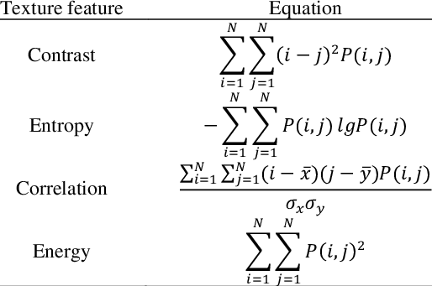

**Model Training and Evaluation:** Built and evaluated multiple machine learning models, recording the results of each iteration and fine-tuning parameters for optimal performance.

**4.6 Limitations**

Despite the successes, several limitations were inherent in the methodology:

* **Sample Size Limitations:** The dataset, while comprehensive, may not fully represent all possible soil variations, potentially affecting model generalization.
* **Time Constraints:** Limited time for the project may have restricted the extent of parameter tuning and model optimization.
* **Potential Biases:** Although efforts were made to mitigate biases, some inherent biases in the dataset or preprocessing techniques might still influence the results.

These limitations were acknowledged, and their potential impacts on the research findings were considered throughout the project.

*Illustration Suggestion:* A table outlining the identified limitations and their potential impacts on the research outcomes.

# CHAPTER – V IMPLEMENTATION





**CHAPTER V**



# IMPLEMENTATION



**5.1 Development Environment**

**Software Tools:**

* **Programming Languages: Python**
* **Development Environments: Google Collab, PyCharm**
* **Libraries and Frameworks:**

1. **OpenCV** for image processing
2. **Scikit-learn ,Tensorflow** for machine learning
3. **NumPy** and **Pandas** for data manipulation
4. **Matplotlib** and **Seaborn** for data visualization

**Hardware:**

* **Development Machine:**

1. Processor: Intel Core i7
2. RAM: 16 GB
3. Storage: 512 GB SSD
4. Testing Environment: Cloud computing platform with GPU support

* **Configuration:**
* **Operating System: Windows 10**
* **Python Version: 3.8**
* **Library Versions:**
  + **OpenCV: 4.5.3**
  + **Scikit-learn: 0.24.2**
  + **NumPy: 1.20.3**
  + **Pandas: 1.2.4**
  + **Matplotlib: 3.4.2**
  + **Seaborn: 0.11.1**

***illustration Suggestion:* A table summarizing the software tools, hardware, and configurations.**

**5.2 Project Execution**

The project execution involved several methodical steps:

1. **Data Collection**

* Collected a dataset of 1500 soil images representing various soil types.
* Applied preprocessing techniques including Laplacian edge detection, Gaussian Blur, Median Filtering, Bilateral Filtering, and Non-Local Means Denoising to enhance image quality.



sample rgb soil image

1. **Image Processing:**

* **converted rgb into grayscale image and resize the original image**



grayscale Image

* converting the input image to grayscale and applying binary thresholding to highlight the soil region. Contours are then detected, and the largest contour is identified and used to calculate a bounding box. Finally, the original image is cropped using this bounding box to isolate the soil region.

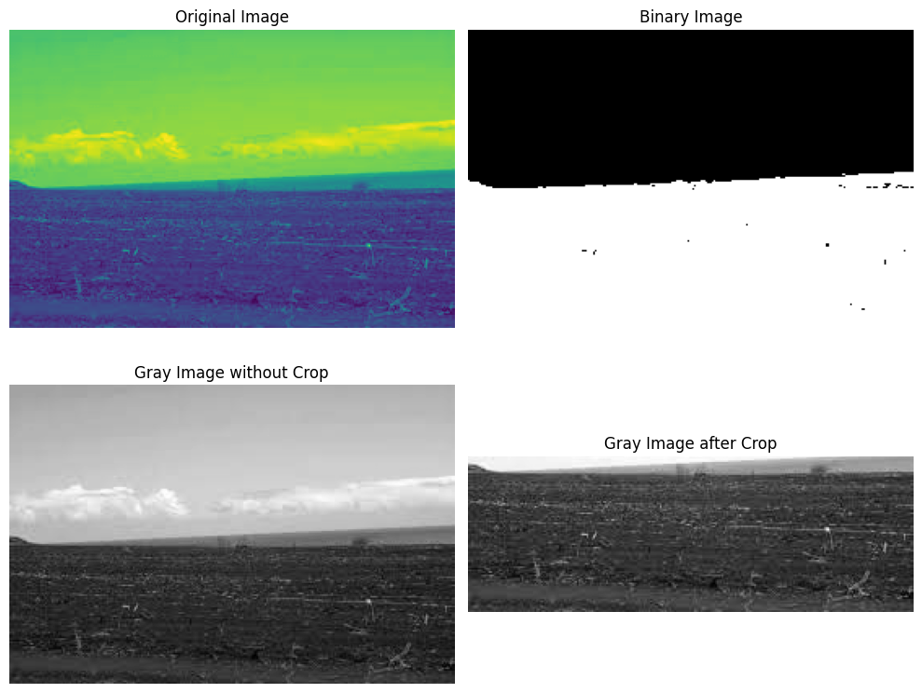

1. **Noise Reduction Implemented:**

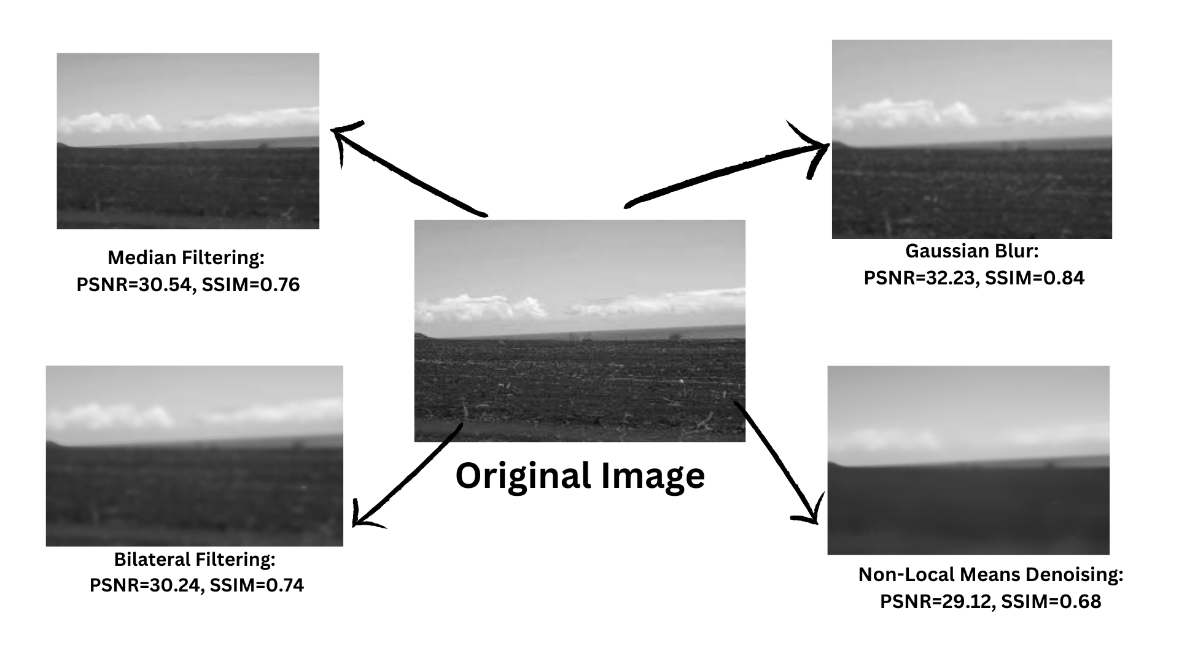

| **Noise Reduction Technique** | **PSNR Value** | **SSIM Value** |
| --- | --- | --- |
| Gaussian Blur | 32.23 | 0.84 |
| Median Filtering | 30.54 | 0.76 |
| Non-Local Means Denoising | 29.12 | 0.68 |
| Bilateral Filtering | 30.24 | 0.74 |

## 

1. **Finding Best Noise Reduction Technique and parameter :**

* Used **Peak Signal-to-Noise Ratio (PSNR)** and Structural **Similarity Index (SSIM)** as evaluation matrices
* We evaluated different noise reduction techniques applied to grayscale images and identified the best performing method and its optimal parameters. Four denoising techniques were compared: Non-Local Means (NLM), Gaussian, Median, and Bilateral filtering. Each technique was tested with various parameter sets, and their performance was assessed using Peak Signal-to-Noise Ratio (PSNR) and Structural Similarity Index Measure (SSIM).
* Non-Local Means (NLM) Denoising:
  + Parameters: (h, hForColor, templateWindowSize)
  + Tested sets: (5, 3, 15), (10, 3, 20), (15, 5, 25), (20, 7, 30), (25, 10, 35), (30, 15, 40)
* Gaussian Denoising:
  + Parameters: (kernel_size, sigma)
  + Tested sets: (3, 1), (5, 1.5), (7, 2), (9, 2.5), (11, 3), (13, 3.5)
* Median Denoising:
  + Parameters: (kernel_size)
  + Tested sets: (3), (5), (7), (9), (11), (13)
* Bilateral Filtering:
  + Parameters: (diameter, sigmaColor, sigmaSpace)
  + Tested sets: (5, 25, 25), (7, 50, 50), (9, 75, 75), (11, 100, 100), (13, 125, 125), (15, 150, 150)

The performance of each technique was evaluated by calculating the average PSNR and SSIM values for each parameter set across the dataset of 1500 images. The results are summarized in the table below:

| Technique | Parameters | Average PSNR | Average SSIM |
| --- | --- | --- | --- |
| nlm | (5, 3, 15) | 47.1912 | 0.9950 |
| nlm | (10, 3, 20) | 33.7452 | 0.9560 |
| nlm | (15, 5, 25) | 28.4377 | 0.8611 |
| nlm | (20, 7, 30) | 25.3884 | 0.7537 |
| nlm | (25, 10, 35) | 23.4362 | 0.6429 |
| nlm | (30, 15, 40) | 22.2458 | 0.5529 |
| gaussian | (3, 1) | 27.1733 | 0.8764 |
| gaussian | (5, 1.5) | 24.9362 | 0.7899 |
| gaussian | (7, 2) | 23.8952 | 0.7310 |
| gaussian | (9, 2.5) | 23.2358 | 0.6854 |
| gaussian | (11, 3) | 22.7567 | 0.6476 |
| gaussian | (13, 3.5) | 22.3965 | 0.6163 |
| median | (3) | 26.6077 | 0.8488 |
| median | (5) | 24.4904 | 0.7558 |
| median | (7) | 23.5003 | 0.6936 |
| median | (9) | 22.8851 | 0.6482 |
| median | (11) | 22.4540 | 0.6114 |
| median | (13) | 22.1353 | 0.5818 |
| bilateral | (5, 25, 25) | 30.9738 | 0.9420 |
| bilateral | (7, 50, 50) | 26.5826 | 0.8409 |
| bilateral | (9, 75, 75) | 24.6908 | 0.7608 |
| bilateral | (11, 100, 100) | 23.4941 | 0.6911 |
| bilateral | (13, 125, 125) | 22.8132 | 0.6429 |
| bilateral | (15, 150, 150) | 22.3481 | 0.6051 |

The results indicate that the **Non-Local Means (NLM) denoising technique with parameters (5, 3, 15)** achieves the highest average PSNR of 47.1912 and the highest average SSIM of 0.9950. This suggests that NLM is the most effective denoising method for the given dataset, providing superior noise reduction while maintaining the structural integrity of the images.

**Findings:**

* **Best Denoising Technique**: Non-Local Means (NLM)
* **Best Parameters**: (5, 3, 15)
* **Average PSNR**: 47.1912
* **Average SSIM**: 0.9950

1. **Feature Extraction:**

* Employed Gray-Level Co-occurrence Matrix (GLCM) to extract texture features from the preprocessed images.
* GLCM is a powerful tool for texture analysis, providing statistical measures that describe the texture of an image. The GLCM was computed for each preprocessed image at multiple angles (0°, 45°, 90°, and 135°) and distances to capture diverse texture patterns. The following GLCM properties were extracted:
  1. Dissimilarity
  2. Correlation
  3. Homogeneity
  4. Contrast
  5. ASM
  6. Energy
* **OVERVIEW:**The dataset consists of 1557 entries with 25 columns, where each row represents an image sample of soil. The columns include various GLCM (Gray Level Co-occurrence Matrix) properties calculated at four different angles (0°, 45°, 90°, and 135°), along with a label indicating the soil type.
* **Columns Description:**

1. dissimilarity_0: Measures the variation of gray-level pairs in the GLCM at 0°.
2. dissimilarity_45: Measures the variation of gray-level pairs in the GLCM at 45°.
3. dissimilarity_90: Measures the variation of gray-level pairs in the GLCM at 90°.
4. dissimilarity_135: Measures the variation of gray-level pairs in the GLCM at 135°.
5. correlation_0: Assesses the correlation of pixels at 0°.
6. correlation_45: Assesses the correlation of pixels at 45°.
7. correlation_90: Assesses the correlation of pixels at 90°.
8. correlation_135: Assesses the correlation of pixels at 135°.
9. homogeneity_0: Evaluates the homogeneity of the GLCM at 0°.
10. homogeneity_45: Evaluates the homogeneity of the GLCM at 45°.
11. homogeneity_90: Evaluates the homogeneity of the GLCM at 90°.
12. homogeneity_135: Evaluates the homogeneity of the GLCM at 135°.
13. contrast_0: Quantifies the contrast in the GLCM at 0°.
14. contrast_45: Quantifies the contrast in the GLCM at 45°.
15. contrast_90: Quantifies the contrast in the GLCM at 90°.
16. contrast_135: Quantifies the contrast in the GLCM at 135°.
17. ASM_0: Measures the Angular Second Moment (ASM) at 0°, indicating uniformity.
18. ASM_45: Measures the Angular Second Moment (ASM) at 45°, indicating uniformity.
19. ASM_90: Measures the Angular Second Moment (ASM) at 90°, indicating uniformity.
20. ASM_135: Measures the Angular Second Moment (ASM) at 135°, indicating uniformity.
21. energy_0: Reflects the sum of squared elements in the GLCM at 0°.
22. energy_45: Reflects the sum of squared elements in the GLCM at 45°.
23. energy_90: Reflects the sum of squared elements in the GLCM at 90°.
24. energy_135: Reflects the sum of squared elements in the GLCM at 135°.
25. label: The categorical label indicating the type of soil.

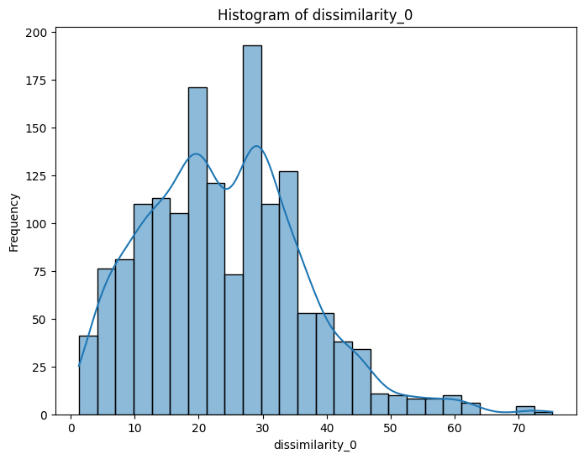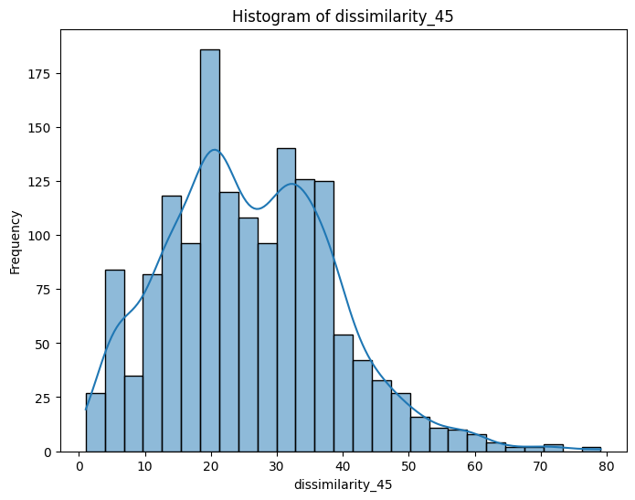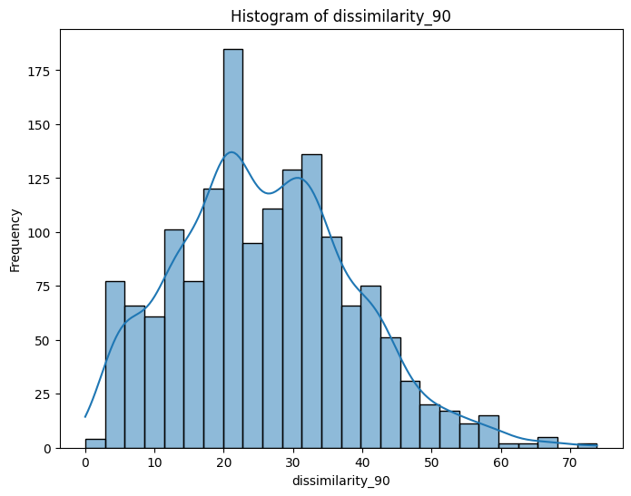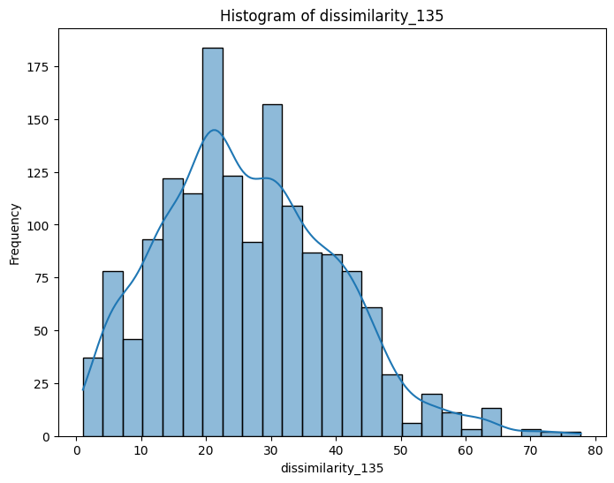

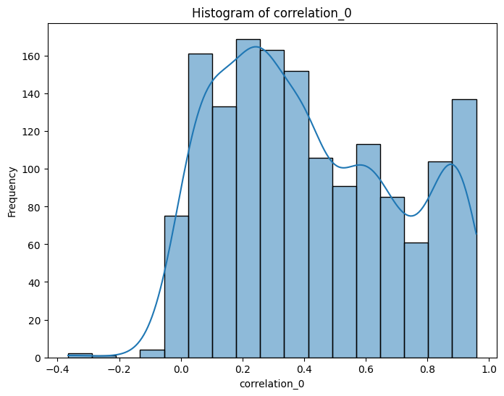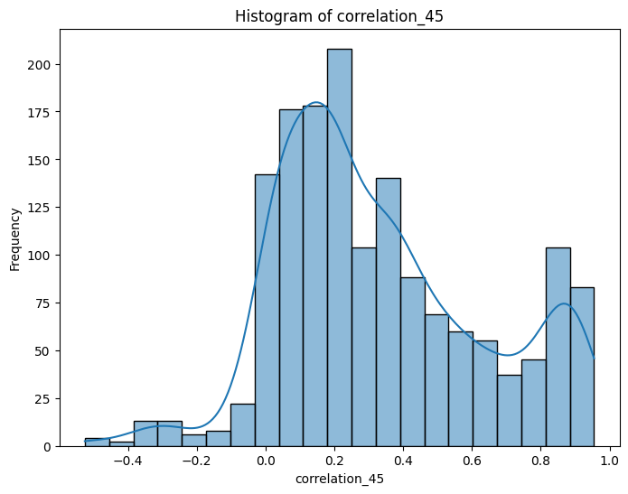

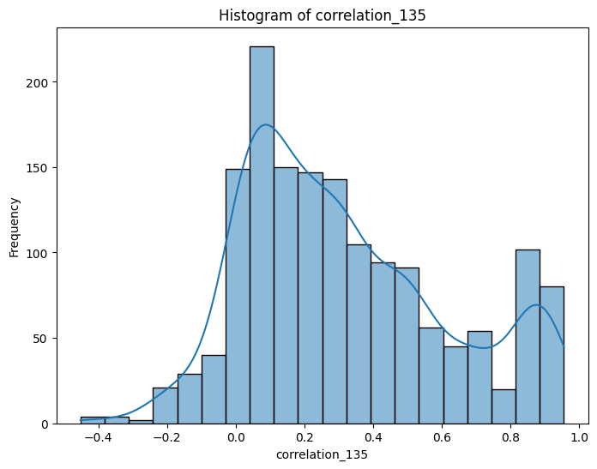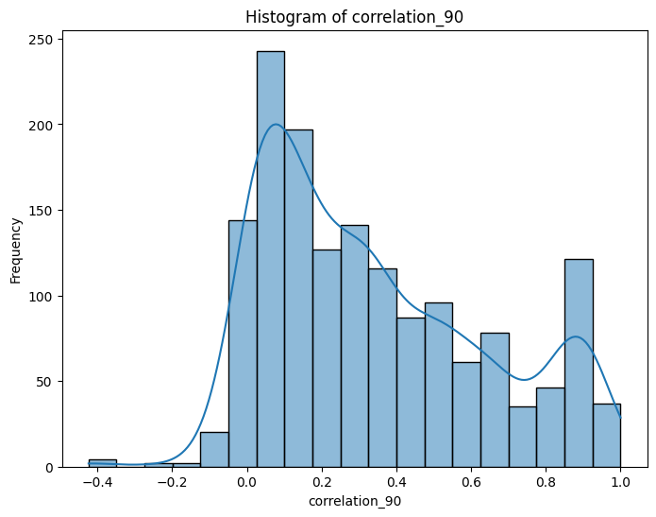

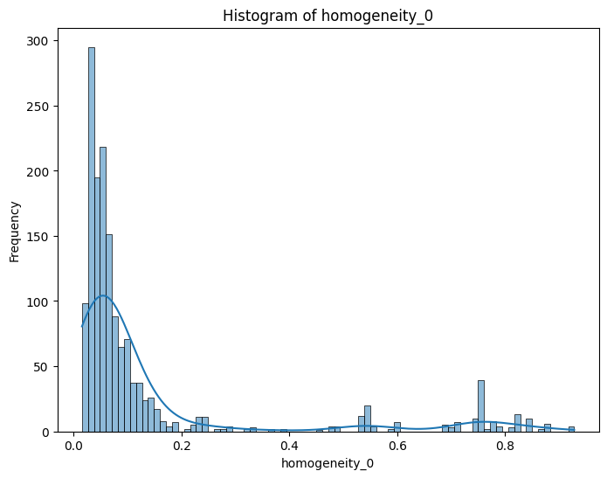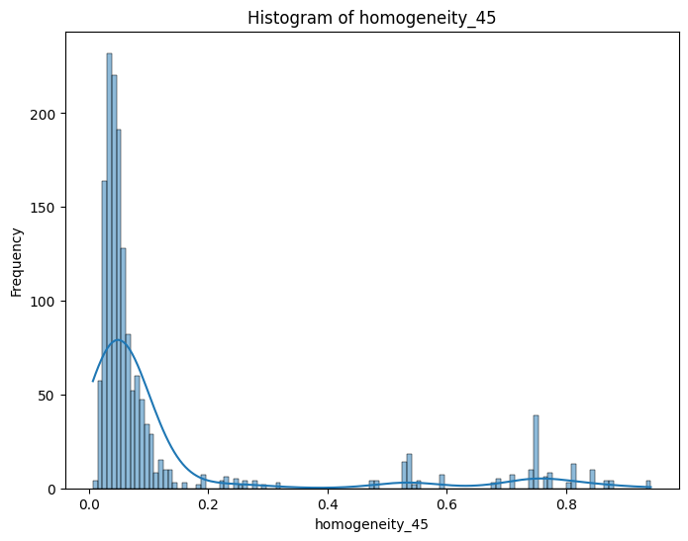

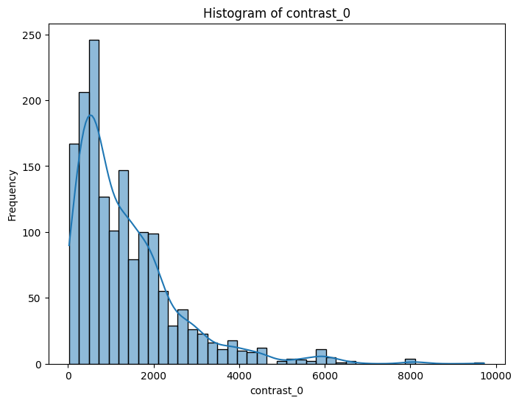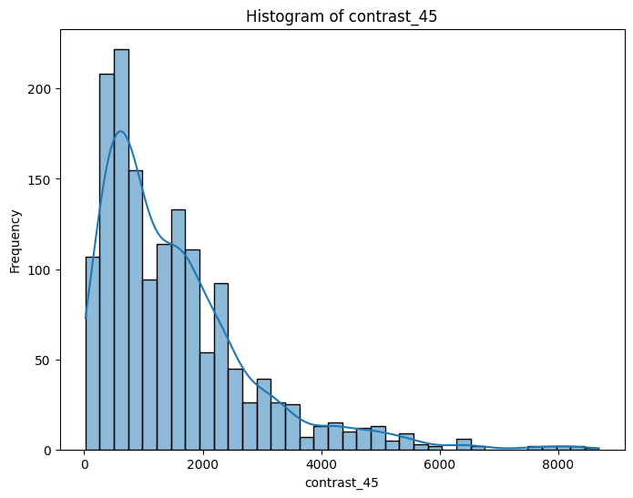

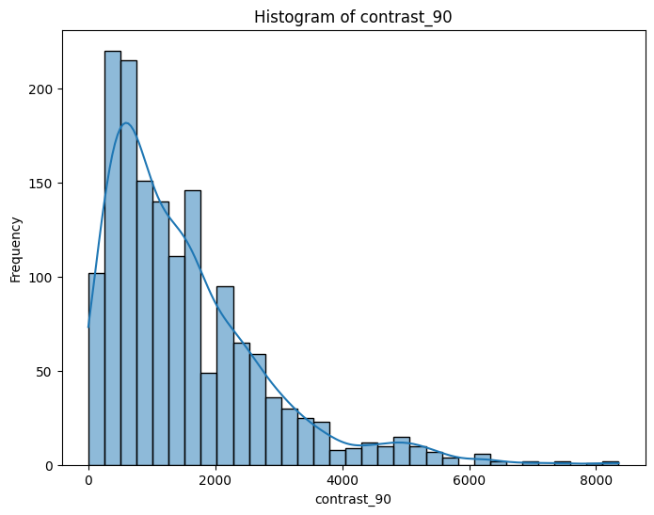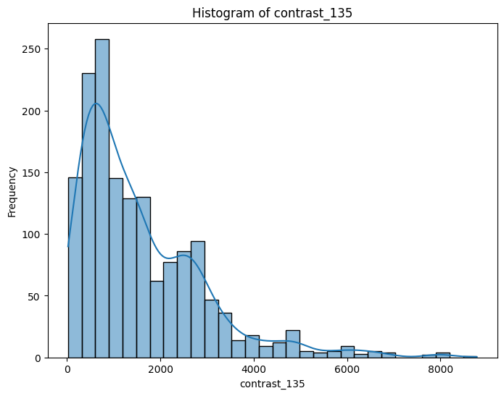

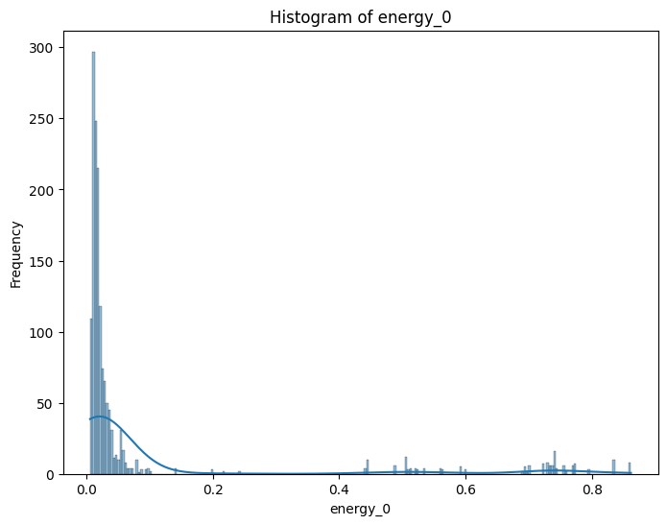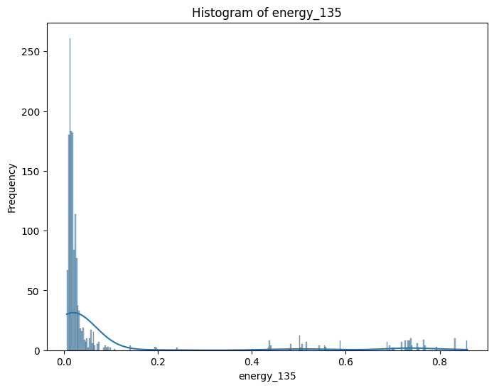

1. **Model Development and Training:**

* Developed and trained multiple machine learning models (SVM, Random Forest, k-NN) using the extracted features.
* Conducted iterative model training, tuning hyperparameters, and evaluating performance.

1. **Model Evaluation:**

* Assessed the performance of each model using metrics such as accuracy, precision, recall, and F1-score.
* Recorded and analyzed the results of each iteration to ensure robustness and accuracy.
* *Illustration Suggestion:* Bar charts comparing the evaluation metrics of different models.

**5.3 Timeline**

**Timeline:**

* **Week 1-2:** Data Collection and Preprocessing
* **Week 3-4:** Feature Extraction using GLCM
* **Week 5-6:** Model Development and Initial Training
* **Week 7-8:** Hyperparameter Tuning and Iterative Model Training
* **Week 9-10:** Model Evaluation and Optimization
* **Week 11-13:** Final Model Selection and Report Preparation

*Illustration Suggestion:* A Gantt chart illustrating the timeline of key milestones and activities.

**5.4 Resource Allocation**

**Resource Allocation:**

* **Time**: Allocated weekly tasks and milestones to ensure steady progress.
* **Budget**: Utilized available software tools and hardware resources effectively, with additional investment in cloud computing for intensive model training.
* **Personnel**: Collaborated with team members, leveraging individual expertise in image processing, machine learning, and data analysis.
* **Technology**: Optimized the use of development environments and cloud resources.

***Illustration*** *Suggestion:* A resource allocation table or chart depicting the distribution and management of resources.

**5.5 Challenges Faced**

**Challenges and Solutions:**

* D**ata Quality and Variability**: Addressed through advanced preprocessing techniques.
* **Model Overfitting**: Mitigated by using regularization techniques and cross-validation methods.
* **Computational Resource Constraints:** Overcome by leveraging cloud computing for model training.
* **Iterative Model Development:** Conducted extensive model iterations, fine-tuning parameters, and recording results.
* **Feature Extraction Complexity:** Simplified by applying GLCM to all images and using averaged features.

***Illustration*** *Suggestion:* A table or flowchart summarizing the challenges faced and the corresponding solutions.

### **5.7 Lessons Learned:**

Throughout the implementation of this project, several key lessons were identified that contributed to its success and provided insights for future projects:

1. **Effective System Architecture:**

* **What Worked Well:** Adopting a modular system architecture approach proved effective. It facilitated seamless integration of various components such as data preprocessing, feature extraction, and model training. This modular approach ensured flexibility and scalability, enabling independent improvement of different system parts.

1. **Iterative Model Training:**

* **What Worked Well:**  Emphasizing iterative model training was crucial. It involved fine-tuning hyperparameters and rigorously evaluating model metrics, which deepened my understanding of model optimization and improved performance. This iterative approach fostered continuous improvement in machine learning techniques.

1. **Thorough Data Preprocessing:**

* **What Worked Well:** Implementing comprehensive data preprocessing techniques, such as edge detection and noise reduction, significantly enhanced data quality. These methods ensured the models were trained on clean and relevant features, essential for accurate soil type classification.

1. **Areas for Improvement:**

* **More Extensive Initial Data Collection:** Recognizing the importance of a diverse dataset, future projects should start with a more extensive and varied data collection phase. This would improve the model's ability to generalize across different soil types and environmental conditions.

1. **Insights for Future Projects:**

* **Importance of Regular Reviews:** Conducting regular project reviews was essential for identifying challenges early and making timely adjustments. This practice ensured project milestones were met and facilitated continuous enhancement throughout the development cycle.
* **Adaptability to New Methodologies:** Staying adaptable to emerging methodologies and technologies is critical in fields like machine learning and image processing. Embracing new techniques enables projects to leverage cutting-edge advancements for improved results.
* **Comprehensive Documentation:** Maintaining thorough documentation was invaluable for tracking decisions, experiments, and insights. Clear documentation supported project continuity, facilitated knowledge transfer, and laid the groundwork for future enhancements.



# CHAPTER – VI RESULTS AND DISCUSSION



**CHAPTER VI**



# RESULTS AND DISCUSSION



**6.1 Presentation of Results:**

This section presents the outcomes of the internship project focused on automating soil classification using machine learning techniques. The findings are structured to provide a detailed and organized overview of the results obtained through systematic experimentation and analysis.

**SVM Model Performance Metrics:**

* **Accuracy:** 95%
* confusion matrix:

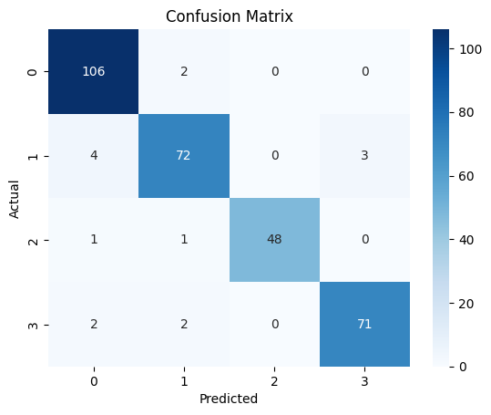

**KNN Model Performance Metrics:**

* **Accuracy:** 94%
* Effect of n_neighbors on KNN Performance:

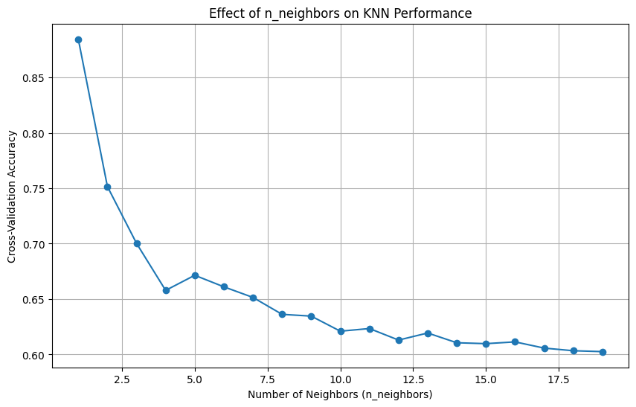

**Decision Tree Model Performance Metrics:**

* **Accuracy:** 87%

Classification Report:

precision recall f1-score support

Alluvial soil 0.95 0.89 0.92 178

Black Soil 0.92 0.85 0.89 114

Clay soil 0.84 0.93 0.88 72

Red soil 0.86 0.96 0.91 104

accuracy 0.90 468

macro avg 0.89 0.91 0.90 468

weighted avg 0.91 0.90 0.90 468

**6.2 Interpretation of Results:**

The interpretation of results encompasses a thorough analysis of the performance of various machine learning models. Each model underwent extensive parameter tuning to optimize its capability in accurately classifying soil types based on extracted image features.

**6.3 Comparison with Objectives:**

**Objective 1: Develop a Robust Soil Classification Model**

* Multiple machine learning models, including **Support Vector Machines (SVM),** **Random Forest**, and **k-Nearest Neighbors (k-NN)**, were implemented and evaluated.
* Each model underwent iterative tuning across different parameters, meticulously recording and analyzing results to identify optimal configurations.
* *Discussion:* The detailed exploration of model performance closely aligns with the project's objective of developing robust classification models capable of accurately identifying diverse soil types from image data.

**Objective 2: Enhance Image Quality through Preprocessing**

* Various preprocessing techniques, such as edge detection using the **Laplacian operator** and noise reduction methods like Gaussian Blur,NLM etc. were applied to enhance image clarity and facilitate effective feature extraction.
* *Discussion:* These preprocessing steps were pivotal in improving the quality of input data, thereby enhancing the models' ability to discern and utilize meaningful features for accurate soil classification.

**6.4 Discussion of Key Findings**

**Key Finding 1: Impact of Parameter Tuning on Model Performance**

* Detailed experimentation with model parameters revealed substantial variations in performance metrics.
* Systematic recording and analysis of results highlighted the significant influence of parameter settings on accuracy, precision, recall, and F1-score.
* *Implications:* This finding underscores the critical role of parameter optimization in achieving superior model performance and reliability.

**Key Finding 2: Visualization of Feature Importance**

* Visual representations of feature importance, such as GLCM matrices and extracted texture features, provided insightful perspectives on the discriminative power of different image characteristics.
* *Implications:* Visualizing feature importance facilitated a deeper understanding of how specific image attributes contribute to the accurate classification of soil types.

**6.5 Limitations and Future Directions**

**Limitations:**

* **Data Size and Diversity:** The project was constrained by the size and diversity of the available dataset, potentially limiting the generalization ability of the models.
* **Computational Resources:** Challenges in computational resources influenced the scalability and efficiency of model training and evaluation processes.

**Future Directions:**

* Expansion of Dataset: Future research should prioritize acquiring a larger and more diverse dataset encompassing a broader spectrum of soil types and environmental conditions.
* Integration of Advanced Techniques: Exploring advanced machine learning techniques, such as deep learning architectures or ensemble methods, holds promise for further enhancing classification accuracy and robustness.



# CHAPTER – VII CONCLUSION AND FUTURE SCOPE





**CHAPTER VII**



# CONCLUSION AND FUTURE SCOPE



**7.1 Summary of Findings**

**7.2 Achievement of Objectives**

**Objective 1: Develop a Robust Soil Classification Model**

* The project successfully implemented and evaluated multiple machine learning models, achieving high accuracy in classifying soil types based on image data.
* Systematic parameter tuning and rigorous evaluation contributed to optimizing model performance and achieving project objectives effectively.

**Objective 2: Enhance Image Quality through Preprocessing**

* Various preprocessing techniques, including edge detection and noise reduction methods, were applied to improve image clarity and feature extraction.
* These efforts significantly enhanced the quality of input data, thereby improving the models' ability to accurately classify soil types.

**7.3 Implications and Recommendations**

**Implications of Findings:**

* The findings underscore the potential of machine learning in automating soil classification tasks, offering efficient and accurate solutions for agricultural practices.
* Insights into feature importance and model performance metrics provide actionable information for enhancing soil management strategies and crop planning.

**Recommendations:**

* Future applications could benefit from expanding the dataset to include a wider range of soil types and environmental conditions, enhancing model generalization capabilities.
* Continued exploration of advanced machine learning techniques, such as deep learning and ensemble methods, could further improve classification accuracy and robustness.

**7.4 Future Scope**

**Potential Avenues for Future Research:**

* **Integration of Advanced Technologies:** Exploring the integration of remote sensing data or multispectral imaging for comprehensive soil analysis.
* **Real-Time Monitoring Systems:** Developing real-time soil classification systems for continuous monitoring and adaptive agricultural practices.
* **Cross-Domain Applications:** Applying similar methodologies to other domains, such as environmental monitoring or geological studies, for broader impact.

**Research Questions and Directions:**

* How can machine learning models be adapted for dynamic soil classification in changing environmental conditions?
* What are the implications of incorporating temporal data for long-term soil health monitoring and management?

**7.5 Personal Reflections:**

**Professional Growth and Development:**

* The internship provided valuable hands-on experience in applying machine learning techniques to real-world agricultural challenges.
* Skills acquired in data preprocessing, model development, and result interpretation have significantly contributed to my technical proficiency and professional growth.

**Lessons Learned:**

* Effective project management, including rigorous experimentation and systematic evaluation, is crucial for achieving robust research outcomes.
* Continuous learning and adaptation to new technologies are essential for staying at the forefront of advancements in data-driven research.

45



**CHAPTER VII LEARNING OUTCOMES**





**CHAPTER VIII**



# LEARNING OUTCOMES



#### 8.1 Skills Developed:

During the internship project, I acquired and honed a diverse set of skills that significantly contributed to my professional growth and technical proficiency:

* **Technical Skills:** Proficiency in implementing machine learning models for image classification, including data preprocessing, feature extraction (e.g., GLCM analysis), and model evaluation.
* **Programming Languages:** Advanced skills in Python for data manipulation, visualization (using libraries like Matplotlib and Seaborn), and model development (utilizing scikit-learn and TensorFlow).
* **Problem-Solving Abilities:** Developed strategies for systematic experimentation, parameter tuning, and troubleshooting challenges encountered during model development and evaluation.
* **Teamwork and Collaboration:** Collaborated effectively with team members, sharing insights, coordinating tasks, and contributing to group discussions and project milestones.
* **Time Management:** Efficiently managed project timelines, balancing multiple tasks, and prioritizing activities to meet deadlines and deliver high-quality outcomes.
* **Communication Skills:** Enhanced communication skills through regular project updates, presenting findings, and articulating technical concepts to diverse audiences.

**8.2 Knowledge Gained:**

The internship provided invaluable insights and knowledge that expanded my understanding of the application of machine learning in agricultural and environmental sciences:

* **Industry Insight:** Gained a deeper understanding of agricultural practices and the role of technology in optimizing soil management and crop productivity.
* **Advanced Techniques:** Acquired knowledge in advanced image processing techniques, such as noise reduction and feature extraction, and their application to real-world datasets.
* **Data-driven Decision Making:** Learned methodologies for leveraging data analysis and machine learning to support informed decision-making in agricultural settings.
* **Practical Experience:** Applied theoretical concepts from academic studies to real-world scenarios, enhancing my ability to bridge academic knowledge with practical application.

#### 

#### 

#### 

#### 

#### 

#### 

#### 8.3 Professional Development

The internship experience significantly contributed to my professional development and career aspirations:

* **Career Goals:** Clarified my career interests in data science and machine learning applications in agriculture, reaffirming my commitment to pursuing a career in this dynamic field.
* **Strengths and Weaknesses:** Identified strengths in data analysis and model development, while recognizing areas for improvement in project management and advanced statistical analysis.
* **Networking Opportunities:** Established professional connections within the industry, expanding my network and gaining insights into career pathways and opportunities.
* **Skill Enhancement:** Strengthened technical skills and gained practical experience that enhances my competitiveness in the job market and future academic pursuits.

#### 8.4 Personal Growth

The internship fostered personal growth and self-awareness through various challenges and learning experiences:

* **Adaptability:** Overcame challenges in data preprocessing and model optimization, developing resilience and adaptability in problem-solving approaches.
* **Personal Values:** Deepened appreciation for the intersection of technology and environmental sustainability, aligning personal values with career aspirations in agricultural innovation.
* **Leadership Potential:** Recognized opportunities for leadership development through project coordination and mentoring activities, fostering confidence in assuming future leadership roles.

#### 8.5 Future Application

I plan to leverage the knowledge, skills, and experiences gained during the internship in the following ways:

* **Academic Studies:** Apply advanced machine learning techniques and data analysis methodologies to academic research projects, contributing to ongoing studies in environmental sciences and agriculture.
* **Career Endeavors:** Pursue opportunities in data science roles within the agricultural sector, focusing on optimizing agricultural processes through innovative technological solutions.
* **Professional Growth:** Continue professional development through certifications, workshops, and collaborative projects that advance my expertise in machine learning and data-driven decision-making.



# REFERENCES

[1] Gachet, Philippe, Georg Klubertanz, Laurent Vulliet, and Lyesse Laloui. "Interfacial behavior of unsaturated soil with small-scale models and use of image processing techniques." Geotechnical Testing Journal 26, no. 1 (2003): 12-21.

[2] Jin, Xiuliang, Jianhang Ma, Zhidan Wen, and Kaishan Song. "Estimation of maize residue cover using Landsat-8 OLI image spectral information and textural features." Remote Sensing 7, no. 11 (2015): 14559-14575.

[3] Su, Wen-Hao. "Advanced Machine Learning in Point Spectroscopy, RGB-and hyperspectral imaging for automatic discriminations of crops and weeds: A review." Smart Cities 3, no. 3 (2020): 767-792

Alazawi, Sundos & Shati, Narjis & Abbas, Amel. (2019). Texture Features Extraction based on GLCM for Face Retrieval System. Periodicals of Engineering and Natural Sciences (PEN). 7. 1459. 10.21533/pen.v7i3.787.

Iqbal N, Mumtaz R, Shafi U, Zaidi SMH. Gray level co-occurrence matrix (GLCM) texture based crop classification using low altitude remote sensing platforms. PeerJ Comput Sci. 2021 May 19;7:e536. doi: 10.7717/peerj-cs.536. PMID: 34141878; PMCID: PMC8176538.

saady, Hana. (2023). Color Image De-noising Based on Mean, Median, and Gaussian filters. IJARCCE. 12. 10.17148/IJARCCE.2023.12816.







# ANNEXURE – I



47



**GENERAL GUIDELINES**

### The internship project report will be written in Times New Roman. The chapter name headings will be sized 18-20 and in bold, which will be common for all chapters. Content headings will be size 14 and in bold, while subheadings will be size 12 and in bold. The content size will be 12 and in bold.

1. Figure numbers will be based on the chapter number. For example, if the first figure is used in Chapter IV, then the number will be "Fig 4.1: Caption". Similarly, the third figure in Chapter V will be written as "Fig 5.3: Caption". The size of the "Fig 5.3: Caption" will be Times New Roman 10 and should be written at the bottom of the figure.

### Tables will be described similarly. For instance, "Table 2" in Chapter III will be written as "Table 3.2: Table Title", or "Table 1" in Chapter V will be written as "Table 5.1: Table Title". The font size of "Table 5.1: Table Title" will be Times New Roman 10 and should be written at the top of the table.



48