Scaling & Updates Replica scaling + rolling update demonstrated live
Step 2 — Scale IN from 4 → 2
helm upgrade streamingapp . --namespace streamingapp --set services.auth.replicas=2
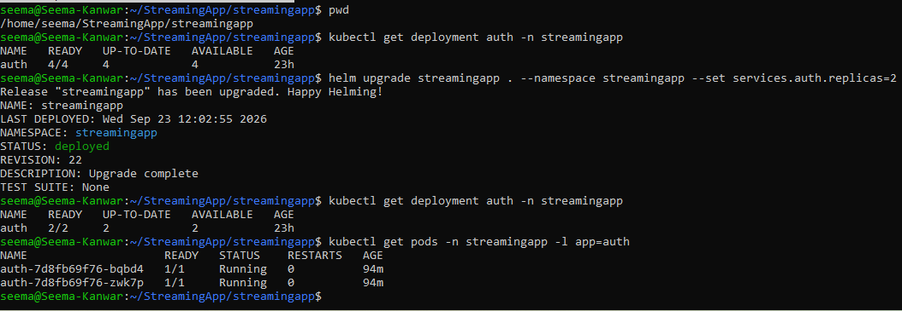

Step 2 — Scale OUT from 2 → 4
helm upgrade streamingapp . --namespace streamingapp --set services.auth.replicas=4

