AMTGC_PROJECT

1. Project Overview
Traffic congestion at busy intersections is one of the most common challenges in modern cities. Traditional traffic signal systems usually operate independently with fixed timing, which often results in unnecessary waiting times, poor traffic flow, and delays during peak hours. To address these limitations, this project proposes an Adaptive Multi-Junction Traffic Grid Controller (AMTGC) that coordinates two four-way traffic junctions to improve overall traffic movement.
The system consists of Junction A and Junction B, both of which operate using a Finite State Machine (FSM) to control the sequence of traffic lights. Instead of functioning independently, the two junctions communicate through a Green-Wave coordination mechanism, allowing vehicles that pass-through Junction A to reach Junction B while its signal is also green. This reduces unnecessary stops and helps maintain a smoother flow of traffic.
To improve pedestrian safety, the design includes a shared pedestrian arbiter that receives crossing requests from both junctions and decides which request should be served first. This ensures that pedestrians at one junction are not continuously delayed because of requests from the other junction.
The controller also includes an Emergency Override feature. Whenever an emergency vehicle is detected, both junctions safely transition to an All-Red state within a limited number of clock cycles, allowing emergency vehicles to pass safely. Once the emergency condition is cleared, the system resumes normal traffic operation from a valid traffic state.
The entire project follows a modular and parameterized architecture, where each module has a specific responsibility. This approach makes the design easier to understand, verify, maintain, and reuse. It also allows different timing values to be assigned to each junction without changing the RTL code. Overall, the AMTGC demonstrates a practical and scalable traffic control system that combines efficient traffic management, pedestrian safety, emergency handling, and reusable digital design principles.

2. Problem Statement
Traffic congestion has become a common problem in cities, especially at busy intersections where multiple roads meet. Most conventional traffic signal systems operate with fixed timing and treat each junction as an independent unit. This often causes unnecessary waiting, longer travel times, and frequent stops for vehicles, even when the next intersection is clear.
Managing pedestrian crossings also becomes challenging when multiple junctions are involved. If each junction handles pedestrian requests independently, it becomes difficult to ensure fair service during simultaneous requests. In addition, emergency situations such as the arrival of an ambulance or fire truck require a fast and reliable way to stop all traffic safely.
The goal of this project is to design an Adaptive Multi-Junction Traffic Grid Controller (AMTGC) that overcomes these limitations. The system coordinates two four-way traffic junctions using a Green-Wave mechanism to improve traffic flow, includes a shared pedestrian arbiter to handle pedestrian requests fairly, and provides an emergency override that safely transitions both junctions to an All-Red state when required. The design also follows a modular and parameterized approach so that it can be easily reused, maintained, and verified while ensuring safe and efficient traffic control.

3. Functional Requirements
The Adaptive Multi-Junction Traffic Grid Controller (AMTGC) is designed to meet the following functional requirements:
- The system shall control two four-way traffic junctions, namely Junction A and Junction B, while allowing them to operate in a coordinated manner.
- Each junction shall follow the standard traffic light sequence consisting of North-South Green, North-South Yellow, All-Red, East-West Green, East-West Yellow, and an optional Pedestrian Crossing phase.
- The system shall implement a Green-Wave coordination mechanism, ensuring that Junction B enters the North-South Green phase within a predefined delay after Junction A to improve the flow of vehicles between the two intersections.
- The system shall include a shared pedestrian arbiter that receives pedestrian crossing requests from both junctions and grants access fairly without causing starvation for either junction.
- The controller shall support a global emergency override that safely transitions both junctions to an All-Red state within a bounded number of clock cycles whenever an emergency condition occurs.
- Once the emergency condition is cleared, the controller shall resume normal operation from a valid traffic phase without entering an undefined state.
- The complete design shall operate using a single clock domain with a consistent reset strategy to ensure reliable and synchronized operation.
- The traffic controller shall be designed using a modular and parameterized architecture, allowing the same controller to be reused for both junctions with different timing configurations.
- The timing of each traffic phase shall be configurable through parameters rather than hardcoded values, making the design flexible and scalable.
- The design shall be verified through simulation using normal operating conditions, pedestrian requests, emergency scenarios, and other corner cases to ensure correct functionality and safe operation.

4. System Architecture
The Adaptive Multi-Junction Traffic Grid Controller (AMTGC) follows a modular and hierarchical architecture, where each module performs a dedicated function while working together to control the complete traffic management system. This modular approach improves readability, simplifies verification, and allows individual modules to be reused or modified without affecting the rest of the design.
At the highest level, the system consists of two parameterized Junction Controllers, namely Junction A and Junction B, which are responsible for controlling the traffic signals at their respective intersections. Both controllers are instantiated from the same RTL module but operate with different timing parameters, demonstrating hardware reusability.
Each junction controller uses a dedicated Generic Timer to control the duration of different traffic phases such as Green, Yellow, All-Red, and Pedestrian Crossing. Separating the timer from the controller keeps the timing logic independent of the traffic control logic, making the design more modular and easier to maintain.
To handle pedestrian requests efficiently, the system includes a shared Pedestrian Arbiter. Instead of assigning a separate pedestrian controller to each junction, a single arbiter receives requests from both junctions and grants them using a fair arbitration policy. This approach reduces hardware duplication while ensuring that neither junction is permanently denied pedestrian access.
The two junctions are also connected through a Green-Wave coordination mechanism. This coordination ensures that Junction B enters its North-South Green phase shortly after Junction A, allowing vehicles travelling along the main road to pass through consecutive intersections with fewer stops and improved traffic flow.
For safety, the system includes a global Emergency Override. Whenever an emergency condition is detected, both junctions safely transition to an All-Red state within a bounded number of clock cycles. Once the emergency condition is cleared, the system resumes normal traffic operation from a valid traffic phase.
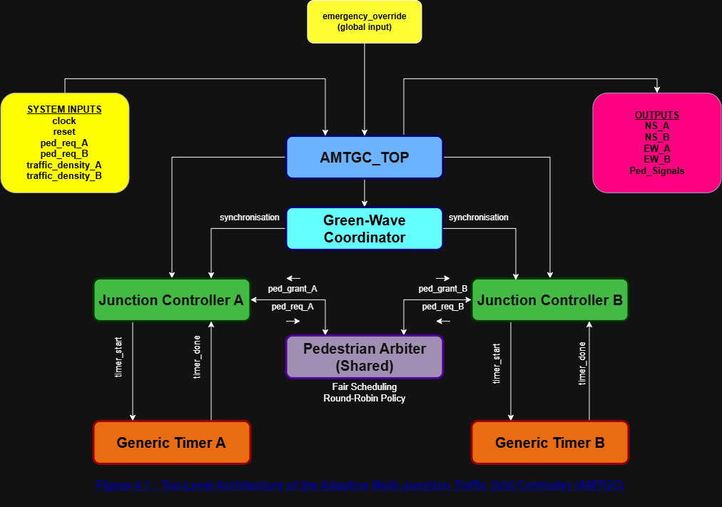
The complete design operates under a single clock domain with a consistent reset strategy, ensuring synchronized operation across all modules. Figure 4.1 illustrates the overall architecture of the proposed Adaptive Multi-Junction Traffic Grid Controller.

5. Module Descriptions
5.1 Introduction
The AMTGC is built using a modular design, where each module is responsible for a specific task within the system. Instead of combining all the functionality into a single design, the project is divided into smaller modules that work together. This approach makes the system easier to understand, test, and maintain. It also allows individual modules to be reused or modified without affecting the rest of the design.

5.2 AMTGC_TOP
The AMTGC_TOP module acts as the central controller of the entire system. It connects all the major modules and manages the flow of information between them. System inputs such as the clock, reset, pedestrian requests, traffic density signals, and the emergency override are received by this module and passed to the appropriate blocks. It also collects the outputs from the junction controllers and generates the final traffic light and pedestrian signals. In simple terms, this module acts as the "brain" of the traffic control system.

5.3 Junction Controller
The Junction Controller is responsible for controlling the traffic lights at a single four-way intersection. It uses a Finite State Machine (FSM) to move through different traffic phases such as North-South Green, North-South Yellow, All-Red, East-West Green, East-West Yellow, and the Pedestrian Crossing phase. Two identical instances of this module are used in the project—one for Junction A and one for Junction B. Although both controllers perform the same task, they operate independently while coordinating with each other through the Green-Wave mechanism whenever required.

5.4 Generic Timer
The Generic Timer module is responsible for keeping track of the duration of each traffic signal phase. Instead of placing timing logic inside the Junction Controller, it has been designed as a separate module to keep the design clean and reusable. Whenever the Junction Controller starts a new traffic phase, it activates the timer. Once the required time has elapsed, the timer sends a completion signal back to the controller, allowing it to move to the next state.

5.5 Green-Wave Coordinator
The Green-Wave Coordinator helps both junctions work together instead of operating completely independently. Its purpose is to synchronize the traffic signals so that vehicles travelling from Junction A can reach Junction B with fewer stops. By coordinating the North-South Green phase between the two intersections, the system improves traffic flow and reduces unnecessary delays. In the RTL implementation, this coordination logic will be handled within the top-level module while remaining a separate functional block in the system architecture.

5.6 Pedestrian Arbiter
The Pedestrian Arbiter manages pedestrian crossing requests from both junctions. If requests arrive at the same time, the arbiter decides which junction should be served first using a Round-Robin scheduling policy. This ensures that both junctions are treated fairly and prevents one junction from continuously receiving priority over the other. Once a request is selected, the arbiter sends a grant signal to the corresponding Junction Controller, allowing the pedestrian crossing phase to begin safely.

6. Module Interfaces
6.1 Introduction
Every module in the AMTGC communicates with other modules through a defined set of input and output signals. Clearly defining these interfaces before implementation helps maintain a modular design and makes integration, debugging, and verification much easier. The following tables summarize the primary interfaces of each module used in the proposed architecture.
6.2 AMTGC_TOP Interface
Signal | Direction | Description
clk | Input | System clock used to synchronize all modules.
reset | Input | Resets the entire system to its initial state.
traffic_density_A | Input | Traffic density input for Junction A.
traffic_density_B | Input | Traffic density input for Junction B.
ped_req_A | Input | Pedestrian crossing request from Junction A.
ped_req_B | Input | Pedestrian crossing request from Junction B.
emergency_override | Input | Forces the system into emergency mode.
A_NS, A_EW | Output | Traffic light signals for Junction A.
B_NS, B_EW | Output | Traffic light signals for Junction B.
ped_signal_A, ped_signal_B | Output | Pedestrian crossing signals for both junctions.

6.3 Junction Controller Interface
Signal | Direction | Description
clk | Input | System clock.
reset | Input | Resets the controller.
traffic_density | Input | Current traffic density for the junction.
ped_grant | Input | Grant signal received from the Pedestrian Arbiter.
emergency_override | Input | Forces the controller into the All-Red state.
timer_done | Input | Indicates that the current traffic phase has completed.
timer_start | Output | Starts the Generic Timer for the next traffic phase.
traffic_lights | Output | Controls the traffic lights of the junction.
ped_signal | Output | Controls the pedestrian crossing signal.

6.4 Generic Timer Interface
Signal | Direction | Description
clk | Input | System clock.
reset | Input | Resets the timer.
timer_start | Input | Starts the timing operation.
target_time | Input | Specifies the required duration of the traffic phase.
timer_done | Output | Indicates that the timer has completed counting.

6.5 Pedestrian Arbiter Interface
Signal | Direction | Description
clk | Input | System clock.
reset | Input | Resets the arbiter.
ped_req_A | Input | Pedestrian request from Junction A.
ped_req_B | Input | Pedestrian request from Junction B.
ped_grant_A | Output | Grants pedestrian access to Junction A.
ped_grant_B | Output | Grants pedestrian access to Junction B.

6.6 Green-Wave Coordination Interface
Signal | Direction | Description
sync_from_A | Input | Indicates that Junction A has entered the North-South Green phase.
sync_to_B | Output | Coordinates the timing of Junction B's North-South Green phase.

7. Clocking Strategy
7.1 Introduction
The AMTGC is designed to operate using a single synchronous clock domain, where all modules receive the same clock signal. Using a common clock ensures that every module changes its state at the same instant, making communication between modules predictable and reliable. This approach also simplifies RTL design, simulation, and verification by eliminating timing issues that can occur when multiple clock domains are used.

Why a Single Clock Domain?
Since all modules in the system are closely related and frequently exchange information, using a single clock domain is the most practical choice. The Junction Controllers, Generic Timers, Pedestrian Arbiter, and Green-Wave Coordination logic all need to remain synchronized throughout operation. A shared clock ensures that signals are transferred correctly between modules without requiring additional clock-domain crossing circuitry.

Clock Distribution
The system clock is distributed from the AMTGC_TOP module to all submodules, including the Junction Controllers, Generic Timers, and Pedestrian Arbiter. This ensures that every module performs its operations on the same clock edge, maintaining consistent timing across the entire design.
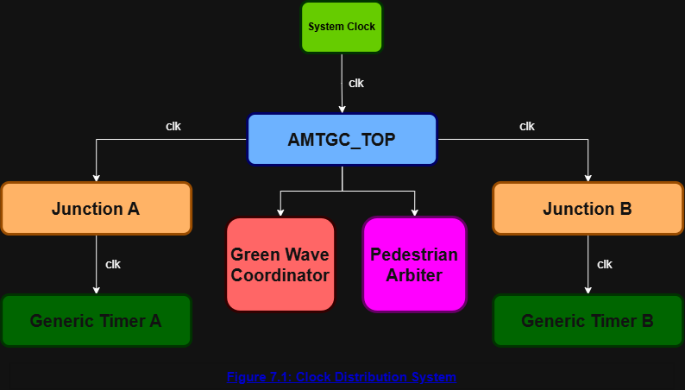

8. Reset Strategy
8.1 Introduction
A reset mechanism is essential in any digital system to ensure that all modules begin operation from a known and predictable state. In the AMTGC, a synchronous active-high reset is used to initialize every module to its default condition. When the reset signal is asserted, all finite state machines, timers, counters, and control logic return to their initial states on the next rising edge of the system clock. This guarantees a safe startup sequence and prevents undefined system behaviour.

Why Synchronous Reset?
Since the entire AMTGC operates within a single clock domain, a synchronous reset provides a simple and reliable way to initialize the system. All modules respond to the reset signal on the same clock edge, ensuring consistent operation across the design. This approach also simplifies RTL implementation and verification while avoiding unnecessary complexity associated with multiple reset domains.

Reset Distribution
The reset signal is received by the AMTGC_TOP module and distributed to every clocked module in the system. This includes both Junction Controllers, the Generic Timers, the Pedestrian Arbiter, and the Green-Wave Coordinator. As a result, all modules are initialized simultaneously and begin normal operation only after the reset signal is de-asserted.
Module | Reset Action
AMTGC_TOP | Initializes internal control signals.
Junction Controller A | Returns FSM to the initial traffic state.
Junction Controller B | Returns FSM to the initial traffic state.
Generic Timer A | Clears timer count.
Generic Timer B | Clears timer count.
Pedestrian Arbiter | Clears all pending requests and grants.
Green-Wave Coordinator | Resets synchronization logic.

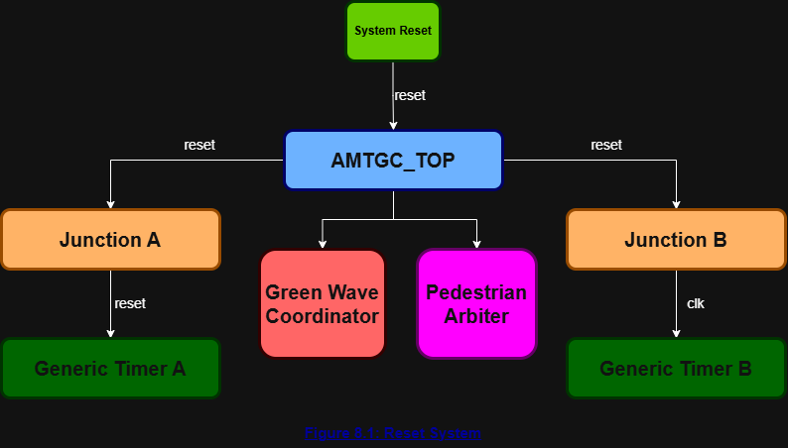

9. Green-Wave Coordination
9.1 Introduction
One of the key features of the proposed Adaptive Multi-Junction Traffic Grid Controller (AMTGC) is the implementation of Green-Wave Coordination. Unlike conventional traffic controllers that operate each junction independently, the proposed system synchronizes adjacent intersections to improve traffic flow along the main road. This coordination allows vehicles travelling through Junction A to reach Junction B with fewer stops, reducing congestion, travel time, and unnecessary waiting at traffic signals.

9.2 Working Principle
The Green-Wave Coordinator continuously monitors the operating state of both junction controllers. When Junction A enters the North-South Green phase, the coordinator calculates the appropriate delay before allowing Junction B to enter the same phase. This delay is selected so that vehicles travelling at a normal speed can move smoothly from one intersection to the next without stopping unnecessarily. By coordinating signal timing between adjacent junctions, the system creates a "green wave" that improves overall traffic progression.

9.3 Synchronization Process
- Junction A enters the North-South Green phase.
- The Green-Wave Coordinator detects this event.
- A predefined synchronization delay is applied.
- Junction B receives the synchronization signal.
- Junction B switches to the North-South Green phase at the appropriate time.
- Vehicles travelling along the main road experience fewer stops and improved traffic flow.

9.4 Advantages
- Reduces vehicle waiting time.
- Improves traffic flow between intersections.
- Minimizes unnecessary signal stops.
- Reduces fuel consumption.
- Helps lower traffic congestion.
- Improves travel efficiency during peak hours.

9.5 Design Considerations
The synchronization delay should be selected based on the distance between adjacent intersections and the average vehicle speed. In this project, the delay is treated as a configurable parameter so that different road layouts can be supported without changing the overall controller architecture.

9.6 Future Improvements
In future versions of the system, the Green-Wave coordination delay can be calculated dynamically using real-time traffic density information instead of relying on a fixed delay. This would allow the controller to adapt more effectively to changing traffic conditions and further improve traffic flow.
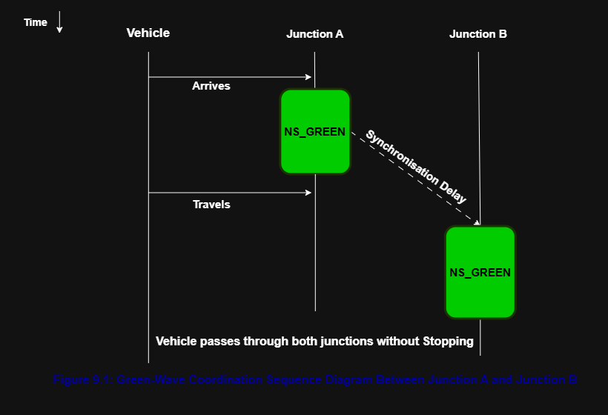

10. Pedestrian Arbitration
10.1 Introduction
To ensure safe and fair pedestrian crossings, the AMTGC includes a dedicated Pedestrian Arbiter module. This module is responsible for handling pedestrian requests received from both Junction A and Junction B. When requests occur simultaneously, the arbiter determines which junction will be granted access first. A Round-Robin arbitration policy is used to ensure fairness, preventing one junction from receiving continuous priority over the other.

10.2 Working Principle
The Pedestrian Arbiter continuously monitors the pedestrian request signals from both junctions. If only one request is active, the arbiter immediately grants permission to that junction. However, when both requests are received at the same time, the arbiter follows a Round-Robin scheduling policy. This policy alternates the priority between Junction A and Junction B after each successful pedestrian crossing, ensuring that both junctions receive equal opportunities over time.

10.3 Arbitration Process
- Monitor pedestrian requests from Junction A and Junction B.
- Check whether one or both requests are active.
- If only one request is present, grant that request immediately.
- If both requests are active, apply the Round-Robin policy.
- Issue the pedestrian grant signal to the selected junction.
- Update the priority for the next simultaneous request.
- Wait for the next pedestrian request.

10.4 Advantages
- Ensures fair access to pedestrian crossings.
- Prevents starvation of either junction.
- Handles simultaneous requests efficiently.
- Simple to implement using sequential logic.
- Easily scalable to additional junctions.

10.5 Design Considerations
The Round-Robin policy was selected because it provides a simple and fair method of resolving simultaneous pedestrian requests. Unlike fixed-priority arbitration, which may repeatedly favor one junction, Round-Robin alternates the priority after each granted request. This approach ensures that no junction experiences starvation while maintaining predictable and efficient system behavior.

10.6 Future Improvements
In future versions of the controller, the arbitration logic can be enhanced by considering additional factors such as pedestrian waiting time, traffic density, emergency vehicle priority, or accessibility requirements. These enhancements would allow the system to make more intelligent crossing decisions while maintaining fairness and safety.
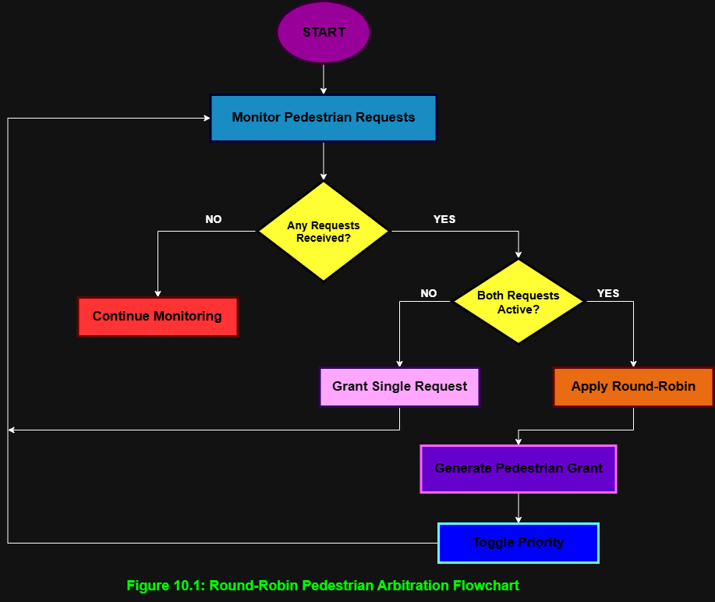

11. Emergency Override
11.1 Introduction
To improve road safety and reduce the response time of emergency vehicles, the AMTGC includes an Emergency Override mechanism. When an emergency signal is received, the controller temporarily suspends the normal traffic sequence and switches the affected junctions into an emergency operating mode. This allows emergency vehicles to pass safely while minimizing the risk of conflicting traffic movements. Once the emergency condition is cleared, the controller resumes normal operation in a controlled and synchronized manner.

11.2 Working Principle
The Emergency Override module continuously monitors the external emergency_override input. Under normal conditions, the traffic controller operates according to its standard timing sequence. When an emergency request is detected, the current traffic phase is interrupted, and the controller immediately transitions to a predefined safe state. After the emergency signal is de-asserted, the controller returns to the normal traffic sequence, ensuring that all junctions remain synchronized.

11.3 Emergency Handling Process
- Monitor the emergency_override input.
- Continue normal traffic operation while no emergency is present.
- Detect the emergency signal.
- Interrupt the normal traffic sequence.
- Activate the emergency traffic mode.
- Maintain emergency operation until the signal is cleared.
- Restore normal traffic control and synchronization.

11.4 Design Considerations
The Emergency Override logic is designed with safety as the highest priority. Emergency operation must always take precedence over pedestrian requests and normal traffic scheduling. The transition between normal and emergency modes is carefully controlled to avoid unsafe signal combinations. Once the emergency condition has ended, the controller resumes normal operation without affecting overall system synchronization.

11.5 Advantages
- Gives highest priority to emergency vehicles.
- Improves public safety.
- Reduces emergency response time.
- Prevents conflicting traffic movements.
- Integrates with the existing traffic controller without requiring major architectural changes.

11.6 Future Improvements
Future versions of the Emergency Override mechanism can support multiple emergency priorities, automatic emergency vehicle detection using sensors or vehicle-to-infrastructure (V2I) communication, and dynamic route clearance across multiple synchronized intersections. These enhancements would improve response efficiency while maintaining safe traffic operation.

12. Verification Plan
12.1 Introduction
Verification is an essential phase of the AMTGC development process. Before deploying the controller, each module and the integrated system must be validated under different operating conditions to ensure correct functionality. The verification strategy focuses on confirming proper traffic sequencing, pedestrian arbitration, Green-Wave coordination, emergency handling, and system recovery. The following test scenarios have been identified to verify the expected behaviour of the proposed controller.
Table 12.1.1 – Verification Scenarios
Test ID | Test Scenario |  | Objective | Expected Result
TC01 |  | Power-On Reset | Verify correct initialization | All modules enter their initial state and timers reset correctly.
TC02 |  | Normal Traffic Cycle | Verify FSM operation | Signals transition through Green → Yellow → Red in the correct order.
TC03 |  | Continuous Low Traffic | Verify basic operation | System continues normal cyclic operation without unnecessary delays.
TC04 |  | High Traffic at Junction A | Test adaptive behaviour | Junction A receives an extended green duration (or higher priority, depending on implementation).
TC05 |  | High Traffic at Junction B | Verify fairness | Junction B adapts its signal timing correctly.
TC06 |  | Single Pedestrian Request at Junction A | Verify pedestrian servicing | Pedestrian crossing is granted after the current traffic phase completes safely.
TC07 |  | Single Pedestrian Request at Junction B | Verify pedestrian servicing | Junction B receives pedestrian access without affecting system stability.
TC08 |  | Simultaneous Pedestrian Requests | Verify Round-Robin arbitration | One request is granted first and the next receives priority on the following arbitration cycle.
TC09 |  | Repeated Pedestrian Requests from Same Junction | Verify starvation prevention | The opposite junction is eventually granted access according to the Round-Robin policy.
TC10 |  | Green-Wave Coordination | Verify synchronization | Junction B enters the coordinated green phase after the defined synchronization delay.
TC11 |  | Emergency Override During Normal Operation | Verify emergency response | Normal operation is interrupted and emergency mode is activated immediately.
TC12 |  | Emergency Cleared | Verify recovery | Controller exits emergency mode and resumes normal synchronized operation.
TC13 |  | Reset During Emergency Mode | Verify robustness | Entire system safely returns to its initial state.
TC14 |  | Rapid Consecutive Pedestrian Requests | Verify controller stability | Multiple requests are processed correctly without losing any valid request.
TC15 |  | Long-Duration Continuous Operation | Verify reliability | System completes many traffic cycles without incorrect state transitions or deadlock.

Q. Why these 15 scenarios?
They cover every major feature of the AMTGC:
Feature | Test Cases
Reset | TC01, TC13
FSM | TC02, TC03
Adaptive Traffic | TC04, TC05
Pedestrian System | TC06–TC09
Green-Wave | TC10
Emergency Override | TC11, TC12
Stress & Reliability | TC14, TC15

12.2 Verification Methodology
The AMTGC will be verified using simulation-based functional verification in ModelSim. A dedicated Verilog testbench will generate different traffic conditions, pedestrian requests, emergency events, and reset sequences. The generated waveforms will be analysed to confirm correct FSM transitions, arbitration decisions, synchronization behaviour, and emergency handling. Each verification scenario will be considered successful only if the observed outputs match the expected behaviour defined in the design specification.

13. Conclusion
This report presented the design and planning of the Adaptive Multi-Junction Traffic Grid Controller (AMTGC), covering the overall system architecture, module organization, communication interfaces, clocking and reset strategies, Green-Wave coordination, pedestrian arbitration, emergency override mechanism, and the proposed verification plan. The modular approach adopted for this project provides a clear separation of functionality, making the system easier to understand, implement, test, and maintain.
Through the planning process, the expected behavior of each module and their interactions have been clearly defined before RTL development. The verification scenarios prepared in this report provide a structured approach for validating the controller under both normal and exceptional operating conditions. These scenarios will serve as the foundation for simulation and functional verification during the implementation phase.
Overall, the proposed AMTGC aims to improve traffic efficiency, ensure fair pedestrian access, and provide safe handling of emergency situations while maintaining a scalable and modular architecture. The work completed in this design phase establishes a strong foundation for the RTL implementation, simulation, and hardware verification that will follow in the next stages of the project.

