# Mircowave Oven : 2nd Hand-in

|  |  |
| --- | --- |
| Team | 42 |
| Mads Krabsen | 201507805 |
| Tobias Dalgaard Nielsen | 201507194 |
| Christian Luke Pedersen | 201509718 |
| Jonas Kjær Rask | 2015 |

## Jenkins

## Github Repository

https://github.com/Krabsenm/SWT42_MicroWaveOven.git

## Dependency tree

Without dependency between CookController and Userinterface

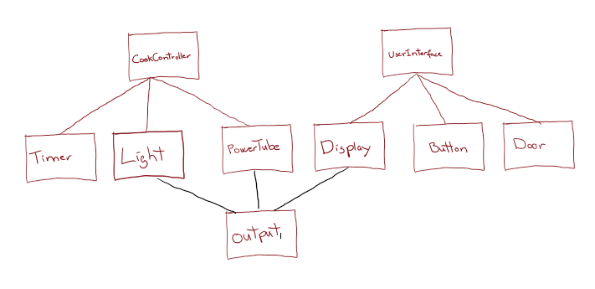

With dependency between CookController and Userinterface

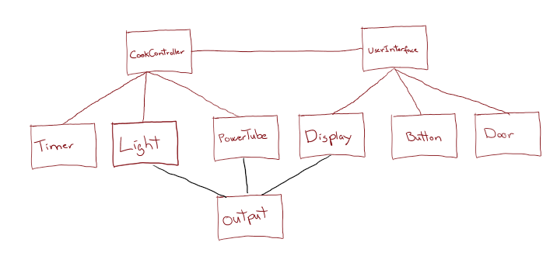

## Integration test strategy

To test the software we have considered the following patterns:

* Big Bang integration Pattern
  + The Big Bang Pattern is not used because it has a very low probability of detecting the errors in the code, and even harder to pin point where in the software the error originated.
* Collaboration Integration Pattern
  + The Collaboration Pattern is not used because the software given is described in one use case and this practically makes the pattern equivalent to the Big Bang Pattern.

The Sandwich Integration Pattern is chosen as the integration strategy because of the following advantages:

* It combines the best parts of the “Top down” and “Bottom Down” patterns while alleviating many of the disadvantages.
* The dependency tree shows that the cluster only has three layers; the bottom layer, top layer and one middle layer. This structure makes it so that it is only necessary to make one stub when using the Sandwich Integration Pattern.

