**BURGLAR ALARM**

**A PROJECT REPORT**

***Submitted By***

**Amit Ahir (SE-01)**

**Meet Bhansali (SE-04)**

**Meet Bhanushali (SE-05)**

**Kush Gada (SE-14)**

*As a part of EDC Subject*



**Department of Electronic and Tele-Communication**

**K.J. Somaiya Institute of Engineering and Information Technology**

**Ayurvihar, Sion Mumbai-400022**

**MUMBAI UNIVERSITY**

**NOVEMBER 2019-20**

ABSTRACT :- A **burglar alarm** system consists of a series of electrical components that are connected to a property. Via sensors and contacts, they detect movement or the opening of doors and windows, after which a loud **alarm** is produced to alert those nearby of the unauthorised entry. A **burglar alarm** is a system designed to detect intrusion – unauthorized entry – into a building or other area. Security alarms are used in residential, commercial, industrial, and military properties for protection against burglary (theft) or property damage, as well as personal protection against intruders. Security alarms in residential areas show a correlation with decreased theft. Car alarms likewise help protect vehicles and their contents. Prisons also use security systems for control of inmates.

Some alarm systems serve a single purpose of burglary protection; combination systems provide both fire and intrusion protection. Intrusion alarm systems may also be combined with closed-circuit television surveillance (CCTV) systems to automatically record the activities of intruders, and may interface to access control systems for electrically locked doors. Systems range from small, self-contained noisemakers, to complicated, multirally systems with computer monitoring and control. It may even include two-way voice which allows communication between the panel and Monitoring station.

AIM :- Implementing a Burglar Alarm circuit by using ,BC547 transistor,IC555 , Resistors , Connecting Wires , Photodiode ,IR Led , LED and a Buzzer .

CIRCUIT DIAGRAM :-

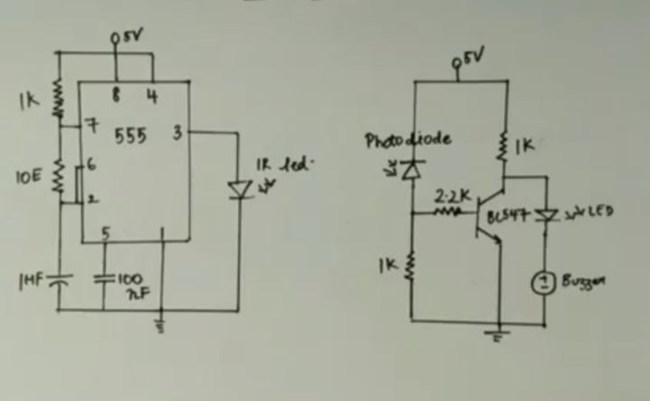

WORKING :-

Monitoring the potential intrusion entry points with sensors that communicate with a control panel, transmitting alarm signal when detecting the illegal intrusion, that's the basic concept of theory of alarm systems.

The sensors are typically installed in doors and windows that expose to potential intrusions or easily accessible places to form invisible perimeter protection. Motion sensors are installed interior for open spaces protection.

Passive infrared motion sensors are widely used motion sensor for anti-burglar applications. It can protect large open space with invisible passive infrared detection technology. These sensors are typically used to protect interior rooms by sensing the infrared energy level changing of intruder.

OUTPUT :-

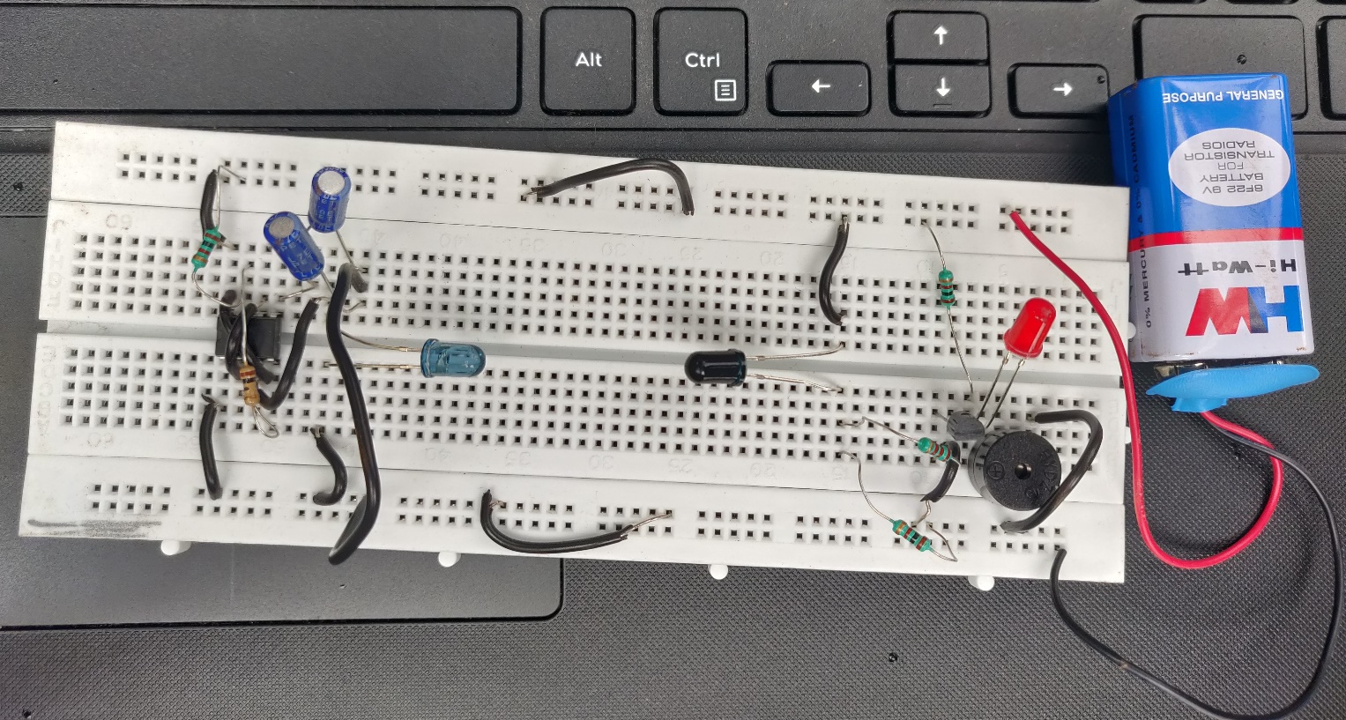

Hence the above circuit implements the Buglar alarm. .