**System and Signal Mini project**

**Matlab Code :**

X=[-5i, 2, 3i, 4, 6, 8i, 8 ,0];

idx = find(imag(X) == 0);

X_real = X(idx);

X_imag = X(~idx);

idx = find(imag(X));

X_new = X(idx);

fprintf('%10.2f%10.2f%20.2f%22f%20f%8.2f\n',X_real);

fprintf('%10.2f%10.2f%20.2f%22f%20f%8.2f\n',X_new);

Real values :

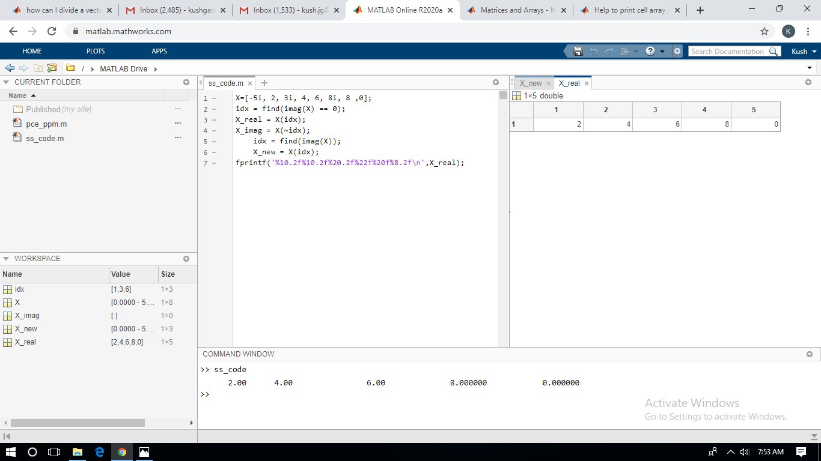

Imaginary Values :

