 

# **K. J. Somaiya Institute of Engineering and Information Technology.**

Somaiya Ayurvihar Complex, Everard Nagar, Eastern Express Highway,Sion (E), Mumbai-400022.

**DEPARTMENT OF ELECTRONICS AND TELECOMUNICATION ENGINEERING.**

SUBJECT: **Linear Integrated Circuit**

PROF: **Ms.Rupali Kadu**

**PROJECT REPORT ON A Variable Audio Frequency oscillator using IC 741**

**By**

**Gada Kush Jayesh(SE-EXTC A-21)C A-5)**

**Index**

|  |  |  |
| --- | --- | --- |
| **Sr. no** | **Content** | **Page no** |
| **1** | Introduction | **3** |
| **2** | Circuit Diagram | **4** |
| **3** | Parts List | **5** |
| **4** | Implementation | **6** |
| **5** | Conclusion | **7** |

**Introduction:**

The frequency of the AF oscillator can be varied over a wide range. It can therefore be used for AF amplifier testing and also as a code practice oscillator.

The circuit of variable audio frequency oscillator  using op-amp 741 is mainly a Wein Bridge oscillator whose frequency is varied using the gang condenser.

Oscillator is an economical but versatile sine and square wave generator for Audio and supersonic frequencies between 20 Hz and 200 KHz. It is suitable for measurement of frequency and distortion of Audio and wide band filters and transmission systems.

# **Circuit Diagram:**

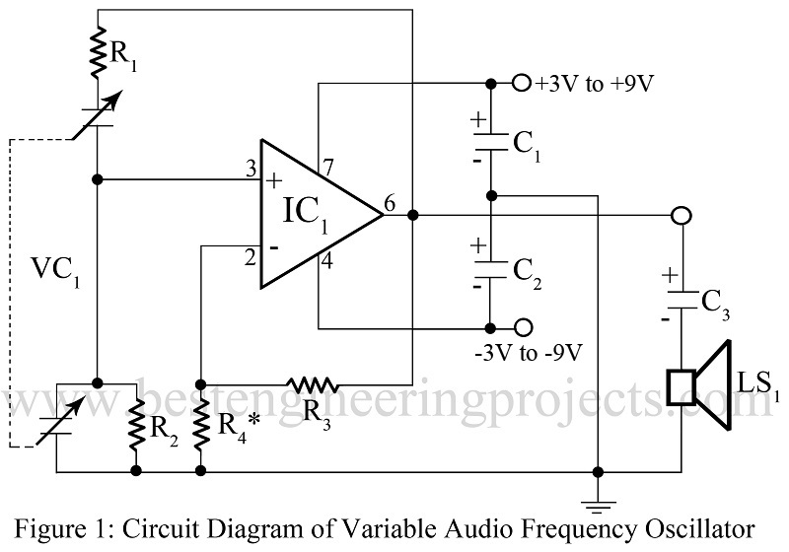

**Parts List:**

**Resistor (all ¼-watt, ± 5% Carbon) :**

R1, R2 = 390 KΩ

R3 = 100 Ω

R4* = 150 Ω

**Capacitors :**

C1, C2 = 100 µF, 15V (Electrolytic Capacitor)

C3 = 10 µF, 15V (Electrolytic Capacitor)

VC1 = 2J GANG 35pF-365pF

**Semiconductors**

IC1 = 741 (Operational Amplifier IC)

**Miscellaneous**

LS1 = 8 Ω speaker

**IMPLEMENTATION :**

 While using the IC1 741 (operational amplifier), the use of split power supply has been avoided by using capacitors C1 and C2, for R4*, a 150-Ω resistor, we can use thermister or even a bulb which control the amplitude of the oscillation.

While using the oscillator, an 8Ω speaker with a 10 µF capacitor connected as in the circuit will provide a good amount of volume. While using for testing, the output pin number 6 of the IC1 I connected to the input of the instrument to be tested via a 0.01 µF capacitor. The circuit works off a 3V to 9V supply satisfactorily.

**Conclusion :**

These are useful in testing audio circuits and components. Eg. in a cassette deck, you can input a certain frequency and attenuate it to a specific output level (db converts to volts) and adjust meters, channel output db (voltage) and other variables per the service manuals specifications. They can also be used to set record levels, Dolby levels, and to determine what bias settings work best with the tape formulation being used.