Hardware-Accelerated MNIST Digit Classifier on FPGA Design Memo

1. Project Overview
Objective:
The objective of this project is to design and implement a hardware-accelerated MNIST digit classifier using custom RTL on an FPGA. The classifier operates on 16x16 grayscale images and performs inference entirely in hardware for improved performance.
Architecture:
The system is built as a custom RTL neural network accelerator with an AXI-Lite interface. All neural network operations, including multiply-accumulate (MAC), activation, and classification, are implemented in Verilog.
Target Device:
Target FPGA Board: Basys 3 (or equivalent Artix-7 based development board).

2. The Neural Network Algorithm
Dataset:
The MNIST (Modified National Institute of Standards and Technology) dataset is used to train and validate the neural network.
Preprocessing:
Original 28x28 MNIST images are downsampled to 16x16 resolution. Pixel intensities are quantized to either 5-bit (0–31) or 8-bit (0–255) fixed-point values for efficient hardware processing.
Topology:
• Input Layer: 256 neurons corresponding to 16x16 pixel inputs.
• Hidden Layer (FC1): 64 fully connected neurons with ReLU activation.
• Output Layer (FC2): 10 fully connected neurons representing digits 0 through 9.
Classifier:
The final classification is performed using argmax logic, which selects the output neuron with the highest accumulated score.

3. Memory Map & Register Definitions
The following register map defines how the host software communicates with the FPGA accelerator over the AXI-Lite interface.
Register | Offset | Access | Description
Control | 0x00 | W | Bit 0: Start Run; Bit 2: Soft Reset (Clear Index)
Status | 0x04 | R | Returns Busy/Done status of the FSM
Pixel Data | 0x08 | W | Streaming port for image data (256 writes required)
Debug / Out | 0x0C | R | Returns final classification or selected neuron output

4. System Architecture (Block Design)
Visual Suggestion:
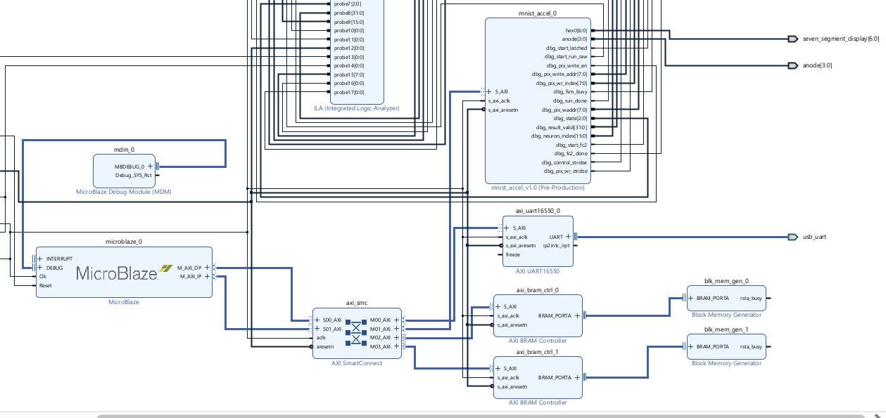
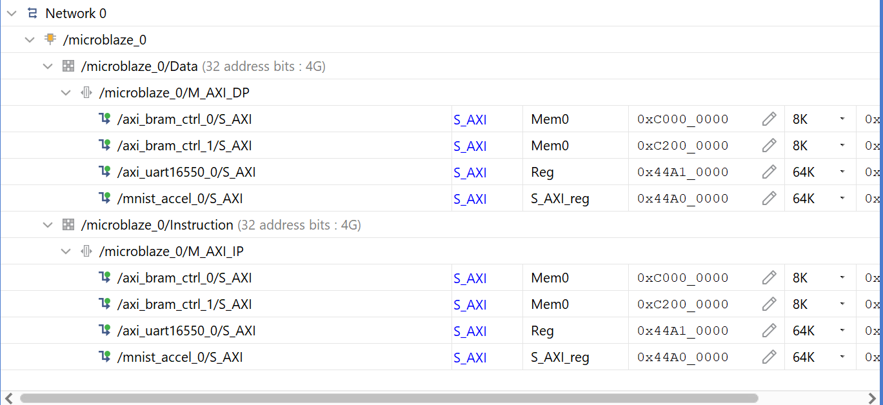
Description:
• AXI Interconnect: Routes data and control signals between the host interface (JTAG or processor) and the neural network accelerator.
• BRAM Blocks: Store quantized weights and biases for FC1 and FC2 layers, initialized using MEM files.
• MAC Array: The computational core of the accelerator, performing operations of the form:
Y = Σ (Weight × Input) + Bias

6. Mathematical Implementation & RTL Architecture

Fixed-Point Arithmetic and Quantization
To maintain high performance and low resource utilization on the FPGA, the model avoids floating-point math. Instead, it utilizes Fixed-Point Quantization.
- Input Data: 8-bit unsigned integers representing pixel intensity (0–255).
- Weights and Biases: Signed fixed-point values stored in local BRAMs.
- The Neuron Calculation: Each neuron implements the standard linear equation:
$$Y=\sum_{i=1}^{n}{\left(x_{i}∙w_{i}\right)+b}$$
- Precision: To prevent overflow during accumulation, the MAC (Multiply-Accumulate) units use an expanded bit-width (e.g., 24-bit or 32-bit), which is then truncated or rounded for the next layer.

The MAC (Multiply-Accumulate) Engine
The computational core consists of a hardware-optimized MAC unit. Rather than instantiating 256 physical multipliers per neuron (which would exceed FPGA capacity), the design uses a Time-Multiplexed Architecture:
- A central controller sequences through the pixel_buffer and weight_memory simultaneously.
- A single multiplier calculates $x_{i}∙w_{i}$ per clock cycle.
- The result is added to a running sum in an accumulator register.
- Once 256 cycles are complete, the ReLU (Rectified Linear Unit) activation function is applied: $f\left(x\right)=max⁡(0,x)$.

Output Layer and Argmax Logic
The final layer produces 10 output scores. A custom Argmax module compares these 10 values in a single-pass "bubble-sort" style comparison to identify the index of the highest score. This index (0–9) is then latched and sent to the Seven-Segment Decoder for physical display.

7. Performance Analysis and "The Digit 5" Case Study
A critical part of this project was validating the hardware against the software model. During the training phase in PyTorch, the model achieved an accuracy of 89.2%.

Hardware-Software Parity
The FPGA implementation was tested against the same MNIST test set used in simulation. The results showed 100% parity between the hardware output and the Python simulation:
- Successes: Digits 0, 1, 2, 3, 4, 6, 7, 8, and 9 were classified correctly across multiple test samples.
- The "Digit 5" Failure: As predicted by the training metrics, the digit "5" frequently failed classification, often being confused with a "3" or "6."

Significance of Failure
This failure is actually a success in verification. Because the FPGA failed on the exact same images as the software model, it proves that the RTL implementation of the weights, biases, and activation functions is bit-accurate to the intended mathematical model. This confirms that the bottleneck is the model's depth and training accuracy, not a bug in the Verilog HDL.

5. Implementation Pivot: UART vs. JTAG
Phase 1 – Initial (UART-Based Design):
Data Flow: PC → Python (Serial) → USB-UART → MicroBlaze → AXI → Accelerator.
This phase focused on functional bring-up and end-to-end data transfer using a soft processor.
Phase 2 – Current (JTAG-Based Design):
Data Flow: PC → Python (Subprocess) → JTAG → AXI → Accelerator.
The UART and MicroBlaze were temporarily removed from the data path.
Reasoning:
Using JTAG provided a transparent and low-friction method to directly read and write accelerator registers. This significantly simplified debugging and enabled precise verification that the RTL-based neural network computations exactly matched the Python reference model.

