JavaScript Full
Оглавление
Array 1
JavaScript Array Methods 4

Array
JavaScript arrays are used to store multiple values in a single variable.
Access the Elements of an Array
You access an array element by referring to the index number.
Array are Objects
Arrays are a special type of objects. The typeof operator in JavaScript returns "object" for arrays. But, JavaScript arrays are best described as arrays. Arrays use numbers to access its "elements".
Objects use names to access its "members".
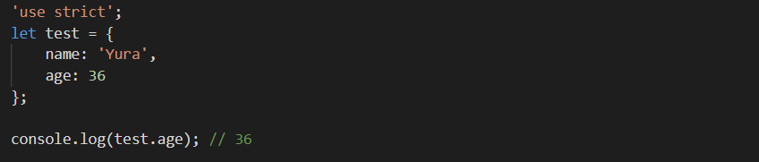
Array Elements Can Be Objects
JavaScript variables can be objects. Arrays are special kinds of objects. Because of this, you can have variables of different types in the same Array.
You can have objects in an Array. You can have functions in an Array. You can have arrays in an Array:
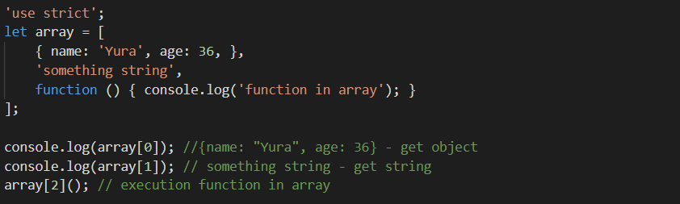
Array Properties and Methods
The real strength of JavaScript arrays are the built-in array properties and methods:
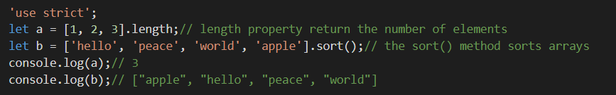
Important: The length property is always one more than the highest array index.
Accessing the Last Array Element
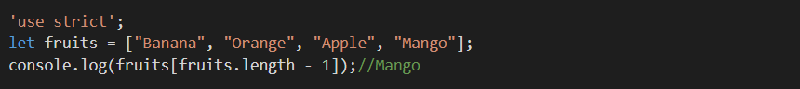
Looping Array Elements
The safest way to loop through an array, is using a for loop:
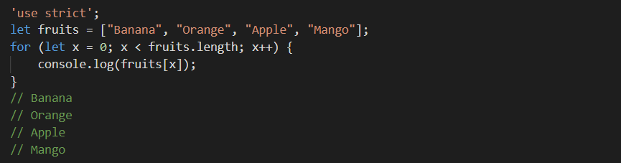
You can also use the Array.forEach() function:
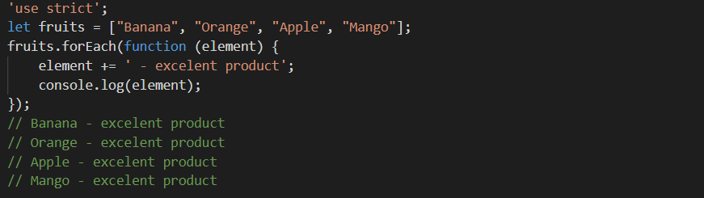
Adding Array Elements
The easiest way to add a new element to an array is using the push() method:
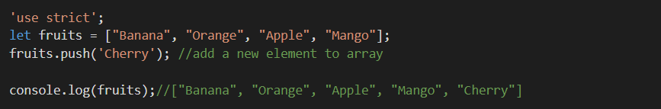
New element can also be added to an array using the length property:
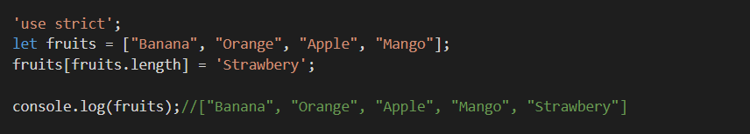

The Difference Between Arrays and Objects
In JavaScript, arrays use numbered indexes.
In JavaScript, objects use named indexes.
When to Use Arrays. When to use Objects.
You should use objects when you want the element names to be strings (text).
You should use arrays when you want the element names to be numbers.
How to Recognize an Array
The problem is that the JavaScript operator typeof returns "object"
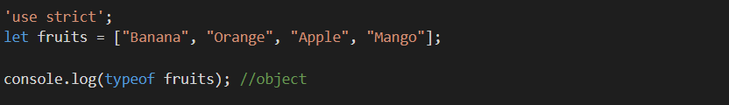
Solution 1:
To solve this problem ECMAScript 5 defines a new method Array.isArray():
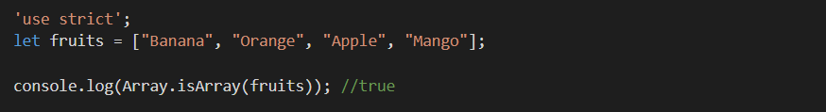
The problem with this solution is that ECMAScript 5 is not supported in older browsers.
Solution 2:
To solve this problem you can create your own isArray() function:
The function above always returns true if the argument is an array. Or more precisely: it returns true if the object prototype contains the word "Array".
Solution 3:
The instanceof operator returns true if an object is created by a given constructor:
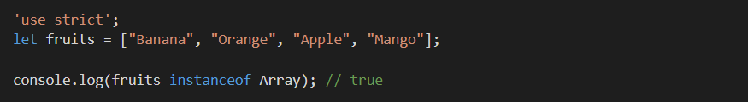

JavaScript Array Methods
Converting Arrays to Strings
toString() converts an array to a string of (comma separated) array values.
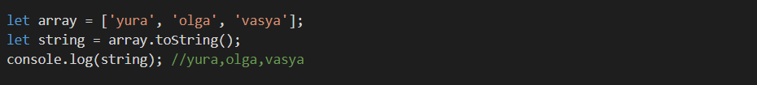
join() method also joins all array elements into a string. It behaves just like toString(), but in addition you can specify the separator:

Popping and Pushing
When you work with arrays, it is easy to remove elements and add new elements. This is what popping and pushing is: Popping items out of an array, or pushing items into an array.
pop() method removes the last element from an array. The pop() method returns the value that was "popped out":
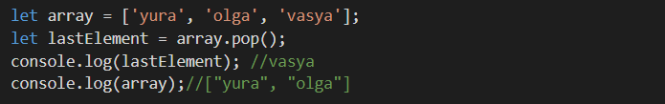
push() method adds a new element to an array (at the end). The push() method returns the new array length:
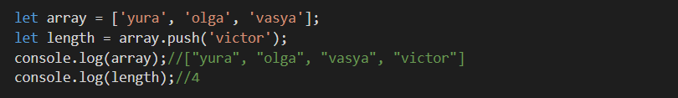
Shifting Elements
shift() method removes the first array element and "shifts" all other elements to a lower index. The shift() method returns the string that was "shifted out":
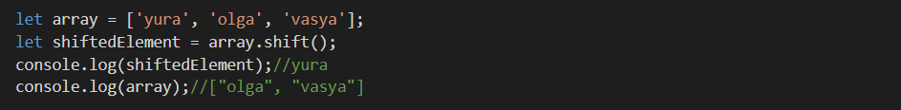
unshift() method adds a new element to an array (at the beginning), and "unshifts" older elements. The unshift() method returns the new array length.
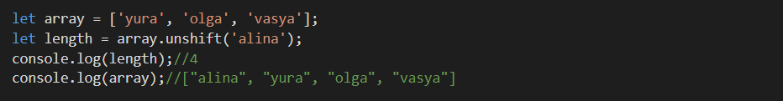
Changing Elements
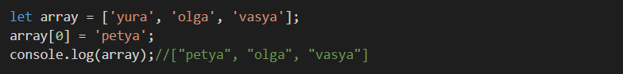
The length property provides an easy way to append a new element to an array:
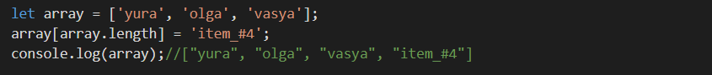
Deleting Elements
Since JavaScript arrays are objects, elements can be deleted by using the JavaScript operator delete, but it is not recommended method (use pop() or shift() instead.
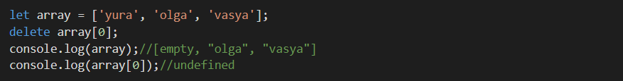
Splicing an Array
splice() method can be used to add new items to an array.
The first parameter defines the position where new elements should be added (spliced in). The second parameter defines how many elements should be removed. The rest of the parameters define the new elements to be added. The splice() method returns an array with the deleted items.
Using splice() to Remove Elements
With clever parameter setting, you can use splice() to remove elements without leaving "holes" in the array:
Merging (Concatenating) Arrays
concat() method creates a new array by merging (concatenating) existing arrays.
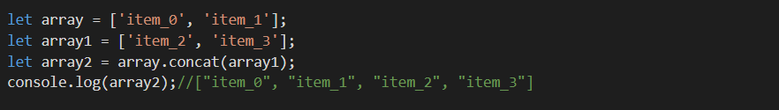
Note! The concat() method does not change the existing arrays. It always returns a new array.
Using concat() method to merge three arrays:
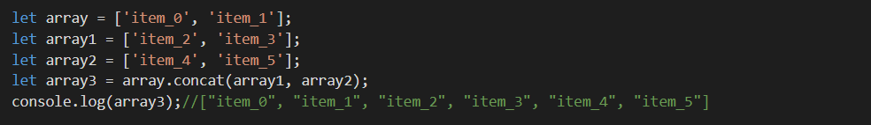
Slicing an Array
The slice() method slices out a piece of an array into a new array.
This example slices out a part of an array starting from array element 1
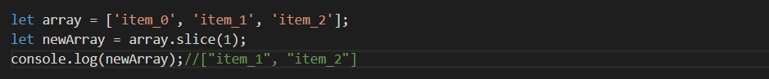
Note! The slice() method creates a new array. It does not remove any elements from the source array.
The slice() method can take two arguments like slice(1, 3).
The method then selects elements from the start argument, and up to (but not including) the end argument.
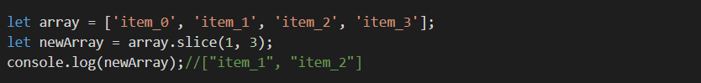
Automatic toString()
JavaScript automatically converts an array to a comma separated string when a primitive value is expected. This is always the case when you try to output an array.
Note! All JavaScript objects have a toString() method.

