Оглавление
Objects 1
Square brackets 2
Computed properties 3
Property value shorthand 4
Existence check 5
The “for…in” loop 5
Ordered like an object 6
Copying by reference 7
Comparison by reference 8
Const object 9
Cloning and merging, Object.assign 9

Objects
Objects are used to store keyed collections of various data and more complex entities.
An object can be created with figure brackets {…} with an optional list of properties. A property is a “key: value” pair, where key is a string (also called a “property name”), and value can be anything.
An empty object can be created using one of two syntaxes:
Usually, the figure brackets {...} are used. That declaration is called an object literal.
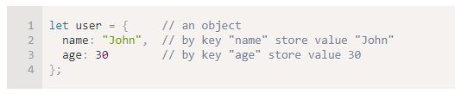
The value can be of any type. We can add, remove and read values from it any time. Property values are accessible using the dot notation:
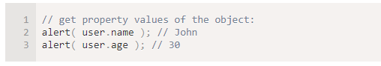
To remove a property, we can use delete operator:

We can also use multiword property names, but then they must be quoted:
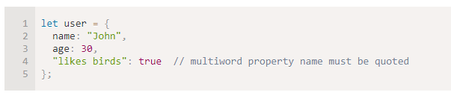
The last property in the list may end with a comma:
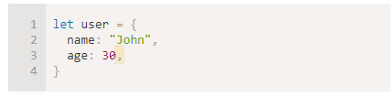
That is called a “trailing” or “hanging” comma. Makes it easier to add/remove/move around properties, because all lines become alike.
Methods of object:
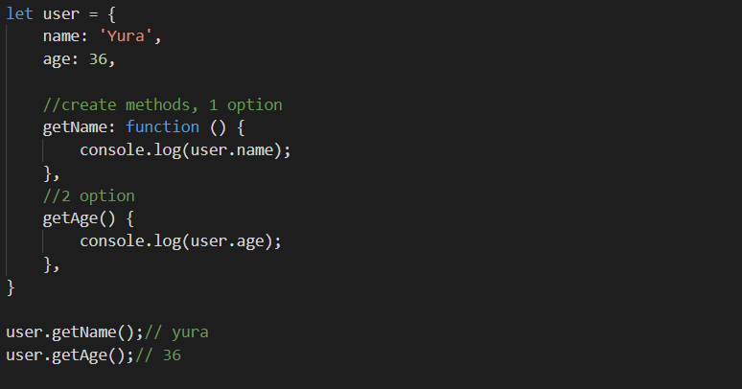

Square brackets
For multiword properties, the dot access doesn’t work:
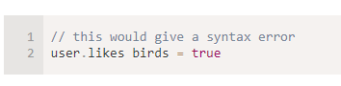
That’s because the dot requires the key to be a valid variable identifier. That is: no spaces and other limitations.
There’s an alternative “square bracket notation” that works with any string:
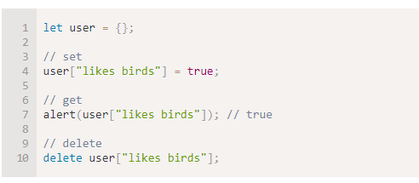
Square brackets also provide a way to obtain the property name as the result of any expression – as opposed to a literal string – like from a variable as follows:
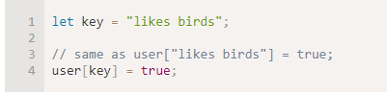
Here, the variable key may be calculated at run-time or depend on the user input. And then we use it to access the property. That gives us a great deal of flexibility.
For instance:
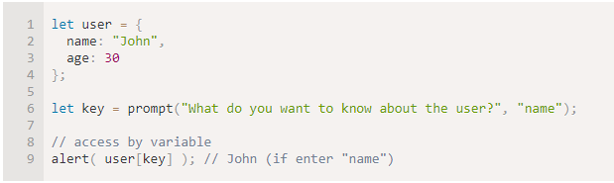

Computed properties
We can use square brackets in an object literal. That’s called computed properties.
For instance:
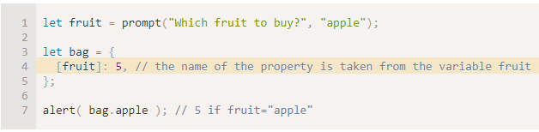
The meaning of a computed property is simple: [fruit] means that the property name should be taken from fruit. So, if a visitor enters "apple", bag will become {apple: 5}.
Essentially, that works the same as:
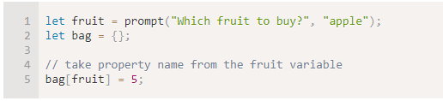
We can use more complex expressions inside square brackets:
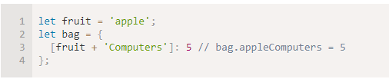
Square brackets are much more powerful than the dot notation. They allow any property names and variables. But they are also more cumbersome to write.
So most of the time, when property names are known and simple, the dot is used. And if we need something more complex, then we switch to square brackets.
Reserved words are allowed as property names
A variable cannot have a name equal to one of language-reserved words like “for”, “let”, “return” etc.
But for an object property, there’s no such restriction. Any name is fine:
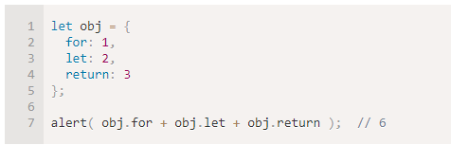

Property value shorthand
In real code we often use existing variables as values for property names.
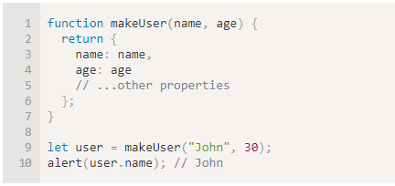
In the example above, properties have the same names as variables. The use-case of making a property from a variable is so common, that there’s a special property value shorthand to make it shorter.
Instead of name:name we can just write name, like this:
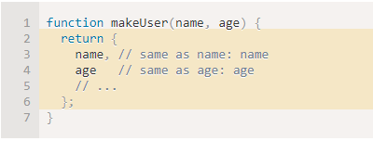
We can use both normal properties and shorthands in the same object:
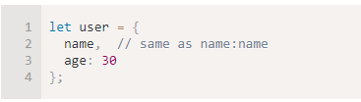

Existence check
A notable objects feature is that it’s possible to access any property. There will be no error if the property doesn’t exist! Accessing a non-existing property just returns undefined. It provides a very common way to test whether the property exists – to get it and compare vs undefined:
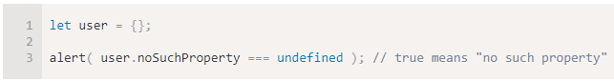
There also exists a special operator "in" to check for the existence of a property. For instance:
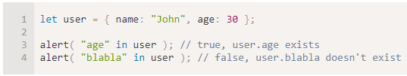
Please note that on the left side of in there must be a property name. That’s usually a quoted string. If we omit quotes, that would mean a variable containing the actual name will be tested. For instance:
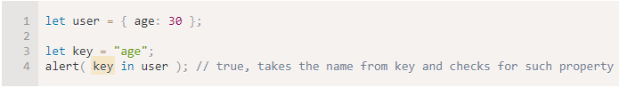

The “for…in” loop
To walk over all keys of an object, there exists a special form of the loop: for..in. This is a completely different thing from the for(;;) construct that we studied before.
The syntax:
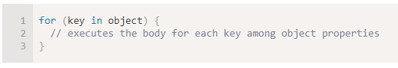
For instance, let’s output all properties of user:
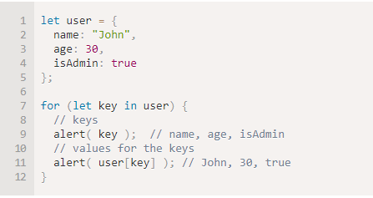
Note that all “for” constructs allow us to declare the looping variable inside the loop, like let key here. Also, we could use another variable name here instead of key. For instance, "for (let prop in obj)" is also widely used.

Ordered like an object
Are objects ordered? In other words, if we loop over an object, do we get all properties in the same order they were added? Can we rely on this?
The short answer is: “ordered in a special fashion”: integer properties are sorted, others appear in creation order. The details follow.
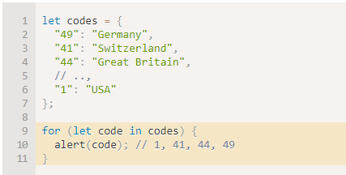
The “integer property” term here means a string that can be converted to-and-from an integer without a change.
…On the other hand, if the keys are non-integer, then they are listed in the creation order, for instance:
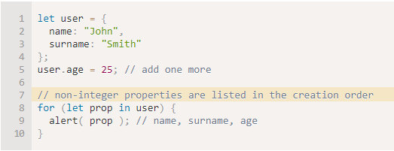

Copying by reference
One of the fundamental differences of objects vs primitives is that they are stored and copied “by reference”.
Primitive values: strings, numbers, booleans – are assigned/copied “as a whole value”.
For instance:
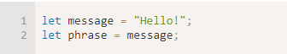
As a result we have two independent variables, each one is storing the string "Hello!".
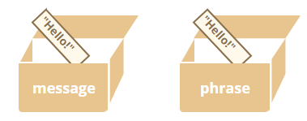
Objects are not like that.
A variable stores not the object itself, but its “address in memory”, in other words “a reference” to it.
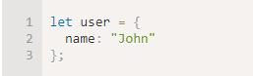
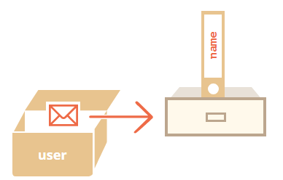
When an object variable is copied – the reference is copied, the object is not duplicated.
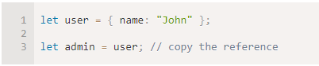
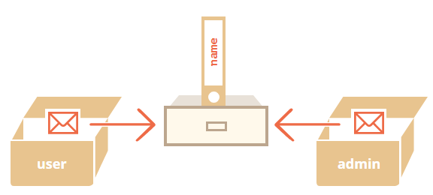
We can use any variable to access the object and modify its contents:

Comparison by reference
The equality == and strict equality === operators for objects work exactly the same.
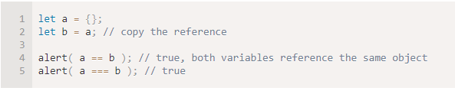
And here two independent objects are not equal, even though both are empty:
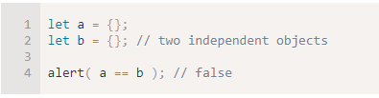

Const object
An object declared as const can be changed.
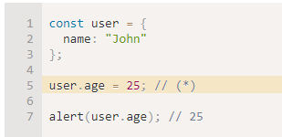
It might seem that the line (*) would cause an error, but no, there’s totally no problem. That’s because const fixes only value of user itself. And here user stores the reference to the same object all the time. The line (*) goes inside the object, it doesn’t reassign user.
The const would give an error if we try to set user to something else, for instance:
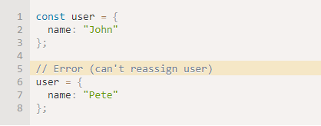
…But what if we want to make constant object properties? So that user.age = 25 would give an error. That’s possible too. We’ll cover it in the chapter Property flags and descriptors.

Cloning and merging, Object.assign
So, copying an object variable creates one more reference to the same object.
But what if we need to duplicate an object? Create an independent copy, a clone?
That’s also doable, but a little bit more difficult, because there’s no built-in method for that in JavaScript. Actually, that’s rarely needed. Copying by reference is good most of the time.
But if we really want that, then we need to create a new object and replicate the structure of the existing one by iterating over its properties and copying them on the primitive level.
Like this:
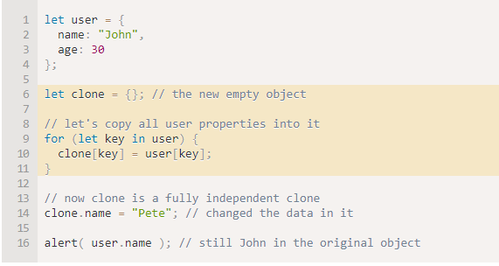
Also we can use the method Object.assign for that.
The syntax is:

For instance, we can use it to merge several objects into one:
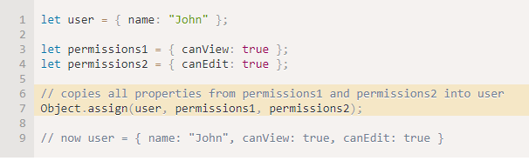
If the receiving object (user) already has the same named property, it will be overwritten:
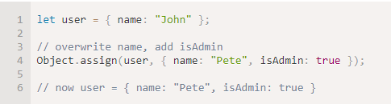
We also can use Object.assign to replace the loop for simple cloning:
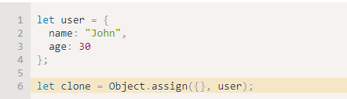
It copies all properties of user into the empty object and returns it. Actually, the same as the loop, but shorter.

There are many other kinds of objects in JavaScript:
Array to store ordered data collections,
Date to store the information about the date and time,
Error to store the information about an error.
…And so on.

