DOM - Document Object Model
The DOM (or Document Object Model) is a tree-like representation of the contents of a webpage - a tree of “nodes” with different relationships depending on how they’re arranged in the HTML document.
Example:
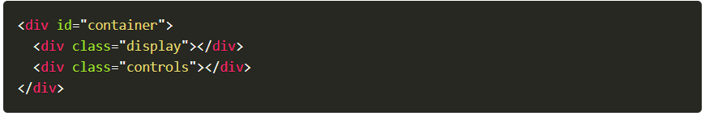
In the above example, the <div class="display"></div> is a “child” of <div id="container"></div> and a sibling to <div class="controls"></div>. Think of it like a family tree. <div id="container"></div> is a parent, with its children on the next level, each on their own “branch”.
Targeting Nodes with Selectors
When working with the DOM, you use “selectors” to target the nodes you want to work with. You can use a combination of CSS-style selectors and relationship properties to target the nodes you want.
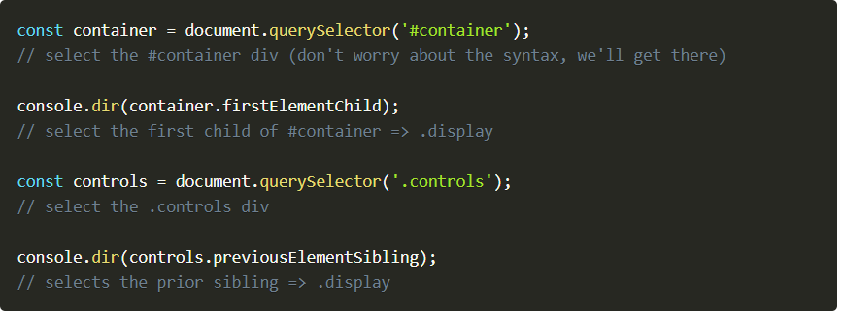
DOM methods
When your HTML code is parsed by a web browser, it is converted to the DOM as was mentioned above. One of the primary differences is that these nodes are objects that have many properties and methods attached to them. These properties and methods are the primary tools we are going to use to manipulate our webpage with JavaScript.
Query Selectors
element.querySelector(selector) returns reference to the first match of selector
element.querySelectorAll(selectors) returns a “nodelist” containing references to all of the matches of the selectors
It’s important to note that when using querySelectorAll, the return value is not an array. It looks like an array, and it somewhat acts like an array, but it’s really a “nodelist”. The big distinction is that several array methods are missing from nodelists. One solution, if problems arise, is to convert the nodelist into an array. You can do this with Array.from() or the spread operator.

Element Creation
document.createElement(tagName[, options]) creates a new element of tag type tagName. [options] in this case means you can add some optional parameters to the function.
This function does NOT put your new element into the DOM - it simply creates it in memory. This is so that you can manipulate the element (by adding styles, classes, ids, text etc.) before placing it on the page. You can place the element into the DOM with one of the following methods.
Append Elements
parentNode.appendChild(childNode) appends childNode as the last child of parentNode
parentNode.insertBefore(newNode, referenceNode) inserts newNode into parentNode before referenceNode
Remove Elements
parentNode.removeChild(child) removes child from parentNode on the DOM and returns reference to child
Altering Elements
When you have a reference to an element, you can use that reference to alter the element’s own properties. This allows you to do many useful alterations, like adding/removing and altering attributes, changing classes, adding inline style information and more.
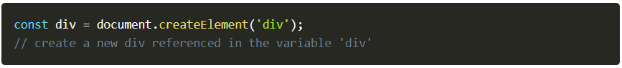
Adding inline style
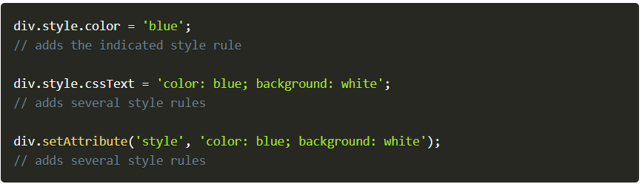
Note that if you’re accessing a kebab-cased css rule from JS, you’ll either need to use camelcase or you’ll need to use bracket notation instead of dot notation.
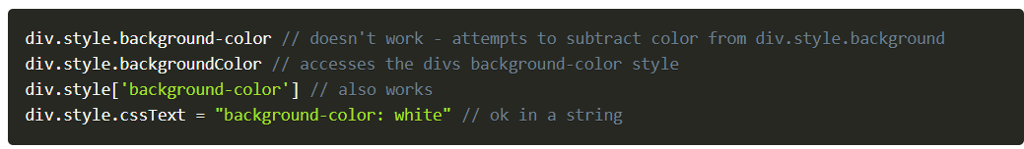
Editing Attributes
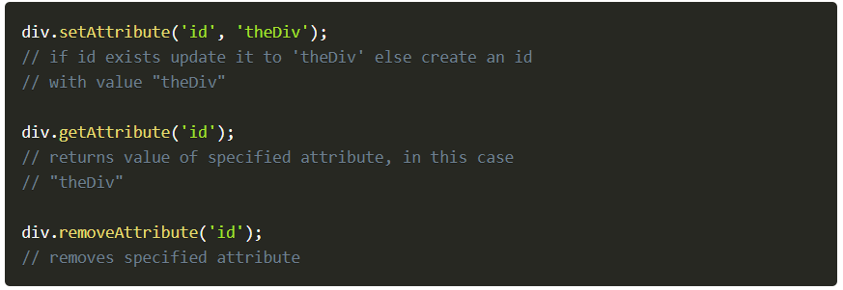
Working with classes
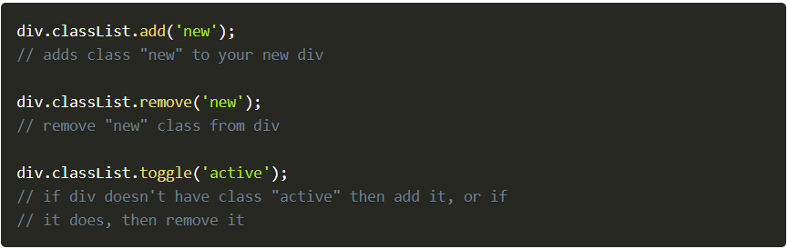
It is often standard (and more clean) to toggle a CSS style rather than adding and removing inline CSS.
Adding text content
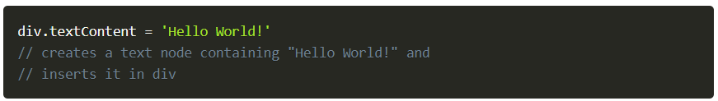
Adding HTML content
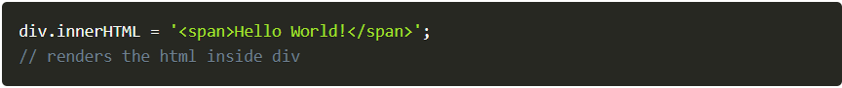
*Note that textContent is preferable for adding text, and innerHTML should be used sparingly as it can create security risks if misused.
*Keep in mind that the JavaScript does not alter your HTML, but the DOM - your HTML file will look the same, but the JavaScript changes what the browser renders.
*Important note: Your JavaScript, for the most part, is run whenever the JS file is run, or when the script tag is encountered in the HTML. If you are including your JavaScript at the top of your file, many of these DOM manipulation methods will not work because the JS code is being run before the nodes are created in the DOM. The simplest way to fix this is to include your JavaScript at the bottom of your HTML file so that it gets run after the DOM nodes are parsed and created.

