EVENTS
Events are actions that occur on your webpage such as mouse-clicks or keypresses, and using JavaScript we can make our webpage listen and react to these events.
There are three primary ways to go about this:
- you can attach functions attributes directly on your HTML elements,
- you can set the “on_event_” property on the DOM object in your JavaScript,
- you can attach event listeners to the nodes in your JavaScript.
Event listeners are definitely the preferred method, but you will regularly see the others in use, so we’re going to cover all three.
Example: we’re going to create 3 buttons that all alert “BUTTON” when clicked.
method 1
This solution is less than ideal because we’re cluttering our HTML with JavaScript. Also, we can only have 1 “onclick” event per element.
method 2
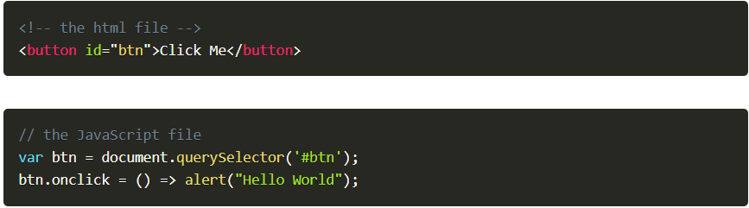
This is a little better. We’ve moved the JS out of the HTML and into a JS file, but we still have the problem that a DOM element can only have 1 “onclick” property.
method 3
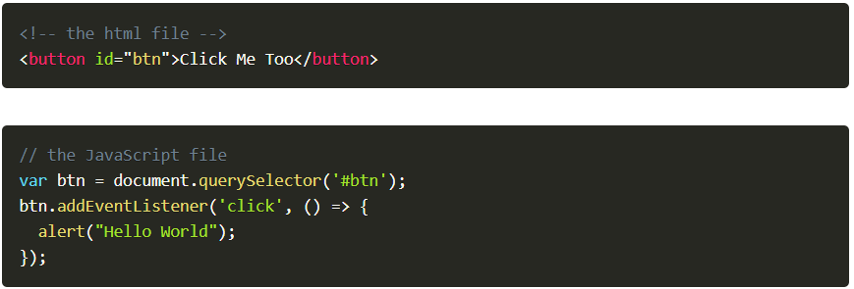
Now, we maintain separation of concerns, and we also allow multiple event listeners if need arise. Method 3 is much more flexible and powerful, though it is a bit more complex to set up.
Note that all 3 of these methods can be used with named functions like so:
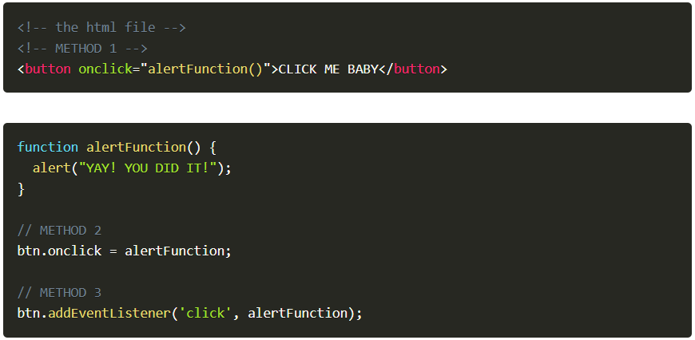
Using named functions can clean up your code considerably, and is a really good idea if the function is something that you are going to want to do in multiple places.
Object event
With all three methods we can access more information about the event by passing a parameter to the function that we are calling.
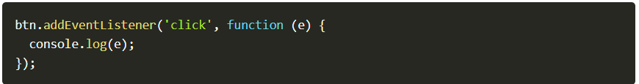
The e in that function is an object that references the event itself. Within that object you have access to many useful properties and functions such as which mouse button or key was pressed, or information about the event’s target - the DOM node that was clicked.
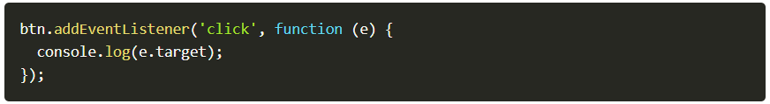
e.target return element which was pressed
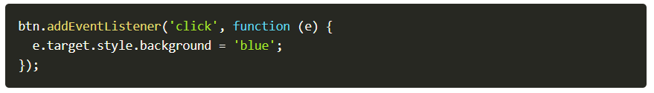

Attaching listeners to groups of nodes
This might seem like a lot of code if you’re attaching lots of similar event listeners to many elements. There’s a few ways to go about doing that more efficiently. We learned above that we can get a nodelist of all of the items matching a specific selector with querySelectorAll('selector'). In order to add a listener to each of them we simply need to iterate through the whole list like so:
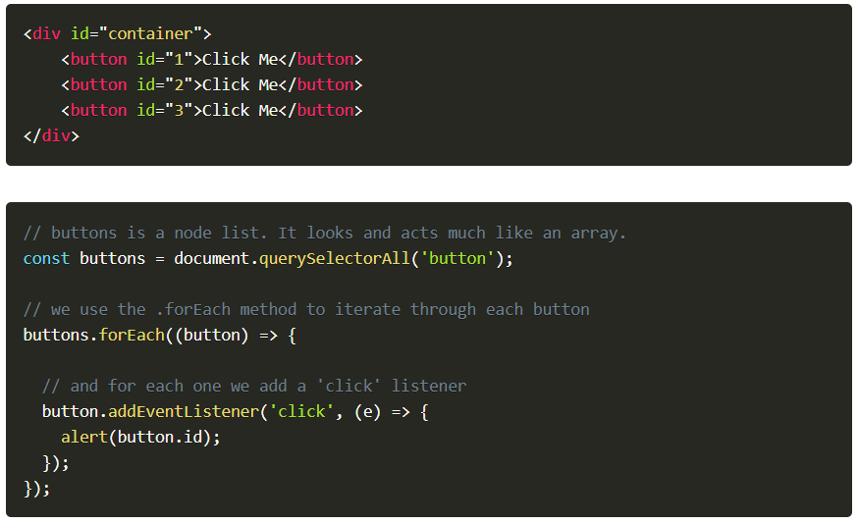
Some useful events include:
click
dblclick
keypress
keydown
keyup

You can find a more complete list with explanations of each event on this page (https://www.w3schools.com/jsref/dom_obj_event.asp).

