LOOP
Programming loops are all to do with doing the same thing over and over again — which is termed iteration in programming speak.
for
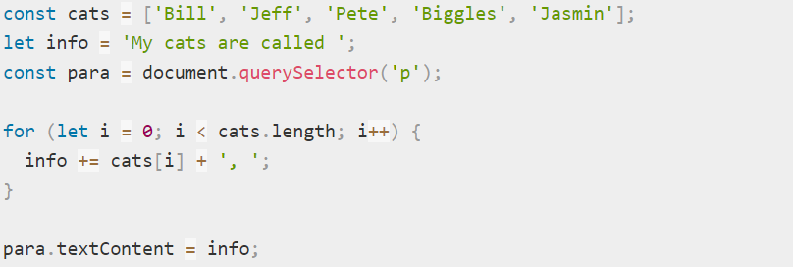
break - immediately exit the loop and make the browser move on to any code that follows it.
continue - skips to the next iteration of the loop.
while
This loop's syntax looks like so:
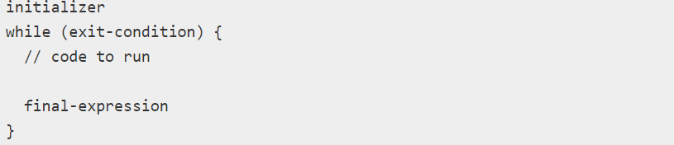
example
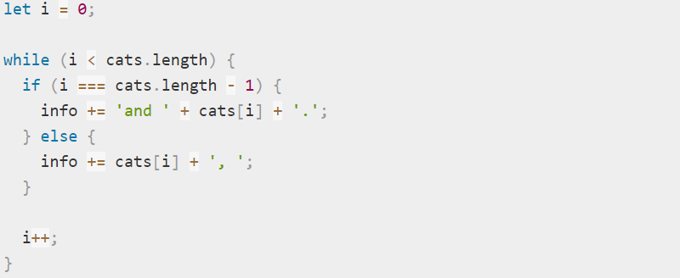

do … while
syntax
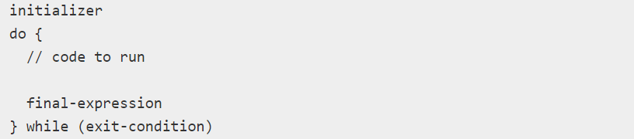
example
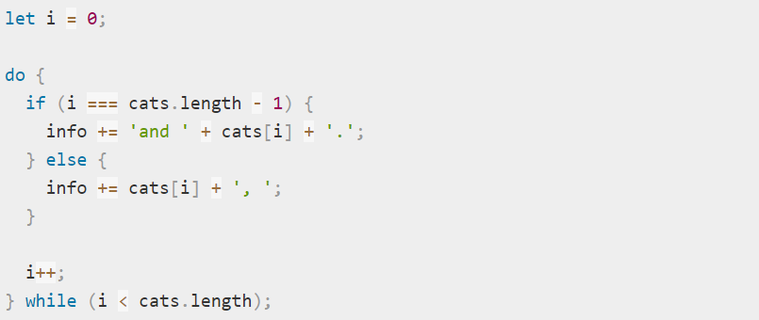
Labels for break/continue
Sometimes we need to break out from multiple nested loops at once. For example in code below break stop inner loop, but outer loop will work.
for(let i = 0; i < 5; i++) {
for(let x = 0; x < 5; x++) {
if(x ==2) {
break;//exit from inner loop but outer loop will work
}
}
}

A label is an identifier with a colon before a loop:
lableName: for(...) {
...
}

firstLoop: for(let i = 0; i < 5; i++) {
for (let x = 0; x < 5; x++) {
if(x == 2) {
break firstLoop; //exit from inner loop and outer loop
}
}
}

In the code above, break firstLoop looks upwards for the label named firstLoop and breaks out of that loop.
The continue directive can also be used with a label. In this case, code execution jumps to the next iteration of the labeled loop.

