Human Faces Generation using DCGAN
In propose project we are employing DCGAN (deep convolution generative adversarial network) to generate human faces. DCGAN consists of two different networks such as Generator and Discriminator where generator will generate faces from trained model and then Discriminator will predict weather uploaded and generated faces are real or fake.
Text to Image Generation
In this module we have used combination of CNN and LSTM algorithm to generate images from text where CNN will be responsible to generate images by utilizing text features predicted by LSTM. This model trained on Image Net dataset and this model will be applied on LSTM features to generated related image. In real time they will train on millions of images so generation will be accurate but we trained the model on 8000 images only so it will work for few sentences which we have given in ‘samples_input_text.txt’ file.
To implement this project we have designed following modules
- User Login: user can login to system using username and password as ‘admin and admin’.
- Train & Load DCGAN: after login user will use this module to generate and load DCGAN model and then perform prediction on test data to calculate prediction accuracy
- Human Faces Generation: using this module user can upload any image and then DCGAN will generate some images and then apply Discriminator to detect those images as Real or Fake (Ai generated).
- Text to Image: in this module user can upload some text and then application will generate related image.
To run project install Python 3.7.2 and then install all packages given in requirements.txt file and then double click on ‘run.bat’ file to start python server and get below page
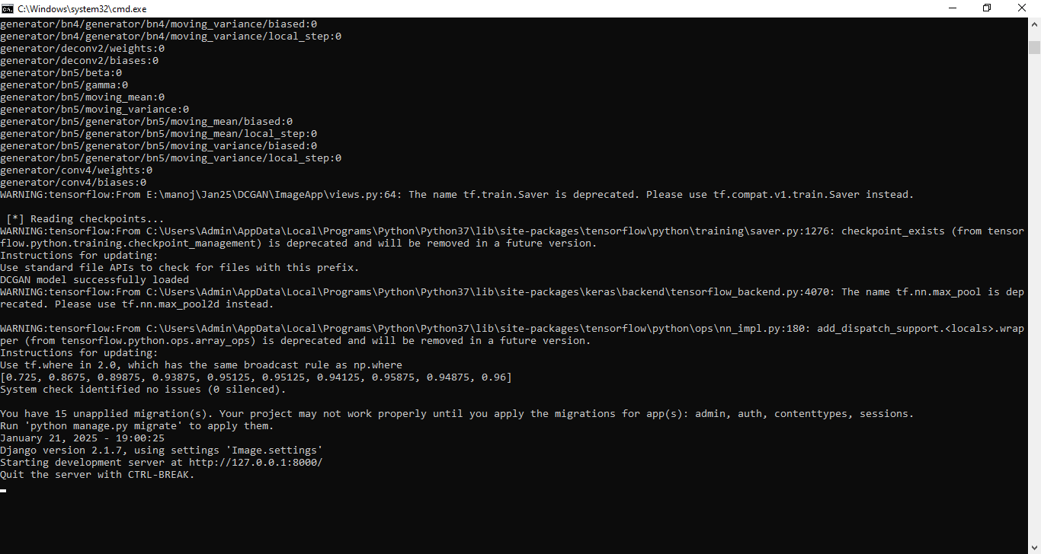
In above screen python server started and now open browser and enter URL as http://127.0.0.1:8000/index.html and then press enter key to get below page
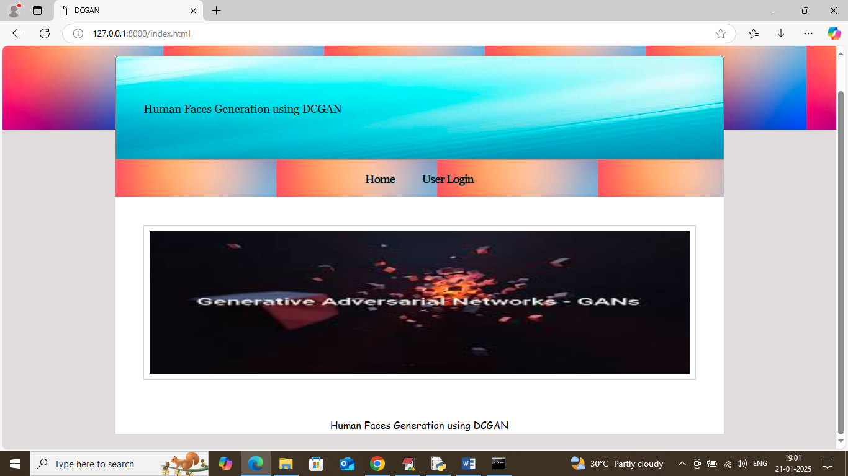
In above screen click on ‘User Login’ link to get below page
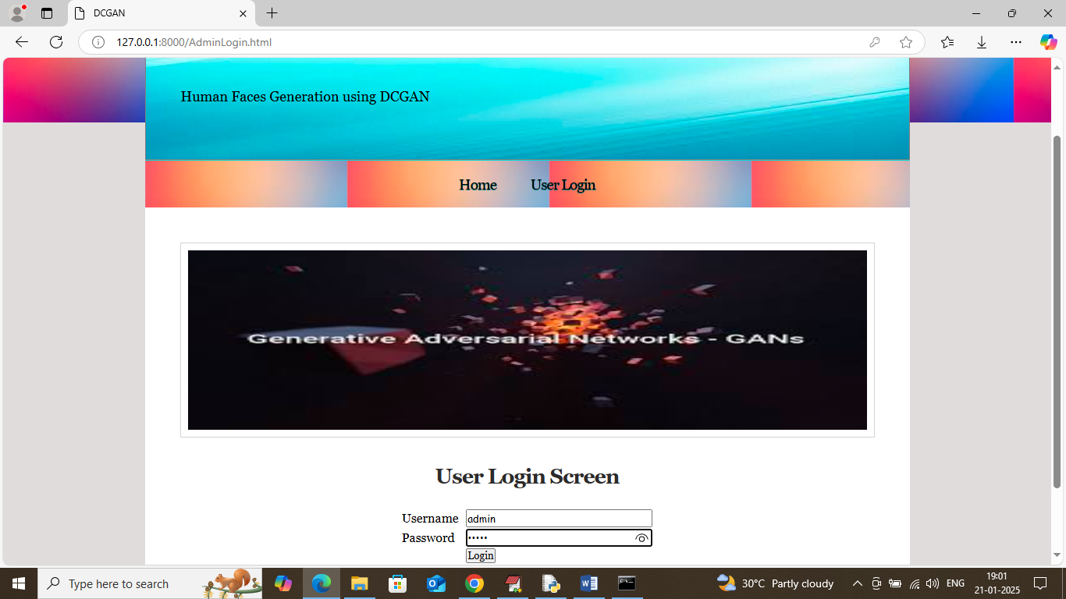
In above screen user is login and after login will get below page

In above screen click on ‘Train & Load DCGAN’ link to train and load model and then will get below page
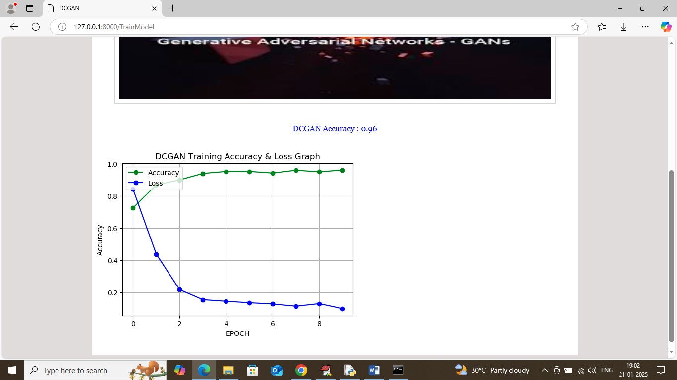
In above screen DCGAN got 96% accuracy and in training graph x-axis represents Training epoch and y-axis represents Accuracy and loss values. In above graph blue line represents LOSS and green line represents accuracy and can see with each increasing epoch accuracy got increase and loss got decrease. Now click on ‘Human Faces Generation’ link to generate faces and get below page
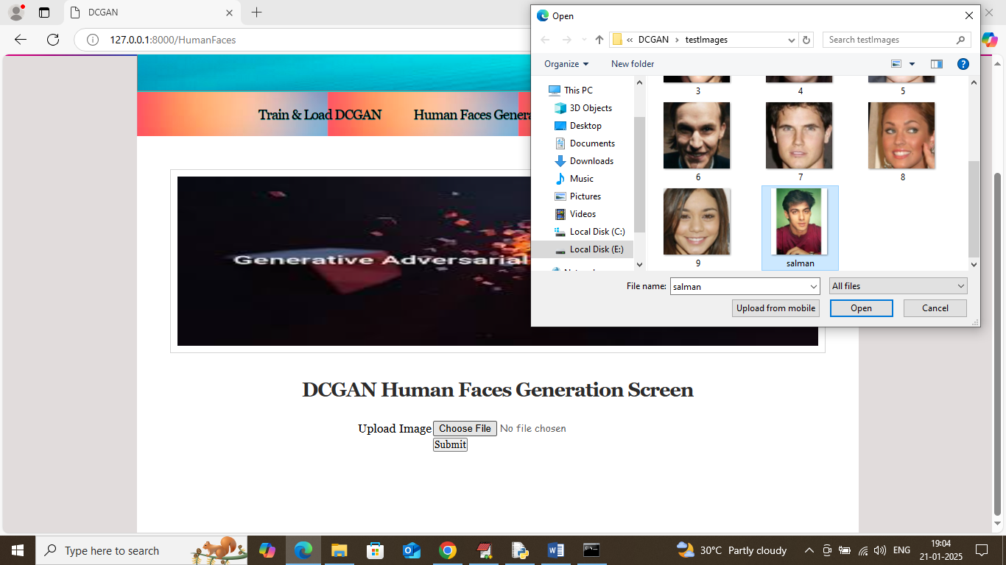
In above screen selecting and uploading test image and then click on ‘Open and Submit’ button to get below output. (note: to generate images system may take 2 to 3 minutes of time).
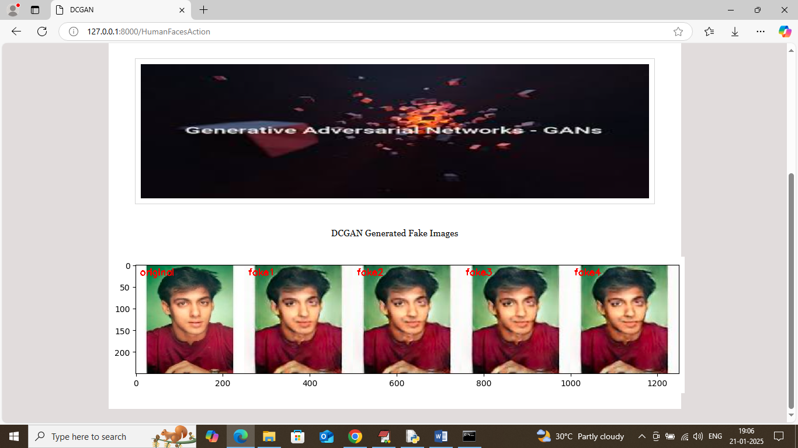
In above screen first image is the original image which is detected as Real and then remaining images are generated by Generator and then discriminator predicted as fake or AI generated. Similarly you can upload and test other images and in below screen showing another sample
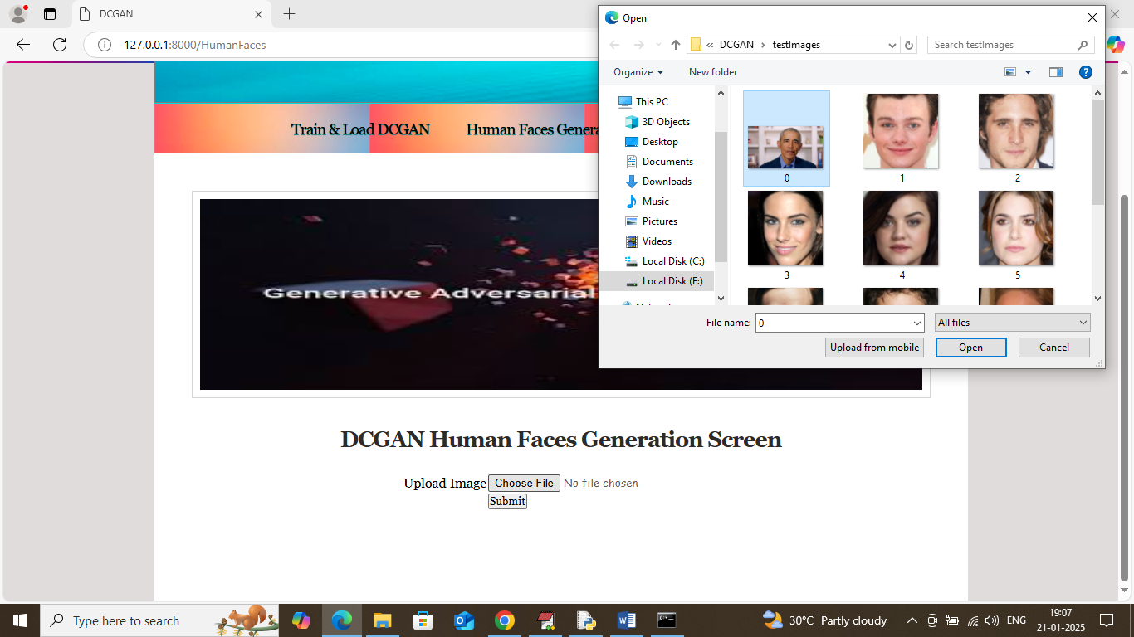
In above screen uploading another image and then wait for some time to get below output
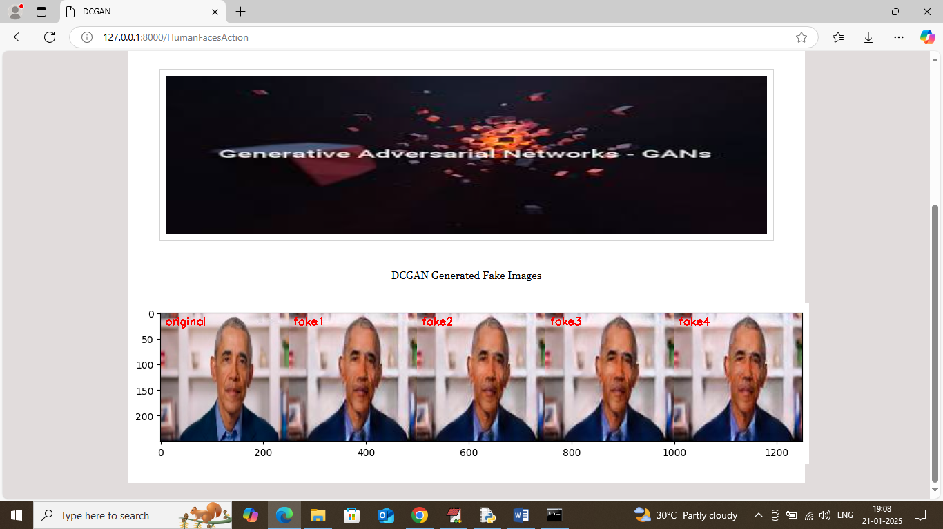
In above screen first image is the original image and remaining images are generated by DCGAN. Now click on ‘Text to Image’ link to get below page
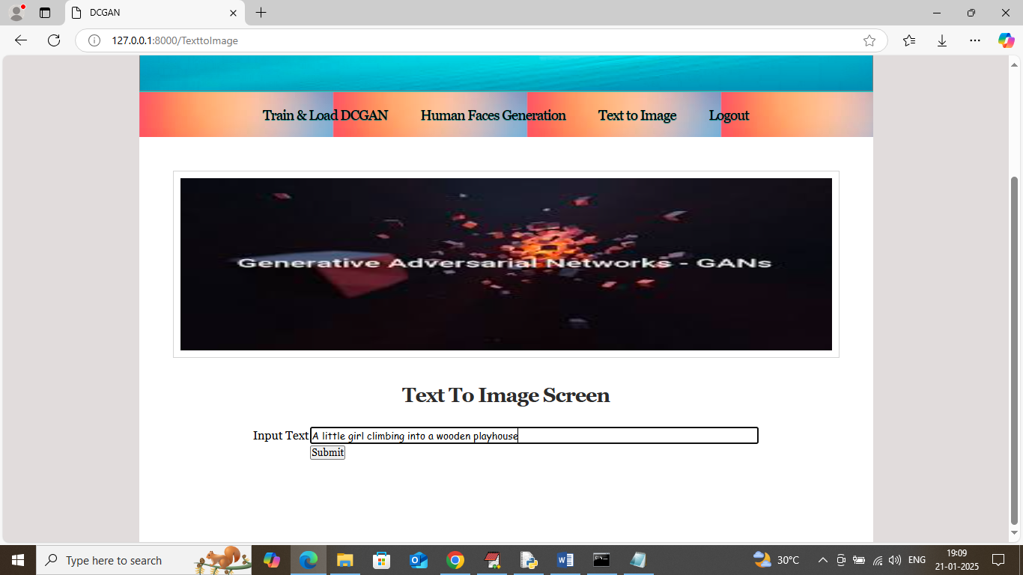
In above screen entering some text and then click on ‘Submit’ button to get below page
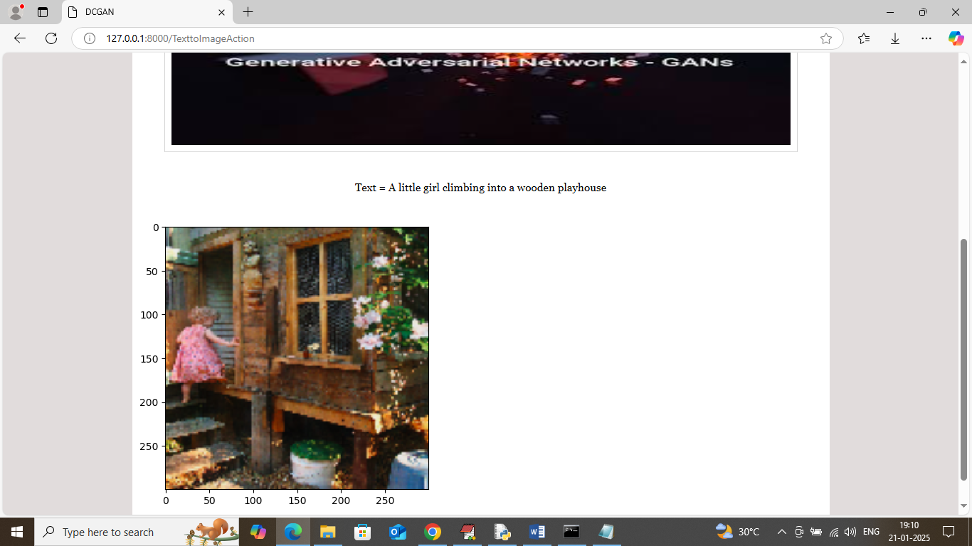
In above screen can see generated image from given text and similarly you can use sentences given in ‘samples_input.txt’ file. Below is another example
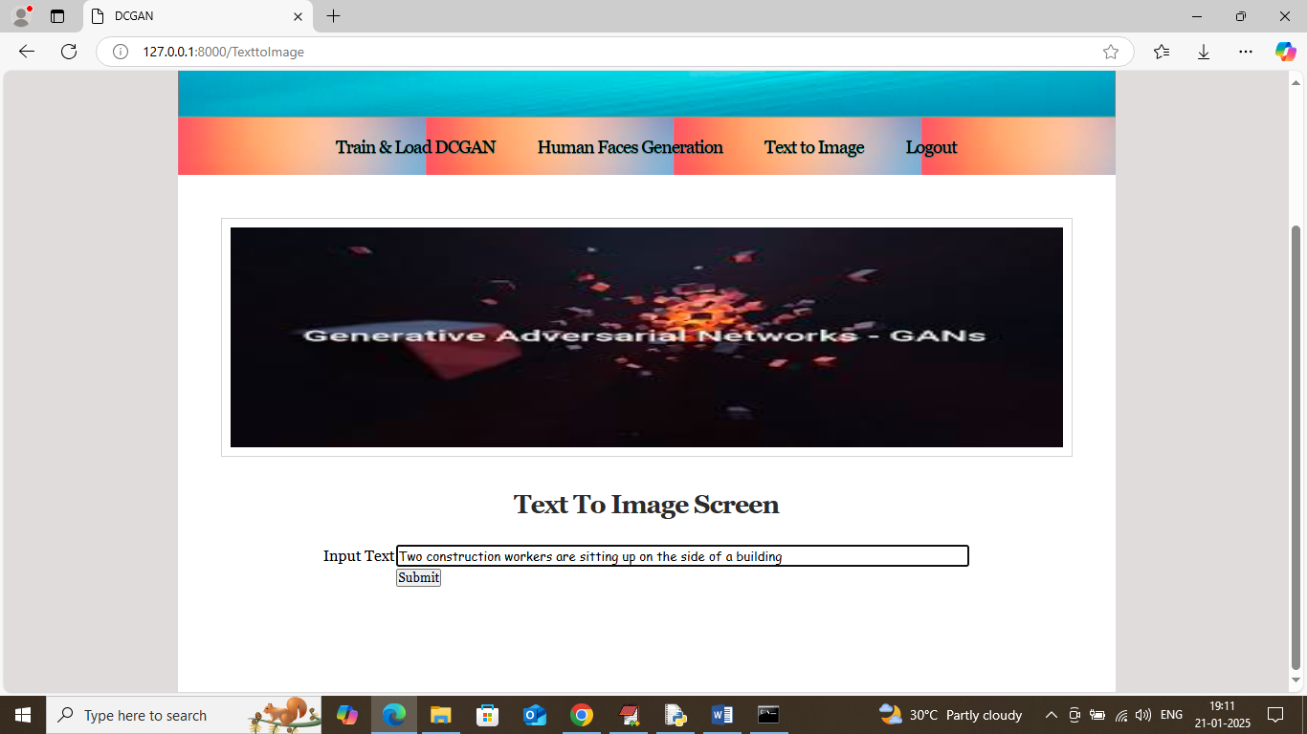
In above screen entering some other text and then will get below output
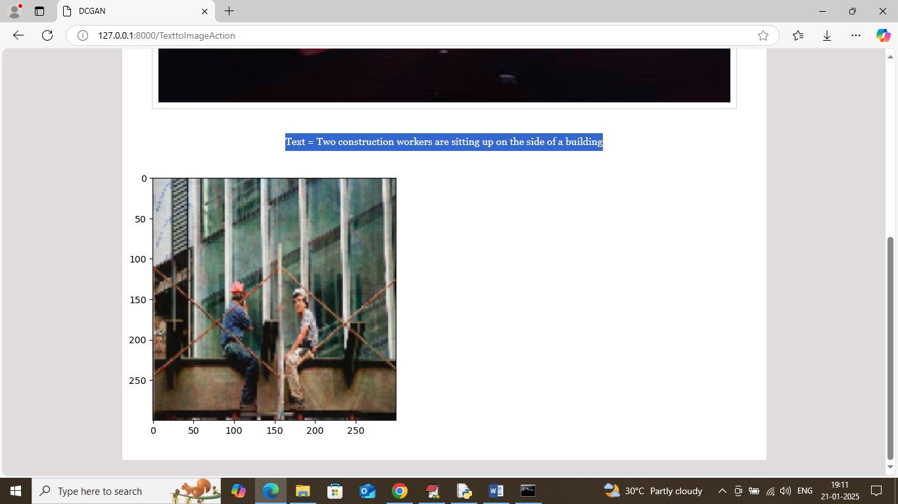
In above screen can see generated image from given text and you can try other sentences.

