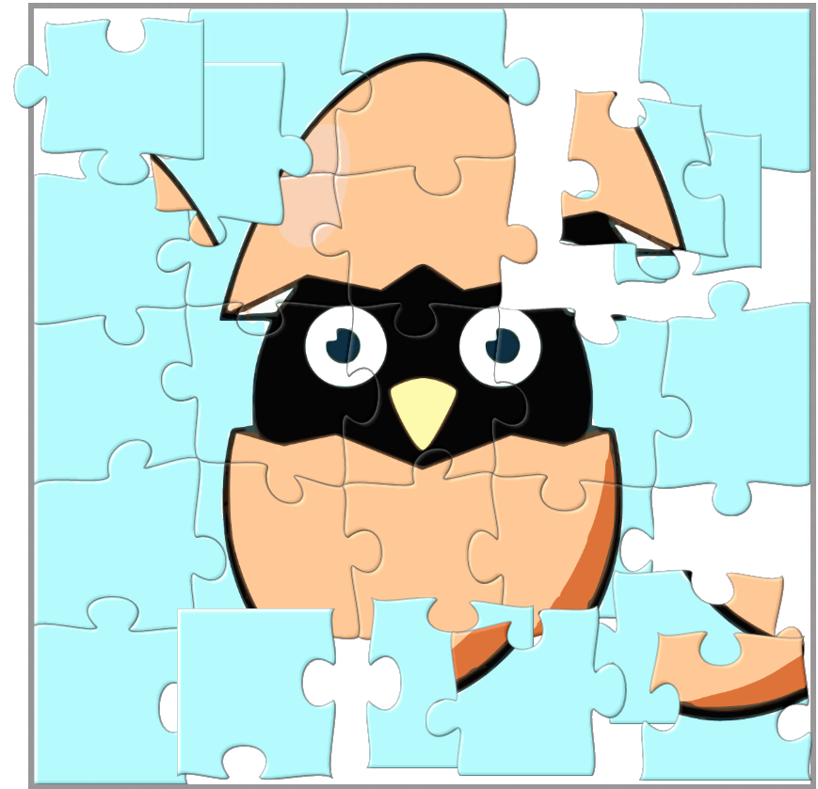
KRAKIN’T
Co- Founder Token
Light-Paper V 1.0

Network: BSC

Standard: BEP20

Address: 0x4180CE5a616E75512fd9DF0bd896AC955C64a246
https://github.com/Krakin-t-CoFounders/solidity

Document Date: April 2021 Version 2.0
Authors: Krakin’t Team

Web: http://www.krakint.com

Introduction
∙ Krakin’t Co-Founder Token (Krc) is a side-project of Krakin’t. The purpose of this token is to pave the way for the ERC20 Token (KRK) while establishing a community.  ∙ Anyone can claim this token from the token-contract, while the claiming follows the BTC model of a distribution. We want to make sure that anyone can use the online voting platform. For this reason, we have deployed a token on the BSC network as a BEP20 standard.  ∙ Our online platform is based on the smart-voting system where amount of tokens someone holds influences the strength of their vote, without exerting a dominance. |  | Krakin’t Co-Founder Token Logo

Brief Token Specifications:
Network: Binance Smart Chain
Standard: BEP20
Name: Krakin’t Co-Founder Token
Symbol: Krc
Decimals: 18
Total Supply (approximate): 42 million
Initial supply: 0 Tokens (or no tokens)
Allocated amount to Krakin’t Team: 0 Tokens (or no tokens at all)
Token is minted/mined by claiming
Any additional tokens may be minted to provide the necessary liquidity or a necessary pre-sale.

Why Co-Founder Token?
The first thing we would like you to keep in mind is that we want to develop a platform where answers can be obtained by voting. Although we have specified that Krakin’t won't work as a community-oriented project, it is necessary to provide an interface where projects joining Krakin’t will gain the opinion from the community regarding their projects. For this reason, we have created a token that will help us gather the initial community and help any other project (including Krakin’t) by providing a voting platform. We chose the BEP20 standard for its simplicity and cheap prices. We want everyone to own this token, and to spread the token as much as possible, to have better voting results.

How does this token work?
In essence, it is the same as any other token, with a few extra functions added. The current supply starts with zero tokens, and anyone can claim tokens, as many times as they want. Each claim increases the current supply by the amount that was minted. The initial amount of tokens anyone can get per claim is 50. This can be repeated 210000 times, after which the amount of tokens anyone can claim becomes 25. The amount of claims increases by +(n/2), which means, for 25 tokens, there are 315000 claims. Therefore, the halving can repeat about 65 times, given that 2^n=50*10^18 and n is a Real Number.
Assuming that each claim costs around 10 cents (US), we can say that it would take USD 11,726 Billion to complete the mining of this token. Therefore, we assume that letting people make as many claims as they want is a safe procedure, since we do not foresee that this token will reach such high numbers. Although this token works on an honor system where anyone can make as many claims as they like with no electricity costs, there will be a point where it will simply become too expensive to claim it. Therefore, the halving and a controlled supply are what regulates the honor system while preventing it from becoming abused.
Please see the full table on the next page to learn about the controlled supply.
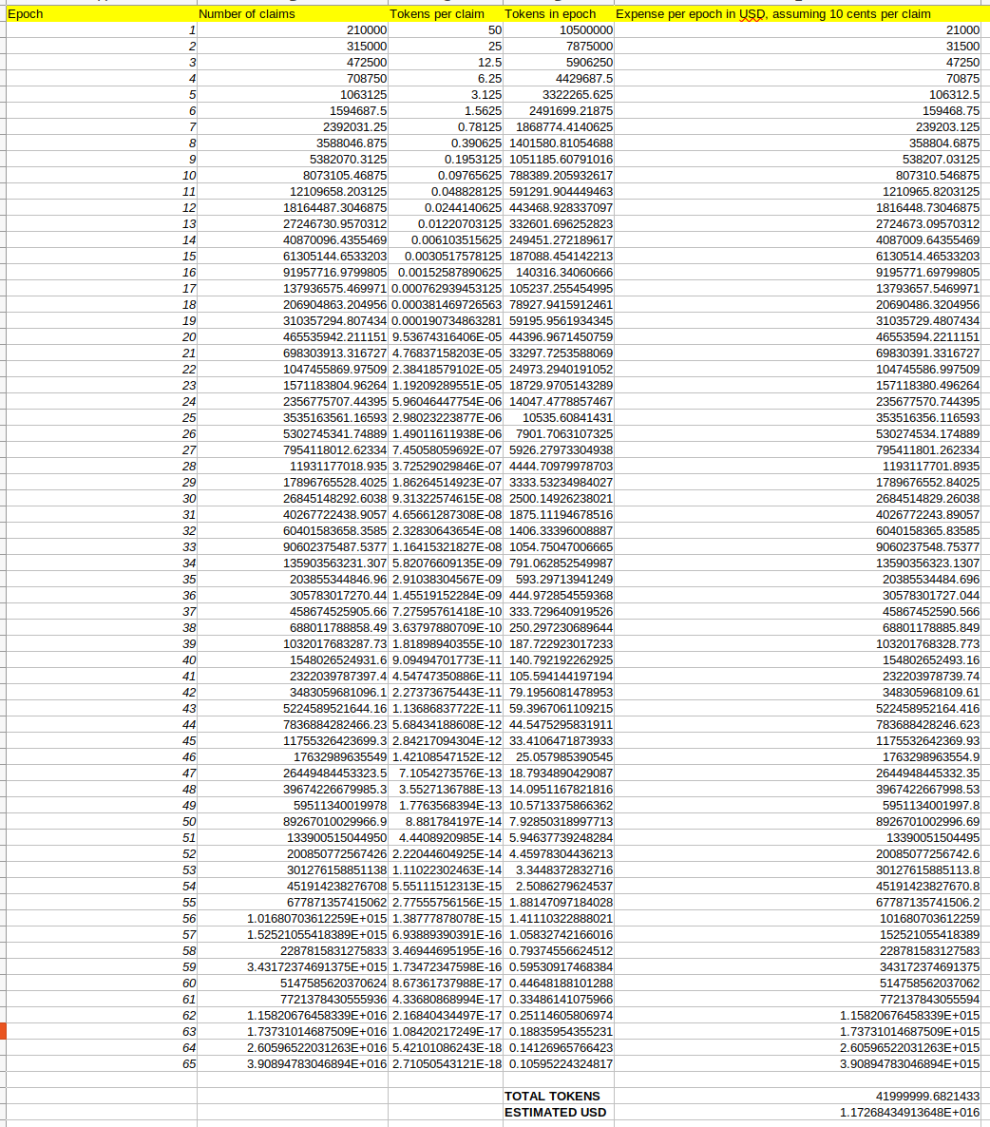

How is this token different from other tokens?
We have included only a few functions. Two functions are open to the public, while the other three are administrator-only functions.

Public Functions Explained
- claimTokens – By executing this function, you are making one claim and minting new tokens.
- caimTokensTo – Same as the claimTokens, except that you can specify the address the tokens are sent to. This is quite useful for airdrops and promotions.

Administrator-only Functions Explained
- mintTo – For mining tokens to some other address. This does not affect the claiming system and is completely independent. However, it increases the total and the current supply. This function is very useful for providing liquidity, minting pre-sale tokens, or anything else that will aid the token distribution and adoption.
- burnFrom – To burn tokens from address, in case there is an error or abuse.
- changeOwner – To change the owner of a contract, or remove the existing one. In the future, we hope to have no owners/administrator access.

How do I claim this token?
Claiming KRc tokens is very easy, and it does not require an application. You can claim it by pressing the Claim Tokens button, or you can do it simply by visiting a block-chain explorer. However, you must specify a BSC Network before claiming. These steps will not cover the network setup. To setup Metamask you can follow these instructions: https://docs.binance.org/smart-chain/wallet/metamask.html
To access the BEP20 chain via mobile platforms, simply download this app: https://trustwallet.com/smart-chain-wallet/
Please note, your address on the BSC chain is the same as the address on ETH chain if you use the same key. You can use the same private key for accessing the Ethereum chain and Binance Smart Chain, and your addresses will be the same.
Before you make a token claim, you need to deposit some BNB (Binance Coin) into your wallet.

Step 1.
Go to: https://bscscan.com/address/0x4180ce5a616e75512fd9df0bd896ac955c64a246#writeContract

Step 2.
Press:

Step 3.
Choose your wallet, in this case, Metamask
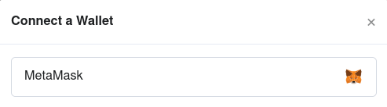

Step 4.
Press OK and approve every relevant popup

Step 5.
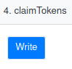
Navigate to:

- And press the “Write” button.


Step 6.
Approve the Metamask pop-up and the GAS costs. Simply wait for a transaction to complete minting your tokens.

How exactly is a token voting-platform going to work?
We will start with an open platform where anyone can post anything they like, as long as their address is not blocked by the centralized authority and as long as they hold any amount of the KRc token. We will start with the simple binary voting platform and then slowly develop a Probabilistic Voting system, which is more than just a simple up/down-vote system. Since we will start from the simplest steps, the simplest voting will be two-dimensional. The first dimension will be the number of either up or down-votes, while the second dimension is going to be the number of tokens associated with up or down-votes. Then, we will simply calculate a distance from the maximum points in n-dimensional space, to find out what the true voting outcome is. Users will allocate a percentage of their tokens to either an up or a down-vote. Now, since this is the simplest (binary) voting system we will develop, this concept can be extrapolated to Polls as well.
As already mentioned, Probabilistic Voting is the next step, however, this area of research is vast. The main idea is that voters don’t always know the right answers, and with the help of machine algorithms, we can derive the best answers.
We will provide the best-suited voting options for the type of answers anyone wants to find out. We will also dedicate the platform to posts that are just informative (seeking no answers) or made just for fun.
Our primary goal is to avoid the exertion of dominance by those who own more tokens than the others. As already mentioned, we are aiming to provide different voting systems, so that users can decide who has the power and what kind of voting power.

CONCLUSION
There are many voting platforms, however, neither is focusing on the multiplicity of the possibilities the concept of voting can assume. For this reason, Krakin’t aim is to enable such a platform and allow anyone to cast their vote by using the token which is cheap to claim and that works on an honor system.

