Assignment 2

INF-2300

Erling Heimstad Willassen

Introduction
Clients and servers can communicate with each other using CRUD (Create, Read, Update, Delete) operations through HTTP (HyperText Transfer Protocol). This form of communication allows a client to receive a web page layout written in HTML (HyperText Markup Language) and JavaScript.
In this assignment, a web page in HTML was created to communicate with a provided server implemented in JavaScript. The server displays and allows manipulation of a list stored on the server side.

Technical Background
HTML is a very much used markup language to display web pages on the internet. HTML is a document file that contains code describing the layout of the page content and how it will be display by a client browser [1]. By entering a domain name or IP address into a browser [2], the browser sends an HTTP request to the corresponding server to retrieve the HTML layout, files, or other resources.
The server handles these requests according to predefined rules, allowing or denying access to certain resources and returning data to the client. In this way, the server determines what the client can access and display through HTTP requests. Furthermore, these HTTP requests can also be used to manipulate the internal state of objects or files on the server if the server provides appropriate handling methods.
JavaScript is a lightweight programming language commonly used on web pages to provide interactivity and dynamic functionality [3]. Web browsers have built-in JavaScript engines that can execute JavaScript code embedded in HTML documents [3]. While HTML alone provides a static layout, JavaScript allows dynamic interaction by executing functions tied to HTML elements. This integration enables communication with a server to fetch or modify information displayed on the client side.
Flask is a web application framework for the Python programming language that simplifies the process of creating and running web servers [4]. Flask includes built-in methods for handling client requests and responses, making it easy to develop a working server in a short amount of time.

Design
The goal of the implementation was to create a static HTML web page displayed on the client side. This file would be hosted on the server and accessible to clients by sending a "GET" request to either "/" or "/index.html". The HTML file defined the layout of the web page, containing elements that triggered different HTTP requests.
These elements were connected to JavaScript functions within the same HTML file, where the HTTP requests were handled and displayed in an organized manner. Since the interface needed to be user-friendly, each interactive object was labeled descriptively and included error handling to minimize invalid requests.
The provided server code already included predefined request routes. These routes were used to modify a list stored on the server side. By interacting with objects on the client page, users could manipulate the state of this list through HTTP requests.

Implementation
As described in Section 3, the assignment included a pre-written Python server using Flask. This code already supported various client requests, except for serving the index.html file. To fix this, a route was added so that when a client accessed the server’s IP or domain (or appended /index.html), the server would return the HTML layout using Flask’s render_template() function.
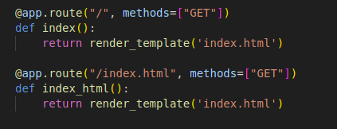Figure 1: Code for routing a GET request to client
The HTML file was created from scratch. Using a basic HTML template, the web page displayed input fields and buttons that interacted with the server to manipulate a list object named items, which contained a dictionary/JSON of TODO entries stored on the server.
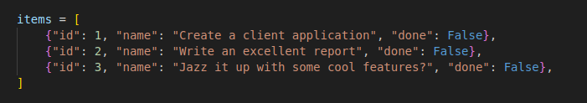Figure 2: Item list on server side to have its state altered by HTTP requests.
One of the main challenges was connecting HTML elements to JavaScript functions. This was solved by wrapping input fields in a <form></form> container and using the onsubmit= event listener to trigger specific JavaScript functions.
The fetch() method in JavaScript was then used to send HTTP requests to the server. Each CRUD operation was implemented as a separate JavaScript function that interacted with the items list depending on user actions in the HTML interface.
To improve responsiveness, asynchronous functions were used with the async keyword. Normally, JavaScript functions execute synchronously, which means other code pauses until a task is complete. By using async, functions can run concurrently, preventing the web page from freezing while waiting for a server response.
The await keyword was combined with fetch() to pause function execution until the server response was received, preventing errors caused by trying to access data before it arrived. Additionally, e.preventDefault() was used to stop the browser from reloading the page automatically, allowing the web page to update dynamically without refreshing.

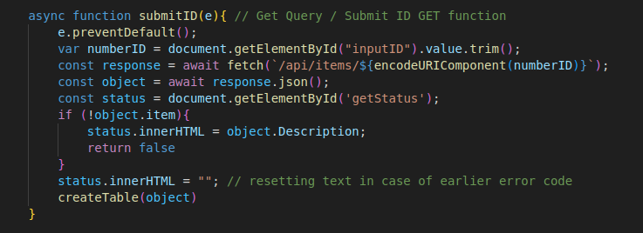Figure 3: An example of how a JavaScript function looks like in the HTML file.

Results
When the server’s IP address was accessed from a client browser as "127.0.0.1:8080" or "localhost:8080", the "index.html" layout was requested and correctly displayed as seen below in figure 4.
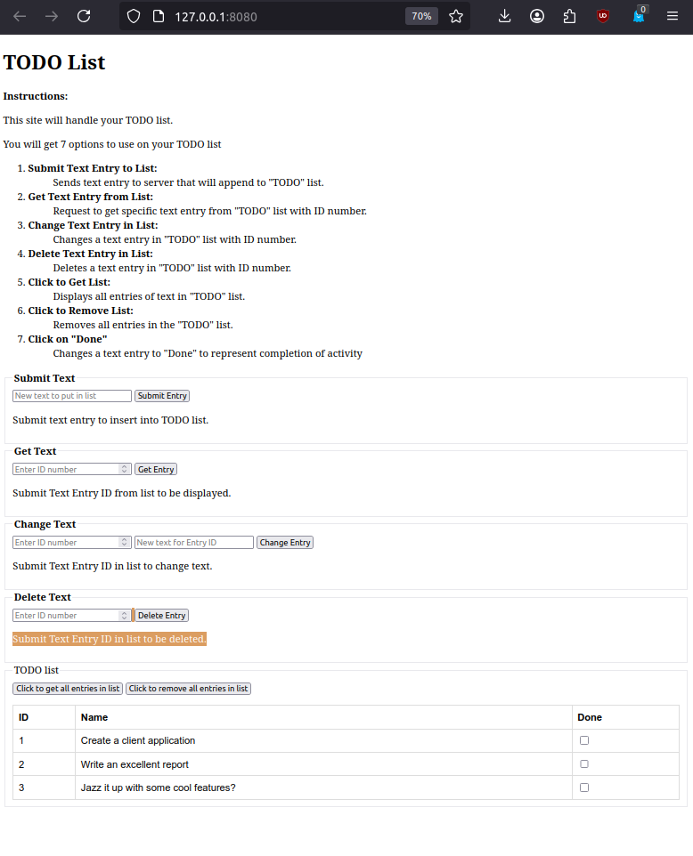Figure 4: How the HTML layout looks in a web-client.
The user could perform seven actions through the web interface. Each action was tied to a specific JavaScript function and HTTP request:
Submit Query | Sends text entry to server that will append to "TODO" list
Get Query | Request to get specific text entry from "TODO" list with ID number.
Change Query | Changes a text entry in "TODO" list with ID number.
Delete Query | Deletes a text entry in "TODO" list with ID number.
Click to fetch list | Displays all entries of text in "TODO" list.
Click to remove list | Removes all entries in the "TODO" list.
Click "Done" | Changes a text entry to "Done" to represent completion of activity

All actions worked as intended and successfully modified the server-side list.

Discussion
The static HTML web page provided an efficient way to display and manipulate the server-side list. This approach was chosen because it offered a simple and straightforward method to create a working client interface without the need for a complex front-end framework.
Developing the connection between JavaScript and the server took some effort. Initially, errors occurred when the client attempted to process responses before the server had finished sending them. This issue was solved by implementing asynchronous functions with the await keyword, ensuring that the JavaScript waited for server responses before proceeding. Once this was implemented, the overall functionality became much more stable and predictable.
Although only minor changes were made to the Python server, using Flask proved to be an efficient and user-friendly way to set up a server. This demonstrates that creating a functional web server can be achieved quickly and with relatively little code. The flask module handles most of the technical back-end code of a server, while the programmer have to handle what the responses should be to each request.

Conclusion
A web client with a user-friendly interface was successfully implemented to handle HTTP requests for manipulating a server-side list. The static HTML web page, enhanced with JavaScript functionality, allowed users to view, add, modify, and delete list items on the server. The project demonstrated effective client-server communication using Flask, HTML, and JavaScript.

8. Sources
[1] Wikipedia Contributors, “HTML,” Wikipedia, Nov. 27, 2018. https://en.wikipedia.org/wiki/HTML
[2] Wikipedia Contributors, “Domain Name System,” Wikipedia, Aug. 09, 2019. https://en.wikipedia.org/wiki/Domain_Name_System
[3] Wikipedia Contributors, “JavaScript,” Wikipedia, Mar. 22, 2019. https://en.wikipedia.org/wiki/JavaScript
[4] Flask, “Welcome to Flask — Flask Documentation (3.0.x),” Palletsprojects.com, 2010. https://flask.palletsprojects.com/en/stable/

