

Monte Carlo Markov Zinciri
ÖRNEK UYGULAMA
Mehmet Eren DOĞAN

Proje Raporu
Elektrik-Elektronik Mühendisliği
Sezim ve Kestirim Kuramı
EĞİTMEN
Dr. Öğr. Üyesi Fatih Serdar SAYIN

Figure 1.Index 152 Silece 25 Histogam 4
Figure 2 Index 152 Silece 50 Histogam 4
Figure 3. Index 152 Silece 75 Histogam 4
Figure 4. Index 152 Silece 100 Histogam 4
Figure 5. Index 375 Silece 25 Histogam 5
Figure 6. Index 375 Silece 50 Histogam 5
Figure 8 Index 375 Silece 100 Histogam 5
Figure 7 Index 375 Silece 75 Histogam 5
Figure 9 Index 408 Silece 25 Histogam 6
Figure 10. Index 408 Silece 50 Histogam 6
Figure 11 Index 408 Silece 75 Histogam 6
Figure 12 Index 408 Silece 100 Histogam 6
Figure 13 Index 643 Silece 25 Histogam 7
Figure 14 Index 643 Silece 50 Histogam 7
Figure 15 Index 643 Silece 100 Histogam 7
Figure 16 Index 643 Silece 75 Histogam 7
Figure 18 Index 687 Silece 50 Histogam 8
Figure 17. Index 687 Silece 25 Histogam 8
Figure 20 Index 687 Silece 100 Histogam 8
Figure 19 Index 687 Silece 75 Histogam 8
Figure 22 Index 720 Silece 50 Histogam 9
Figure 21 Index 720 Silece 25 Histogam 9
Figure 24 Index 720 Silece 100 Histogam 9
Figure 23 Index 720 Silece 75 Histogam 9
Figure 26 Index 1148 Silece 50 Histogam 10
Figure 25 Index 1148 Silece 25 Histogam 10
Figure 28 Index 1148 Silece 100 Histogam 10
Figure 27 Index 1148 Silece 75 Histogam 10
Figure 30 Index 1362 Silece 50 Histogam 11
Figure 29 Index 1362 Silece 25 Histogam 11
Figure 32 Index 1362 Silece 100 Histogam 11
Figure 31 Index 1362 Silece 75 Histogam 11
Figure 34 Index 1532 Silece 50 Histogam 12
Figure 33 Index 1532 Silece 25 Histogam 12
Figure 35 Index 1532 Silece 100 Histogram 12
Figure 36 Index 1532 Silece 75 Histogram 12
Figure 40 Index 3102 Silece 100 Histogram 13
Figure 38 Index 3102 Silece 50 Histogram 13
Figure 39 Index 3102 Silece 75 Histogram 13
Figure 37 Index 3102 Silece 25 Histogram 13
Figure 42 Index 3679 Silece 50 Histogram 14
Figure 41. Index 3679 Silece 25 Histogram 14
Figure 44 Index 3679 Silece 100 Histogram 14
Figure 43 Index 3679 Silece 75 Histogram 14
Figure 46 Index 3931 Silece 50 Histogram 15
Figure 45 Index 3931 Silece 25 Histogram 15
Figure 48 Index 3931 Silece 100 Histogram 15
Figure 47 Index 3931 Silece 75 Histogram 15
Figure 50 Index 10742 Silece 50 Histogram 16
Figure 49 Index 10742 Silece 25 Histogram 16
Figure 52 Index 10742 Silece 100 Histogram 16
Figure 51 Index 10742 Silece 75 Histogram 16
Figure 53 Index 14374 Silece 25 Histogram 17
Figure 54 Index 14374 Silece 50 Histogram 17
Figure 56 Index 14374 Silece 100 Histogram 17
Figure 55 Index 14374 Silece 75 Histogram 17
Figure 58 Index 16268 Silece 50 Histogram 18
Figure 57 Index 16268 Silece 25 Histogram 18
Figure 60 Index 16268 Silece 100 Histogram 18
Figure 59. Index 16268 Silece 75 Histogram 18
Figure 62 Index 18129 Silece 50 Histogram 19
Figure 61 Index 18129 Silece 25 Histogram 19
Figure 64 Index 18129 Silece 100 Histogram 19
Figure 63 Index 18129 Silece 75 Histogram 19

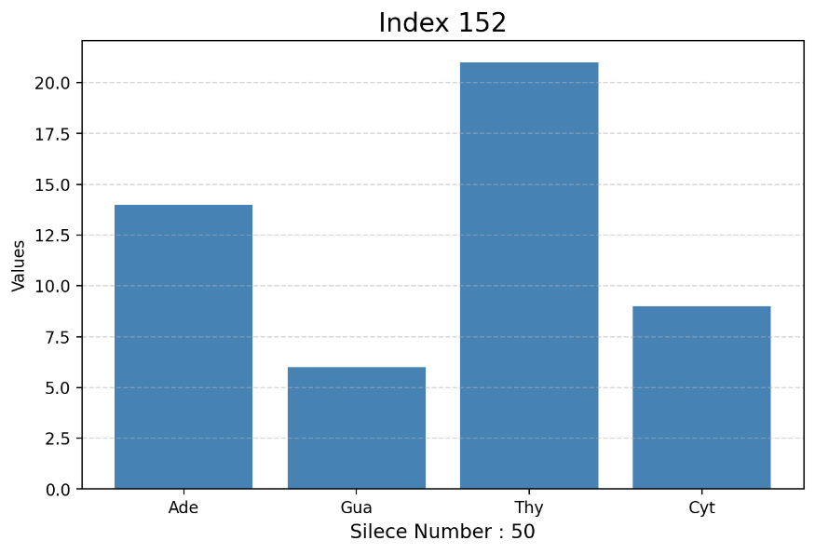
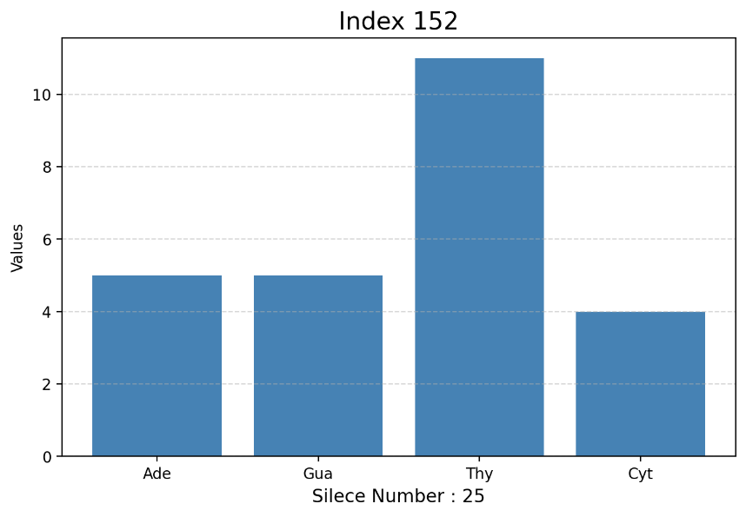
Figure 1.Index 152 Silece 25 Histogam
Figure 2 Index 152 Silece 50 Histogam

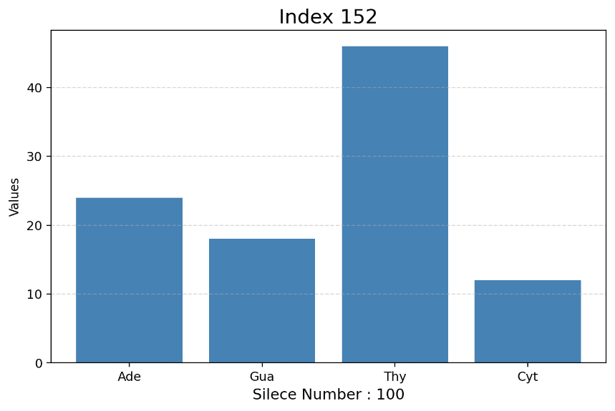
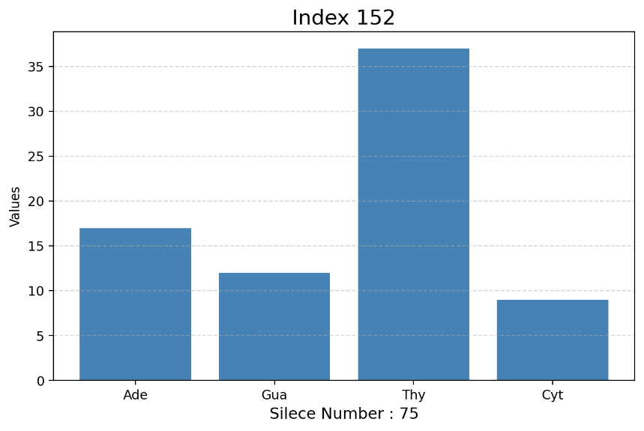
Figure 3. Index 152 Silece 75 Histogam
Figure 4. Index 152 Silece 100 Histogam

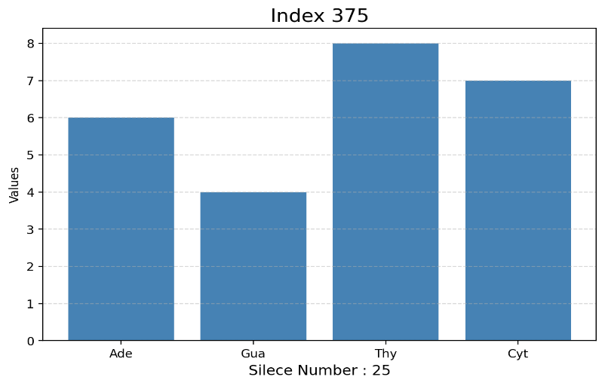
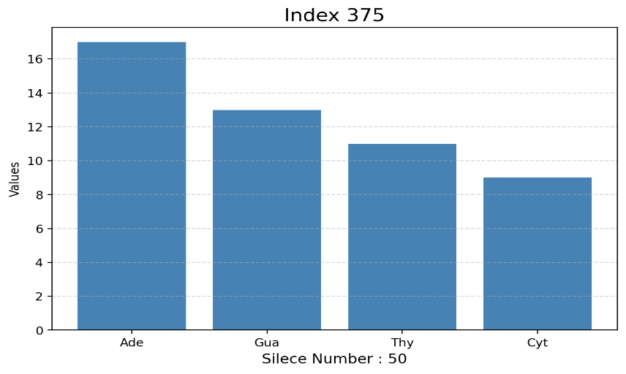
Figure 5. Index 375 Silece 25 Histogam
Figure 6. Index 375 Silece 50 Histogam

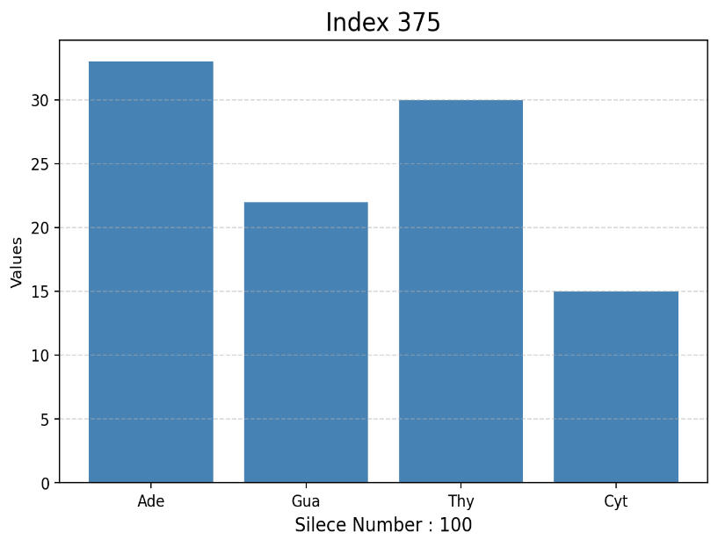
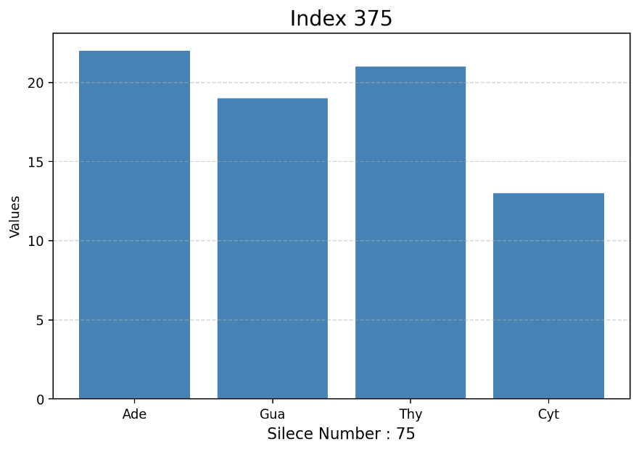
Figure 8 Index 375 Silece 100 Histogam
Figure 7 Index 375 Silece 75 Histogam

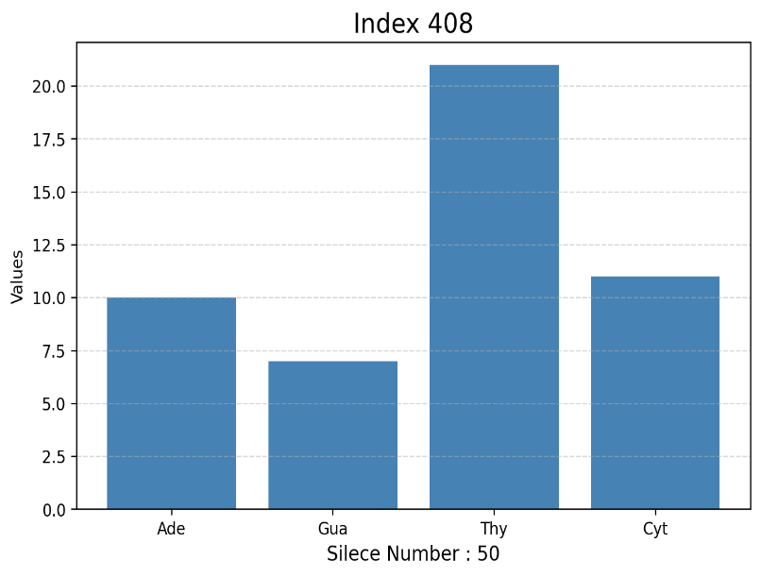
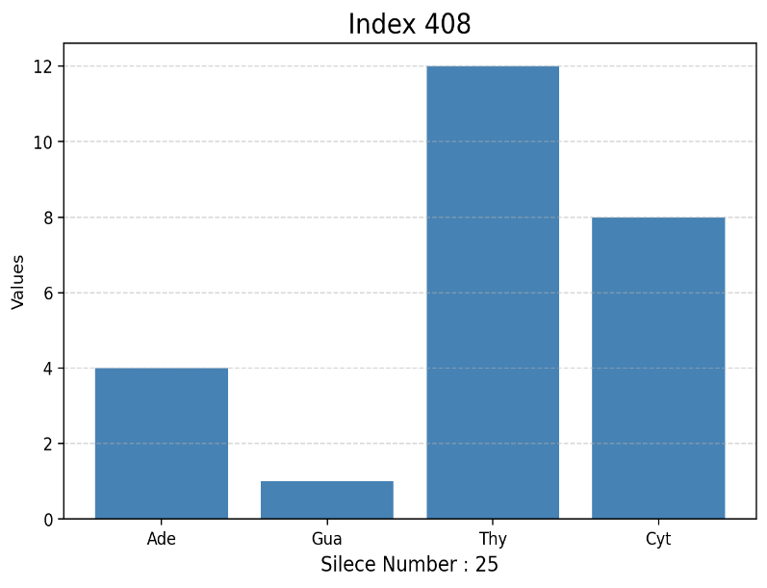
Figure 9 Index 408 Silece 25 Histogam
Figure 10. Index 408 Silece 50 Histogam

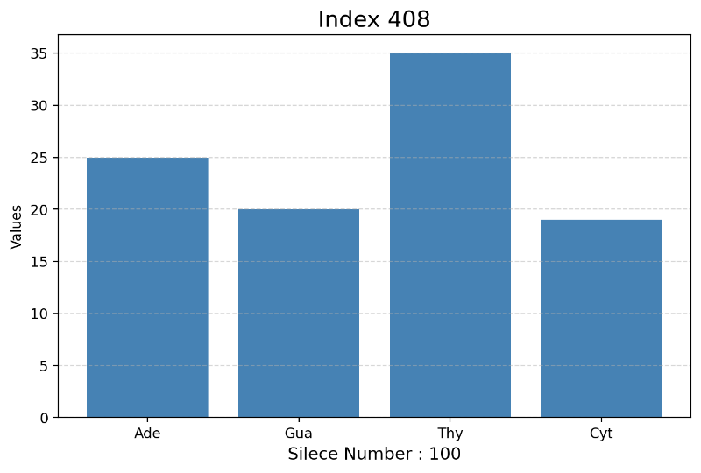
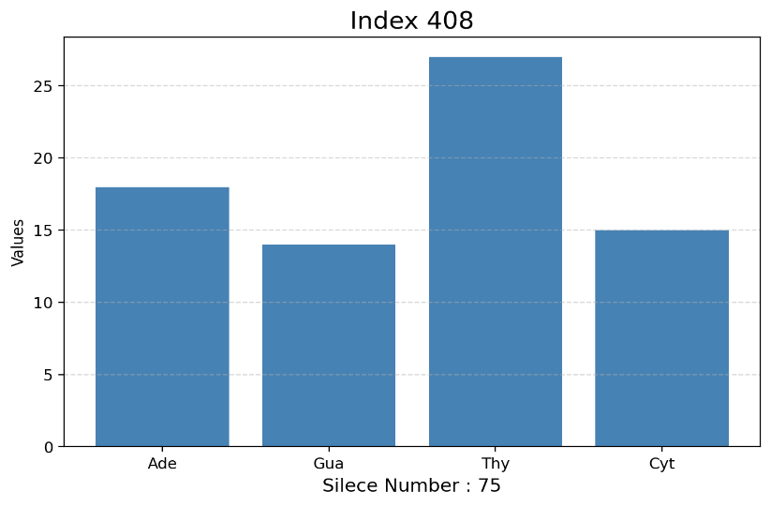
Figure 11 Index 408 Silece 75 Histogam
Figure 12 Index 408 Silece 100 Histogam

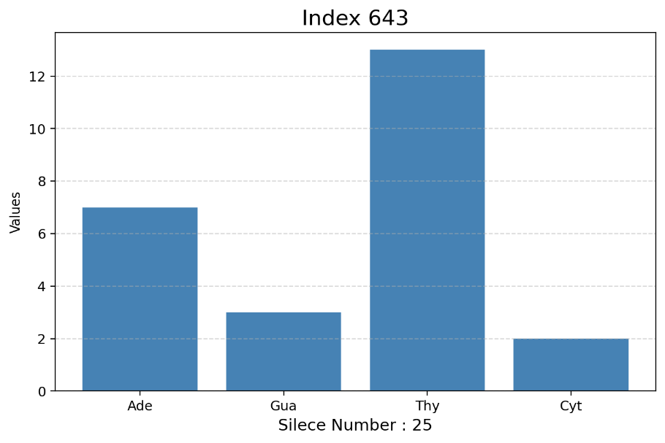
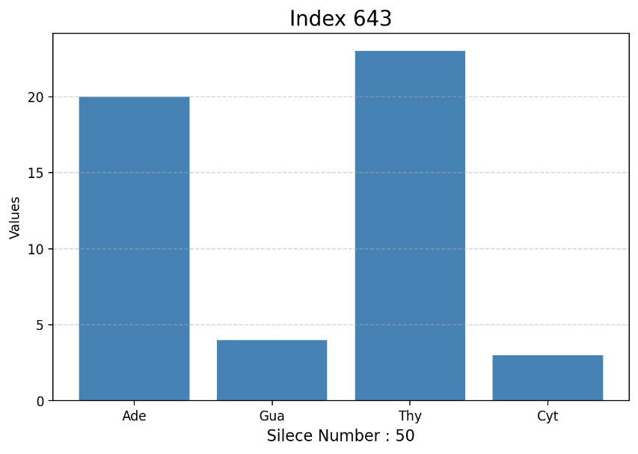
Figure 13 Index 643 Silece 25 Histogam
Figure 14 Index 643 Silece 50 Histogam

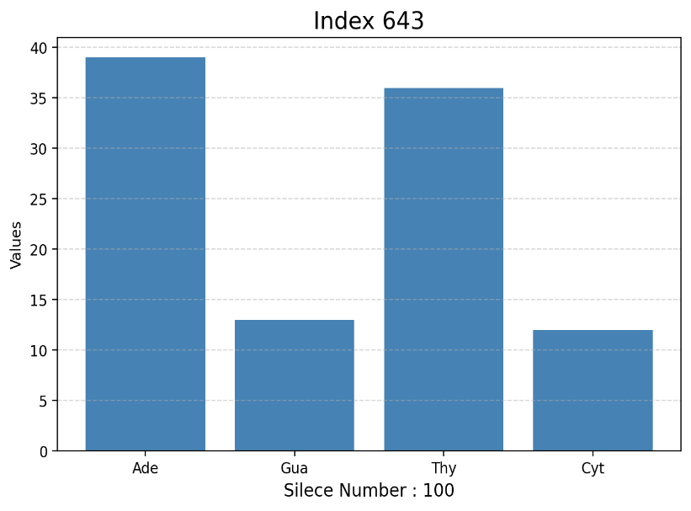
Figure 15 Index 643 Silece 100 Histogam

Figure 16 Index 643 Silece 75 Histogam
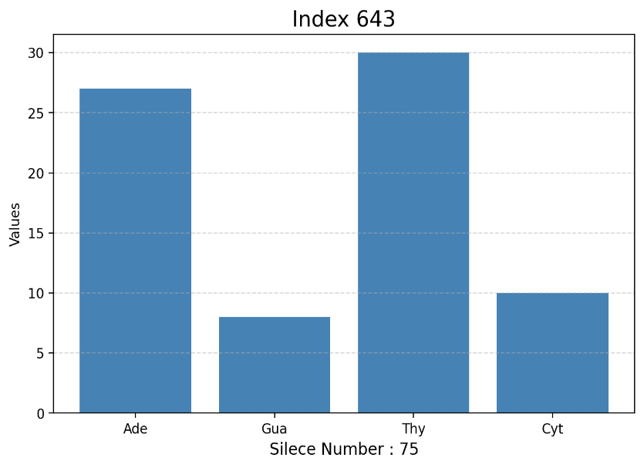

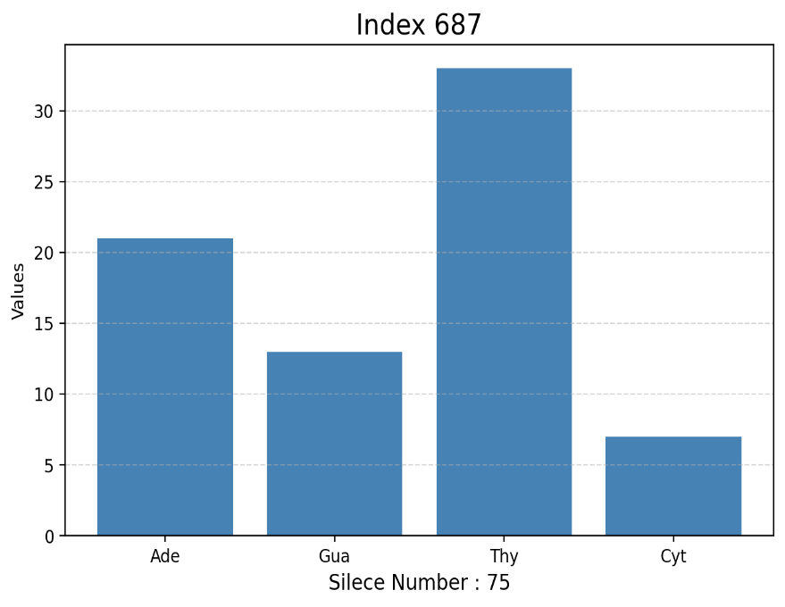
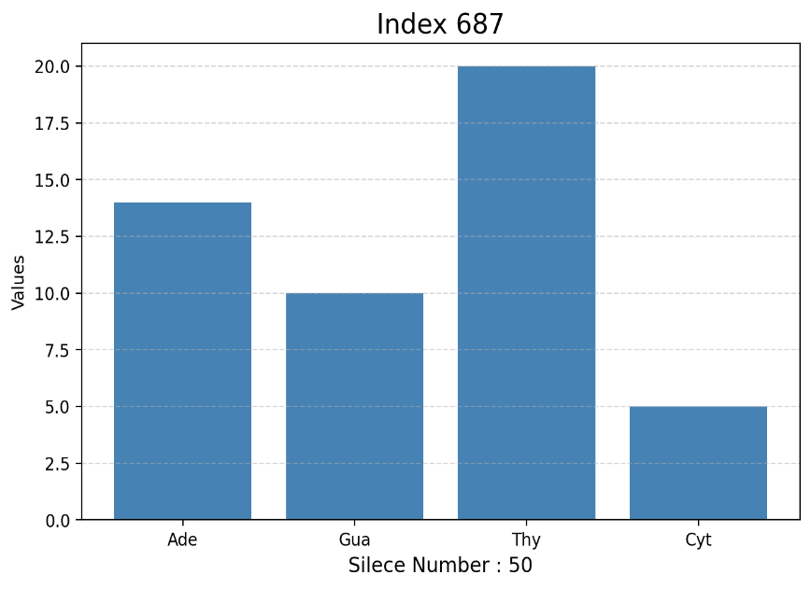
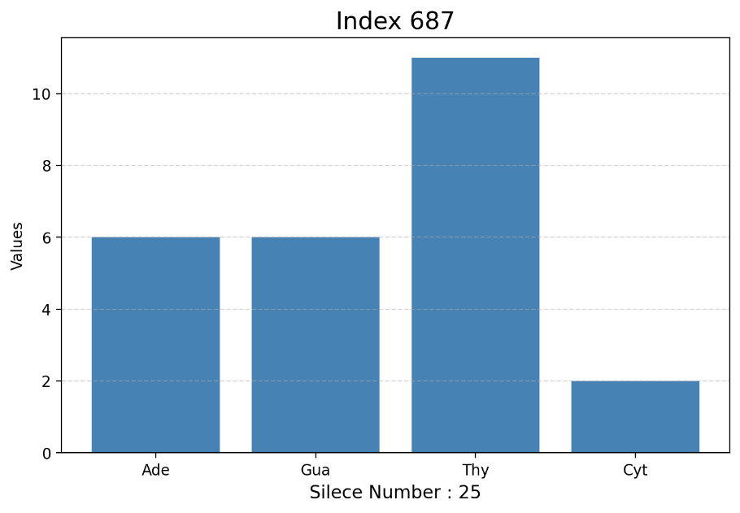
Figure 18 Index 687 Silece 50 Histogam

Figure 17. Index 687 Silece 25 Histogam

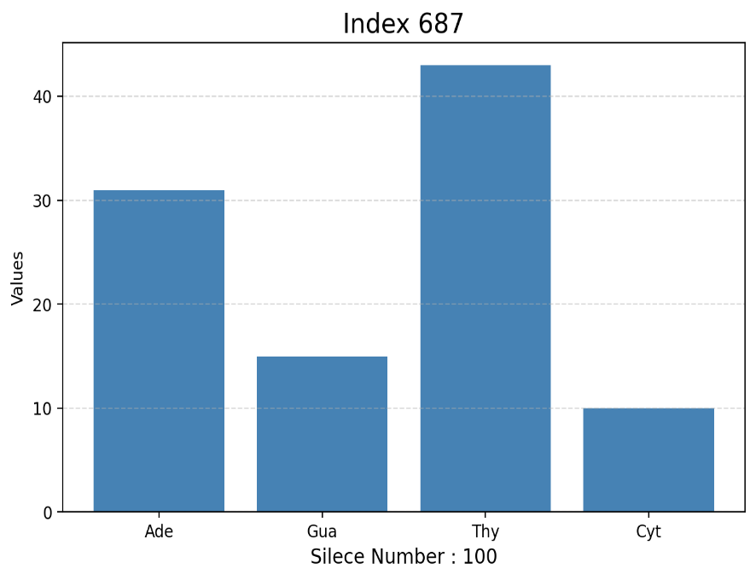
Figure 20 Index 687 Silece 100 Histogam

Figure 19 Index 687 Silece 75 Histogam
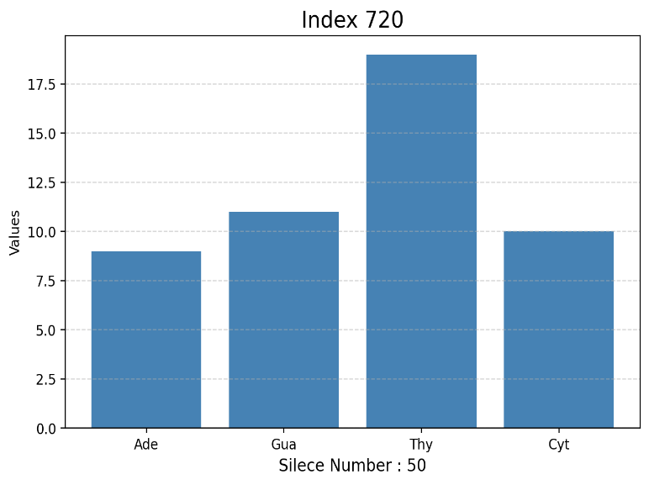
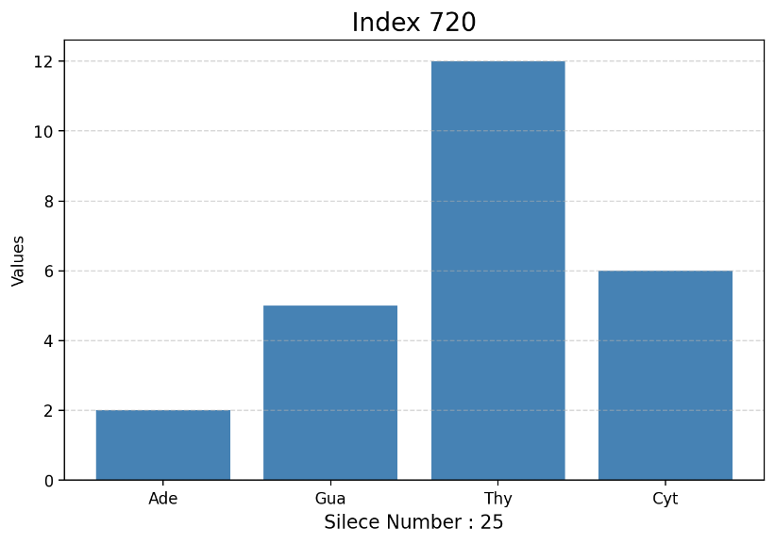
Figure 22 Index 720 Silece 50 Histogam

Figure 21 Index 720 Silece 25 Histogam

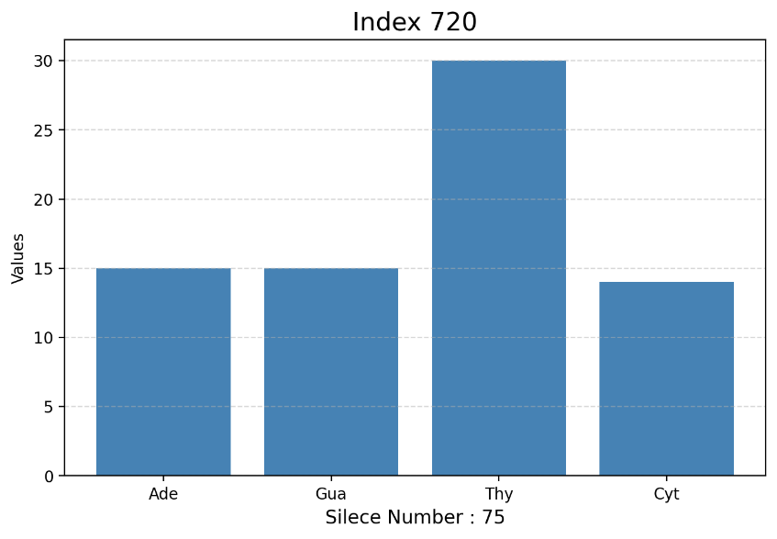
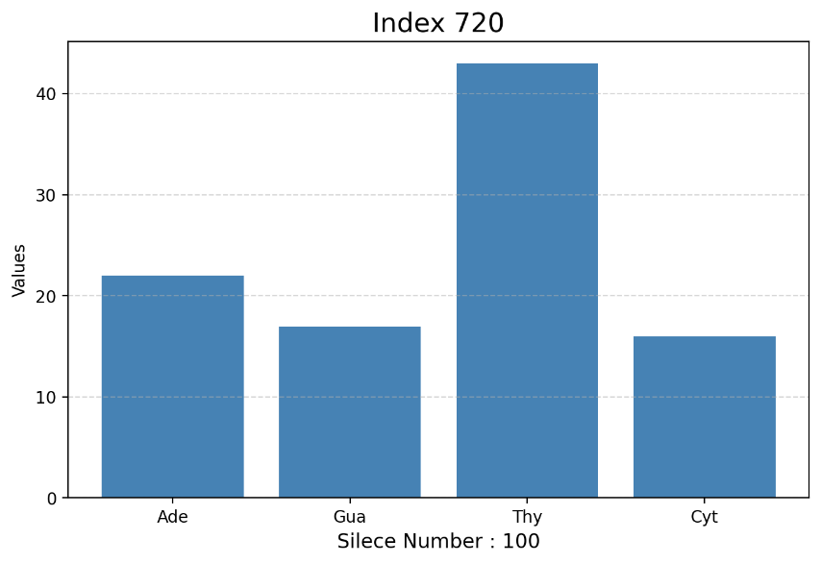
Figure 24 Index 720 Silece 100 Histogam

Figure 23 Index 720 Silece 75 Histogam

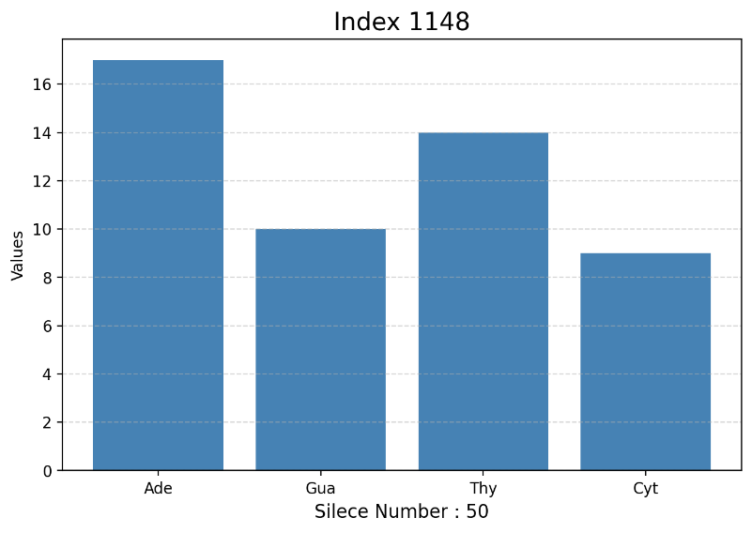
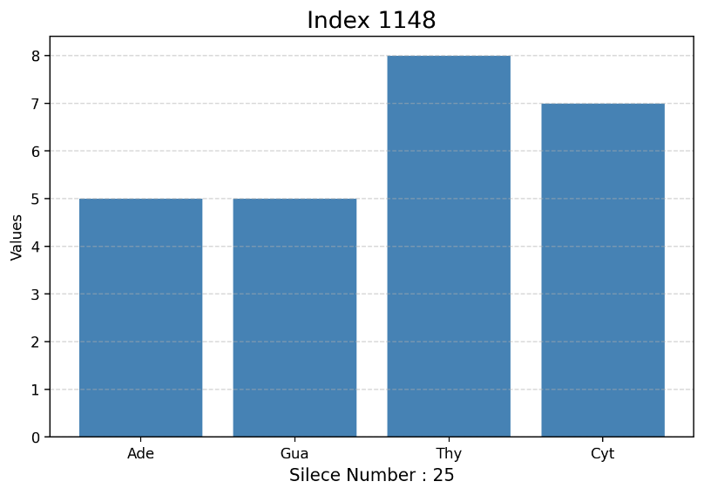
Figure 26 Index 1148 Silece 50 Histogam

Figure 25 Index 1148 Silece 25 Histogam

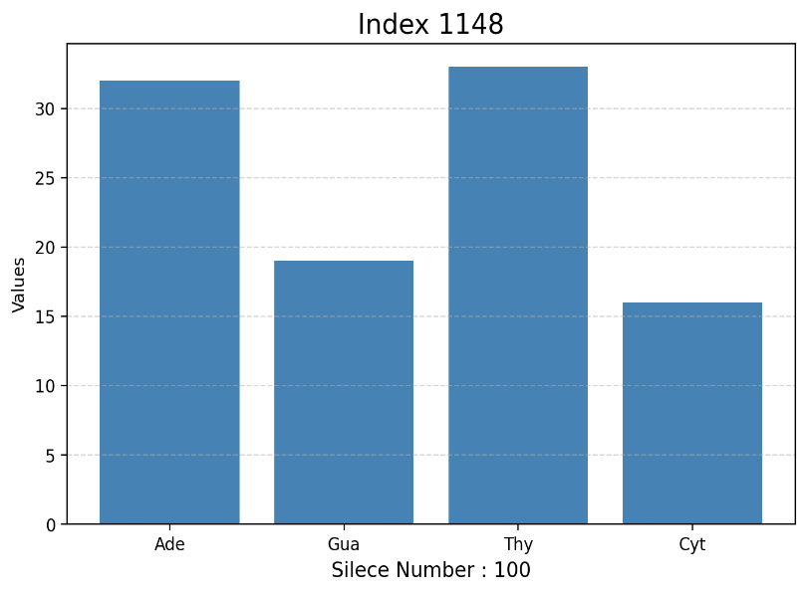
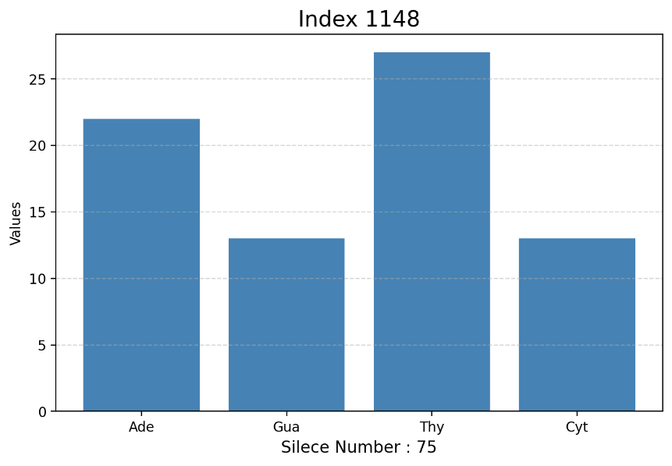
Figure 28 Index 1148 Silece 100 Histogam

Figure 27 Index 1148 Silece 75 Histogam
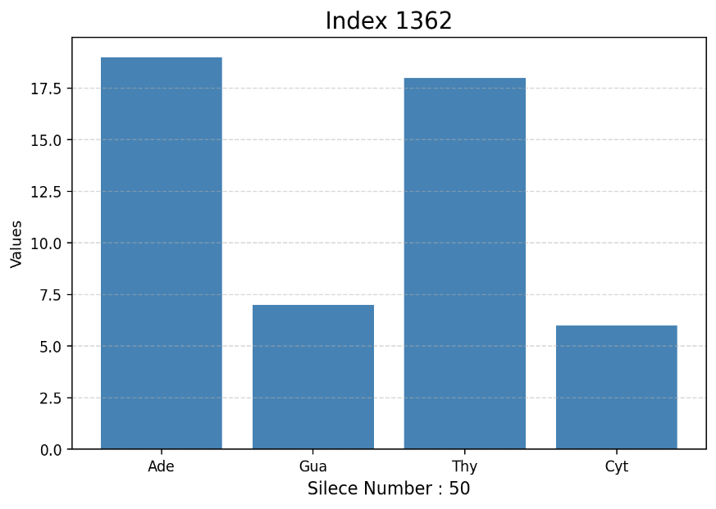
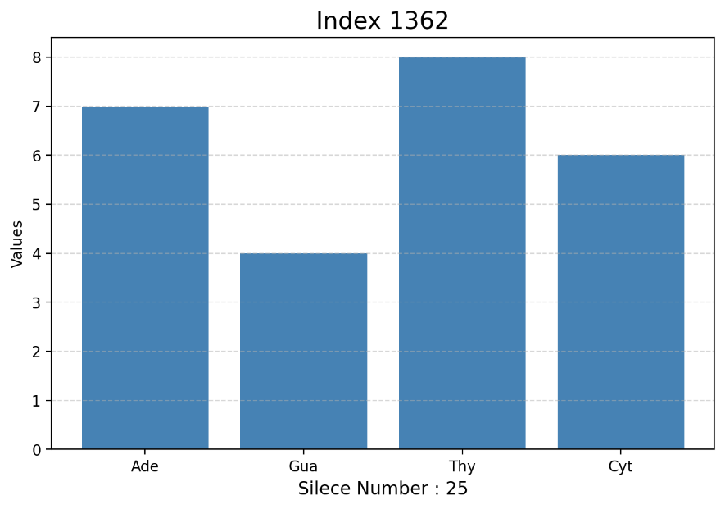
Figure 30 Index 1362 Silece 50 Histogam

Figure 29 Index 1362 Silece 25 Histogam
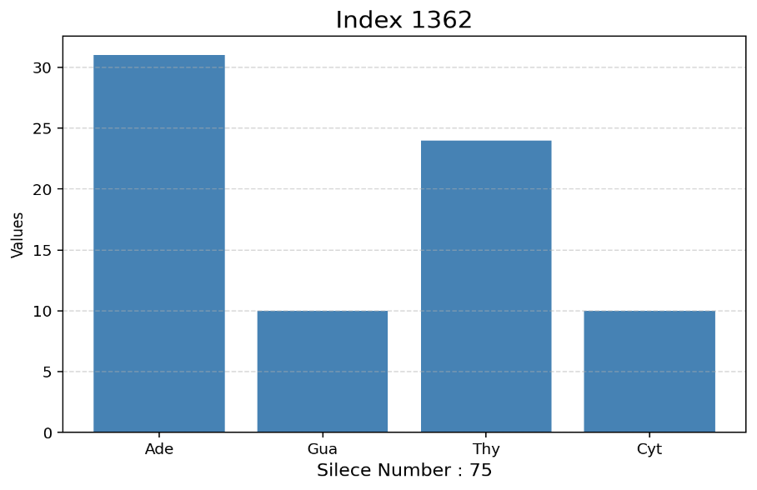
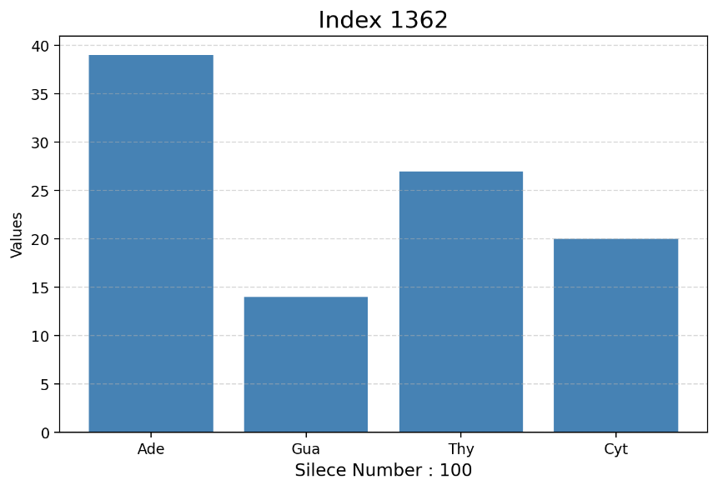
Figure 32 Index 1362 Silece 100 Histogam

Figure 31 Index 1362 Silece 75 Histogam
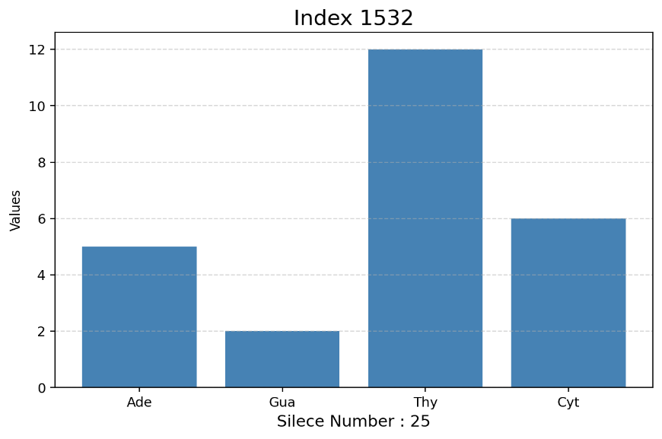
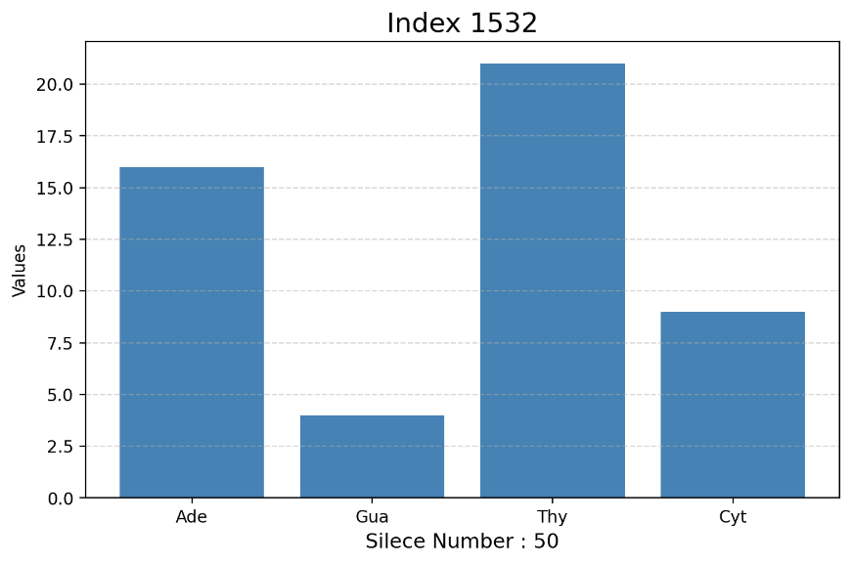
Figure 34 Index 1532 Silece 50 Histogam

Figure 33 Index 1532 Silece 25 Histogam

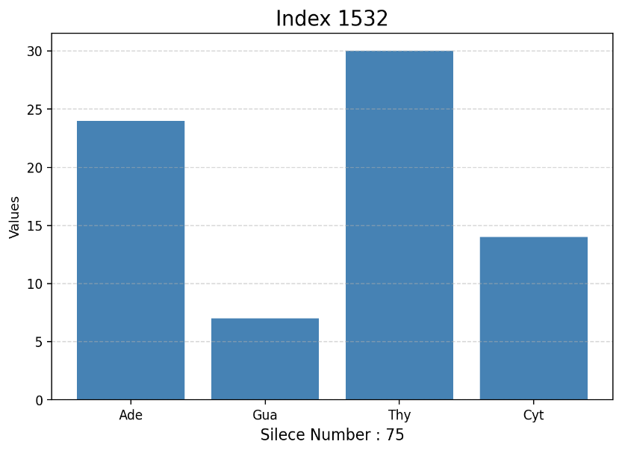
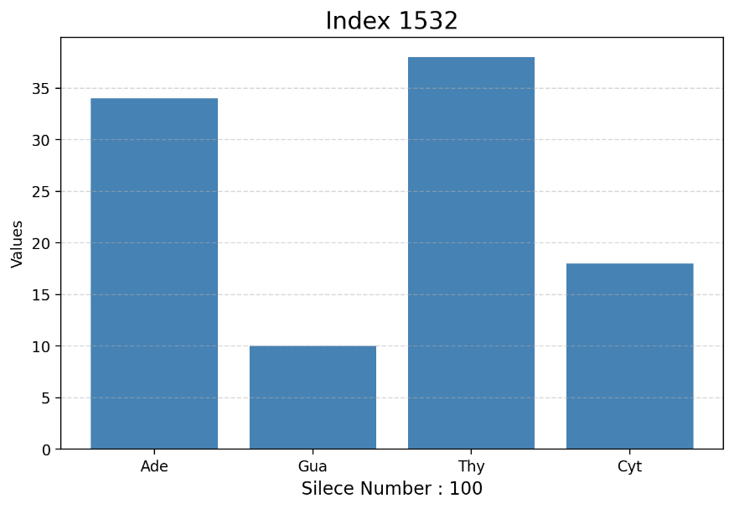
Figure 35 Index 1532 Silece 100 Histogram

Figure 36 Index 1532 Silece 75 Histogram

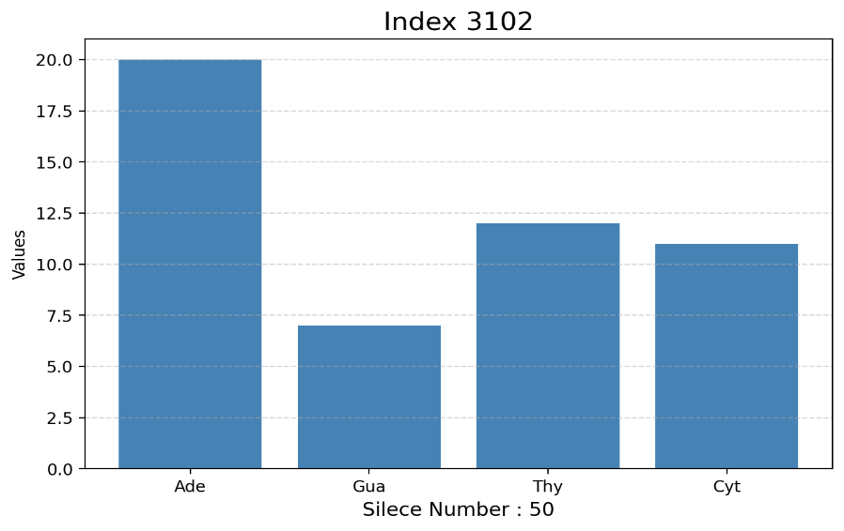
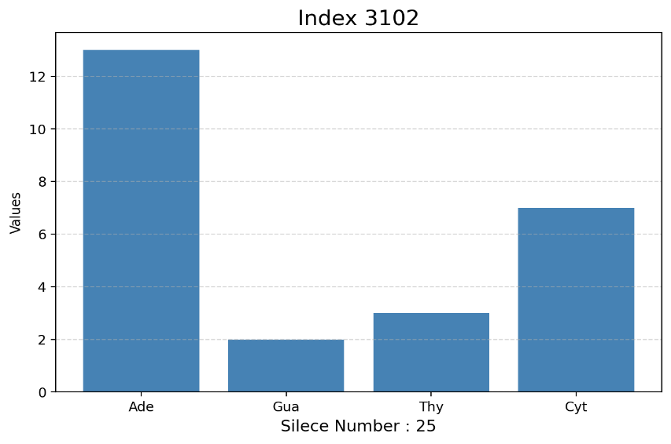
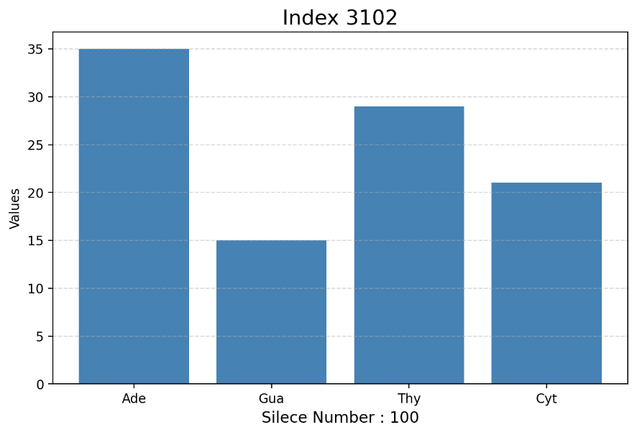
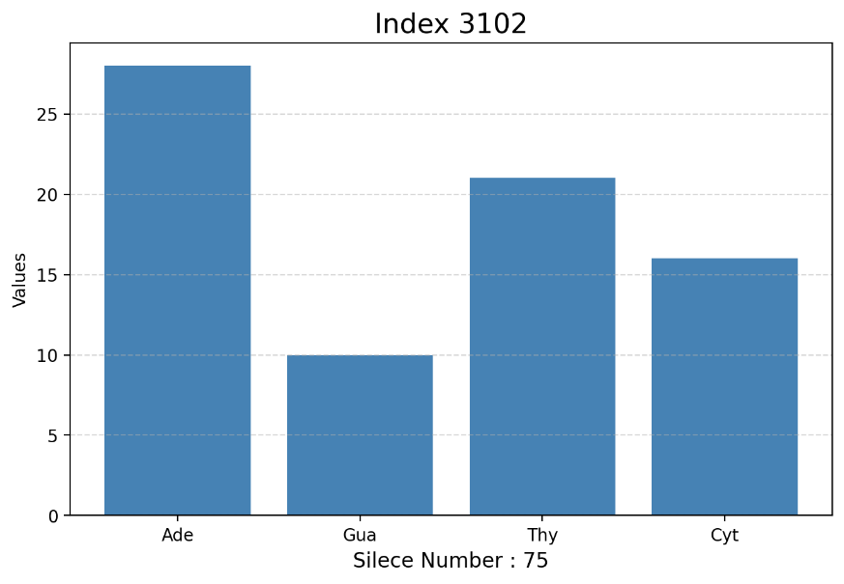
Figure 40 Index 3102 Silece 100 Histogram
Figure 38 Index 3102 Silece 50 Histogram
Figure 39 Index 3102 Silece 75 Histogram

Figure 37 Index 3102 Silece 25 Histogram

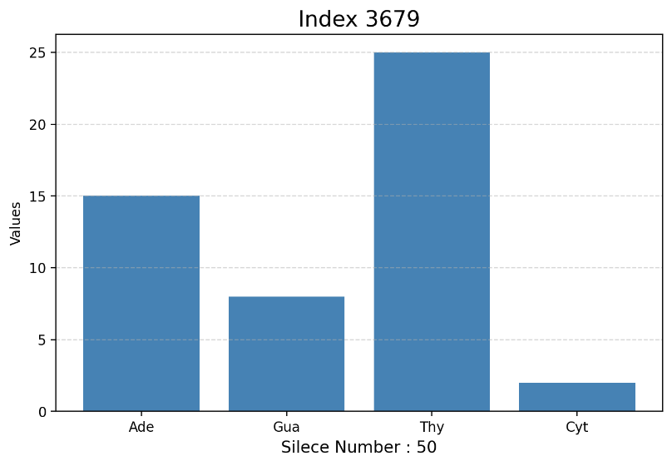
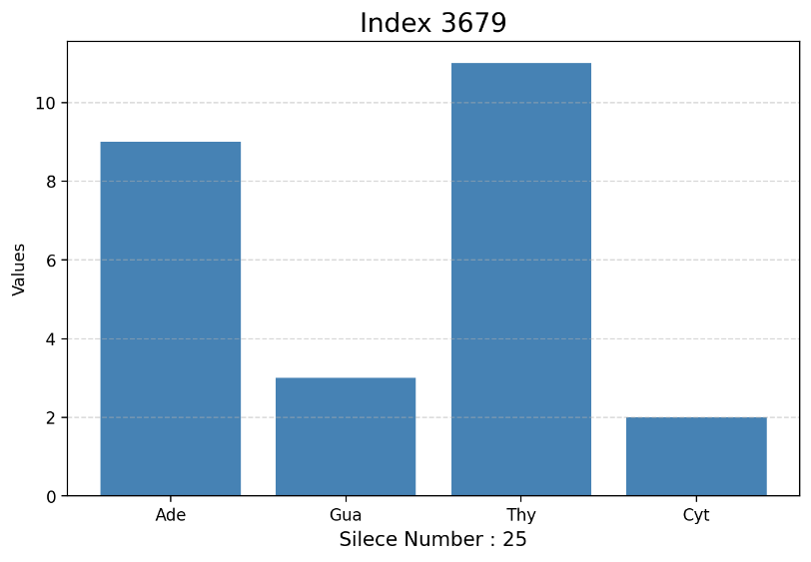
Figure 42 Index 3679 Silece 50 Histogram

Figure 41. Index 3679 Silece 25 Histogram
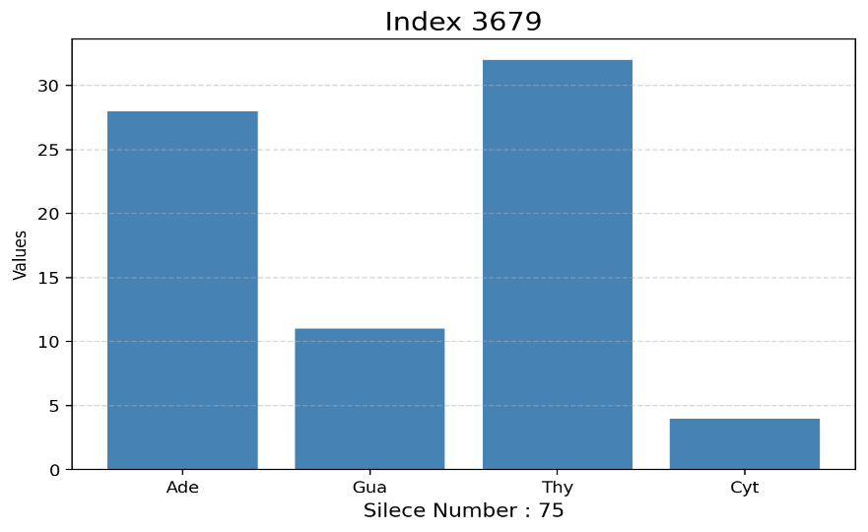
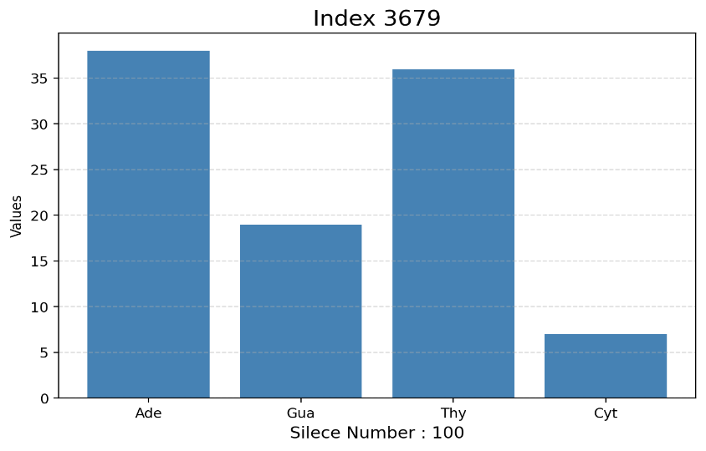
Figure 44 Index 3679 Silece 100 Histogram

Figure 43 Index 3679 Silece 75 Histogram
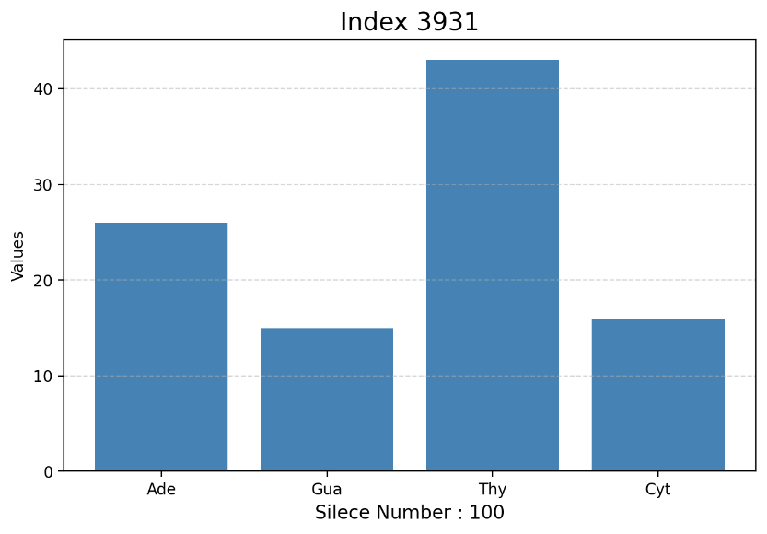
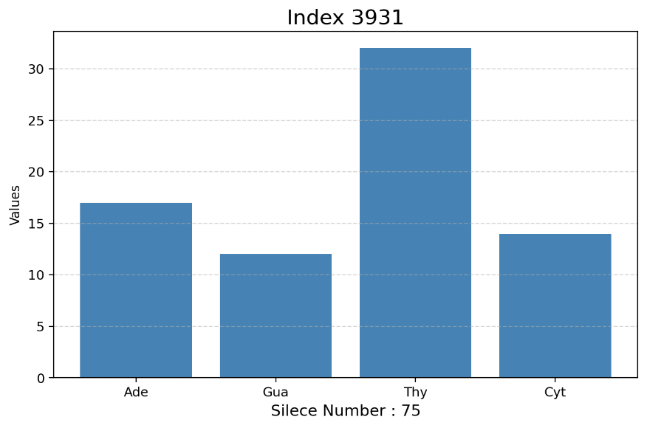
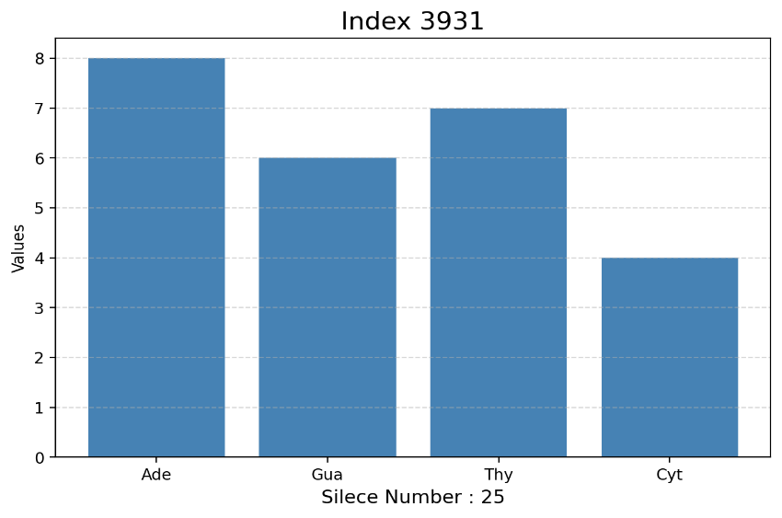
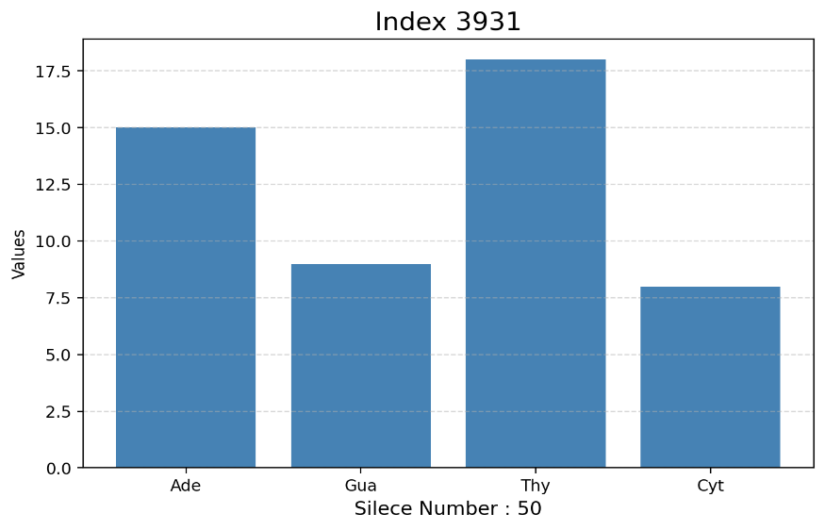
Figure 46 Index 3931 Silece 50 Histogram

Figure 45 Index 3931 Silece 25 Histogram
Figure 48 Index 3931 Silece 100 Histogram

Figure 47 Index 3931 Silece 75 Histogram
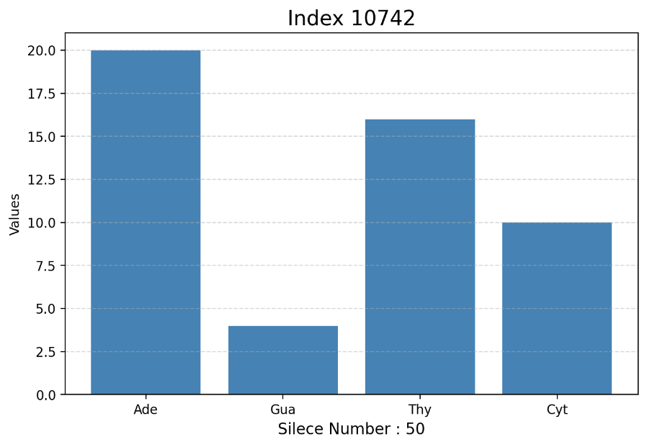
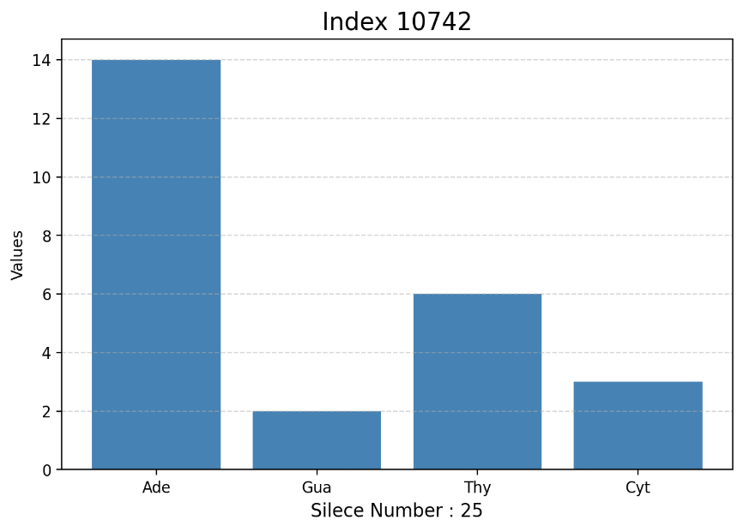
Figure 50 Index 10742 Silece 50 Histogram

Figure 49 Index 10742 Silece 25 Histogram
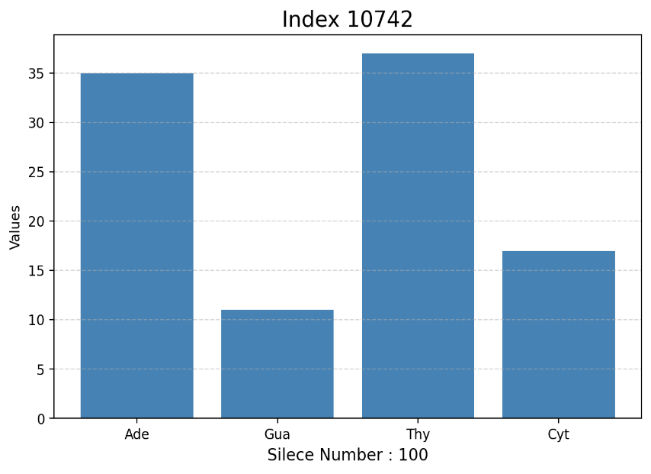
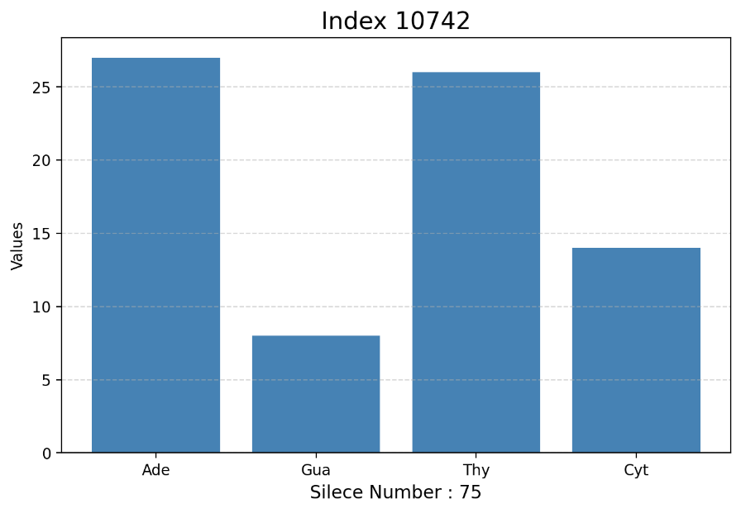
Figure 52 Index 10742 Silece 100 Histogram

Figure 51 Index 10742 Silece 75 Histogram
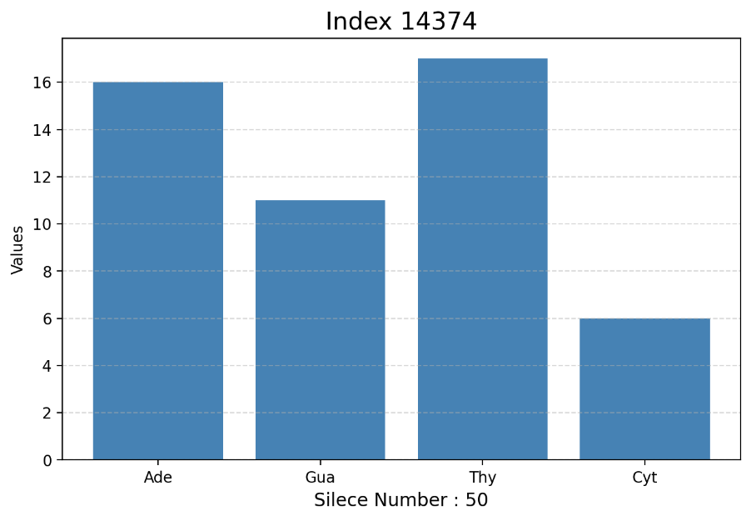
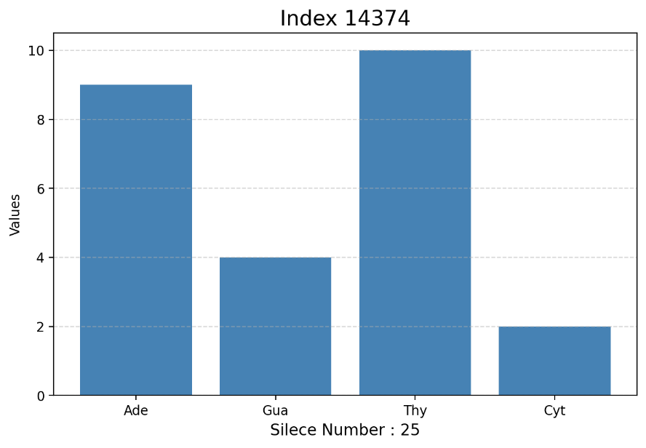
Figure 53 Index 14374 Silece 25 Histogram
Figure 54 Index 14374 Silece 50 Histogram

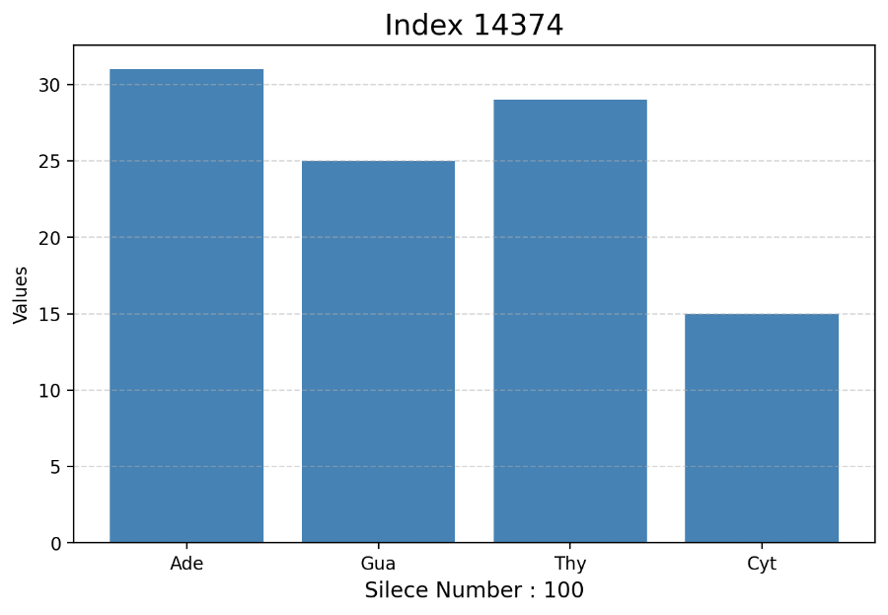
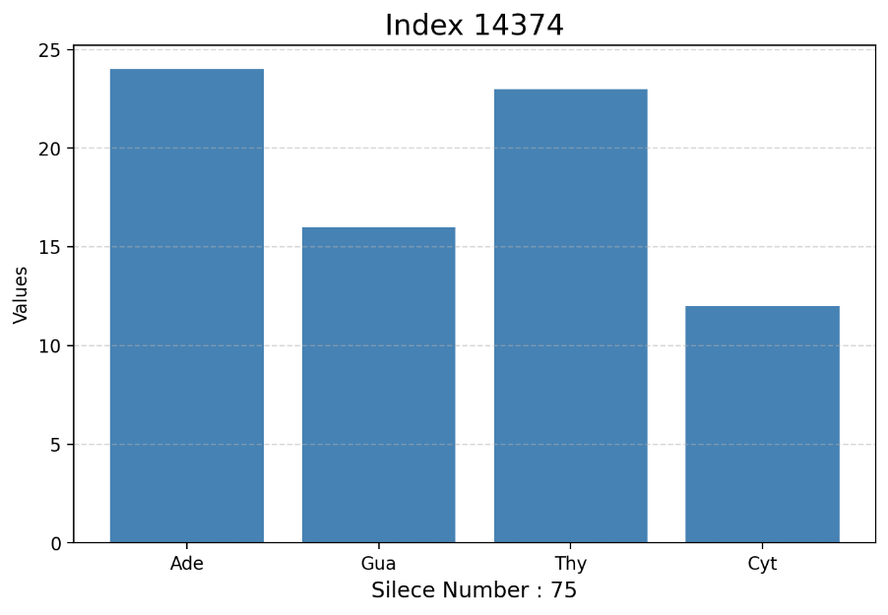
Figure 56 Index 14374 Silece 100 Histogram

Figure 55 Index 14374 Silece 75 Histogram
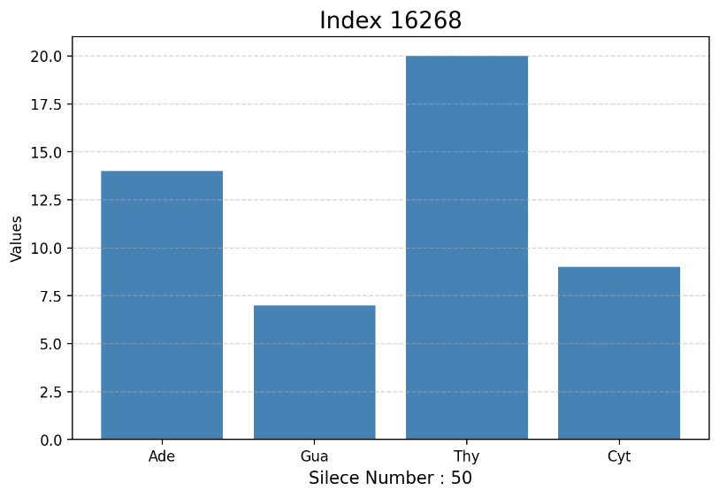
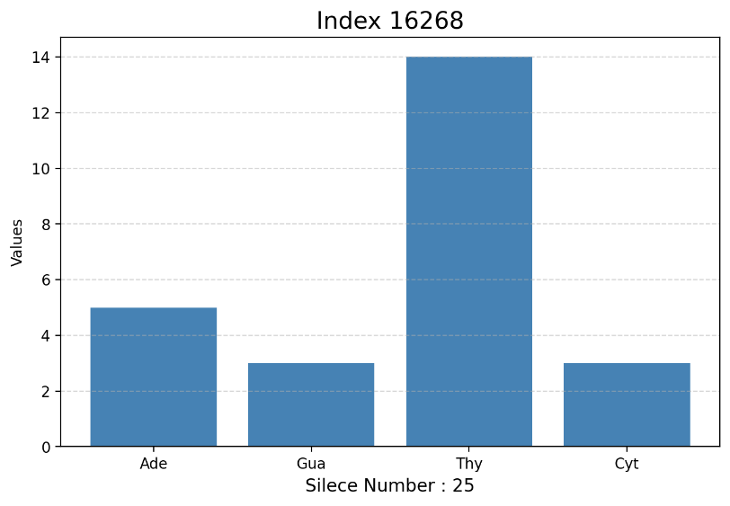
Figure 58 Index 16268 Silece 50 Histogram

Figure 57 Index 16268 Silece 25 Histogram
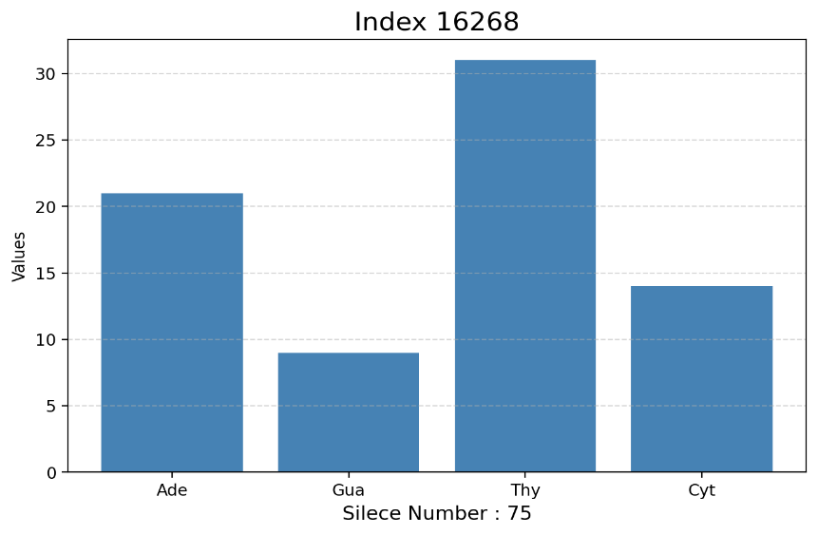
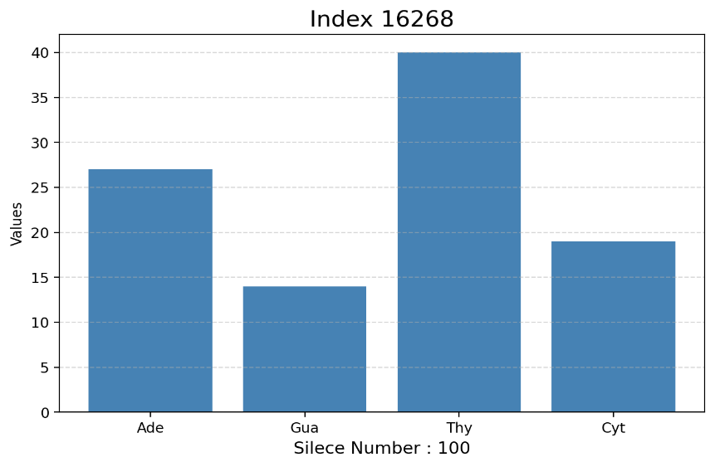
Figure 60 Index 16268 Silece 100 Histogram

Figure 59. Index 16268 Silece 75 Histogram
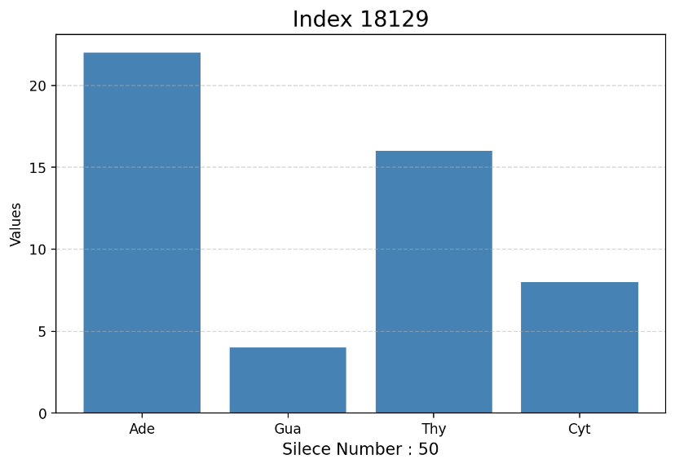
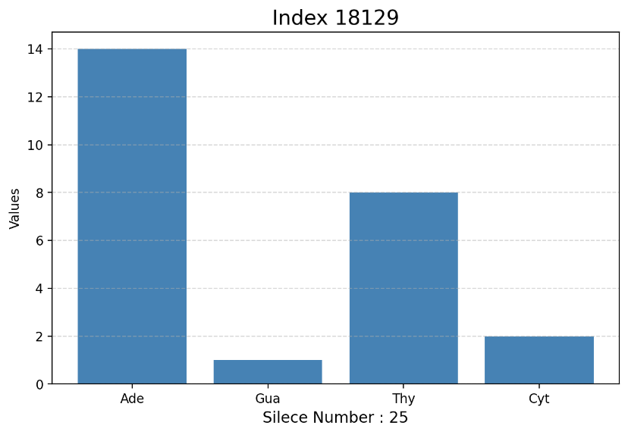
Figure 62 Index 18129 Silece 50 Histogram

Figure 61 Index 18129 Silece 25 Histogram
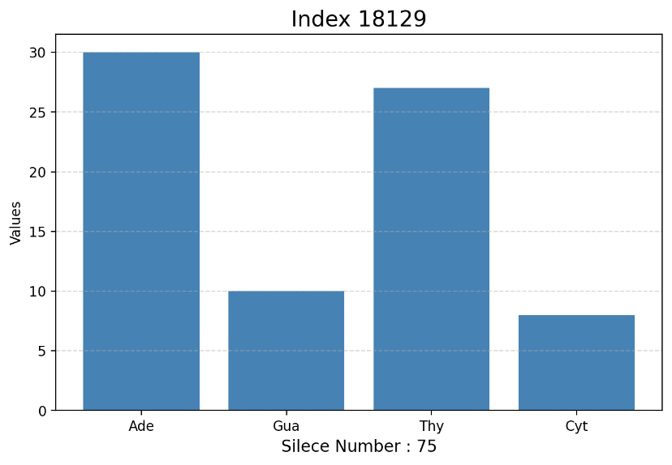
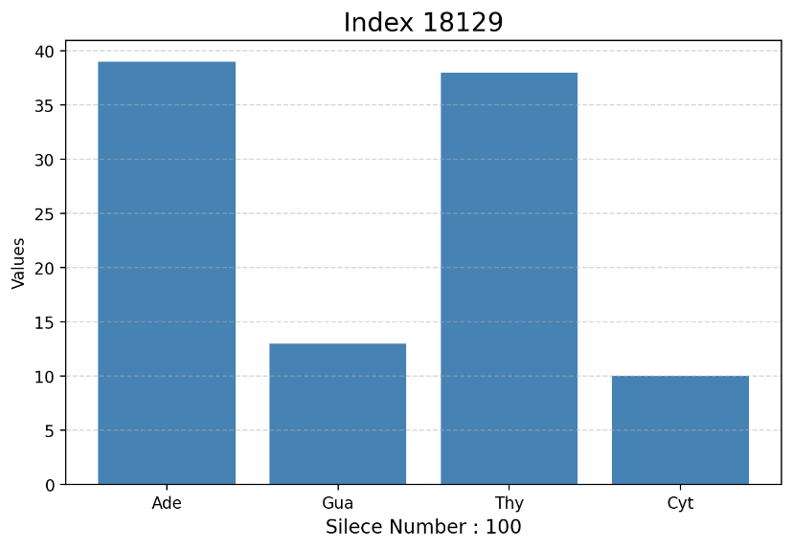
Figure 64 Index 18129 Silece 100 Histogram

Figure 63 Index 18129 Silece 75 Histogram

