

University of Birmingham

*Software Workshop - Team Project*

**Risk – The Game**

Assignment prepared by:

**Team Boston**

# Introduction

Risk, a Strategy game, based on the widely loved board game that focuses on one simple task: to take over the world. This is a very complex yet rewarding game that challenges players skill and luck. Every player participating in a game will attempt to take over the world, by taking over the world or eliminating all other players. A player can be eliminated if they have lost all their territories on the world map, meaning all their armies have been eliminated.

The general theme that we will follow in our game is a normal world map split into different countries. This is the most popular version of risk, which the team believes will create the most fun yet challenging game for the players.

# Basic Rules of Risk

The components of a basic Risk game:

## Table Top board

For our map, our team chose a standard world map, which will look as follows (Reference here);

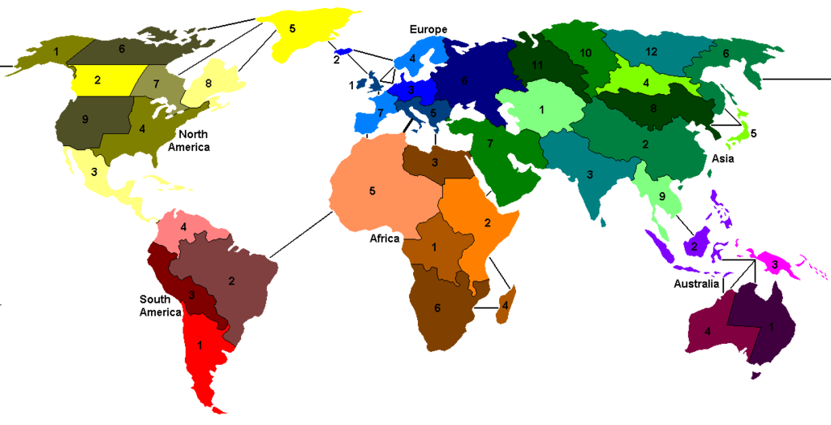

This is a normal map based on the current state of the world, with territories drawn within countries. This is the map design we will base the game on.

## Rules of the Game

Initially, our project will focus on letting two clients play a game of risk (our view is to scale up to eventually let multiple players play a game of Risk together) over the server. The game starts off with allocating a fixed number of troops to both players and having each select a territory to take in turns, depositing a single troop unit on it until all territories are taken. Thereafter, any number of the troops that are left over can be dropped off (still in turns) until every troop unit has been allocated a territory.

Then, the game truly commences, with each players’ turn following a DRAFT-ATTACK-FORTIFY structure.

### DRAFT

At the start of every turn, the player is allocated 3 additional troop unit for every territory owned with an extra amount of units depending on whether all the territories in a given continent are owned by the player. The player will have to allocate all given troops to owned territories in order to proceed.

### ATTACK

In order to take over territories, a player has to select a territory from which to attack and an adjacent opponent-owned territory to attack. The attacking territory must have at least 2 units in order to attack as a successful take over requires at least one unit to be left behind. For every attack, the attacking player attacks with either 1, 2 or 3 troops whilst the defending player defends with two troops (if available). Then dice rolls are used to decide who loses troops based on the number of troops used to attack/defend (the diagram shows the process, with the # of dice showing the # of troops allocated for the attack). If the attacker’s rolled number is greater than the defender’s number, then the defender loses a unit and vice versa in the opposite case.

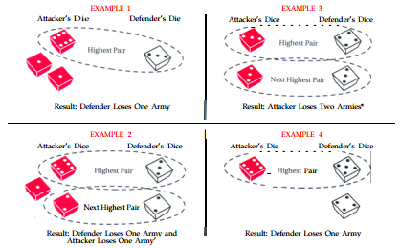

At the end of every attack, the player can decide to keep attacking the same territory, a different territory (either from the same territory or a different one), or to end the attack state of his turn.

### FORTIFY

The player has the option to send any number of troops from one owned territory to another owned territory, provided that at least one unit is left behind. Just like the attack state, the player has the option to not fortify. Regardless of his choice, the player’s turn ends and the above repeats for the opposing player.

This continues until a player either owns all territories or a player forfeits

## Simplifications

The game which we will be creating has had some modifications to the popular common version of Risk.

* ***Two players per game:*** The first modification which we have put into place are the number of players that will be able to play at the same time. Initially the teams goal is to create a game where two different users will be able to play at the same time, in order to meet specification of the game. However, we will build the game so that it will have the ability to expand, hence allowing multiple players to play at any single moment of time. However, this is an extra feature which we will implement if we get the time.
* ***No cards:*** Another modification is that our game will not be using cards. A game piece that is very common with most Risk games, however, our system does not require this features to let a user play. We also decided that these features would only add more cluster to the program, and would distract the player from the main goal of the game, to conquer the world.

# (Short) Specification of the client:

The user of our system should be able to:

1. Log in to our system:
   1. As a new user; by specifying their username and password.
   2. As an existing user; by logging in with their correct username and password.
2. Start a game:
   1. A new game
   2. Load an existing game
3. Connect to another player
4. Play the game against their connected player
   1. The user should be able to consistently play against another user until either:
      1. The user loses all their territories.
      2. The (opposing) other user loses all their territories.
      3. One of the users forfeits the game
5. Navigate the software adjusting the locations of their troops (within their allowable moves)

//This report is still being written – it will be completed and added to as we proceed over the remaining three weeks.

# Function Requirements

The **functional requirements** for our Risk game:

Gui:

1. The player should be able to log in with his username and password, where the password field is hidden.
2. The user should be able to click on the various territories on the world map
3. The user should be able to see his current orders; what the user is doing
4. The user should be able to see the territories that are owned by that user
5. User should also be able to see the territories owned by the player whom you are facing
6. The user should be able to set the number of available armies onto the different territories
7. The user should be able to view the current army on the map location and whether its possible for his army to move here
8. Should be able to see the turn number the user is on
9. User should be able to chat with the other user