1. After login component (Not developed)
2. Report Screen would be open up

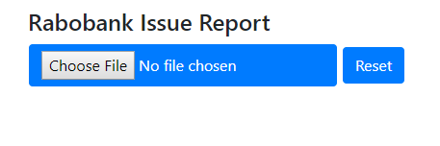

1. User can select .csv file , immediately report would be open

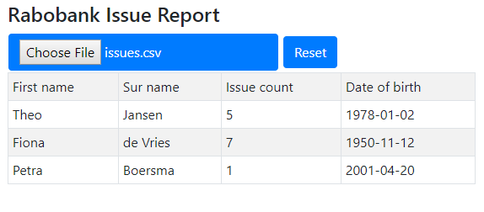

1. Sorting or filter functionality needs to implement.