Name: Mark D. Guanzon
Subject: CAPSTONE 2
Date: 12/1/2025
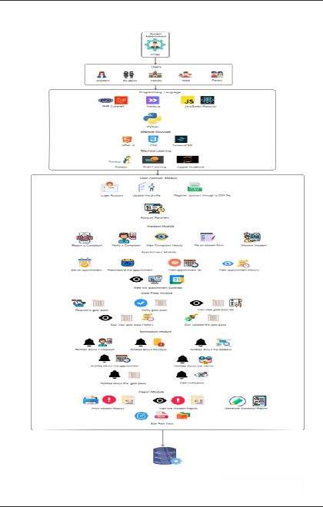

Name: Mark D. Guanzon
Subject: CAPSTONE 2
Date: 12/1/2025
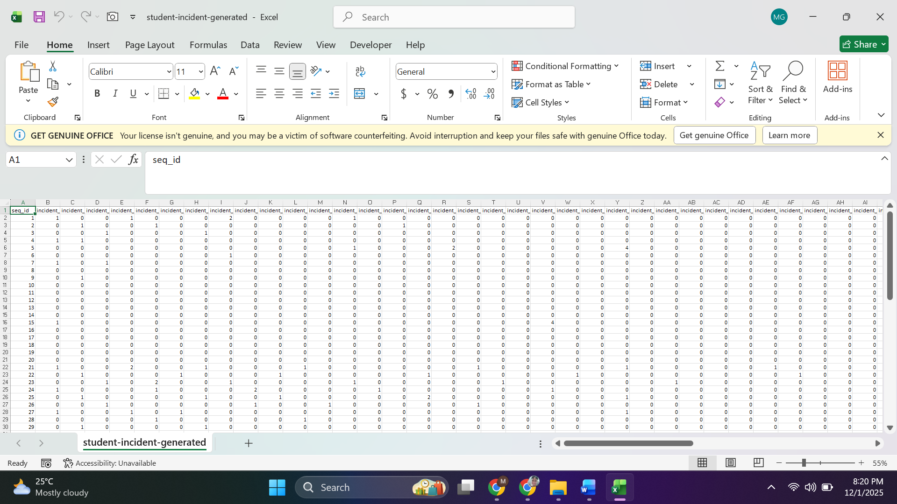

Name: Mark D. Guanzon
Subject: CAPSTONE 2
Date: 12/1/2025
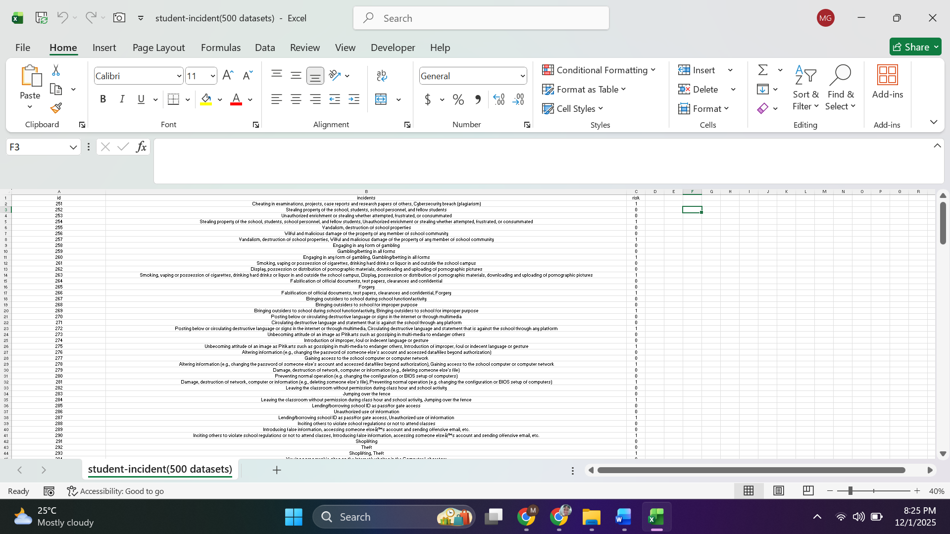

Name: Mark D. Guanzon
Subject: CAPSTONE 2
Date: 12/1/2025
