TABLE OF CONTENTS

No table of contents entries found.

Open Source FEA using adapy
This report describes the main verification work of the simulation results produced by the Open Source Finite Element (FE) solvers Code Aster and Calculix.
The motivation behind producing this report is to increase confidence in the conversion of FEM models in adapy and also the results from the various FEA solvers.

Introduction
The results from Code Aster and Calculix and tools will be compared with proprietary FEA solvers such as;
- Abaqus
- Sestra (part of DNV’s Sesam suite)
The simulations are pre- and post processed using adapy and this report is automatically generated using paradoc as part of a ci/cd pipeline within the adapy repositories.
For each new addition of code affecting the handling of FEM in adapy a new set of analyses is performed, whereas the results are gathered in this auto-generated document.
Please note! This report will not go into detail into the specifics of why the results are different between different element representations. This report will only investigate and compare the results from different FEA software.

FEA Solvers
- Calculix v2.23
- Code Aster v18.1.7
- Abaqus v2025
- Sestra v11.3.1.0

Python packages
The following python packages were instrumental in the creation of this document and the FEA results herein.

Adapy
The intention behind adapy is to make it easier to work with finite element models and BIM models and act as a high-level scripting library for parametric and procedural modelling techniques.

Paradoc
paradoc was created to simplify the generation of reports by creating the structure of the document and text in markdown with a string substitution scheme that lets you easily pass in tables, functions and finally be able to produce production ready documents in Microsoft Word.

Summary
A summary of all performed analyses will be performed in this section and a percentage difference for each FEA solver per type of analysis will be calculated and presented.

Analyses

Eigenvalue Analysis
A simple cantilevered beam is subjected to eigenvalue analysis with a total of 11 eigenmodes requested. 47 cases are compared across solvers: abaqus, calculix, code_aster, sesam.
The beam model will be analyzed by varying the following parameters:
- Mesh type (Solid, Shell, Line)
- Mesh element types (TET, HEX, TRI, QUAD)
- Mesh element order (1st and 2nd order)
- Reduced integration elements (R)
- Different FEA solvers (Calculix, Code Aster, Abaqus, Sesam)

Model Description
Property | Value
Description | Beam(“MyBeam”, [0.0, 0.5, 0.5], [3.0, 0.5, 0.5], “IPE400”, “S420”)
Length | 3.00 m
Section | IPE400
Material | S420
Young’s modulus | 2.100e+11 Pa
Yield stress | 4.200e+08 Pa
Density | 7850 kg/m³
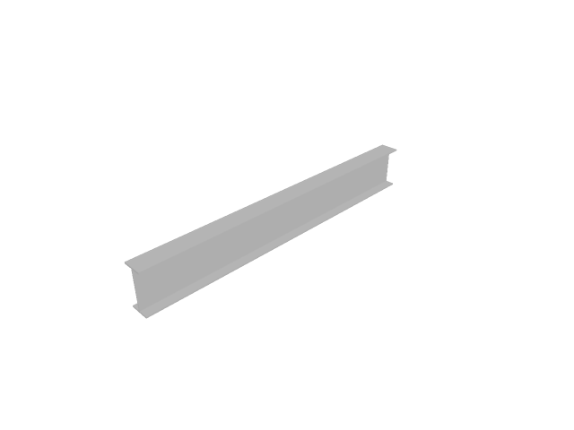
Figure 1: Cantilever beam geometry.

Summary
This section presents a comparison between the calculated results from the eigenvalue analysis of a cantilever beam using the different FEA tools.
Note! The Sestra and Abaqus analyses are not performed as part of the github actions step. The eigenmode results are kept in cached json files and imported during the compilation of the report using paradoc.

Eigenfrequency vs. mode number
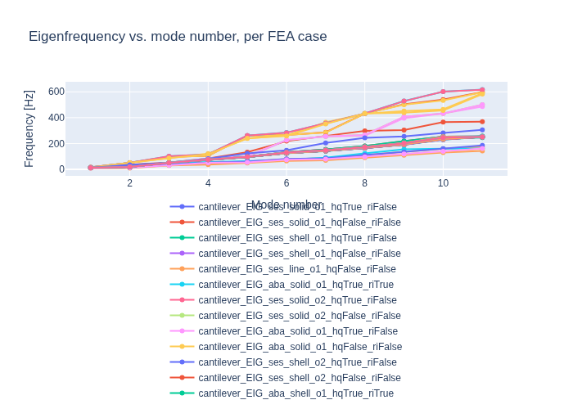
Figure 2: Eigenfrequency vs. mode number across FEA cases.

Comparison tables
Columns are sortable; the table grammar {tbl:sortby:Mode:asc;index:no} sets the initial sort and hides the index column.
Table 1-1: Eigenfrequency comparison (Hz) — solid, 1st order.
Mode | ses_HEX | ses_TET | aba_HEXR | aba_HEX | aba_TET | ccx_TET | ca_TET | ccx_HEX | ca_HEX | ccx_HEXR | ca_HEXR
1 | 12.9766 | 15.7932 | 12.514 | 13.435 | 15.79 | 15.9285 | 15.9277 | 13.6205 | 13.6205 | 14.3018 | 13.5291
2 | 20.3015 | 51.5418 | 34.157 | 20.731 | 51.532 | 51.5896 | 51.5872 | 21.0685 | 21.0685 | 51.6653 | 34.7401
3 | 50.6181 | 97.7314 | 49.598 | 50.678 | 97.588 | 102.446 | 102.41 | 50.8252 | 50.8252 | 88.2331 | 50.7365
4 | 77.3921 | 105.691 | 55.271 | 82.799 | 104.8 | 116.744 | 116.512 | 84.066 | 84.066 | 116.873 | 82.2962
5 | 98.1185 | 260.887 | 64.305 | 100.19 | 260.59 | 261.877 | 261.806 | 102.334 | 102.334 | 240.766 | 123.303
6 | 133.016 | 267.131 | 74.866 | 223.14 | 266.26 | 284.697 | 284.465 | 227.25 | 227.25 | 258.286 | 147.139
7 | 153.833 | 287.461 | 90.033 | 254.98 | 285.05 | 357.062 | 356.306 | 255.872 | 255.872 | 351.823 | 205.267
8 | 178.565 | 432.347 | 124.58 | 260.1 | 432.31 | 432.36 | 432.35 | 266.519 | 266.519 | 431.955 | 243.985
9 | 214.689 | 503.862 | 155.99 | 396.57 | 500.86 | 529.297 | 528.489 | 407.869 | 407.869 | 439.038 | 254.838
10 | 253.463 | 539.506 | 159.95 | 431.8 | 534.26 | 601.943 | 601.586 | 432.207 | 432.207 | 456.762 | 282.888
11 | 256.05 | 598.2 | 162.56 | 486.96 | 596.78 | 617.646 | 616.155 | 500.931 | 500.931 | 582.562 | 305.247

Table 1-1: Eigenfrequency comparison (Hz) — solid, 2nd order.
Mode | ses_HEX | ses_TET | aba_HEXR | aba_HEX | aba_TET | ccx_TET | ca_TET | ccx_HEX | ca_HEX | ccx_HEXR | ca_HEXR
1 | 12.9541 | 12.9537 | 12.943 | 12.955 | 12.954 | 12.9542 | 12.9542 | 12.9551 | 12.9551 | 12.9428 | 12.9427
2 | 20.0445 | 20.2945 | 20.029 | 20.15 | 20.294 | 20.2876 | 20.2877 | 20.1503 | 20.1503 | 20.0288 | 20.0288
3 | 50.5342 | 50.5401 | 50.498 | 50.541 | 50.54 | 50.5401 | 50.5402 | 50.5412 | 50.5412 | 50.4977 | 50.4977
4 | 76.7467 | 77.1278 | 76.687 | 76.89 | 77.128 | 77.2297 | 77.2297 | 76.8903 | 76.8903 | 76.6876 | 76.6875
5 | 97.4723 | 97.8296 | 97.391 | 97.594 | 97.83 | 97.8506 | 97.8505 | 97.5939 | 97.5939 | 97.3913 | 97.3912
6 | 130.865 | 132.478 | 130.81 | 131.37 | 132.48 | 133.015 | 133.014 | 131.365 | 131.365 | 130.814 | 130.809
7 | 148.496 | 153.631 | 148.47 | 149.96 | 153.63 | 154.804 | 154.802 | 149.958 | 149.958 | 148.478 | 148.474
8 | 172.243 | 178.114 | 172.17 | 173.92 | 178.12 | 181.029 | 181.026 | 173.925 | 173.925 | 172.177 | 172.171
9 | 201.904 | 215.815 | 201.84 | 205.29 | 215.82 | 219.501 | 219.497 | 205.292 | 205.292 | 201.846 | 201.839
10 | 246.353 | 253.203 | 246.17 | 251.35 | 253.2 | 253.193 | 253.193 | 251.347 | 251.347 | 246.177 | 246.165
11 | 252.742 | 254.466 | 252.57 | 252.92 | 254.47 | 254.685 | 254.684 | 252.917 | 252.917 | 252.573 | 252.573

Table 1-1: Eigenfrequency comparison (Hz) — shell, 1st order.
Mode | ses_QUAD | ses_TRI | aba_QUADR | aba_QUAD | aba_TRIR | ccx_TRI | ca_TRI | ccx_QUAD | ca_QUAD | ccx_QUADR
1 | 12.7628 | 13.6414 | 12.373 | 12.78 | 13.6869 | 13.7254 | 13.642 | 12.7639 | 13.1463 | 14.2558
2 | 19.3943 | 20.1983 | 19.23 | 19.593 | 20.3643 | 36.6896 | 20.4181 | 19.6304 | 19.9719 | 53.2618
3 | 51.9912 | 52.1922 | 51.849 | 51.998 | 52.1874 | 52.2485 | 52.1927 | 51.9997 | 52.0595 | 87.9153
4 | 75.1918 | 79.5226 | 73.558 | 75.683 | 80.2058 | 83.7093 | 79.6596 | 75.4574 | 77.2361 | 121.85
5 | 95.9297 | 101.756 | 93.709 | 96.393 | 102.043 | 132.928 | 102.01 | 96.2959 | 98.7619 | 239.804
6 | 125.116 | 125.093 | 126.87 | 126.96 | 124.093 | 218.167 | 125.459 | 125.898 | 125.442 | 262.83
7 | 141.556 | 143.164 | 144.58 | 145.57 | 145.486 | 259.245 | 144.895 | 145.282 | 143.864 | 365.1
8 | 165.03 | 166.668 | 168.38 | 169.39 | 168.62 | 297.856 | 168.951 | 169.441 | 167.974 | 431.774
9 | 190.099 | 191.533 | 197.51 | 198.75 | 199.719 | 304.464 | 195.184 | 200.494 | 193.96 | 451.745
10 | 229.46 | 230.489 | 241.27 | 242.55 | 242.995 | 365.943 | 235.115 | 247.276 | 233.817 | 464.44
11 | 250.786 | 257.362 | 245.07 | 252.49 | 257.447 | 368.764 | 257.409 | 251.554 | 257.105 | 589.24

Table 1-1: Eigenfrequency comparison (Hz) — shell, 2nd order.
Mode | ses_QUAD | ses_TRI | aba_QUADR | aba_QUAD | aba_TRI | ccx_TRI | ca_TRI | ccx_QUAD | ca_QUAD | ccx_QUADR
1 | 12.7554 | 12.7558 | 12.758 | 12.758 | 12.756 | 12.7562 | 12.7566 | 12.7576 | 12.7561 | 12.7559
2 | 19.4731 | 19.5048 | 19.486 | 19.486 | 19.567 | 19.5254 | 19.4509 | 19.5638 | 19.4736 | 19.5021
3 | 51.9702 | 51.9704 | 51.998 | 51.998 | 51.969 | 51.974 | 51.97 | 51.9801 | 51.97 | 51.9741
4 | 75.1245 | 75.1716 | 75.149 | 75.149 | 75.145 | 75.1848 | 75.1443 | 75.2685 | 75.1252 | 75.1399
5 | 95.8886 | 95.9337 | 95.92 | 95.92 | 96.001 | 95.9713 | 95.8707 | 96.0372 | 95.8893 | 95.9349
6 | 124.987 | 125.173 | 125 | 125 | 125.21 | 125.465 | 125.087 | 125.889 | 124.987 | 125.257
7 | 142.234 | 142.768 | 142.32 | 142.32 | 142.77 | 142.995 | 142.359 | 143.72 | 142.233 | 142.497
8 | 165.718 | 166.334 | 165.85 | 165.85 | 166.6 | 166.579 | 165.79 | 167.347 | 165.719 | 165.981
9 | 191.999 | 193.308 | 192.18 | 192.18 | 192.84 | 194.014 | 192.406 | 195.577 | 191.998 | 192.87
10 | 232.626 | 234.613 | 232.87 | 232.87 | 233.36 | 236.042 | 233.389 | 238.389 | 232.628 | 234.347
11 | 250.095 | 250.24 | 250.17 | 250.17 | 250.13 | 250.287 | 250.175 | 250.521 | 250.096 | 250.147

Table 1-1: Eigenfrequency comparison (Hz) — line, 1st order.
Mode | ses | aba | ca
1 | 12.2454 | 10.785 | 12.2454
2 | 12.9431 | 12.928 | 12.9793
3 | 36.7525 | 32.342 | 36.7525
4 | 44.9622 | 50.543 | 52.9559
5 | 61.3087 | 53.855 | 61.3087
6 | 79.793 | 75.296 | 81.3401
7 | 85.9466 | 79.59 | 85.9466
8 | 110.699 | 96.637 | 110.699
9 | 135.6 | 117.85 | 135.6
10 | 160.681 | 138.9 | 160.681
11 | 176.495 | 159.77 | 185.976

Table 1-1: Eigenfrequency comparison (Hz) — line, 2nd order.
Mode | ses | aba
1 | 10.039 | 10.786
2 | 10.6144 | 12.932
3 | 30.1078 | 32.358
4 | 36.752 | 50.557
5 | 50.1488 | 53.93
6 | 65.3265 | 75.502
7 | 70.1429 | 79.684
8 | 90.0695 | 97.074
9 | 109.907 | 118.65
10 | 129.631 | 140.22
11 | 142.572 | 161.8

Effective modal mass
Effective modal mass [kg] per case, summed over the captured modes in the global X / Y / Z directions. Every solver reports it; Code Aster and Sesam give translational mass only. Summing over enough modes approaches the structure’s total mass in each direction.
Table 1-1: Effective modal mass [kg] per case, summed over the captured modes in the global X/Y/Z directions. Code_Aster and Sesam report translational effective mass only.
Case | Modes | ΣMeff X | ΣMeff Y | ΣMeff Z
aba_line_o1 | 11 | 0 | 152.8 | 118.2
aba_line_o2 | 11 | 0 | 152.8 | 118.2
aba_shell_o1_QUAD | 11 | 0 | 168 | 122
aba_shell_o1_QUADR | 11 | 0 | 168.4 | 122
aba_shell_o2_QUAD | 11 | 0 | 167.8 | 122
aba_shell_o2_QUADR | 11 | 0 | 167.8 | 122
aba_shell_o2_TRI | 11 | 0 | 167.9 | 122
aba_solid_o1_HEX | 11 | 153.5 | 170.5 | 158.2
aba_solid_o1_HEXR | 11 | 0 | 154.3 | 119
aba_solid_o1_TET | 11 | 153.4 | 172 | 170.9
aba_solid_o2_HEX | 11 | 0 | 163.3 | 158.6
aba_solid_o2_HEXR | 11 | 0 | 163.2 | 158.7
aba_solid_o2_TET | 11 | 0 | 162 | 158.6
ca_line_o1 | 11 | 0 | 152.3 | 116.5
ca_shell_o1_QUAD | 11 | 0 | 167.6 | 163.7
ca_shell_o1_TRI | 11 | 0 | 167.3 | 163.7
ca_shell_o2_QUAD | 11 | 0 | 167.8 | 122
ca_shell_o2_TRI | 11 | 0 | 167.8 | 122
ca_solid_o1_HEX | 11 | 153.5 | 170.8 | 158.3
ca_solid_o1_HEXR | 11 | 0 | 164.7 | 158.5
ca_solid_o1_TET | 11 | 153.4 | 172.6 | 171
ca_solid_o2_HEX | 11 | 0 | 163.3 | 158.6
ca_solid_o2_HEXR | 11 | 0 | 163.2 | 158.7
ca_solid_o2_TET | 11 | 0 | 162.2 | 158.6
ccx_shell_o1_QUAD | 11 | 0 | 168.1 | 122
ccx_shell_o1_QUADR | 11 | 158 | 176.8 | 176.5
ccx_shell_o1_TRI | 11 | 0 | 174.8 | 163.6
ccx_shell_o2_QUAD | 11 | 0 | 167.8 | 122
ccx_shell_o2_QUADR | 11 | 0 | 167.8 | 122
ccx_shell_o2_TRI | 11 | 0 | 167.8 | 122
ccx_solid_o1_HEX | 11 | 153.4 | 170.7 | 158.2
ccx_solid_o1_HEXR | 11 | 153.5 | 171.8 | 171.3
ccx_solid_o1_TET | 11 | 153.4 | 172.6 | 171
ccx_solid_o2_HEX | 11 | 0 | 163.3 | 158.6
ccx_solid_o2_HEXR | 11 | 0 | 163.2 | 158.7
ccx_solid_o2_TET | 11 | 0 | 162.2 | 158.6
ses_line_o1 | 11 | 0 | 153 | 166.4
ses_line_o2 | 11 | 0 | 231.8 | 252.3
ses_shell_o1_QUAD | 11 | 0 | 167.6 | 122
ses_shell_o1_TRI | 11 | 0 | 167.1 | 163.6
ses_shell_o2_QUAD | 11 | 0 | 167.8 | 122
ses_shell_o2_TRI | 11 | 0 | 167.9 | 122
ses_solid_o1_HEX | 11 | 0 | 161.7 | 158.6
ses_solid_o1_TET | 11 | 153.4 | 172.1 | 170.9
ses_solid_o2_HEX | 11 | 0 | 163.1 | 158.7
ses_solid_o2_TET | 11 | 0 | 162 | 158.6
The per-mode effective masses and participation factors, compared across solvers for every mesh configuration, are in the appendix.
Short description:
Fem formats
- ccx: Calculix
- ca: Code Aster
- ses: Sesam
- aba: Abaqus
Element Types
- TET: Tetrahedrons
- HEX: Hexahedrons
- TRI: Triangle
- QUAD: Quadrilateral
Reduced Integration
All element types ending with capital R (QUADR, HEXR etc.) are reduced integration elements.

Nonlinear Analysis
A simple cantilever beam with a series of cutouts is subjugated to a large vertical acceleration field. The level of plastic strains are monitored for comparison across different FE tools.

Model Description

Summary

Plate Analysis
The analyses above are one beam, in three representations. This section is the plate case: an ada.Plate object, meshed into shell elements by adapy’s own meshing module, written out as an input deck per solver, and checked against a closed form as well as against the other solvers.
Nothing here drives a solver through its API. Each solver reads a file adapy wrote — an .inp, a .fem, a .comm/.med — which is the same route a user’s own model takes, so what this section verifies is the thing adapy actually ships.
9 cases ran on the machine that built this report, using: calculix, code_aster. The remaining columns come from cached results measured elsewhere, the same arrangement the eigenvalue section uses for Abaqus and Sestra.

Model Description
A rectangular strip, simply supported on its two short edges and held in cylindrical bending on the two long ones, under a uniform surface pressure.
Property | Value
Span | 4.00 m
Width | 0.50 m
Thickness | 0.010 m
Pressure | 1000 Pa
Material | S355 (E = 210 GPa, ν = 0.3, ρ = 7850 kg/m³)
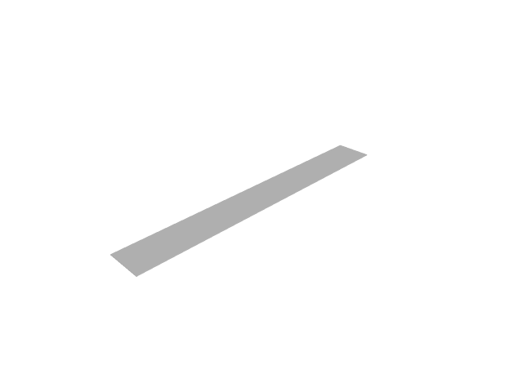
Figure 1: Plate strip geometry.
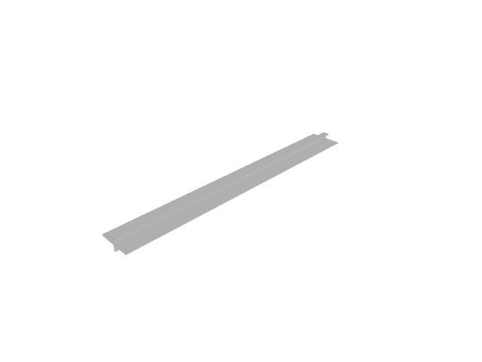
Figure 2: Plate strip with a T-profile stiffener on its centreline.
The span-to-thickness ratio is 400, so transverse shear sits several orders below the discretisation error and the thin-plate closed forms are the right reference rather than an approximation of one.
The supports are written as four node sets rather than one per edge. Simple support and cylindrical bending overlap at the four corners, and the obvious spelling constrains u2 twice there: Abaqus and Sestra accept that, while Code_Aster refuses it outright (<ASSEMBLA_26> … est bloqué plusieurs fois). A model that only some solvers will read is not a cross-solver case, so the corner nodes carry only the rotation the long edges add.

Static analysis under pressure
The static case is the only one that reaches the distributed-load records — Abaqus’ *Dsload, Calculix’ *DLOAD, Code_Aster’s FORCE_COQUE and Sesam’s BEUSLO. The eigenvalue analyses reach the mass and stiffness matrices and nothing else, so a pressure written wrongly is invisible to them.
Mid-span deflection against the closed form 5 q L⁴ / (384 D), with D = E t³ / (12 (1 − ν²)) — which evaluates to 0.173333 m for this strip. Halving the seed should quarter the remaining error; the three rows are a factor of two apart so the order is readable off the table rather than asserted.
Table 1-1: Plate strip mid-span deflection [m] under 1 kPa, by solver and mesh seed. The closed form is 5 q L^4 / (384 D) for a strip in cylindrical bending.
Seed [m] | aba | ca | ccx | ses | closed form
0.125 | 0.173065 | 0.173198 | 0.173065 | 0.173198 | 0.173333
0.0625 | 0.173269 | 0.173299 | 0.173268 | 0.173299 | 0.173333
0.03125 | 0.173319 | 0.173325 | 0.173319 | 0.173325 | 0.173333
The same strip with a T-profile stiffener along its centreline, meshed as line elements sharing the shells’ nodes. There is no closed form for it — a parallel-spring estimate is not one — so this is an agreement case between solvers, and it is what carries a T section through the deck writers.
Table 1-1: The same strip with a T-profile stiffener on its centreline [m]. No closed form: this is a cross-solver agreement case.
Seed [m] | aba_st | ca_st | ses_st
0.125 | 0.000584531 | 0.000710295 | 0.00073971
0.0625 | 0.000585478 | 0.000710711 | 0.000738964
0.03125 | 0.000585996 | 0.000710815 | 0.000736999

Sign convention
Every writer above places a positive pressure so that it pushes into the face it names. That is Abaqus’ convention, and it has to be shared, because a load direction that depends on the output format makes a cross-solver comparison meaningless.
It is worth stating which face that is, because it is not a global direction: gmsh winds every element of this strip with its normal along −z, so the positive face looks down and a positive pressure on it moves the strip up. The deflections above are therefore positive. tests/fem/test_pressure_load_cross_format.py pins this per format.

Eigenvalue analysis
The same plate, as an eigenvalue analysis, against f_n = n² π / (2 L²) √(D / (ρ t)) — the simply supported beam frequencies with the beam’s EI / (ρ A) replaced by the strip’s D / (ρ t). Valid for the cylindrical modes, which are the ones the long-edge constraint admits.
Table 1-1: Plate strip eigenfrequencies [Hz], by solver, at a 0.0625 m seed. The closed form is f_n = n^2 pi / (2 L^2) sqrt(D / (rho t)), valid for the cylindrical modes the long-edge constraint admits.
Mode | aba | ca | ccx | ses | closed form
1 | 1.5371 | 1.53661 | 1.53675 | 1.53661 | 1.53661
2 | 6.1536 | 6.14644 | 6.14861 | 6.14644 | 6.14644
3 | 13.866 | 13.8295 | 13.8405 | 13.8295 | 13.8295
4 | 24.7 | 24.5858 | 24.6205 | 24.5858 | 24.5857
5 | 38.695 | 38.4153 | 38.5002 | 38.4153 | 38.4152
6 | 55.9 | 55.3181 | 55.4943 | 55.3182 | 55.3179
Short description of the solver column names:
- ccx: Calculix
- ca: Code Aster
- ses: Sesam
- aba: Abaqus
A _st suffix marks the stiffened variant.

- Detailed results
Mode shapes and deflected shapes from every format that ran on the machine that built this report, laid out so the formats can be read against each other: one section per mesh configuration, one heading per mode, and the formats side by side under it. A swapped mode pair or a differently deflected shape shows up as two pictures that do not match.
Abaqus and Sesam cannot run where this report is built. Their mode shapes are the raw results a licensed machine committed beside its cached frequencies, and the figures are rendered from them here; a case with no committed results has no figures. Solver versions: Abaqus v2025, Calculix v2.23, Code Aster v18.1.7, Sesam v11.3.1.0.
- Cantilever modal participation
Per-mode effective modal mass and participation factors in the global X / Y / Z directions, for every mesh configuration, with the formats side by side. Code Aster and Sesam report the translational directions only.
A participation factor Γ is relative to how the solver normalised its eigenvectors: Abaqus scales the largest displacement to 1, the others scale to unit generalised mass. Raw factors from different solvers therefore do not compare. The tables give the factor scaled to unit generalised mass, sign(Γ)·√Meff, which is what the others report as-is. Its sign is the solver’s choice of eigenvector sign and may differ from mode to mode. The effective mass Meff = Γ²·m_gen does not depend on the normalisation.
- Solid, 1st order
Table 1-1: Effective modal mass [kg] per mode, global X/Y/Z — solid, order 1.
Mode | Direction | ses_HEX | ses_TET | aba_HEXR | aba_HEX | aba_TET | ccx_TET | ca_TET | ccx_HEX | ca_HEX | ccx_HEXR | ca_HEXR
1 | X | 0 | 0 | 0 | 0 | 0 | 0 | 0 | 0 | 0 | 0 | 0
1 | Y | 116.4 | 117.5 | 116.9 | 116.4 | 117.5 | 118.2 | 118.2 | 116.4 | 116.4 | 116.5 | 116.4
1 | Z | 0 | 0 | 0 | 0 | 0 | 0 | 0 | 0 | 0 | 0 | 0
2 | X | 0 | 0 | 0 | 0 | 0 | 0 | 0 | 0 | 0 | 0 | 0
2 | Y | 0 | 0 | 0 | 0 | 0 | 0 | 0 | 0 | 0 | 0 | 0
2 | Z | 0 | 118.3 | 0 | 0 | 118.2 | 118.4 | 118.4 | 0 | 0 | 118.5 | 0
3 | X | 0 | 0 | 0 | 0 | 0 | 0 | 0 | 0 | 0 | 0 | 0
3 | Y | 0 | 34.9 | 0 | 0 | 34.9 | 35.5 | 35.5 | 0 | 0 | 36.2 | 0
3 | Z | 118.3 | 0 | 119 | 118.2 | 0 | 0 | 0 | 118.2 | 118.2 | 0 | 118.3
4 | X | 0 | 0 | 0 | 0 | 0 | 0 | 0 | 0 | 0 | 0 | 0
4 | Y | 35.9 | 0 | 2.1 | 36 | 0 | 0 | 0 | 36 | 36.1 | 0 | 36.1
4 | Z | 0 | 0 | 0 | 0 | 0 | 0 | 0 | 0 | 0 | 0 | 0
5 | X | 0 | 0 | 0 | 0 | 0 | 0 | 0 | 0 | 0 | 0 | 0
5 | Y | 0 | 0 | 0 | 0 | 0 | 0 | 0 | 0 | 0 | 12.6 | 0
5 | Z | 0 | 39.8 | 0 | 0 | 39.7 | 39.9 | 39.9 | 0 | 0 | 0 | 0
6 | X | 0 | 0 | 0 | 0 | 0 | 0 | 0 | 0 | 0 | 0 | 0
6 | Y | 0 | 13.3 | 31.4 | 12.4 | 13.2 | 12.8 | 12.8 | 12.5 | 12.5 | 0 | 0
6 | Z | 0 | 0 | 0 | 0 | 0.1 | 0 | 0 | 0 | 0 | 40.2 | 0
7 | X | 0 | 0 | 0 | 0 | 0 | 0 | 0 | 0 | 0 | 0 | 0
7 | Y | 3.2 | 0 | 2.8 | 0 | 0 | 0 | 0 | 0 | 0 | 0 | 8.9
7 | Z | 0 | 0 | 0 | 40 | 0 | 0 | 0 | 40 | 40.1 | 0 | 0
8 | X | 0 | 153.4 | 0 | 0 | 153.4 | 153.4 | 153.4 | 0 | 0 | 153.5 | 0
8 | Y | 5.7 | 0 | 0 | 0 | 0 | 0 | 0 | 0 | 0 | 0 | 3.1
8 | Z | 0 | 0 | 0 | 0 | 0 | 0 | 0 | 0 | 0 | 0 | 0.3
9 | X | 0 | 0 | 0 | 0 | 0 | 0 | 0 | 0 | 0 | 0 | 0
9 | Y | 0.4 | 6.3 | 1.1 | 5.7 | 6.3 | 6.1 | 6.1 | 5.9 | 5.9 | 0.4 | 0
9 | Z | 0 | 0 | 0 | 0 | 0 | 0 | 0 | 0 | 0 | 0 | 39.9
10 | X | 0 | 0 | 0 | 153.5 | 0 | 0 | 0 | 153.4 | 153.5 | 0 | 0
10 | Y | 0 | 0 | 0 | 0 | 0 | 0 | 0 | 0 | 0 | 6.1 | 0
10 | Z | 40.3 | 0 | 0 | 0 | 0 | 12.8 | 12.8 | 0 | 0 | 0 | 0
11 | X | 0 | 0 | 0 | 0 | 0 | 0 | 0 | 0 | 0 | 0 | 0
11 | Y | 0 | 0 | 0 | 0 | 0 | 0 | 0 | 0 | 0 | 0 | 0
11 | Z | 0 | 12.8 | 0 | 0 | 12.8 | 0 | 0 | 0 | 0 | 12.7 | 0

Table 1-1: Participation factor per mode scaled to unit generalised mass [√kg], global X/Y/Z — solid, order 1.
Mode | Direction | ses_HEX | ses_TET | aba_HEXR | aba_HEX | aba_TET | ccx_TET | ca_TET | ccx_HEX | ca_HEX | ccx_HEXR | ca_HEXR
1 | X | -0 | 0 | 0 | -0 | 0 | -0 | 0 | -0 | 0 | 0 | 0
1 | Y | 10.79 | -10.841 | 10.813 | 10.788 | 10.838 | -10.871 | 10.871 | 10.787 | 10.787 | 10.794 | 10.791
1 | Z | 0 | 0.017 | -0 | -0 | -0.017 | 0.019 | -0.019 | -0 | -0 | 0 | -0.001
2 | X | -0 | -0 | 0 | 0 | 0 | 0 | 0 | -0 | -0 | -0 | 0.001
2 | Y | -0 | -0.028 | 0 | 0 | 0.028 | 0.03 | 0.03 | 0 | 0 | 0 | 0.022
2 | Z | 0 | -10.876 | -0 | -0 | 10.874 | 10.88 | 10.88 | -0 | 0 | -10.884 | -0
3 | X | -0 | 0 | -0 | -0 | -0 | 0 | -0 | -0 | -0 | 0 | 0
3 | Y | -0 | 5.911 | 0 | 0 | -5.909 | 5.961 | -5.961 | 0 | 0 | -6.013 | 0
3 | Z | 10.876 | -0.019 | 10.907 | 10.872 | 0.019 | -0.02 | 0.02 | 10.871 | 10.872 | -0 | 10.876
4 | X | -0 | -0.003 | -0 | -0 | 0.003 | 0.003 | 0.003 | 0 | 0 | 0 | -0
4 | Y | 5.995 | 0.069 | -1.456 | -6.002 | -0.075 | -0.108 | -0.11 | 6.004 | -6.004 | -0 | -6.01
4 | Z | -0 | -0.003 | 0 | 0 | 0.003 | 0.007 | 0.008 | 0 | -0 | -0 | -0.004
5 | X | 0 | -0.001 | -0 | 0 | -0.001 | 0 | -0 | -0 | -0 | -0 | -0.002
5 | Y | -0 | 0.122 | -0 | -0 | 0.132 | -0.028 | 0.029 | 0 | -0 | -3.549 | -0.084
5 | Z | -0 | -6.305 | 0 | 0 | -6.305 | 6.313 | -6.315 | -0 | -0 | 0 | 0.006
6 | X | -0 | 0 | 0 | -0 | 0 | 0 | -0.001 | 0 | -0 | 0 | -0.001
6 | Y | -0.114 | 3.642 | -5.603 | 3.522 | 3.638 | -3.576 | 3.577 | 3.53 | 3.532 | -0 | 0.192
6 | Z | 0 | 0.207 | -0 | 0 | 0.226 | -0.056 | 0.057 | 0 | -0 | -6.34 | -0.015
7 | X | -0 | 0 | -0 | -0 | 0 | -0.021 | -0.021 | 0 | 0 | 0 | 0
7 | Y | -1.788 | 0.027 | -1.671 | 0 | 0.03 | 0.04 | 0.04 | -0 | -0 | -0 | 2.99
7 | Z | 0 | -0.033 | 0 | -6.326 | -0.035 | -0.02 | -0.02 | 6.327 | -6.329 | -0 | 0.071
8 | X | -0 | 12.384 | -0 | -0 | 12.385 | 12.384 | 12.386 | 0 | -0 | 12.389 | 0.001
8 | Y | 2.39 | -0.001 | -0 | 0 | -0.001 | 0 | 0 | 0 | 0 | 0 | 1.76
8 | Z | 0 | 0 | -0 | 0 | 0 | -0 | -0 | -0 | -0 | 0 | -0.503
9 | X | -0 | -0.005 | -0 | 0 | -0.006 | 0.001 | 0.001 | -0 | -0 | 0 | 0.001
9 | Y | 0.662 | -2.518 | -1.056 | -2.385 | -2.515 | -2.462 | -2.464 | 2.426 | -2.43 | -0.619 | -0.115
9 | Z | -0 | 0.007 | -0 | 0 | 0.007 | 0.064 | 0.064 | 0 | 0 | -0 | -6.318
10 | X | -0 | -0.015 | 0.019 | 12.391 | -0.016 | 0.001 | -0.001 | -12.385 | 12.388 | -0 | 0.006
10 | Y | 0 | -0.015 | -0 | 0 | -0.017 | -0.045 | 0.045 | -0 | -0 | 2.478 | 0.086
10 | Z | -6.346 | 0.003 | 0 | -0 | 0.003 | -3.572 | 3.576 | 0 | 0 | -0 | -0.006
11 | X | 0 | 0.001 | -0 | 0 | -0.001 | -0.012 | 0.012 | 0 | 0 | -0 | 0.005
11 | Y | -0 | 0 | 0 | 0 | -0 | 0.016 | -0.016 | -0 | 0 | -0 | 0.009
11 | Z | -0 | -3.578 | -0 | 0 | 3.578 | 0.029 | -0.031 | 0 | -0 | 3.558 | -0.001
- Solid, 2nd order
Table 1-1: Effective modal mass [kg] per mode, global X/Y/Z — solid, order 2.
Mode | Direction | ses_HEX | ses_TET | aba_HEXR | aba_HEX | aba_TET | ccx_TET | ca_TET | ccx_HEX | ca_HEX | ccx_HEXR | ca_HEXR
1 | X | 0 | 0 | 0 | 0 | 0 | 0 | 0 | 0 | 0 | 0 | 0
1 | Y | 116.5 | 116.5 | 116.6 | 116.5 | 116.5 | 116.5 | 116.5 | 116.5 | 116.5 | 116.6 | 116.6
1 | Z | 0 | 0 | 0 | 0 | 0 | 0 | 0 | 0 | 0 | 0 | 0
2 | X | 0 | 0 | 0 | 0 | 0 | 0 | 0 | 0 | 0 | 0 | 0
2 | Y | 0 | 0 | 0 | 0 | 0 | 0 | 0 | 0 | 0 | 0 | 0
2 | Z | 0 | 0 | 0 | 0 | 0 | 0 | 0 | 0 | 0 | 0 | 0
3 | X | 0 | 0 | 0 | 0 | 0 | 0 | 0 | 0 | 0 | 0 | 0
3 | Y | 0 | 0 | 0 | 0 | 0 | 0 | 0 | 0 | 0 | 0 | 0
3 | Z | 118.4 | 118.4 | 118.4 | 118.4 | 118.4 | 118.4 | 118.4 | 118.4 | 118.4 | 118.4 | 118.4
4 | X | 0 | 0 | 0 | 0 | 0 | 0 | 0 | 0 | 0 | 0 | 0
4 | Y | 35.9 | 36 | 35.9 | 35.9 | 36 | 36 | 36 | 35.9 | 35.9 | 35.9 | 35.9
4 | Z | 0 | 0 | 0 | 0 | 0 | 0 | 0 | 0 | 0 | 0 | 0
5 | X | 0 | 0 | 0 | 0 | 0 | 0 | 0 | 0 | 0 | 0 | 0
5 | Y | 0 | 0 | 0 | 0 | 0 | 0 | 0 | 0 | 0 | 0 | 0
5 | Z | 0 | 0 | 0 | 0 | 0 | 0 | 0 | 0 | 0 | 0 | 0
6 | X | 0 | 0 | 0 | 0 | 0 | 0 | 0 | 0 | 0 | 0 | 0
6 | Y | 0 | 0 | 0 | 0 | 0 | 0 | 0 | 0 | 0 | 0 | 0
6 | Z | 0 | 0 | 0 | 0 | 0 | 0 | 0 | 0 | 0 | 0 | 0
7 | X | 0 | 0 | 0 | 0 | 0 | 0 | 0 | 0 | 0 | 0 | 0
7 | Y | 3.4 | 3.1 | 3.4 | 3.3 | 3.1 | 3.2 | 3.2 | 3.3 | 3.3 | 3.4 | 3.4
7 | Z | 0 | 0 | 0 | 0 | 0 | 0 | 0 | 0 | 0 | 0 | 0
8 | X | 0 | 0 | 0 | 0 | 0 | 0 | 0 | 0 | 0 | 0 | 0
8 | Y | 5.3 | 5.8 | 5.3 | 5.4 | 5.8 | 5.9 | 5.9 | 5.4 | 5.4 | 5.3 | 5.3
8 | Z | 0 | 0 | 0 | 0 | 0 | 0 | 0 | 0 | 0 | 0 | 0
9 | X | 0 | 0 | 0 | 0 | 0 | 0 | 0 | 0 | 0 | 0 | 0
9 | Y | 0.6 | 0.6 | 0.6 | 0.5 | 0.6 | 0.5 | 0.5 | 0.5 | 0.5 | 0.6 | 0.6
9 | Z | 0 | 0 | 0 | 0 | 0 | 0 | 0 | 0 | 0 | 0 | 0
10 | X | 0 | 0 | 0 | 0 | 0 | 0 | 0 | 0 | 0 | 0 | 0
10 | Y | 1.5 | 0 | 1.5 | 1.6 | 0 | 0 | 0 | 1.6 | 1.6 | 1.5 | 1.5
10 | Z | 0 | 40.2 | 0 | 0 | 40.2 | 40.2 | 40.2 | 0 | 0 | 0 | 0
11 | X | 0 | 0 | 0 | 0 | 0 | 0 | 0 | 0 | 0 | 0 | 0
11 | Y | 0 | 0 | 0 | 0 | 0 | 0 | 0 | 0 | 0 | 0 | 0
11 | Z | 40.3 | 0 | 40.3 | 40.3 | 0 | 0 | 0 | 40.3 | 40.3 | 40.3 | 40.3

Table 1-1: Participation factor per mode scaled to unit generalised mass [√kg], global X/Y/Z — solid, order 2.
Mode | Direction | ses_HEX | ses_TET | aba_HEXR | aba_HEX | aba_TET | ccx_TET | ca_TET | ccx_HEX | ca_HEX | ccx_HEXR | ca_HEXR
1 | X | 0 | -0 | -0 | 0 | 0 | -0 | 0 | -0 | -0 | 0 | -0
1 | Y | 10.794 | -10.794 | 10.796 | 10.794 | 10.794 | -10.794 | 10.794 | 10.794 | 10.794 | 10.796 | 10.796
1 | Z | 0 | -0 | 0 | 0 | 0 | -0 | 0 | -0 | 0 | 0 | -0
2 | X | 0 | 0 | -0 | -0 | 0 | -0 | 0 | -0 | -0 | -0 | -0
2 | Y | -0 | -0 | 0 | 0 | -0 | -0 | 0 | 0 | 0 | -0 | 0
2 | Z | 0 | 0 | -0 | 0 | 0 | -0 | 0 | 0 | -0 | 0 | 0
3 | X | 0 | 0 | -0 | -0 | 0 | -0 | -0 | -0 | -0 | -0 | -0
3 | Y | 0 | -0 | -0 | -0 | -0 | -0 | -0 | 0 | -0 | -0 | 0
3 | Z | 10.88 | 10.879 | 10.882 | 10.879 | 10.879 | 10.879 | 10.879 | 10.879 | 10.879 | 10.882 | 10.882
4 | X | -0 | 0 | -0 | -0 | 0 | -0 | -0 | 0 | 0 | 0 | -0
4 | Y | -5.991 | -5.997 | -5.992 | -5.993 | -5.997 | -6.004 | -6.004 | -5.993 | -5.993 | -5.992 | -5.992
4 | Z | 0 | -0 | -0 | -0 | -0 | 0 | 0 | 0 | -0 | -0 | -0
5 | X | -0 | 0 | 0 | 0 | -0 | -0 | 0 | 0 | -0 | -0 | -0
5 | Y | 0 | 0.001 | -0 | -0 | -0.001 | 0.001 | -0.001 | 0 | -0 | -0 | -0
5 | Z | -0 | -0 | -0 | -0 | 0 | -0 | 0 | -0 | 0 | 0 | 0
6 | X | 0 | -0 | -0 | 0 | 0 | 0 | 0 | 0 | -0 | -0 | 0
6 | Y | -0.096 | -0.119 | -0.097 | -0.103 | 0.119 | -0.093 | -0.093 | 0.103 | -0.103 | 0.096 | -0.097
6 | Z | 0 | 0 | 0 | -0 | -0 | 0 | 0 | 0 | -0 | 0 | -0
7 | X | 0 | 0 | -0 | 0 | -0 | 0 | 0 | -0 | 0 | 0 | -0
7 | Y | -1.839 | -1.768 | 1.84 | 1.818 | 1.768 | 1.799 | 1.799 | 1.818 | 1.818 | 1.84 | 1.84
7 | Z | -0 | 0 | -0 | 0 | -0 | 0 | 0 | 0 | 0 | 0 | 0
8 | X | 0 | 0 | 0 | 0 | -0 | 0 | 0 | -0 | -0 | 0 | -0
8 | Y | -2.305 | -2.406 | 2.304 | 2.328 | 2.405 | 2.436 | 2.435 | 2.328 | 2.328 | 2.304 | 2.304
8 | Z | -0 | 0 | 0 | -0 | -0 | -0 | -0 | -0 | -0 | 0 | -0
9 | X | -0 | 0 | -0 | 0 | -0 | 0 | 0 | -0 | 0 | -0 | -0
9 | Y | -0.746 | -0.774 | -0.747 | -0.719 | 0.774 | 0.69 | 0.69 | 0.72 | -0.719 | 0.747 | -0.747
9 | Z | 0 | -0 | 0 | 0 | 0 | -0 | -0 | 0 | -0 | 0 | -0
10 | X | -0 | -0 | 0 | 0 | -0 | -0 | 0 | -0 | -0 | -0 | 0
10 | Y | 1.211 | 0 | 1.212 | 1.267 | 0 | -0 | 0 | -1.267 | 1.267 | -1.213 | 1.212
10 | Z | 0 | -6.344 | -0 | -0 | -6.344 | 6.344 | -6.344 | 0 | -0 | 0 | -0
11 | X | -0 | -0 | 0 | 0 | -0 | -0 | 0 | -0 | -0 | 0 | -0
11 | Y | 0 | -0.001 | 0 | 0 | -0.001 | -0.008 | 0.008 | 0 | -0 | -0 | -0
11 | Z | 6.346 | -0.006 | -6.345 | -6.344 | -0.006 | 0.004 | -0.004 | 6.345 | -6.344 | 6.345 | -6.345
- Shell, 1st order
Table 1-1: Effective modal mass [kg] per mode, global X/Y/Z — shell, order 1.
Mode | Direction | ses_QUAD | ses_TRI | aba_QUADR | aba_QUAD | ccx_TRI | ca_TRI | ccx_QUAD | ca_QUAD | ccx_QUADR
1 | X | 0 | 0 | 0 | 0 | 0 | 0 | 0 | 0 | 0
1 | Y | 119.9 | 119.9 | 120 | 119.9 | 119.7 | 119.9 | 119.9 | 119.9 | 119.9
1 | Z | 0 | 0 | 0 | 0 | 0 | 0 | 0 | 0 | 0
2 | X | 0 | 0 | 0 | 0 | 0 | 0 | 0 | 0 | 0
2 | Y | 0 | 0 | 0 | 0 | 0 | 0 | 0 | 0 | 0
2 | Z | 0 | 0 | 0 | 0 | 0 | 0 | 0 | 0 | 122.1
3 | X | 0 | 0 | 0 | 0 | 0 | 0 | 0 | 0 | 0
3 | Y | 0 | 0 | 0 | 0 | 0 | 0 | 0 | 0 | 37.2
3 | Z | 122 | 122 | 122 | 122 | 122.1 | 122 | 122 | 122 | 0
4 | X | 0 | 0 | 0 | 0 | 0 | 0 | 0 | 0 | 0
4 | Y | 36.8 | 36.6 | 37 | 36.9 | 37.3 | 36.6 | 36.9 | 36.8 | 0
4 | Z | 0 | 0 | 0 | 0 | 0 | 0 | 0 | 0 | 0
5 | X | 0 | 0 | 0 | 0 | 0 | 0 | 0 | 0 | 0
5 | Y | 0 | 0 | 0 | 0 | 0 | 0 | 0 | 0 | 13
5 | Z | 0 | 0 | 0 | 0 | 0 | 0 | 0 | 0 | 0
6 | X | 0 | 0 | 0 | 0 | 0 | 0 | 0 | 0 | 0
6 | Y | 0 | 0.1 | 0 | 0 | 12.7 | 0.1 | 0 | 0 | 0
6 | Z | 0 | 0 | 0 | 0 | 0 | 0 | 0 | 0 | 41.5
7 | X | 0 | 0 | 0 | 0 | 0 | 0 | 0 | 0 | 0
7 | Y | 3.5 | 2.7 | 3.8 | 3.3 | 0 | 2.7 | 3.3 | 3.2 | 0
7 | Z | 0 | 0 | 0 | 0 | 41.6 | 0 | 0 | 0 | 0
8 | X | 0 | 0 | 0 | 0 | 0 | 0 | 0 | 0 | 158
8 | Y | 5.4 | 5.9 | 5.4 | 5.7 | 0 | 6 | 5.8 | 5.7 | 0
8 | Z | 0 | 0 | 0 | 0 | 0 | 0 | 0 | 0 | 0
9 | X | 0 | 0 | 0 | 0 | 0 | 0 | 0 | 0 | 0
9 | Y | 0.6 | 0.6 | 0.6 | 0.6 | 0 | 0.6 | 0.6 | 0.6 | 5.7
9 | Z | 0 | 0 | 0 | 0 | 0 | 0 | 0 | 0 | 0
10 | X | 0 | 0 | 0 | 0 | 0 | 0 | 0 | 0 | 0
10 | Y | 1.3 | 1.3 | 1.6 | 1.5 | 1.5 | 1.3 | 1.7 | 1.3 | 1
10 | Z | 0 | 0 | 0 | 0 | 0 | 0 | 0 | 0 | 0
11 | X | 0 | 0 | 0 | 0 | 0 | 0 | 0 | 0 | 0
11 | Y | 0 | 0 | 0 | 0 | 3.6 | 0 | 0 | 0 | 0
11 | Z | 0 | 41.6 | 0 | 0 | 0 | 41.6 | 0 | 41.6 | 12.9

Table 1-1: Participation factor per mode scaled to unit generalised mass [√kg], global X/Y/Z — shell, order 1.
Mode | Direction | ses_QUAD | ses_TRI | aba_QUADR | aba_QUAD | ccx_TRI | ca_TRI | ccx_QUAD | ca_QUAD | ccx_QUADR
1 | X | -0 | -0 | -0 | -0 | 0 | -0 | 0 | 0 | -0
1 | Y | 10.95 | -10.951 | 10.952 | 10.951 | 10.941 | 10.951 | 10.95 | 10.951 | 10.95
1 | Z | -0 | -0 | -0 | -0 | 0 | 0 | 0 | -0 | 0
2 | X | -0 | 0 | -0 | -0 | -0 | 0 | 0 | -0 | -0
2 | Y | -0 | -0 | 0 | 0 | 0.002 | -0 | 0 | -0 | 0
2 | Z | -0 | 0 | 0 | 0 | -0 | 0 | 0 | 0 | -11.051
3 | X | 0 | -0 | -0 | -0 | -0 | 0 | -0 | -0 | -0
3 | Y | -0 | 0 | 0 | 0 | 0 | -0 | 0 | 0 | 6.101
3 | Z | -11.046 | -11.047 | 11.046 | 11.046 | -11.048 | 11.047 | -11.045 | 11.046 | 0
4 | X | -0 | 0 | -0 | -0 | -0 | 0 | -0 | -0 | 0
4 | Y | -6.067 | -6.048 | -6.081 | -6.076 | -6.104 | -6.053 | -6.072 | 6.065 | 0
4 | Z | -0 | -0 | -0 | -0 | 0 | -0 | 0 | 0 | 0
5 | X | 0 | -0 | 0 | -0 | 0 | 0 | -0 | -0 | -0
5 | Y | 0 | 0 | -0 | -0 | -0.005 | -0 | -0 | 0 | -3.601
5 | Z | -0 | -0 | 0 | -0 | -0 | -0 | 0 | -0 | 0
6 | X | -0 | -0 | 0 | 0 | -0 | -0 | 0 | -0 | 0
6 | Y | 0.134 | -0.252 | -0.078 | -0.132 | -3.561 | 0.263 | -0.174 | -0.194 | -0
6 | Z | -0 | 0 | -0 | -0 | -0 | -0 | -0 | -0 | -6.443
7 | X | 0 | -0 | -0 | -0 | -0 | -0 | -0 | 0 | -0
7 | Y | -1.86 | -1.651 | 1.947 | 1.829 | -0 | -1.652 | 1.805 | 1.776 | -0
7 | Z | 0 | 0 | 0 | 0 | -6.446 | 0 | 0 | 0 | 0
8 | X | 0 | -0 | 0 | -0 | 0 | 0 | -0 | -0 | 12.568
8 | Y | 2.334 | 2.438 | 2.332 | 2.383 | 0.003 | -2.455 | -2.406 | 2.398 | 0
8 | Z | 0 | -0 | -0 | -0 | 0 | -0 | 0 | -0 | 0
9 | X | -0 | -0 | -0 | 0 | -0 | 0 | -0 | -0 | -0
9 | Y | -0.798 | -0.781 | -0.786 | -0.771 | -0.156 | 0.788 | -0.76 | -0.795 | -2.388
9 | Z | 0 | -0 | 0 | 0 | 0 | -0 | 0 | 0 | -0
10 | X | 0 | 0 | -0 | 0 | -0 | 0 | -0 | -0 | -0
10 | Y | -1.15 | -1.128 | 1.269 | 1.232 | 1.218 | -1.148 | 1.31 | 1.152 | 1.006
10 | Z | 0 | -0 | 0 | 0 | -0 | 0 | 0 | -0 | -0
11 | X | 0 | -0 | -0 | 0 | -0 | 0 | 0 | 0 | -0
11 | Y | -0 | -0 | 0 | 0 | -1.9 | -0 | 0 | 0 | 0
11 | Z | 0 | -6.451 | 0 | 0 | 0 | 6.453 | 0 | 6.453 | 3.589
- Shell, 2nd order
Table 1-1: Effective modal mass [kg] per mode, global X/Y/Z — shell, order 2.
Mode | Direction | ses_QUAD | ses_TRI | aba_QUADR | aba_QUAD | aba_TRI | ccx_TRI | ca_TRI | ccx_QUAD | ca_QUAD | ccx_QUADR
1 | X | 0 | 0 | 0 | 0 | 0 | 0 | 0 | 0 | 0 | 0
1 | Y | 119.9 | 119.9 | 119.9 | 119.9 | 119.9 | 119.9 | 119.9 | 119.9 | 119.9 | 119.9
1 | Z | 0 | 0 | 0 | 0 | 0 | 0 | 0 | 0 | 0 | 0
2 | X | 0 | 0 | 0 | 0 | 0 | 0 | 0 | 0 | 0 | 0
2 | Y | 0 | 0 | 0 | 0 | 0 | 0 | 0 | 0 | 0 | 0
2 | Z | 0 | 0 | 0 | 0 | 0 | 0 | 0 | 0 | 0 | 0
3 | X | 0 | 0 | 0 | 0 | 0 | 0 | 0 | 0 | 0 | 0
3 | Y | 0 | 0 | 0 | 0 | 0 | 0 | 0 | 0 | 0 | 0
3 | Z | 122 | 122 | 122 | 122 | 122 | 122 | 122 | 122 | 122 | 122
4 | X | 0 | 0 | 0 | 0 | 0 | 0 | 0 | 0 | 0 | 0
4 | Y | 36.9 | 36.9 | 36.9 | 36.9 | 36.9 | 36.9 | 36.9 | 36.9 | 36.9 | 36.9
4 | Z | 0 | 0 | 0 | 0 | 0 | 0 | 0 | 0 | 0 | 0
5 | X | 0 | 0 | 0 | 0 | 0 | 0 | 0 | 0 | 0 | 0
5 | Y | 0 | 0 | 0 | 0 | 0 | 0 | 0 | 0 | 0 | 0
5 | Z | 0 | 0 | 0 | 0 | 0 | 0 | 0 | 0 | 0 | 0
6 | X | 0 | 0 | 0 | 0 | 0 | 0 | 0 | 0 | 0 | 0
6 | Y | 0 | 0 | 0 | 0 | 0 | 0 | 0 | 0 | 0 | 0
6 | Z | 0 | 0 | 0 | 0 | 0 | 0 | 0 | 0 | 0 | 0
7 | X | 0 | 0 | 0 | 0 | 0 | 0 | 0 | 0 | 0 | 0
7 | Y | 3.5 | 3.4 | 3.5 | 3.5 | 3.5 | 3.4 | 3.4 | 3.4 | 3.5 | 3.4
7 | Z | 0 | 0 | 0 | 0 | 0 | 0 | 0 | 0 | 0 | 0
8 | X | 0 | 0 | 0 | 0 | 0 | 0 | 0 | 0 | 0 | 0
8 | Y | 5.5 | 5.6 | 5.5 | 5.5 | 5.5 | 5.6 | 5.5 | 5.6 | 5.5 | 5.5
8 | Z | 0 | 0 | 0 | 0 | 0 | 0 | 0 | 0 | 0 | 0
9 | X | 0 | 0 | 0 | 0 | 0 | 0 | 0 | 0 | 0 | 0
9 | Y | 0.7 | 0.6 | 0.7 | 0.7 | 0.7 | 0.6 | 0.6 | 0.6 | 0.7 | 0.6
9 | Z | 0 | 0 | 0 | 0 | 0 | 0 | 0 | 0 | 0 | 0
10 | X | 0 | 0 | 0 | 0 | 0 | 0 | 0 | 0 | 0 | 0
10 | Y | 1.4 | 1.4 | 1.4 | 1.4 | 1.4 | 1.4 | 1.4 | 1.4 | 1.4 | 1.4
10 | Z | 0 | 0 | 0 | 0 | 0 | 0 | 0 | 0 | 0 | 0
11 | X | 0 | 0 | 0 | 0 | 0 | 0 | 0 | 0 | 0 | 0
11 | Y | 0 | 0 | 0 | 0 | 0 | 0 | 0 | 0 | 0 | 0
11 | Z | 0 | 0 | 0 | 0 | 0 | 0 | 0 | 0 | 0 | 0

Table 1-1: Participation factor per mode scaled to unit generalised mass [√kg], global X/Y/Z — shell, order 2.
Mode | Direction | ses_QUAD | ses_TRI | aba_QUADR | aba_QUAD | aba_TRI | ccx_TRI | ca_TRI | ccx_QUAD | ca_QUAD | ccx_QUADR
1 | X | -0 | -0 | 0 | 0 | 0 | -0 | 0 | 0 | -0 | -0
1 | Y | -10.952 | 10.952 | 10.951 | 10.951 | 10.952 | 10.952 | 10.952 | 10.951 | 10.952 | 10.951
1 | Z | -0 | -0 | 0 | 0 | 0 | 0 | -0 | 0 | 0 | 0
2 | X | -0 | 0 | 0 | 0 | 0 | -0 | -0 | 0 | 0 | 0
2 | Y | 0 | 0 | 0 | 0 | 0 | 0 | -0 | 0 | -0 | 0
2 | Z | 0 | 0 | 0 | 0 | -0 | -0 | 0 | -0 | -0 | -0
3 | X | -0 | -0 | 0 | 0 | 0 | -0 | 0 | 0 | 0 | 0
3 | Y | -0 | -0 | 0 | 0 | 0 | 0 | 0 | 0 | 0 | 0
3 | Z | 11.047 | -11.047 | 11.044 | 11.044 | 11.047 | -11.046 | 11.047 | -11.046 | 11.047 | -11.046
4 | X | -0 | -0 | -0 | -0 | 0 | -0 | -0 | -0 | 0 | 0
4 | Y | -6.071 | 6.072 | -6.071 | -6.071 | -6.073 | 6.072 | 6.071 | 6.073 | -6.071 | 6.071
4 | Z | 0 | -0 | 0 | 0 | 0 | -0 | -0 | -0 | 0 | -0
5 | X | 0 | -0 | -0 | -0 | -0 | 0 | -0 | -0 | 0 | -0
5 | Y | 0 | 0 | -0 | -0 | -0 | 0 | -0 | -0 | -0 | -0
5 | Z | -0 | 0 | -0 | -0 | 0 | -0 | -0 | -0 | -0 | 0
6 | X | -0 | 0 | -0 | -0 | -0 | -0 | 0 | -0 | 0 | 0
6 | Y | -0.137 | -0.144 | -0.137 | -0.137 | -0.138 | -0.144 | 0.142 | 0.141 | -0.137 | 0.138
6 | Z | 0 | 0 | 0 | 0 | -0 | -0 | -0 | 0 | 0 | 0
7 | X | 0 | -0 | -0 | -0 | -0 | -0 | -0 | -0 | -0 | -0
7 | Y | 1.859 | -1.85 | 1.858 | 1.858 | 1.88 | 1.848 | -1.849 | 1.839 | -1.859 | 1.852
7 | Z | -0 | 0 | -0 | -0 | 0 | 0 | 0 | 0 | 0 | 0
8 | X | -0 | 0 | -0 | -0 | -0 | 0 | -0 | -0 | -0 | 0
8 | Y | -2.35 | -2.358 | 2.351 | 2.351 | 2.349 | 2.356 | 2.353 | -2.362 | 2.35 | -2.35
8 | Z | -0 | -0 | 0 | 0 | 0 | -0 | 0 | 0 | 0 | 0
9 | X | 0 | 0 | -0 | -0 | 0 | -0 | -0 | 0 | -0 | 0
9 | Y | -0.809 | -0.801 | -0.808 | -0.808 | -0.818 | 0.793 | 0.801 | 0.781 | -0.809 | 0.799
9 | Z | 0 | 0 | 0 | 0 | -0 | -0 | -0 | -0 | -0 | -0
10 | X | -0 | -0 | -0 | -0 | -0 | -0 | 0 | -0 | -0 | -0
10 | Y | -1.171 | -1.185 | 1.17 | 1.17 | 1.175 | 1.193 | 1.178 | -1.201 | 1.17 | 1.178
10 | Z | -0 | -0 | -0 | -0 | 0.001 | 0 | 0 | -0 | 0 | 0
11 | X | -0 | -0 | 0 | 0 | 0 | -0 | -0 | -0 | -0 | -0
11 | Y | -0 | 0.001 | 0 | 0 | 0 | 0.001 | -0.001 | 0 | 0 | 0
11 | Z | 0 | -0 | -0 | -0 | 0 | -0 | -0 | 0 | -0 | -0
- Line, 1st order
Table 1-1: Effective modal mass [kg] per mode, global X/Y/Z — line, order 1.
Mode | Direction | ses | aba | ca
1 | X | 0 | 0 | 0
1 | Y | 0 | 0 | 0
1 | Z | 0 | 0 | 0
2 | X | 0 | 0 | 0
2 | Y | 116.7 | 116.6 | 116.5
2 | Z | 0 | 0 | 0
3 | X | 0 | 0 | 0
3 | Y | 0 | 0 | 0
3 | Z | 0 | 0 | 0
4 | X | 0 | 0 | 0
4 | Y | 0 | 0 | 0
4 | Z | 128 | 118.2 | 116.5
5 | X | 0 | 0 | 0
5 | Y | 0 | 0 | 0
5 | Z | 0 | 0 | 0
6 | X | 0 | 0 | 0
6 | Y | 36.3 | 0 | 35.8
6 | Z | 0 | 0 | 0
7 | X | 0 | 0 | 0
7 | Y | 0 | 36.2 | 0
7 | Z | 0 | 0 | 0
8 | X | 0 | 0 | 0
8 | Y | 0 | 0 | 0
8 | Z | 0 | 0 | 0
9 | X | 0 | 0 | 0
9 | Y | 0 | 0 | 0
9 | Z | 0 | 0 | 0
10 | X | 0 | 0 | 0
10 | Y | 0 | 0 | 0
10 | Z | 0 | 0 | 0
11 | X | 0 | 0 | 0
11 | Y | 0 | 0 | 0
11 | Z | 38.3 | 0 | 0

Table 1-1: Participation factor per mode scaled to unit generalised mass [√kg], global X/Y/Z — line, order 1.
Mode | Direction | ses | aba | ca
1 | X | 0 | -0 | 0
1 | Y | 0 | -0 | -0
1 | Z | -0 | 0 | 0
2 | X | 0 | -0 | 0
2 | Y | 10.803 | 10.797 | 10.793
2 | Z | -0 | -0 | 0
3 | X | -0 | 0 | 0
3 | Y | 0 | -0 | -0
3 | Z | -0 | 0 | -0
4 | X | -0 | 0 | -0
4 | Y | 0 | -0 | 0
4 | Z | -11.316 | 10.87 | 10.793
5 | X | -0 | -0 | 0
5 | Y | -0 | 0 | 0
5 | Z | 0 | 0 | 0
6 | X | -0 | -0 | 0
6 | Y | -6.024 | -0 | -5.981
6 | Z | -0 | 0 | -0
7 | X | -0 | 0 | 0
7 | Y | -0 | -6.016 | 0
7 | Z | -0 | -0 | -0
8 | X | 0 | -0 | 0
8 | Y | 0 | -0 | 0
8 | Z | -0 | 0 | -0
9 | X | -0 | 0 | -0
9 | Y | 0 | 0 | 0
9 | Z | -0 | 0 | -0
10 | X | -0 | 0 | -0
10 | Y | 0 | 0 | 0
10 | Z | -0 | -0 | 0
11 | X | -0 | 0 | 0
11 | Y | 0 | -0 | -0
11 | Z | -6.193 | 0 | 0
- Line, 2nd order
Table 1-1: Effective modal mass [kg] per mode, global X/Y/Z — line, order 2.
Mode | Direction | ses | aba
1 | X | 0 | 0
1 | Y | 0 | 0
1 | Z | 0 | 0
2 | X | 0 | 0
2 | Y | 176.8 | 116.6
2 | Z | 0 | 0
3 | X | 0 | 0
3 | Y | 0 | 0
3 | Z | 0 | 0
4 | X | 0 | 0
4 | Y | 0 | 0
4 | Z | 192.8 | 118.2
5 | X | 0 | 0
5 | Y | 0 | 0
5 | Z | 0 | 0
6 | X | 0 | 0
6 | Y | 55 | 0
6 | Z | 0 | 0
7 | X | 0 | 0
7 | Y | 0 | 36.2
7 | Z | 0 | 0
8 | X | 0 | 0
8 | Y | 0 | 0
8 | Z | 0 | 0
9 | X | 0 | 0
9 | Y | 0 | 0
9 | Z | 0 | 0
10 | X | 0 | 0
10 | Y | 0 | 0
10 | Z | 0 | 0
11 | X | 0 | 0
11 | Y | 0 | 0
11 | Z | 59.6 | 0

Table 1-1: Participation factor per mode scaled to unit generalised mass [√kg], global X/Y/Z — line, order 2.
Mode | Direction | ses | aba
1 | X | 0 | 0
1 | Y | 0 | 0
1 | Z | -0 | -0
2 | X | -0 | -0
2 | Y | 13.297 | 10.798
2 | Z | 0 | -0
3 | X | 0 | 0
3 | Y | 0 | -0
3 | Z | -0 | -0
4 | X | 0 | -0
4 | Y | 0 | -0
4 | Z | -13.884 | 10.871
5 | X | -0 | -0
5 | Y | -0 | 0
5 | Z | -0 | 0
6 | X | 0 | -0
6 | Y | -7.413 | 0
6 | Z | -0 | -0
7 | X | -0 | 0
7 | Y | 0 | -6.015
7 | Z | 0 | -0
8 | X | -0 | 0
8 | Y | 0 | 0
8 | Z | 0 | -0
9 | X | 0 | 0
9 | Y | -0 | 0
9 | Z | -0 | -0
10 | X | 0 | -0
10 | Y | 0 | 0
10 | Z | -0 | 0
11 | X | 0 | -0
11 | Y | 0 | -0
11 | Z | -7.719 | 0
- Cantilever eigenvalue analysis
- Line, 1st order
- Mode 1
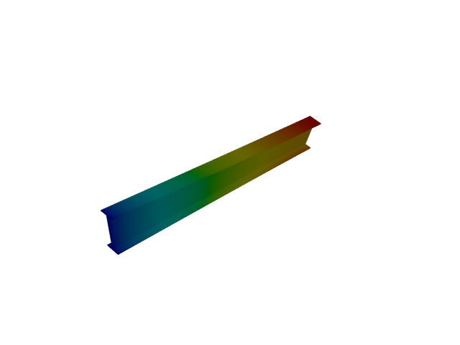
Figure 1: Abaqus — mode 1, 10.785 Hz
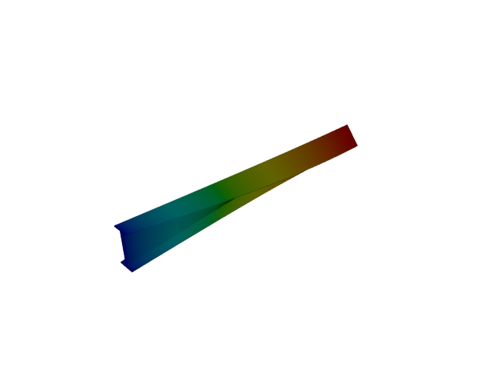
Figure 2: Sesam — mode 1, 12.245 Hz
Solver | f [Hz] | Δf vs mean [%] | λ [rad²/s²] | Meff X [kg] | Meff Y [kg] | Meff Z [kg] | Γ X | Γ Y | Γ Z
Abaqus | 10.785 | -6.34 | 4592.3 | 4.83e-34 | 1.00e-29 | 1.05e-31 | -2.20e-17 | -3.17e-15 | 3.24e-16
Sesam | 12.245 | +6.34 | 5919.77 | 8.88e-35 | 2.77e-27 | 1.18e-30 | 9.42e-18 | 5.26e-14 | -1.09e-15
- Mode 2
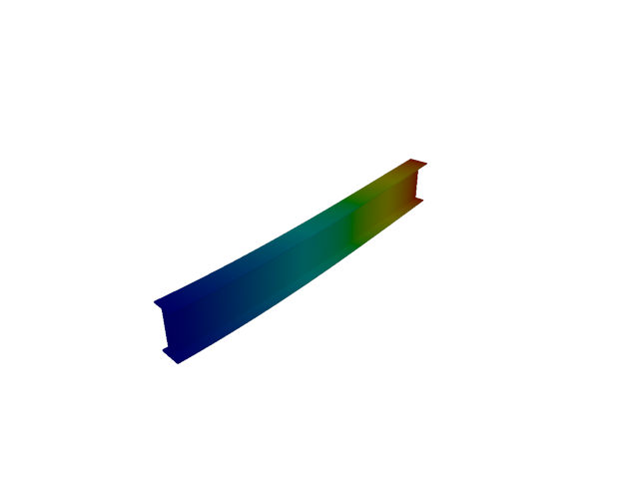
Figure 3: Abaqus — mode 2, 12.928 Hz
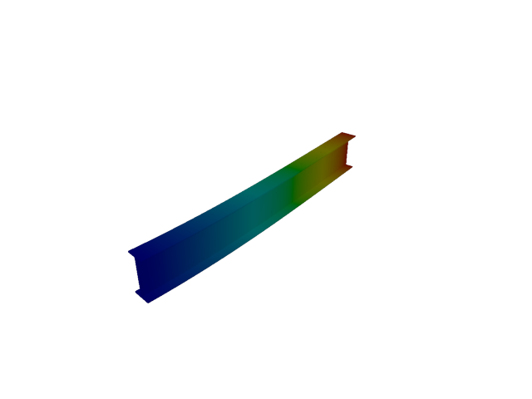
Figure 4: Sesam — mode 2, 12.943 Hz
Solver | f [Hz] | Δf vs mean [%] | λ [rad²/s²] | Meff X [kg] | Meff Y [kg] | Meff Z [kg] | Γ X | Γ Y | Γ Z
Abaqus | 12.928 | -0.06 | 6598.4 | 6.75e-31 | 116.57 | 3.27e-31 | -8.21e-16 | 10.797 | -5.72e-16
Sesam | 12.943 | +0.06 | 6613.55 | 4.64e-35 | 116.71 | 5.64e-31 | 6.81e-18 | 10.803 | -7.51e-16
- Mode 3
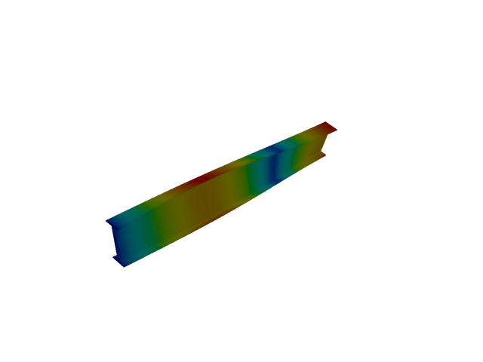
Figure 5: Abaqus — mode 3, 32.342 Hz
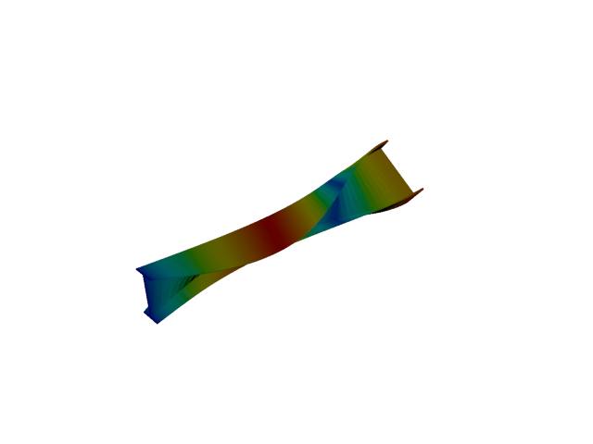
Figure 6: Sesam — mode 3, 36.752 Hz
Solver | f [Hz] | Δf vs mean [%] | λ [rad²/s²] | Meff X [kg] | Meff Y [kg] | Meff Z [kg] | Γ X | Γ Y | Γ Z
Abaqus | 32.342 | -6.38 | 41294 | 7.85e-31 | 8.23e-32 | 1.14e-28 | 8.86e-16 | -2.87e-16 | 1.07e-14
Sesam | 36.752 | +6.38 | 53325.3 | 8.68e-35 | 1.01e-30 | 1.52e-32 | -9.32e-18 | 1.00e-15 | -1.23e-16
- Mode 4
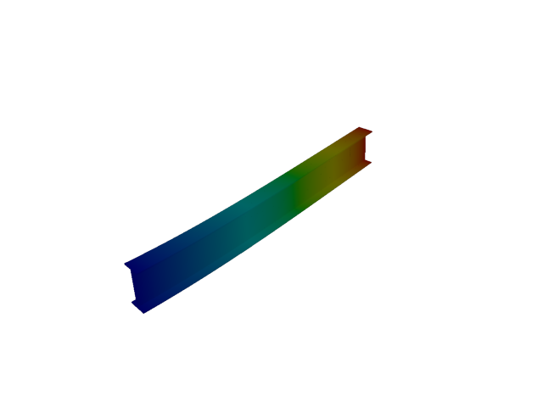
Figure 7: Abaqus — mode 4, 50.543 Hz
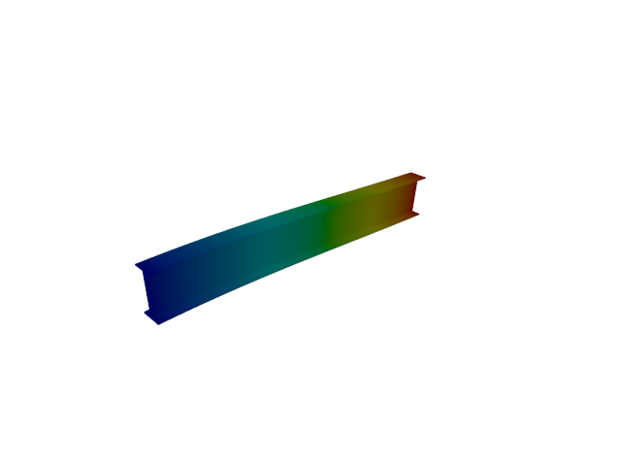
Figure 8: Sesam — mode 4, 44.962 Hz
Solver | f [Hz] | Δf vs mean [%] | λ [rad²/s²] | Meff X [kg] | Meff Y [kg] | Meff Z [kg] | Γ X | Γ Y | Γ Z
Abaqus | 50.543 | +5.84 | 100852 | 2.51e-30 | 1.42e-29 | 118.16 | 1.58e-15 | -3.76e-15 | 10.870
Sesam | 44.962 | -5.84 | 79809.7 | 3.16e-33 | 9.04e-30 | 128.05 | -5.62e-17 | 3.01e-15 | -11.316
- Mode 5
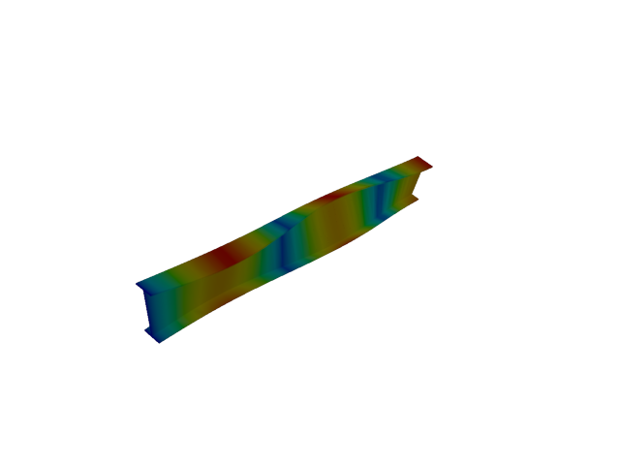
Figure 9: Abaqus — mode 5, 53.855 Hz
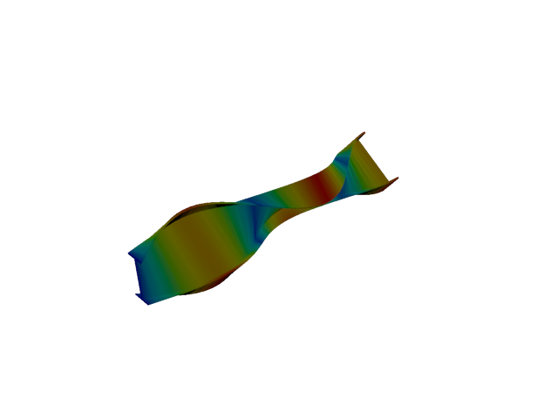
Figure 10: Sesam — mode 5, 61.309 Hz
Solver | f [Hz] | Δf vs mean [%] | λ [rad²/s²] | Meff X [kg] | Meff Y [kg] | Meff Z [kg] | Γ X | Γ Y | Γ Z
Abaqus | 53.855 | -6.47 | 114501 | 1.75e-29 | 8.90e-30 | 2.61e-27 | -4.18e-15 | 2.98e-15 | 5.11e-14
Sesam | 61.309 | +6.47 | 148390 | 3.02e-32 | 3.54e-30 | 1.09e-29 | -1.74e-16 | -1.88e-15 | 3.30e-15
- Mode 6
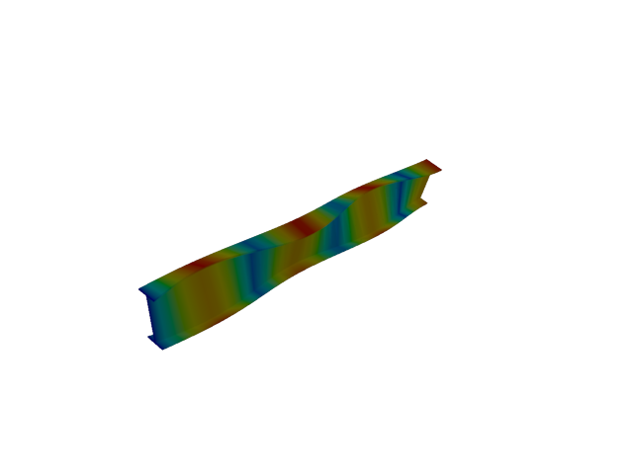
Figure 11: Abaqus — mode 6, 75.296 Hz
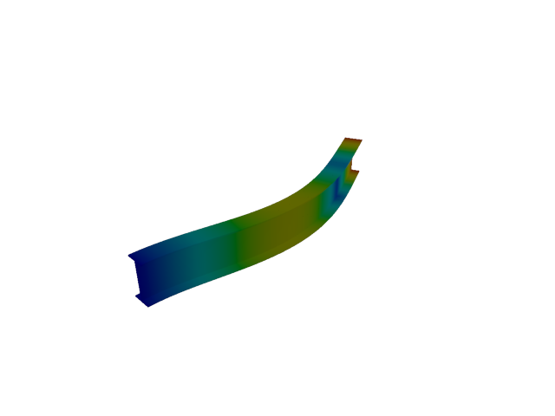
Figure 12: Sesam — mode 6, 79.793 Hz
Solver | f [Hz] | Δf vs mean [%] | λ [rad²/s²] | Meff X [kg] | Meff Y [kg] | Meff Z [kg] | Γ X | Γ Y | Γ Z
Abaqus | 75.296 | -2.90 | 223823 | 3.82e-29 | 2.17e-28 | 3.67e-28 | -6.18e-15 | -1.47e-14 | 1.92e-14
Sesam | 79.793 | +2.90 | 251356 | 8.03e-33 | 36.29 | 4.50e-29 | -8.96e-17 | -6.024 | -6.71e-15
- Mode 7
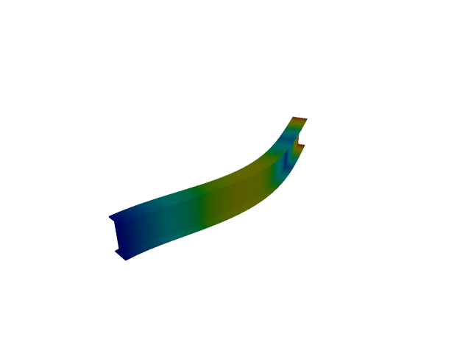
Figure 13: Abaqus — mode 7, 79.590 Hz
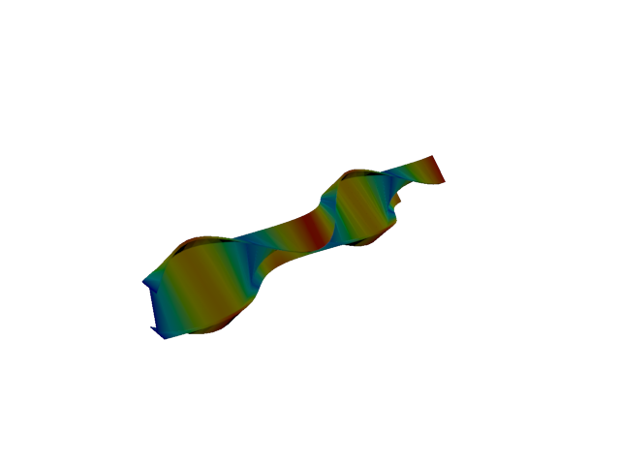
Figure 14: Sesam — mode 7, 85.947 Hz
Solver | f [Hz] | Δf vs mean [%] | λ [rad²/s²] | Meff X [kg] | Meff Y [kg] | Meff Z [kg] | Γ X | Γ Y | Γ Z
Abaqus | 79.590 | -3.84 | 250078 | 1.01e-30 | 36.20 | 1.38e-29 | 1.01e-15 | -6.016 | -3.72e-15
Sesam | 85.947 | +3.84 | 291620 | 1.09e-31 | 9.28e-29 | 2.34e-30 | -3.31e-16 | -9.63e-15 | -1.53e-15
- Mode 8
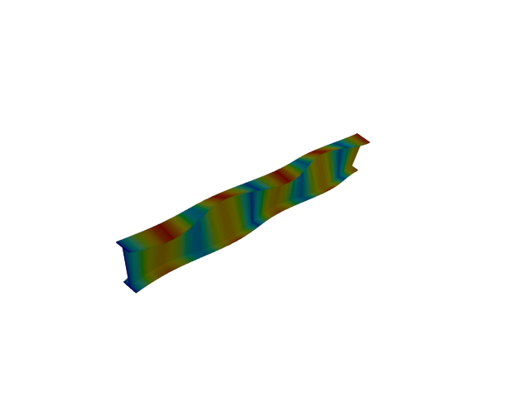
Figure 15: Abaqus — mode 8, 96.637 Hz
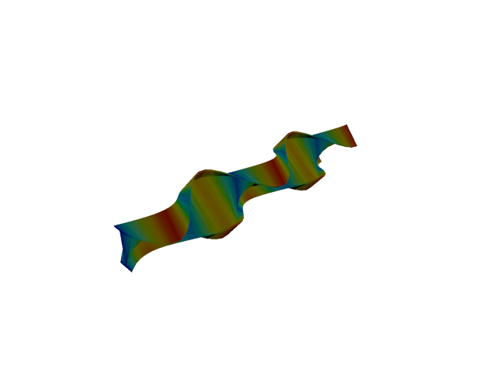
Figure 16: Sesam — mode 8, 110.699 Hz
Solver | f [Hz] | Δf vs mean [%] | λ [rad²/s²] | Meff X [kg] | Meff Y [kg] | Meff Z [kg] | Γ X | Γ Y | Γ Z
Abaqus | 96.637 | -6.78 | 368677 | 4.04e-26 | 1.03e-27 | 4.21e-27 | -2.01e-13 | -3.20e-14 | 6.49e-14
Sesam | 110.699 | +6.78 | 483782 | 2.49e-33 | 6.18e-30 | 2.43e-29 | 4.99e-17 | 2.49e-15 | -4.93e-15
- Mode 9
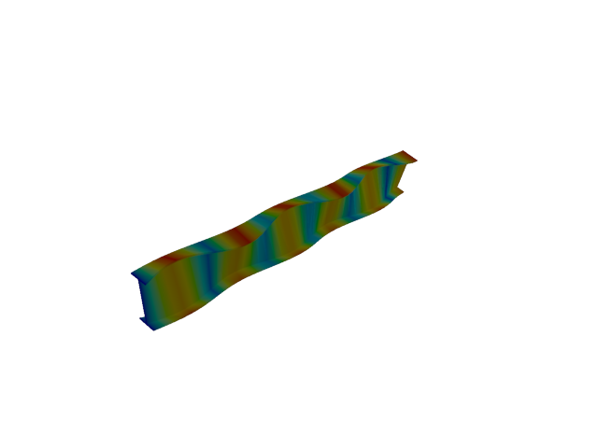
Figure 17: Abaqus — mode 9, 117.849 Hz
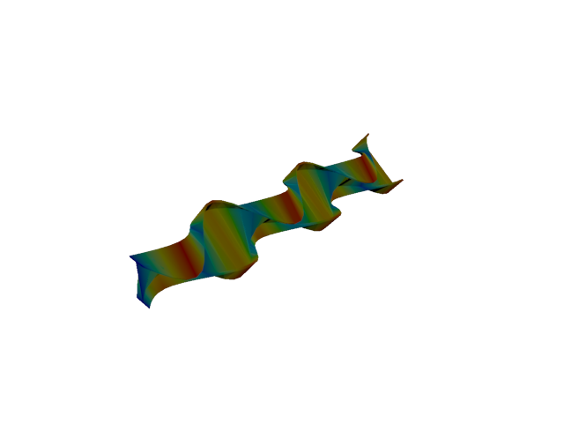
Figure 18: Sesam — mode 9, 135.600 Hz
Solver | f [Hz] | Δf vs mean [%] | λ [rad²/s²] | Meff X [kg] | Meff Y [kg] | Meff Z [kg] | Γ X | Γ Y | Γ Z
Abaqus | 117.850 | -7.00 | 548290 | 9.24e-23 | 1.72e-25 | 7.37e-24 | 9.61e-12 | 4.15e-13 | 2.71e-12
Sesam | 135.600 | +7.00 | 725900 | 3.52e-30 | 2.31e-30 | 4.44e-29 | -1.88e-15 | 1.52e-15 | -6.66e-15
- Mode 10
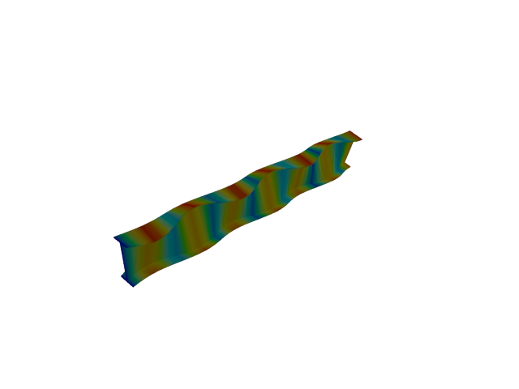
Figure 19: Abaqus — mode 10, 138.904 Hz
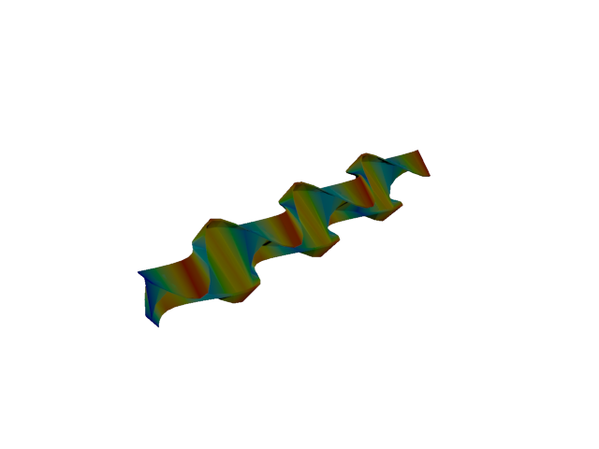
Figure 20: Sesam — mode 10, 160.681 Hz
Solver | f [Hz] | Δf vs mean [%] | λ [rad²/s²] | Meff X [kg] | Meff Y [kg] | Meff Z [kg] | Γ X | Γ Y | Γ Z
Abaqus | 138.900 | -7.27 | 761704 | 1.00e-20 | 2.09e-22 | 2.61e-21 | 1.00e-10 | 1.45e-11 | -5.11e-11
Sesam | 160.681 | +7.27 | 1.01927e+06 | 6.22e-23 | 1.67e-23 | 7.04e-23 | -7.88e-12 | 4.09e-12 | -8.39e-12
- Mode 11
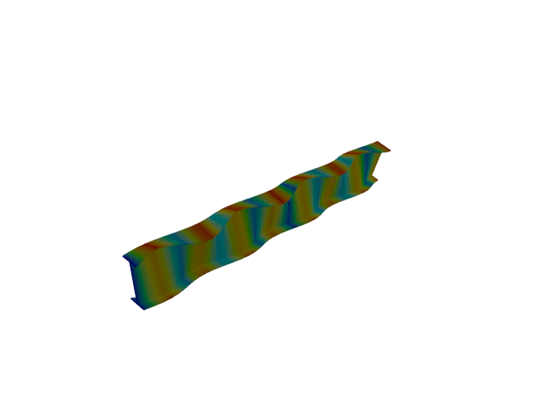
Figure 21: Abaqus — mode 11, 159.773 Hz
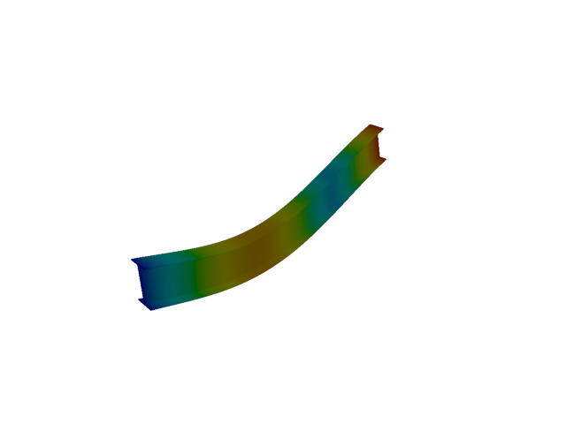
Figure 22: Sesam — mode 11, 176.495 Hz
Solver | f [Hz] | Δf vs mean [%] | λ [rad²/s²] | Meff X [kg] | Meff Y [kg] | Meff Z [kg] | Γ X | Γ Y | Γ Z
Abaqus | 159.770 | -4.97 | 1.00778e+06 | 1.05e-18 | 1.96e-22 | 2.87e-21 | 1.02e-09 | -1.40e-11 | 5.35e-11
Sesam | 176.495 | +4.97 | 1.22977e+06 | 3.95e-21 | 1.04e-21 | 38.35 | -6.28e-11 | 3.22e-11 | -6.193
- Line, 2nd order
- Mode 1
Figure 23: Abaqus — mode 1, 10.786 Hz
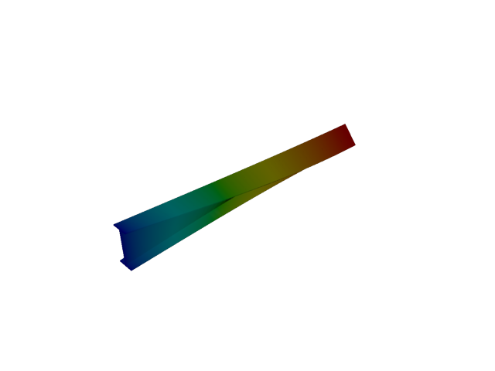
Figure 24: Sesam — mode 1, 10.039 Hz
Solver | f [Hz] | Δf vs mean [%] | λ [rad²/s²] | Meff X [kg] | Meff Y [kg] | Meff Z [kg] | Γ X | Γ Y | Γ Z
Abaqus | 10.786 | +3.59 | 4592.8 | 3.02e-31 | 1.31e-30 | 3.09e-30 | 5.50e-16 | 1.14e-15 | -1.76e-15
Sesam | 10.039 | -3.59 | 3978.68 | 5.26e-40 | 1.31e-27 | 4.46e-29 | 2.29e-20 | 3.62e-14 | -6.68e-15
- Mode 2
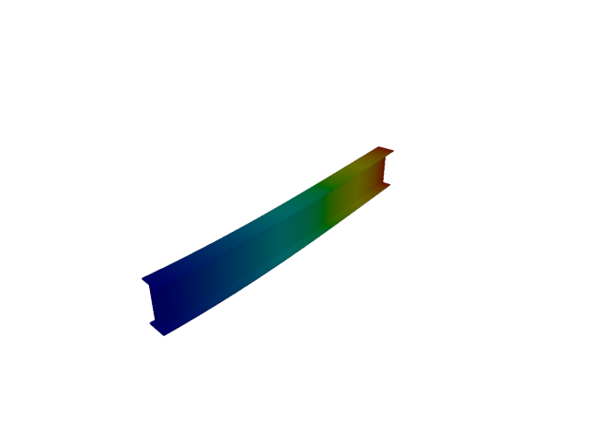
Figure 25: Abaqus — mode 2, 12.932 Hz
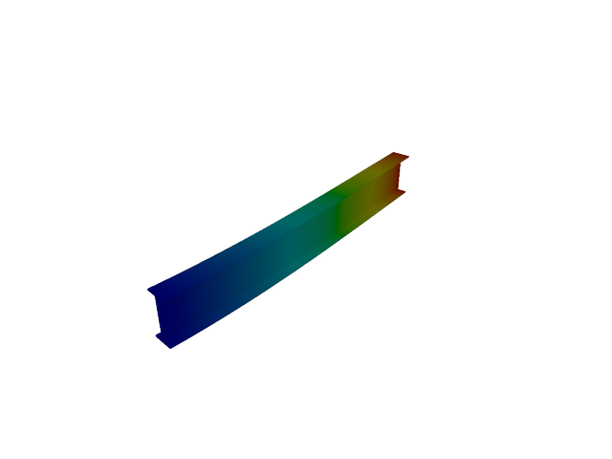
Figure 26: Sesam — mode 2, 10.614 Hz
Solver | f [Hz] | Δf vs mean [%] | λ [rad²/s²] | Meff X [kg] | Meff Y [kg] | Meff Z [kg] | Γ X | Γ Y | Γ Z
Abaqus | 12.932 | +9.84 | 6602.4 | 1.50e-32 | 116.59 | 2.60e-32 | -1.22e-16 | 10.798 | -1.61e-16
Sesam | 10.614 | -9.84 | 4447.85 | 3.31e-28 | 176.82 | 7.82e-31 | -1.82e-14 | 13.297 | 8.84e-16
- Mode 3
Figure 27: Abaqus — mode 3, 32.358 Hz
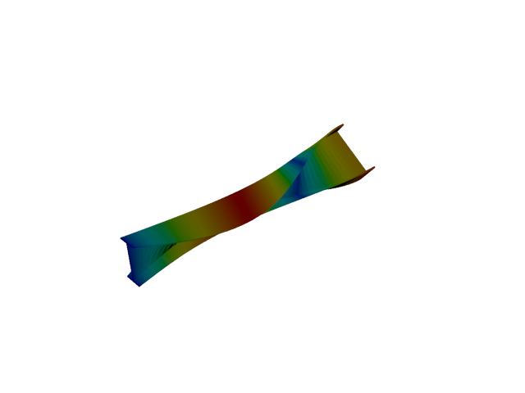
Figure 28: Sesam — mode 3, 30.108 Hz
Solver | f [Hz] | Δf vs mean [%] | λ [rad²/s²] | Meff X [kg] | Meff Y [kg] | Meff Z [kg] | Γ X | Γ Y | Γ Z
Abaqus | 32.358 | +3.60 | 41335 | 2.64e-31 | 5.69e-29 | 8.91e-29 | 5.14e-16 | -7.54e-15 | -9.44e-15
Sesam | 30.108 | -3.60 | 35786.3 | 4.57e-37 | 6.51e-30 | 2.81e-29 | 6.76e-19 | 2.55e-15 | -5.30e-15
- Mode 4
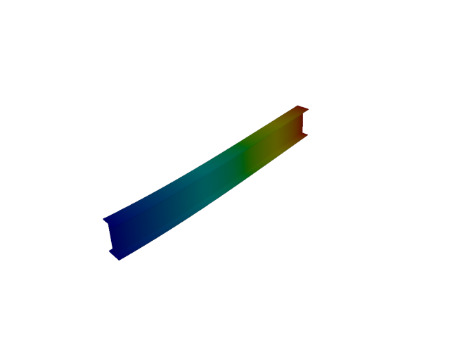
Figure 29: Abaqus — mode 4, 50.557 Hz
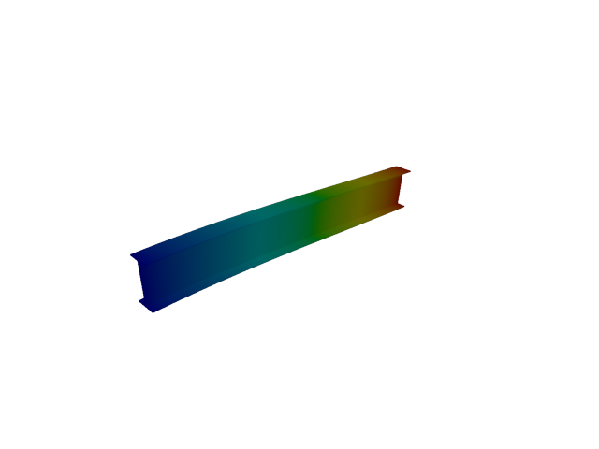
Figure 30: Sesam — mode 4, 36.752 Hz
Solver | f [Hz] | Δf vs mean [%] | λ [rad²/s²] | Meff X [kg] | Meff Y [kg] | Meff Z [kg] | Γ X | Γ Y | Γ Z
Abaqus | 50.557 | +15.81 | 100907 | 6.29e-36 | 9.63e-28 | 118.18 | -2.51e-18 | -3.10e-14 | 10.871
Sesam | 36.752 | -15.81 | 53323.9 | 3.71e-28 | 2.58e-29 | 192.77 | 1.93e-14 | 5.08e-15 | -13.884
- Mode 5
Figure 31: Abaqus — mode 5, 53.930 Hz
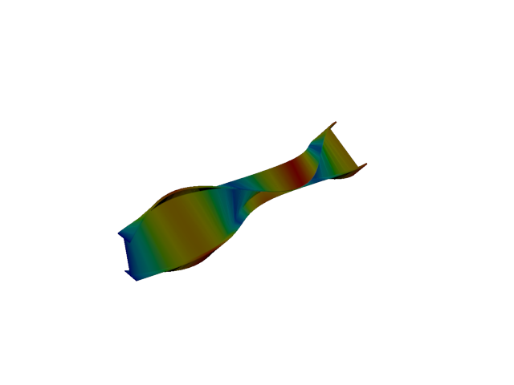
Figure 32: Sesam — mode 5, 50.149 Hz
Solver | f [Hz] | Δf vs mean [%] | λ [rad²/s²] | Meff X [kg] | Meff Y [kg] | Meff Z [kg] | Γ X | Γ Y | Γ Z
Abaqus | 53.930 | +3.63 | 114820 | 1.13e-29 | 6.97e-31 | 2.94e-28 | -3.36e-15 | 8.35e-16 | 1.72e-14
Sesam | 50.149 | -3.63 | 99284.4 | 1.91e-35 | 1.10e-30 | 4.31e-29 | -4.37e-18 | -1.05e-15 | -6.57e-15
- Mode 6
Figure 33: Abaqus — mode 6, 75.502 Hz
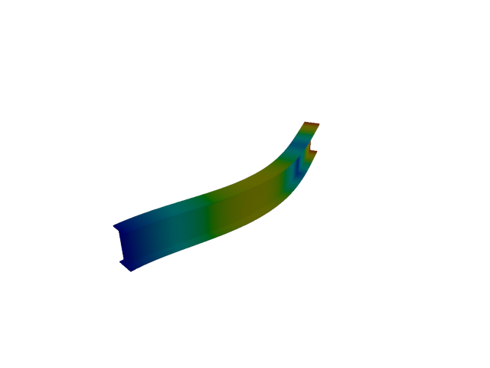
Figure 34: Sesam — mode 6, 65.327 Hz
Solver | f [Hz] | Δf vs mean [%] | λ [rad²/s²] | Meff X [kg] | Meff Y [kg] | Meff Z [kg] | Γ X | Γ Y | Γ Z
Abaqus | 75.502 | +7.23 | 225048 | 6.44e-34 | 3.07e-27 | 1.85e-29 | -2.54e-17 | 5.54e-14 | -4.30e-15
Sesam | 65.327 | -7.23 | 168476 | 1.08e-28 | 54.95 | 1.07e-28 | 1.04e-14 | -7.413 | -1.03e-14
- Mode 7
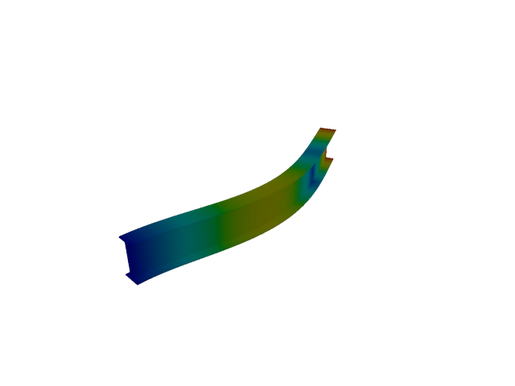
Figure 35: Abaqus — mode 7, 79.684 Hz
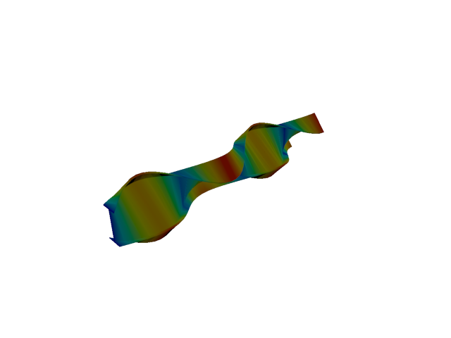
Figure 36: Sesam — mode 7, 70.143 Hz
Solver | f [Hz] | Δf vs mean [%] | λ [rad²/s²] | Meff X [kg] | Meff Y [kg] | Meff Z [kg] | Γ X | Γ Y | Γ Z
Abaqus | 79.684 | +6.37 | 250668 | 9.57e-31 | 36.19 | 1.97e-27 | 9.78e-16 | -6.015 | -4.44e-14
Sesam | 70.143 | -6.37 | 194235 | 7.33e-35 | 4.66e-28 | 4.83e-30 | -8.56e-18 | 2.16e-14 | 2.20e-15
- Mode 8
Figure 37: Abaqus — mode 8, 97.074 Hz
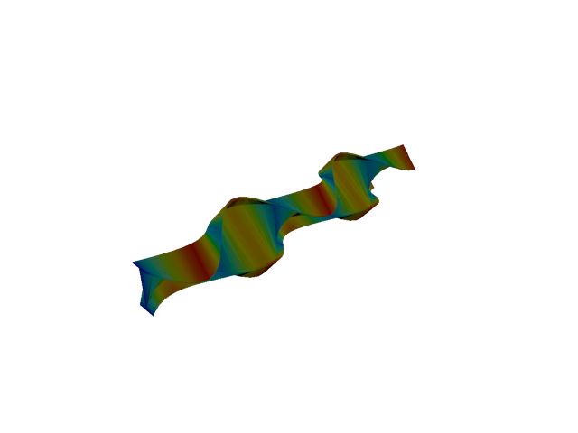
Figure 38: Sesam — mode 8, 90.070 Hz
Solver | f [Hz] | Δf vs mean [%] | λ [rad²/s²] | Meff X [kg] | Meff Y [kg] | Meff Z [kg] | Γ X | Γ Y | Γ Z
Abaqus | 97.074 | +3.74 | 372022 | 4.46e-28 | 1.86e-30 | 1.09e-27 | 2.11e-14 | 1.36e-15 | -3.31e-14
Sesam | 90.070 | -3.74 | 320270 | 1.65e-33 | 4.85e-29 | 3.89e-29 | -4.06e-17 | 6.96e-15 | 6.24e-15
- Mode 9
Figure 39: Abaqus — mode 9, 118.648 Hz
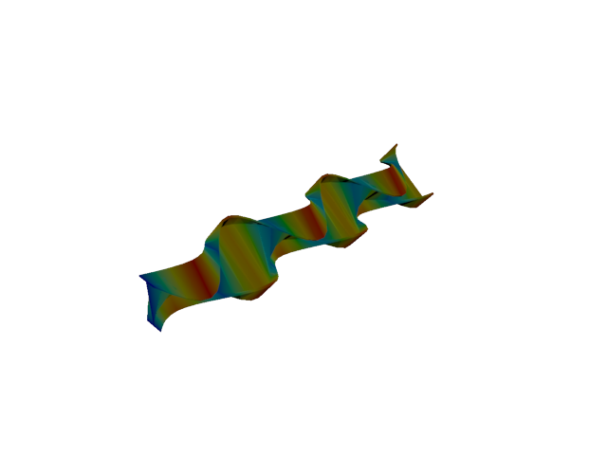
Figure 40: Sesam — mode 9, 109.907 Hz
Solver | f [Hz] | Δf vs mean [%] | λ [rad²/s²] | Meff X [kg] | Meff Y [kg] | Meff Z [kg] | Γ X | Γ Y | Γ Z
Abaqus | 118.650 | +3.83 | 555748 | 3.94e-25 | 6.15e-26 | 2.26e-25 | 6.28e-13 | 2.48e-13 | -4.75e-13
Sesam | 109.907 | -3.83 | 476881 | 3.54e-29 | 2.19e-32 | 8.17e-29 | 5.95e-15 | -1.48e-16 | -9.04e-15
- Mode 10
Figure 41: Abaqus — mode 10, 140.222 Hz
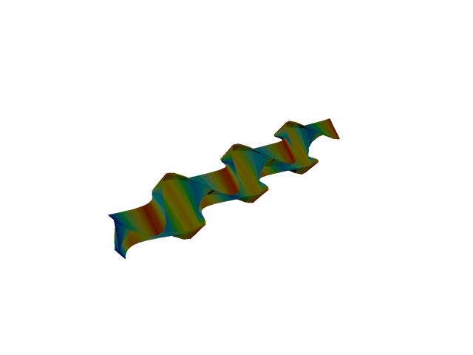
Figure 42: Sesam — mode 10, 129.631 Hz
Solver | f [Hz] | Δf vs mean [%] | λ [rad²/s²] | Meff X [kg] | Meff Y [kg] | Meff Z [kg] | Γ X | Γ Y | Γ Z
Abaqus | 140.220 | +3.92 | 776236 | 2.58e-24 | 4.27e-23 | 1.99e-23 | -1.61e-12 | 6.54e-12 | 4.46e-12
Sesam | 129.631 | -3.92 | 663407 | 8.02e-21 | 1.12e-21 | 1.11e-21 | 8.95e-11 | 3.35e-11 | -3.34e-11
- Mode 11
Figure 43: Abaqus — mode 11, 161.799 Hz
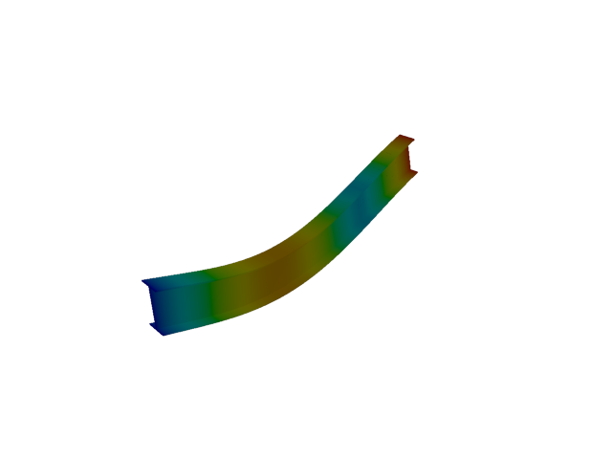
Figure 44: Sesam — mode 11, 142.572 Hz
Solver | f [Hz] | Δf vs mean [%] | λ [rad²/s²] | Meff X [kg] | Meff Y [kg] | Meff Z [kg] | Γ X | Γ Y | Γ Z
Abaqus | 161.800 | +6.32 | 1.03351e+06 | 2.30e-19 | 1.18e-19 | 3.67e-20 | -4.80e-10 | -3.43e-10 | 1.92e-10
Sesam | 142.572 | -6.32 | 802475 | 5.07e-20 | 7.21e-21 | 59.58 | 2.25e-10 | 8.49e-11 | -7.719
- Shell, 1st order, TRI
- Mode 1
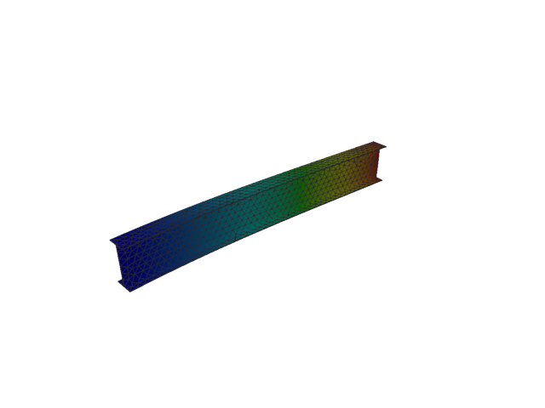
Figure 45: Sesam — mode 1, 13.641 Hz
Solver | f [Hz] | λ [rad²/s²] | Meff X [kg] | Meff Y [kg] | Meff Z [kg] | Γ X | Γ Y | Γ Z
Sesam | 13.641 | 7346.4 | 2.57e-27 | 119.93 | 7.93e-25 | -5.07e-14 | -10.951 | -8.90e-13
- Mode 2
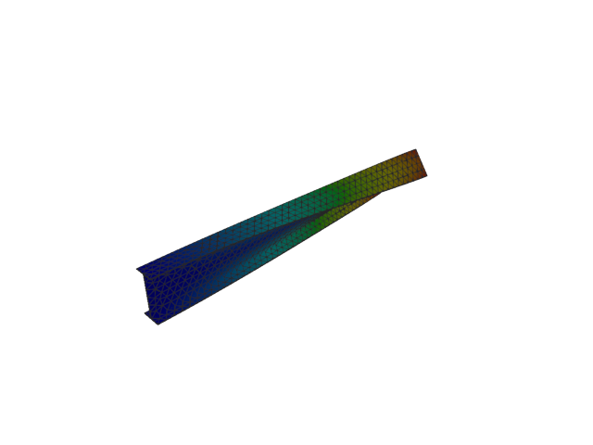
Figure 46: Sesam — mode 2, 20.198 Hz
Solver | f [Hz] | λ [rad²/s²] | Meff X [kg] | Meff Y [kg] | Meff Z [kg] | Γ X | Γ Y | Γ Z
Sesam | 20.198 | 16106.1 | 1.92e-26 | 3.02e-11 | 1.82e-25 | 1.38e-13 | -5.49e-06 | 4.26e-13
- Mode 3
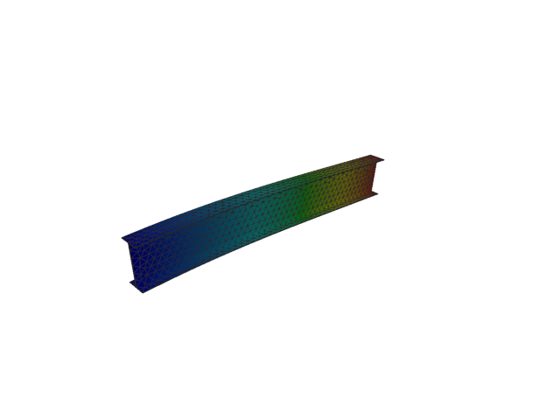
Figure 47: Sesam — mode 3, 52.192 Hz
Solver | f [Hz] | λ [rad²/s²] | Meff X [kg] | Meff Y [kg] | Meff Z [kg] | Γ X | Γ Y | Γ Z
Sesam | 52.192 | 107540 | 4.79e-10 | 1.24e-24 | 122.03 | -2.19e-05 | 1.12e-12 | -11.047
- Mode 4
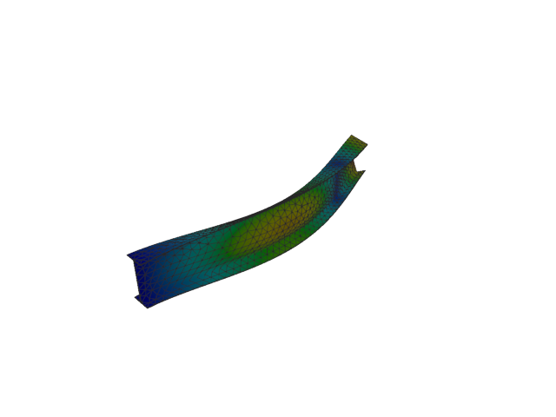
Figure 48: Sesam — mode 4, 79.523 Hz
Solver | f [Hz] | λ [rad²/s²] | Meff X [kg] | Meff Y [kg] | Meff Z [kg] | Γ X | Γ Y | Γ Z
Sesam | 79.523 | 249655 | 1.26e-27 | 36.58 | 1.11e-25 | 3.55e-14 | -6.048 | -3.33e-13
- Mode 5
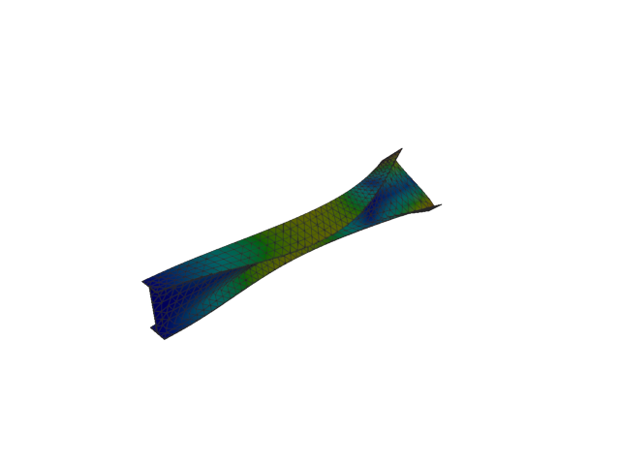
Figure 49: Sesam — mode 5, 101.756 Hz
Solver | f [Hz] | λ [rad²/s²] | Meff X [kg] | Meff Y [kg] | Meff Z [kg] | Γ X | Γ Y | Γ Z
Sesam | 101.756 | 408770 | 3.14e-27 | 4.27e-09 | 1.42e-27 | -5.60e-14 | 6.54e-05 | -3.77e-14
- Mode 6
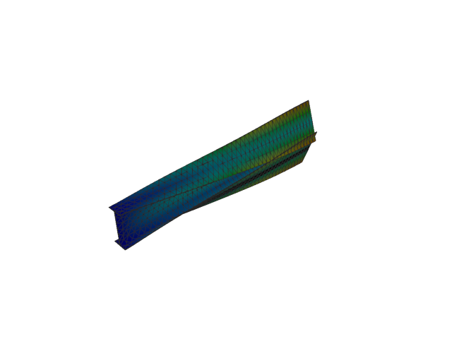
Figure 50: Sesam — mode 6, 125.093 Hz
Solver | f [Hz] | λ [rad²/s²] | Meff X [kg] | Meff Y [kg] | Meff Z [kg] | Γ X | Γ Y | Γ Z
Sesam | 125.093 | 617772 | 5.83e-28 | 0.06 | 2.58e-27 | -2.41e-14 | -0.252 | 5.08e-14
- Mode 7
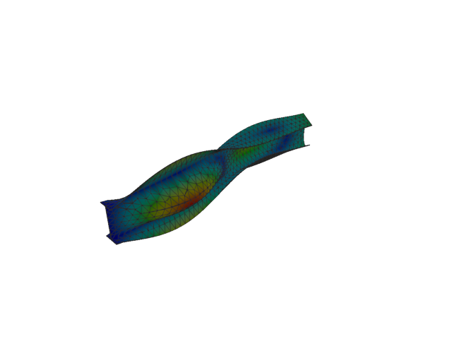
Figure 51: Sesam — mode 7, 143.164 Hz
Solver | f [Hz] | λ [rad²/s²] | Meff X [kg] | Meff Y [kg] | Meff Z [kg] | Γ X | Γ Y | Γ Z
Sesam | 143.164 | 809150 | 1.19e-28 | 2.72 | 6.22e-28 | -1.09e-14 | -1.651 | 2.49e-14
- Mode 8
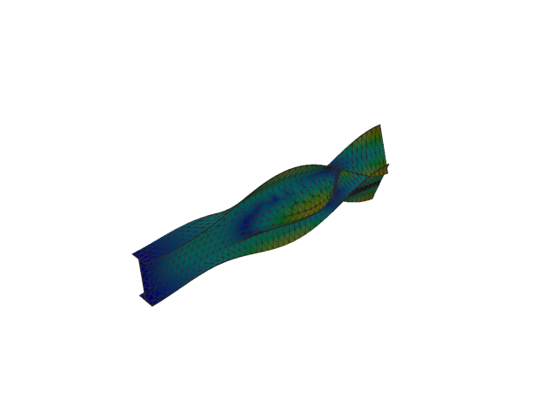
Figure 52: Sesam — mode 8, 166.668 Hz
Solver | f [Hz] | λ [rad²/s²] | Meff X [kg] | Meff Y [kg] | Meff Z [kg] | Γ X | Γ Y | Γ Z
Sesam | 166.668 | 1.09664e+06 | 1.64e-27 | 5.94 | 3.89e-27 | -4.05e-14 | 2.438 | -6.23e-14
- Mode 9
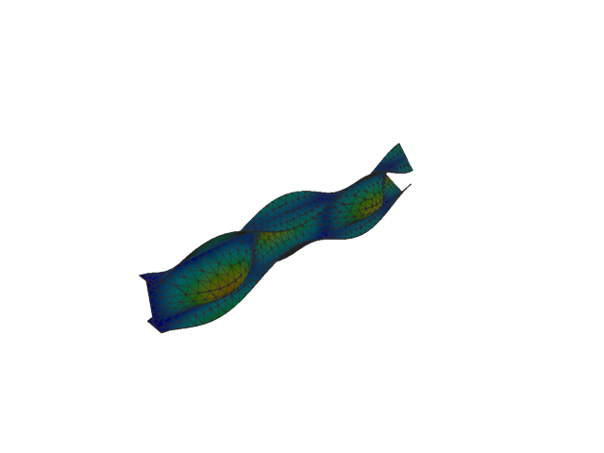
Figure 53: Sesam — mode 9, 191.533 Hz
Solver | f [Hz] | λ [rad²/s²] | Meff X [kg] | Meff Y [kg] | Meff Z [kg] | Γ X | Γ Y | Γ Z
Sesam | 191.533 | 1.44826e+06 | 2.66e-28 | 0.61 | 7.55e-28 | -1.63e-14 | -0.781 | -2.75e-14
- Mode 10
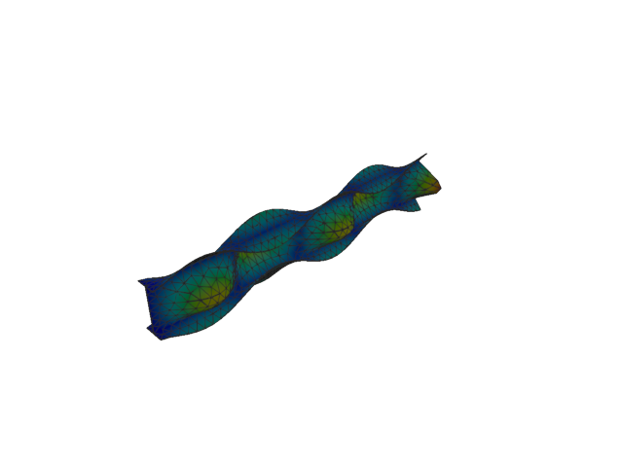
Figure 54: Sesam — mode 10, 230.489 Hz
Solver | f [Hz] | λ [rad²/s²] | Meff X [kg] | Meff Y [kg] | Meff Z [kg] | Γ X | Γ Y | Γ Z
Sesam | 230.489 | 2.09731e+06 | 2.70e-28 | 1.27 | 2.42e-28 | 1.64e-14 | -1.128 | -1.55e-14
- Mode 11
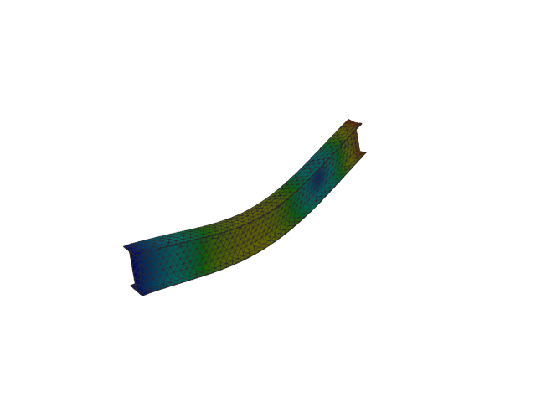
Figure 55: Sesam — mode 11, 257.362 Hz
Solver | f [Hz] | λ [rad²/s²] | Meff X [kg] | Meff Y [kg] | Meff Z [kg] | Γ X | Γ Y | Γ Z
Sesam | 257.362 | 2.61487e+06 | 6.51e-09 | 3.57e-22 | 41.62 | -8.07e-05 | -1.89e-11 | -6.451
- Shell, 1st order, QUAD
- Mode 1
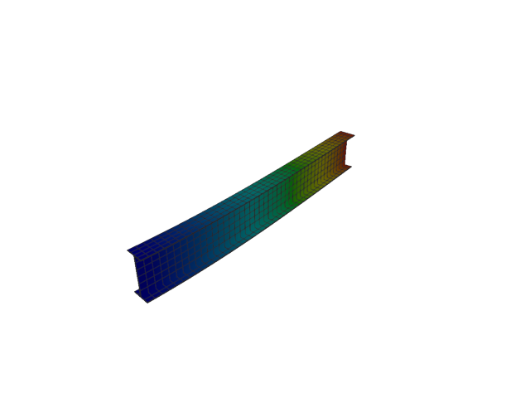
Figure 56: Abaqus — mode 1, 12.780 Hz
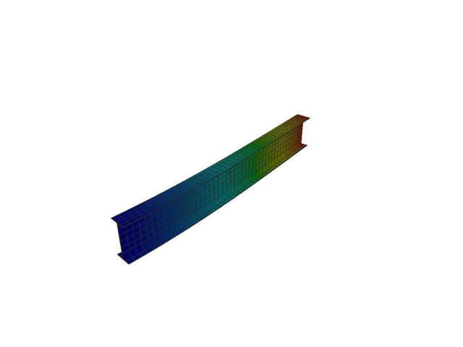
Figure 57: Sesam — mode 1, 12.763 Hz
Solver | f [Hz] | Δf vs mean [%] | λ [rad²/s²] | Meff X [kg] | Meff Y [kg] | Meff Z [kg] | Γ X | Γ Y | Γ Z
Abaqus | 12.780 | +0.07 | 6448.4 | 7.41e-27 | 119.92 | 1.38e-25 | -8.61e-14 | 10.951 | -3.71e-13
Sesam | 12.763 | -0.07 | 6430.64 | 1.47e-28 | 119.90 | 2.22e-25 | -1.21e-14 | 10.950 | -4.71e-13
- Mode 2
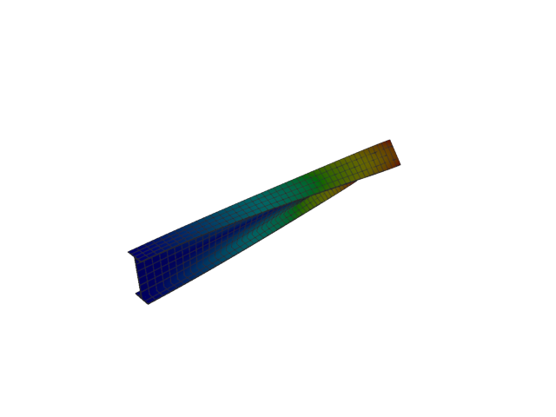
Figure 58: Abaqus — mode 2, 19.593 Hz
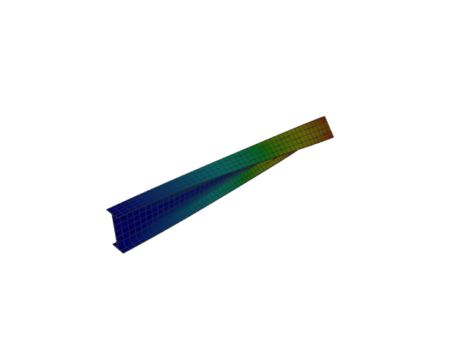
Figure 59: Sesam — mode 2, 19.394 Hz
Solver | f [Hz] | Δf vs mean [%] | λ [rad²/s²] | Meff X [kg] | Meff Y [kg] | Meff Z [kg] | Γ X | Γ Y | Γ Z
Abaqus | 19.593 | +0.51 | 15155 | 1.46e-27 | 1.08e-19 | 7.67e-28 | -3.83e-14 | 3.28e-10 | 2.77e-14
Sesam | 19.394 | -0.51 | 14849.3 | 3.80e-27 | 7.43e-19 | 1.60e-24 | -6.16e-14 | -8.62e-10 | -1.27e-12
- Mode 3
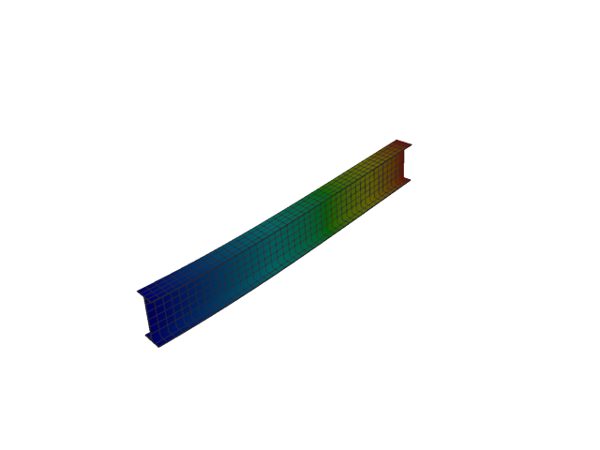
Figure 60: Abaqus — mode 3, 51.998 Hz
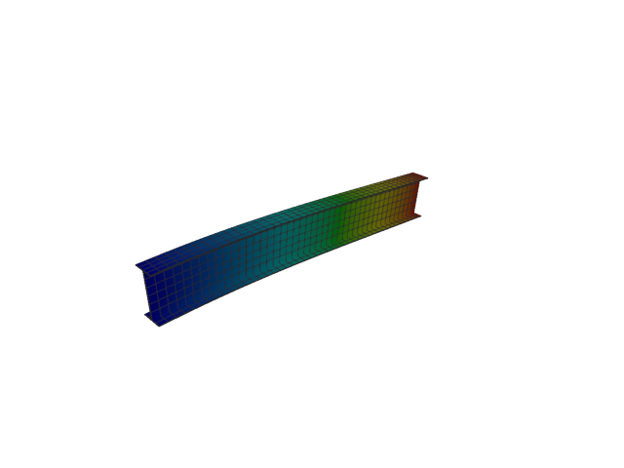
Figure 61: Sesam — mode 3, 51.991 Hz
Solver | f [Hz] | Δf vs mean [%] | λ [rad²/s²] | Meff X [kg] | Meff Y [kg] | Meff Z [kg] | Γ X | Γ Y | Γ Z
Abaqus | 51.998 | +0.01 | 106741 | 1.35e-26 | 1.05e-26 | 122.01 | -1.16e-13 | 1.03e-13 | 11.046
Sesam | 51.991 | -0.01 | 106714 | 7.03e-28 | 8.47e-26 | 122.00 | 2.65e-14 | -2.91e-13 | -11.046
- Mode 4
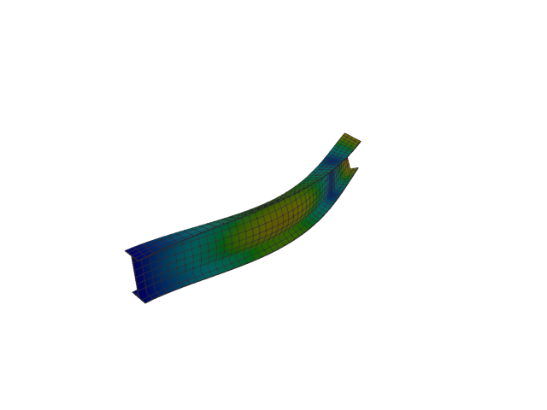
Figure 62: Abaqus — mode 4, 75.683 Hz
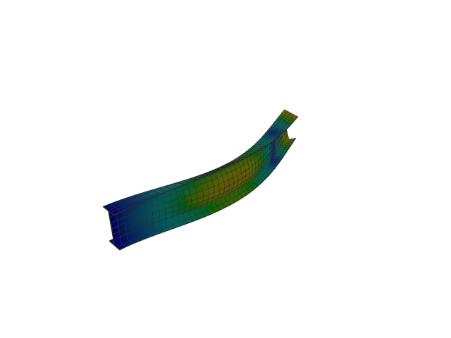
Figure 63: Sesam — mode 4, 75.192 Hz
Solver | f [Hz] | Δf vs mean [%] | λ [rad²/s²] | Meff X [kg] | Meff Y [kg] | Meff Z [kg] | Γ X | Γ Y | Γ Z
Abaqus | 75.683 | +0.33 | 226132 | 1.88e-28 | 36.92 | 2.68e-25 | -1.37e-14 | -6.076 | -5.18e-13
Sesam | 75.192 | -0.33 | 223203 | 1.10e-27 | 36.80 | 9.74e-26 | -3.31e-14 | -6.067 | -3.12e-13
- Mode 5
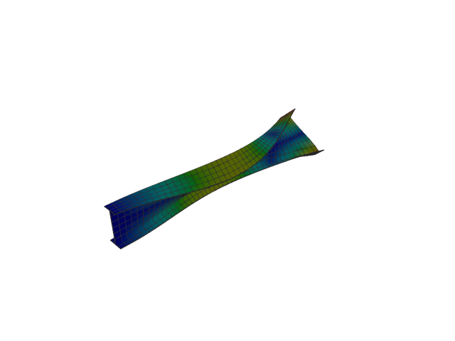
Figure 64: Abaqus — mode 5, 96.393 Hz
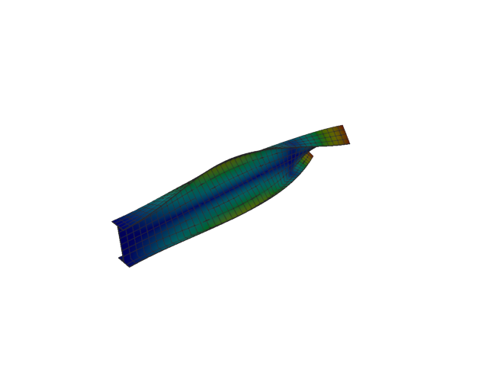
Figure 65: Sesam — mode 5, 95.930 Hz
Solver | f [Hz] | Δf vs mean [%] | λ [rad²/s²] | Meff X [kg] | Meff Y [kg] | Meff Z [kg] | Γ X | Γ Y | Γ Z
Abaqus | 96.393 | +0.24 | 366818 | 7.25e-28 | 1.11e-22 | 7.70e-26 | -2.69e-14 | -1.05e-11 | -2.77e-13
Sesam | 95.930 | -0.24 | 363300 | 2.85e-27 | 3.92e-24 | 2.81e-26 | 5.34e-14 | 1.98e-12 | -1.68e-13
- Mode 6
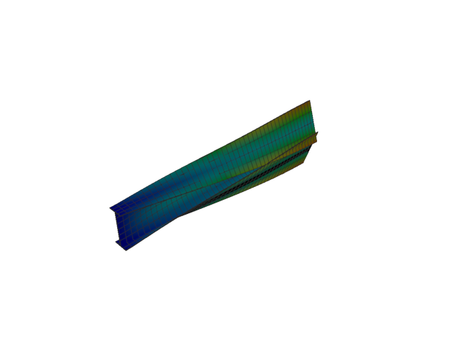
Figure 66: Abaqus — mode 6, 126.961 Hz
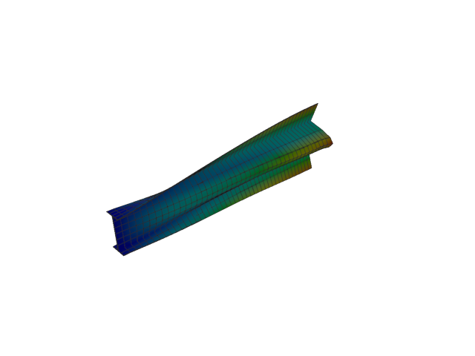
Figure 67: Sesam — mode 6, 125.116 Hz
Solver | f [Hz] | Δf vs mean [%] | λ [rad²/s²] | Meff X [kg] | Meff Y [kg] | Meff Z [kg] | Γ X | Γ Y | Γ Z
Abaqus | 126.960 | +0.73 | 636351 | 1.52e-27 | 0.02 | 2.42e-26 | 3.90e-14 | -0.132 | -1.56e-13
Sesam | 125.116 | -0.73 | 617993 | 3.59e-30 | 0.02 | 5.54e-26 | -1.89e-15 | 0.134 | -2.35e-13
- Mode 7
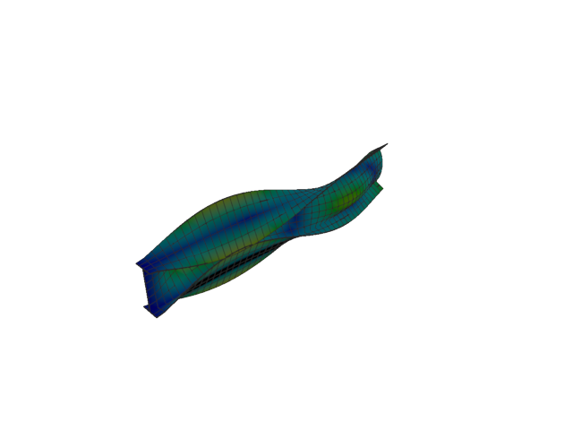
Figure 68: Abaqus — mode 7, 145.566 Hz
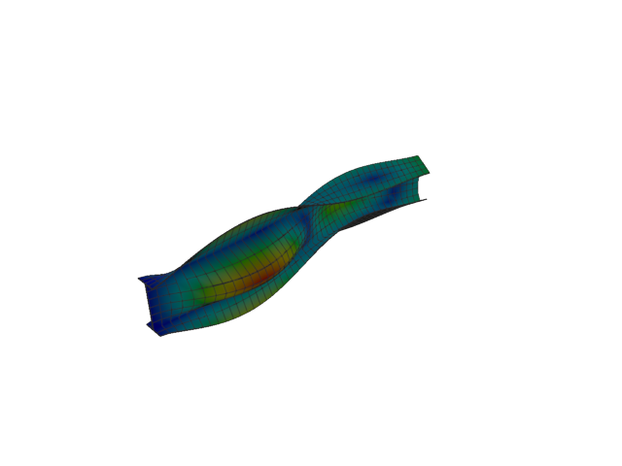
Figure 69: Sesam — mode 7, 141.556 Hz
Solver | f [Hz] | Δf vs mean [%] | λ [rad²/s²] | Meff X [kg] | Meff Y [kg] | Meff Z [kg] | Γ X | Γ Y | Γ Z
Abaqus | 145.570 | +1.40 | 836523 | 2.58e-27 | 3.34 | 1.12e-26 | -5.08e-14 | 1.829 | 1.06e-13
Sesam | 141.556 | -1.40 | 791068 | 1.14e-28 | 3.46 | 3.39e-27 | 1.07e-14 | -1.860 | 5.82e-14
- Mode 8
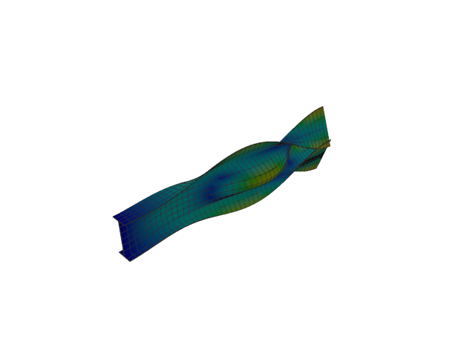
Figure 70: Abaqus — mode 8, 169.389 Hz
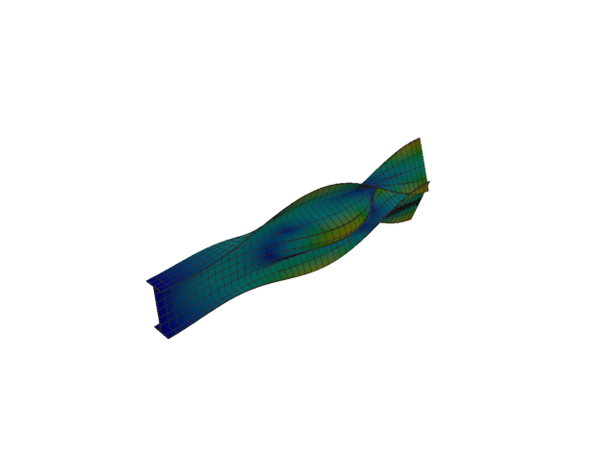
Figure 71: Sesam — mode 8, 165.030 Hz
Solver | f [Hz] | Δf vs mean [%] | λ [rad²/s²] | Meff X [kg] | Meff Y [kg] | Meff Z [kg] | Γ X | Γ Y | Γ Z
Abaqus | 169.390 | +1.30 | 1.13275e+06 | 2.66e-25 | 5.68 | 6.71e-24 | -5.16e-13 | 2.383 | -2.59e-12
Sesam | 165.030 | -1.30 | 1.07519e+06 | 5.28e-28 | 5.45 | 4.78e-26 | 2.30e-14 | 2.334 | 2.19e-13
- Mode 9
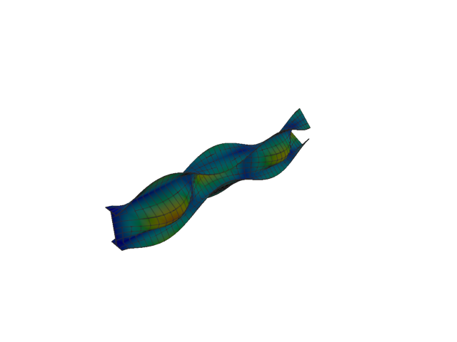
Figure 72: Abaqus — mode 9, 198.748 Hz
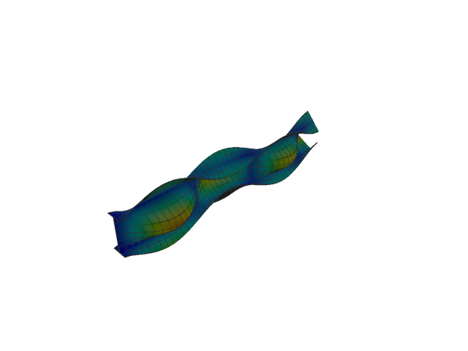
Figure 73: Sesam — mode 9, 190.099 Hz
Solver | f [Hz] | Δf vs mean [%] | λ [rad²/s²] | Meff X [kg] | Meff Y [kg] | Meff Z [kg] | Γ X | Γ Y | Γ Z
Abaqus | 198.750 | +2.22 | 1.55943e+06 | 6.12e-22 | 0.59 | 1.15e-20 | 2.47e-11 | -0.771 | 1.07e-10
Sesam | 190.099 | -2.22 | 1.42665e+06 | 1.59e-30 | 0.64 | 8.33e-27 | -1.26e-15 | -0.798 | 9.13e-14
- Mode 10
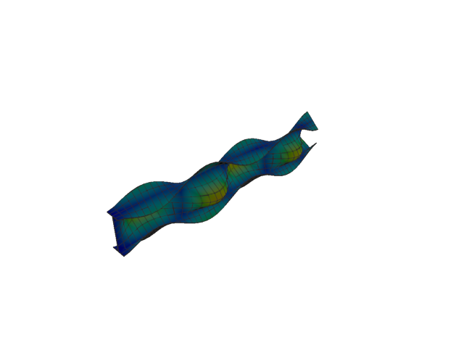
Figure 74: Abaqus — mode 10, 242.545 Hz
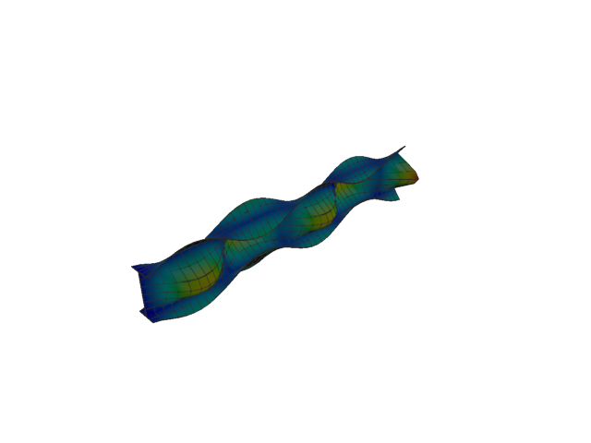
Figure 75: Sesam — mode 10, 229.460 Hz
Solver | f [Hz] | Δf vs mean [%] | λ [rad²/s²] | Meff X [kg] | Meff Y [kg] | Meff Z [kg] | Γ X | Γ Y | Γ Z
Abaqus | 242.550 | +2.77 | 2.32244e+06 | 3.62e-17 | 1.52 | 5.68e-16 | 6.02e-09 | 1.232 | 2.38e-08
Sesam | 229.460 | -2.77 | 2.07861e+06 | 1.61e-29 | 1.32 | 5.25e-27 | 4.01e-15 | -1.150 | 7.25e-14
- Mode 11
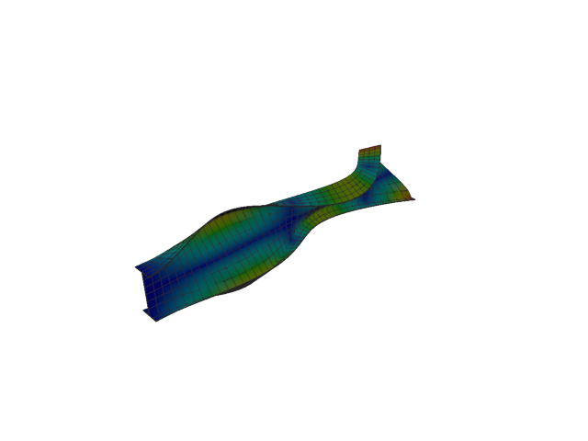
Figure 76: Abaqus — mode 11, 252.486 Hz
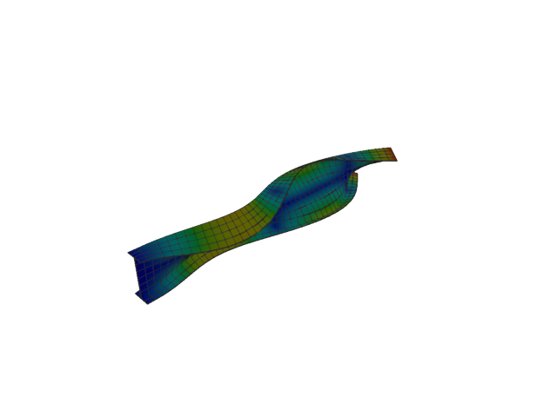
Figure 77: Sesam — mode 11, 250.786 Hz
Solver | f [Hz] | Δf vs mean [%] | λ [rad²/s²] | Meff X [kg] | Meff Y [kg] | Meff Z [kg] | Γ X | Γ Y | Γ Z
Abaqus | 252.490 | +0.34 | 2.51672e+06 | 4.88e-17 | 7.27e-17 | 7.10e-16 | 6.99e-09 | 8.53e-09 | 2.67e-08
Sesam | 250.786 | -0.34 | 2.48294e+06 | 6.33e-21 | 7.49e-20 | 8.71e-20 | 7.95e-11 | -2.74e-10 | 2.95e-10
- Shell, 1st order, QUAD, reduced integration
- Mode 1
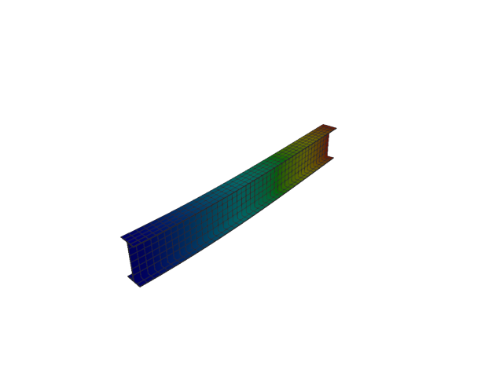
Figure 78: Abaqus — mode 1, 12.373 Hz
Solver | f [Hz] | λ [rad²/s²] | Meff X [kg] | Meff Y [kg] | Meff Z [kg] | Γ X | Γ Y | Γ Z
Abaqus | 12.373 | 6043.5 | 1.78e-28 | 119.95 | 5.35e-25 | -1.33e-14 | 10.952 | -7.31e-13
- Mode 2
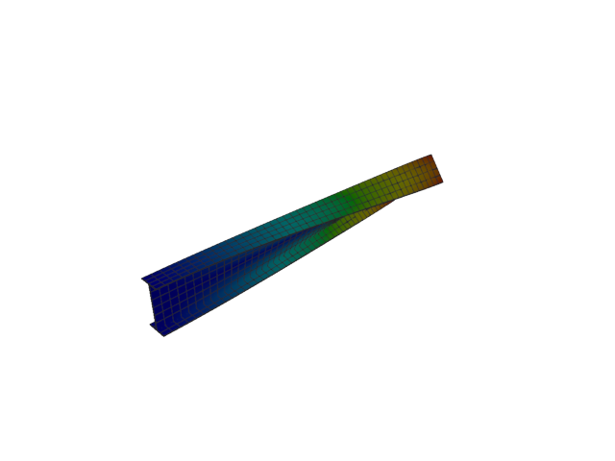
Figure 79: Abaqus — mode 2, 19.230 Hz
Solver | f [Hz] | λ [rad²/s²] | Meff X [kg] | Meff Y [kg] | Meff Z [kg] | Γ X | Γ Y | Γ Z
Abaqus | 19.230 | 14599 | 1.25e-26 | 4.60e-21 | 3.10e-26 | -1.12e-13 | 6.78e-11 | 1.76e-13
- Mode 3
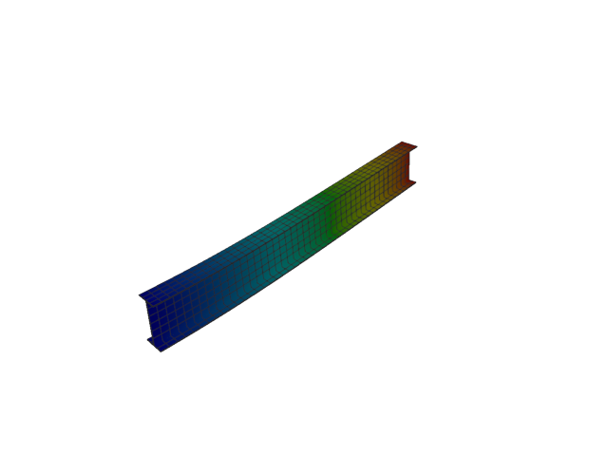
Figure 80: Abaqus — mode 3, 51.849 Hz
Solver | f [Hz] | λ [rad²/s²] | Meff X [kg] | Meff Y [kg] | Meff Z [kg] | Γ X | Γ Y | Γ Z
Abaqus | 51.849 | 106129 | 2.48e-26 | 1.19e-25 | 122.02 | -1.58e-13 | 3.45e-13 | 11.046
- Mode 4
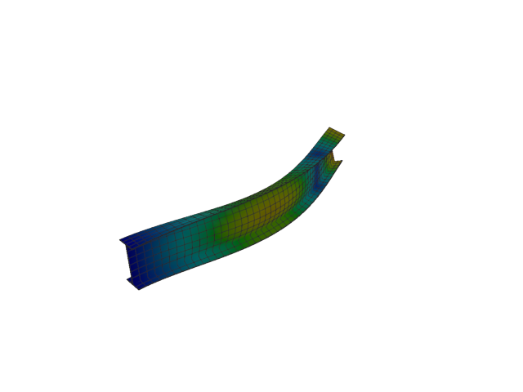
Figure 81: Abaqus — mode 4, 73.558 Hz
Solver | f [Hz] | λ [rad²/s²] | Meff X [kg] | Meff Y [kg] | Meff Z [kg] | Γ X | Γ Y | Γ Z
Abaqus | 73.558 | 213611 | 2.90e-28 | 36.98 | 6.94e-25 | -1.70e-14 | -6.081 | -8.33e-13
- Mode 5
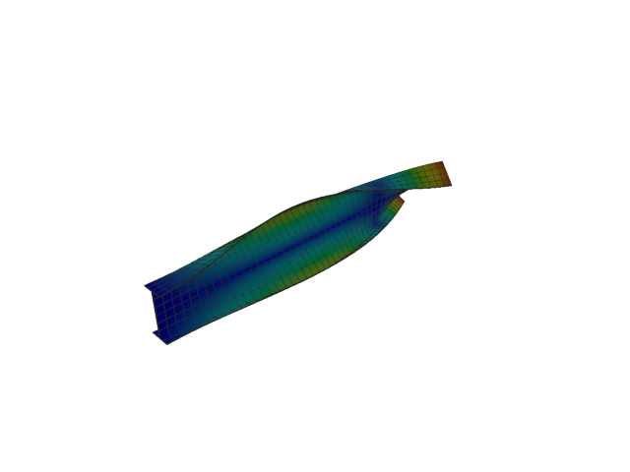
Figure 82: Abaqus — mode 5, 93.709 Hz
Solver | f [Hz] | λ [rad²/s²] | Meff X [kg] | Meff Y [kg] | Meff Z [kg] | Γ X | Γ Y | Γ Z
Abaqus | 93.709 | 346673 | 9.12e-28 | 8.02e-23 | 5.37e-26 | 3.02e-14 | -8.96e-12 | 2.32e-13
- Mode 6
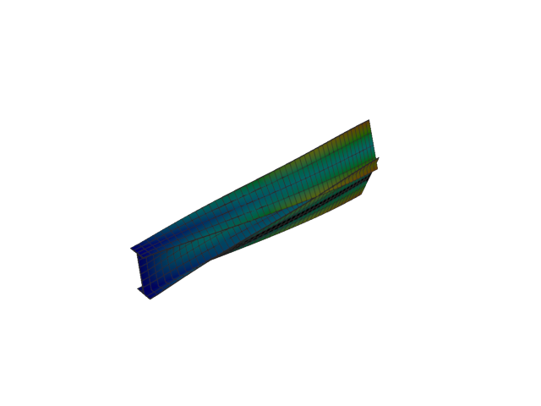
Figure 83: Abaqus — mode 6, 126.870 Hz
Solver | f [Hz] | λ [rad²/s²] | Meff X [kg] | Meff Y [kg] | Meff Z [kg] | Γ X | Γ Y | Γ Z
Abaqus | 126.870 | 635447 | 1.80e-30 | 0.01 | 1.84e-25 | 1.34e-15 | -0.078 | -4.29e-13
- Mode 7
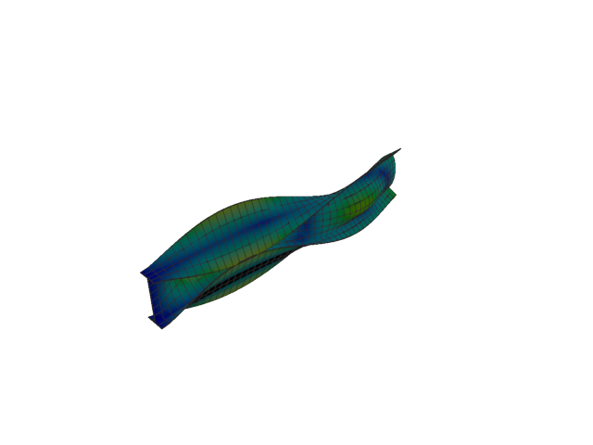
Figure 84: Abaqus — mode 7, 144.579 Hz
Solver | f [Hz] | λ [rad²/s²] | Meff X [kg] | Meff Y [kg] | Meff Z [kg] | Γ X | Γ Y | Γ Z
Abaqus | 144.580 | 825226 | 1.99e-29 | 3.79 | 2.06e-26 | -4.46e-15 | 1.947 | 1.43e-13
- Mode 8
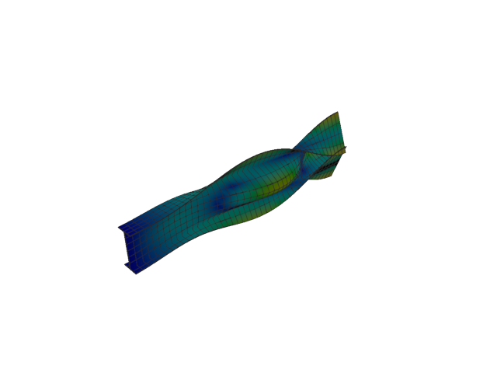
Figure 85: Abaqus — mode 8, 168.379 Hz
Solver | f [Hz] | λ [rad²/s²] | Meff X [kg] | Meff Y [kg] | Meff Z [kg] | Γ X | Γ Y | Γ Z
Abaqus | 168.380 | 1.11927e+06 | 2.51e-28 | 5.44 | 1.97e-25 | 1.58e-14 | 2.332 | -4.43e-13
- Mode 9
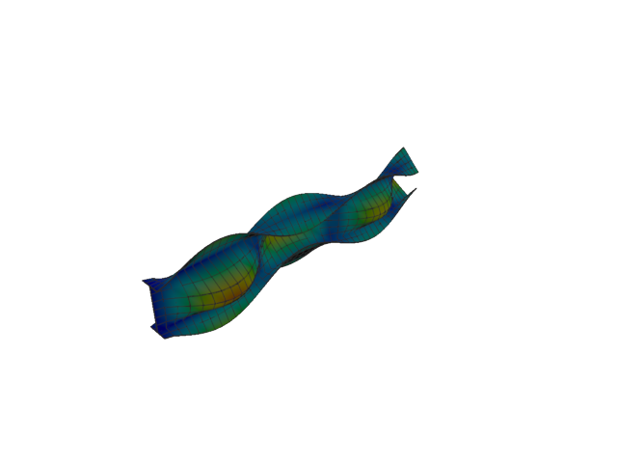
Figure 86: Abaqus — mode 9, 197.515 Hz
Solver | f [Hz] | λ [rad²/s²] | Meff X [kg] | Meff Y [kg] | Meff Z [kg] | Γ X | Γ Y | Γ Z
Abaqus | 197.510 | 1.54014e+06 | 1.19e-26 | 0.62 | 1.84e-25 | -1.09e-13 | -0.786 | 4.29e-13
- Mode 10
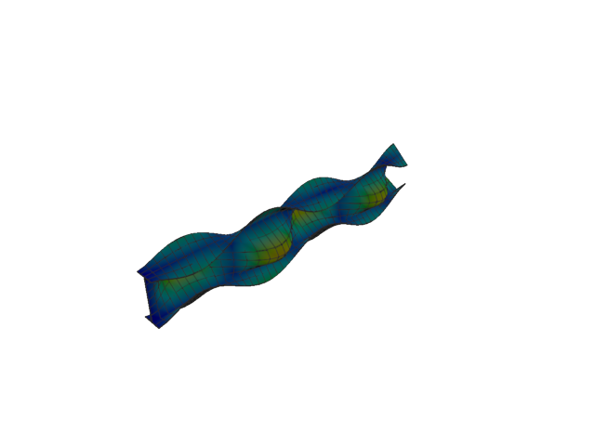
Figure 87: Abaqus — mode 10, 241.275 Hz
Solver | f [Hz] | λ [rad²/s²] | Meff X [kg] | Meff Y [kg] | Meff Z [kg] | Γ X | Γ Y | Γ Z
Abaqus | 241.270 | 2.29818e+06 | 2.67e-22 | 1.61 | 1.69e-20 | -1.63e-11 | 1.269 | 1.30e-10
- Mode 11
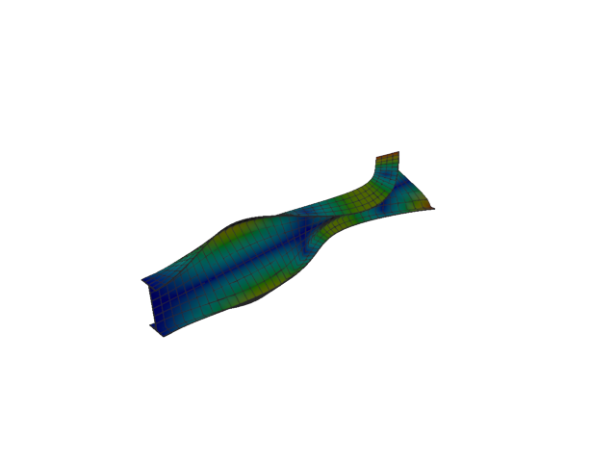
Figure 88: Abaqus — mode 11, 245.071 Hz
Solver | f [Hz] | λ [rad²/s²] | Meff X [kg] | Meff Y [kg] | Meff Z [kg] | Γ X | Γ Y | Γ Z
Abaqus | 245.070 | 2.37106e+06 | 3.55e-23 | 8.35e-21 | 8.47e-21 | -5.95e-12 | 9.14e-11 | 9.20e-11
- Shell, 2nd order, TRI
- Mode 1
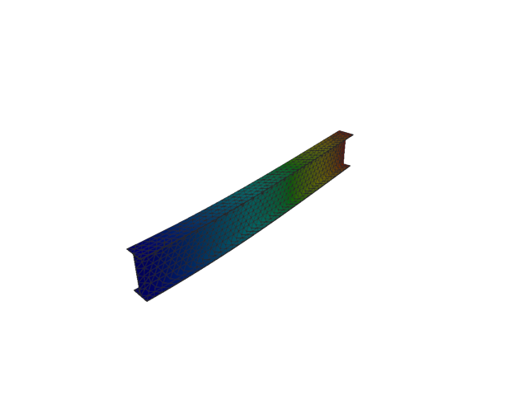
Figure 89: Abaqus — mode 1, 12.756 Hz
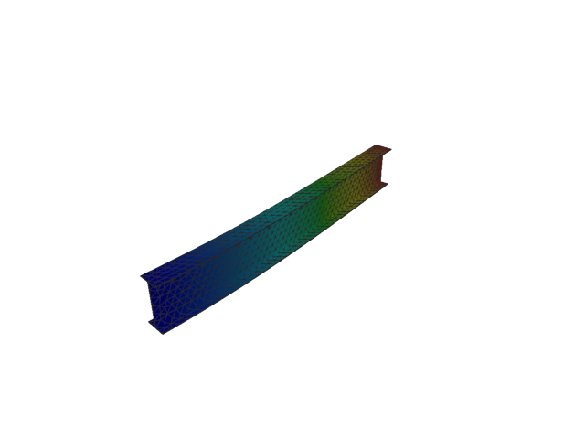
Figure 90: Sesam — mode 1, 12.756 Hz
Solver | f [Hz] | Δf vs mean [%] | λ [rad²/s²] | Meff X [kg] | Meff Y [kg] | Meff Z [kg] | Γ X | Γ Y | Γ Z
Abaqus | 12.756 | 9.02e-04 | 6423.3 | 2.07e-18 | 119.94 | 3.02e-12 | 1.44e-09 | 10.952 | 1.74e-06
Sesam | 12.756 | -9.02e-04 | 6423.52 | 1.73e-27 | 119.94 | 5.84e-24 | -4.16e-14 | 10.952 | -2.42e-12
- Mode 2
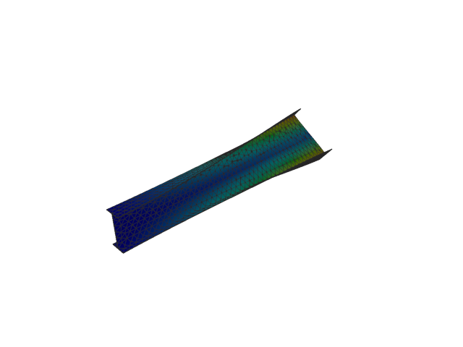
Figure 91: Abaqus — mode 2, 19.567 Hz
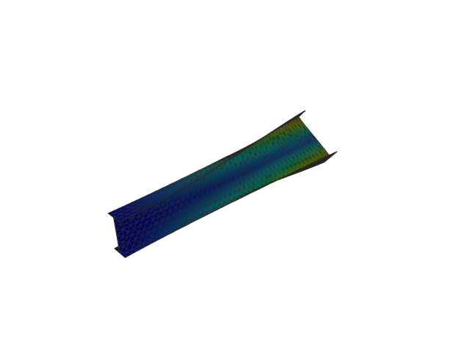
Figure 92: Sesam — mode 2, 19.505 Hz
Solver | f [Hz] | Δf vs mean [%] | λ [rad²/s²] | Meff X [kg] | Meff Y [kg] | Meff Z [kg] | Γ X | Γ Y | Γ Z
Abaqus | 19.567 | +0.16 | 15115 | 3.71e-13 | 3.08e-10 | 4.41e-12 | 6.09e-07 | 1.75e-05 | -2.10e-06
Sesam | 19.505 | -0.16 | 15019.1 | 2.03e-25 | 1.78e-08 | 1.33e-23 | 4.51e-13 | 1.33e-04 | 3.65e-12
- Mode 3
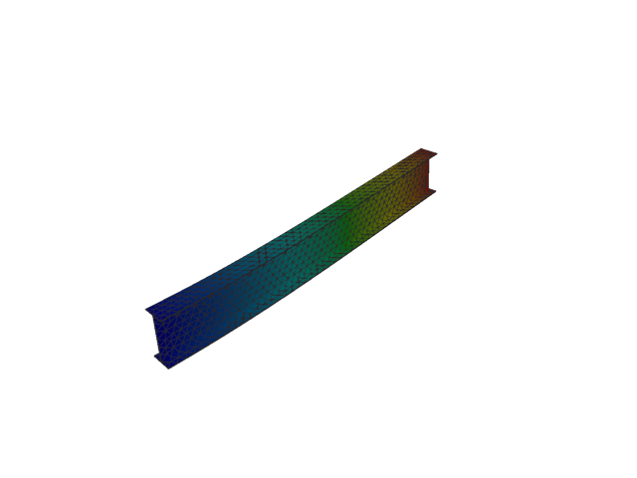
Figure 93: Abaqus — mode 3, 51.969 Hz
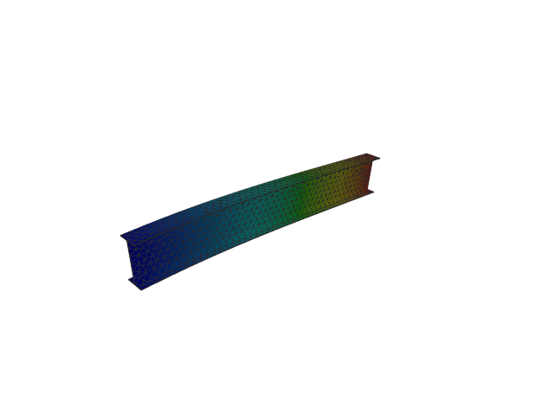
Figure 94: Sesam — mode 3, 51.970 Hz
Solver | f [Hz] | Δf vs mean [%] | λ [rad²/s²] | Meff X [kg] | Meff Y [kg] | Meff Z [kg] | Γ X | Γ Y | Γ Z
Abaqus | 51.969 | -1.34e-03 | 106622 | 4.50e-14 | 9.00e-10 | 122.03 | 2.12e-07 | 3.00e-05 | 11.047
Sesam | 51.970 | 1.34e-03 | 106628 | 6.59e-14 | 9.47e-24 | 122.03 | -2.57e-07 | -3.08e-12 | -11.047
- Mode 4
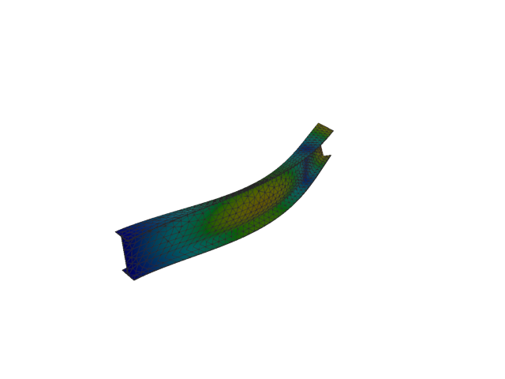
Figure 95: Abaqus — mode 4, 75.145 Hz
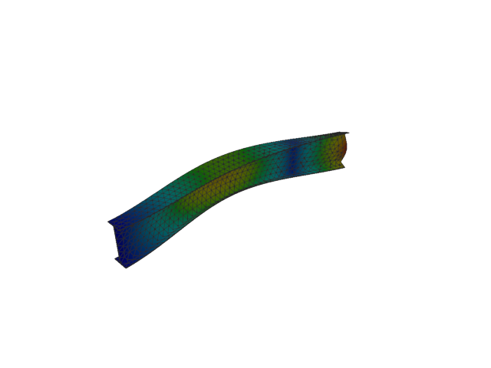
Figure 96: Sesam — mode 4, 75.172 Hz
Solver | f [Hz] | Δf vs mean [%] | λ [rad²/s²] | Meff X [kg] | Meff Y [kg] | Meff Z [kg] | Γ X | Γ Y | Γ Z
Abaqus | 75.145 | -0.02 | 222925 | 1.24e-16 | 36.88 | 1.80e-09 | 1.11e-08 | -6.073 | 4.24e-05
Sesam | 75.172 | +0.02 | 223083 | 1.13e-25 | 36.87 | 8.58e-25 | -3.36e-13 | 6.072 | -9.26e-13
- Mode 5
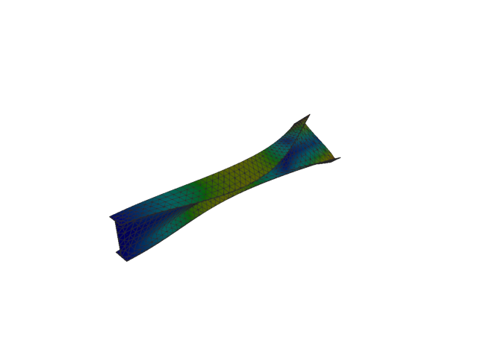
Figure 97: Abaqus — mode 5, 96.001 Hz
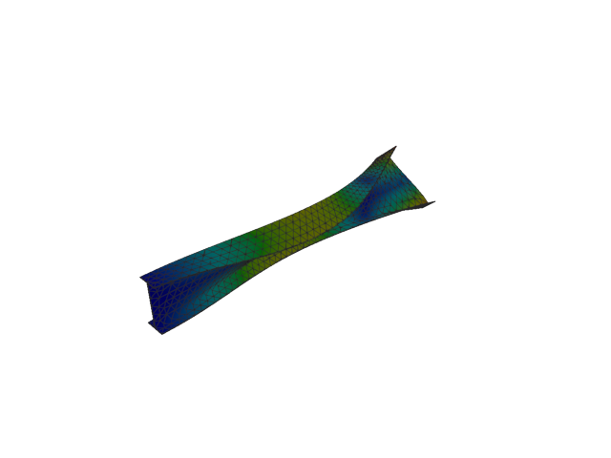
Figure 98: Sesam — mode 5, 95.934 Hz
Solver | f [Hz] | Δf vs mean [%] | λ [rad²/s²] | Meff X [kg] | Meff Y [kg] | Meff Z [kg] | Γ X | Γ Y | Γ Z
Abaqus | 96.001 | +0.04 | 363843 | 8.08e-12 | 6.17e-09 | 5.02e-12 | -2.84e-06 | -7.85e-05 | 2.24e-06
Sesam | 95.934 | -0.04 | 363330 | 7.77e-26 | 1.06e-09 | 4.95e-24 | -2.79e-13 | 3.26e-05 | 2.22e-12
- Mode 6
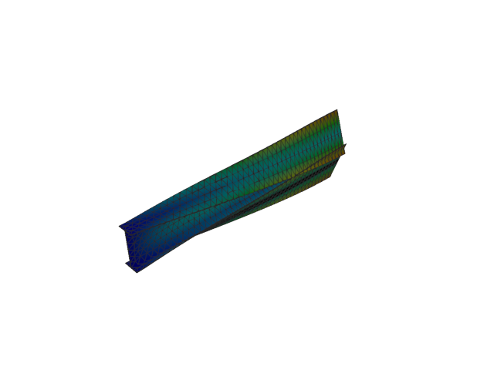
Figure 99: Abaqus — mode 6, 125.207 Hz
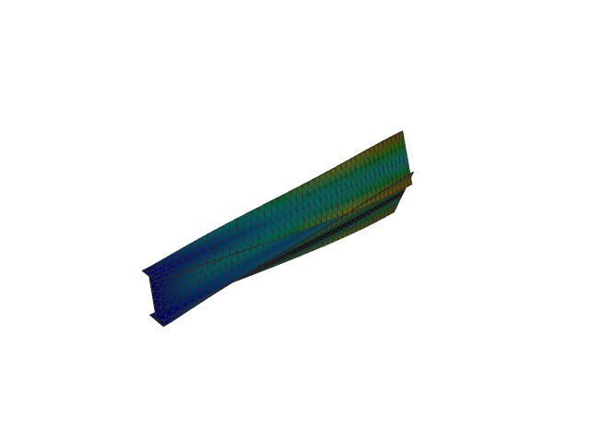
Figure 100: Sesam — mode 6, 125.173 Hz
Solver | f [Hz] | Δf vs mean [%] | λ [rad²/s²] | Meff X [kg] | Meff Y [kg] | Meff Z [kg] | Γ X | Γ Y | Γ Z
Abaqus | 125.210 | +0.01 | 618895 | 4.62e-16 | 0.02 | 1.76e-10 | -2.15e-08 | -0.138 | -1.33e-05
Sesam | 125.173 | -0.01 | 618555 | 1.13e-26 | 0.02 | 5.47e-23 | 1.06e-13 | -0.144 | 7.40e-12
- Mode 7
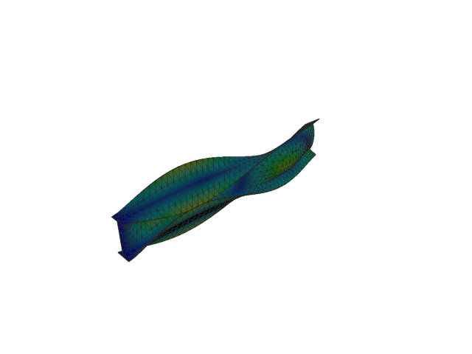
Figure 101: Abaqus — mode 7, 142.773 Hz
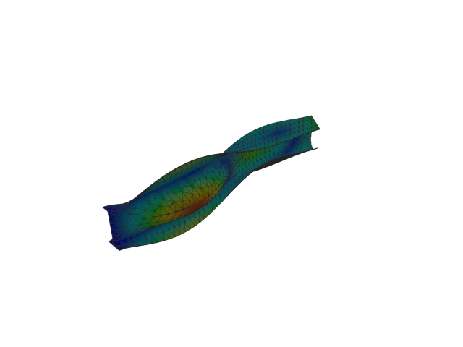
Figure 102: Sesam — mode 7, 142.768 Hz
Solver | f [Hz] | Δf vs mean [%] | λ [rad²/s²] | Meff X [kg] | Meff Y [kg] | Meff Z [kg] | Γ X | Γ Y | Γ Z
Abaqus | 142.770 | 5.60e-04 | 804737 | 9.41e-15 | 3.54 | 1.08e-09 | -9.70e-08 | 1.880 | 3.28e-05
Sesam | 142.768 | -5.60e-04 | 804681 | 3.82e-26 | 3.42 | 8.44e-24 | -1.95e-13 | -1.850 | 2.90e-12
- Mode 8
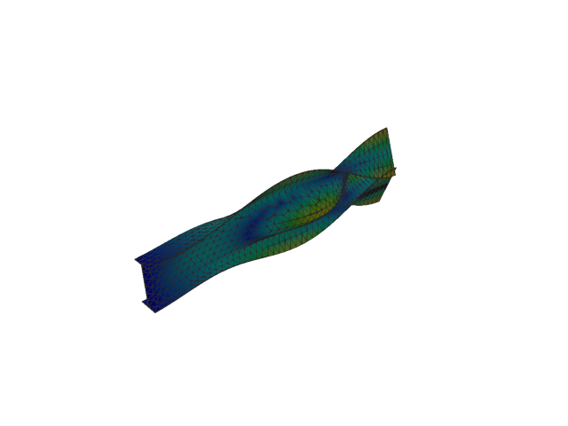
Figure 103: Abaqus — mode 8, 166.598 Hz
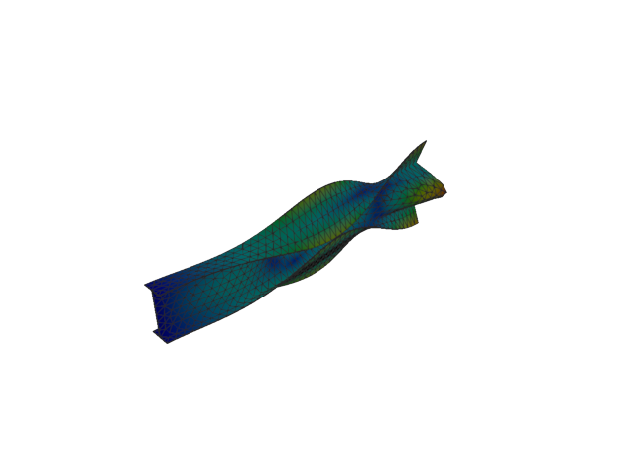
Figure 104: Sesam — mode 8, 166.334 Hz
Solver | f [Hz] | Δf vs mean [%] | λ [rad²/s²] | Meff X [kg] | Meff Y [kg] | Meff Z [kg] | Γ X | Γ Y | Γ Z
Abaqus | 166.600 | +0.08 | 1.09572e+06 | 1.06e-14 | 5.52 | 1.13e-08 | -1.03e-07 | 2.349 | 1.06e-04
Sesam | 166.334 | -0.08 | 1.09224e+06 | 4.59e-26 | 5.56 | 5.51e-24 | 2.14e-13 | -2.358 | -2.35e-12
- Mode 9
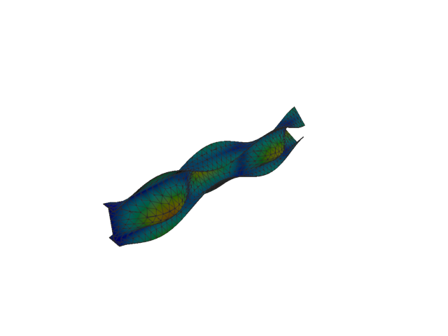
Figure 105: Abaqus — mode 9, 192.840 Hz
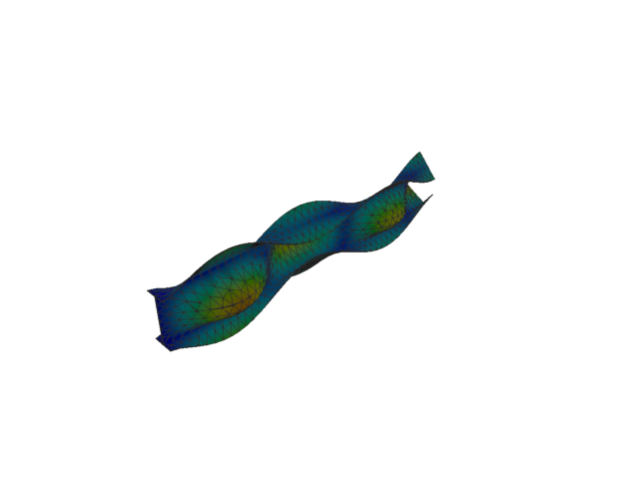
Figure 106: Sesam — mode 9, 193.308 Hz
Solver | f [Hz] | Δf vs mean [%] | λ [rad²/s²] | Meff X [kg] | Meff Y [kg] | Meff Z [kg] | Γ X | Γ Y | Γ Z
Abaqus | 192.840 | -0.12 | 1.4681e+06 | 5.91e-14 | 0.67 | 5.79e-09 | 2.43e-07 | -0.818 | -7.61e-05
Sesam | 193.308 | +0.12 | 1.47524e+06 | 3.41e-27 | 0.64 | 9.39e-26 | 5.84e-14 | -0.801 | 3.06e-13
- Mode 10
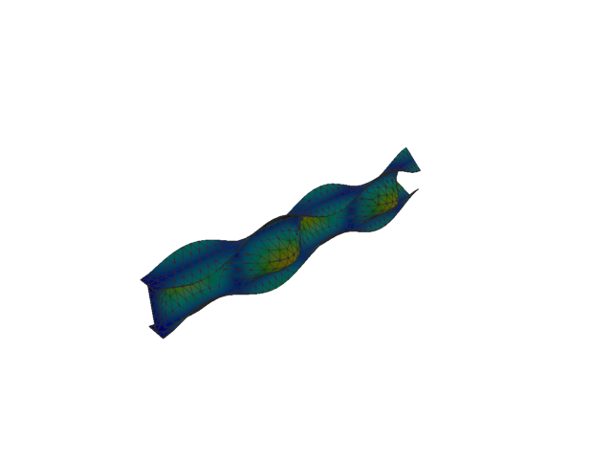
Figure 107: Abaqus — mode 10, 233.355 Hz
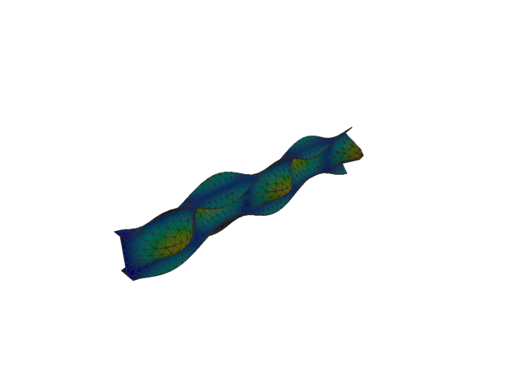
Figure 108: Sesam — mode 10, 234.613 Hz
Solver | f [Hz] | Δf vs mean [%] | λ [rad²/s²] | Meff X [kg] | Meff Y [kg] | Meff Z [kg] | Γ X | Γ Y | Γ Z
Abaqus | 233.360 | -0.27 | 2.14979e+06 | 3.28e-15 | 1.38 | 3.26e-07 | -5.73e-08 | 1.175 | 0.001
Sesam | 234.613 | +0.27 | 2.17302e+06 | 1.23e-18 | 1.40 | 2.13e-20 | -1.11e-09 | -1.185 | -1.46e-10
- Mode 11
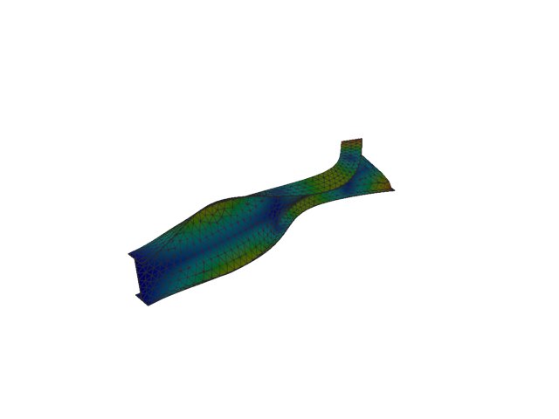
Figure 109: Abaqus — mode 11, 250.125 Hz
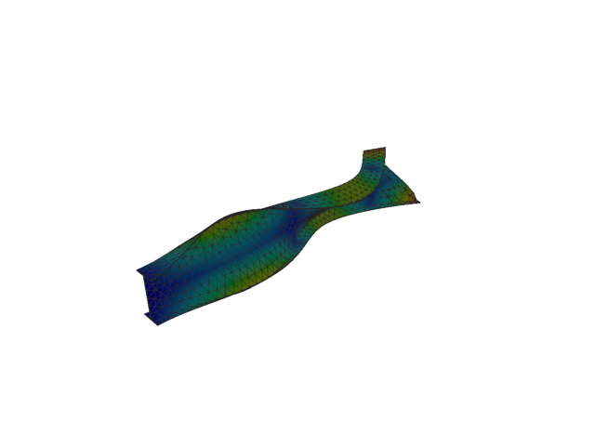
Figure 110: Sesam — mode 11, 250.240 Hz
Solver | f [Hz] | Δf vs mean [%] | λ [rad²/s²] | Meff X [kg] | Meff Y [kg] | Meff Z [kg] | Γ X | Γ Y | Γ Z
Abaqus | 250.130 | -0.02 | 2.46987e+06 | 9.03e-11 | 3.18e-08 | 4.03e-09 | 9.50e-06 | 1.78e-04 | 6.35e-05
Sesam | 250.240 | +0.02 | 2.47215e+06 | 1.60e-13 | 1.65e-06 | 2.77e-15 | -4.01e-07 | 0.001 | -5.26e-08
- Shell, 2nd order, QUAD
- Mode 1
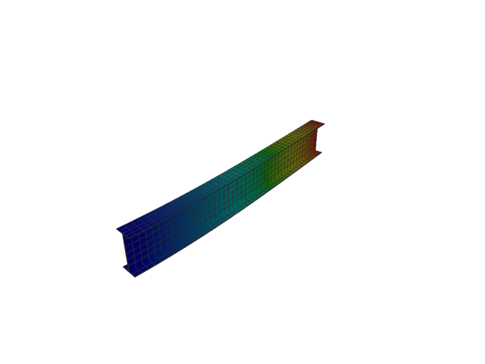
Figure 111: Abaqus — mode 1, 12.758 Hz
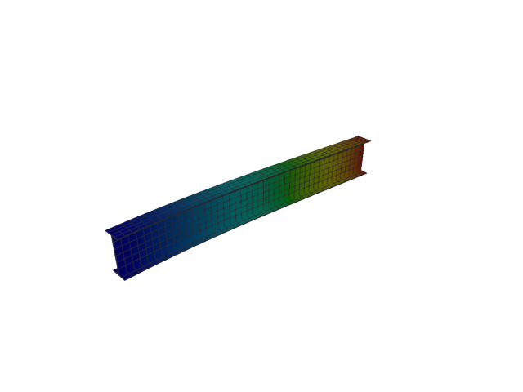
Figure 112: Sesam — mode 1, 12.755 Hz
Solver | f [Hz] | Δf vs mean [%] | λ [rad²/s²] | Meff X [kg] | Meff Y [kg] | Meff Z [kg] | Γ X | Γ Y | Γ Z
Abaqus | 12.758 | +0.01 | 6426.1 | 1.23e-25 | 119.92 | 9.18e-25 | 3.51e-13 | 10.951 | 9.58e-13
Sesam | 12.755 | -0.01 | 6423.15 | 3.36e-26 | 119.94 | 2.47e-24 | -1.83e-13 | -10.952 | -1.57e-12
- Mode 2
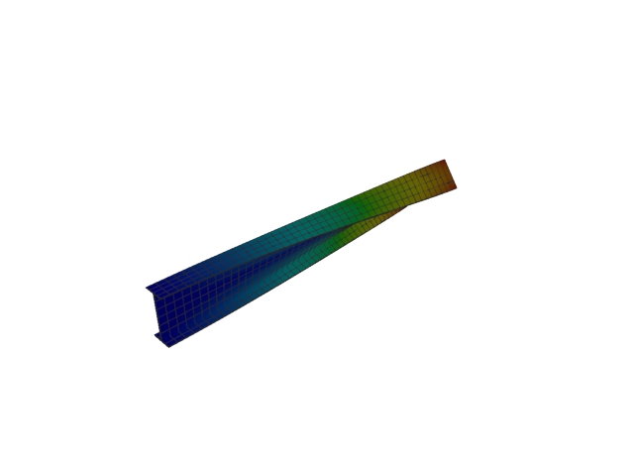
Figure 113: Abaqus — mode 2, 19.486 Hz
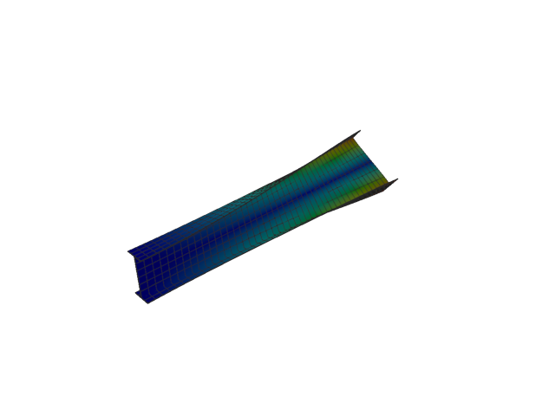
Figure 114: Sesam — mode 2, 19.473 Hz
Solver | f [Hz] | Δf vs mean [%] | λ [rad²/s²] | Meff X [kg] | Meff Y [kg] | Meff Z [kg] | Γ X | Γ Y | Γ Z
Abaqus | 19.486 | +0.03 | 14990 | 1.04e-26 | 4.65e-20 | 2.40e-23 | 1.02e-13 | 2.16e-10 | 4.90e-12
Sesam | 19.473 | -0.03 | 14970.3 | 4.30e-26 | 1.24e-18 | 1.37e-23 | -2.07e-13 | 1.11e-09 | 3.71e-12
- Mode 3
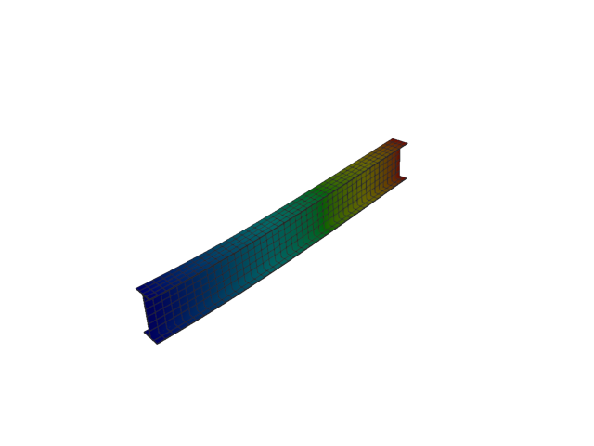
Figure 115: Abaqus — mode 3, 51.998 Hz
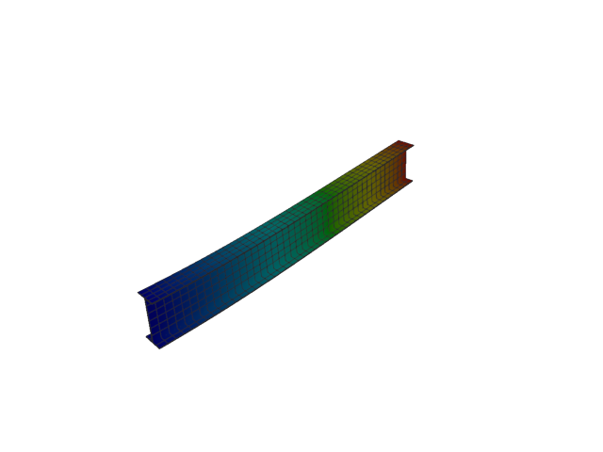
Figure 116: Sesam — mode 3, 51.970 Hz
Solver | f [Hz] | Δf vs mean [%] | λ [rad²/s²] | Meff X [kg] | Meff Y [kg] | Meff Z [kg] | Γ X | Γ Y | Γ Z
Abaqus | 51.998 | +0.03 | 106740 | 5.15e-27 | 9.66e-26 | 121.97 | 7.18e-14 | 3.11e-13 | 11.044
Sesam | 51.970 | -0.03 | 106628 | 6.42e-26 | 7.11e-25 | 122.03 | -2.53e-13 | -8.43e-13 | 11.047
- Mode 4
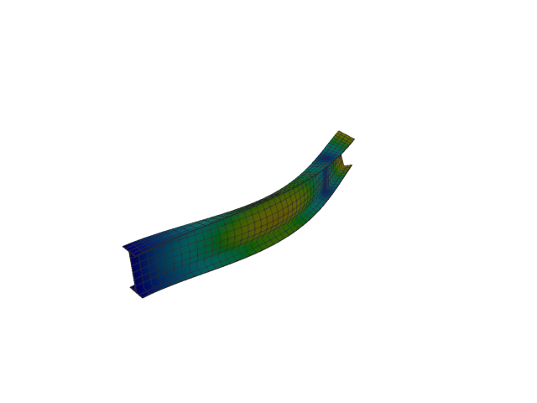
Figure 117: Abaqus — mode 4, 75.149 Hz
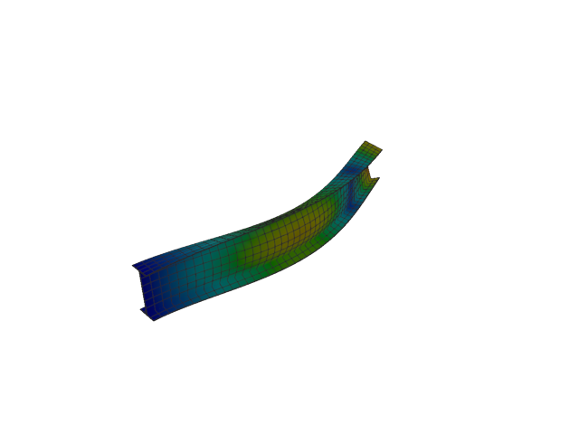
Figure 118: Sesam — mode 4, 75.125 Hz
Solver | f [Hz] | Δf vs mean [%] | λ [rad²/s²] | Meff X [kg] | Meff Y [kg] | Meff Z [kg] | Γ X | Γ Y | Γ Z
Abaqus | 75.149 | +0.02 | 222949 | 1.40e-27 | 36.85 | 6.29e-24 | -3.75e-14 | -6.071 | 2.51e-12
Sesam | 75.125 | -0.02 | 222804 | 2.91e-28 | 36.86 | 2.56e-24 | -1.70e-14 | -6.071 | 1.60e-12
- Mode 5
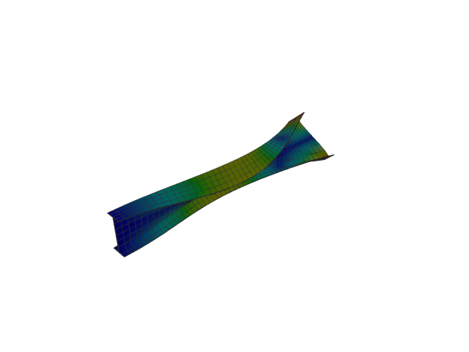
Figure 119: Abaqus — mode 5, 95.920 Hz
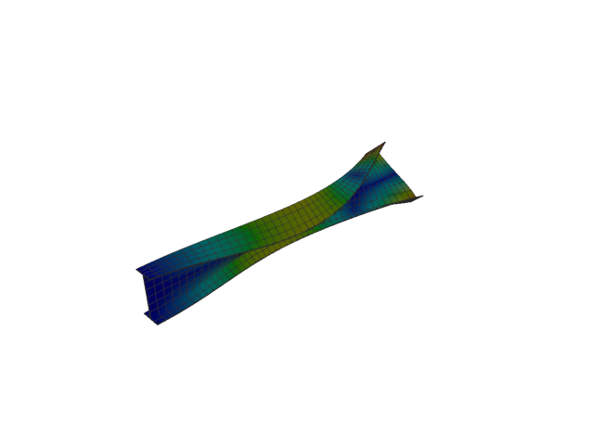
Figure 120: Sesam — mode 5, 95.889 Hz
Solver | f [Hz] | Δf vs mean [%] | λ [rad²/s²] | Meff X [kg] | Meff Y [kg] | Meff Z [kg] | Γ X | Γ Y | Γ Z
Abaqus | 95.920 | +0.02 | 363224 | 7.50e-27 | 2.54e-21 | 8.04e-25 | -8.66e-14 | -5.04e-11 | -8.97e-13
Sesam | 95.889 | -0.02 | 362989 | 1.39e-26 | 1.97e-21 | 1.90e-24 | 1.18e-13 | 4.44e-11 | -1.38e-12
- Mode 6
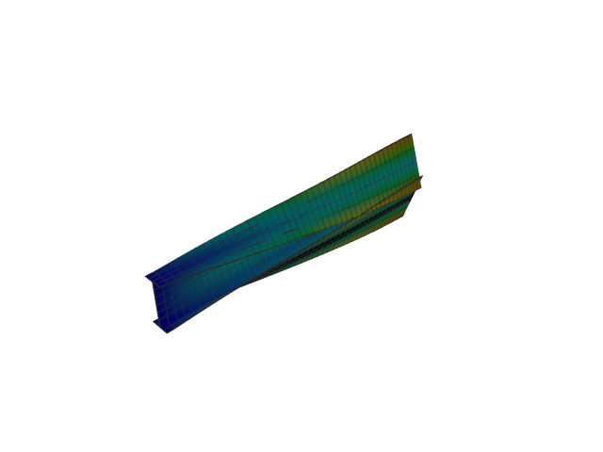
Figure 121: Abaqus — mode 6, 125.001 Hz
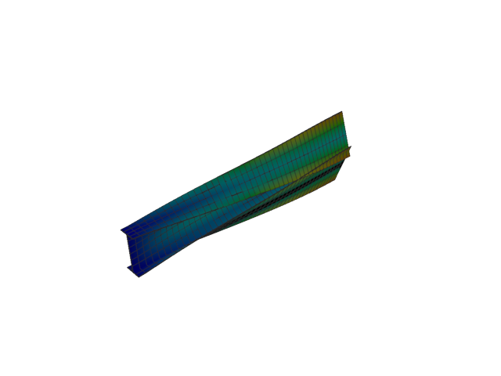
Figure 122: Sesam — mode 6, 124.987 Hz
Solver | f [Hz] | Δf vs mean [%] | λ [rad²/s²] | Meff X [kg] | Meff Y [kg] | Meff Z [kg] | Γ X | Γ Y | Γ Z
Abaqus | 125.000 | +0.01 | 616856 | 5.44e-26 | 0.02 | 4.78e-23 | -2.33e-13 | -0.137 | 6.92e-12
Sesam | 124.987 | -0.01 | 616722 | 1.29e-26 | 0.02 | 6.86e-24 | -1.13e-13 | -0.137 | 2.62e-12
- Mode 7
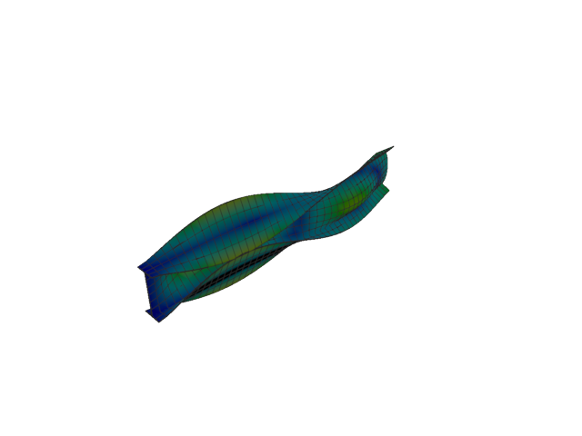
Figure 123: Abaqus — mode 7, 142.325 Hz
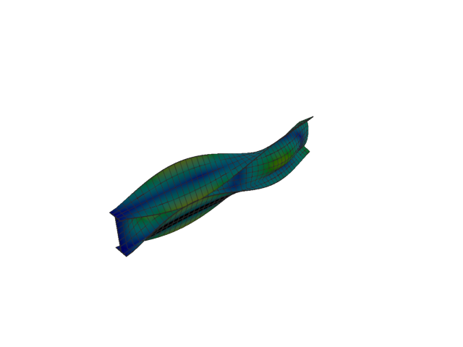
Figure 124: Sesam — mode 7, 142.234 Hz
Solver | f [Hz] | Δf vs mean [%] | λ [rad²/s²] | Meff X [kg] | Meff Y [kg] | Meff Z [kg] | Γ X | Γ Y | Γ Z
Abaqus | 142.320 | +0.03 | 799690 | 2.49e-27 | 3.45 | 4.42e-24 | -4.99e-14 | 1.858 | -2.10e-12
Sesam | 142.234 | -0.03 | 798665 | 6.03e-28 | 3.45 | 4.89e-25 | 2.46e-14 | 1.859 | -6.99e-13
- Mode 8
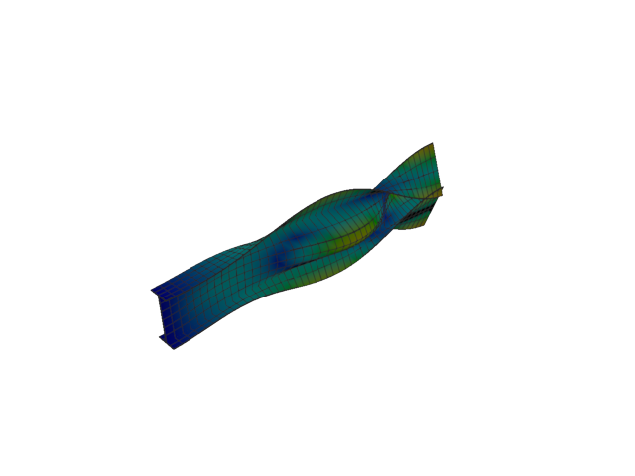
Figure 125: Abaqus — mode 8, 165.849 Hz
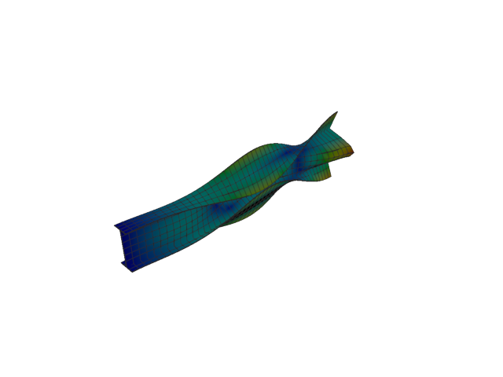
Figure 126: Sesam — mode 8, 165.718 Hz
Solver | f [Hz] | Δf vs mean [%] | λ [rad²/s²] | Meff X [kg] | Meff Y [kg] | Meff Z [kg] | Γ X | Γ Y | Γ Z
Abaqus | 165.850 | +0.04 | 1.08589e+06 | 2.43e-27 | 5.53 | 1.06e-23 | -4.93e-14 | 2.351 | 3.25e-12
Sesam | 165.718 | -0.04 | 1.08418e+06 | 4.51e-28 | 5.52 | 2.31e-24 | -2.12e-14 | -2.350 | -1.52e-12
- Mode 9
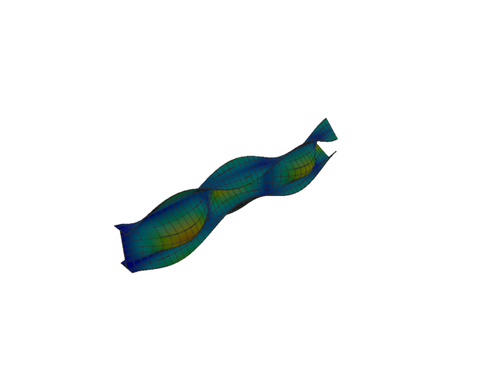
Figure 127: Abaqus — mode 9, 192.184 Hz
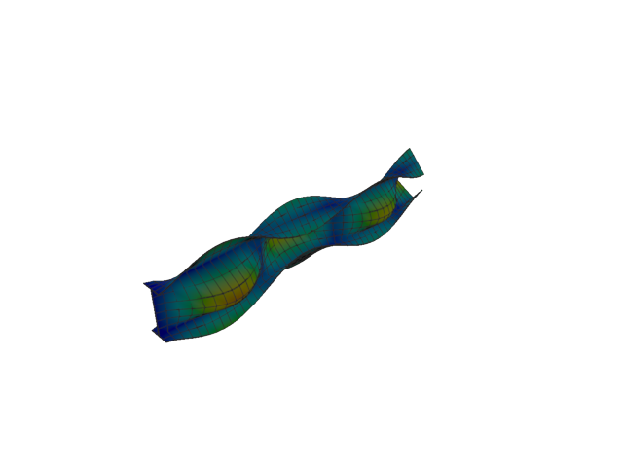
Figure 128: Sesam — mode 9, 191.999 Hz
Solver | f [Hz] | Δf vs mean [%] | λ [rad²/s²] | Meff X [kg] | Meff Y [kg] | Meff Z [kg] | Γ X | Γ Y | Γ Z
Abaqus | 192.180 | +0.05 | 1.45812e+06 | 1.15e-27 | 0.65 | 1.20e-25 | -3.40e-14 | -0.808 | 3.47e-13
Sesam | 191.999 | -0.05 | 1.45531e+06 | 3.95e-28 | 0.65 | 4.22e-27 | 1.99e-14 | -0.809 | 6.50e-14
- Mode 10
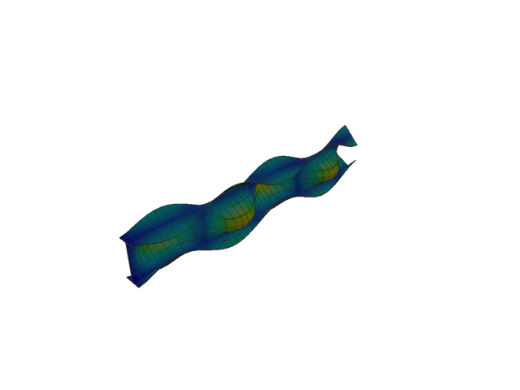
Figure 129: Abaqus — mode 10, 232.867 Hz
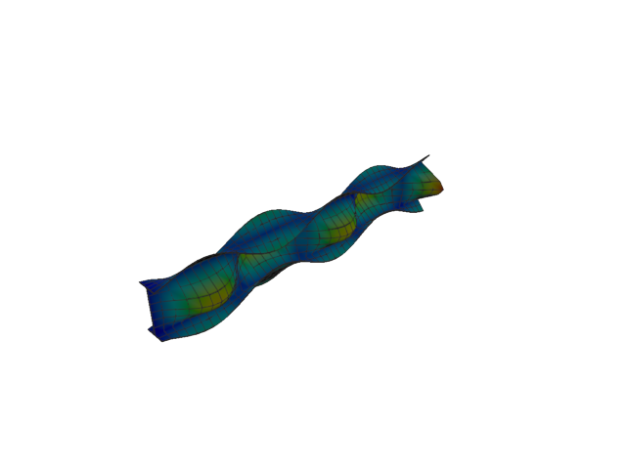
Figure 130: Sesam — mode 10, 232.626 Hz
Solver | f [Hz] | Δf vs mean [%] | λ [rad²/s²] | Meff X [kg] | Meff Y [kg] | Meff Z [kg] | Γ X | Γ Y | Γ Z
Abaqus | 232.870 | +0.05 | 2.14079e+06 | 4.88e-26 | 1.37 | 1.33e-23 | -2.21e-13 | 1.170 | -3.65e-12
Sesam | 232.626 | -0.05 | 2.13637e+06 | 1.30e-26 | 1.37 | 2.70e-25 | -1.14e-13 | -1.171 | -5.20e-13
- Mode 11
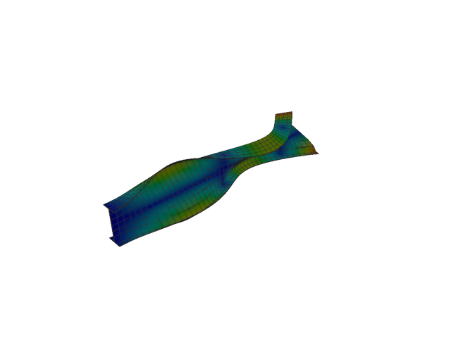
Figure 131: Abaqus — mode 11, 250.173 Hz
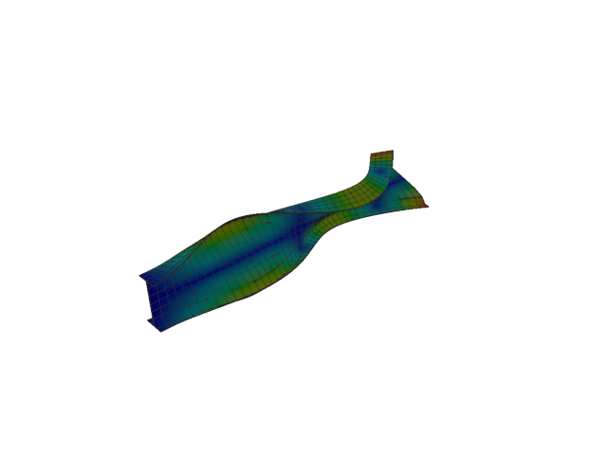
Figure 132: Sesam — mode 11, 250.095 Hz
Solver | f [Hz] | Δf vs mean [%] | λ [rad²/s²] | Meff X [kg] | Meff Y [kg] | Meff Z [kg] | Γ X | Γ Y | Γ Z
Abaqus | 250.170 | +0.01 | 2.47082e+06 | 3.28e-21 | 3.98e-19 | 6.25e-19 | 5.72e-11 | 6.31e-10 | -7.90e-10
Sesam | 250.095 | -0.01 | 2.46928e+06 | 1.10e-19 | 3.85e-22 | 2.18e-21 | -3.32e-10 | -1.96e-11 | 4.67e-11
- Shell, 2nd order, QUAD, reduced integration
- Mode 1
Figure 133: Abaqus — mode 1, 12.758 Hz
Solver | f [Hz] | λ [rad²/s²] | Meff X [kg] | Meff Y [kg] | Meff Z [kg] | Γ X | Γ Y | Γ Z
Abaqus | 12.758 | 6426.1 | 1.23e-25 | 119.92 | 9.18e-25 | 3.51e-13 | 10.951 | 9.58e-13
- Mode 2
Figure 134: Abaqus — mode 2, 19.486 Hz
Solver | f [Hz] | λ [rad²/s²] | Meff X [kg] | Meff Y [kg] | Meff Z [kg] | Γ X | Γ Y | Γ Z
Abaqus | 19.486 | 14990 | 1.04e-26 | 4.65e-20 | 2.40e-23 | 1.02e-13 | 2.16e-10 | 4.90e-12
- Mode 3
Figure 135: Abaqus — mode 3, 51.998 Hz
Solver | f [Hz] | λ [rad²/s²] | Meff X [kg] | Meff Y [kg] | Meff Z [kg] | Γ X | Γ Y | Γ Z
Abaqus | 51.998 | 106740 | 5.15e-27 | 9.66e-26 | 121.97 | 7.18e-14 | 3.11e-13 | 11.044
- Mode 4
Figure 136: Abaqus — mode 4, 75.149 Hz
Solver | f [Hz] | λ [rad²/s²] | Meff X [kg] | Meff Y [kg] | Meff Z [kg] | Γ X | Γ Y | Γ Z
Abaqus | 75.149 | 222949 | 1.40e-27 | 36.85 | 6.29e-24 | -3.75e-14 | -6.071 | 2.51e-12
- Mode 5
Figure 137: Abaqus — mode 5, 95.920 Hz
Solver | f [Hz] | λ [rad²/s²] | Meff X [kg] | Meff Y [kg] | Meff Z [kg] | Γ X | Γ Y | Γ Z
Abaqus | 95.920 | 363224 | 7.50e-27 | 2.54e-21 | 8.04e-25 | -8.66e-14 | -5.04e-11 | -8.97e-13
- Mode 6
Figure 138: Abaqus — mode 6, 125.001 Hz
Solver | f [Hz] | λ [rad²/s²] | Meff X [kg] | Meff Y [kg] | Meff Z [kg] | Γ X | Γ Y | Γ Z
Abaqus | 125.000 | 616856 | 5.44e-26 | 0.02 | 4.78e-23 | -2.33e-13 | -0.137 | 6.92e-12
- Mode 7
Figure 139: Abaqus — mode 7, 142.325 Hz
Solver | f [Hz] | λ [rad²/s²] | Meff X [kg] | Meff Y [kg] | Meff Z [kg] | Γ X | Γ Y | Γ Z
Abaqus | 142.320 | 799690 | 2.49e-27 | 3.45 | 4.42e-24 | -4.99e-14 | 1.858 | -2.10e-12
- Mode 8
Figure 140: Abaqus — mode 8, 165.849 Hz
Solver | f [Hz] | λ [rad²/s²] | Meff X [kg] | Meff Y [kg] | Meff Z [kg] | Γ X | Γ Y | Γ Z
Abaqus | 165.850 | 1.08589e+06 | 2.43e-27 | 5.53 | 1.06e-23 | -4.93e-14 | 2.351 | 3.25e-12
- Mode 9
Figure 141: Abaqus — mode 9, 192.184 Hz
Solver | f [Hz] | λ [rad²/s²] | Meff X [kg] | Meff Y [kg] | Meff Z [kg] | Γ X | Γ Y | Γ Z
Abaqus | 192.180 | 1.45812e+06 | 1.15e-27 | 0.65 | 1.20e-25 | -3.40e-14 | -0.808 | 3.47e-13
- Mode 10
Figure 142: Abaqus — mode 10, 232.867 Hz
Solver | f [Hz] | λ [rad²/s²] | Meff X [kg] | Meff Y [kg] | Meff Z [kg] | Γ X | Γ Y | Γ Z
Abaqus | 232.870 | 2.14079e+06 | 4.88e-26 | 1.37 | 1.33e-23 | -2.21e-13 | 1.170 | -3.65e-12
- Mode 11
Figure 143: Abaqus — mode 11, 250.173 Hz
Solver | f [Hz] | λ [rad²/s²] | Meff X [kg] | Meff Y [kg] | Meff Z [kg] | Γ X | Γ Y | Γ Z
Abaqus | 250.170 | 2.47082e+06 | 3.28e-21 | 3.98e-19 | 6.25e-19 | 5.72e-11 | 6.31e-10 | -7.90e-10
- Solid, 1st order, TET
- Mode 1
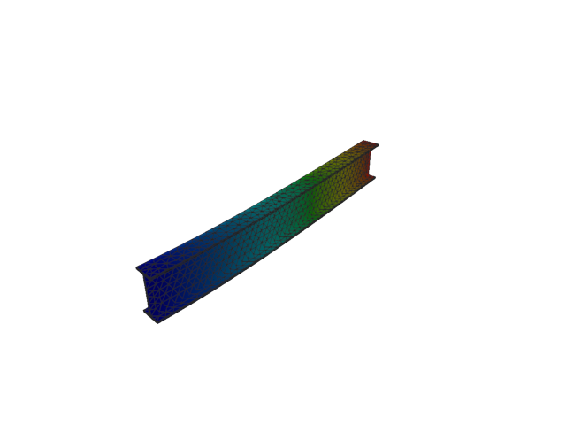
Figure 144: Abaqus — mode 1, 15.790 Hz
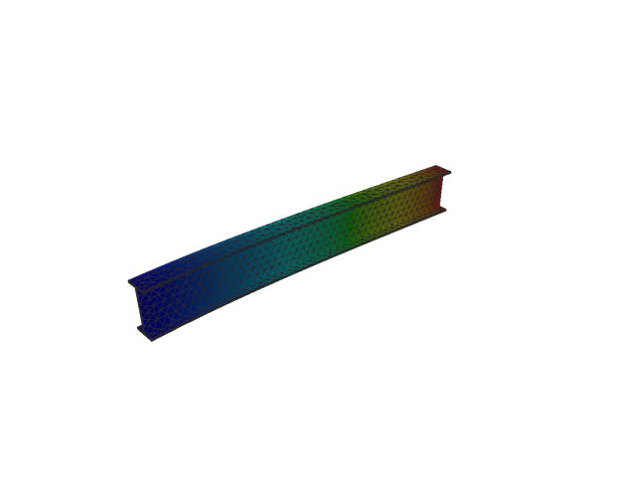
Figure 145: Sesam — mode 1, 15.793 Hz
Solver | f [Hz] | Δf vs mean [%] | λ [rad²/s²] | Meff X [kg] | Meff Y [kg] | Meff Z [kg] | Γ X | Γ Y | Γ Z
Abaqus | 15.790 | -0.01 | 9842.9 | 2.50e-14 | 117.47 | 2.82e-04 | 1.58e-07 | 10.838 | -0.017
Sesam | 15.793 | +0.01 | 9846.92 | 5.82e-13 | 117.52 | 2.82e-04 | 7.63e-07 | -10.841 | 0.017
- Mode 2
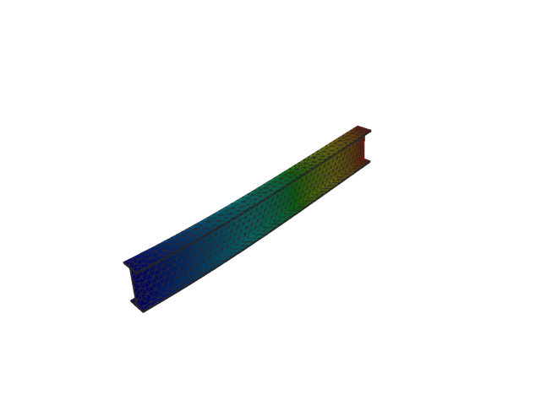
Figure 146: Abaqus — mode 2, 51.532 Hz
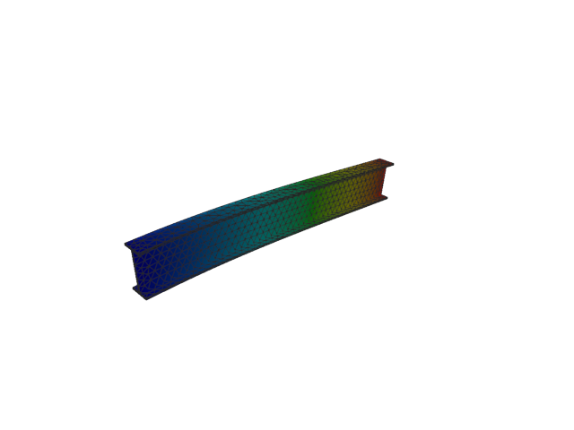
Figure 147: Sesam — mode 2, 51.542 Hz
Solver | f [Hz] | Δf vs mean [%] | λ [rad²/s²] | Meff X [kg] | Meff Y [kg] | Meff Z [kg] | Γ X | Γ Y | Γ Z
Abaqus | 51.532 | -0.01 | 104836 | 1.44e-08 | 7.90e-04 | 118.25 | 1.20e-04 | 0.028 | 10.874
Sesam | 51.542 | +0.01 | 104877 | 1.53e-08 | 7.86e-04 | 118.29 | -1.24e-04 | -0.028 | -10.876
- Mode 3
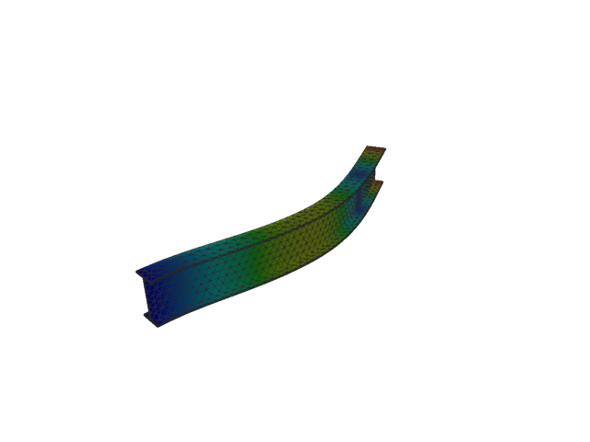
Figure 148: Abaqus — mode 3, 97.588 Hz
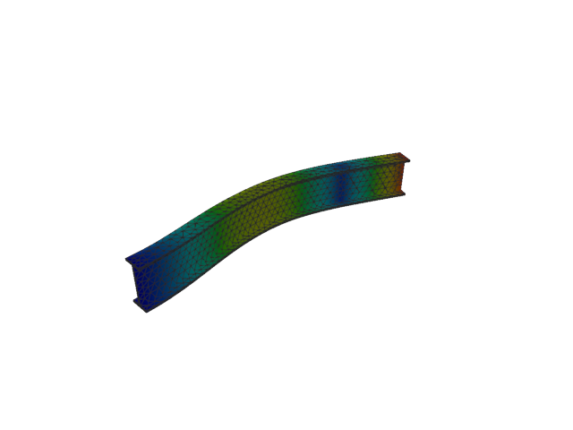
Figure 149: Sesam — mode 3, 97.731 Hz
Solver | f [Hz] | Δf vs mean [%] | λ [rad²/s²] | Meff X [kg] | Meff Y [kg] | Meff Z [kg] | Γ X | Γ Y | Γ Z
Abaqus | 97.588 | -0.07 | 375967 | 4.61e-08 | 34.91 | 3.71e-04 | -2.15e-04 | -5.909 | 0.019
Sesam | 97.731 | +0.07 | 377075 | 4.30e-08 | 34.94 | 3.65e-04 | 2.07e-04 | 5.911 | -0.019
- Mode 4
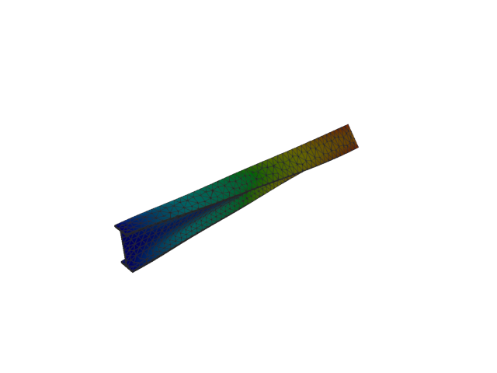
Figure 150: Abaqus — mode 4, 104.803 Hz
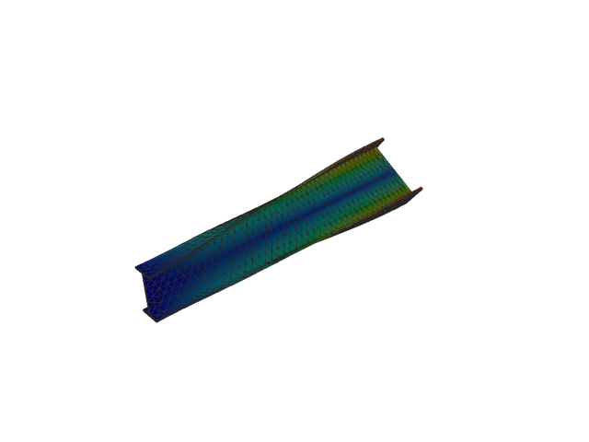
Figure 151: Sesam — mode 4, 105.691 Hz
Solver | f [Hz] | Δf vs mean [%] | λ [rad²/s²] | Meff X [kg] | Meff Y [kg] | Meff Z [kg] | Γ X | Γ Y | Γ Z
Abaqus | 104.800 | -0.42 | 433617 | 6.83e-06 | 0.01 | 1.07e-05 | 0.003 | -0.075 | 0.003
Sesam | 105.691 | +0.42 | 440993 | 6.99e-06 | 4.82e-03 | 1.08e-05 | -0.003 | 0.069 | -0.003
- Mode 5
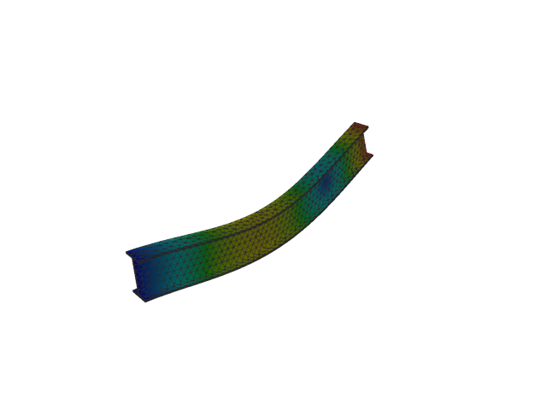
Figure 152: Abaqus — mode 5, 260.590 Hz
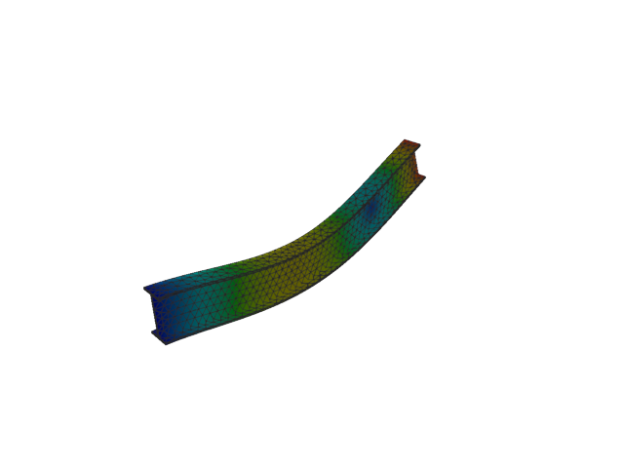
Figure 153: Sesam — mode 5, 260.887 Hz
Solver | f [Hz] | Δf vs mean [%] | λ [rad²/s²] | Meff X [kg] | Meff Y [kg] | Meff Z [kg] | Γ X | Γ Y | Γ Z
Abaqus | 260.590 | -0.06 | 2.68086e+06 | 3.30e-07 | 0.02 | 39.75 | -0.001 | 0.132 | -6.305
Sesam | 260.887 | +0.06 | 2.68699e+06 | 3.61e-07 | 0.01 | 39.76 | -0.001 | 0.122 | -6.305
- Mode 6
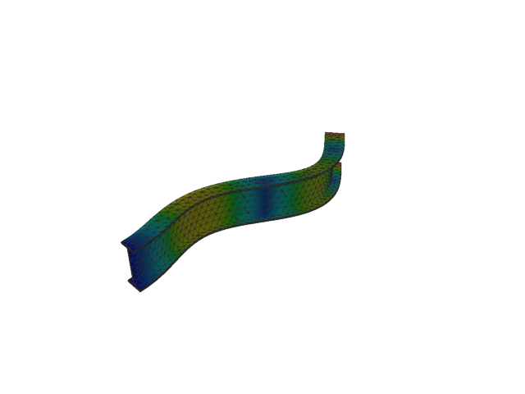
Figure 154: Abaqus — mode 6, 266.263 Hz
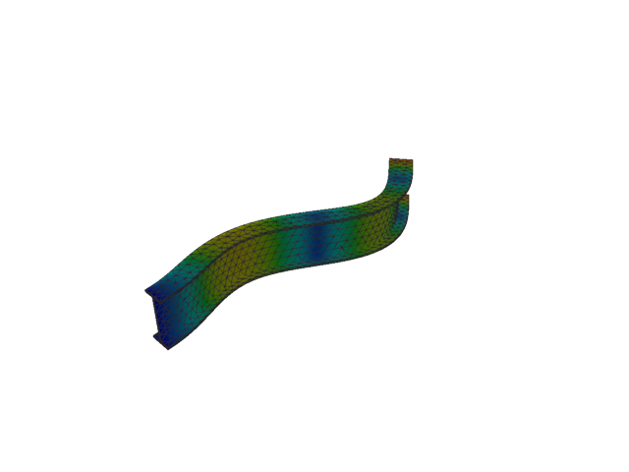
Figure 155: Sesam — mode 6, 267.131 Hz
Solver | f [Hz] | Δf vs mean [%] | λ [rad²/s²] | Meff X [kg] | Meff Y [kg] | Meff Z [kg] | Γ X | Γ Y | Γ Z
Abaqus | 266.260 | -0.16 | 2.79886e+06 | 1.72e-08 | 13.24 | 0.05 | 1.31e-04 | 3.638 | 0.226
Sesam | 267.131 | +0.16 | 2.81714e+06 | 1.49e-08 | 13.26 | 0.04 | 1.22e-04 | 3.642 | 0.207
- Mode 7
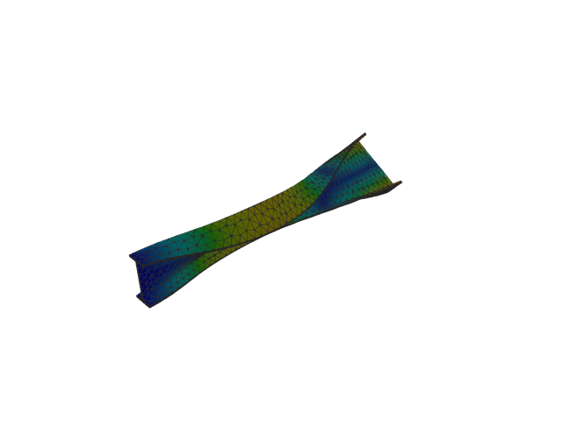
Figure 156: Abaqus — mode 7, 285.051 Hz
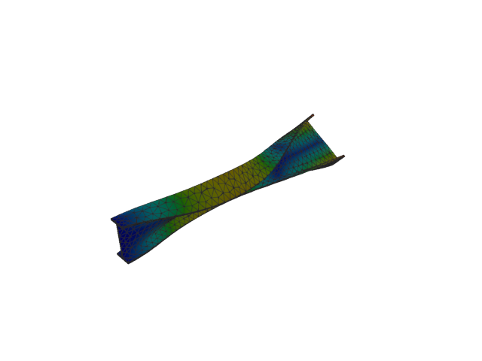
Figure 157: Sesam — mode 7, 287.461 Hz
Solver | f [Hz] | Δf vs mean [%] | λ [rad²/s²] | Meff X [kg] | Meff Y [kg] | Meff Z [kg] | Γ X | Γ Y | Γ Z
Abaqus | 285.050 | -0.42 | 3.20779e+06 | 1.44e-07 | 9.28e-04 | 1.25e-03 | 3.79e-04 | 0.030 | -0.035
Sesam | 287.461 | +0.42 | 3.26225e+06 | 1.26e-07 | 7.47e-04 | 1.07e-03 | 3.54e-04 | 0.027 | -0.033
- Mode 8
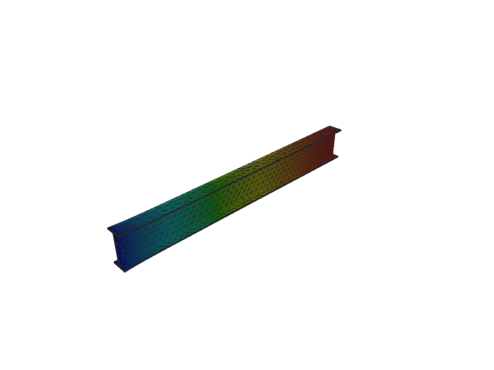
Figure 158: Abaqus — mode 8, 432.310 Hz
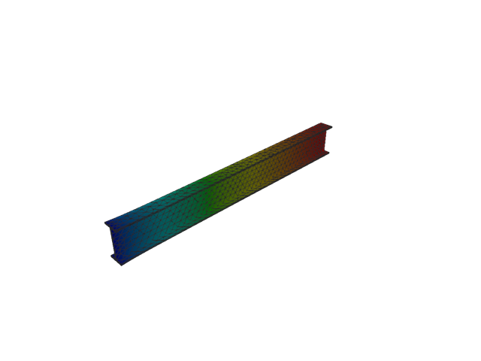
Figure 159: Sesam — mode 8, 432.347 Hz
Solver | f [Hz] | Δf vs mean [%] | λ [rad²/s²] | Meff X [kg] | Meff Y [kg] | Meff Z [kg] | Γ X | Γ Y | Γ Z
Abaqus | 432.310 | -4.31e-03 | 7.37819e+06 | 153.38 | 2.06e-06 | 3.31e-08 | 12.385 | -0.001 | 1.82e-04
Sesam | 432.347 | 4.31e-03 | 7.37947e+06 | 153.37 | 1.91e-06 | 2.88e-08 | 12.384 | -0.001 | 1.70e-04
- Mode 9
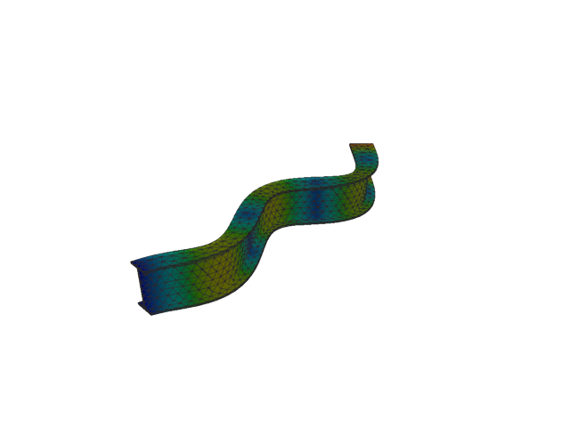
Figure 160: Abaqus — mode 9, 500.864 Hz
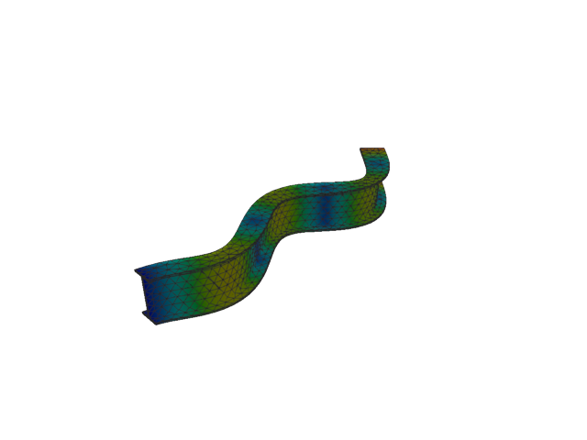
Figure 161: Sesam — mode 9, 503.862 Hz
Solver | f [Hz] | Δf vs mean [%] | λ [rad²/s²] | Meff X [kg] | Meff Y [kg] | Meff Z [kg] | Γ X | Γ Y | Γ Z
Abaqus | 500.860 | -0.30 | 9.90373e+06 | 3.39e-05 | 6.33 | 4.73e-05 | -0.006 | -2.515 | 0.007
Sesam | 503.862 | +0.30 | 1.00226e+07 | 3.01e-05 | 6.34 | 4.92e-05 | -0.005 | -2.518 | 0.007
- Mode 10
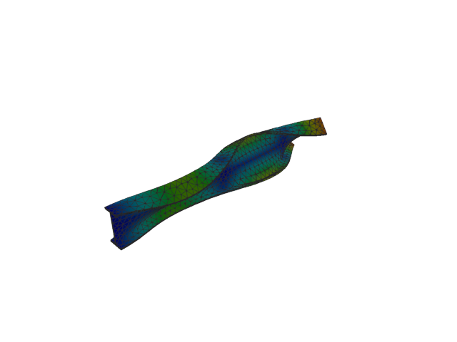
Figure 162: Abaqus — mode 10, 534.263 Hz
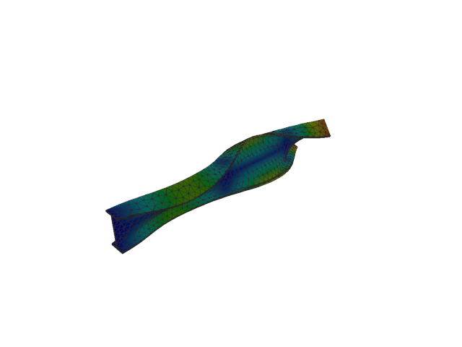
Figure 163: Sesam — mode 10, 539.506 Hz
Solver | f [Hz] | Δf vs mean [%] | λ [rad²/s²] | Meff X [kg] | Meff Y [kg] | Meff Z [kg] | Γ X | Γ Y | Γ Z
Abaqus | 534.260 | -0.49 | 1.12686e+07 | 2.60e-04 | 2.77e-04 | 6.63e-06 | -0.016 | -0.017 | 0.003
Sesam | 539.506 | +0.49 | 1.14909e+07 | 2.36e-04 | 2.31e-04 | 6.55e-06 | -0.015 | -0.015 | 0.003
- Mode 11
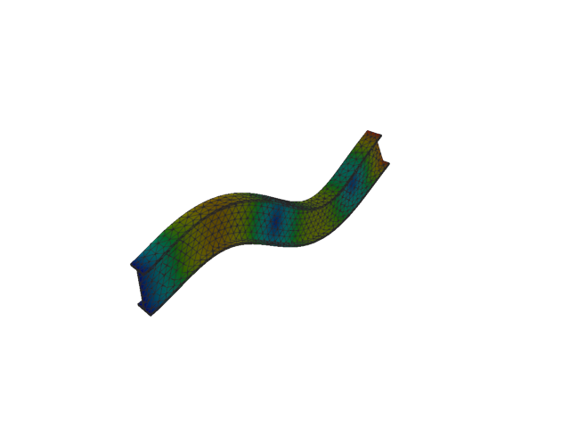
Figure 164: Abaqus — mode 11, 596.780 Hz
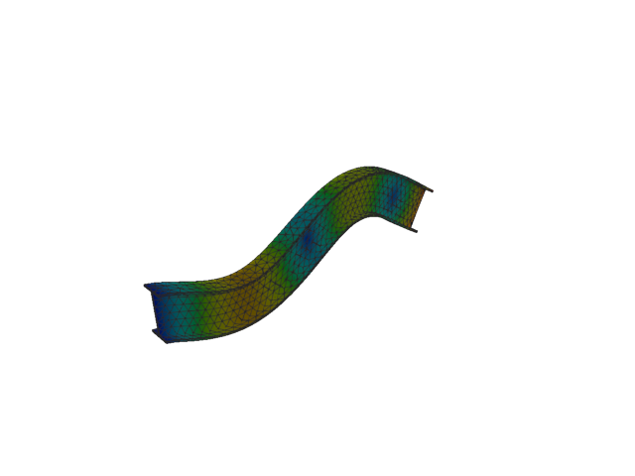
Figure 165: Sesam — mode 11, 598.200 Hz
Solver | f [Hz] | Δf vs mean [%] | λ [rad²/s²] | Meff X [kg] | Meff Y [kg] | Meff Z [kg] | Γ X | Γ Y | Γ Z
Abaqus | 596.780 | -0.12 | 1.40601e+07 | 4.55e-07 | 1.33e-07 | 12.80 | -0.001 | -3.65e-04 | 3.578
Sesam | 598.200 | +0.12 | 1.41271e+07 | 4.36e-07 | 3.62e-08 | 12.80 | 0.001 | 1.90e-04 | -3.578
- Solid, 1st order, HEX
- Mode 1
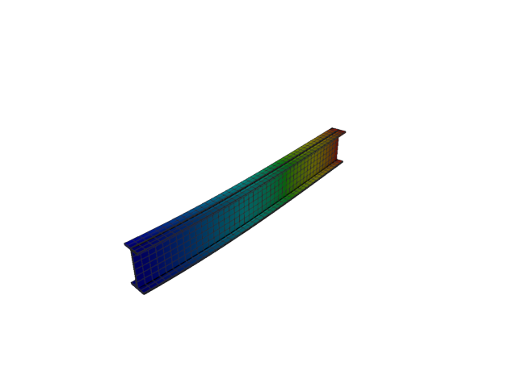
Figure 166: Abaqus — mode 1, 13.435 Hz
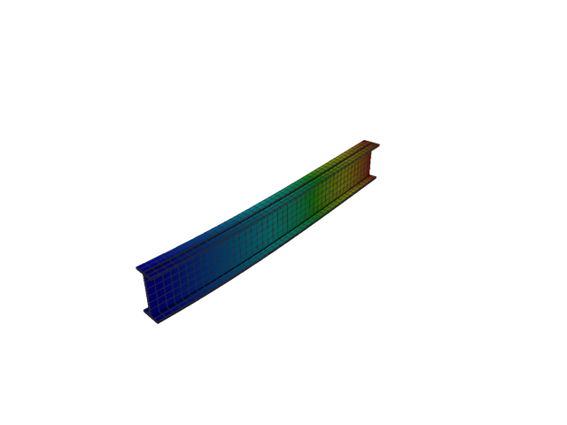
Figure 167: Sesam — mode 1, 12.977 Hz
Solver | f [Hz] | Δf vs mean [%] | λ [rad²/s²] | Meff X [kg] | Meff Y [kg] | Meff Z [kg] | Γ X | Γ Y | Γ Z
Abaqus | 13.435 | +1.74 | 7125.8 | 4.92e-29 | 116.39 | 5.47e-23 | -7.01e-15 | 10.788 | -7.39e-12
Sesam | 12.977 | -1.74 | 6647.9 | 8.06e-25 | 116.43 | 1.16e-20 | -8.98e-13 | 10.790 | 1.08e-10
- Mode 2
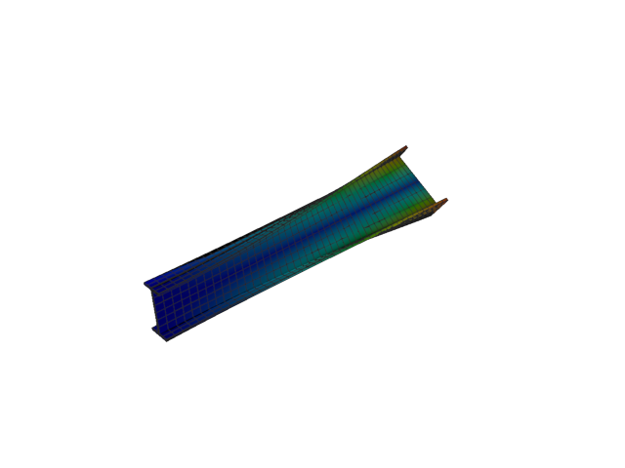
Figure 168: Abaqus — mode 2, 20.731 Hz
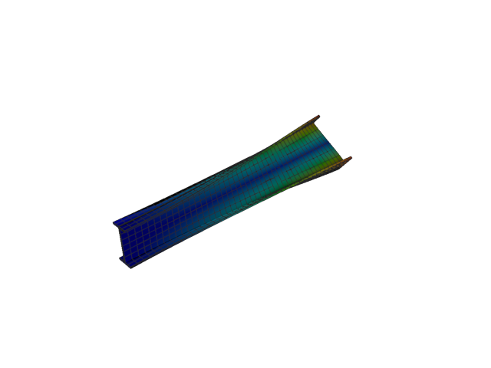
Figure 169: Sesam — mode 2, 20.302 Hz
Solver | f [Hz] | Δf vs mean [%] | λ [rad²/s²] | Meff X [kg] | Meff Y [kg] | Meff Z [kg] | Γ X | Γ Y | Γ Z
Abaqus | 20.731 | +1.05 | 16967 | 7.03e-26 | 1.48e-18 | 2.87e-22 | 2.65e-13 | 1.22e-09 | -1.69e-11
Sesam | 20.302 | -1.05 | 16271.1 | 2.93e-27 | 2.21e-19 | 3.64e-20 | -5.41e-14 | -4.70e-10 | 1.91e-10
- Mode 3
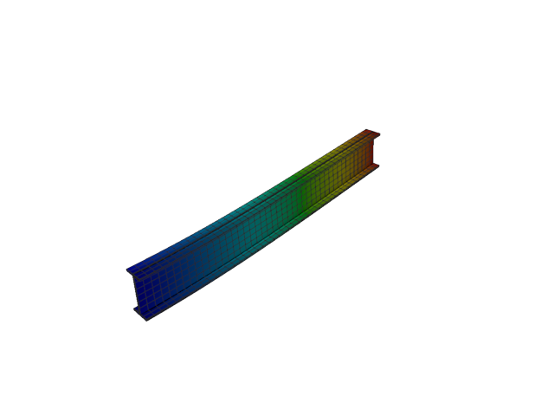
Figure 170: Abaqus — mode 3, 50.678 Hz
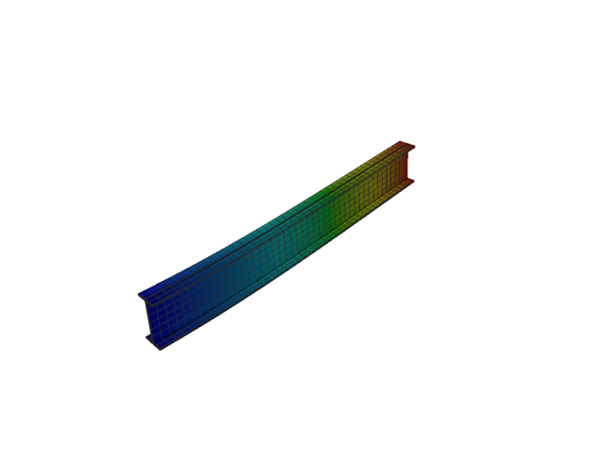
Figure 171: Sesam — mode 3, 50.618 Hz
Solver | f [Hz] | Δf vs mean [%] | λ [rad²/s²] | Meff X [kg] | Meff Y [kg] | Meff Z [kg] | Γ X | Γ Y | Γ Z
Abaqus | 50.678 | +0.06 | 101392 | 1.09e-25 | 2.57e-22 | 118.20 | -3.30e-13 | 1.60e-11 | 10.872
Sesam | 50.618 | -0.06 | 101151 | 1.08e-24 | 8.70e-21 | 118.29 | -1.04e-12 | -9.33e-11 | 10.876
- Mode 4
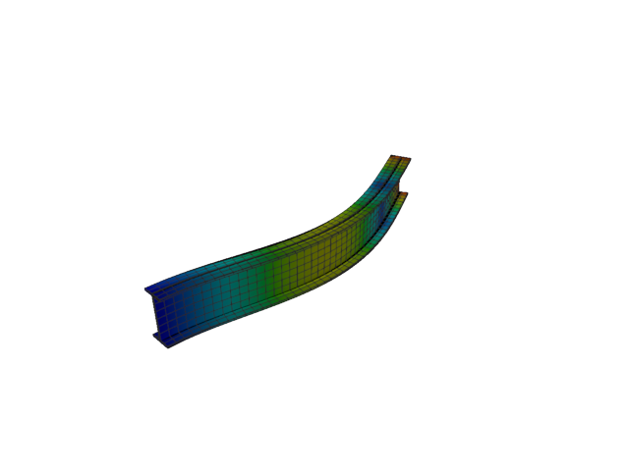
Figure 172: Abaqus — mode 4, 82.799 Hz
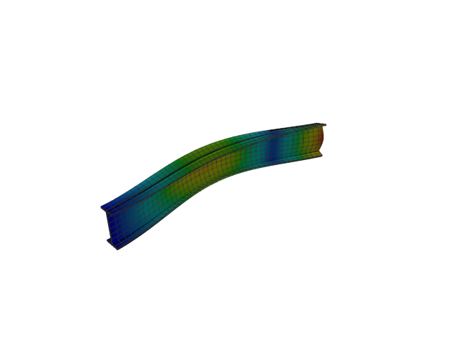
Figure 173: Sesam — mode 4, 77.392 Hz
Solver | f [Hz] | Δf vs mean [%] | λ [rad²/s²] | Meff X [kg] | Meff Y [kg] | Meff Z [kg] | Γ X | Γ Y | Γ Z
Abaqus | 82.799 | +3.38 | 270652 | 7.52e-26 | 36.02 | 2.70e-22 | -2.74e-13 | -6.002 | 1.64e-11
Sesam | 77.392 | -3.38 | 236458 | 6.94e-26 | 35.94 | 6.82e-22 | -2.63e-13 | 5.995 | -2.61e-11
- Mode 5
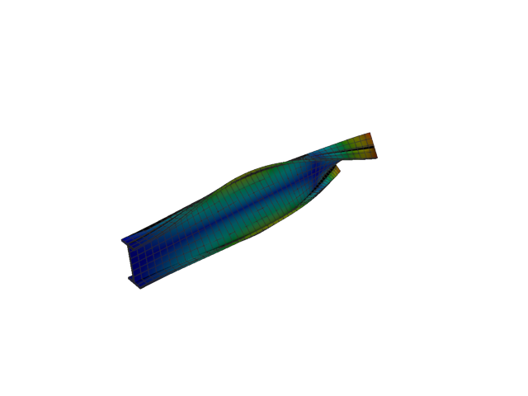
Figure 174: Abaqus — mode 5, 100.195 Hz
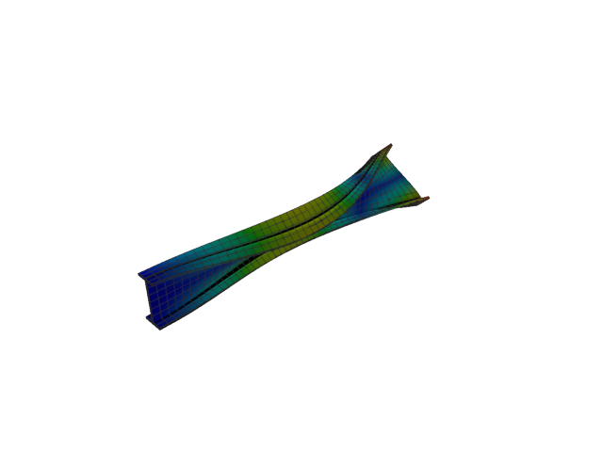
Figure 175: Sesam — mode 5, 98.119 Hz
Solver | f [Hz] | Δf vs mean [%] | λ [rad²/s²] | Meff X [kg] | Meff Y [kg] | Meff Z [kg] | Γ X | Γ Y | Γ Z
Abaqus | 100.190 | +1.04 | 396325 | 4.10e-26 | 6.87e-21 | 7.52e-23 | 2.03e-13 | -8.29e-11 | 8.67e-12
Sesam | 98.119 | -1.04 | 380068 | 1.62e-25 | 2.53e-21 | 7.29e-23 | 4.03e-13 | -5.03e-11 | -8.54e-12
- Mode 6
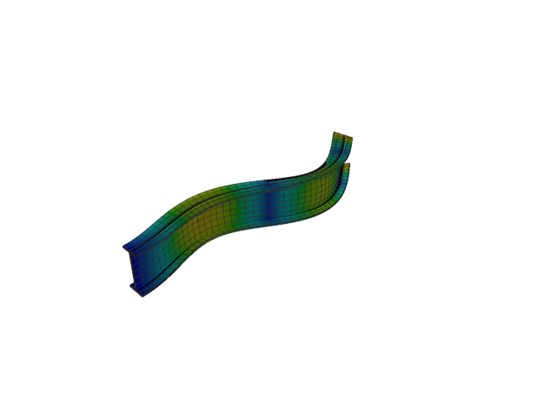
Figure 176: Abaqus — mode 6, 223.139 Hz
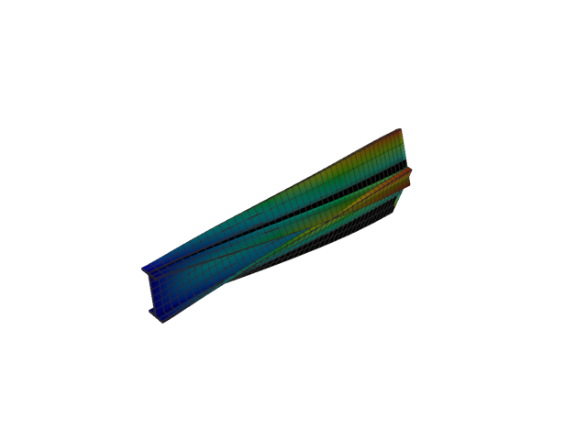
Figure 177: Sesam — mode 6, 133.016 Hz
Solver | f [Hz] | Δf vs mean [%] | λ [rad²/s²] | Meff X [kg] | Meff Y [kg] | Meff Z [kg] | Γ X | Γ Y | Γ Z
Abaqus | 223.140 | +25.30 | 1.96567e+06 | 2.33e-25 | 12.40 | 1.64e-23 | -4.83e-13 | 3.522 | 4.05e-12
Sesam | 133.016 | -25.30 | 698501 | 3.07e-26 | 0.01 | 1.44e-20 | -1.75e-13 | -0.114 | 1.20e-10
- Mode 7
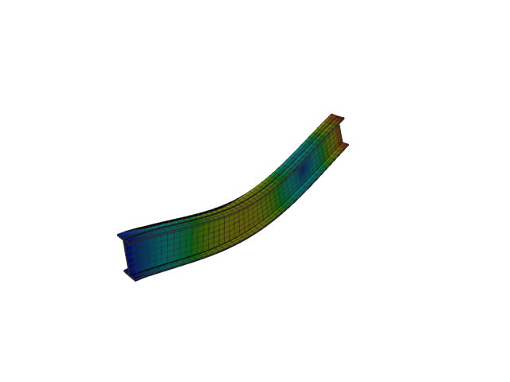
Figure 178: Abaqus — mode 7, 254.984 Hz
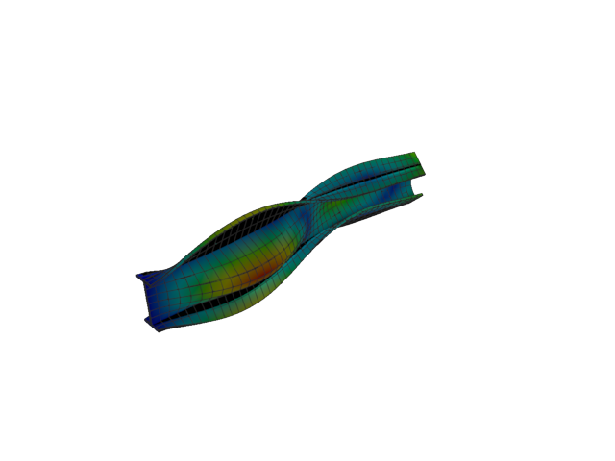
Figure 179: Sesam — mode 7, 153.833 Hz
Solver | f [Hz] | Δf vs mean [%] | λ [rad²/s²] | Meff X [kg] | Meff Y [kg] | Meff Z [kg] | Γ X | Γ Y | Γ Z
Abaqus | 254.980 | +24.74 | 2.56676e+06 | 2.24e-25 | 2.85e-24 | 40.01 | -4.74e-13 | 1.69e-12 | -6.326
Sesam | 153.833 | -24.74 | 934235 | 3.75e-25 | 3.20 | 1.37e-21 | -6.13e-13 | -1.788 | 3.70e-11
- Mode 8
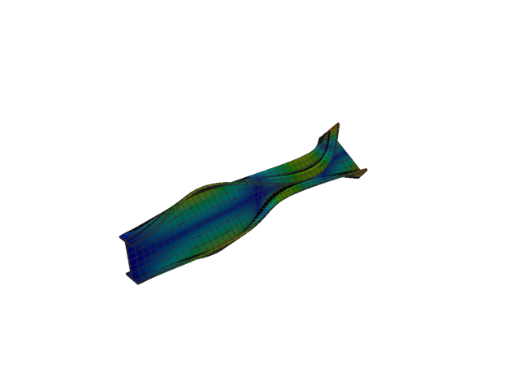
Figure 180: Abaqus — mode 8, 260.095 Hz
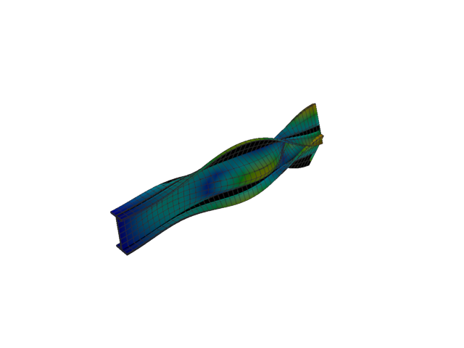
Figure 181: Sesam — mode 8, 178.565 Hz
Solver | f [Hz] | Δf vs mean [%] | λ [rad²/s²] | Meff X [kg] | Meff Y [kg] | Meff Z [kg] | Γ X | Γ Y | Γ Z
Abaqus | 260.100 | +18.59 | 2.6707e+06 | 2.66e-26 | 6.24e-23 | 3.82e-21 | -1.63e-13 | 7.90e-12 | 6.18e-11
Sesam | 178.565 | -18.59 | 1.25879e+06 | 3.19e-27 | 5.71 | 3.11e-21 | -5.65e-14 | 2.390 | 5.58e-11
- Mode 9
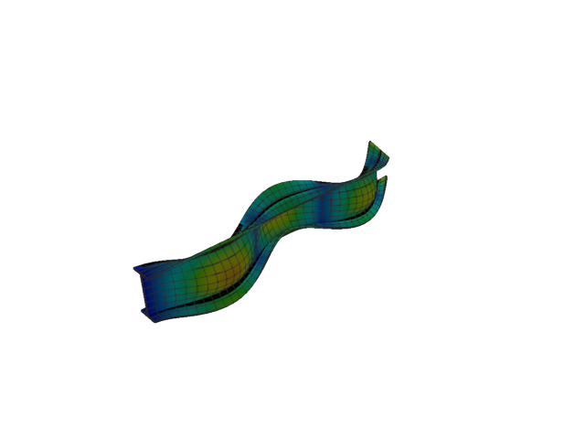
Figure 182: Abaqus — mode 9, 396.567 Hz
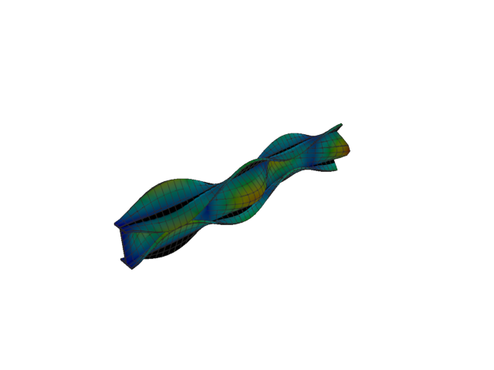
Figure 183: Sesam — mode 9, 214.689 Hz
Solver | f [Hz] | Δf vs mean [%] | λ [rad²/s²] | Meff X [kg] | Meff Y [kg] | Meff Z [kg] | Γ X | Γ Y | Γ Z
Abaqus | 396.570 | +29.76 | 6.20858e+06 | 2.52e-22 | 5.69 | 2.13e-23 | 1.59e-11 | -2.385 | 4.61e-12
Sesam | 214.689 | -29.76 | 1.81962e+06 | 5.15e-26 | 0.44 | 2.62e-22 | -2.27e-13 | 0.662 | -1.62e-11
- Mode 10
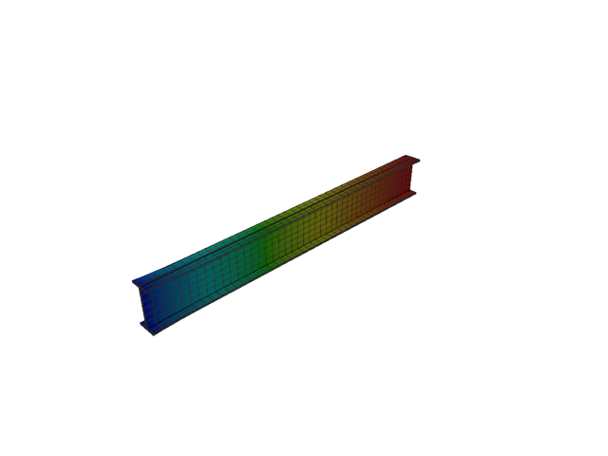
Figure 184: Abaqus — mode 10, 431.802 Hz
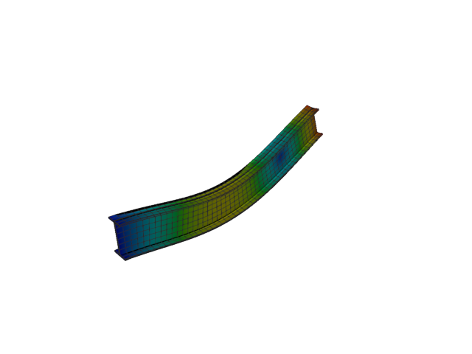
Figure 185: Sesam — mode 10, 253.463 Hz
Solver | f [Hz] | Δf vs mean [%] | λ [rad²/s²] | Meff X [kg] | Meff Y [kg] | Meff Z [kg] | Γ X | Γ Y | Γ Z
Abaqus | 431.800 | +26.02 | 7.36085e+06 | 153.54 | 1.07e-21 | 9.26e-21 | 12.391 | 3.27e-11 | -9.62e-11
Sesam | 253.463 | -26.02 | 2.53623e+06 | 1.48e-19 | 5.14e-20 | 40.27 | -3.84e-10 | 2.27e-10 | -6.346
- Mode 11
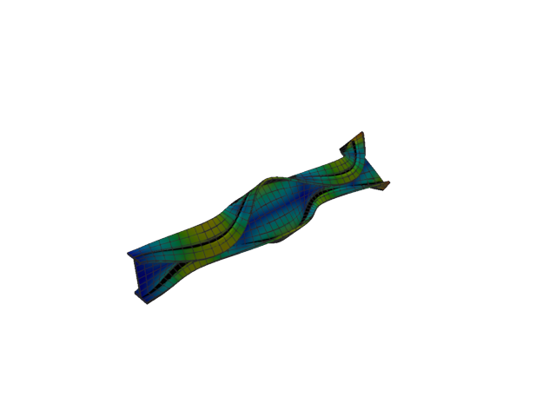
Figure 186: Abaqus — mode 11, 486.965 Hz
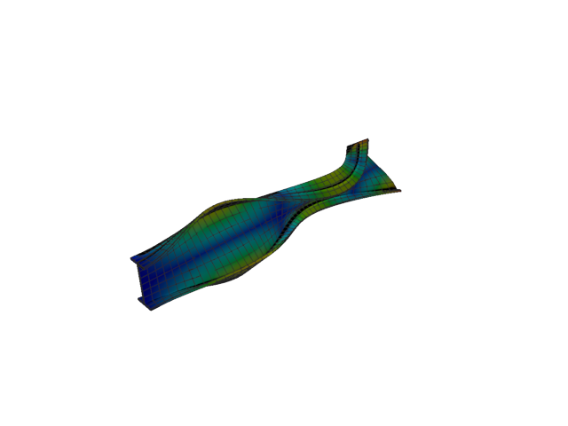
Figure 187: Sesam — mode 11, 256.050 Hz
Solver | f [Hz] | Δf vs mean [%] | λ [rad²/s²] | Meff X [kg] | Meff Y [kg] | Meff Z [kg] | Γ X | Γ Y | Γ Z
Abaqus | 486.960 | +31.08 | 9.3617e+06 | 1.09e-16 | 2.28e-18 | 1.17e-18 | 1.04e-08 | 1.51e-09 | 1.08e-09
Sesam | 256.050 | -31.08 | 2.58827e+06 | 4.64e-20 | 1.35e-20 | 4.71e-23 | 2.15e-10 | -1.16e-10 | -6.86e-12
- Solid, 1st order, HEX, reduced integration
- Mode 1
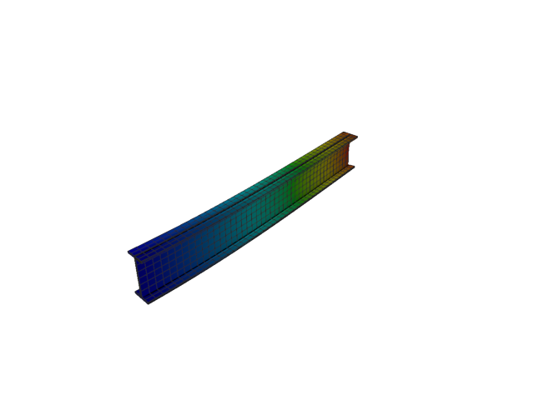
Figure 188: Abaqus — mode 1, 12.514 Hz
Solver | f [Hz] | λ [rad²/s²] | Meff X [kg] | Meff Y [kg] | Meff Z [kg] | Γ X | Γ Y | Γ Z
Abaqus | 12.514 | 6182 | 1.92e-26 | 116.92 | 5.56e-23 | 1.39e-13 | 10.813 | -7.45e-12
- Mode 2
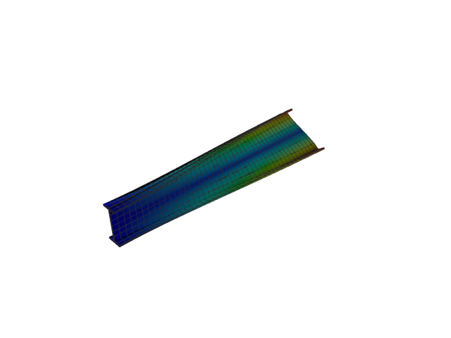
Figure 189: Abaqus — mode 2, 34.157 Hz
Solver | f [Hz] | λ [rad²/s²] | Meff X [kg] | Meff Y [kg] | Meff Z [kg] | Γ X | Γ Y | Γ Z
Abaqus | 34.157 | 46060 | 4.54e-27 | 1.11e-19 | 8.80e-22 | 6.74e-14 | 3.33e-10 | -2.97e-11
- Mode 3
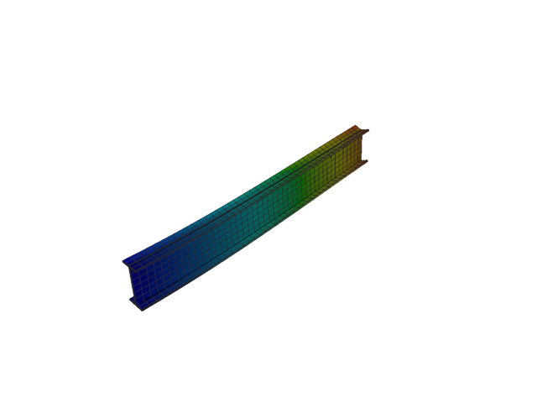
Figure 190: Abaqus — mode 3, 49.598 Hz
Solver | f [Hz] | λ [rad²/s²] | Meff X [kg] | Meff Y [kg] | Meff Z [kg] | Γ X | Γ Y | Γ Z
Abaqus | 49.598 | 97114 | 1.57e-26 | 1.07e-20 | 118.97 | -1.25e-13 | 1.03e-10 | 10.907
- Mode 4
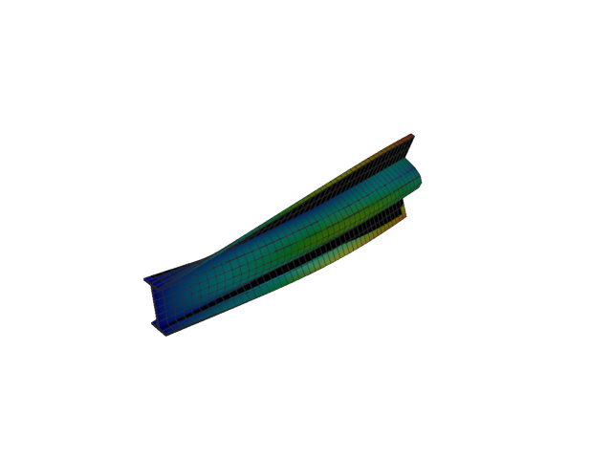
Figure 191: Abaqus — mode 4, 55.271 Hz
Solver | f [Hz] | λ [rad²/s²] | Meff X [kg] | Meff Y [kg] | Meff Z [kg] | Γ X | Γ Y | Γ Z
Abaqus | 55.271 | 120602 | 1.14e-25 | 2.12 | 1.05e-18 | -3.37e-13 | -1.456 | 1.02e-09
- Mode 5
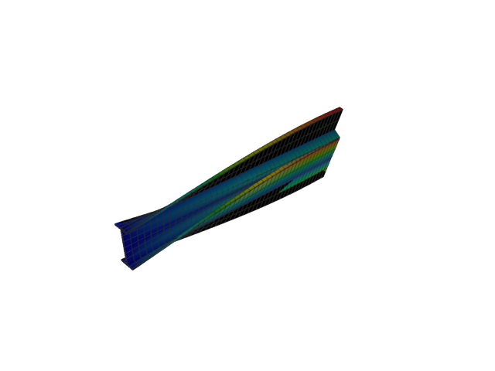
Figure 192: Abaqus — mode 5, 64.305 Hz
Solver | f [Hz] | λ [rad²/s²] | Meff X [kg] | Meff Y [kg] | Meff Z [kg] | Γ X | Γ Y | Γ Z
Abaqus | 64.305 | 163249 | 1.13e-26 | 8.64e-20 | 1.24e-20 | -1.06e-13 | -2.94e-10 | 1.11e-10
- Mode 6
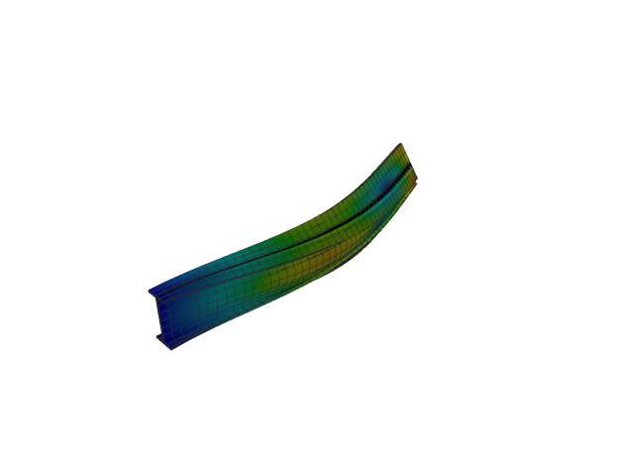
Figure 193: Abaqus — mode 6, 74.866 Hz
Solver | f [Hz] | λ [rad²/s²] | Meff X [kg] | Meff Y [kg] | Meff Z [kg] | Γ X | Γ Y | Γ Z
Abaqus | 74.866 | 221271 | 1.12e-26 | 31.40 | 1.02e-20 | 1.06e-13 | -5.603 | -1.01e-10
- Mode 7
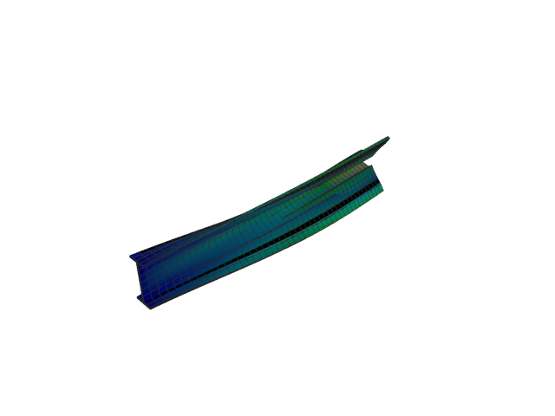
Figure 194: Abaqus — mode 7, 90.033 Hz
Solver | f [Hz] | λ [rad²/s²] | Meff X [kg] | Meff Y [kg] | Meff Z [kg] | Γ X | Γ Y | Γ Z
Abaqus | 90.033 | 320010 | 1.17e-28 | 2.79 | 5.27e-21 | -1.08e-14 | -1.671 | 7.26e-11
- Mode 8
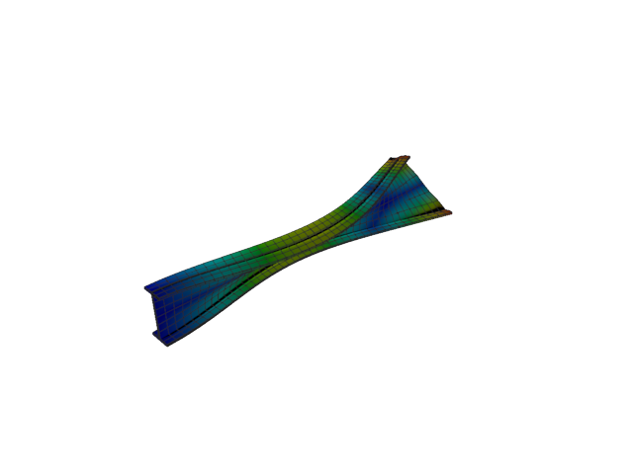
Figure 195: Abaqus — mode 8, 124.578 Hz
Solver | f [Hz] | λ [rad²/s²] | Meff X [kg] | Meff Y [kg] | Meff Z [kg] | Γ X | Γ Y | Γ Z
Abaqus | 124.580 | 612693 | 3.87e-24 | 3.38e-21 | 2.90e-24 | -1.97e-12 | -5.82e-11 | -1.70e-12
- Mode 9
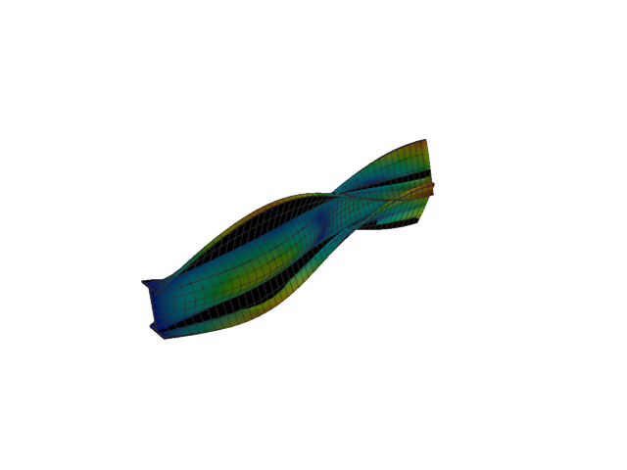
Figure 196: Abaqus — mode 9, 155.992 Hz
Solver | f [Hz] | λ [rad²/s²] | Meff X [kg] | Meff Y [kg] | Meff Z [kg] | Γ X | Γ Y | Γ Z
Abaqus | 155.990 | 960645 | 7.43e-21 | 1.12 | 2.07e-20 | -8.62e-11 | -1.056 | -1.44e-10
- Mode 10
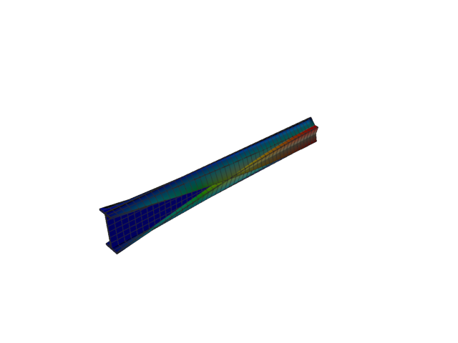
Figure 197: Abaqus — mode 10, 159.952 Hz
Solver | f [Hz] | λ [rad²/s²] | Meff X [kg] | Meff Y [kg] | Meff Z [kg] | Γ X | Γ Y | Γ Z
Abaqus | 159.950 | 1.01004e+06 | 3.65e-04 | 8.80e-19 | 3.04e-19 | 0.019 | -9.38e-10 | 5.51e-10
- Mode 11
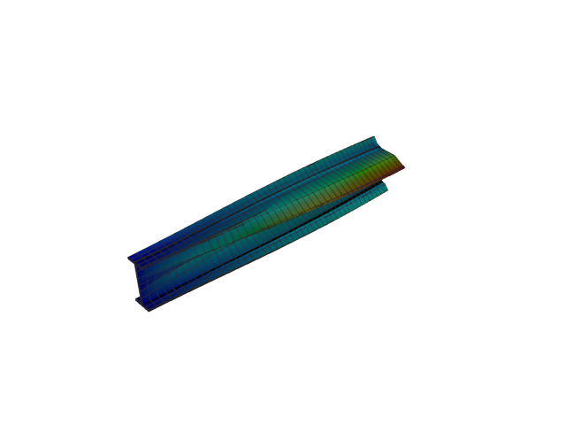
Figure 198: Abaqus — mode 11, 162.557 Hz
Solver | f [Hz] | λ [rad²/s²] | Meff X [kg] | Meff Y [kg] | Meff Z [kg] | Γ X | Γ Y | Γ Z
Abaqus | 162.560 | 1.04321e+06 | 4.88e-19 | 1.57e-19 | 3.29e-20 | -6.98e-10 | 3.96e-10 | -1.81e-10
- Solid, 2nd order, TET
- Mode 1
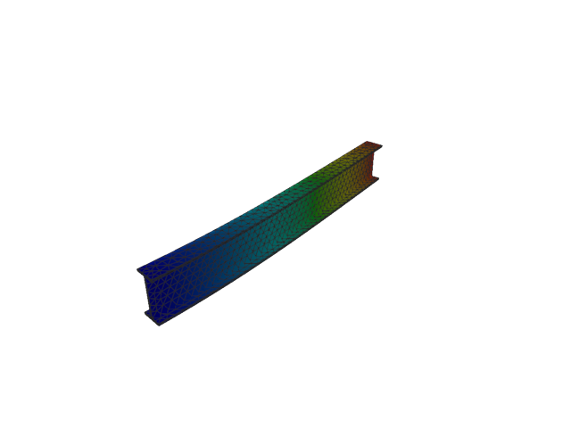
Figure 199: Abaqus — mode 1, 12.954 Hz
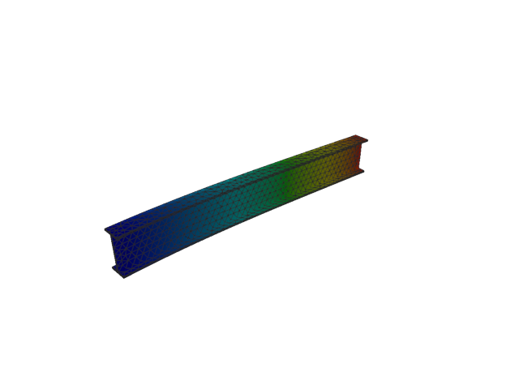
Figure 200: Sesam — mode 1, 12.954 Hz
Solver | f [Hz] | Δf vs mean [%] | λ [rad²/s²] | Meff X [kg] | Meff Y [kg] | Meff Z [kg] | Γ X | Γ Y | Γ Z
Abaqus | 12.954 | 1.00e-03 | 6624.5 | 3.65e-13 | 116.51 | 2.81e-11 | 6.04e-07 | 10.794 | 5.30e-06
Sesam | 12.954 | -1.00e-03 | 6624.46 | 3.01e-13 | 116.51 | 2.70e-11 | -5.49e-07 | -10.794 | -5.20e-06
- Mode 2
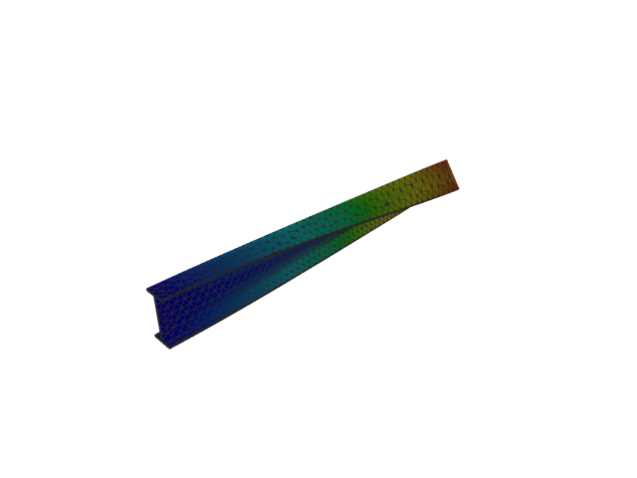
Figure 201: Abaqus — mode 2, 20.294 Hz
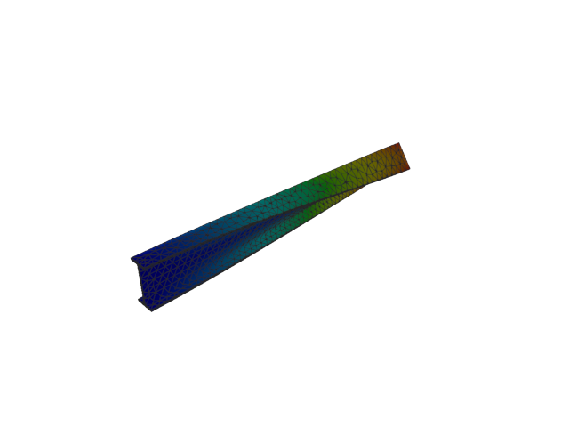
Figure 202: Sesam — mode 2, 20.294 Hz
Solver | f [Hz] | Δf vs mean [%] | λ [rad²/s²] | Meff X [kg] | Meff Y [kg] | Meff Z [kg] | Γ X | Γ Y | Γ Z
Abaqus | 20.294 | -1.13e-03 | 16260 | 8.19e-12 | 5.86e-08 | 1.99e-09 | 2.86e-06 | -2.42e-04 | 4.47e-05
Sesam | 20.294 | 1.13e-03 | 16259.8 | 8.59e-12 | 5.86e-08 | 1.98e-09 | 2.93e-06 | -2.42e-04 | 4.45e-05
- Mode 3
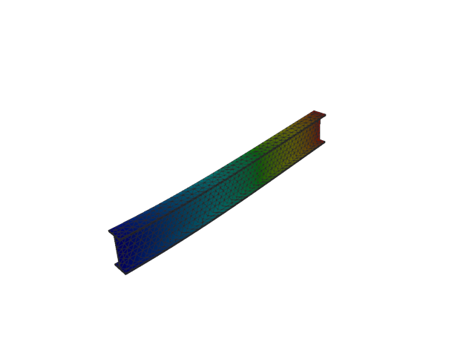
Figure 203: Abaqus — mode 3, 50.540 Hz
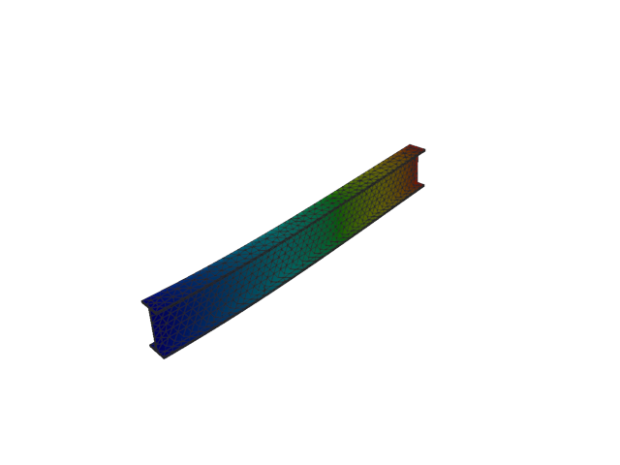
Figure 204: Sesam — mode 3, 50.540 Hz
Solver | f [Hz] | Δf vs mean [%] | λ [rad²/s²] | Meff X [kg] | Meff Y [kg] | Meff Z [kg] | Γ X | Γ Y | Γ Z
Abaqus | 50.540 | -4.95e-05 | 100840 | 3.09e-10 | 1.03e-08 | 118.35 | 1.76e-05 | -1.01e-04 | 10.879
Sesam | 50.540 | 4.95e-05 | 100840 | 3.10e-10 | 1.03e-08 | 118.35 | 1.76e-05 | -1.01e-04 | 10.879
- Mode 4
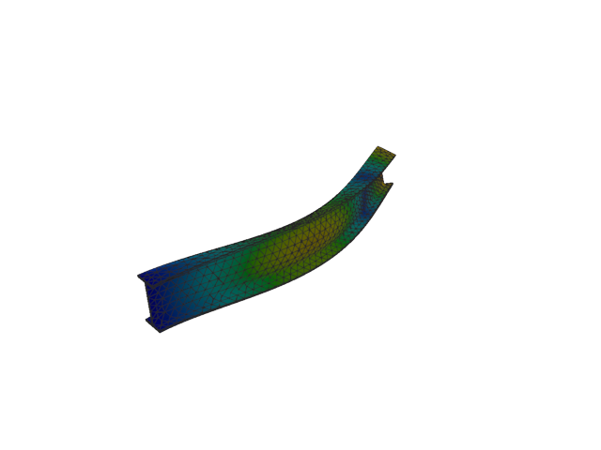
Figure 205: Abaqus — mode 4, 77.128 Hz
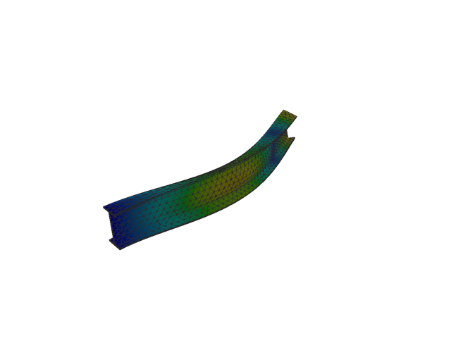
Figure 206: Sesam — mode 4, 77.128 Hz
Solver | f [Hz] | Δf vs mean [%] | λ [rad²/s²] | Meff X [kg] | Meff Y [kg] | Meff Z [kg] | Γ X | Γ Y | Γ Z
Abaqus | 77.128 | 1.43e-04 | 234845 | 6.40e-12 | 35.97 | 1.94e-09 | 2.53e-06 | -5.997 | -4.41e-05
Sesam | 77.128 | -1.43e-04 | 234845 | 1.04e-11 | 35.97 | 1.89e-09 | 3.22e-06 | -5.997 | -4.35e-05
- Mode 5
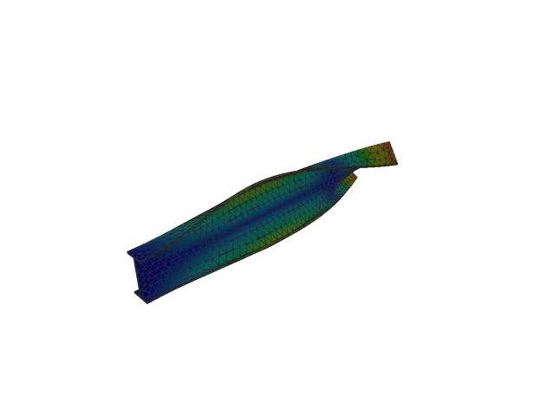
Figure 207: Abaqus — mode 5, 97.830 Hz
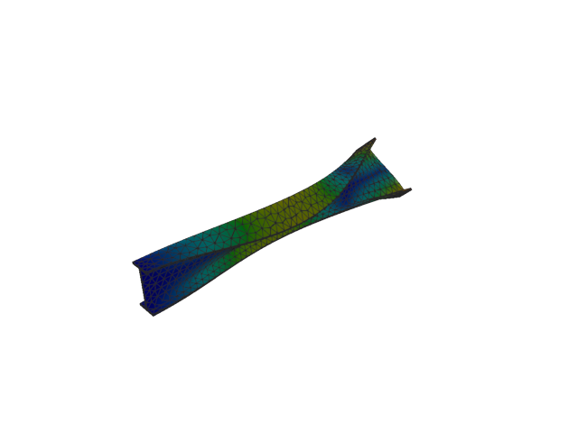
Figure 208: Sesam — mode 5, 97.830 Hz
Solver | f [Hz] | Δf vs mean [%] | λ [rad²/s²] | Meff X [kg] | Meff Y [kg] | Meff Z [kg] | Γ X | Γ Y | Γ Z
Abaqus | 97.830 | 2.10e-04 | 377834 | 1.93e-10 | 3.14e-07 | 6.49e-09 | -1.39e-05 | -0.001 | 8.06e-05
Sesam | 97.830 | -2.10e-04 | 377833 | 1.99e-10 | 3.14e-07 | 6.59e-09 | 1.41e-05 | 0.001 | -8.12e-05
- Mode 6
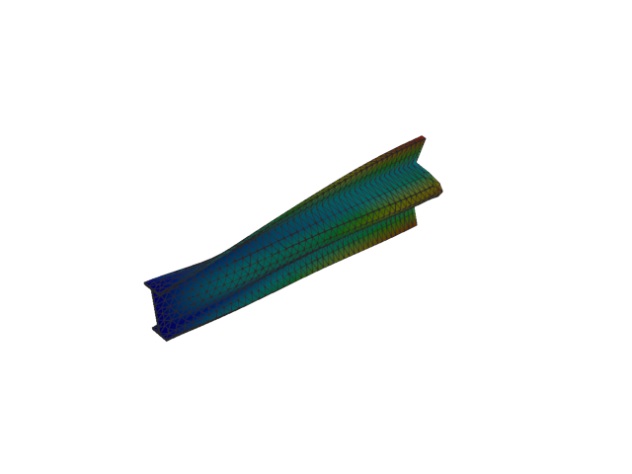
Figure 209: Abaqus — mode 6, 132.482 Hz
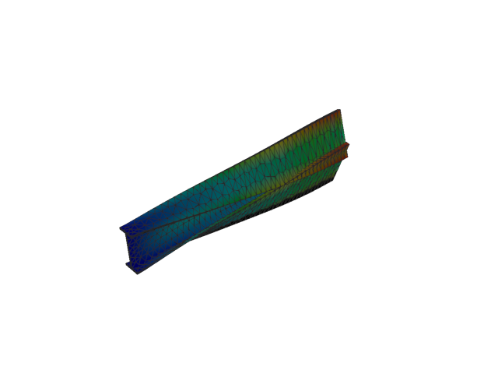
Figure 210: Sesam — mode 6, 132.478 Hz
Solver | f [Hz] | Δf vs mean [%] | λ [rad²/s²] | Meff X [kg] | Meff Y [kg] | Meff Z [kg] | Γ X | Γ Y | Γ Z
Abaqus | 132.480 | 6.04e-04 | 692901 | 1.05e-09 | 0.01 | 2.04e-09 | 3.23e-05 | 0.119 | -4.51e-05
Sesam | 132.478 | -6.04e-04 | 692867 | 1.14e-09 | 0.01 | 2.04e-09 | -3.38e-05 | -0.119 | 4.52e-05
- Mode 7
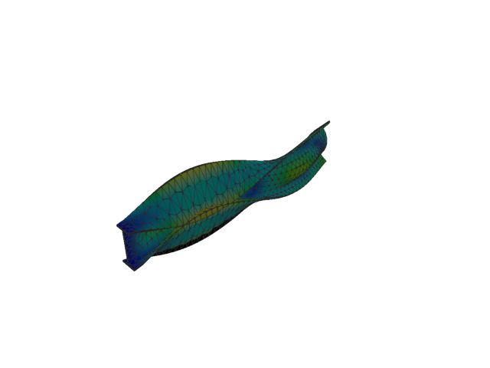
Figure 211: Abaqus — mode 7, 153.634 Hz
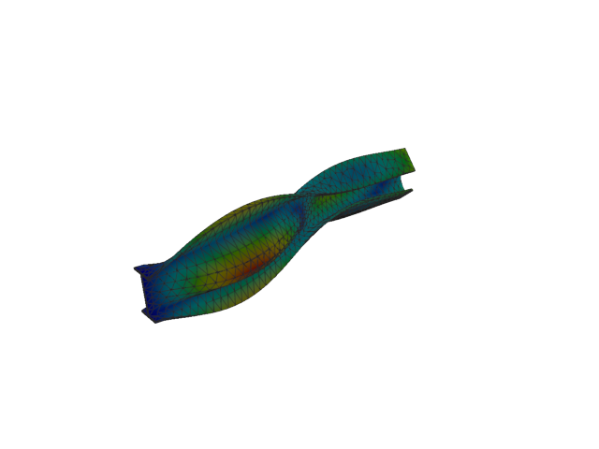
Figure 212: Sesam — mode 7, 153.631 Hz
Solver | f [Hz] | Δf vs mean [%] | λ [rad²/s²] | Meff X [kg] | Meff Y [kg] | Meff Z [kg] | Γ X | Γ Y | Γ Z
Abaqus | 153.630 | -4.56e-04 | 931828 | 1.43e-08 | 3.12 | 2.11e-09 | -1.19e-04 | 1.768 | -4.59e-05
Sesam | 153.631 | 4.56e-04 | 931794 | 1.56e-08 | 3.12 | 2.15e-09 | 1.25e-04 | -1.768 | 4.63e-05
- Mode 8
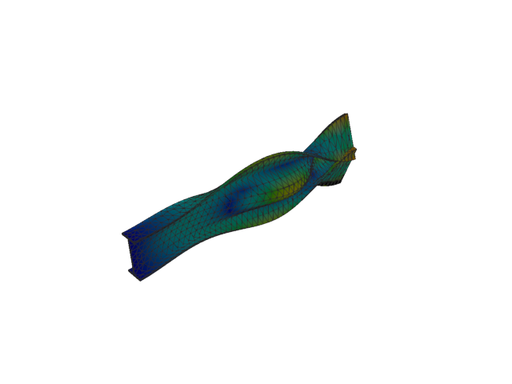
Figure 213: Abaqus — mode 8, 178.118 Hz
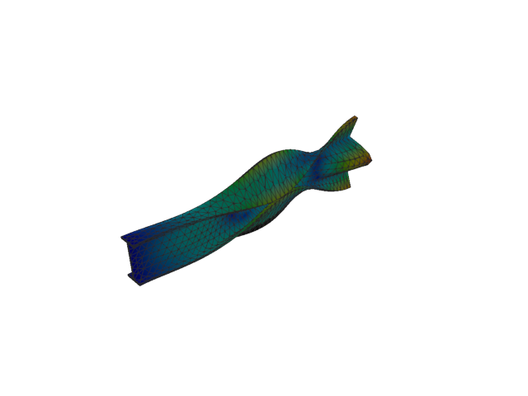
Figure 214: Sesam — mode 8, 178.114 Hz
Solver | f [Hz] | Δf vs mean [%] | λ [rad²/s²] | Meff X [kg] | Meff Y [kg] | Meff Z [kg] | Γ X | Γ Y | Γ Z
Abaqus | 178.120 | 1.74e-03 | 1.2525e+06 | 2.65e-10 | 5.79 | 5.99e-10 | -1.63e-05 | 2.405 | -2.45e-05
Sesam | 178.114 | -1.74e-03 | 1.25243e+06 | 3.03e-10 | 5.79 | 6.40e-10 | 1.74e-05 | -2.406 | 2.53e-05
- Mode 9
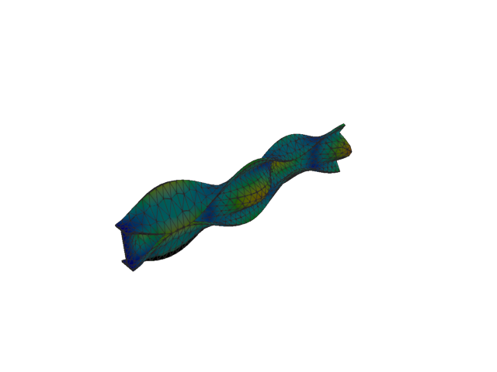
Figure 215: Abaqus — mode 9, 215.822 Hz
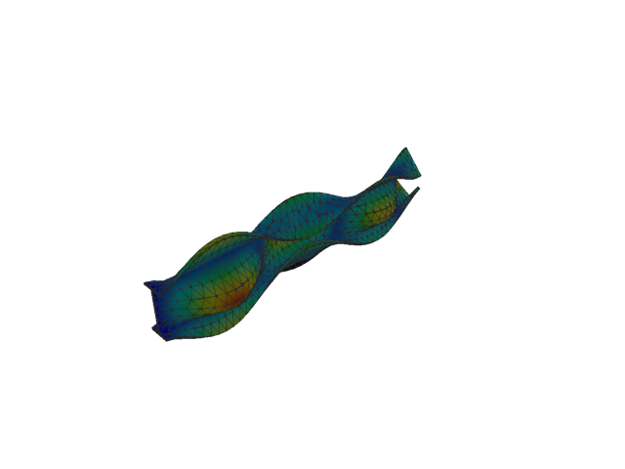
Figure 216: Sesam — mode 9, 215.815 Hz
Solver | f [Hz] | Δf vs mean [%] | λ [rad²/s²] | Meff X [kg] | Meff Y [kg] | Meff Z [kg] | Γ X | Γ Y | Γ Z
Abaqus | 215.820 | 1.20e-03 | 1.83887e+06 | 8.48e-08 | 0.60 | 8.50e-08 | -2.91e-04 | 0.774 | 2.91e-04
Sesam | 215.815 | -1.20e-03 | 1.83875e+06 | 9.03e-08 | 0.60 | 8.47e-08 | 3.00e-04 | -0.774 | -2.91e-04
- Mode 10
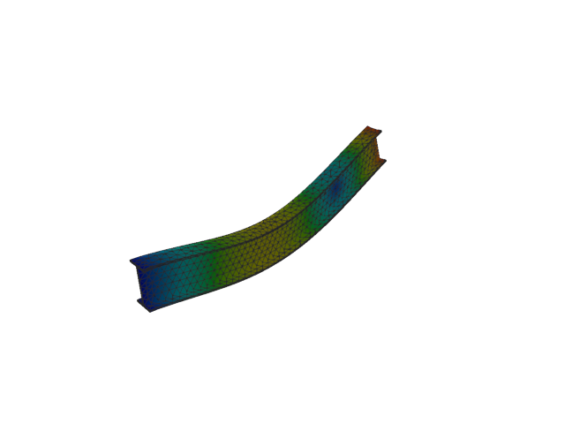
Figure 217: Abaqus — mode 10, 253.203 Hz
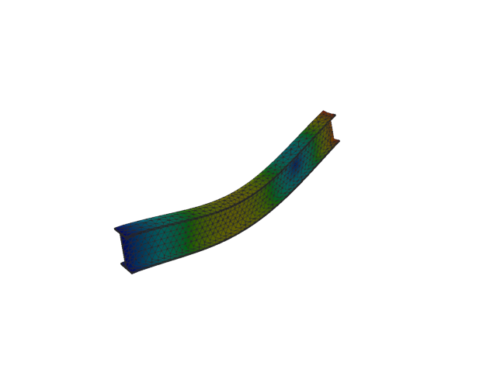
Figure 218: Sesam — mode 10, 253.203 Hz
Solver | f [Hz] | Δf vs mean [%] | λ [rad²/s²] | Meff X [kg] | Meff Y [kg] | Meff Z [kg] | Γ X | Γ Y | Γ Z
Abaqus | 253.200 | -5.73e-04 | 2.53103e+06 | 8.86e-09 | 1.97e-08 | 40.25 | -9.41e-05 | 1.40e-04 | -6.344
Sesam | 253.203 | 5.73e-04 | 2.53103e+06 | 9.13e-09 | 1.99e-08 | 40.25 | -9.56e-05 | 1.41e-04 | -6.344
- Mode 11
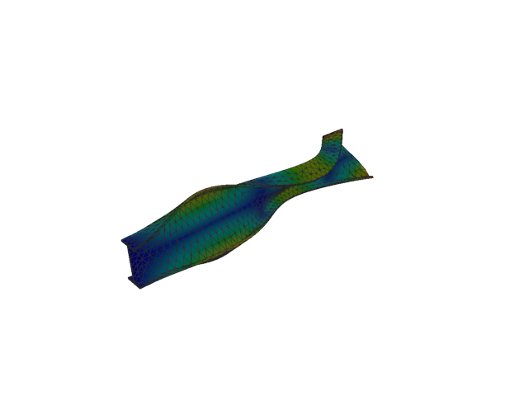
Figure 219: Abaqus — mode 11, 254.466 Hz
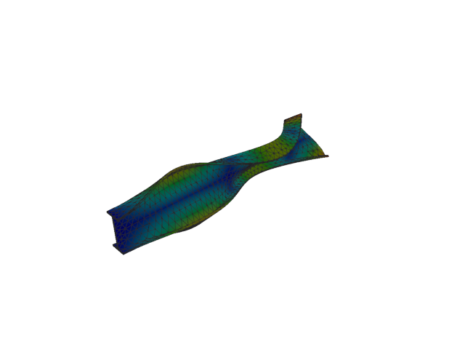
Figure 220: Sesam — mode 11, 254.466 Hz
Solver | f [Hz] | Δf vs mean [%] | λ [rad²/s²] | Meff X [kg] | Meff Y [kg] | Meff Z [kg] | Γ X | Γ Y | Γ Z
Abaqus | 254.470 | 8.65e-04 | 2.55635e+06 | 1.63e-09 | 6.96e-07 | 4.16e-05 | -4.04e-05 | -0.001 | -0.006
Sesam | 254.466 | -8.65e-04 | 2.55634e+06 | 1.66e-09 | 6.95e-07 | 4.17e-05 | -4.07e-05 | -0.001 | -0.006
- Solid, 2nd order, HEX
- Mode 1
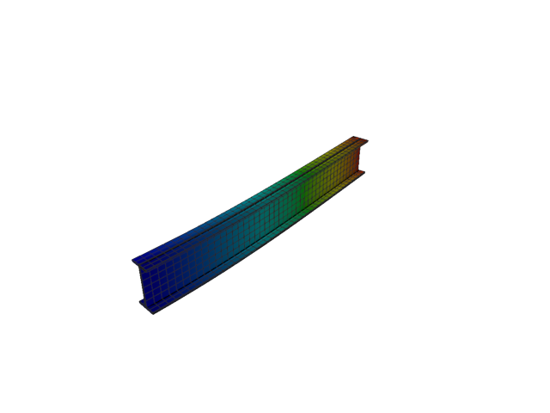
Figure 221: Abaqus — mode 1, 12.955 Hz
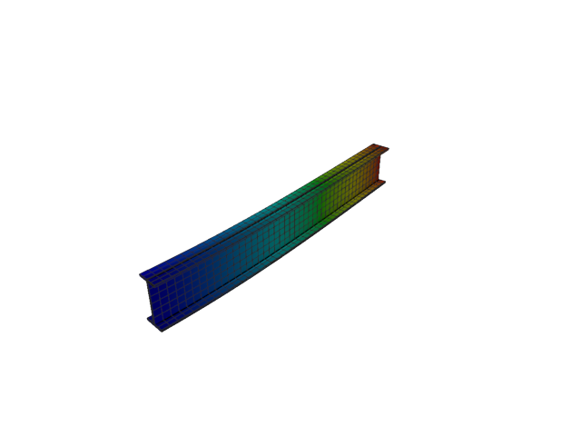
Figure 222: Sesam — mode 1, 12.954 Hz
Solver | f [Hz] | Δf vs mean [%] | λ [rad²/s²] | Meff X [kg] | Meff Y [kg] | Meff Z [kg] | Γ X | Γ Y | Γ Z
Abaqus | 12.955 | 3.32e-03 | 6625.8 | 3.08e-24 | 116.50 | 5.64e-20 | 1.76e-12 | 10.794 | 2.37e-10
Sesam | 12.954 | -3.32e-03 | 6624.86 | 3.50e-24 | 116.51 | 1.44e-22 | 1.87e-12 | 10.794 | 1.20e-11
- Mode 2
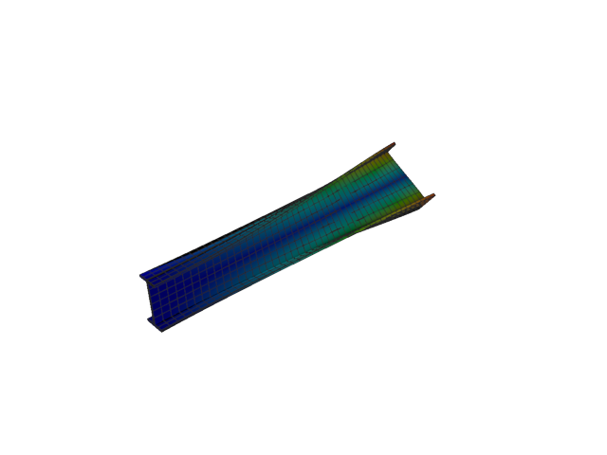
Figure 223: Abaqus — mode 2, 20.150 Hz
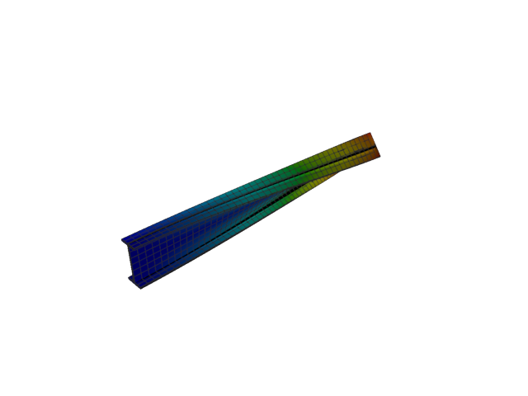
Figure 224: Sesam — mode 2, 20.044 Hz
Solver | f [Hz] | Δf vs mean [%] | λ [rad²/s²] | Meff X [kg] | Meff Y [kg] | Meff Z [kg] | Γ X | Γ Y | Γ Z
Abaqus | 20.150 | +0.26 | 16030 | 2.26e-25 | 4.71e-16 | 2.32e-18 | -4.76e-13 | 2.17e-08 | 1.52e-09
Sesam | 20.044 | -0.26 | 15861.7 | 2.99e-24 | 4.86e-15 | 1.02e-18 | 1.73e-12 | -6.97e-08 | 1.01e-09
- Mode 3
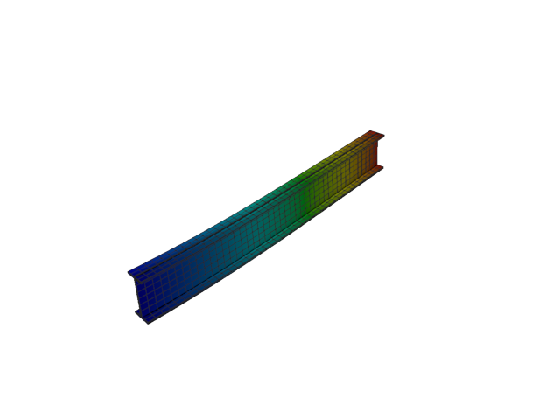
Figure 225: Abaqus — mode 3, 50.541 Hz
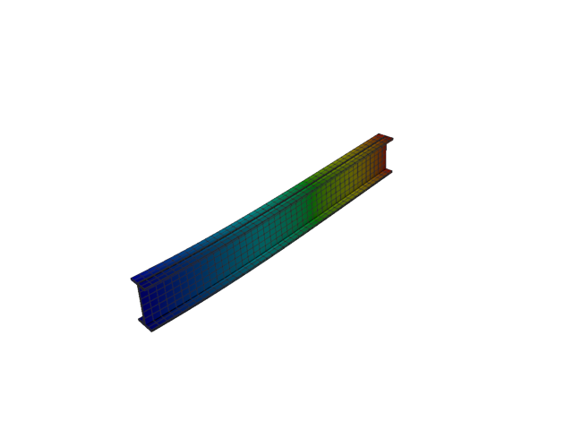
Figure 226: Sesam — mode 3, 50.534 Hz
Solver | f [Hz] | Δf vs mean [%] | λ [rad²/s²] | Meff X [kg] | Meff Y [kg] | Meff Z [kg] | Γ X | Γ Y | Γ Z
Abaqus | 50.541 | +0.01 | 100844 | 1.71e-23 | 8.62e-20 | 118.36 | -4.13e-12 | -2.94e-10 | 10.879
Sesam | 50.534 | -0.01 | 100816 | 4.30e-24 | 5.72e-22 | 118.37 | 2.07e-12 | 2.39e-11 | 10.880
- Mode 4
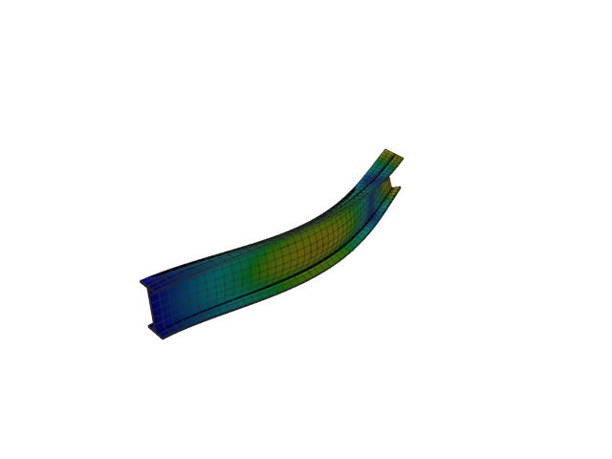
Figure 227: Abaqus — mode 4, 76.890 Hz
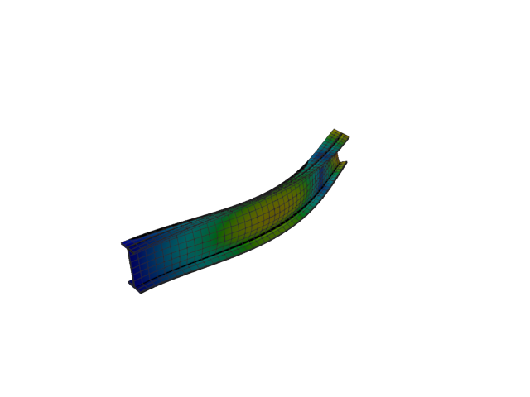
Figure 228: Sesam — mode 4, 76.747 Hz
Solver | f [Hz] | Δf vs mean [%] | λ [rad²/s²] | Meff X [kg] | Meff Y [kg] | Meff Z [kg] | Γ X | Γ Y | Γ Z
Abaqus | 76.890 | +0.09 | 233401 | 9.37e-28 | 35.91 | 1.14e-20 | -3.06e-14 | -5.993 | -1.07e-10
Sesam | 76.747 | -0.09 | 232530 | 1.68e-24 | 35.89 | 3.76e-21 | -1.29e-12 | -5.991 | 6.13e-11
- Mode 5
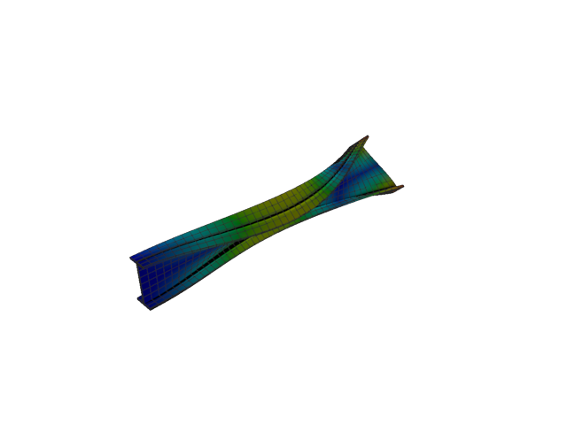
Figure 229: Abaqus — mode 5, 97.594 Hz
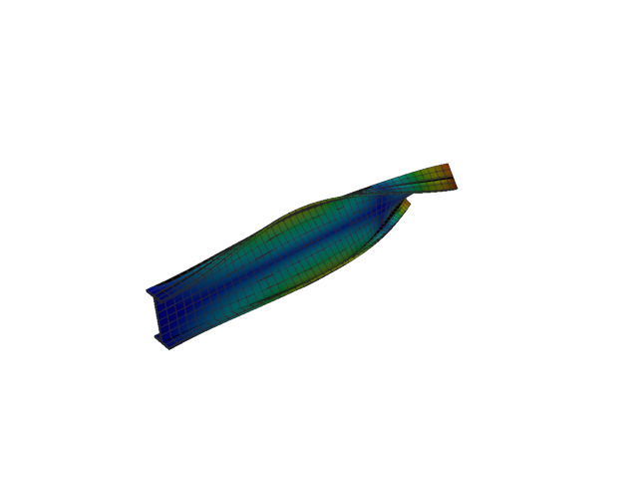
Figure 230: Sesam — mode 5, 97.472 Hz
Solver | f [Hz] | Δf vs mean [%] | λ [rad²/s²] | Meff X [kg] | Meff Y [kg] | Meff Z [kg] | Γ X | Γ Y | Γ Z
Abaqus | 97.594 | +0.06 | 376015 | 1.21e-24 | 3.12e-19 | 1.62e-21 | 1.10e-12 | -5.59e-10 | -4.02e-11
Sesam | 97.472 | -0.06 | 375078 | 8.04e-25 | 3.55e-18 | 2.80e-21 | -8.97e-13 | 1.88e-09 | -5.29e-11
- Mode 6
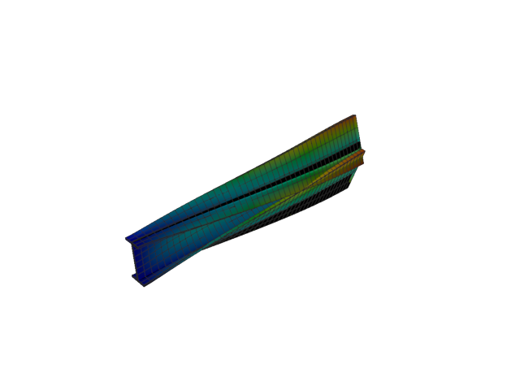
Figure 231: Abaqus — mode 6, 131.365 Hz
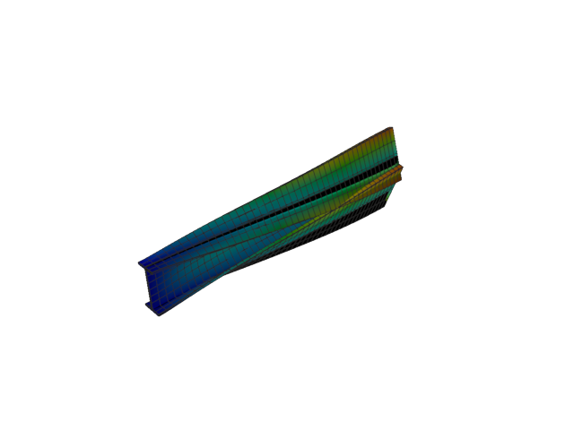
Figure 232: Sesam — mode 6, 130.865 Hz
Solver | f [Hz] | Δf vs mean [%] | λ [rad²/s²] | Meff X [kg] | Meff Y [kg] | Meff Z [kg] | Γ X | Γ Y | Γ Z
Abaqus | 131.370 | +0.19 | 681273 | 2.05e-24 | 0.01 | 1.33e-19 | 1.43e-12 | -0.103 | -3.65e-10
Sesam | 130.865 | -0.19 | 676090 | 1.00e-25 | 0.01 | 9.22e-22 | 3.16e-13 | -0.096 | 3.04e-11
- Mode 7
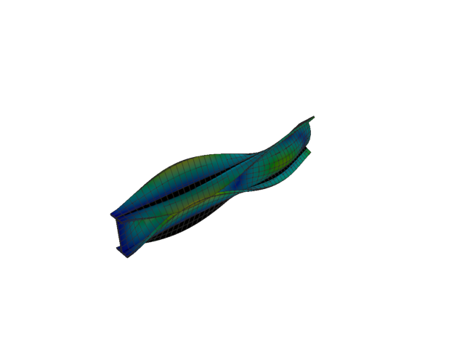
Figure 233: Abaqus — mode 7, 149.958 Hz
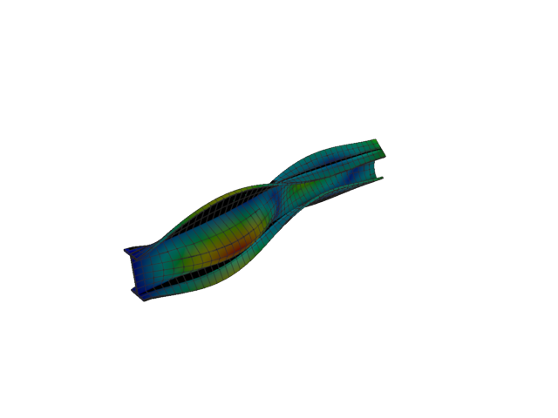
Figure 234: Sesam — mode 7, 148.496 Hz
Solver | f [Hz] | Δf vs mean [%] | λ [rad²/s²] | Meff X [kg] | Meff Y [kg] | Meff Z [kg] | Γ X | Γ Y | Γ Z
Abaqus | 149.960 | +0.49 | 887766 | 2.76e-24 | 3.31 | 8.83e-21 | 1.66e-12 | 1.818 | 9.40e-11
Sesam | 148.496 | -0.49 | 870539 | 3.33e-25 | 3.38 | 1.39e-22 | 5.77e-13 | -1.839 | -1.18e-11
- Mode 8
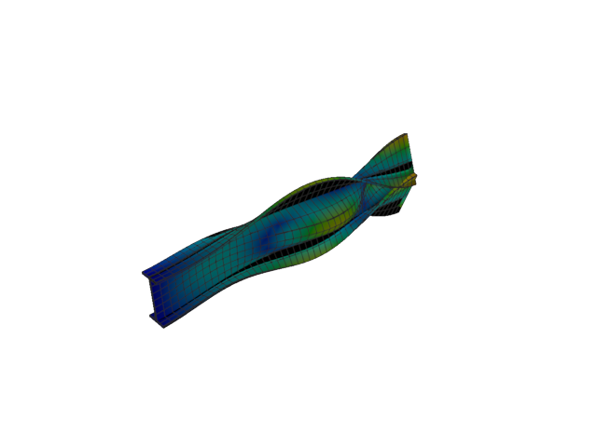
Figure 235: Abaqus — mode 8, 173.925 Hz
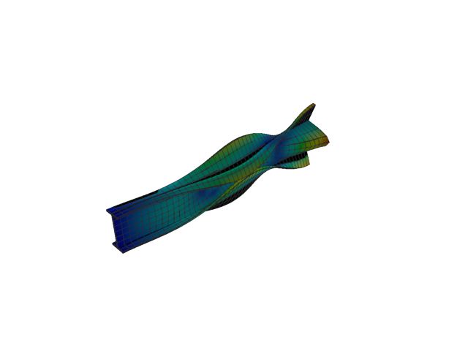
Figure 236: Sesam — mode 8, 172.243 Hz
Solver | f [Hz] | Δf vs mean [%] | λ [rad²/s²] | Meff X [kg] | Meff Y [kg] | Meff Z [kg] | Γ X | Γ Y | Γ Z
Abaqus | 173.920 | +0.48 | 1.19422e+06 | 4.36e-26 | 5.42 | 1.76e-20 | 2.09e-13 | 2.328 | -1.33e-10
Sesam | 172.243 | -0.48 | 1.17124e+06 | 8.12e-26 | 5.31 | 3.08e-22 | 2.85e-13 | -2.305 | -1.76e-11
- Mode 9
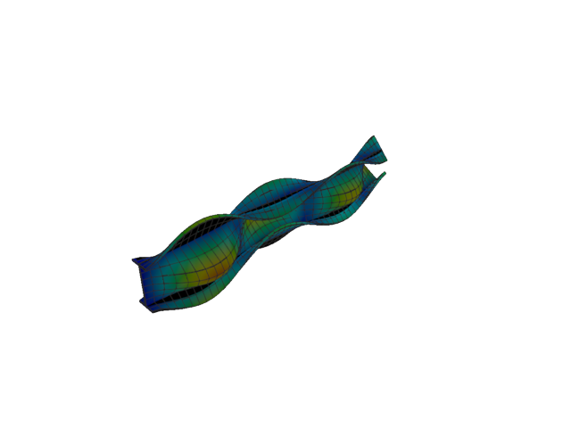
Figure 237: Abaqus — mode 9, 205.292 Hz
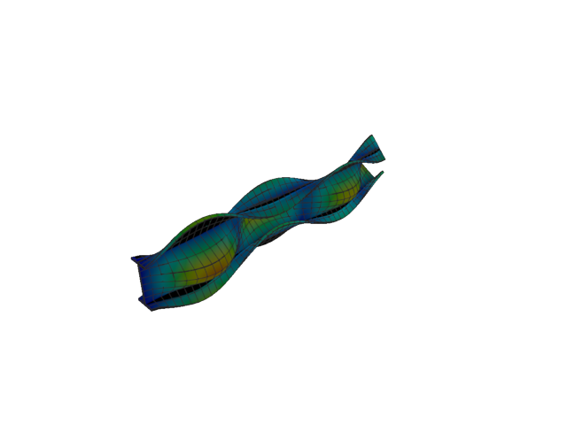
Figure 238: Sesam — mode 9, 201.904 Hz
Solver | f [Hz] | Δf vs mean [%] | λ [rad²/s²] | Meff X [kg] | Meff Y [kg] | Meff Z [kg] | Γ X | Γ Y | Γ Z
Abaqus | 205.290 | +0.83 | 1.66381e+06 | 4.78e-27 | 0.52 | 2.91e-22 | 6.91e-14 | -0.719 | 1.71e-11
Sesam | 201.904 | -0.83 | 1.60935e+06 | 1.55e-24 | 0.56 | 1.71e-22 | -1.25e-12 | -0.746 | 1.31e-11
- Mode 10
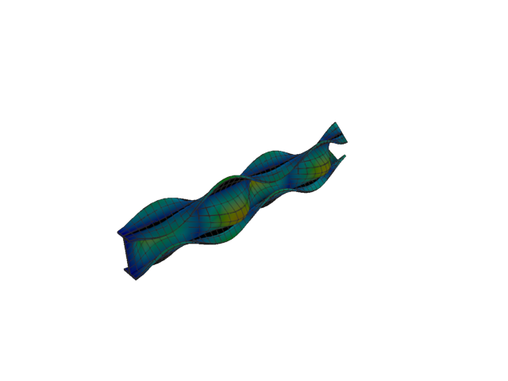
Figure 239: Abaqus — mode 10, 251.347 Hz
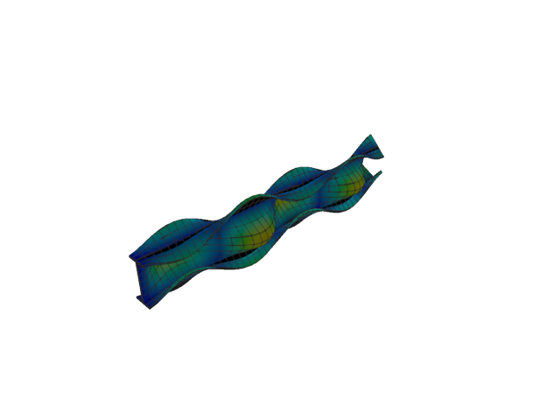
Figure 240: Sesam — mode 10, 246.353 Hz
Solver | f [Hz] | Δf vs mean [%] | λ [rad²/s²] | Meff X [kg] | Meff Y [kg] | Meff Z [kg] | Γ X | Γ Y | Γ Z
Abaqus | 251.350 | +1.00 | 2.49407e+06 | 1.08e-21 | 1.60 | 3.13e-19 | 3.29e-11 | 1.267 | -5.59e-10
Sesam | 246.353 | -1.00 | 2.39594e+06 | 1.32e-18 | 1.47 | 6.50e-19 | -1.15e-09 | 1.211 | 8.06e-10
- Mode 11
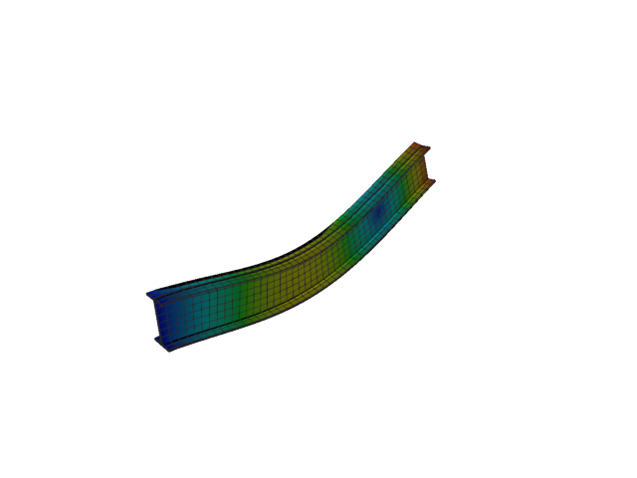
Figure 241: Abaqus — mode 11, 252.917 Hz
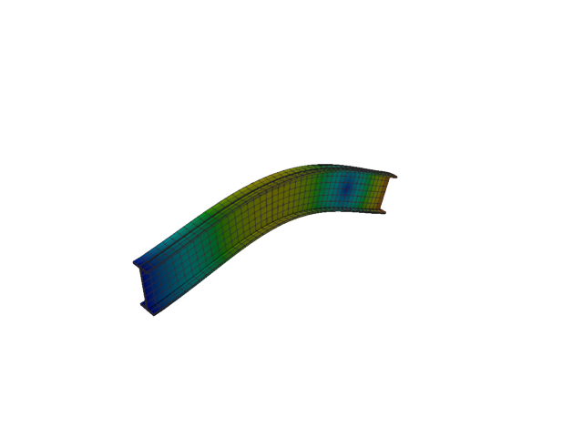
Figure 242: Sesam — mode 11, 252.742 Hz
Solver | f [Hz] | Δf vs mean [%] | λ [rad²/s²] | Meff X [kg] | Meff Y [kg] | Meff Z [kg] | Γ X | Γ Y | Γ Z
Abaqus | 252.920 | +0.04 | 2.52532e+06 | 4.22e-22 | 4.70e-20 | 40.25 | 2.05e-11 | 2.17e-10 | -6.344
Sesam | 252.742 | -0.04 | 2.52182e+06 | 2.26e-15 | 2.80e-16 | 40.28 | -4.75e-08 | 1.67e-08 | 6.346
- Solid, 2nd order, HEX, reduced integration
- Mode 1
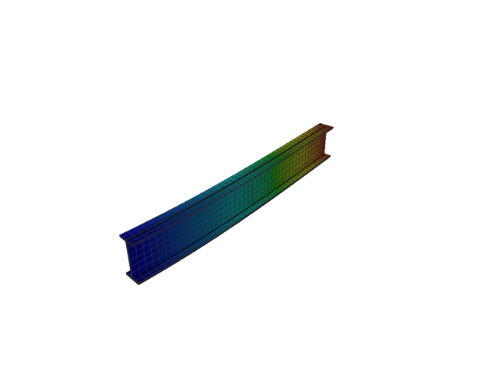
Figure 243: Abaqus — mode 1, 12.943 Hz
Solver | f [Hz] | λ [rad²/s²] | Meff X [kg] | Meff Y [kg] | Meff Z [kg] | Γ X | Γ Y | Γ Z
Abaqus | 12.943 | 6613.2 | 5.11e-26 | 116.56 | 2.93e-20 | -2.26e-13 | 10.796 | 1.71e-10
- Mode 2
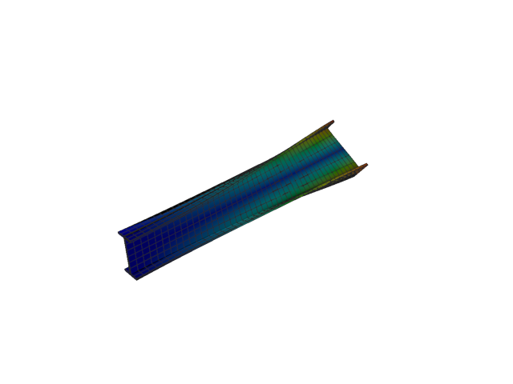
Figure 244: Abaqus — mode 2, 20.029 Hz
Solver | f [Hz] | λ [rad²/s²] | Meff X [kg] | Meff Y [kg] | Meff Z [kg] | Γ X | Γ Y | Γ Z
Abaqus | 20.029 | 15837 | 2.00e-26 | 8.47e-16 | 7.79e-20 | -1.41e-13 | 2.91e-08 | -2.79e-10
- Mode 3
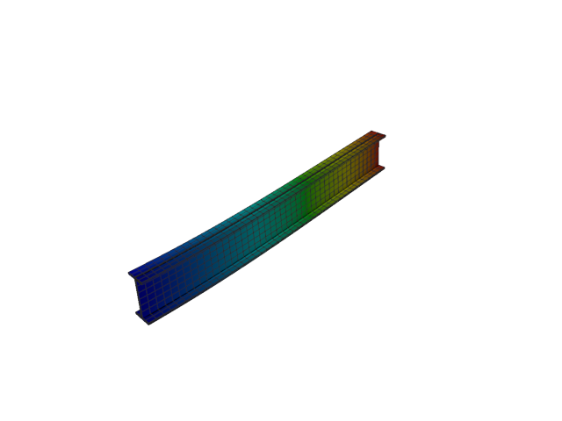
Figure 245: Abaqus — mode 3, 50.498 Hz
Solver | f [Hz] | λ [rad²/s²] | Meff X [kg] | Meff Y [kg] | Meff Z [kg] | Γ X | Γ Y | Γ Z
Abaqus | 50.498 | 100671 | 1.64e-24 | 3.78e-20 | 118.41 | -1.28e-12 | -1.94e-10 | 10.882
- Mode 4
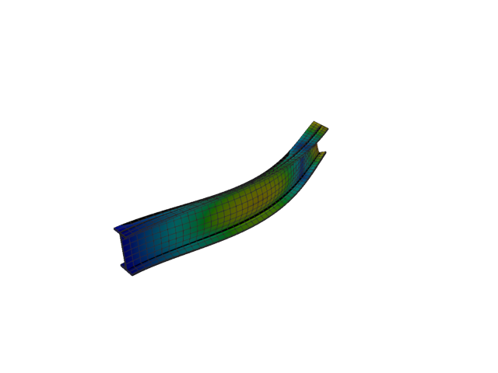
Figure 246: Abaqus — mode 4, 76.687 Hz
Solver | f [Hz] | λ [rad²/s²] | Meff X [kg] | Meff Y [kg] | Meff Z [kg] | Γ X | Γ Y | Γ Z
Abaqus | 76.687 | 232171 | 2.11e-25 | 35.90 | 8.07e-22 | -4.60e-13 | -5.992 | -2.84e-11
- Mode 5
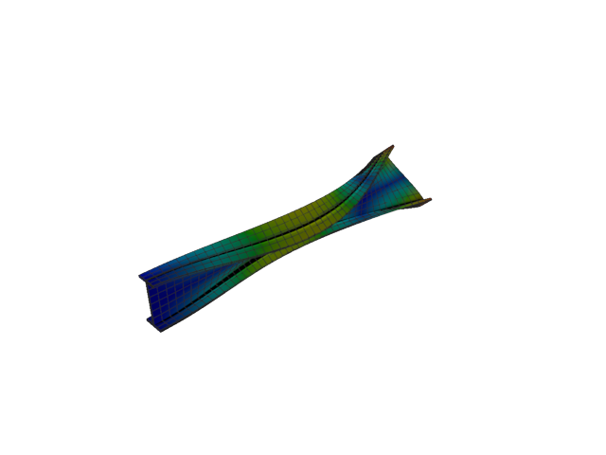
Figure 247: Abaqus — mode 5, 97.391 Hz
Solver | f [Hz] | λ [rad²/s²] | Meff X [kg] | Meff Y [kg] | Meff Z [kg] | Γ X | Γ Y | Γ Z
Abaqus | 97.391 | 374455 | 1.68e-25 | 8.25e-19 | 2.52e-24 | 4.10e-13 | -9.08e-10 | -1.59e-12
- Mode 6
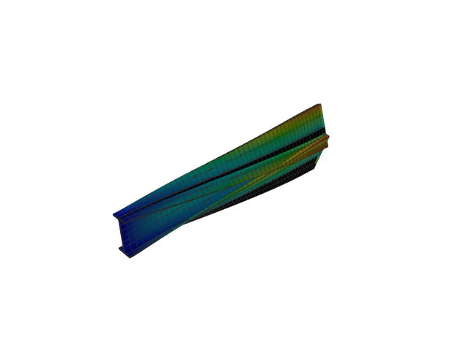
Figure 248: Abaqus — mode 6, 130.809 Hz
Solver | f [Hz] | λ [rad²/s²] | Meff X [kg] | Meff Y [kg] | Meff Z [kg] | Γ X | Γ Y | Γ Z
Abaqus | 130.810 | 675515 | 5.64e-26 | 0.01 | 6.07e-21 | -2.37e-13 | -0.097 | 7.79e-11
- Mode 7
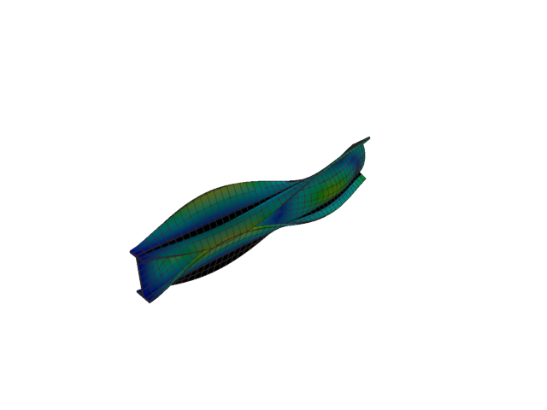
Figure 249: Abaqus — mode 7, 148.474 Hz
Solver | f [Hz] | λ [rad²/s²] | Meff X [kg] | Meff Y [kg] | Meff Z [kg] | Γ X | Γ Y | Γ Z
Abaqus | 148.470 | 870287 | 1.93e-24 | 3.39 | 2.12e-22 | -1.39e-12 | 1.840 | -1.46e-11
- Mode 8
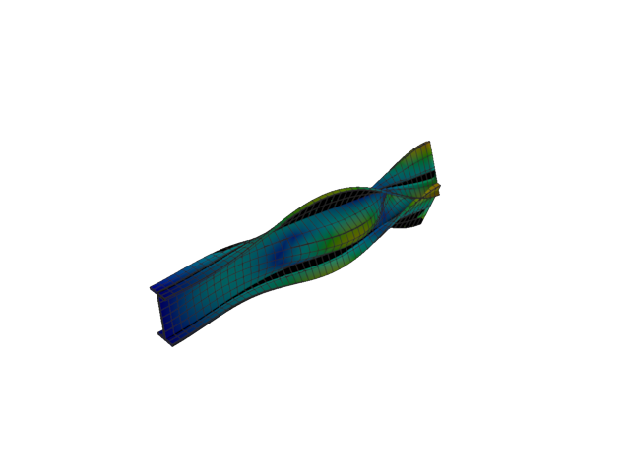
Figure 250: Abaqus — mode 8, 172.171 Hz
Solver | f [Hz] | λ [rad²/s²] | Meff X [kg] | Meff Y [kg] | Meff Z [kg] | Γ X | Γ Y | Γ Z
Abaqus | 172.170 | 1.17026e+06 | 1.27e-25 | 5.31 | 9.73e-21 | 3.57e-13 | 2.304 | 9.86e-11
- Mode 9
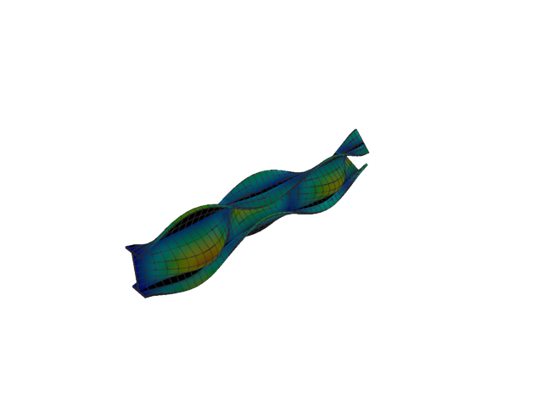
Figure 251: Abaqus — mode 9, 201.839 Hz
Solver | f [Hz] | λ [rad²/s²] | Meff X [kg] | Meff Y [kg] | Meff Z [kg] | Γ X | Γ Y | Γ Z
Abaqus | 201.840 | 1.60831e+06 | 9.86e-25 | 0.56 | 1.17e-21 | -9.93e-13 | -0.747 | 3.42e-11
- Mode 10
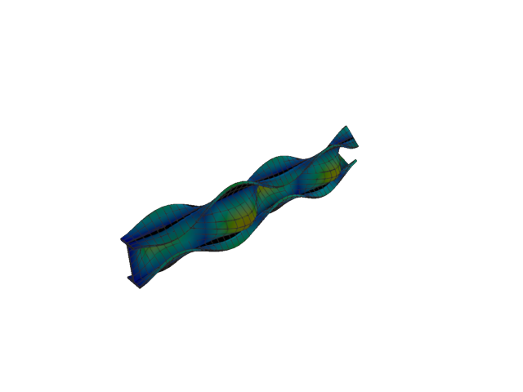
Figure 252: Abaqus — mode 10, 246.165 Hz
Solver | f [Hz] | λ [rad²/s²] | Meff X [kg] | Meff Y [kg] | Meff Z [kg] | Γ X | Γ Y | Γ Z
Abaqus | 246.170 | 2.39228e+06 | 3.32e-21 | 1.47 | 1.28e-24 | 5.76e-11 | 1.212 | -1.13e-12
- Mode 11
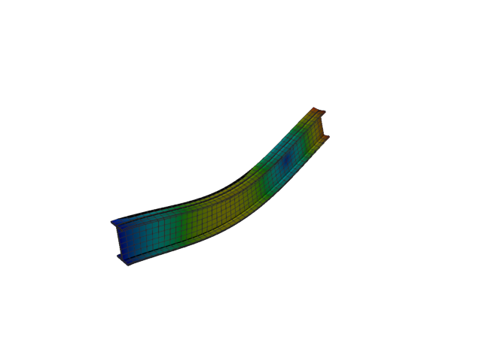
Figure 253: Abaqus — mode 11, 252.573 Hz
Solver | f [Hz] | λ [rad²/s²] | Meff X [kg] | Meff Y [kg] | Meff Z [kg] | Γ X | Γ Y | Γ Z
Abaqus | 252.570 | 2.51846e+06 | 4.57e-21 | 2.25e-19 | 40.26 | 6.76e-11 | 4.75e-10 | -6.345
- Plate eigenvalue analysis
The plain and the stiffened strip, at the eigen case’s 0.0625 m seed.
- Shell, 1st order, plain
- Mode 1
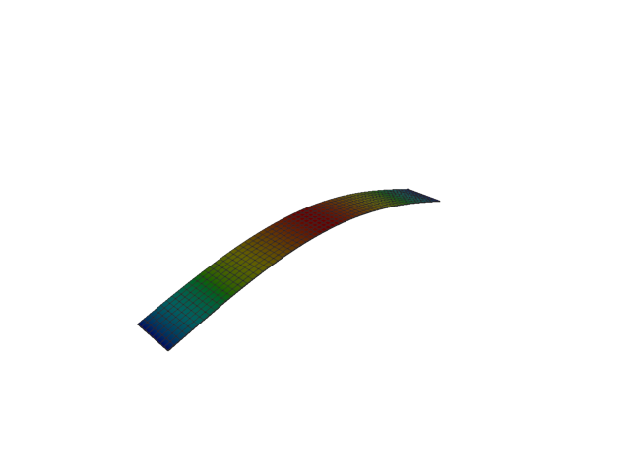
Figure 254: Abaqus — mode 1, 1.537 Hz
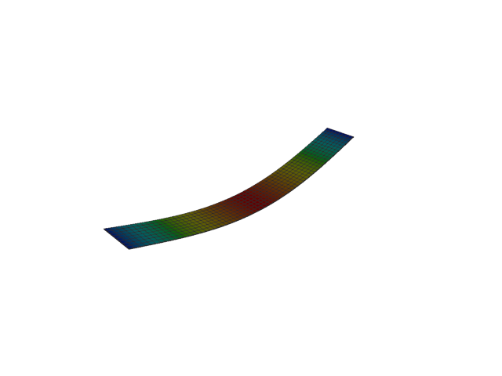
Figure 255: Sesam — mode 1, 1.537 Hz
Solver | f [Hz] | Δf vs closed form [%] | λ [rad²/s²] | Meff X [kg] | Meff Y [kg] | Meff Z [kg] | Γ X | Γ Y | Γ Z
Abaqus | 1.537 | +0.03 | 93.269 | 6.40e-31 | 3.03e-35 | 127.26 | -8.00e-16 | 5.50e-18 | 11.281
Sesam | 1.537 | -4.98e-06 | 93.2152 | 2.62e-40 | 5.38e-45 | 127.17 | -1.62e-20 | 7.33e-23 | -11.277
Closed form | 1.537
- Mode 2
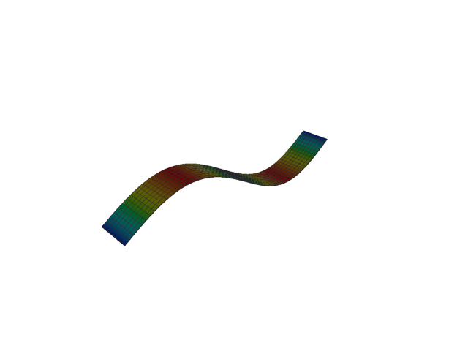
Figure 256: Abaqus — mode 2, 6.154 Hz
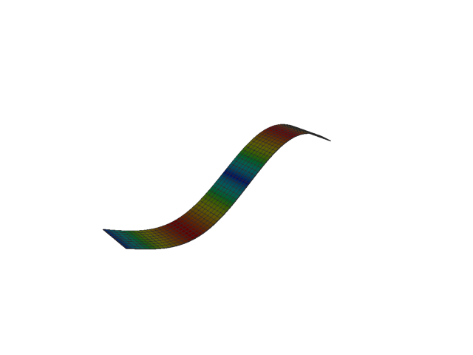
Figure 257: Sesam — mode 2, 6.146 Hz
Solver | f [Hz] | Δf vs closed form [%] | λ [rad²/s²] | Meff X [kg] | Meff Y [kg] | Meff Z [kg] | Γ X | Γ Y | Γ Z
Abaqus | 6.154 | +0.12 | 1494.9 | 5.42e-31 | 1.34e-33 | 5.32e-21 | 7.36e-16 | -3.66e-17 | 7.29e-11
Sesam | 6.146 | 1.13e-05 | 1491.44 | 2.17e-34 | 3.37e-39 | 9.71e-23 | -1.47e-17 | 5.81e-20 | -9.85e-12
Closed form | 6.146
- Mode 3
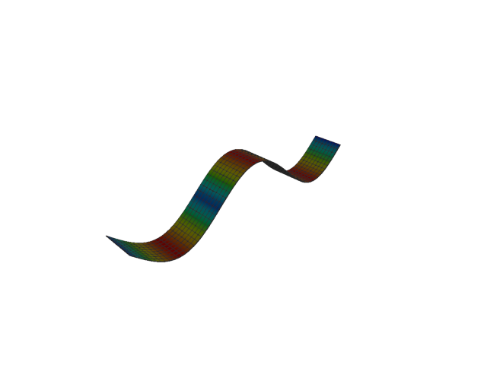
Figure 258: Abaqus — mode 3, 13.866 Hz
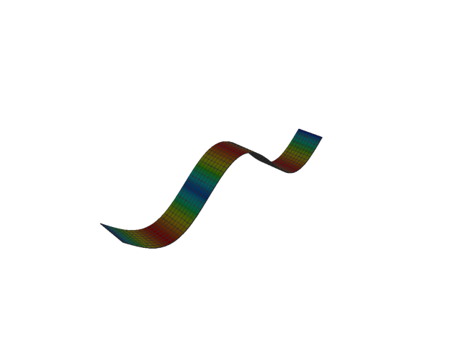
Figure 259: Sesam — mode 3, 13.829 Hz
Solver | f [Hz] | Δf vs closed form [%] | λ [rad²/s²] | Meff X [kg] | Meff Y [kg] | Meff Z [kg] | Γ X | Γ Y | Γ Z
Abaqus | 13.866 | +0.26 | 7589.9 | 4.43e-30 | 5.80e-32 | 14.14 | 2.10e-15 | -2.41e-16 | -3.760
Sesam | 13.829 | 6.01e-05 | 7550.43 | 2.14e-34 | 3.80e-39 | 14.05 | -1.46e-17 | 6.17e-20 | -3.748
Closed form | 13.829
- Mode 4
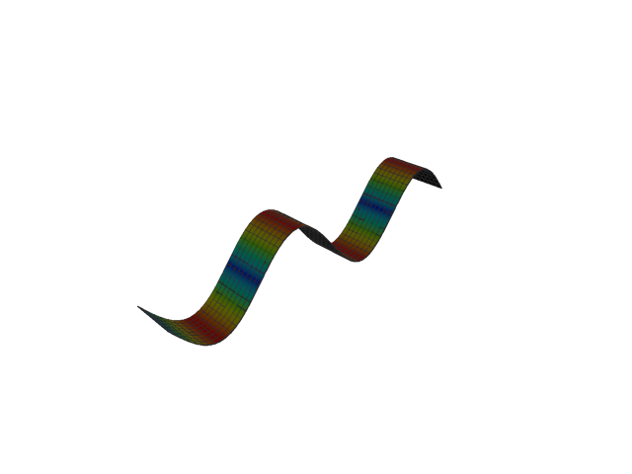
Figure 260: Abaqus — mode 4, 24.700 Hz
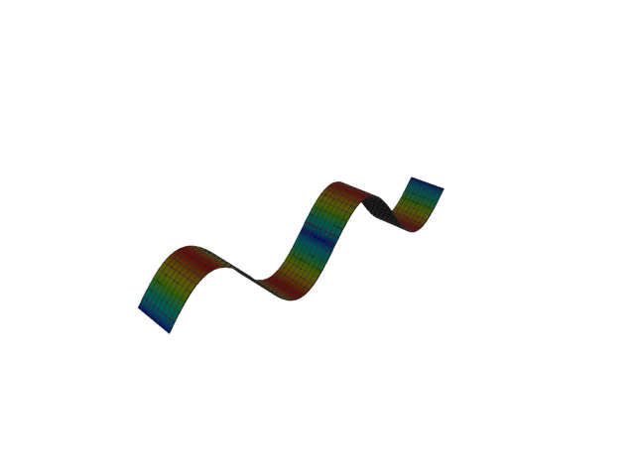
Figure 261: Sesam — mode 4, 24.586 Hz
Solver | f [Hz] | Δf vs closed form [%] | λ [rad²/s²] | Meff X [kg] | Meff Y [kg] | Meff Z [kg] | Γ X | Γ Y | Γ Z
Abaqus | 24.700 | +0.46 | 24086 | 1.04e-28 | 7.36e-32 | 1.83e-23 | -1.02e-14 | 2.71e-16 | 4.27e-12
Sesam | 24.586 | 1.01e-04 | 23863.1 | 1.77e-33 | 1.52e-36 | 1.13e-23 | 4.21e-17 | 1.23e-18 | 3.36e-12
Closed form | 24.586
- Mode 5
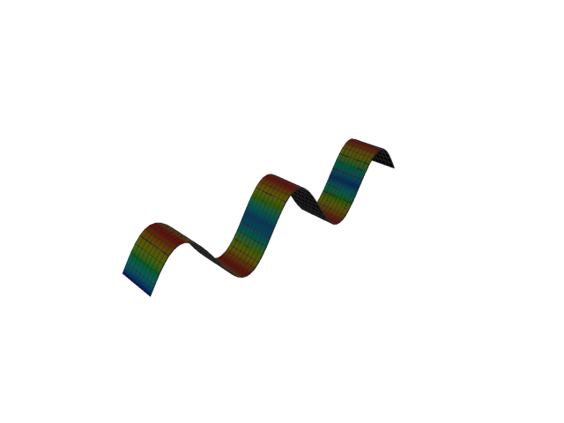
Figure 262: Abaqus — mode 5, 38.695 Hz
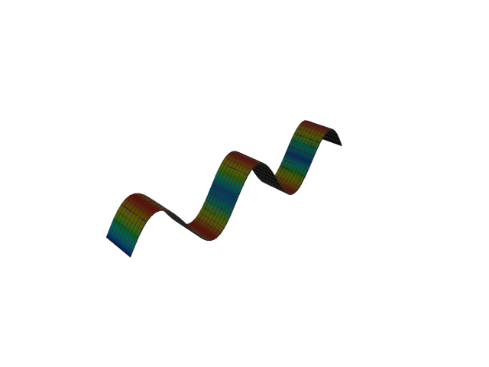
Figure 263: Sesam — mode 5, 38.415 Hz
Solver | f [Hz] | Δf vs closed form [%] | λ [rad²/s²] | Meff X [kg] | Meff Y [kg] | Meff Z [kg] | Γ X | Γ Y | Γ Z
Abaqus | 38.695 | +0.73 | 59111 | 1.02e-28 | 1.84e-30 | 5.09 | 1.01e-14 | -1.36e-15 | 2.256
Sesam | 38.415 | 2.42e-04 | 58259.8 | 1.78e-26 | 3.30e-27 | 5.00 | 1.33e-13 | 5.75e-14 | 2.236
Closed form | 38.415
- Mode 6
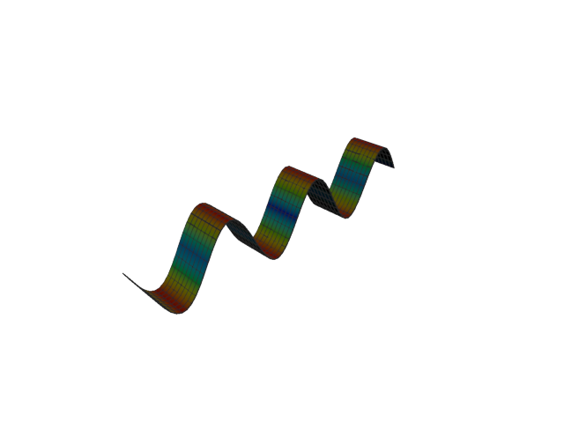
Figure 264: Abaqus — mode 6, 55.900 Hz
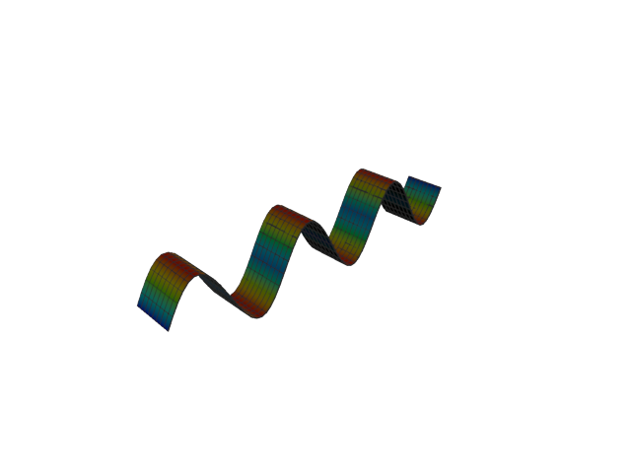
Figure 265: Sesam — mode 6, 55.318 Hz
Solver | f [Hz] | Δf vs closed form [%] | λ [rad²/s²] | Meff X [kg] | Meff Y [kg] | Meff Z [kg] | Γ X | Γ Y | Γ Z
Abaqus | 55.900 | +1.05 | 123361 | 4.94e-20 | 7.80e-26 | 3.09e-20 | -2.22e-10 | -2.79e-13 | -1.76e-10
Sesam | 55.318 | 5.30e-04 | 120808 | 1.43e-17 | 2.77e-18 | 6.63e-16 | 3.78e-09 | 1.66e-09 | -2.58e-08
Closed form | 55.318
- Shell, 1st order, stiffened
- Mode 1
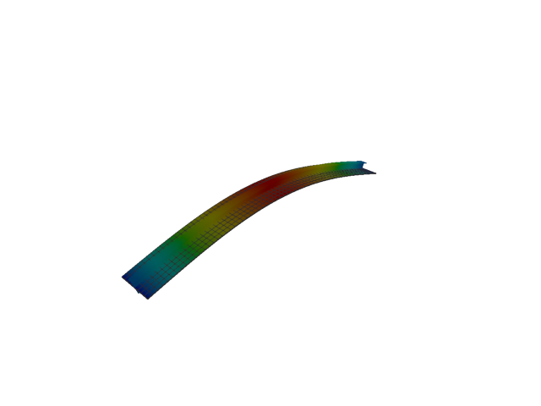
Figure 266: Abaqus — mode 1, 21.242 Hz
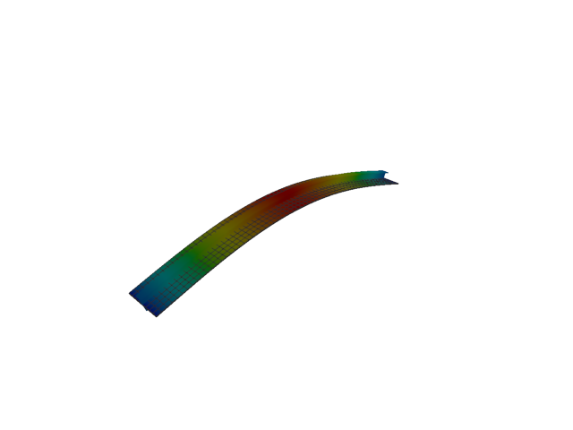
Figure 267: Sesam — mode 1, 18.917 Hz
Solver | f [Hz] | Δf vs mean [%] | λ [rad²/s²] | Meff X [kg] | Meff Y [kg] | Meff Z [kg] | Γ X | Γ Y | Γ Z
Abaqus | 21.242 | +5.79 | 17813 | 0.05 | 9.45e-26 | 195.80 | -0.214 | -3.07e-13 | 13.993
Sesam | 18.917 | -5.79 | 14127.2 | 2.29e-32 | 2.10e-37 | 195.94 | -1.51e-16 | -4.58e-19 | 13.998
- Mode 2
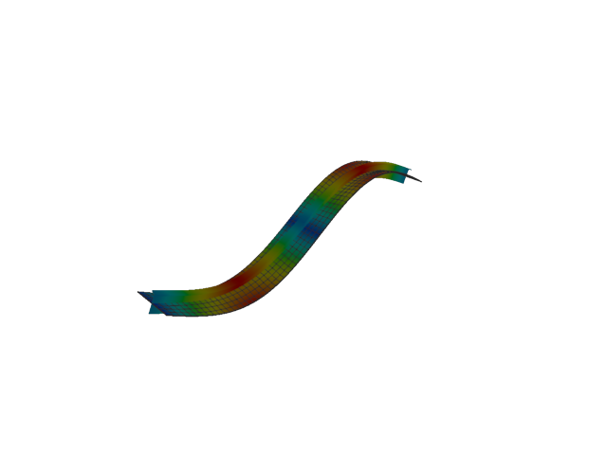
Figure 268: Abaqus — mode 2, 80.469 Hz
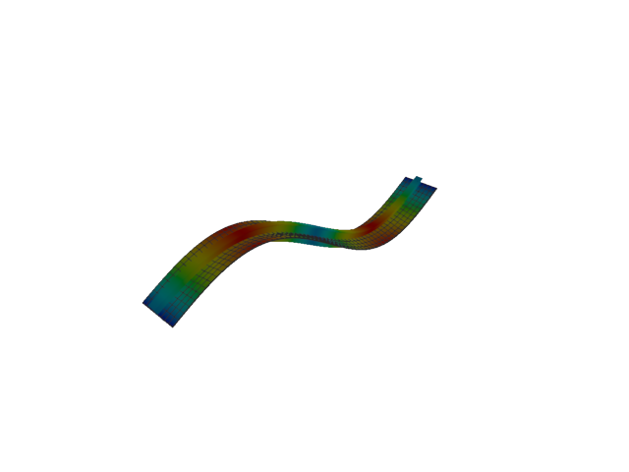
Figure 269: Sesam — mode 2, 70.063 Hz
Solver | f [Hz] | Δf vs mean [%] | λ [rad²/s²] | Meff X [kg] | Meff Y [kg] | Meff Z [kg] | Γ X | Γ Y | Γ Z
Abaqus | 80.469 | +6.91 | 255632 | 0.16 | 1.91e-25 | 3.42e-05 | 0.403 | 4.37e-13 | 0.006
Sesam | 70.063 | -6.91 | 193794 | 4.69e-34 | 9.89e-36 | 8.76e-26 | 2.17e-17 | 3.14e-18 | 2.96e-13
- Mode 3
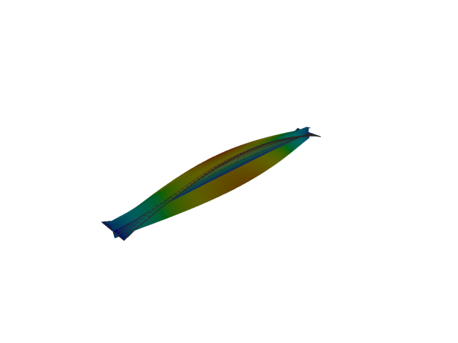
Figure 270: Abaqus — mode 3, 93.088 Hz
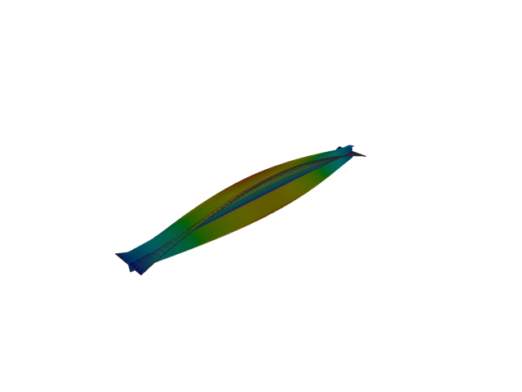
Figure 271: Sesam — mode 3, 92.575 Hz
Solver | f [Hz] | Δf vs mean [%] | λ [rad²/s²] | Meff X [kg] | Meff Y [kg] | Meff Z [kg] | Γ X | Γ Y | Γ Z
Abaqus | 93.088 | +0.28 | 342097 | 2.75e-24 | 3.95 | 1.03e-23 | 1.66e-12 | 1.988 | 3.22e-12
Sesam | 92.575 | -0.28 | 338332 | 5.73e-33 | 2.02e-07 | 3.30e-28 | -7.57e-17 | 4.49e-04 | 1.82e-14
- Mode 4
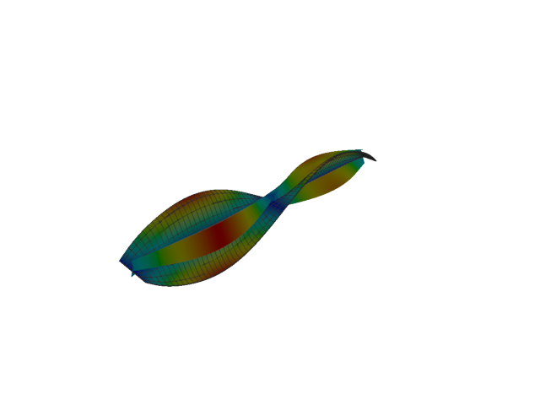
Figure 272: Abaqus — mode 4, 106.618 Hz
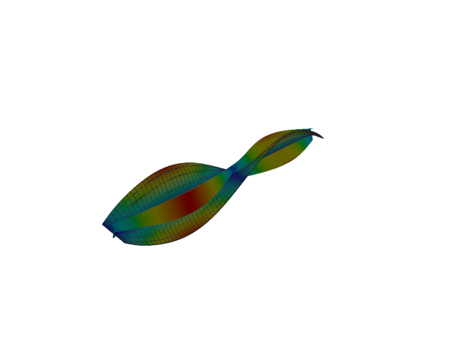
Figure 273: Sesam — mode 4, 100.998 Hz
Solver | f [Hz] | Δf vs mean [%] | λ [rad²/s²] | Meff X [kg] | Meff Y [kg] | Meff Z [kg] | Γ X | Γ Y | Γ Z
Abaqus | 106.620 | +2.71 | 448765 | 1.14e-22 | 2.35e-08 | 5.91e-22 | 1.07e-11 | 1.53e-04 | -2.43e-11
Sesam | 100.998 | -2.71 | 402700 | 1.38e-29 | 1.02e-09 | 1.26e-26 | -3.71e-15 | 3.19e-05 | 1.12e-13
- Mode 5
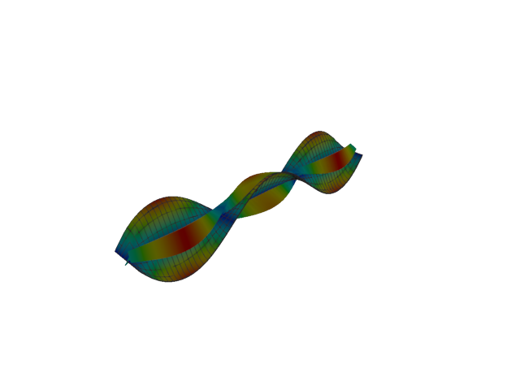
Figure 274: Abaqus — mode 5, 128.504 Hz
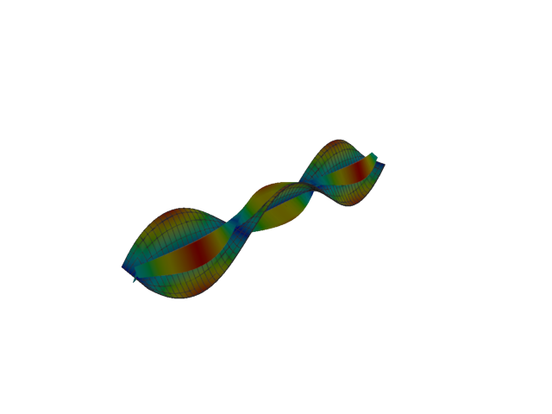
Figure 275: Sesam — mode 5, 115.222 Hz
Solver | f [Hz] | Δf vs mean [%] | λ [rad²/s²] | Meff X [kg] | Meff Y [kg] | Meff Z [kg] | Γ X | Γ Y | Γ Z
Abaqus | 128.500 | +5.45 | 651919 | 5.66e-20 | 0.39 | 1.44e-19 | 2.38e-10 | -0.624 | 3.79e-10
Sesam | 115.222 | -5.45 | 524118 | 4.47e-23 | 4.62e-07 | 1.89e-22 | -6.69e-12 | -0.001 | 1.37e-11
- Mode 6
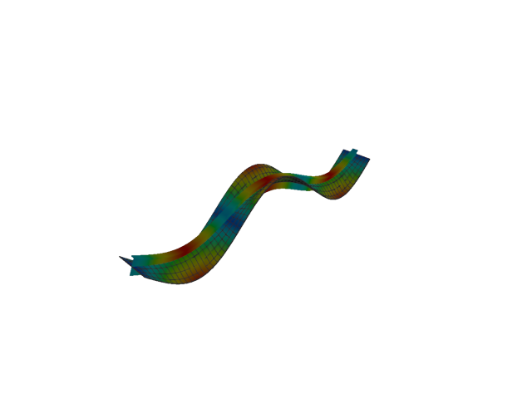
Figure 276: Abaqus — mode 6, 155.525 Hz
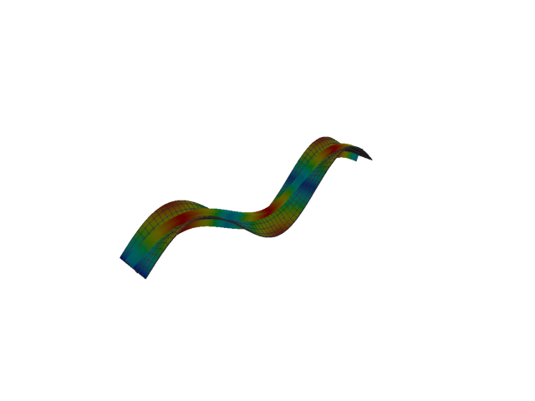
Figure 277: Sesam — mode 6, 134.344 Hz
Solver | f [Hz] | Δf vs mean [%] | λ [rad²/s²] | Meff X [kg] | Meff Y [kg] | Meff Z [kg] | Γ X | Γ Y | Γ Z
Abaqus | 155.520 | +7.31 | 954899 | 0.26 | 3.11e-16 | 20.18 | 0.507 | 1.76e-08 | -4.492
Sesam | 134.344 | -7.31 | 712516 | 3.13e-16 | 2.60e-18 | 20.78 | -1.77e-08 | 1.61e-09 | 4.558
- Plate static analysis
The deflected strip under 1 kPa, plain and stiffened, at the same 0.0625 m seed. The other seeds deform into the same shape; their convergence is in the summary table.
- Shell, 1st order, plain, seed 0.0625 m
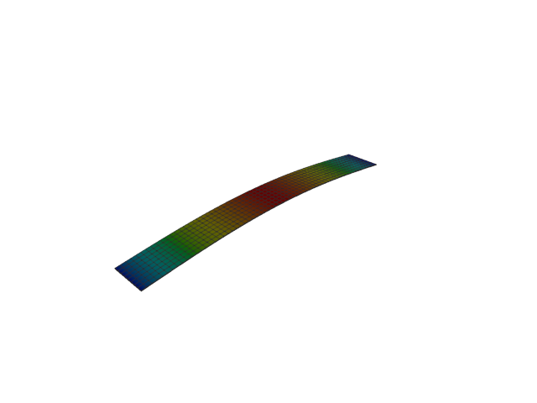
Figure 278: Abaqus — displacement
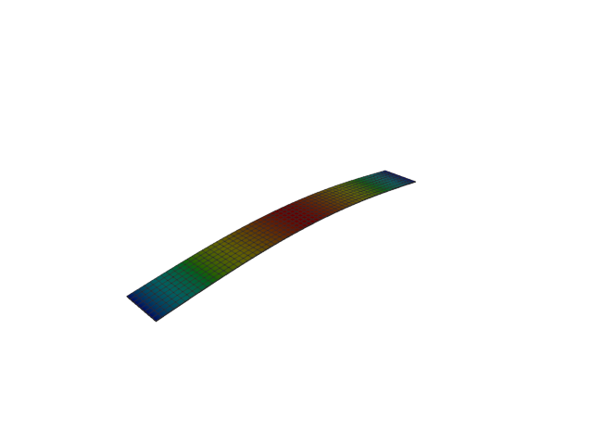
Figure 279: Sesam — displacement
Solver | Mid-span u_z [mm] | Δ vs closed form [%] | Peak u_z [mm] | Peak u_x [mm] | Peak u_y [mm]
Abaqus | 173.2686 | -0.04 | 173.2686 | 5.59e-17 | 4.12e-29
Sesam | 173.2995 | -0.02 | 173.2995 | 0.0000 | 0.0000
Closed form | 173.3333
- Shell, 1st order, stiffened, seed 0.0625 m
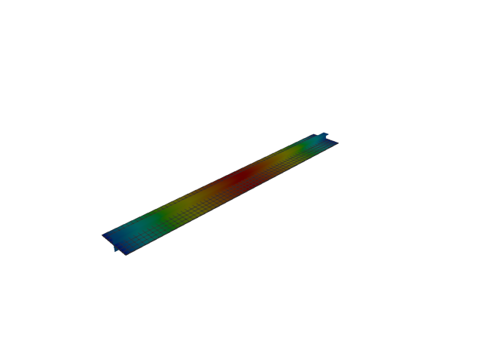
Figure 280: Abaqus — displacement
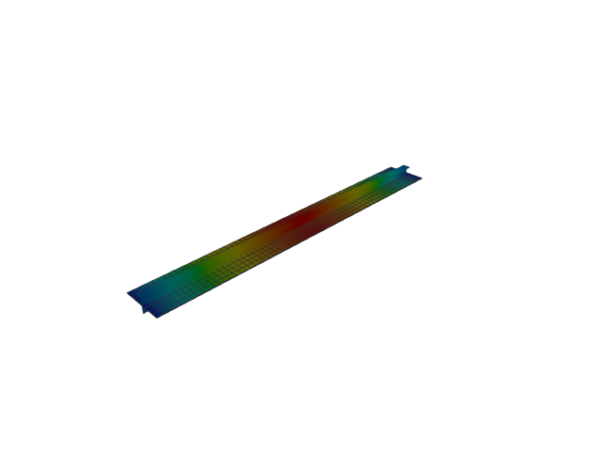
Figure 281: Sesam — displacement
Solver | Mid-span u_z [mm] | Δ vs mean [%] | Peak u_z [mm] | Peak u_x [mm] | Peak u_y [mm]
Abaqus | 0.5855 | -11.59 | 0.5934 | 0.0118 | 2.12e-05
Sesam | 0.7390 | +11.59 | 0.7474 | 1.25e-17 | 2.34e-17

