Open Source FEA using adapy
This report describes the main verification work of the simulation results produced by the Open Source Finite Element (FE) solvers Code Aster and Calculix.
The motivation behind producing this report is to increase confidence in the conversion of FEM models in adapy and also the results from the various FEA solvers.

Introduction
The results from Code Aster and Calculix and tools will be compared with proprietary FEA solvers such as;
- Abaqus
- Sestra (part of DNV’s Sesam suite)
The simulations are pre- and post processed using adapy and this report is automatically generated using paradoc as part of a ci/cd pipeline within the adapy repositories.
For each new addition of code affecting the handling of FEM in adapy a new set of analyses is performed, whereas the results are gathered in this auto-generated document.
Please note! This report will not go into detail into the specifics of why the results are different between different element representations. This report will only investigate and compare the results from different FEA software.

FEA Solvers
- Calculix v2.23
- Code Aster v18.1.7
- Abaqus v2025
- Sestra v11.3.1.0

Python packages
The following python packages were instrumental in the creation of this document and the FEA results herein.

Adapy
The intention behind adapy is to make it easier to work with finite element models and BIM models and act as a high-level scripting library for parametric and procedural modelling techniques.

Paradoc
paradoc was created to simplify the generation of reports by creating the structure of the document and text in markdown with a string substitution scheme that lets you easily pass in tables, functions and finally be able to produce production ready documents in Microsoft Word.

Summary
A summary of all performed analyses will be performed in this section and a percentage difference for each FEA solver per type of analysis will be calculated and presented.

Analyses

Eigenvalue Analysis
A simple cantilevered beam is subjected to eigenvalue analysis with a total of 11 eigenmodes requested. 47 cases are compared across solvers: abaqus, calculix, code_aster, sesam.
The beam model will be analyzed by varying the following parameters:
- Mesh type (Solid, Shell, Line)
- Mesh element types (TET, HEX, TRI, QUAD)
- Mesh element order (1st and 2nd order)
- Reduced integration elements (R)
- Different FEA solvers (Calculix, Code Aster, Abaqus, Sesam)

Model Description
Property | Value
Description | Beam(“MyBeam”, [0.0, 0.5, 0.5], [3.0, 0.5, 0.5], “IPE400”, “S420”)
Length | 3.00 m
Section | IPE400
Material | S420
Young’s modulus | 2.100e+11 Pa
Yield stress | 4.200e+08 Pa
Density | 7850 kg/m³
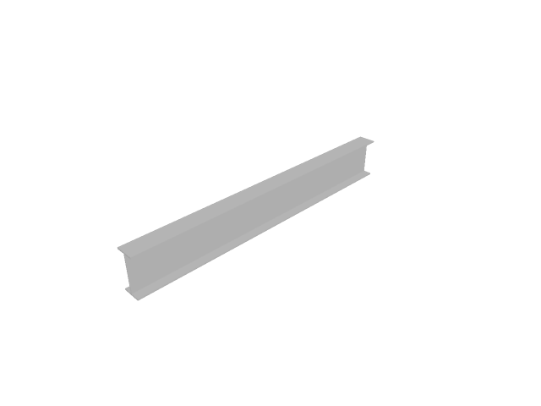
Figure 1: Cantilever beam geometry.

Summary
This section presents a comparison between the calculated results from the eigenvalue analysis of a cantilever beam using the different FEA tools.
Note! The Sestra and Abaqus analyses are not performed as part of the github actions step. The eigenmode results are kept in cached json files and imported during the compilation of the report using paradoc.

Eigenfrequency vs. mode number
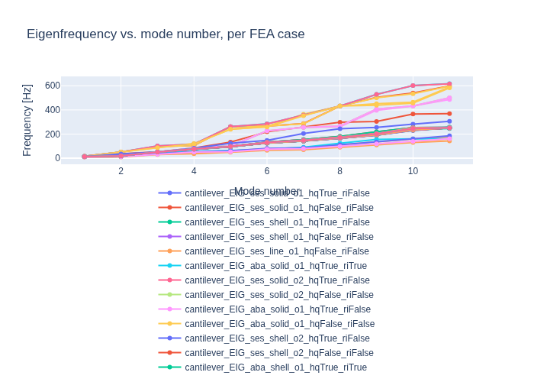
Figure 2: Eigenfrequency vs. mode number across FEA cases.

Comparison tables
Columns are sortable; the table grammar {tbl:sortby:Mode:asc;index:no} sets the initial sort and hides the index column.
Table 1: Eigenfrequency comparison (Hz) — solid, 1st order.
Mode | ses_HEX | ses_TET | aba_HEXR | aba_HEX | aba_TET | ccx_TET | ca_TET | ccx_HEX | ca_HEX | ccx_HEXR | ca_HEXR
1 | 12.9766 | 15.7932 | 12.514 | 13.435 | 15.79 | 15.9285 | 15.9277 | 13.6205 | 13.6205 | 14.3018 | 13.5291
2 | 20.3015 | 51.5418 | 34.157 | 20.731 | 51.532 | 51.5896 | 51.5872 | 21.0685 | 21.0685 | 51.6653 | 34.7401
3 | 50.6181 | 97.7314 | 49.598 | 50.678 | 97.588 | 102.446 | 102.41 | 50.8252 | 50.8252 | 88.2331 | 50.7365
4 | 77.3921 | 105.691 | 55.271 | 82.799 | 104.8 | 116.744 | 116.512 | 84.066 | 84.066 | 116.873 | 82.2962
5 | 98.1185 | 260.887 | 64.305 | 100.19 | 260.59 | 261.877 | 261.806 | 102.334 | 102.334 | 240.766 | 123.303
6 | 133.016 | 267.131 | 74.866 | 223.14 | 266.26 | 284.697 | 284.465 | 227.25 | 227.25 | 258.286 | 147.139
7 | 153.833 | 287.461 | 90.033 | 254.98 | 285.05 | 357.062 | 356.306 | 255.872 | 255.872 | 351.823 | 205.267
8 | 178.565 | 432.347 | 124.58 | 260.1 | 432.31 | 432.36 | 432.35 | 266.519 | 266.519 | 431.955 | 243.985
9 | 214.689 | 503.862 | 155.99 | 396.57 | 500.86 | 529.297 | 528.489 | 407.869 | 407.869 | 439.038 | 254.838
10 | 253.463 | 539.506 | 159.95 | 431.8 | 534.26 | 601.943 | 601.586 | 432.207 | 432.207 | 456.762 | 282.888
11 | 256.05 | 598.2 | 162.56 | 486.96 | 596.78 | 617.646 | 616.155 | 500.931 | 500.931 | 582.562 | 305.247
Table 2: Eigenfrequency comparison (Hz) — solid, 2nd order.
Mode | ses_HEX | ses_TET | aba_HEXR | aba_HEX | aba_TET | ccx_TET | ca_TET | ccx_HEX | ca_HEX | ccx_HEXR | ca_HEXR
1 | 12.9541 | 12.9537 | 12.943 | 12.955 | 12.954 | 12.9542 | 12.9542 | 12.9551 | 12.9551 | 12.9428 | 12.9427
2 | 20.0445 | 20.2945 | 20.029 | 20.15 | 20.294 | 20.2876 | 20.2877 | 20.1503 | 20.1503 | 20.0288 | 20.0288
3 | 50.5342 | 50.5401 | 50.498 | 50.541 | 50.54 | 50.5401 | 50.5402 | 50.5412 | 50.5412 | 50.4977 | 50.4977
4 | 76.7467 | 77.1278 | 76.687 | 76.89 | 77.128 | 77.2297 | 77.2297 | 76.8903 | 76.8903 | 76.6876 | 76.6875
5 | 97.4723 | 97.8296 | 97.391 | 97.594 | 97.83 | 97.8506 | 97.8505 | 97.5939 | 97.5939 | 97.3913 | 97.3912
6 | 130.865 | 132.478 | 130.81 | 131.37 | 132.48 | 133.015 | 133.014 | 131.365 | 131.365 | 130.814 | 130.809
7 | 148.496 | 153.631 | 148.47 | 149.96 | 153.63 | 154.804 | 154.802 | 149.958 | 149.958 | 148.478 | 148.474
8 | 172.243 | 178.114 | 172.17 | 173.92 | 178.12 | 181.029 | 181.026 | 173.925 | 173.925 | 172.177 | 172.171
9 | 201.904 | 215.815 | 201.84 | 205.29 | 215.82 | 219.501 | 219.497 | 205.292 | 205.292 | 201.846 | 201.839
10 | 246.353 | 253.203 | 246.17 | 251.35 | 253.2 | 253.193 | 253.193 | 251.347 | 251.347 | 246.177 | 246.165
11 | 252.742 | 254.466 | 252.57 | 252.92 | 254.47 | 254.685 | 254.684 | 252.917 | 252.917 | 252.573 | 252.573
Table 3: Eigenfrequency comparison (Hz) — shell, 1st order.
Mode | ses_QUAD | ses_TRI | aba_QUADR | aba_QUAD | aba_TRIR | ccx_TRI | ca_TRI | ccx_QUAD | ca_QUAD | ccx_QUADR
1 | 12.7628 | 13.6414 | 12.373 | 12.78 | 13.6869 | 13.7254 | 13.642 | 12.7639 | 13.1463 | 14.2558
2 | 19.3943 | 20.1983 | 19.23 | 19.593 | 20.3643 | 36.6896 | 20.4181 | 19.6304 | 19.9719 | 53.2618
3 | 51.9912 | 52.1922 | 51.849 | 51.998 | 52.1874 | 52.2485 | 52.1927 | 51.9997 | 52.0595 | 87.9153
4 | 75.1918 | 79.5226 | 73.558 | 75.683 | 80.2058 | 83.7093 | 79.6596 | 75.4574 | 77.2361 | 121.85
5 | 95.9297 | 101.756 | 93.709 | 96.393 | 102.043 | 132.928 | 102.01 | 96.2959 | 98.7619 | 239.804
6 | 125.116 | 125.093 | 126.87 | 126.96 | 124.093 | 218.167 | 125.459 | 125.898 | 125.442 | 262.83
7 | 141.556 | 143.164 | 144.58 | 145.57 | 145.486 | 259.245 | 144.895 | 145.282 | 143.864 | 365.1
8 | 165.03 | 166.668 | 168.38 | 169.39 | 168.62 | 297.856 | 168.951 | 169.441 | 167.974 | 431.774
9 | 190.099 | 191.533 | 197.51 | 198.75 | 199.719 | 304.464 | 195.184 | 200.494 | 193.96 | 451.745
10 | 229.46 | 230.489 | 241.27 | 242.55 | 242.995 | 365.943 | 235.115 | 247.276 | 233.817 | 464.44
11 | 250.786 | 257.362 | 245.07 | 252.49 | 257.447 | 368.764 | 257.409 | 251.554 | 257.105 | 589.24
Table 4: Eigenfrequency comparison (Hz) — shell, 2nd order.
Mode | ses_QUAD | ses_TRI | aba_QUADR | aba_QUAD | aba_TRI | ccx_TRI | ca_TRI | ccx_QUAD | ca_QUAD | ccx_QUADR
1 | 12.7554 | 12.7558 | 12.758 | 12.758 | 12.756 | 12.7562 | 12.7566 | 12.7576 | 12.7561 | 12.7559
2 | 19.4731 | 19.5048 | 19.486 | 19.486 | 19.567 | 19.5254 | 19.4509 | 19.5638 | 19.4736 | 19.5021
3 | 51.9702 | 51.9704 | 51.998 | 51.998 | 51.969 | 51.974 | 51.97 | 51.9801 | 51.97 | 51.9741
4 | 75.1245 | 75.1716 | 75.149 | 75.149 | 75.145 | 75.1848 | 75.1443 | 75.2685 | 75.1252 | 75.1399
5 | 95.8886 | 95.9337 | 95.92 | 95.92 | 96.001 | 95.9713 | 95.8707 | 96.0372 | 95.8893 | 95.9349
6 | 124.987 | 125.173 | 125 | 125 | 125.21 | 125.465 | 125.087 | 125.889 | 124.987 | 125.257
7 | 142.234 | 142.768 | 142.32 | 142.32 | 142.77 | 142.995 | 142.359 | 143.72 | 142.233 | 142.497
8 | 165.718 | 166.334 | 165.85 | 165.85 | 166.6 | 166.579 | 165.79 | 167.347 | 165.719 | 165.981
9 | 191.999 | 193.308 | 192.18 | 192.18 | 192.84 | 194.014 | 192.406 | 195.577 | 191.998 | 192.87
10 | 232.626 | 234.613 | 232.87 | 232.87 | 233.36 | 236.042 | 233.389 | 238.389 | 232.628 | 234.347
11 | 250.095 | 250.24 | 250.17 | 250.17 | 250.13 | 250.287 | 250.175 | 250.521 | 250.096 | 250.147
Table 5: Eigenfrequency comparison (Hz) — line, 1st order.
Mode | ses | aba | ca
1 | 12.2454 | 10.785 | 12.2454
2 | 12.9431 | 12.928 | 12.9793
3 | 36.7525 | 32.342 | 36.7525
4 | 44.9622 | 50.543 | 52.9559
5 | 61.3087 | 53.855 | 61.3087
6 | 79.793 | 75.296 | 81.3401
7 | 85.9466 | 79.59 | 85.9466
8 | 110.699 | 96.637 | 110.699
9 | 135.6 | 117.85 | 135.6
10 | 160.681 | 138.9 | 160.681
11 | 176.495 | 159.77 | 185.976
Table 6: Eigenfrequency comparison (Hz) — line, 2nd order.
Mode | ses | aba
1 | 10.039 | 10.786
2 | 10.6144 | 12.932
3 | 30.1078 | 32.358
4 | 36.752 | 50.557
5 | 50.1488 | 53.93
6 | 65.3265 | 75.502
7 | 70.1429 | 79.684
8 | 90.0695 | 97.074
9 | 109.907 | 118.65
10 | 129.631 | 140.22
11 | 142.572 | 161.8

Effective modal mass
Effective modal mass [kg] per case, summed over the captured modes in the global X / Y / Z directions. Every solver reports it; Code Aster and Sesam give translational mass only. Summing over enough modes approaches the structure’s total mass in each direction.
Table 7: Effective modal mass [kg] per case, summed over the captured modes in the global X/Y/Z directions. Code_Aster and Sesam report translational effective mass only.
Case | Modes | ΣMeff X | ΣMeff Y | ΣMeff Z
aba_line_o1 | 11 | 0 | 152.8 | 118.2
aba_line_o2 | 11 | 0 | 152.8 | 118.2
aba_shell_o1_QUAD | 11 | 0 | 168 | 122
aba_shell_o1_QUADR | 11 | 0 | 168.4 | 122
aba_shell_o2_QUAD | 11 | 0 | 167.8 | 122
aba_shell_o2_QUADR | 11 | 0 | 167.8 | 122
aba_shell_o2_TRI | 11 | 0 | 167.9 | 122
aba_solid_o1_HEX | 11 | 153.5 | 170.5 | 158.2
aba_solid_o1_HEXR | 11 | 0 | 154.3 | 119
aba_solid_o1_TET | 11 | 153.4 | 172 | 170.9
aba_solid_o2_HEX | 11 | 0 | 163.3 | 158.6
aba_solid_o2_HEXR | 11 | 0 | 163.2 | 158.7
aba_solid_o2_TET | 11 | 0 | 162 | 158.6
ca_line_o1 | 11 | 0 | 152.3 | 116.5
ca_shell_o1_QUAD | 11 | 0 | 167.6 | 163.7
ca_shell_o1_TRI | 11 | 0 | 167.3 | 163.7
ca_shell_o2_QUAD | 11 | 0 | 167.8 | 122
ca_shell_o2_TRI | 11 | 0 | 167.8 | 122
ca_solid_o1_HEX | 11 | 153.5 | 170.8 | 158.3
ca_solid_o1_HEXR | 11 | 0 | 164.7 | 158.5
ca_solid_o1_TET | 11 | 153.4 | 172.6 | 171
ca_solid_o2_HEX | 11 | 0 | 163.3 | 158.6
ca_solid_o2_HEXR | 11 | 0 | 163.2 | 158.7
ca_solid_o2_TET | 11 | 0 | 162.2 | 158.6
ccx_shell_o1_QUAD | 11 | 0 | 168.1 | 122
ccx_shell_o1_QUADR | 11 | 158 | 176.8 | 176.5
ccx_shell_o1_TRI | 11 | 0 | 174.8 | 163.6
ccx_shell_o2_QUAD | 11 | 0 | 167.8 | 122
ccx_shell_o2_QUADR | 11 | 0 | 167.8 | 122
ccx_shell_o2_TRI | 11 | 0 | 167.8 | 122
ccx_solid_o1_HEX | 11 | 153.4 | 170.7 | 158.2
ccx_solid_o1_HEXR | 11 | 153.5 | 171.8 | 171.3
ccx_solid_o1_TET | 11 | 153.4 | 172.6 | 171
ccx_solid_o2_HEX | 11 | 0 | 163.3 | 158.6
ccx_solid_o2_HEXR | 11 | 0 | 163.2 | 158.7
ccx_solid_o2_TET | 11 | 0 | 162.2 | 158.6
ses_line_o1 | 11 | 0 | 153 | 166.4
ses_line_o2 | 11 | 0 | 231.8 | 252.3
ses_shell_o1_QUAD | 11 | 0 | 167.6 | 122
ses_shell_o1_TRI | 11 | 0 | 167.1 | 163.6
ses_shell_o2_QUAD | 11 | 0 | 167.8 | 122
ses_shell_o2_TRI | 11 | 0 | 167.9 | 122
ses_solid_o1_HEX | 11 | 0 | 161.7 | 158.6
ses_solid_o1_TET | 11 | 153.4 | 172.1 | 170.9
ses_solid_o2_HEX | 11 | 0 | 163.1 | 158.7
ses_solid_o2_TET | 11 | 0 | 162 | 158.6
The per-mode effective masses and participation factors, compared across solvers for every mesh configuration, are in the appendix.
Short description:
Fem formats
- ccx: Calculix
- ca: Code Aster
- ses: Sesam
- aba: Abaqus
Element Types
- TET: Tetrahedrons
- HEX: Hexahedrons
- TRI: Triangle
- QUAD: Quadrilateral
Reduced Integration
All element types ending with capital R (QUADR, HEXR etc.) are reduced integration elements.

Nonlinear Analysis
A simple cantilever beam with a series of cutouts is subjugated to a large vertical acceleration field. The level of plastic strains are monitored for comparison across different FE tools.

Model Description

Summary

Plate Analysis
The analyses above are one beam, in three representations. This section is the plate case: an ada.Plate object, meshed into shell elements by adapy’s own meshing module, written out as an input deck per solver, and checked against a closed form as well as against the other solvers.
Nothing here drives a solver through its API. Each solver reads a file adapy wrote — an .inp, a .fem, a .comm/.med — which is the same route a user’s own model takes, so what this section verifies is the thing adapy actually ships.
9 cases ran on the machine that built this report, using: calculix, code_aster. The remaining columns come from cached results measured elsewhere, the same arrangement the eigenvalue section uses for Abaqus and Sestra.

Model Description
A rectangular strip, simply supported on its two short edges and held in cylindrical bending on the two long ones, under a uniform surface pressure.
Property | Value
Span | 4.00 m
Width | 0.50 m
Thickness | 0.010 m
Pressure | 1000 Pa
Material | S355 (E = 210 GPa, ν = 0.3, ρ = 7850 kg/m³)
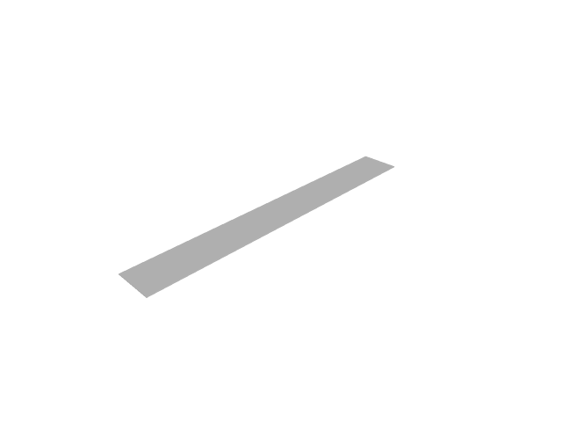
Figure 3: Plate strip geometry.
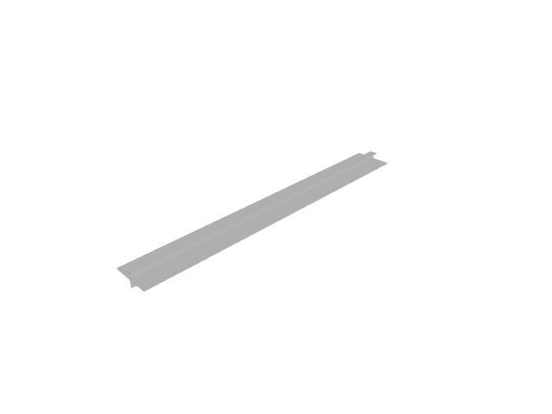
Figure 4: Plate strip with a T-profile stiffener on its centreline.
The span-to-thickness ratio is 400, so transverse shear sits several orders below the discretisation error and the thin-plate closed forms are the right reference rather than an approximation of one.
The supports are written as four node sets rather than one per edge. Simple support and cylindrical bending overlap at the four corners, and the obvious spelling constrains u2 twice there: Abaqus and Sestra accept that, while Code_Aster refuses it outright (<ASSEMBLA_26> … est bloqué plusieurs fois). A model that only some solvers will read is not a cross-solver case, so the corner nodes carry only the rotation the long edges add.

Static analysis under pressure
The static case is the only one that reaches the distributed-load records — Abaqus’ *Dsload, Calculix’ *DLOAD, Code_Aster’s FORCE_COQUE and Sesam’s BEUSLO. The eigenvalue analyses reach the mass and stiffness matrices and nothing else, so a pressure written wrongly is invisible to them.
Mid-span deflection against the closed form 5 q L⁴ / (384 D), with D = E t³ / (12 (1 − ν²)) — which evaluates to 0.173333 m for this strip. Halving the seed should quarter the remaining error; the three rows are a factor of two apart so the order is readable off the table rather than asserted.
Table 8: Plate strip mid-span deflection [m] under 1 kPa, by solver and mesh seed. The closed form is 5 q L^4 / (384 D) for a strip in cylindrical bending.
Seed [m] | aba | ca | ccx | ses | closed form
0.125 | 0.173065 | 0.173198 | 0.173065 | 0.173198 | 0.173333
0.0625 | 0.173269 | 0.173299 | 0.173268 | 0.173299 | 0.173333
0.03125 | 0.173319 | 0.173325 | 0.173319 | 0.173325 | 0.173333
The same strip with a T-profile stiffener along its centreline, meshed as line elements sharing the shells’ nodes. There is no closed form for it — a parallel-spring estimate is not one — so this is an agreement case between solvers, and it is what carries a T section through the deck writers.
Table 9: The same strip with a T-profile stiffener on its centreline [m]. No closed form: this is a cross-solver agreement case.
Seed [m] | aba_st | ca_st | ses_st
0.125 | 0.000584531 | 0.000710295 | 0.00073971
0.0625 | 0.000585478 | 0.000710711 | 0.000738964
0.03125 | 0.000585996 | 0.000710815 | 0.000736999

Sign convention
Every writer above places a positive pressure so that it pushes into the face it names. That is Abaqus’ convention, and it has to be shared, because a load direction that depends on the output format makes a cross-solver comparison meaningless.
It is worth stating which face that is, because it is not a global direction: gmsh winds every element of this strip with its normal along −z, so the positive face looks down and a positive pressure on it moves the strip up. The deflections above are therefore positive. tests/fem/test_pressure_load_cross_format.py pins this per format.

Eigenvalue analysis
The same plate, as an eigenvalue analysis, against f_n = n² π / (2 L²) √(D / (ρ t)) — the simply supported beam frequencies with the beam’s EI / (ρ A) replaced by the strip’s D / (ρ t). Valid for the cylindrical modes, which are the ones the long-edge constraint admits.
Table 10: Plate strip eigenfrequencies [Hz], by solver, at a 0.0625 m seed. The closed form is f_n = n^2 pi / (2 L^2) sqrt(D / (rho t)), valid for the cylindrical modes the long-edge constraint admits.
Mode | aba | ca | ccx | ses | closed form
1 | 1.5371 | 1.53661 | 1.53675 | 1.53661 | 1.53661
2 | 6.1536 | 6.14644 | 6.14861 | 6.14644 | 6.14644
3 | 13.866 | 13.8295 | 13.8405 | 13.8295 | 13.8295
4 | 24.7 | 24.5858 | 24.6205 | 24.5858 | 24.5857
5 | 38.695 | 38.4153 | 38.5002 | 38.4153 | 38.4152
6 | 55.9 | 55.3181 | 55.4943 | 55.3182 | 55.3179
Short description of the solver column names:
- ccx: Calculix
- ca: Code Aster
- ses: Sesam
- aba: Abaqus
A _st suffix marks the stiffened variant.

Detailed results
Mode shapes and deflected shapes from every format that ran on the machine that built this report, laid out so the formats can be read against each other: one section per mesh configuration, one heading per mode, and the formats side by side under it. A swapped mode pair or a differently deflected shape shows up as two pictures that do not match.
Abaqus and Sesam cannot run where this report is built. Their mode shapes are the raw results a licensed machine committed beside its cached frequencies, and the figures are rendered from them here; a case with no committed results has no figures. Solver versions: Abaqus v2025, Calculix v2.23, Code Aster v18.1.7, Sesam v11.3.1.0.

Cantilever modal participation
Per-mode effective modal mass and participation factors in the global X / Y / Z directions, for every mesh configuration, with the formats side by side. Code Aster and Sesam report the translational directions only.
A participation factor Γ is relative to how the solver normalised its eigenvectors: Abaqus scales the largest displacement to 1, the others scale to unit generalised mass. Raw factors from different solvers therefore do not compare. The tables give the factor scaled to unit generalised mass, sign(Γ)·√Meff, which is what the others report as-is. Its sign is the solver’s choice of eigenvector sign and may differ from mode to mode. The effective mass Meff = Γ²·m_gen does not depend on the normalisation.

Solid, 1st order
Table 11: Effective modal mass [kg] per mode, global X/Y/Z — solid, order 1.
Mode | Direction | ses_HEX | ses_TET | aba_HEXR | aba_HEX | aba_TET | ccx_TET | ca_TET | ccx_HEX | ca_HEX | ccx_HEXR | ca_HEXR
1 | X | 0 | 0 | 0 | 0 | 0 | 0 | 0 | 0 | 0 | 0 | 0
1 | Y | 116.4 | 117.5 | 116.9 | 116.4 | 117.5 | 118.2 | 118.2 | 116.4 | 116.4 | 116.5 | 116.4
1 | Z | 0 | 0 | 0 | 0 | 0 | 0 | 0 | 0 | 0 | 0 | 0
2 | X | 0 | 0 | 0 | 0 | 0 | 0 | 0 | 0 | 0 | 0 | 0
2 | Y | 0 | 0 | 0 | 0 | 0 | 0 | 0 | 0 | 0 | 0 | 0
2 | Z | 0 | 118.3 | 0 | 0 | 118.2 | 118.4 | 118.4 | 0 | 0 | 118.5 | 0
3 | X | 0 | 0 | 0 | 0 | 0 | 0 | 0 | 0 | 0 | 0 | 0
3 | Y | 0 | 34.9 | 0 | 0 | 34.9 | 35.5 | 35.5 | 0 | 0 | 36.2 | 0
3 | Z | 118.3 | 0 | 119 | 118.2 | 0 | 0 | 0 | 118.2 | 118.2 | 0 | 118.3
4 | X | 0 | 0 | 0 | 0 | 0 | 0 | 0 | 0 | 0 | 0 | 0
4 | Y | 35.9 | 0 | 2.1 | 36 | 0 | 0 | 0 | 36 | 36.1 | 0 | 36.1
4 | Z | 0 | 0 | 0 | 0 | 0 | 0 | 0 | 0 | 0 | 0 | 0
5 | X | 0 | 0 | 0 | 0 | 0 | 0 | 0 | 0 | 0 | 0 | 0
5 | Y | 0 | 0 | 0 | 0 | 0 | 0 | 0 | 0 | 0 | 12.6 | 0
5 | Z | 0 | 39.8 | 0 | 0 | 39.7 | 39.9 | 39.9 | 0 | 0 | 0 | 0
6 | X | 0 | 0 | 0 | 0 | 0 | 0 | 0 | 0 | 0 | 0 | 0
6 | Y | 0 | 13.3 | 31.4 | 12.4 | 13.2 | 12.8 | 12.8 | 12.5 | 12.5 | 0 | 0
6 | Z | 0 | 0 | 0 | 0 | 0.1 | 0 | 0 | 0 | 0 | 40.2 | 0
7 | X | 0 | 0 | 0 | 0 | 0 | 0 | 0 | 0 | 0 | 0 | 0
7 | Y | 3.2 | 0 | 2.8 | 0 | 0 | 0 | 0 | 0 | 0 | 0 | 8.9
7 | Z | 0 | 0 | 0 | 40 | 0 | 0 | 0 | 40 | 40.1 | 0 | 0
8 | X | 0 | 153.4 | 0 | 0 | 153.4 | 153.4 | 153.4 | 0 | 0 | 153.5 | 0
8 | Y | 5.7 | 0 | 0 | 0 | 0 | 0 | 0 | 0 | 0 | 0 | 3.1
8 | Z | 0 | 0 | 0 | 0 | 0 | 0 | 0 | 0 | 0 | 0 | 0.3
9 | X | 0 | 0 | 0 | 0 | 0 | 0 | 0 | 0 | 0 | 0 | 0
9 | Y | 0.4 | 6.3 | 1.1 | 5.7 | 6.3 | 6.1 | 6.1 | 5.9 | 5.9 | 0.4 | 0
9 | Z | 0 | 0 | 0 | 0 | 0 | 0 | 0 | 0 | 0 | 0 | 39.9
10 | X | 0 | 0 | 0 | 153.5 | 0 | 0 | 0 | 153.4 | 153.5 | 0 | 0
10 | Y | 0 | 0 | 0 | 0 | 0 | 0 | 0 | 0 | 0 | 6.1 | 0
10 | Z | 40.3 | 0 | 0 | 0 | 0 | 12.8 | 12.8 | 0 | 0 | 0 | 0
11 | X | 0 | 0 | 0 | 0 | 0 | 0 | 0 | 0 | 0 | 0 | 0
11 | Y | 0 | 0 | 0 | 0 | 0 | 0 | 0 | 0 | 0 | 0 | 0
11 | Z | 0 | 12.8 | 0 | 0 | 12.8 | 0 | 0 | 0 | 0 | 12.7 | 0
Table 12: Participation factor per mode scaled to unit generalised mass [√kg], global X/Y/Z — solid, order 1.
Mode | Direction | ses_HEX | ses_TET | aba_HEXR | aba_HEX | aba_TET | ccx_TET | ca_TET | ccx_HEX | ca_HEX | ccx_HEXR | ca_HEXR
1 | X | -0 | 0 | 0 | -0 | 0 | -0 | 0 | -0 | 0 | 0 | 0
1 | Y | 10.79 | -10.841 | 10.813 | 10.788 | 10.838 | -10.871 | 10.871 | 10.787 | 10.787 | 10.794 | 10.791
1 | Z | 0 | 0.017 | -0 | -0 | -0.017 | 0.019 | -0.019 | -0 | -0 | 0 | -0.001
2 | X | -0 | -0 | 0 | 0 | 0 | 0 | 0 | -0 | -0 | -0 | 0.001
2 | Y | -0 | -0.028 | 0 | 0 | 0.028 | 0.03 | 0.03 | 0 | 0 | 0 | 0.022
2 | Z | 0 | -10.876 | -0 | -0 | 10.874 | 10.88 | 10.88 | -0 | 0 | -10.884 | -0
3 | X | -0 | 0 | -0 | -0 | -0 | 0 | -0 | -0 | -0 | 0 | 0
3 | Y | -0 | 5.911 | 0 | 0 | -5.909 | 5.961 | -5.961 | 0 | 0 | -6.013 | 0
3 | Z | 10.876 | -0.019 | 10.907 | 10.872 | 0.019 | -0.02 | 0.02 | 10.871 | 10.872 | -0 | 10.876
4 | X | -0 | -0.003 | -0 | -0 | 0.003 | 0.003 | 0.003 | 0 | 0 | 0 | -0
4 | Y | 5.995 | 0.069 | -1.456 | -6.002 | -0.075 | -0.108 | -0.11 | 6.004 | -6.004 | -0 | -6.01
4 | Z | -0 | -0.003 | 0 | 0 | 0.003 | 0.007 | 0.008 | 0 | -0 | -0 | -0.004
5 | X | 0 | -0.001 | -0 | 0 | -0.001 | 0 | -0 | -0 | -0 | -0 | -0.002
5 | Y | -0 | 0.122 | -0 | -0 | 0.132 | -0.028 | 0.029 | 0 | -0 | -3.549 | -0.084
5 | Z | -0 | -6.305 | 0 | 0 | -6.305 | 6.313 | -6.315 | -0 | -0 | 0 | 0.006
6 | X | -0 | 0 | 0 | -0 | 0 | 0 | -0.001 | 0 | -0 | 0 | -0.001
6 | Y | -0.114 | 3.642 | -5.603 | 3.522 | 3.638 | -3.576 | 3.577 | 3.53 | 3.532 | -0 | 0.192
6 | Z | 0 | 0.207 | -0 | 0 | 0.226 | -0.056 | 0.057 | 0 | -0 | -6.34 | -0.015
7 | X | -0 | 0 | -0 | -0 | 0 | -0.021 | -0.021 | 0 | 0 | 0 | 0
7 | Y | -1.788 | 0.027 | -1.671 | 0 | 0.03 | 0.04 | 0.04 | -0 | -0 | -0 | 2.99
7 | Z | 0 | -0.033 | 0 | -6.326 | -0.035 | -0.02 | -0.02 | 6.327 | -6.329 | -0 | 0.071
8 | X | -0 | 12.384 | -0 | -0 | 12.385 | 12.384 | 12.386 | 0 | -0 | 12.389 | 0.001
8 | Y | 2.39 | -0.001 | -0 | 0 | -0.001 | 0 | 0 | 0 | 0 | 0 | 1.76
8 | Z | 0 | 0 | -0 | 0 | 0 | -0 | -0 | -0 | -0 | 0 | -0.503
9 | X | -0 | -0.005 | -0 | 0 | -0.006 | 0.001 | 0.001 | -0 | -0 | 0 | 0.001
9 | Y | 0.662 | -2.518 | -1.056 | -2.385 | -2.515 | -2.462 | -2.464 | 2.426 | -2.43 | -0.619 | -0.115
9 | Z | -0 | 0.007 | -0 | 0 | 0.007 | 0.064 | 0.064 | 0 | 0 | -0 | -6.318
10 | X | -0 | -0.015 | 0.019 | 12.391 | -0.016 | 0.001 | -0.001 | -12.385 | 12.388 | -0 | 0.006
10 | Y | 0 | -0.015 | -0 | 0 | -0.017 | -0.045 | 0.045 | -0 | -0 | 2.478 | 0.086
10 | Z | -6.346 | 0.003 | 0 | -0 | 0.003 | -3.572 | 3.576 | 0 | 0 | -0 | -0.006
11 | X | 0 | 0.001 | -0 | 0 | -0.001 | -0.012 | 0.012 | 0 | 0 | -0 | 0.005
11 | Y | -0 | 0 | 0 | 0 | -0 | 0.016 | -0.016 | -0 | 0 | -0 | 0.009
11 | Z | -0 | -3.578 | -0 | 0 | 3.578 | 0.029 | -0.031 | 0 | -0 | 3.558 | -0.001

Solid, 2nd order
Table 13: Effective modal mass [kg] per mode, global X/Y/Z — solid, order 2.
Mode | Direction | ses_HEX | ses_TET | aba_HEXR | aba_HEX | aba_TET | ccx_TET | ca_TET | ccx_HEX | ca_HEX | ccx_HEXR | ca_HEXR
1 | X | 0 | 0 | 0 | 0 | 0 | 0 | 0 | 0 | 0 | 0 | 0
1 | Y | 116.5 | 116.5 | 116.6 | 116.5 | 116.5 | 116.5 | 116.5 | 116.5 | 116.5 | 116.6 | 116.6
1 | Z | 0 | 0 | 0 | 0 | 0 | 0 | 0 | 0 | 0 | 0 | 0
2 | X | 0 | 0 | 0 | 0 | 0 | 0 | 0 | 0 | 0 | 0 | 0
2 | Y | 0 | 0 | 0 | 0 | 0 | 0 | 0 | 0 | 0 | 0 | 0
2 | Z | 0 | 0 | 0 | 0 | 0 | 0 | 0 | 0 | 0 | 0 | 0
3 | X | 0 | 0 | 0 | 0 | 0 | 0 | 0 | 0 | 0 | 0 | 0
3 | Y | 0 | 0 | 0 | 0 | 0 | 0 | 0 | 0 | 0 | 0 | 0
3 | Z | 118.4 | 118.4 | 118.4 | 118.4 | 118.4 | 118.4 | 118.4 | 118.4 | 118.4 | 118.4 | 118.4
4 | X | 0 | 0 | 0 | 0 | 0 | 0 | 0 | 0 | 0 | 0 | 0
4 | Y | 35.9 | 36 | 35.9 | 35.9 | 36 | 36 | 36 | 35.9 | 35.9 | 35.9 | 35.9
4 | Z | 0 | 0 | 0 | 0 | 0 | 0 | 0 | 0 | 0 | 0 | 0
5 | X | 0 | 0 | 0 | 0 | 0 | 0 | 0 | 0 | 0 | 0 | 0
5 | Y | 0 | 0 | 0 | 0 | 0 | 0 | 0 | 0 | 0 | 0 | 0
5 | Z | 0 | 0 | 0 | 0 | 0 | 0 | 0 | 0 | 0 | 0 | 0
6 | X | 0 | 0 | 0 | 0 | 0 | 0 | 0 | 0 | 0 | 0 | 0
6 | Y | 0 | 0 | 0 | 0 | 0 | 0 | 0 | 0 | 0 | 0 | 0
6 | Z | 0 | 0 | 0 | 0 | 0 | 0 | 0 | 0 | 0 | 0 | 0
7 | X | 0 | 0 | 0 | 0 | 0 | 0 | 0 | 0 | 0 | 0 | 0
7 | Y | 3.4 | 3.1 | 3.4 | 3.3 | 3.1 | 3.2 | 3.2 | 3.3 | 3.3 | 3.4 | 3.4
7 | Z | 0 | 0 | 0 | 0 | 0 | 0 | 0 | 0 | 0 | 0 | 0
8 | X | 0 | 0 | 0 | 0 | 0 | 0 | 0 | 0 | 0 | 0 | 0
8 | Y | 5.3 | 5.8 | 5.3 | 5.4 | 5.8 | 5.9 | 5.9 | 5.4 | 5.4 | 5.3 | 5.3
8 | Z | 0 | 0 | 0 | 0 | 0 | 0 | 0 | 0 | 0 | 0 | 0
9 | X | 0 | 0 | 0 | 0 | 0 | 0 | 0 | 0 | 0 | 0 | 0
9 | Y | 0.6 | 0.6 | 0.6 | 0.5 | 0.6 | 0.5 | 0.5 | 0.5 | 0.5 | 0.6 | 0.6
9 | Z | 0 | 0 | 0 | 0 | 0 | 0 | 0 | 0 | 0 | 0 | 0
10 | X | 0 | 0 | 0 | 0 | 0 | 0 | 0 | 0 | 0 | 0 | 0
10 | Y | 1.5 | 0 | 1.5 | 1.6 | 0 | 0 | 0 | 1.6 | 1.6 | 1.5 | 1.5
10 | Z | 0 | 40.2 | 0 | 0 | 40.2 | 40.2 | 40.2 | 0 | 0 | 0 | 0
11 | X | 0 | 0 | 0 | 0 | 0 | 0 | 0 | 0 | 0 | 0 | 0
11 | Y | 0 | 0 | 0 | 0 | 0 | 0 | 0 | 0 | 0 | 0 | 0
11 | Z | 40.3 | 0 | 40.3 | 40.3 | 0 | 0 | 0 | 40.3 | 40.3 | 40.3 | 40.3
Table 14: Participation factor per mode scaled to unit generalised mass [√kg], global X/Y/Z — solid, order 2.
Mode | Direction | ses_HEX | ses_TET | aba_HEXR | aba_HEX | aba_TET | ccx_TET | ca_TET | ccx_HEX | ca_HEX | ccx_HEXR | ca_HEXR
1 | X | 0 | -0 | -0 | 0 | 0 | -0 | 0 | -0 | -0 | 0 | -0
1 | Y | 10.794 | -10.794 | 10.796 | 10.794 | 10.794 | -10.794 | 10.794 | 10.794 | 10.794 | 10.796 | 10.796
1 | Z | 0 | -0 | 0 | 0 | 0 | -0 | 0 | -0 | 0 | 0 | -0
2 | X | 0 | 0 | -0 | -0 | 0 | -0 | 0 | -0 | -0 | -0 | -0
2 | Y | -0 | -0 | 0 | 0 | -0 | -0 | 0 | 0 | 0 | -0 | 0
2 | Z | 0 | 0 | -0 | 0 | 0 | -0 | 0 | 0 | -0 | 0 | 0
3 | X | 0 | 0 | -0 | -0 | 0 | -0 | -0 | -0 | -0 | -0 | -0
3 | Y | 0 | -0 | -0 | -0 | -0 | -0 | -0 | 0 | -0 | -0 | 0
3 | Z | 10.88 | 10.879 | 10.882 | 10.879 | 10.879 | 10.879 | 10.879 | 10.879 | 10.879 | 10.882 | 10.882
4 | X | -0 | 0 | -0 | -0 | 0 | -0 | -0 | 0 | 0 | 0 | -0
4 | Y | -5.991 | -5.997 | -5.992 | -5.993 | -5.997 | -6.004 | -6.004 | -5.993 | -5.993 | -5.992 | -5.992
4 | Z | 0 | -0 | -0 | -0 | -0 | 0 | 0 | 0 | -0 | -0 | -0
5 | X | -0 | 0 | 0 | 0 | -0 | -0 | 0 | 0 | -0 | -0 | -0
5 | Y | 0 | 0.001 | -0 | -0 | -0.001 | 0.001 | -0.001 | 0 | -0 | -0 | -0
5 | Z | -0 | -0 | -0 | -0 | 0 | -0 | 0 | -0 | 0 | 0 | 0
6 | X | 0 | -0 | -0 | 0 | 0 | 0 | 0 | 0 | -0 | -0 | 0
6 | Y | -0.096 | -0.119 | -0.097 | -0.103 | 0.119 | -0.093 | -0.093 | 0.103 | -0.103 | 0.096 | -0.097
6 | Z | 0 | 0 | 0 | -0 | -0 | 0 | 0 | 0 | -0 | 0 | -0
7 | X | 0 | 0 | -0 | 0 | -0 | 0 | 0 | -0 | 0 | 0 | -0
7 | Y | -1.839 | -1.768 | 1.84 | 1.818 | 1.768 | 1.799 | 1.799 | 1.818 | 1.818 | 1.84 | 1.84
7 | Z | -0 | 0 | -0 | 0 | -0 | 0 | 0 | 0 | 0 | 0 | 0
8 | X | 0 | 0 | 0 | 0 | -0 | 0 | 0 | -0 | -0 | 0 | -0
8 | Y | -2.305 | -2.406 | 2.304 | 2.328 | 2.405 | 2.436 | 2.435 | 2.328 | 2.328 | 2.304 | 2.304
8 | Z | -0 | 0 | 0 | -0 | -0 | -0 | -0 | -0 | -0 | 0 | -0
9 | X | -0 | 0 | -0 | 0 | -0 | 0 | 0 | -0 | 0 | -0 | -0
9 | Y | -0.746 | -0.774 | -0.747 | -0.719 | 0.774 | 0.69 | 0.69 | 0.72 | -0.719 | 0.747 | -0.747
9 | Z | 0 | -0 | 0 | 0 | 0 | -0 | -0 | 0 | -0 | 0 | -0
10 | X | -0 | -0 | 0 | 0 | -0 | -0 | 0 | -0 | -0 | -0 | 0
10 | Y | 1.211 | 0 | 1.212 | 1.267 | 0 | -0 | 0 | -1.267 | 1.267 | -1.213 | 1.212
10 | Z | 0 | -6.344 | -0 | -0 | -6.344 | 6.344 | -6.344 | 0 | -0 | 0 | -0
11 | X | -0 | -0 | 0 | 0 | -0 | -0 | 0 | -0 | -0 | 0 | -0
11 | Y | 0 | -0.001 | 0 | 0 | -0.001 | -0.008 | 0.008 | 0 | -0 | -0 | -0
11 | Z | 6.346 | -0.006 | -6.345 | -6.344 | -0.006 | 0.004 | -0.004 | 6.345 | -6.344 | 6.345 | -6.345

Shell, 1st order
Table 15: Effective modal mass [kg] per mode, global X/Y/Z — shell, order 1.
Mode | Direction | ses_QUAD | ses_TRI | aba_QUADR | aba_QUAD | ccx_TRI | ca_TRI | ccx_QUAD | ca_QUAD | ccx_QUADR
1 | X | 0 | 0 | 0 | 0 | 0 | 0 | 0 | 0 | 0
1 | Y | 119.9 | 119.9 | 120 | 119.9 | 119.7 | 119.9 | 119.9 | 119.9 | 119.9
1 | Z | 0 | 0 | 0 | 0 | 0 | 0 | 0 | 0 | 0
2 | X | 0 | 0 | 0 | 0 | 0 | 0 | 0 | 0 | 0
2 | Y | 0 | 0 | 0 | 0 | 0 | 0 | 0 | 0 | 0
2 | Z | 0 | 0 | 0 | 0 | 0 | 0 | 0 | 0 | 122.1
3 | X | 0 | 0 | 0 | 0 | 0 | 0 | 0 | 0 | 0
3 | Y | 0 | 0 | 0 | 0 | 0 | 0 | 0 | 0 | 37.2
3 | Z | 122 | 122 | 122 | 122 | 122.1 | 122 | 122 | 122 | 0
4 | X | 0 | 0 | 0 | 0 | 0 | 0 | 0 | 0 | 0
4 | Y | 36.8 | 36.6 | 37 | 36.9 | 37.3 | 36.6 | 36.9 | 36.8 | 0
4 | Z | 0 | 0 | 0 | 0 | 0 | 0 | 0 | 0 | 0
5 | X | 0 | 0 | 0 | 0 | 0 | 0 | 0 | 0 | 0
5 | Y | 0 | 0 | 0 | 0 | 0 | 0 | 0 | 0 | 13
5 | Z | 0 | 0 | 0 | 0 | 0 | 0 | 0 | 0 | 0
6 | X | 0 | 0 | 0 | 0 | 0 | 0 | 0 | 0 | 0
6 | Y | 0 | 0.1 | 0 | 0 | 12.7 | 0.1 | 0 | 0 | 0
6 | Z | 0 | 0 | 0 | 0 | 0 | 0 | 0 | 0 | 41.5
7 | X | 0 | 0 | 0 | 0 | 0 | 0 | 0 | 0 | 0
7 | Y | 3.5 | 2.7 | 3.8 | 3.3 | 0 | 2.7 | 3.3 | 3.2 | 0
7 | Z | 0 | 0 | 0 | 0 | 41.6 | 0 | 0 | 0 | 0
8 | X | 0 | 0 | 0 | 0 | 0 | 0 | 0 | 0 | 158
8 | Y | 5.4 | 5.9 | 5.4 | 5.7 | 0 | 6 | 5.8 | 5.7 | 0
8 | Z | 0 | 0 | 0 | 0 | 0 | 0 | 0 | 0 | 0
9 | X | 0 | 0 | 0 | 0 | 0 | 0 | 0 | 0 | 0
9 | Y | 0.6 | 0.6 | 0.6 | 0.6 | 0 | 0.6 | 0.6 | 0.6 | 5.7
9 | Z | 0 | 0 | 0 | 0 | 0 | 0 | 0 | 0 | 0
10 | X | 0 | 0 | 0 | 0 | 0 | 0 | 0 | 0 | 0
10 | Y | 1.3 | 1.3 | 1.6 | 1.5 | 1.5 | 1.3 | 1.7 | 1.3 | 1
10 | Z | 0 | 0 | 0 | 0 | 0 | 0 | 0 | 0 | 0
11 | X | 0 | 0 | 0 | 0 | 0 | 0 | 0 | 0 | 0
11 | Y | 0 | 0 | 0 | 0 | 3.6 | 0 | 0 | 0 | 0
11 | Z | 0 | 41.6 | 0 | 0 | 0 | 41.6 | 0 | 41.6 | 12.9
Table 16: Participation factor per mode scaled to unit generalised mass [√kg], global X/Y/Z — shell, order 1.
Mode | Direction | ses_QUAD | ses_TRI | aba_QUADR | aba_QUAD | ccx_TRI | ca_TRI | ccx_QUAD | ca_QUAD | ccx_QUADR
1 | X | -0 | -0 | -0 | -0 | 0 | -0 | 0 | 0 | -0
1 | Y | 10.95 | -10.951 | 10.952 | 10.951 | 10.941 | 10.951 | 10.95 | 10.951 | 10.95
1 | Z | -0 | -0 | -0 | -0 | 0 | 0 | 0 | -0 | 0
2 | X | -0 | 0 | -0 | -0 | -0 | 0 | 0 | -0 | -0
2 | Y | -0 | -0 | 0 | 0 | 0.002 | -0 | 0 | -0 | 0
2 | Z | -0 | 0 | 0 | 0 | -0 | 0 | 0 | 0 | -11.051
3 | X | 0 | -0 | -0 | -0 | -0 | 0 | -0 | -0 | -0
3 | Y | -0 | 0 | 0 | 0 | 0 | -0 | 0 | 0 | 6.101
3 | Z | -11.046 | -11.047 | 11.046 | 11.046 | -11.048 | 11.047 | -11.045 | 11.046 | 0
4 | X | -0 | 0 | -0 | -0 | -0 | 0 | -0 | -0 | 0
4 | Y | -6.067 | -6.048 | -6.081 | -6.076 | -6.104 | -6.053 | -6.072 | 6.065 | 0
4 | Z | -0 | -0 | -0 | -0 | 0 | -0 | 0 | 0 | 0
5 | X | 0 | -0 | 0 | -0 | 0 | 0 | -0 | -0 | -0
5 | Y | 0 | 0 | -0 | -0 | -0.005 | -0 | -0 | 0 | -3.601
5 | Z | -0 | -0 | 0 | -0 | -0 | -0 | 0 | -0 | 0
6 | X | -0 | -0 | 0 | 0 | -0 | -0 | 0 | -0 | 0
6 | Y | 0.134 | -0.252 | -0.078 | -0.132 | -3.561 | 0.263 | -0.174 | -0.194 | -0
6 | Z | -0 | 0 | -0 | -0 | -0 | -0 | -0 | -0 | -6.443
7 | X | 0 | -0 | -0 | -0 | -0 | -0 | -0 | 0 | -0
7 | Y | -1.86 | -1.651 | 1.947 | 1.829 | -0 | -1.652 | 1.805 | 1.776 | -0
7 | Z | 0 | 0 | 0 | 0 | -6.446 | 0 | 0 | 0 | 0
8 | X | 0 | -0 | 0 | -0 | 0 | 0 | -0 | -0 | 12.568
8 | Y | 2.334 | 2.438 | 2.332 | 2.383 | 0.003 | -2.455 | -2.406 | 2.398 | 0
8 | Z | 0 | -0 | -0 | -0 | 0 | -0 | 0 | -0 | 0
9 | X | -0 | -0 | -0 | 0 | -0 | 0 | -0 | -0 | -0
9 | Y | -0.798 | -0.781 | -0.786 | -0.771 | -0.156 | 0.788 | -0.76 | -0.795 | -2.388
9 | Z | 0 | -0 | 0 | 0 | 0 | -0 | 0 | 0 | -0
10 | X | 0 | 0 | -0 | 0 | -0 | 0 | -0 | -0 | -0
10 | Y | -1.15 | -1.128 | 1.269 | 1.232 | 1.218 | -1.148 | 1.31 | 1.152 | 1.006
10 | Z | 0 | -0 | 0 | 0 | -0 | 0 | 0 | -0 | -0
11 | X | 0 | -0 | -0 | 0 | -0 | 0 | 0 | 0 | -0
11 | Y | -0 | -0 | 0 | 0 | -1.9 | -0 | 0 | 0 | 0
11 | Z | 0 | -6.451 | 0 | 0 | 0 | 6.453 | 0 | 6.453 | 3.589

Shell, 2nd order
Table 17: Effective modal mass [kg] per mode, global X/Y/Z — shell, order 2.
Mode | Direction | ses_QUAD | ses_TRI | aba_QUADR | aba_QUAD | aba_TRI | ccx_TRI | ca_TRI | ccx_QUAD | ca_QUAD | ccx_QUADR
1 | X | 0 | 0 | 0 | 0 | 0 | 0 | 0 | 0 | 0 | 0
1 | Y | 119.9 | 119.9 | 119.9 | 119.9 | 119.9 | 119.9 | 119.9 | 119.9 | 119.9 | 119.9
1 | Z | 0 | 0 | 0 | 0 | 0 | 0 | 0 | 0 | 0 | 0
2 | X | 0 | 0 | 0 | 0 | 0 | 0 | 0 | 0 | 0 | 0
2 | Y | 0 | 0 | 0 | 0 | 0 | 0 | 0 | 0 | 0 | 0
2 | Z | 0 | 0 | 0 | 0 | 0 | 0 | 0 | 0 | 0 | 0
3 | X | 0 | 0 | 0 | 0 | 0 | 0 | 0 | 0 | 0 | 0
3 | Y | 0 | 0 | 0 | 0 | 0 | 0 | 0 | 0 | 0 | 0
3 | Z | 122 | 122 | 122 | 122 | 122 | 122 | 122 | 122 | 122 | 122
4 | X | 0 | 0 | 0 | 0 | 0 | 0 | 0 | 0 | 0 | 0
4 | Y | 36.9 | 36.9 | 36.9 | 36.9 | 36.9 | 36.9 | 36.9 | 36.9 | 36.9 | 36.9
4 | Z | 0 | 0 | 0 | 0 | 0 | 0 | 0 | 0 | 0 | 0
5 | X | 0 | 0 | 0 | 0 | 0 | 0 | 0 | 0 | 0 | 0
5 | Y | 0 | 0 | 0 | 0 | 0 | 0 | 0 | 0 | 0 | 0
5 | Z | 0 | 0 | 0 | 0 | 0 | 0 | 0 | 0 | 0 | 0
6 | X | 0 | 0 | 0 | 0 | 0 | 0 | 0 | 0 | 0 | 0
6 | Y | 0 | 0 | 0 | 0 | 0 | 0 | 0 | 0 | 0 | 0
6 | Z | 0 | 0 | 0 | 0 | 0 | 0 | 0 | 0 | 0 | 0
7 | X | 0 | 0 | 0 | 0 | 0 | 0 | 0 | 0 | 0 | 0
7 | Y | 3.5 | 3.4 | 3.5 | 3.5 | 3.5 | 3.4 | 3.4 | 3.4 | 3.5 | 3.4
7 | Z | 0 | 0 | 0 | 0 | 0 | 0 | 0 | 0 | 0 | 0
8 | X | 0 | 0 | 0 | 0 | 0 | 0 | 0 | 0 | 0 | 0
8 | Y | 5.5 | 5.6 | 5.5 | 5.5 | 5.5 | 5.6 | 5.5 | 5.6 | 5.5 | 5.5
8 | Z | 0 | 0 | 0 | 0 | 0 | 0 | 0 | 0 | 0 | 0
9 | X | 0 | 0 | 0 | 0 | 0 | 0 | 0 | 0 | 0 | 0
9 | Y | 0.7 | 0.6 | 0.7 | 0.7 | 0.7 | 0.6 | 0.6 | 0.6 | 0.7 | 0.6
9 | Z | 0 | 0 | 0 | 0 | 0 | 0 | 0 | 0 | 0 | 0
10 | X | 0 | 0 | 0 | 0 | 0 | 0 | 0 | 0 | 0 | 0
10 | Y | 1.4 | 1.4 | 1.4 | 1.4 | 1.4 | 1.4 | 1.4 | 1.4 | 1.4 | 1.4
10 | Z | 0 | 0 | 0 | 0 | 0 | 0 | 0 | 0 | 0 | 0
11 | X | 0 | 0 | 0 | 0 | 0 | 0 | 0 | 0 | 0 | 0
11 | Y | 0 | 0 | 0 | 0 | 0 | 0 | 0 | 0 | 0 | 0
11 | Z | 0 | 0 | 0 | 0 | 0 | 0 | 0 | 0 | 0 | 0
Table 18: Participation factor per mode scaled to unit generalised mass [√kg], global X/Y/Z — shell, order 2.
Mode | Direction | ses_QUAD | ses_TRI | aba_QUADR | aba_QUAD | aba_TRI | ccx_TRI | ca_TRI | ccx_QUAD | ca_QUAD | ccx_QUADR
1 | X | -0 | -0 | 0 | 0 | 0 | -0 | 0 | 0 | -0 | -0
1 | Y | -10.952 | 10.952 | 10.951 | 10.951 | 10.952 | 10.952 | 10.952 | 10.951 | 10.952 | 10.951
1 | Z | -0 | -0 | 0 | 0 | 0 | 0 | -0 | 0 | 0 | 0
2 | X | -0 | 0 | 0 | 0 | 0 | -0 | -0 | 0 | 0 | 0
2 | Y | 0 | 0 | 0 | 0 | 0 | 0 | -0 | 0 | -0 | 0
2 | Z | 0 | 0 | 0 | 0 | -0 | -0 | 0 | -0 | -0 | -0
3 | X | -0 | -0 | 0 | 0 | 0 | -0 | 0 | 0 | 0 | 0
3 | Y | -0 | -0 | 0 | 0 | 0 | 0 | 0 | 0 | 0 | 0
3 | Z | 11.047 | -11.047 | 11.044 | 11.044 | 11.047 | -11.046 | 11.047 | -11.046 | 11.047 | -11.046
4 | X | -0 | -0 | -0 | -0 | 0 | -0 | -0 | -0 | 0 | 0
4 | Y | -6.071 | 6.072 | -6.071 | -6.071 | -6.073 | 6.072 | 6.071 | 6.073 | -6.071 | 6.071
4 | Z | 0 | -0 | 0 | 0 | 0 | -0 | -0 | -0 | 0 | -0
5 | X | 0 | -0 | -0 | -0 | -0 | 0 | -0 | -0 | 0 | -0
5 | Y | 0 | 0 | -0 | -0 | -0 | 0 | -0 | -0 | -0 | -0
5 | Z | -0 | 0 | -0 | -0 | 0 | -0 | -0 | -0 | -0 | 0
6 | X | -0 | 0 | -0 | -0 | -0 | -0 | 0 | -0 | 0 | 0
6 | Y | -0.137 | -0.144 | -0.137 | -0.137 | -0.138 | -0.144 | 0.142 | 0.141 | -0.137 | 0.138
6 | Z | 0 | 0 | 0 | 0 | -0 | -0 | -0 | 0 | 0 | 0
7 | X | 0 | -0 | -0 | -0 | -0 | -0 | -0 | -0 | -0 | -0
7 | Y | 1.859 | -1.85 | 1.858 | 1.858 | 1.88 | 1.848 | -1.849 | 1.839 | -1.859 | 1.852
7 | Z | -0 | 0 | -0 | -0 | 0 | 0 | 0 | 0 | 0 | 0
8 | X | -0 | 0 | -0 | -0 | -0 | 0 | -0 | -0 | -0 | 0
8 | Y | -2.35 | -2.358 | 2.351 | 2.351 | 2.349 | 2.356 | 2.353 | -2.362 | 2.35 | -2.35
8 | Z | -0 | -0 | 0 | 0 | 0 | -0 | 0 | 0 | 0 | 0
9 | X | 0 | 0 | -0 | -0 | 0 | -0 | -0 | 0 | -0 | 0
9 | Y | -0.809 | -0.801 | -0.808 | -0.808 | -0.818 | 0.793 | 0.801 | 0.781 | -0.809 | 0.799
9 | Z | 0 | 0 | 0 | 0 | -0 | -0 | -0 | -0 | -0 | -0
10 | X | -0 | -0 | -0 | -0 | -0 | -0 | 0 | -0 | -0 | -0
10 | Y | -1.171 | -1.185 | 1.17 | 1.17 | 1.175 | 1.193 | 1.178 | -1.201 | 1.17 | 1.178
10 | Z | -0 | -0 | -0 | -0 | 0.001 | 0 | 0 | -0 | 0 | 0
11 | X | -0 | -0 | 0 | 0 | 0 | -0 | -0 | -0 | -0 | -0
11 | Y | -0 | 0.001 | 0 | 0 | 0 | 0.001 | -0.001 | 0 | 0 | 0
11 | Z | 0 | -0 | -0 | -0 | 0 | -0 | -0 | 0 | -0 | -0

Line, 1st order
Table 19: Effective modal mass [kg] per mode, global X/Y/Z — line, order 1.
Mode | Direction | ses | aba | ca
1 | X | 0 | 0 | 0
1 | Y | 0 | 0 | 0
1 | Z | 0 | 0 | 0
2 | X | 0 | 0 | 0
2 | Y | 116.7 | 116.6 | 116.5
2 | Z | 0 | 0 | 0
3 | X | 0 | 0 | 0
3 | Y | 0 | 0 | 0
3 | Z | 0 | 0 | 0
4 | X | 0 | 0 | 0
4 | Y | 0 | 0 | 0
4 | Z | 128 | 118.2 | 116.5
5 | X | 0 | 0 | 0
5 | Y | 0 | 0 | 0
5 | Z | 0 | 0 | 0
6 | X | 0 | 0 | 0
6 | Y | 36.3 | 0 | 35.8
6 | Z | 0 | 0 | 0
7 | X | 0 | 0 | 0
7 | Y | 0 | 36.2 | 0
7 | Z | 0 | 0 | 0
8 | X | 0 | 0 | 0
8 | Y | 0 | 0 | 0
8 | Z | 0 | 0 | 0
9 | X | 0 | 0 | 0
9 | Y | 0 | 0 | 0
9 | Z | 0 | 0 | 0
10 | X | 0 | 0 | 0
10 | Y | 0 | 0 | 0
10 | Z | 0 | 0 | 0
11 | X | 0 | 0 | 0
11 | Y | 0 | 0 | 0
11 | Z | 38.3 | 0 | 0
Table 20: Participation factor per mode scaled to unit generalised mass [√kg], global X/Y/Z — line, order 1.
Mode | Direction | ses | aba | ca
1 | X | 0 | -0 | 0
1 | Y | 0 | -0 | -0
1 | Z | -0 | 0 | 0
2 | X | 0 | -0 | 0
2 | Y | 10.803 | 10.797 | 10.793
2 | Z | -0 | -0 | 0
3 | X | -0 | 0 | 0
3 | Y | 0 | -0 | -0
3 | Z | -0 | 0 | -0
4 | X | -0 | 0 | -0
4 | Y | 0 | -0 | 0
4 | Z | -11.316 | 10.87 | 10.793
5 | X | -0 | -0 | 0
5 | Y | -0 | 0 | 0
5 | Z | 0 | 0 | 0
6 | X | -0 | -0 | 0
6 | Y | -6.024 | -0 | -5.981
6 | Z | -0 | 0 | -0
7 | X | -0 | 0 | 0
7 | Y | -0 | -6.016 | 0
7 | Z | -0 | -0 | -0
8 | X | 0 | -0 | 0
8 | Y | 0 | -0 | 0
8 | Z | -0 | 0 | -0
9 | X | -0 | 0 | -0
9 | Y | 0 | 0 | 0
9 | Z | -0 | 0 | -0
10 | X | -0 | 0 | -0
10 | Y | 0 | 0 | 0
10 | Z | -0 | -0 | 0
11 | X | -0 | 0 | 0
11 | Y | 0 | -0 | -0
11 | Z | -6.193 | 0 | 0

Line, 2nd order
Table 21: Effective modal mass [kg] per mode, global X/Y/Z — line, order 2.
Mode | Direction | ses | aba
1 | X | 0 | 0
1 | Y | 0 | 0
1 | Z | 0 | 0
2 | X | 0 | 0
2 | Y | 176.8 | 116.6
2 | Z | 0 | 0
3 | X | 0 | 0
3 | Y | 0 | 0
3 | Z | 0 | 0
4 | X | 0 | 0
4 | Y | 0 | 0
4 | Z | 192.8 | 118.2
5 | X | 0 | 0
5 | Y | 0 | 0
5 | Z | 0 | 0
6 | X | 0 | 0
6 | Y | 55 | 0
6 | Z | 0 | 0
7 | X | 0 | 0
7 | Y | 0 | 36.2
7 | Z | 0 | 0
8 | X | 0 | 0
8 | Y | 0 | 0
8 | Z | 0 | 0
9 | X | 0 | 0
9 | Y | 0 | 0
9 | Z | 0 | 0
10 | X | 0 | 0
10 | Y | 0 | 0
10 | Z | 0 | 0
11 | X | 0 | 0
11 | Y | 0 | 0
11 | Z | 59.6 | 0
Table 22: Participation factor per mode scaled to unit generalised mass [√kg], global X/Y/Z — line, order 2.
Mode | Direction | ses | aba
1 | X | 0 | 0
1 | Y | 0 | 0
1 | Z | -0 | -0
2 | X | -0 | -0
2 | Y | 13.297 | 10.798
2 | Z | 0 | -0
3 | X | 0 | 0
3 | Y | 0 | -0
3 | Z | -0 | -0
4 | X | 0 | -0
4 | Y | 0 | -0
4 | Z | -13.884 | 10.871
5 | X | -0 | -0
5 | Y | -0 | 0
5 | Z | -0 | 0
6 | X | 0 | -0
6 | Y | -7.413 | 0
6 | Z | -0 | -0
7 | X | -0 | 0
7 | Y | 0 | -6.015
7 | Z | 0 | -0
8 | X | -0 | 0
8 | Y | 0 | 0
8 | Z | 0 | -0
9 | X | 0 | 0
9 | Y | -0 | 0
9 | Z | -0 | -0
10 | X | 0 | -0
10 | Y | 0 | 0
10 | Z | -0 | 0
11 | X | 0 | -0
11 | Y | 0 | -0
11 | Z | -7.719 | 0

Cantilever eigenvalue analysis

Line, 1st order

Mode 1
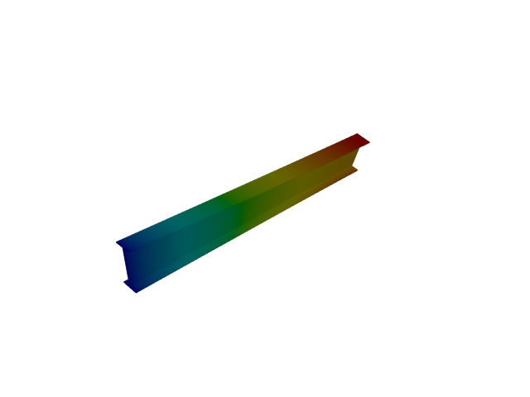
Figure 5: Abaqus — mode 1, 10.785 Hz
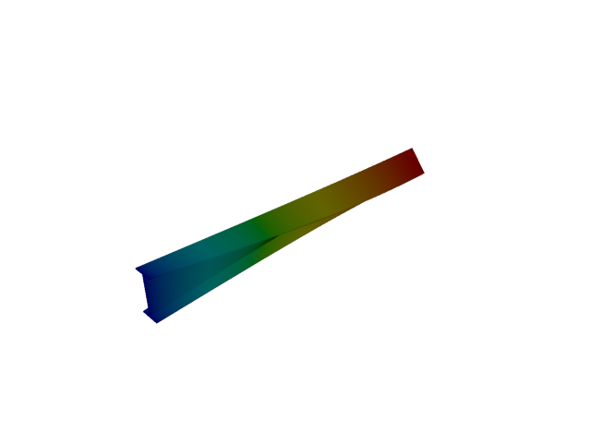
Figure 6: Sesam — mode 1, 12.245 Hz
Solver | f [Hz] | Δf vs mean [%] | λ [rad²/s²] | Meff X [kg] | Meff Y [kg] | Meff Z [kg] | Γ X | Γ Y | Γ Z
Abaqus | 10.785 | -6.34 | 4592.3 | 4.83e-34 | 1.00e-29 | 1.05e-31 | -2.20e-17 | -3.17e-15 | 3.24e-16
Sesam | 12.245 | +6.34 | 5919.77 | 8.88e-35 | 2.77e-27 | 1.18e-30 | 9.42e-18 | 5.26e-14 | -1.09e-15

Mode 2
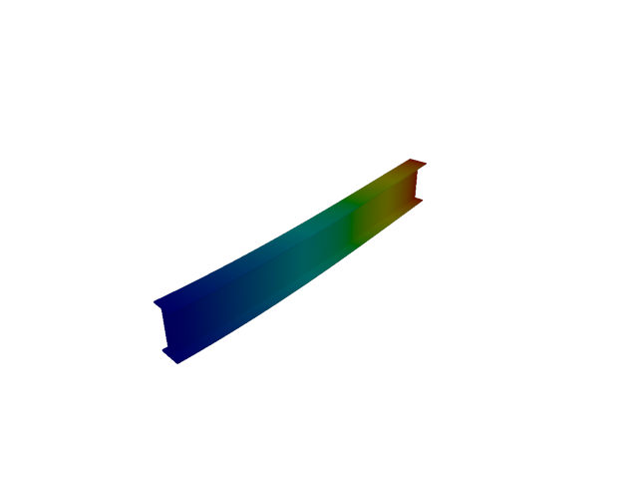
Figure 7: Abaqus — mode 2, 12.928 Hz
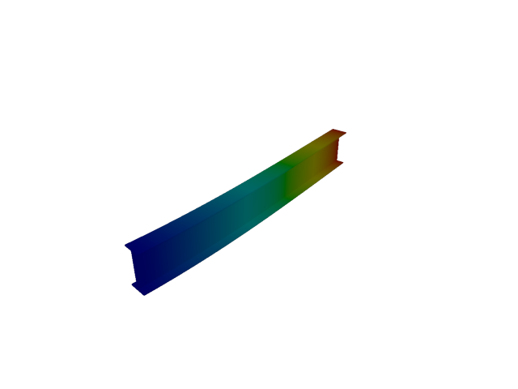
Figure 8: Sesam — mode 2, 12.943 Hz
Solver | f [Hz] | Δf vs mean [%] | λ [rad²/s²] | Meff X [kg] | Meff Y [kg] | Meff Z [kg] | Γ X | Γ Y | Γ Z
Abaqus | 12.928 | -0.06 | 6598.4 | 6.75e-31 | 116.57 | 3.27e-31 | -8.21e-16 | 10.797 | -5.72e-16
Sesam | 12.943 | +0.06 | 6613.55 | 4.64e-35 | 116.71 | 5.64e-31 | 6.81e-18 | 10.803 | -7.51e-16

Mode 3
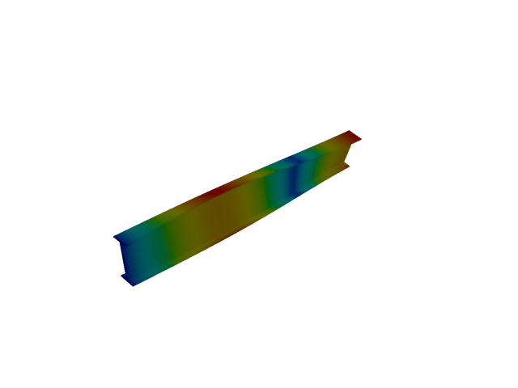
Figure 9: Abaqus — mode 3, 32.342 Hz
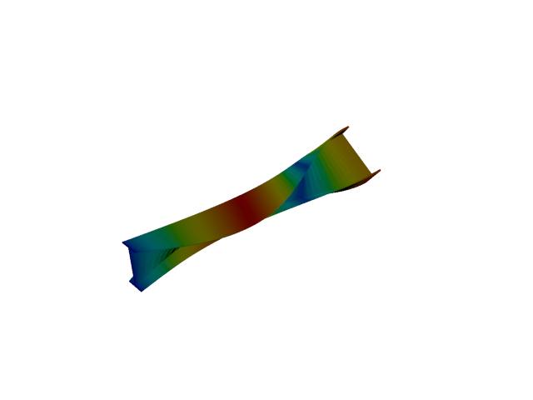
Figure 10: Sesam — mode 3, 36.752 Hz
Solver | f [Hz] | Δf vs mean [%] | λ [rad²/s²] | Meff X [kg] | Meff Y [kg] | Meff Z [kg] | Γ X | Γ Y | Γ Z
Abaqus | 32.342 | -6.38 | 41294 | 7.85e-31 | 8.23e-32 | 1.14e-28 | 8.86e-16 | -2.87e-16 | 1.07e-14
Sesam | 36.752 | +6.38 | 53325.3 | 8.68e-35 | 1.01e-30 | 1.52e-32 | -9.32e-18 | 1.00e-15 | -1.23e-16

Mode 4
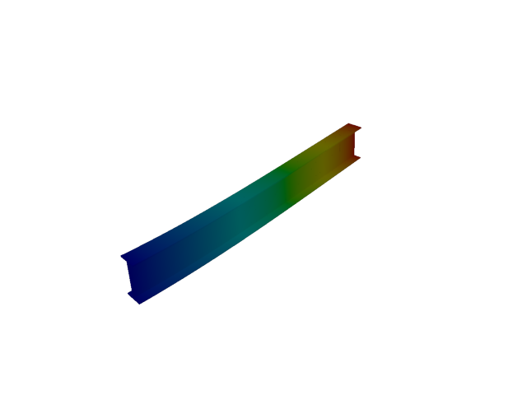
Figure 11: Abaqus — mode 4, 50.543 Hz
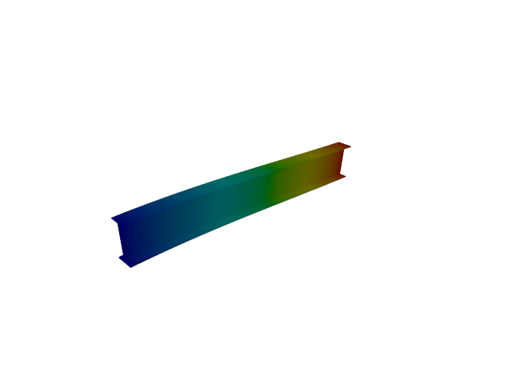
Figure 12: Sesam — mode 4, 44.962 Hz
Solver | f [Hz] | Δf vs mean [%] | λ [rad²/s²] | Meff X [kg] | Meff Y [kg] | Meff Z [kg] | Γ X | Γ Y | Γ Z
Abaqus | 50.543 | +5.84 | 100852 | 2.51e-30 | 1.42e-29 | 118.16 | 1.58e-15 | -3.76e-15 | 10.870
Sesam | 44.962 | -5.84 | 79809.7 | 3.16e-33 | 9.04e-30 | 128.05 | -5.62e-17 | 3.01e-15 | -11.316

Mode 5
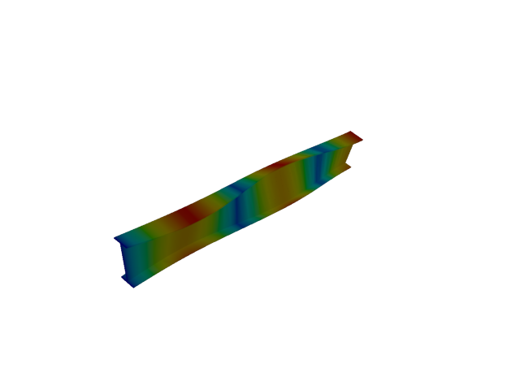
Figure 13: Abaqus — mode 5, 53.855 Hz
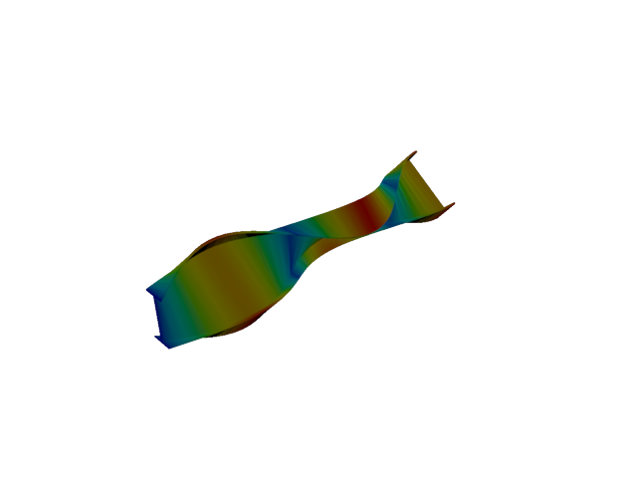
Figure 14: Sesam — mode 5, 61.309 Hz
Solver | f [Hz] | Δf vs mean [%] | λ [rad²/s²] | Meff X [kg] | Meff Y [kg] | Meff Z [kg] | Γ X | Γ Y | Γ Z
Abaqus | 53.855 | -6.47 | 114501 | 1.75e-29 | 8.90e-30 | 2.61e-27 | -4.18e-15 | 2.98e-15 | 5.11e-14
Sesam | 61.309 | +6.47 | 148390 | 3.02e-32 | 3.54e-30 | 1.09e-29 | -1.74e-16 | -1.88e-15 | 3.30e-15

Mode 6
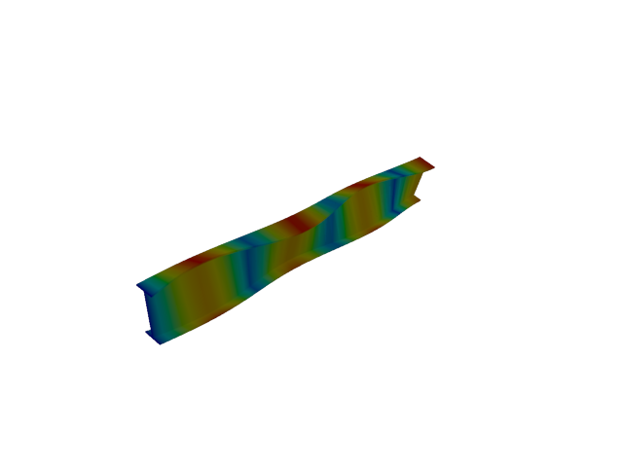
Figure 15: Abaqus — mode 6, 75.296 Hz
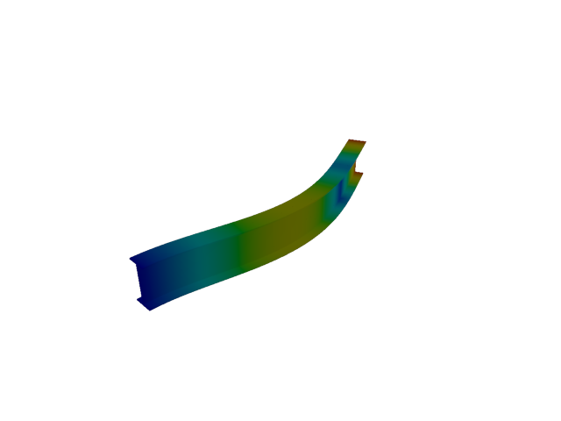
Figure 16: Sesam — mode 6, 79.793 Hz
Solver | f [Hz] | Δf vs mean [%] | λ [rad²/s²] | Meff X [kg] | Meff Y [kg] | Meff Z [kg] | Γ X | Γ Y | Γ Z
Abaqus | 75.296 | -2.90 | 223823 | 3.82e-29 | 2.17e-28 | 3.67e-28 | -6.18e-15 | -1.47e-14 | 1.92e-14
Sesam | 79.793 | +2.90 | 251356 | 8.03e-33 | 36.29 | 4.50e-29 | -8.96e-17 | -6.024 | -6.71e-15

Mode 7
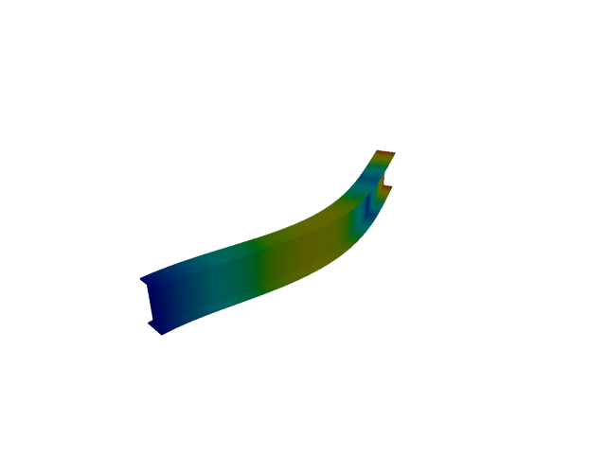
Figure 17: Abaqus — mode 7, 79.590 Hz
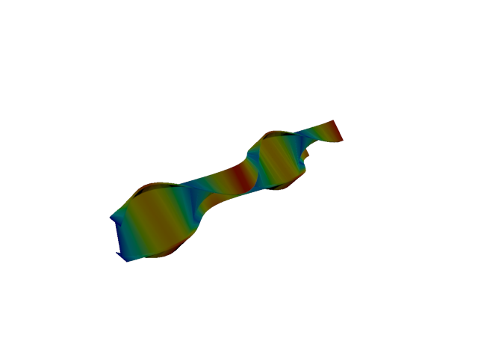
Figure 18: Sesam — mode 7, 85.947 Hz
Solver | f [Hz] | Δf vs mean [%] | λ [rad²/s²] | Meff X [kg] | Meff Y [kg] | Meff Z [kg] | Γ X | Γ Y | Γ Z
Abaqus | 79.590 | -3.84 | 250078 | 1.01e-30 | 36.20 | 1.38e-29 | 1.01e-15 | -6.016 | -3.72e-15
Sesam | 85.947 | +3.84 | 291620 | 1.09e-31 | 9.28e-29 | 2.34e-30 | -3.31e-16 | -9.63e-15 | -1.53e-15

Mode 8
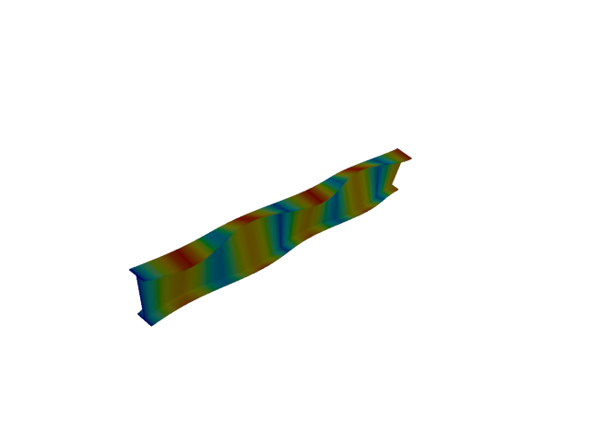
Figure 19: Abaqus — mode 8, 96.637 Hz
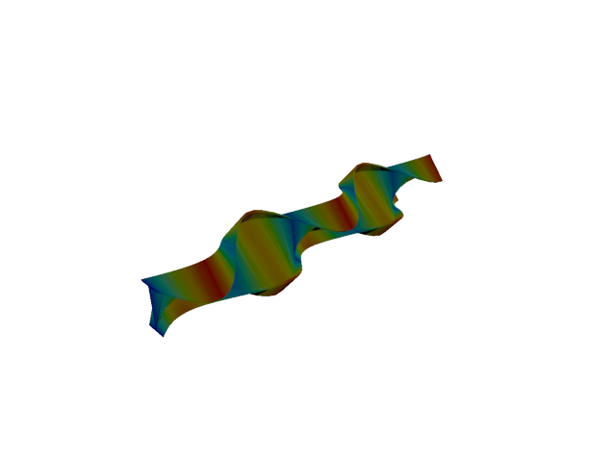
Figure 20: Sesam — mode 8, 110.699 Hz
Solver | f [Hz] | Δf vs mean [%] | λ [rad²/s²] | Meff X [kg] | Meff Y [kg] | Meff Z [kg] | Γ X | Γ Y | Γ Z
Abaqus | 96.637 | -6.78 | 368677 | 4.04e-26 | 1.03e-27 | 4.21e-27 | -2.01e-13 | -3.20e-14 | 6.49e-14
Sesam | 110.699 | +6.78 | 483782 | 2.49e-33 | 6.18e-30 | 2.43e-29 | 4.99e-17 | 2.49e-15 | -4.93e-15

Mode 9
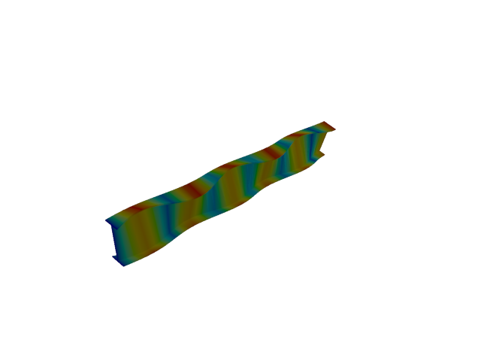
Figure 21: Abaqus — mode 9, 117.849 Hz
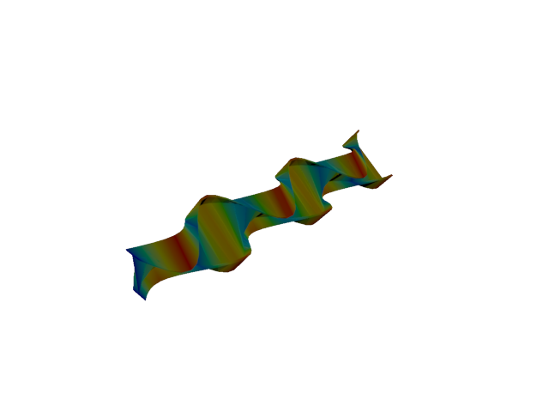
Figure 22: Sesam — mode 9, 135.600 Hz
Solver | f [Hz] | Δf vs mean [%] | λ [rad²/s²] | Meff X [kg] | Meff Y [kg] | Meff Z [kg] | Γ X | Γ Y | Γ Z
Abaqus | 117.850 | -7.00 | 548290 | 9.24e-23 | 1.72e-25 | 7.37e-24 | 9.61e-12 | 4.15e-13 | 2.71e-12
Sesam | 135.600 | +7.00 | 725900 | 3.52e-30 | 2.31e-30 | 4.44e-29 | -1.88e-15 | 1.52e-15 | -6.66e-15

Mode 10
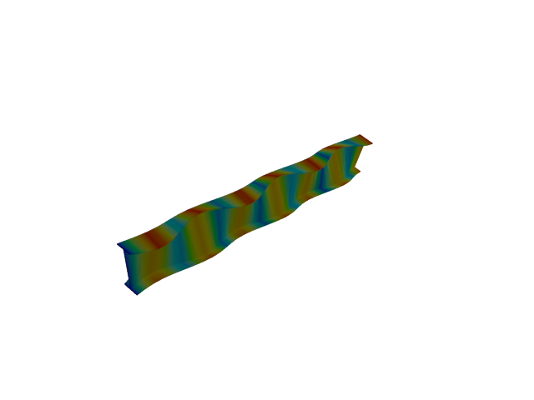
Figure 23: Abaqus — mode 10, 138.904 Hz
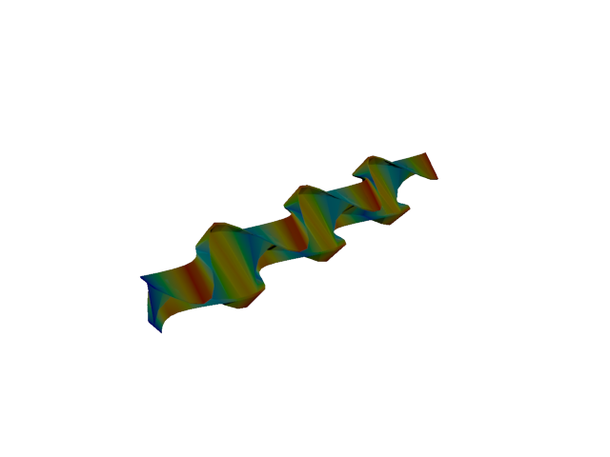
Figure 24: Sesam — mode 10, 160.681 Hz
Solver | f [Hz] | Δf vs mean [%] | λ [rad²/s²] | Meff X [kg] | Meff Y [kg] | Meff Z [kg] | Γ X | Γ Y | Γ Z
Abaqus | 138.900 | -7.27 | 761704 | 1.00e-20 | 2.09e-22 | 2.61e-21 | 1.00e-10 | 1.45e-11 | -5.11e-11
Sesam | 160.681 | +7.27 | 1.01927e+06 | 6.22e-23 | 1.67e-23 | 7.04e-23 | -7.88e-12 | 4.09e-12 | -8.39e-12

Mode 11
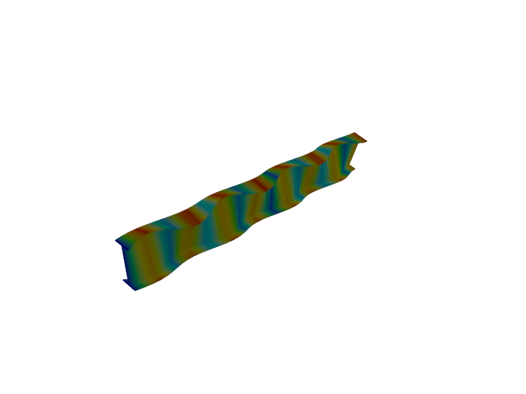
Figure 25: Abaqus — mode 11, 159.773 Hz
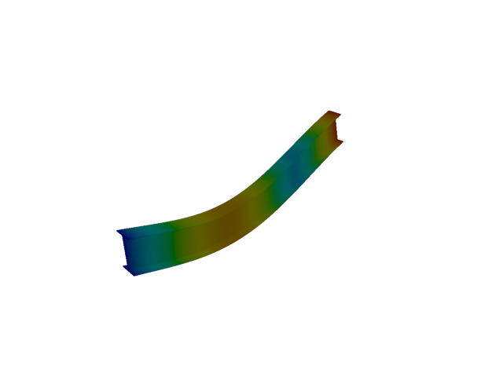
Figure 26: Sesam — mode 11, 176.495 Hz
Solver | f [Hz] | Δf vs mean [%] | λ [rad²/s²] | Meff X [kg] | Meff Y [kg] | Meff Z [kg] | Γ X | Γ Y | Γ Z
Abaqus | 159.770 | -4.97 | 1.00778e+06 | 1.05e-18 | 1.96e-22 | 2.87e-21 | 1.02e-09 | -1.40e-11 | 5.35e-11
Sesam | 176.495 | +4.97 | 1.22977e+06 | 3.95e-21 | 1.04e-21 | 38.35 | -6.28e-11 | 3.22e-11 | -6.193

Line, 2nd order

Mode 1
Figure 27: Abaqus — mode 1, 10.786 Hz
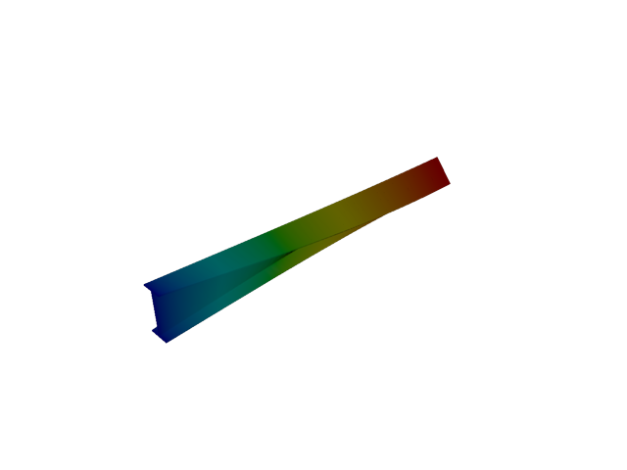
Figure 28: Sesam — mode 1, 10.039 Hz
Solver | f [Hz] | Δf vs mean [%] | λ [rad²/s²] | Meff X [kg] | Meff Y [kg] | Meff Z [kg] | Γ X | Γ Y | Γ Z
Abaqus | 10.786 | +3.59 | 4592.8 | 3.02e-31 | 1.31e-30 | 3.09e-30 | 5.50e-16 | 1.14e-15 | -1.76e-15
Sesam | 10.039 | -3.59 | 3978.68 | 5.26e-40 | 1.31e-27 | 4.46e-29 | 2.29e-20 | 3.62e-14 | -6.68e-15

Mode 2
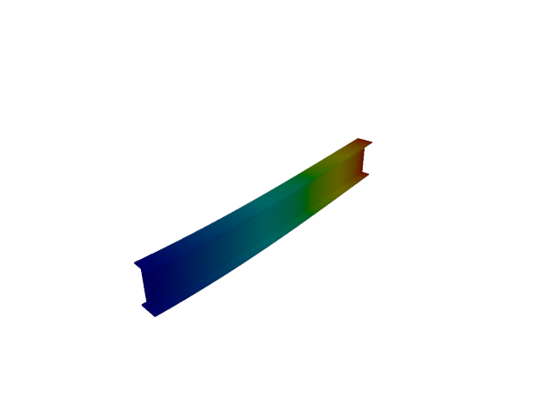
Figure 29: Abaqus — mode 2, 12.932 Hz
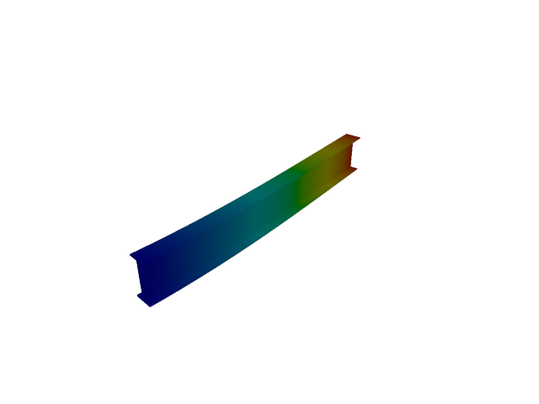
Figure 30: Sesam — mode 2, 10.614 Hz
Solver | f [Hz] | Δf vs mean [%] | λ [rad²/s²] | Meff X [kg] | Meff Y [kg] | Meff Z [kg] | Γ X | Γ Y | Γ Z
Abaqus | 12.932 | +9.84 | 6602.4 | 1.50e-32 | 116.59 | 2.60e-32 | -1.22e-16 | 10.798 | -1.61e-16
Sesam | 10.614 | -9.84 | 4447.85 | 3.31e-28 | 176.82 | 7.82e-31 | -1.82e-14 | 13.297 | 8.84e-16

Mode 3
Figure 31: Abaqus — mode 3, 32.358 Hz
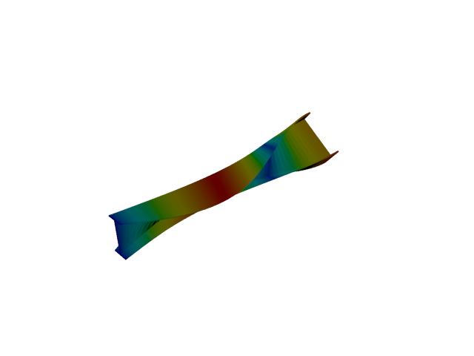
Figure 32: Sesam — mode 3, 30.108 Hz
Solver | f [Hz] | Δf vs mean [%] | λ [rad²/s²] | Meff X [kg] | Meff Y [kg] | Meff Z [kg] | Γ X | Γ Y | Γ Z
Abaqus | 32.358 | +3.60 | 41335 | 2.64e-31 | 5.69e-29 | 8.91e-29 | 5.14e-16 | -7.54e-15 | -9.44e-15
Sesam | 30.108 | -3.60 | 35786.3 | 4.57e-37 | 6.51e-30 | 2.81e-29 | 6.76e-19 | 2.55e-15 | -5.30e-15

Mode 4
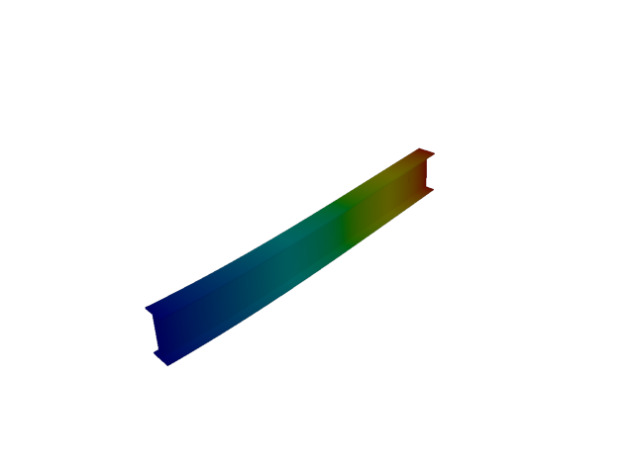
Figure 33: Abaqus — mode 4, 50.557 Hz
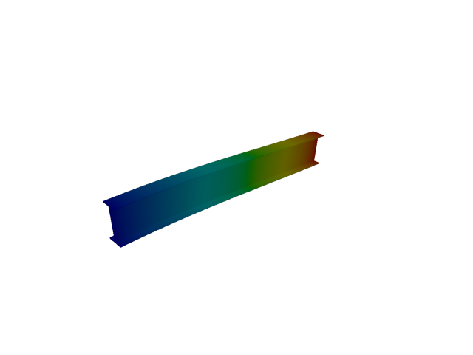
Figure 34: Sesam — mode 4, 36.752 Hz
Solver | f [Hz] | Δf vs mean [%] | λ [rad²/s²] | Meff X [kg] | Meff Y [kg] | Meff Z [kg] | Γ X | Γ Y | Γ Z
Abaqus | 50.557 | +15.81 | 100907 | 6.29e-36 | 9.63e-28 | 118.18 | -2.51e-18 | -3.10e-14 | 10.871
Sesam | 36.752 | -15.81 | 53323.9 | 3.71e-28 | 2.58e-29 | 192.77 | 1.93e-14 | 5.08e-15 | -13.884

Mode 5
Figure 35: Abaqus — mode 5, 53.930 Hz
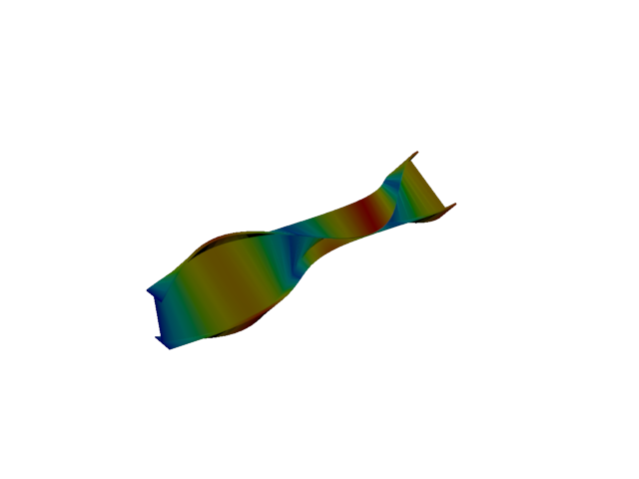
Figure 36: Sesam — mode 5, 50.149 Hz
Solver | f [Hz] | Δf vs mean [%] | λ [rad²/s²] | Meff X [kg] | Meff Y [kg] | Meff Z [kg] | Γ X | Γ Y | Γ Z
Abaqus | 53.930 | +3.63 | 114820 | 1.13e-29 | 6.97e-31 | 2.94e-28 | -3.36e-15 | 8.35e-16 | 1.72e-14
Sesam | 50.149 | -3.63 | 99284.4 | 1.91e-35 | 1.10e-30 | 4.31e-29 | -4.37e-18 | -1.05e-15 | -6.57e-15

Mode 6
Figure 37: Abaqus — mode 6, 75.502 Hz
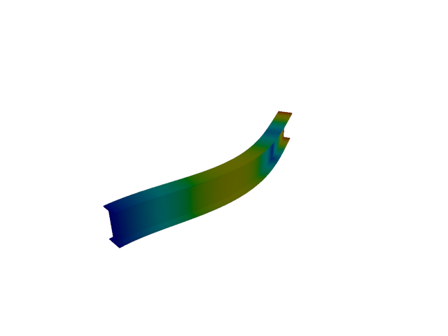
Figure 38: Sesam — mode 6, 65.327 Hz
Solver | f [Hz] | Δf vs mean [%] | λ [rad²/s²] | Meff X [kg] | Meff Y [kg] | Meff Z [kg] | Γ X | Γ Y | Γ Z
Abaqus | 75.502 | +7.23 | 225048 | 6.44e-34 | 3.07e-27 | 1.85e-29 | -2.54e-17 | 5.54e-14 | -4.30e-15
Sesam | 65.327 | -7.23 | 168476 | 1.08e-28 | 54.95 | 1.07e-28 | 1.04e-14 | -7.413 | -1.03e-14

Mode 7
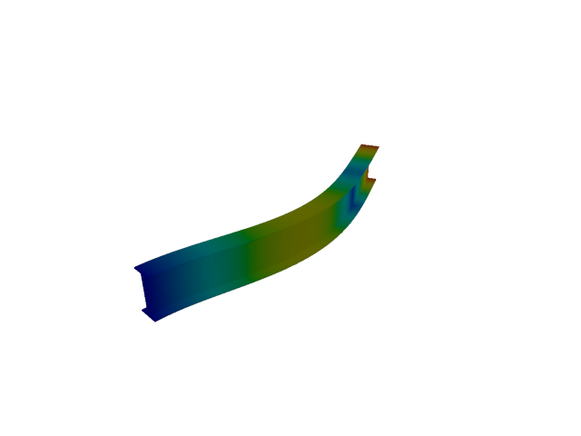
Figure 39: Abaqus — mode 7, 79.684 Hz
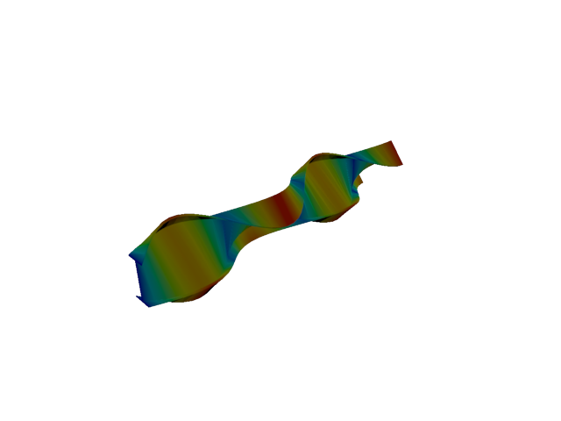
Figure 40: Sesam — mode 7, 70.143 Hz
Solver | f [Hz] | Δf vs mean [%] | λ [rad²/s²] | Meff X [kg] | Meff Y [kg] | Meff Z [kg] | Γ X | Γ Y | Γ Z
Abaqus | 79.684 | +6.37 | 250668 | 9.57e-31 | 36.19 | 1.97e-27 | 9.78e-16 | -6.015 | -4.44e-14
Sesam | 70.143 | -6.37 | 194235 | 7.33e-35 | 4.66e-28 | 4.83e-30 | -8.56e-18 | 2.16e-14 | 2.20e-15

Mode 8
Figure 41: Abaqus — mode 8, 97.074 Hz
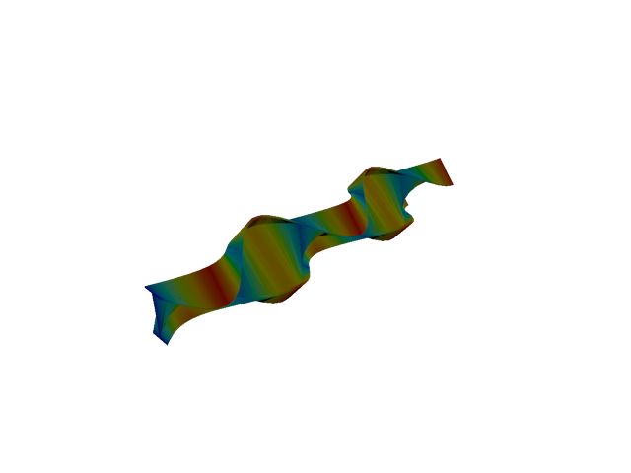
Figure 42: Sesam — mode 8, 90.070 Hz
Solver | f [Hz] | Δf vs mean [%] | λ [rad²/s²] | Meff X [kg] | Meff Y [kg] | Meff Z [kg] | Γ X | Γ Y | Γ Z
Abaqus | 97.074 | +3.74 | 372022 | 4.46e-28 | 1.86e-30 | 1.09e-27 | 2.11e-14 | 1.36e-15 | -3.31e-14
Sesam | 90.070 | -3.74 | 320270 | 1.65e-33 | 4.85e-29 | 3.89e-29 | -4.06e-17 | 6.96e-15 | 6.24e-15

Mode 9
Figure 43: Abaqus — mode 9, 118.648 Hz
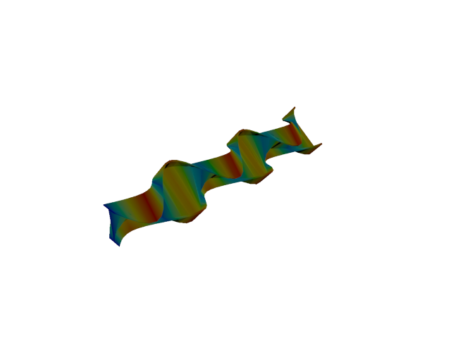
Figure 44: Sesam — mode 9, 109.907 Hz
Solver | f [Hz] | Δf vs mean [%] | λ [rad²/s²] | Meff X [kg] | Meff Y [kg] | Meff Z [kg] | Γ X | Γ Y | Γ Z
Abaqus | 118.650 | +3.83 | 555748 | 3.94e-25 | 6.15e-26 | 2.26e-25 | 6.28e-13 | 2.48e-13 | -4.75e-13
Sesam | 109.907 | -3.83 | 476881 | 3.54e-29 | 2.19e-32 | 8.17e-29 | 5.95e-15 | -1.48e-16 | -9.04e-15

Mode 10
Figure 45: Abaqus — mode 10, 140.222 Hz
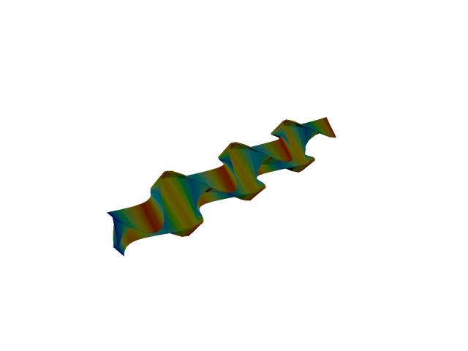
Figure 46: Sesam — mode 10, 129.631 Hz
Solver | f [Hz] | Δf vs mean [%] | λ [rad²/s²] | Meff X [kg] | Meff Y [kg] | Meff Z [kg] | Γ X | Γ Y | Γ Z
Abaqus | 140.220 | +3.92 | 776236 | 2.58e-24 | 4.27e-23 | 1.99e-23 | -1.61e-12 | 6.54e-12 | 4.46e-12
Sesam | 129.631 | -3.92 | 663407 | 8.02e-21 | 1.12e-21 | 1.11e-21 | 8.95e-11 | 3.35e-11 | -3.34e-11

Mode 11
Figure 47: Abaqus — mode 11, 161.799 Hz
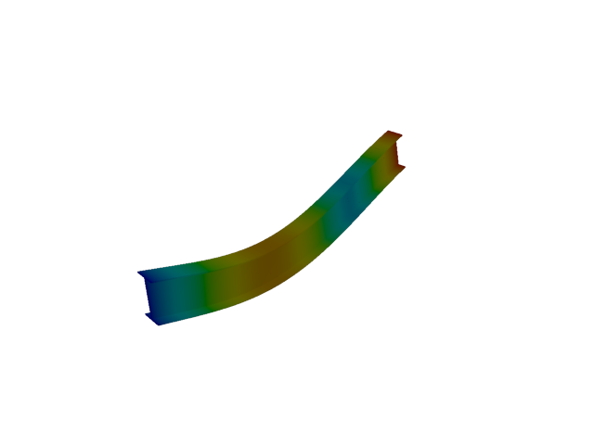
Figure 48: Sesam — mode 11, 142.572 Hz
Solver | f [Hz] | Δf vs mean [%] | λ [rad²/s²] | Meff X [kg] | Meff Y [kg] | Meff Z [kg] | Γ X | Γ Y | Γ Z
Abaqus | 161.800 | +6.32 | 1.03351e+06 | 2.30e-19 | 1.18e-19 | 3.67e-20 | -4.80e-10 | -3.43e-10 | 1.92e-10
Sesam | 142.572 | -6.32 | 802475 | 5.07e-20 | 7.21e-21 | 59.58 | 2.25e-10 | 8.49e-11 | -7.719

Shell, 1st order, TRI

Mode 1
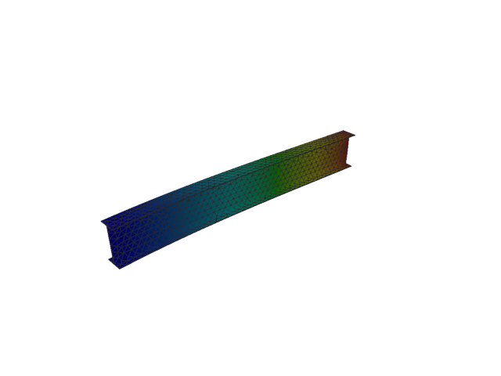
Figure 49: Sesam — mode 1, 13.641 Hz
Solver | f [Hz] | λ [rad²/s²] | Meff X [kg] | Meff Y [kg] | Meff Z [kg] | Γ X | Γ Y | Γ Z
Sesam | 13.641 | 7346.4 | 2.57e-27 | 119.93 | 7.93e-25 | -5.07e-14 | -10.951 | -8.90e-13

Mode 2
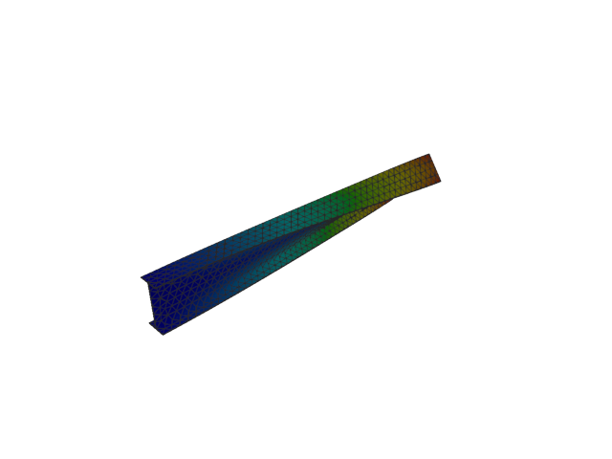
Figure 50: Sesam — mode 2, 20.198 Hz
Solver | f [Hz] | λ [rad²/s²] | Meff X [kg] | Meff Y [kg] | Meff Z [kg] | Γ X | Γ Y | Γ Z
Sesam | 20.198 | 16106.1 | 1.92e-26 | 3.02e-11 | 1.82e-25 | 1.38e-13 | -5.49e-06 | 4.26e-13

Mode 3
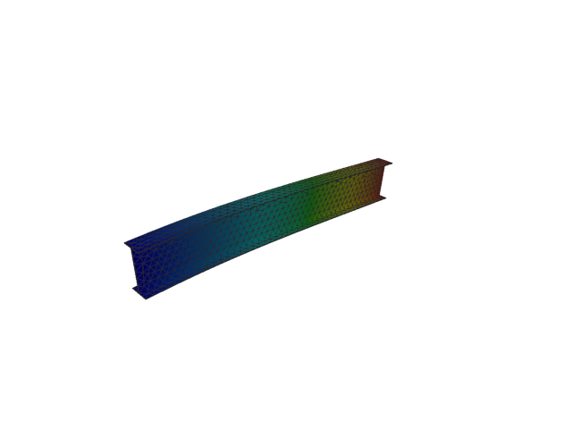
Figure 51: Sesam — mode 3, 52.192 Hz
Solver | f [Hz] | λ [rad²/s²] | Meff X [kg] | Meff Y [kg] | Meff Z [kg] | Γ X | Γ Y | Γ Z
Sesam | 52.192 | 107540 | 4.79e-10 | 1.24e-24 | 122.03 | -2.19e-05 | 1.12e-12 | -11.047

Mode 4
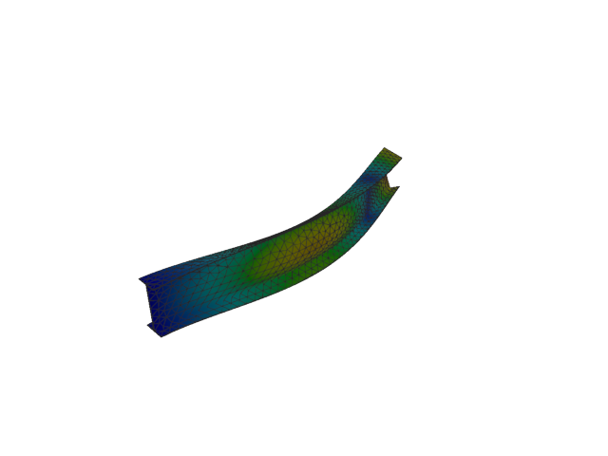
Figure 52: Sesam — mode 4, 79.523 Hz
Solver | f [Hz] | λ [rad²/s²] | Meff X [kg] | Meff Y [kg] | Meff Z [kg] | Γ X | Γ Y | Γ Z
Sesam | 79.523 | 249655 | 1.26e-27 | 36.58 | 1.11e-25 | 3.55e-14 | -6.048 | -3.33e-13

Mode 5
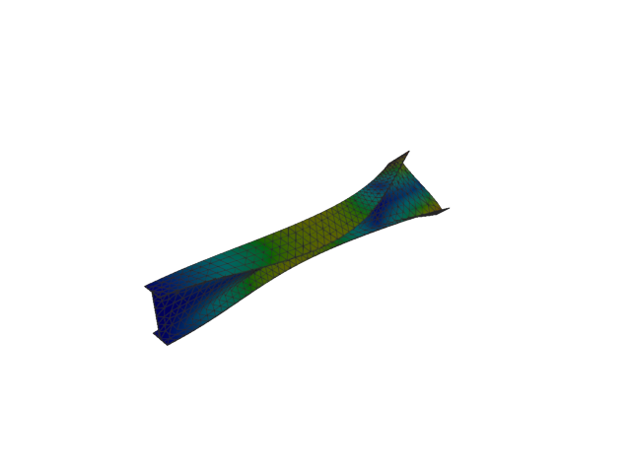
Figure 53: Sesam — mode 5, 101.756 Hz
Solver | f [Hz] | λ [rad²/s²] | Meff X [kg] | Meff Y [kg] | Meff Z [kg] | Γ X | Γ Y | Γ Z
Sesam | 101.756 | 408770 | 3.14e-27 | 4.27e-09 | 1.42e-27 | -5.60e-14 | 6.54e-05 | -3.77e-14

Mode 6
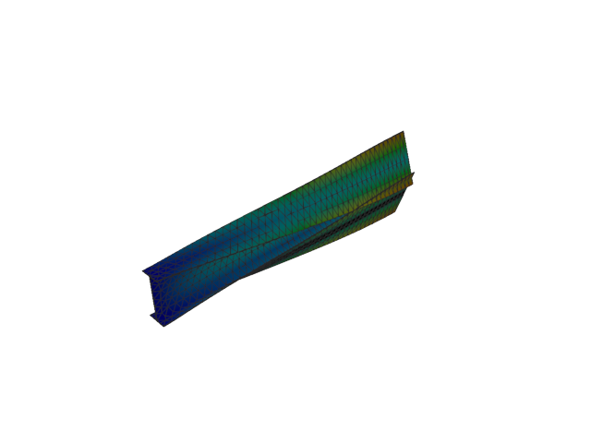
Figure 54: Sesam — mode 6, 125.093 Hz
Solver | f [Hz] | λ [rad²/s²] | Meff X [kg] | Meff Y [kg] | Meff Z [kg] | Γ X | Γ Y | Γ Z
Sesam | 125.093 | 617772 | 5.83e-28 | 0.06 | 2.58e-27 | -2.41e-14 | -0.252 | 5.08e-14

Mode 7
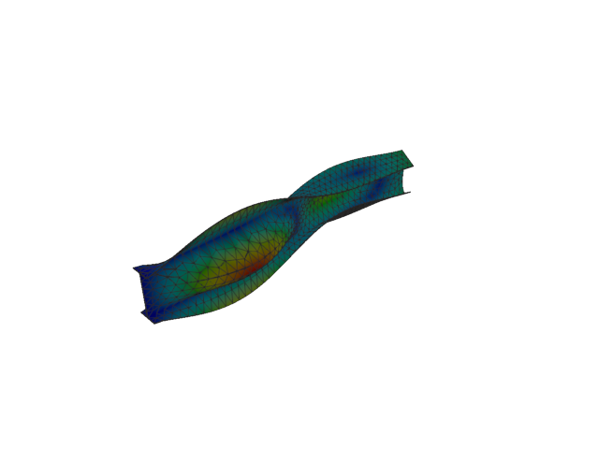
Figure 55: Sesam — mode 7, 143.164 Hz
Solver | f [Hz] | λ [rad²/s²] | Meff X [kg] | Meff Y [kg] | Meff Z [kg] | Γ X | Γ Y | Γ Z
Sesam | 143.164 | 809150 | 1.19e-28 | 2.72 | 6.22e-28 | -1.09e-14 | -1.651 | 2.49e-14

Mode 8
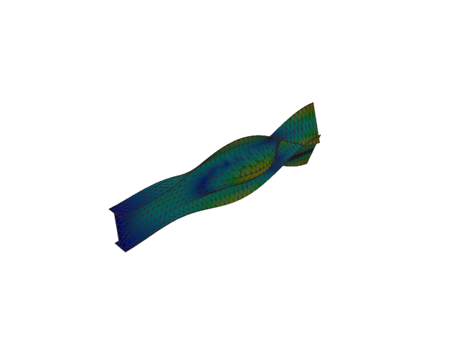
Figure 56: Sesam — mode 8, 166.668 Hz
Solver | f [Hz] | λ [rad²/s²] | Meff X [kg] | Meff Y [kg] | Meff Z [kg] | Γ X | Γ Y | Γ Z
Sesam | 166.668 | 1.09664e+06 | 1.64e-27 | 5.94 | 3.89e-27 | -4.05e-14 | 2.438 | -6.23e-14

Mode 9
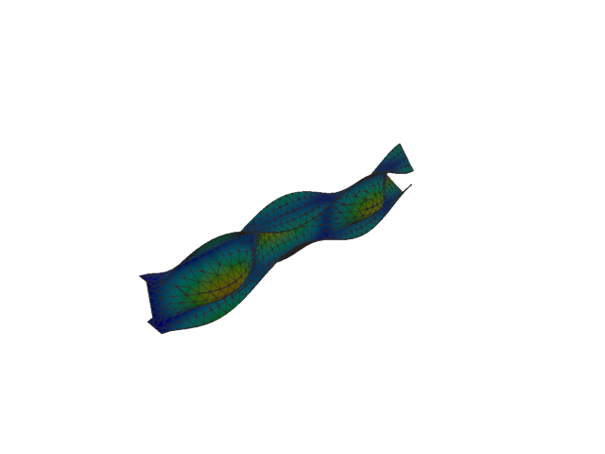
Figure 57: Sesam — mode 9, 191.533 Hz
Solver | f [Hz] | λ [rad²/s²] | Meff X [kg] | Meff Y [kg] | Meff Z [kg] | Γ X | Γ Y | Γ Z
Sesam | 191.533 | 1.44826e+06 | 2.66e-28 | 0.61 | 7.55e-28 | -1.63e-14 | -0.781 | -2.75e-14

Mode 10
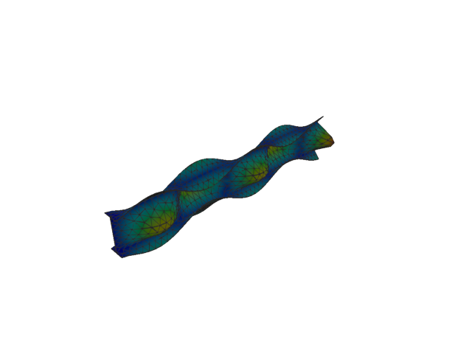
Figure 58: Sesam — mode 10, 230.489 Hz
Solver | f [Hz] | λ [rad²/s²] | Meff X [kg] | Meff Y [kg] | Meff Z [kg] | Γ X | Γ Y | Γ Z
Sesam | 230.489 | 2.09731e+06 | 2.70e-28 | 1.27 | 2.42e-28 | 1.64e-14 | -1.128 | -1.55e-14

Mode 11
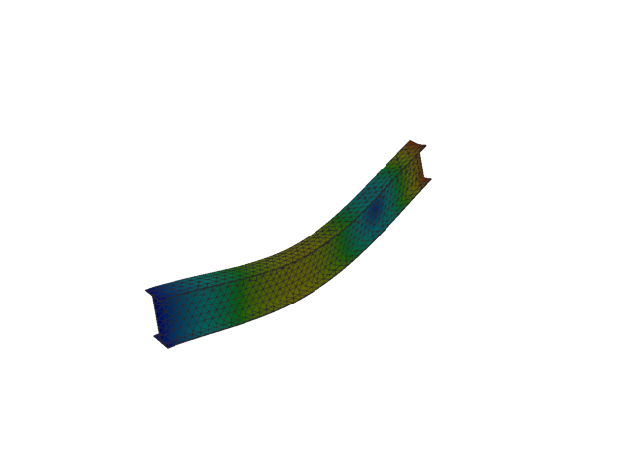
Figure 59: Sesam — mode 11, 257.362 Hz
Solver | f [Hz] | λ [rad²/s²] | Meff X [kg] | Meff Y [kg] | Meff Z [kg] | Γ X | Γ Y | Γ Z
Sesam | 257.362 | 2.61487e+06 | 6.51e-09 | 3.57e-22 | 41.62 | -8.07e-05 | -1.89e-11 | -6.451

Shell, 1st order, QUAD

Mode 1
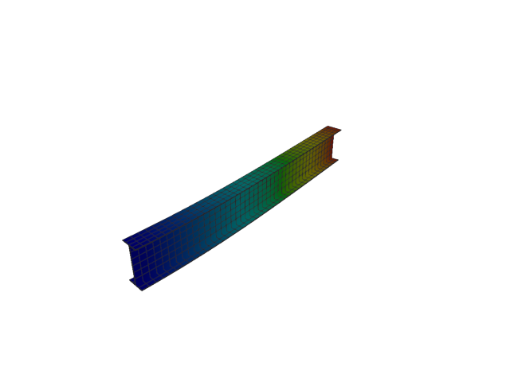
Figure 60: Abaqus — mode 1, 12.780 Hz
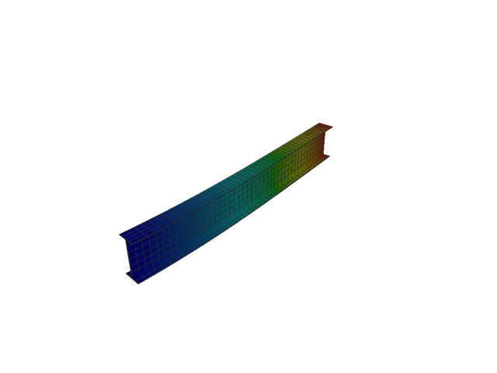
Figure 61: Sesam — mode 1, 12.763 Hz
Solver | f [Hz] | Δf vs mean [%] | λ [rad²/s²] | Meff X [kg] | Meff Y [kg] | Meff Z [kg] | Γ X | Γ Y | Γ Z
Abaqus | 12.780 | +0.07 | 6448.4 | 7.41e-27 | 119.92 | 1.38e-25 | -8.61e-14 | 10.951 | -3.71e-13
Sesam | 12.763 | -0.07 | 6430.64 | 1.47e-28 | 119.90 | 2.22e-25 | -1.21e-14 | 10.950 | -4.71e-13

Mode 2
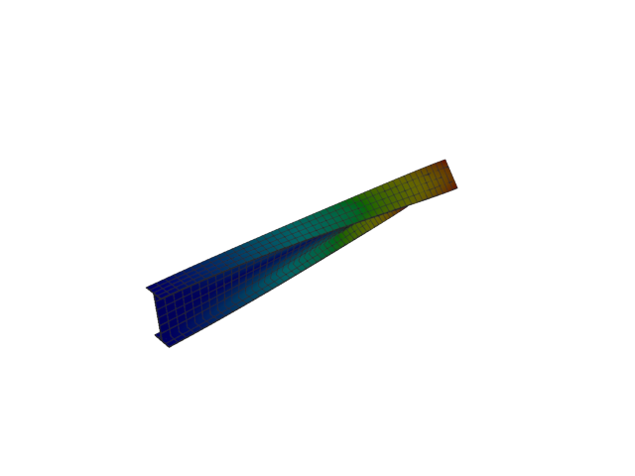
Figure 62: Abaqus — mode 2, 19.593 Hz
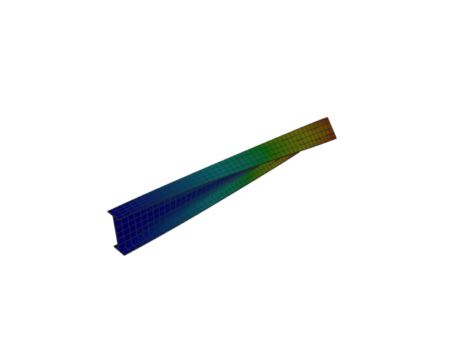
Figure 63: Sesam — mode 2, 19.394 Hz
Solver | f [Hz] | Δf vs mean [%] | λ [rad²/s²] | Meff X [kg] | Meff Y [kg] | Meff Z [kg] | Γ X | Γ Y | Γ Z
Abaqus | 19.593 | +0.51 | 15155 | 1.46e-27 | 1.08e-19 | 7.67e-28 | -3.83e-14 | 3.28e-10 | 2.77e-14
Sesam | 19.394 | -0.51 | 14849.3 | 3.80e-27 | 7.43e-19 | 1.60e-24 | -6.16e-14 | -8.62e-10 | -1.27e-12

Mode 3
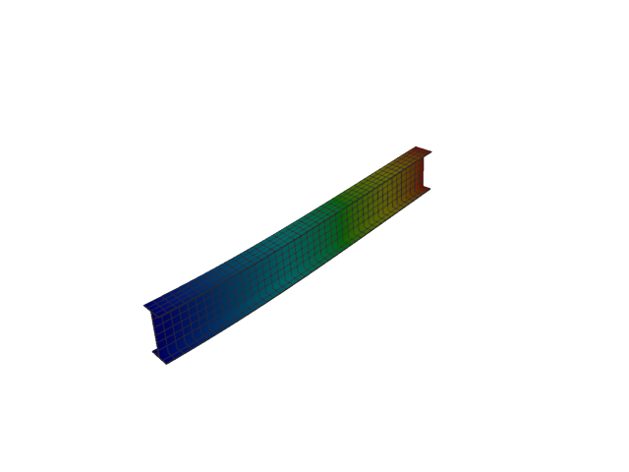
Figure 64: Abaqus — mode 3, 51.998 Hz
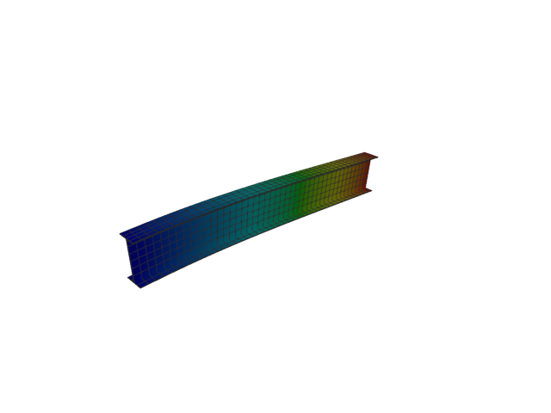
Figure 65: Sesam — mode 3, 51.991 Hz
Solver | f [Hz] | Δf vs mean [%] | λ [rad²/s²] | Meff X [kg] | Meff Y [kg] | Meff Z [kg] | Γ X | Γ Y | Γ Z
Abaqus | 51.998 | +0.01 | 106741 | 1.35e-26 | 1.05e-26 | 122.01 | -1.16e-13 | 1.03e-13 | 11.046
Sesam | 51.991 | -0.01 | 106714 | 7.03e-28 | 8.47e-26 | 122.00 | 2.65e-14 | -2.91e-13 | -11.046

Mode 4
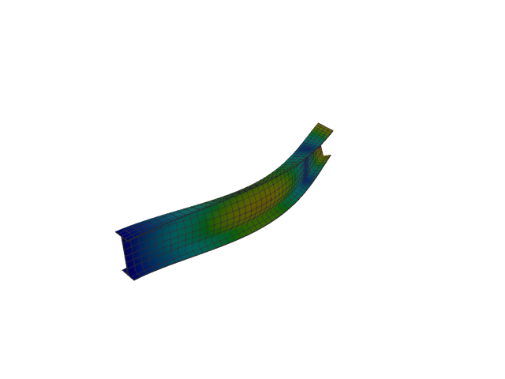
Figure 66: Abaqus — mode 4, 75.683 Hz
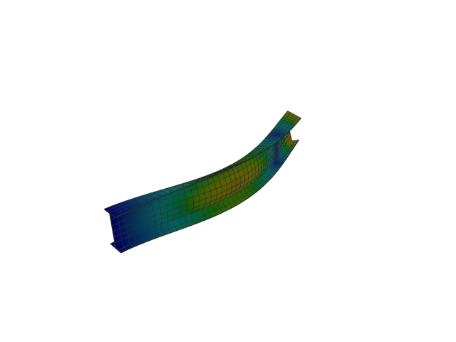
Figure 67: Sesam — mode 4, 75.192 Hz
Solver | f [Hz] | Δf vs mean [%] | λ [rad²/s²] | Meff X [kg] | Meff Y [kg] | Meff Z [kg] | Γ X | Γ Y | Γ Z
Abaqus | 75.683 | +0.33 | 226132 | 1.88e-28 | 36.92 | 2.68e-25 | -1.37e-14 | -6.076 | -5.18e-13
Sesam | 75.192 | -0.33 | 223203 | 1.10e-27 | 36.80 | 9.74e-26 | -3.31e-14 | -6.067 | -3.12e-13

Mode 5
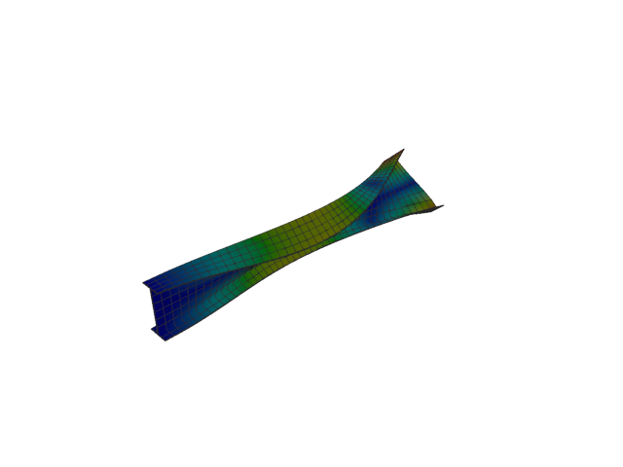
Figure 68: Abaqus — mode 5, 96.393 Hz
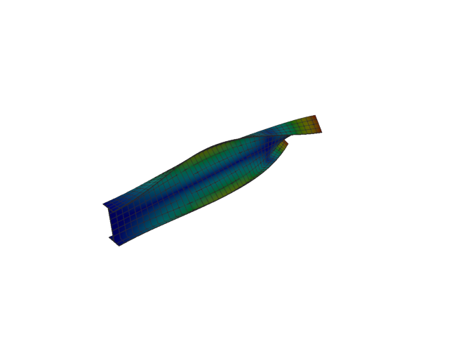
Figure 69: Sesam — mode 5, 95.930 Hz
Solver | f [Hz] | Δf vs mean [%] | λ [rad²/s²] | Meff X [kg] | Meff Y [kg] | Meff Z [kg] | Γ X | Γ Y | Γ Z
Abaqus | 96.393 | +0.24 | 366818 | 7.25e-28 | 1.11e-22 | 7.70e-26 | -2.69e-14 | -1.05e-11 | -2.77e-13
Sesam | 95.930 | -0.24 | 363300 | 2.85e-27 | 3.92e-24 | 2.81e-26 | 5.34e-14 | 1.98e-12 | -1.68e-13

Mode 6
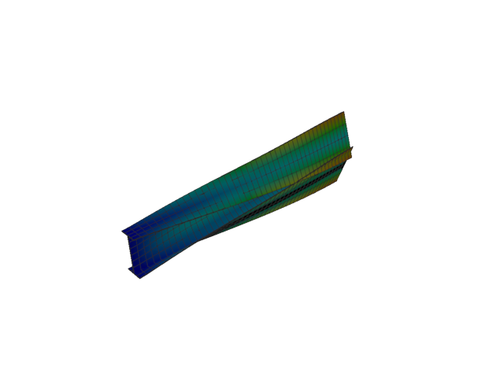
Figure 70: Abaqus — mode 6, 126.961 Hz
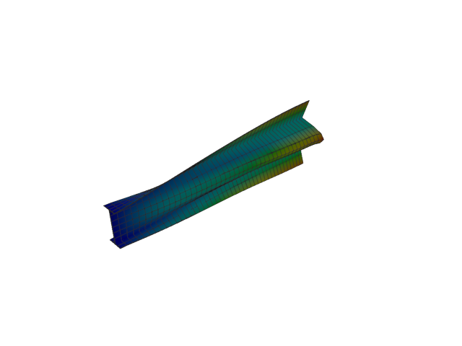
Figure 71: Sesam — mode 6, 125.116 Hz
Solver | f [Hz] | Δf vs mean [%] | λ [rad²/s²] | Meff X [kg] | Meff Y [kg] | Meff Z [kg] | Γ X | Γ Y | Γ Z
Abaqus | 126.960 | +0.73 | 636351 | 1.52e-27 | 0.02 | 2.42e-26 | 3.90e-14 | -0.132 | -1.56e-13
Sesam | 125.116 | -0.73 | 617993 | 3.59e-30 | 0.02 | 5.54e-26 | -1.89e-15 | 0.134 | -2.35e-13

Mode 7
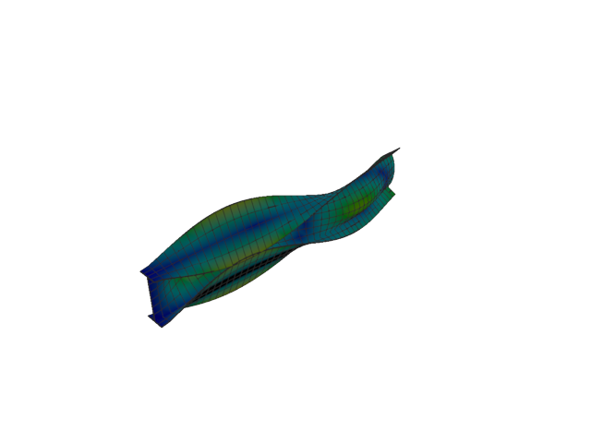
Figure 72: Abaqus — mode 7, 145.566 Hz
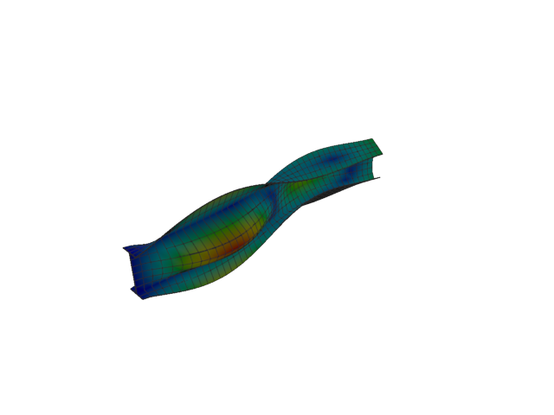
Figure 73: Sesam — mode 7, 141.556 Hz
Solver | f [Hz] | Δf vs mean [%] | λ [rad²/s²] | Meff X [kg] | Meff Y [kg] | Meff Z [kg] | Γ X | Γ Y | Γ Z
Abaqus | 145.570 | +1.40 | 836523 | 2.58e-27 | 3.34 | 1.12e-26 | -5.08e-14 | 1.829 | 1.06e-13
Sesam | 141.556 | -1.40 | 791068 | 1.14e-28 | 3.46 | 3.39e-27 | 1.07e-14 | -1.860 | 5.82e-14

Mode 8
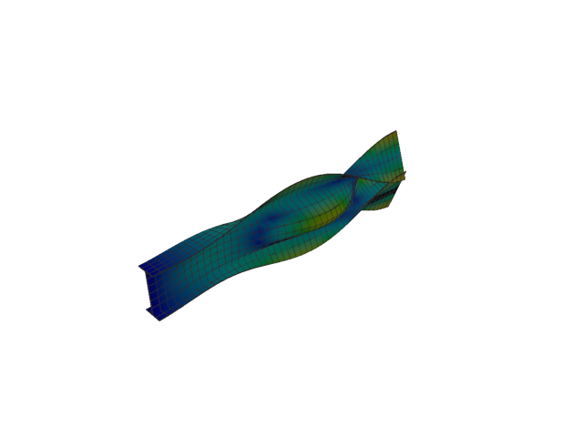
Figure 74: Abaqus — mode 8, 169.389 Hz
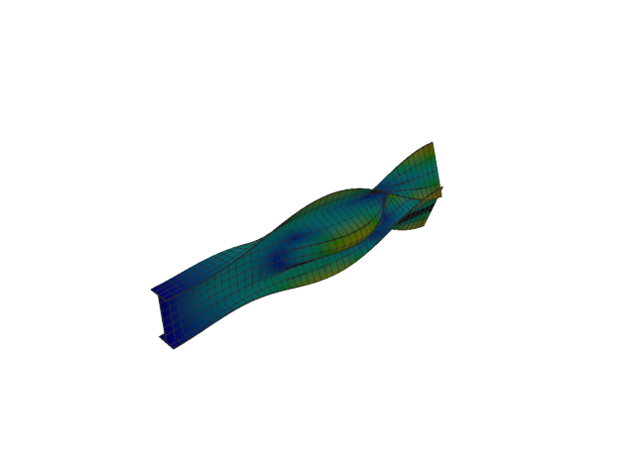
Figure 75: Sesam — mode 8, 165.030 Hz
Solver | f [Hz] | Δf vs mean [%] | λ [rad²/s²] | Meff X [kg] | Meff Y [kg] | Meff Z [kg] | Γ X | Γ Y | Γ Z
Abaqus | 169.390 | +1.30 | 1.13275e+06 | 2.66e-25 | 5.68 | 6.71e-24 | -5.16e-13 | 2.383 | -2.59e-12
Sesam | 165.030 | -1.30 | 1.07519e+06 | 5.28e-28 | 5.45 | 4.78e-26 | 2.30e-14 | 2.334 | 2.19e-13

Mode 9
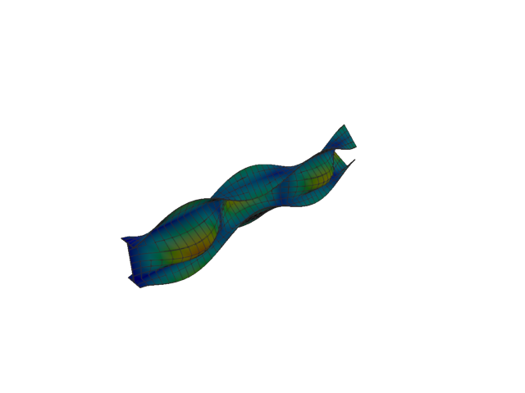
Figure 76: Abaqus — mode 9, 198.748 Hz
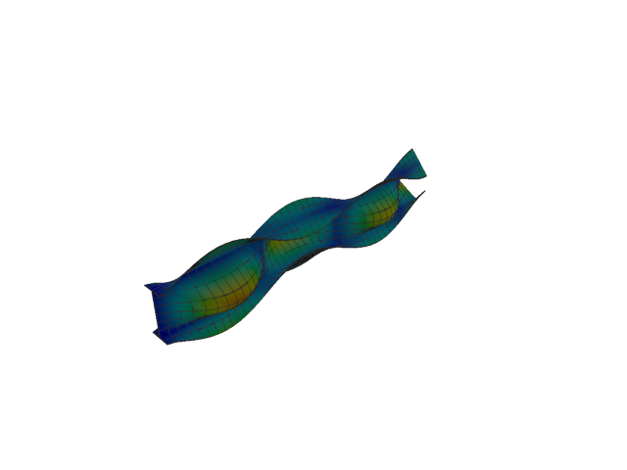
Figure 77: Sesam — mode 9, 190.099 Hz
Solver | f [Hz] | Δf vs mean [%] | λ [rad²/s²] | Meff X [kg] | Meff Y [kg] | Meff Z [kg] | Γ X | Γ Y | Γ Z
Abaqus | 198.750 | +2.22 | 1.55943e+06 | 6.12e-22 | 0.59 | 1.15e-20 | 2.47e-11 | -0.771 | 1.07e-10
Sesam | 190.099 | -2.22 | 1.42665e+06 | 1.59e-30 | 0.64 | 8.33e-27 | -1.26e-15 | -0.798 | 9.13e-14

Mode 10
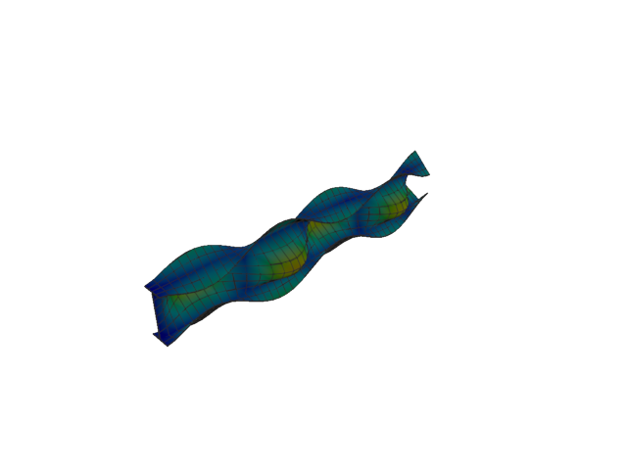
Figure 78: Abaqus — mode 10, 242.545 Hz
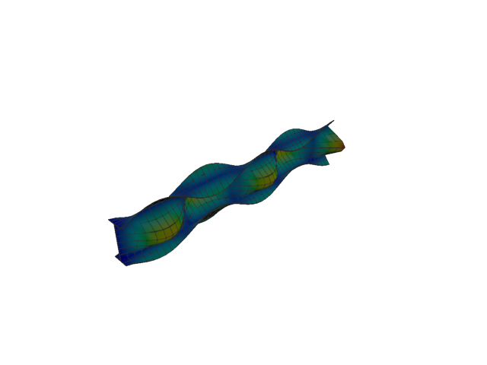
Figure 79: Sesam — mode 10, 229.460 Hz
Solver | f [Hz] | Δf vs mean [%] | λ [rad²/s²] | Meff X [kg] | Meff Y [kg] | Meff Z [kg] | Γ X | Γ Y | Γ Z
Abaqus | 242.550 | +2.77 | 2.32244e+06 | 3.62e-17 | 1.52 | 5.68e-16 | 6.02e-09 | 1.232 | 2.38e-08
Sesam | 229.460 | -2.77 | 2.07861e+06 | 1.61e-29 | 1.32 | 5.25e-27 | 4.01e-15 | -1.150 | 7.25e-14

Mode 11
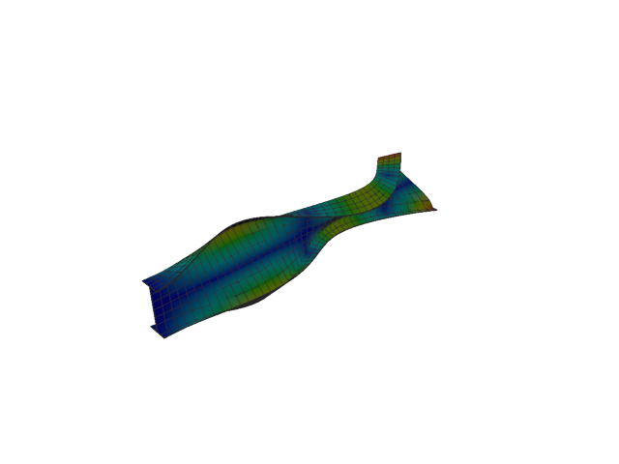
Figure 80: Abaqus — mode 11, 252.486 Hz
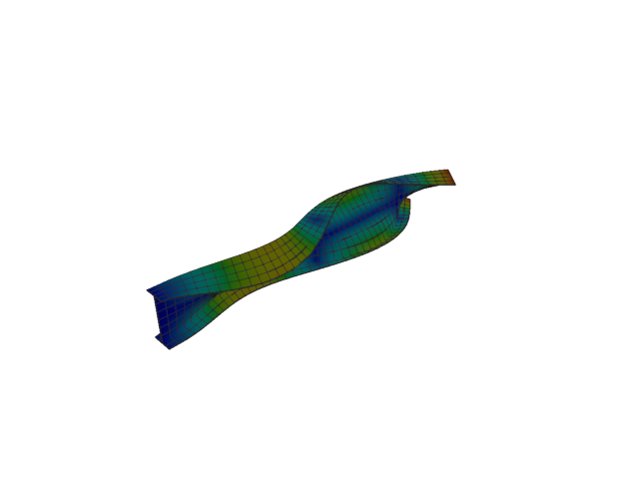
Figure 81: Sesam — mode 11, 250.786 Hz
Solver | f [Hz] | Δf vs mean [%] | λ [rad²/s²] | Meff X [kg] | Meff Y [kg] | Meff Z [kg] | Γ X | Γ Y | Γ Z
Abaqus | 252.490 | +0.34 | 2.51672e+06 | 4.88e-17 | 7.27e-17 | 7.10e-16 | 6.99e-09 | 8.53e-09 | 2.67e-08
Sesam | 250.786 | -0.34 | 2.48294e+06 | 6.33e-21 | 7.49e-20 | 8.71e-20 | 7.95e-11 | -2.74e-10 | 2.95e-10

Shell, 1st order, QUAD, reduced integration

Mode 1
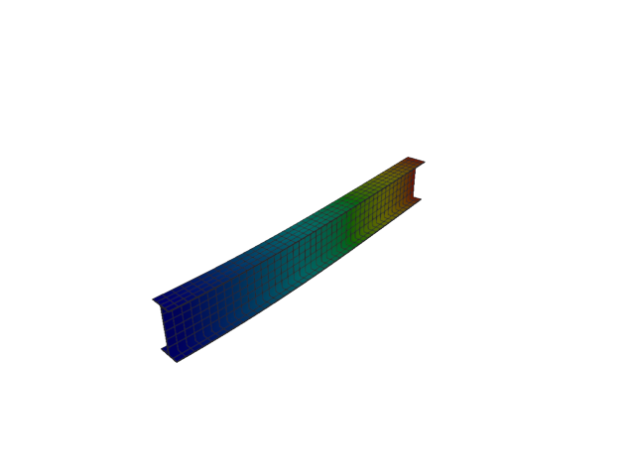
Figure 82: Abaqus — mode 1, 12.373 Hz
Solver | f [Hz] | λ [rad²/s²] | Meff X [kg] | Meff Y [kg] | Meff Z [kg] | Γ X | Γ Y | Γ Z
Abaqus | 12.373 | 6043.5 | 1.78e-28 | 119.95 | 5.35e-25 | -1.33e-14 | 10.952 | -7.31e-13

Mode 2
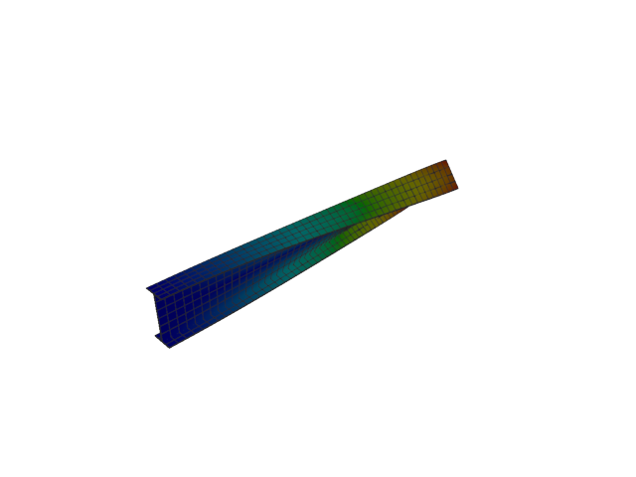
Figure 83: Abaqus — mode 2, 19.230 Hz
Solver | f [Hz] | λ [rad²/s²] | Meff X [kg] | Meff Y [kg] | Meff Z [kg] | Γ X | Γ Y | Γ Z
Abaqus | 19.230 | 14599 | 1.25e-26 | 4.60e-21 | 3.10e-26 | -1.12e-13 | 6.78e-11 | 1.76e-13

Mode 3
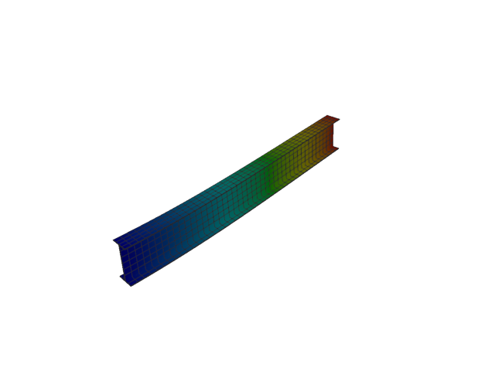
Figure 84: Abaqus — mode 3, 51.849 Hz
Solver | f [Hz] | λ [rad²/s²] | Meff X [kg] | Meff Y [kg] | Meff Z [kg] | Γ X | Γ Y | Γ Z
Abaqus | 51.849 | 106129 | 2.48e-26 | 1.19e-25 | 122.02 | -1.58e-13 | 3.45e-13 | 11.046

Mode 4
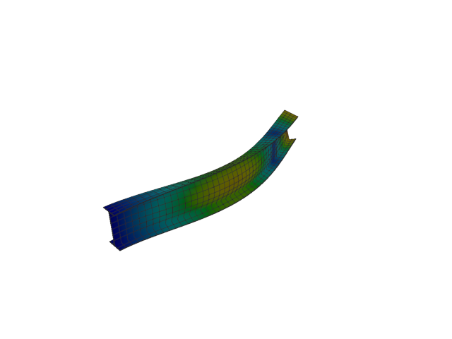
Figure 85: Abaqus — mode 4, 73.558 Hz
Solver | f [Hz] | λ [rad²/s²] | Meff X [kg] | Meff Y [kg] | Meff Z [kg] | Γ X | Γ Y | Γ Z
Abaqus | 73.558 | 213611 | 2.90e-28 | 36.98 | 6.94e-25 | -1.70e-14 | -6.081 | -8.33e-13

Mode 5
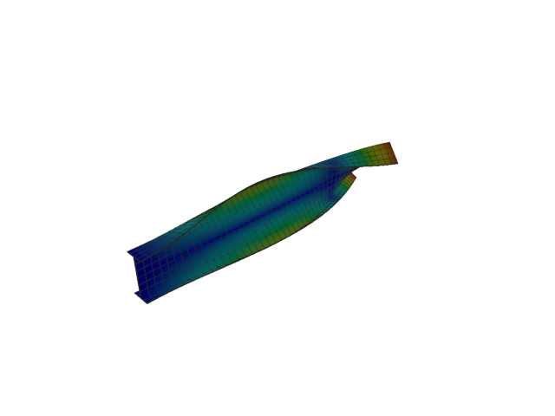
Figure 86: Abaqus — mode 5, 93.709 Hz
Solver | f [Hz] | λ [rad²/s²] | Meff X [kg] | Meff Y [kg] | Meff Z [kg] | Γ X | Γ Y | Γ Z
Abaqus | 93.709 | 346673 | 9.12e-28 | 8.02e-23 | 5.37e-26 | 3.02e-14 | -8.96e-12 | 2.32e-13

Mode 6
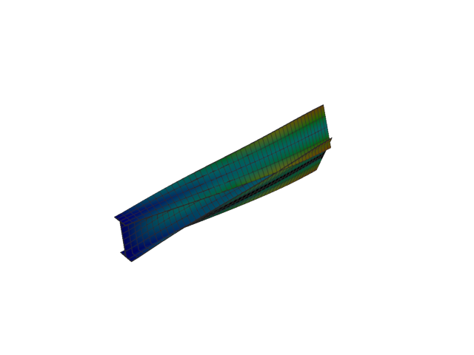
Figure 87: Abaqus — mode 6, 126.870 Hz
Solver | f [Hz] | λ [rad²/s²] | Meff X [kg] | Meff Y [kg] | Meff Z [kg] | Γ X | Γ Y | Γ Z
Abaqus | 126.870 | 635447 | 1.80e-30 | 0.01 | 1.84e-25 | 1.34e-15 | -0.078 | -4.29e-13

Mode 7
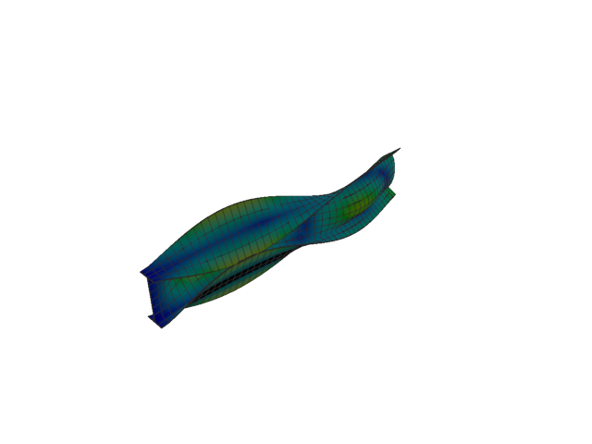
Figure 88: Abaqus — mode 7, 144.579 Hz
Solver | f [Hz] | λ [rad²/s²] | Meff X [kg] | Meff Y [kg] | Meff Z [kg] | Γ X | Γ Y | Γ Z
Abaqus | 144.580 | 825226 | 1.99e-29 | 3.79 | 2.06e-26 | -4.46e-15 | 1.947 | 1.43e-13

Mode 8
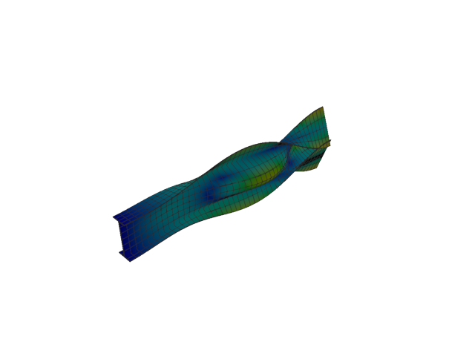
Figure 89: Abaqus — mode 8, 168.379 Hz
Solver | f [Hz] | λ [rad²/s²] | Meff X [kg] | Meff Y [kg] | Meff Z [kg] | Γ X | Γ Y | Γ Z
Abaqus | 168.380 | 1.11927e+06 | 2.51e-28 | 5.44 | 1.97e-25 | 1.58e-14 | 2.332 | -4.43e-13

Mode 9
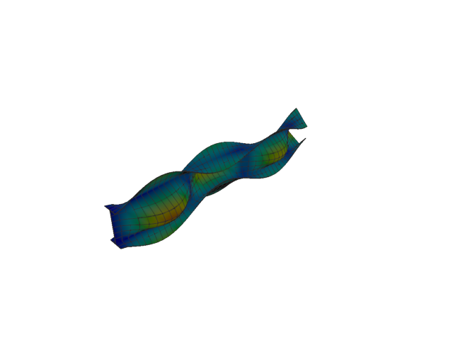
Figure 90: Abaqus — mode 9, 197.515 Hz
Solver | f [Hz] | λ [rad²/s²] | Meff X [kg] | Meff Y [kg] | Meff Z [kg] | Γ X | Γ Y | Γ Z
Abaqus | 197.510 | 1.54014e+06 | 1.19e-26 | 0.62 | 1.84e-25 | -1.09e-13 | -0.786 | 4.29e-13

Mode 10
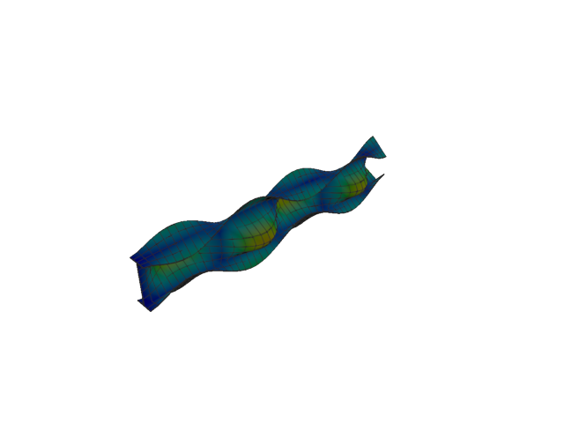
Figure 91: Abaqus — mode 10, 241.275 Hz
Solver | f [Hz] | λ [rad²/s²] | Meff X [kg] | Meff Y [kg] | Meff Z [kg] | Γ X | Γ Y | Γ Z
Abaqus | 241.270 | 2.29818e+06 | 2.67e-22 | 1.61 | 1.69e-20 | -1.63e-11 | 1.269 | 1.30e-10

Mode 11
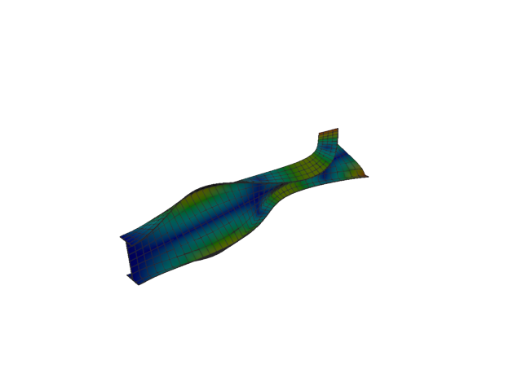
Figure 92: Abaqus — mode 11, 245.071 Hz
Solver | f [Hz] | λ [rad²/s²] | Meff X [kg] | Meff Y [kg] | Meff Z [kg] | Γ X | Γ Y | Γ Z
Abaqus | 245.070 | 2.37106e+06 | 3.55e-23 | 8.35e-21 | 8.47e-21 | -5.95e-12 | 9.14e-11 | 9.20e-11

Shell, 2nd order, TRI

Mode 1
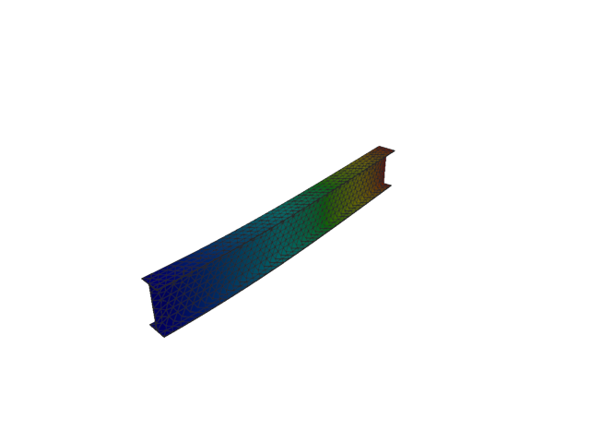
Figure 93: Abaqus — mode 1, 12.756 Hz
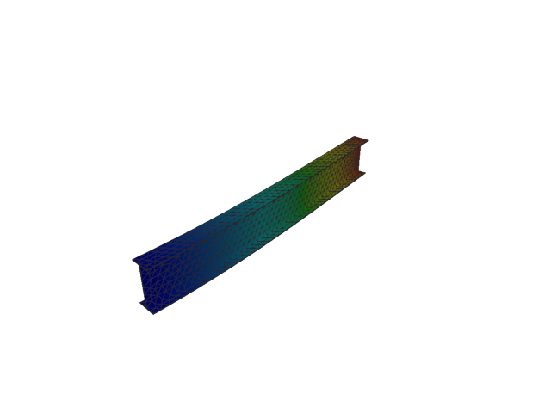
Figure 94: Sesam — mode 1, 12.756 Hz
Solver | f [Hz] | Δf vs mean [%] | λ [rad²/s²] | Meff X [kg] | Meff Y [kg] | Meff Z [kg] | Γ X | Γ Y | Γ Z
Abaqus | 12.756 | 9.02e-04 | 6423.3 | 2.07e-18 | 119.94 | 3.02e-12 | 1.44e-09 | 10.952 | 1.74e-06
Sesam | 12.756 | -9.02e-04 | 6423.52 | 1.73e-27 | 119.94 | 5.84e-24 | -4.16e-14 | 10.952 | -2.42e-12

Mode 2
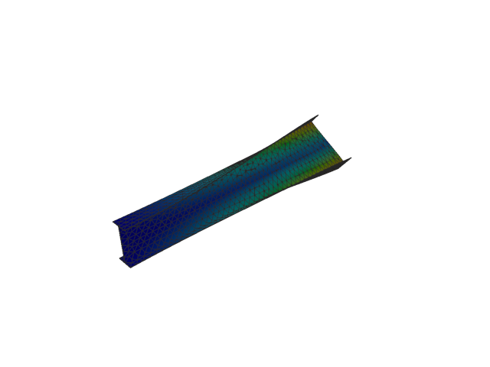
Figure 95: Abaqus — mode 2, 19.567 Hz
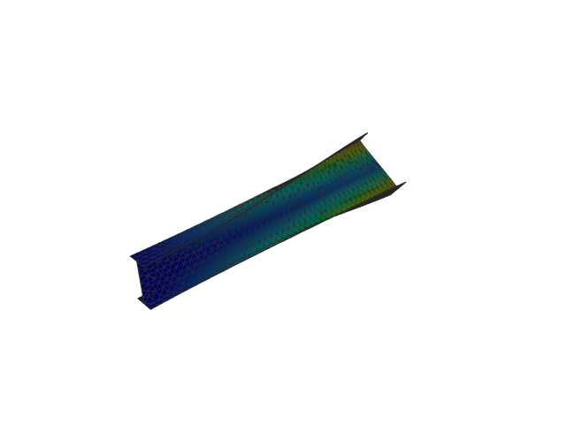
Figure 96: Sesam — mode 2, 19.505 Hz
Solver | f [Hz] | Δf vs mean [%] | λ [rad²/s²] | Meff X [kg] | Meff Y [kg] | Meff Z [kg] | Γ X | Γ Y | Γ Z
Abaqus | 19.567 | +0.16 | 15115 | 3.71e-13 | 3.08e-10 | 4.41e-12 | 6.09e-07 | 1.75e-05 | -2.10e-06
Sesam | 19.505 | -0.16 | 15019.1 | 2.03e-25 | 1.78e-08 | 1.33e-23 | 4.51e-13 | 1.33e-04 | 3.65e-12

Mode 3
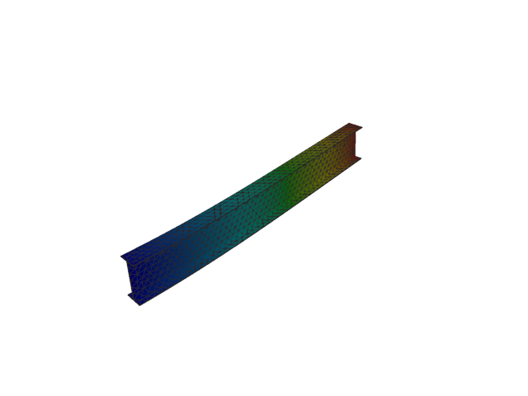
Figure 97: Abaqus — mode 3, 51.969 Hz
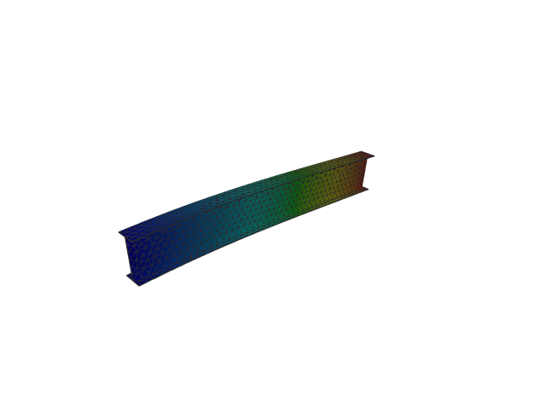
Figure 98: Sesam — mode 3, 51.970 Hz
Solver | f [Hz] | Δf vs mean [%] | λ [rad²/s²] | Meff X [kg] | Meff Y [kg] | Meff Z [kg] | Γ X | Γ Y | Γ Z
Abaqus | 51.969 | -1.34e-03 | 106622 | 4.50e-14 | 9.00e-10 | 122.03 | 2.12e-07 | 3.00e-05 | 11.047
Sesam | 51.970 | 1.34e-03 | 106628 | 6.59e-14 | 9.47e-24 | 122.03 | -2.57e-07 | -3.08e-12 | -11.047

Mode 4
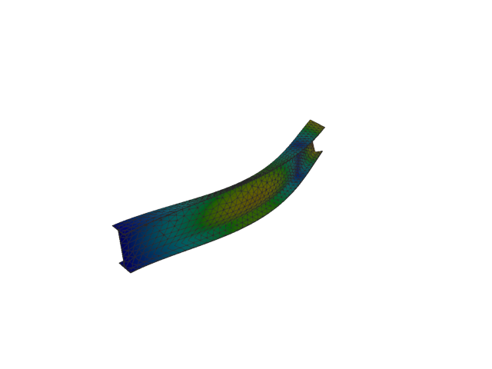
Figure 99: Abaqus — mode 4, 75.145 Hz
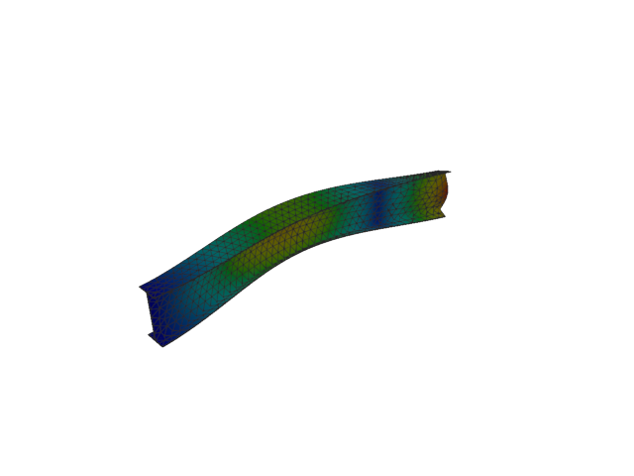
Figure 100: Sesam — mode 4, 75.172 Hz
Solver | f [Hz] | Δf vs mean [%] | λ [rad²/s²] | Meff X [kg] | Meff Y [kg] | Meff Z [kg] | Γ X | Γ Y | Γ Z
Abaqus | 75.145 | -0.02 | 222925 | 1.24e-16 | 36.88 | 1.80e-09 | 1.11e-08 | -6.073 | 4.24e-05
Sesam | 75.172 | +0.02 | 223083 | 1.13e-25 | 36.87 | 8.58e-25 | -3.36e-13 | 6.072 | -9.26e-13

Mode 5
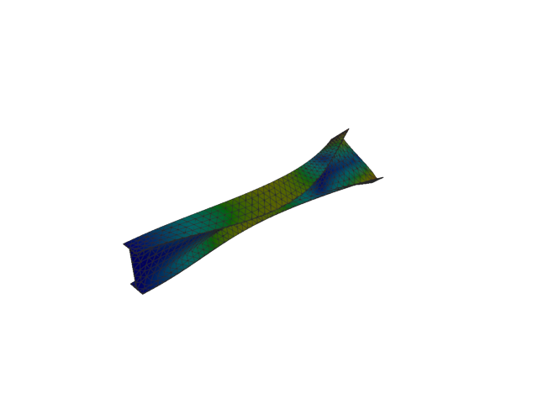
Figure 101: Abaqus — mode 5, 96.001 Hz
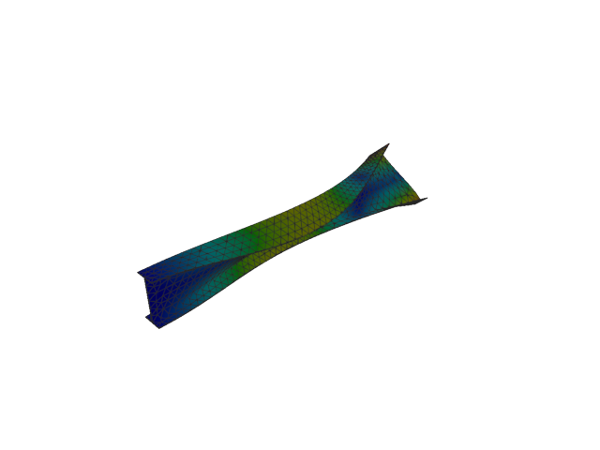
Figure 102: Sesam — mode 5, 95.934 Hz
Solver | f [Hz] | Δf vs mean [%] | λ [rad²/s²] | Meff X [kg] | Meff Y [kg] | Meff Z [kg] | Γ X | Γ Y | Γ Z
Abaqus | 96.001 | +0.04 | 363843 | 8.08e-12 | 6.17e-09 | 5.02e-12 | -2.84e-06 | -7.85e-05 | 2.24e-06
Sesam | 95.934 | -0.04 | 363330 | 7.77e-26 | 1.06e-09 | 4.95e-24 | -2.79e-13 | 3.26e-05 | 2.22e-12

Mode 6
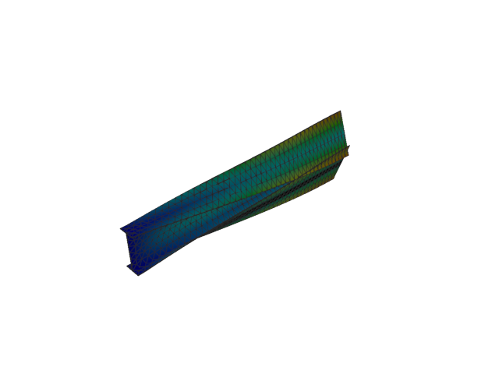
Figure 103: Abaqus — mode 6, 125.207 Hz
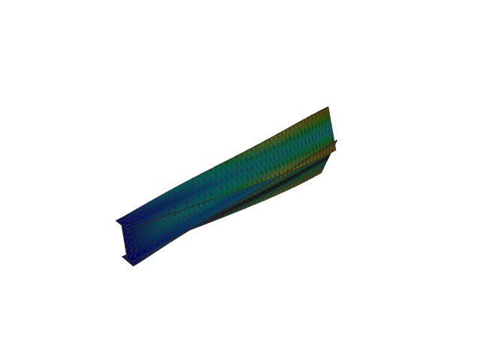
Figure 104: Sesam — mode 6, 125.173 Hz
Solver | f [Hz] | Δf vs mean [%] | λ [rad²/s²] | Meff X [kg] | Meff Y [kg] | Meff Z [kg] | Γ X | Γ Y | Γ Z
Abaqus | 125.210 | +0.01 | 618895 | 4.62e-16 | 0.02 | 1.76e-10 | -2.15e-08 | -0.138 | -1.33e-05
Sesam | 125.173 | -0.01 | 618555 | 1.13e-26 | 0.02 | 5.47e-23 | 1.06e-13 | -0.144 | 7.40e-12

Mode 7
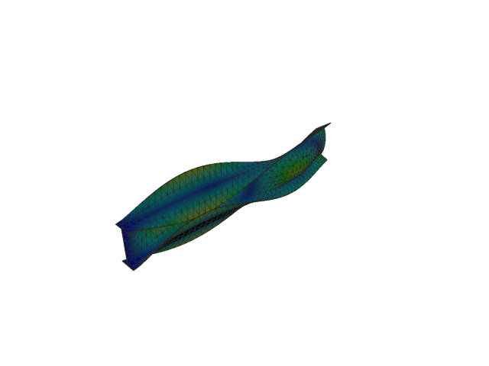
Figure 105: Abaqus — mode 7, 142.773 Hz
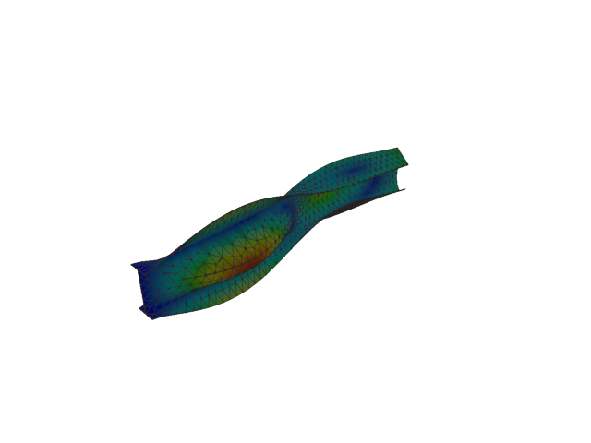
Figure 106: Sesam — mode 7, 142.768 Hz
Solver | f [Hz] | Δf vs mean [%] | λ [rad²/s²] | Meff X [kg] | Meff Y [kg] | Meff Z [kg] | Γ X | Γ Y | Γ Z
Abaqus | 142.770 | 5.60e-04 | 804737 | 9.41e-15 | 3.54 | 1.08e-09 | -9.70e-08 | 1.880 | 3.28e-05
Sesam | 142.768 | -5.60e-04 | 804681 | 3.82e-26 | 3.42 | 8.44e-24 | -1.95e-13 | -1.850 | 2.90e-12

Mode 8
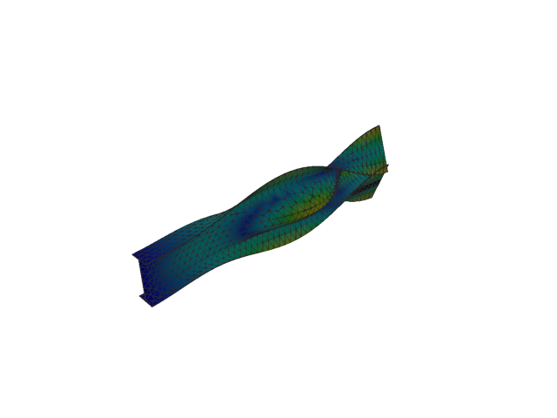
Figure 107: Abaqus — mode 8, 166.598 Hz
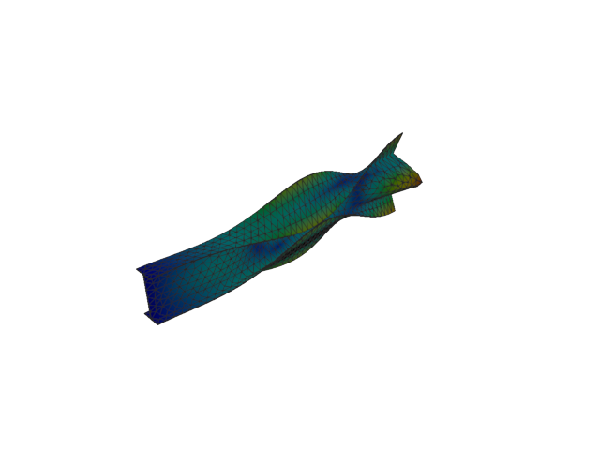
Figure 108: Sesam — mode 8, 166.334 Hz
Solver | f [Hz] | Δf vs mean [%] | λ [rad²/s²] | Meff X [kg] | Meff Y [kg] | Meff Z [kg] | Γ X | Γ Y | Γ Z
Abaqus | 166.600 | +0.08 | 1.09572e+06 | 1.06e-14 | 5.52 | 1.13e-08 | -1.03e-07 | 2.349 | 1.06e-04
Sesam | 166.334 | -0.08 | 1.09224e+06 | 4.59e-26 | 5.56 | 5.51e-24 | 2.14e-13 | -2.358 | -2.35e-12

Mode 9
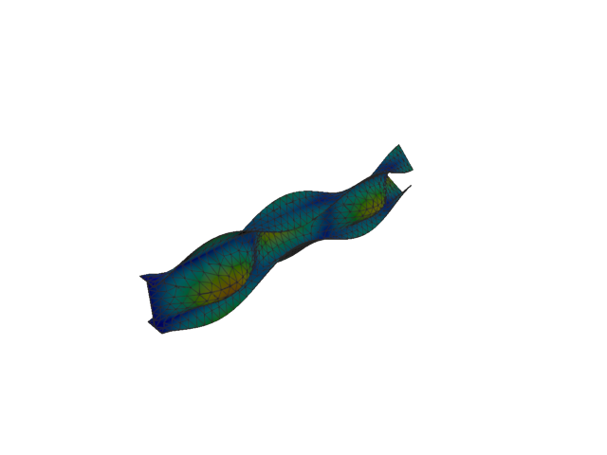
Figure 109: Abaqus — mode 9, 192.840 Hz
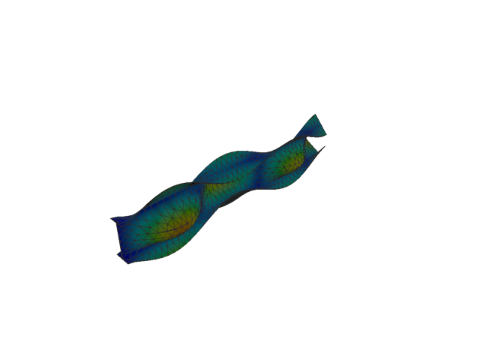
Figure 110: Sesam — mode 9, 193.308 Hz
Solver | f [Hz] | Δf vs mean [%] | λ [rad²/s²] | Meff X [kg] | Meff Y [kg] | Meff Z [kg] | Γ X | Γ Y | Γ Z
Abaqus | 192.840 | -0.12 | 1.4681e+06 | 5.91e-14 | 0.67 | 5.79e-09 | 2.43e-07 | -0.818 | -7.61e-05
Sesam | 193.308 | +0.12 | 1.47524e+06 | 3.41e-27 | 0.64 | 9.39e-26 | 5.84e-14 | -0.801 | 3.06e-13

Mode 10
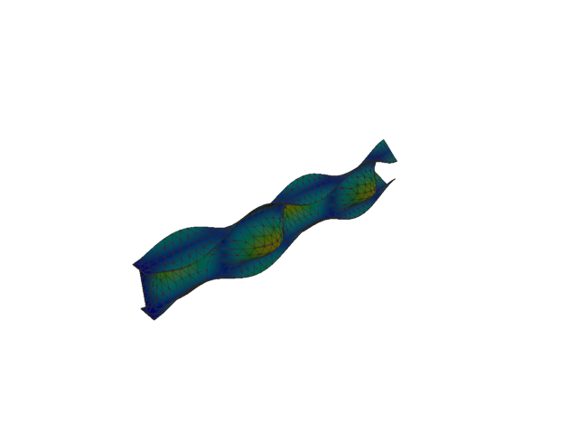
Figure 111: Abaqus — mode 10, 233.355 Hz
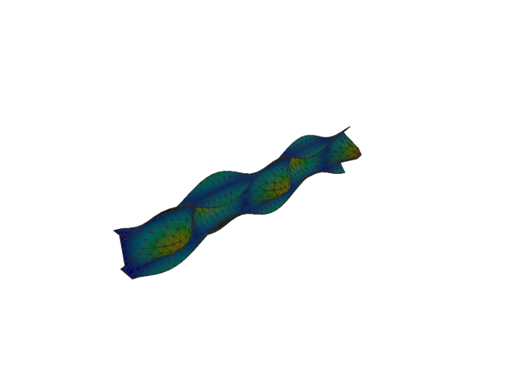
Figure 112: Sesam — mode 10, 234.613 Hz
Solver | f [Hz] | Δf vs mean [%] | λ [rad²/s²] | Meff X [kg] | Meff Y [kg] | Meff Z [kg] | Γ X | Γ Y | Γ Z
Abaqus | 233.360 | -0.27 | 2.14979e+06 | 3.28e-15 | 1.38 | 3.26e-07 | -5.73e-08 | 1.175 | 0.001
Sesam | 234.613 | +0.27 | 2.17302e+06 | 1.23e-18 | 1.40 | 2.13e-20 | -1.11e-09 | -1.185 | -1.46e-10

Mode 11
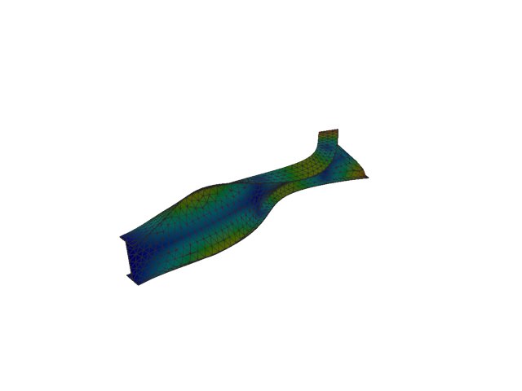
Figure 113: Abaqus — mode 11, 250.125 Hz
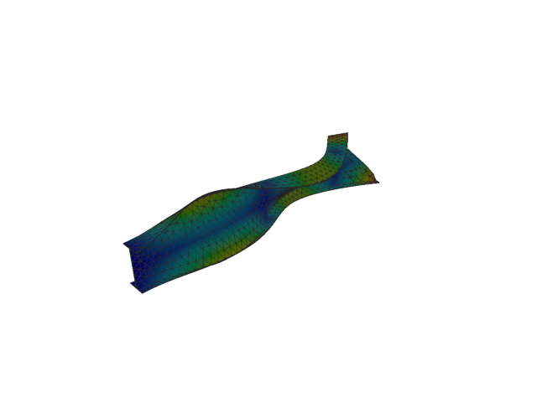
Figure 114: Sesam — mode 11, 250.240 Hz
Solver | f [Hz] | Δf vs mean [%] | λ [rad²/s²] | Meff X [kg] | Meff Y [kg] | Meff Z [kg] | Γ X | Γ Y | Γ Z
Abaqus | 250.130 | -0.02 | 2.46987e+06 | 9.03e-11 | 3.18e-08 | 4.03e-09 | 9.50e-06 | 1.78e-04 | 6.35e-05
Sesam | 250.240 | +0.02 | 2.47215e+06 | 1.60e-13 | 1.65e-06 | 2.77e-15 | -4.01e-07 | 0.001 | -5.26e-08

Shell, 2nd order, QUAD

Mode 1
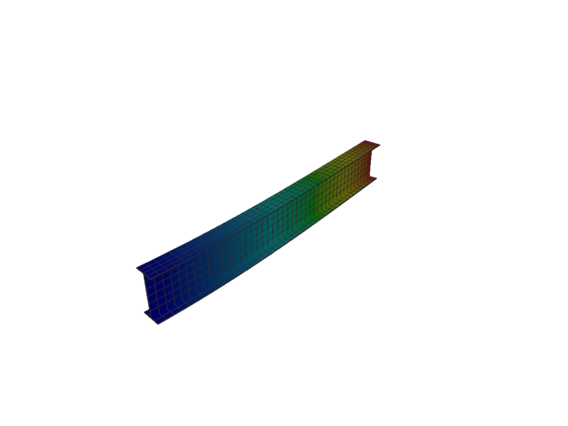
Figure 115: Abaqus — mode 1, 12.758 Hz
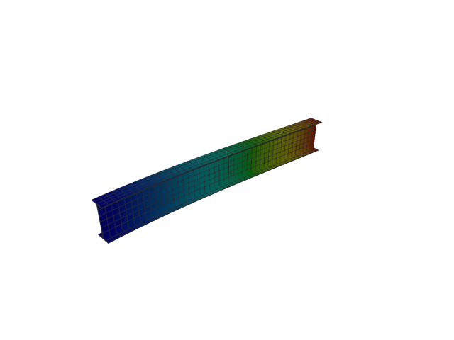
Figure 116: Sesam — mode 1, 12.755 Hz
Solver | f [Hz] | Δf vs mean [%] | λ [rad²/s²] | Meff X [kg] | Meff Y [kg] | Meff Z [kg] | Γ X | Γ Y | Γ Z
Abaqus | 12.758 | +0.01 | 6426.1 | 1.23e-25 | 119.92 | 9.18e-25 | 3.51e-13 | 10.951 | 9.58e-13
Sesam | 12.755 | -0.01 | 6423.15 | 3.36e-26 | 119.94 | 2.47e-24 | -1.83e-13 | -10.952 | -1.57e-12

Mode 2
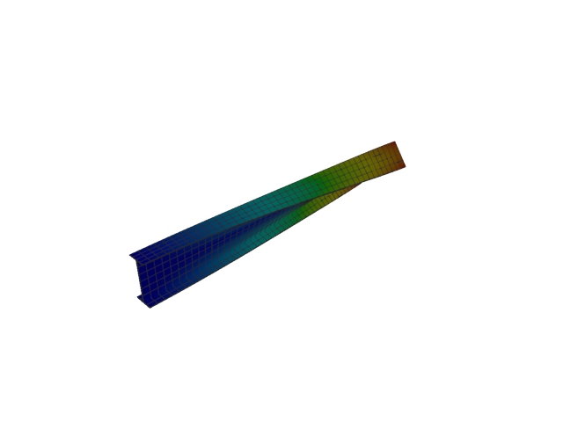
Figure 117: Abaqus — mode 2, 19.486 Hz
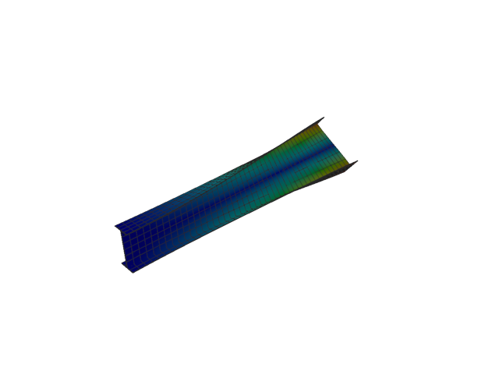
Figure 118: Sesam — mode 2, 19.473 Hz
Solver | f [Hz] | Δf vs mean [%] | λ [rad²/s²] | Meff X [kg] | Meff Y [kg] | Meff Z [kg] | Γ X | Γ Y | Γ Z
Abaqus | 19.486 | +0.03 | 14990 | 1.04e-26 | 4.65e-20 | 2.40e-23 | 1.02e-13 | 2.16e-10 | 4.90e-12
Sesam | 19.473 | -0.03 | 14970.3 | 4.30e-26 | 1.24e-18 | 1.37e-23 | -2.07e-13 | 1.11e-09 | 3.71e-12

Mode 3
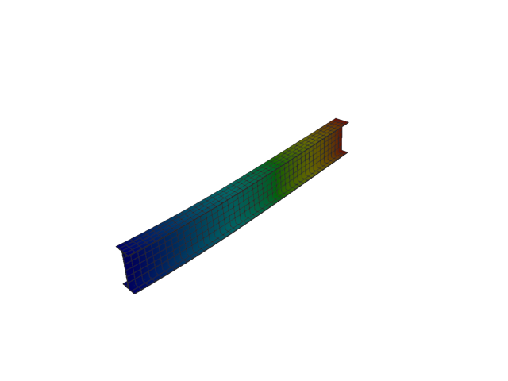
Figure 119: Abaqus — mode 3, 51.998 Hz
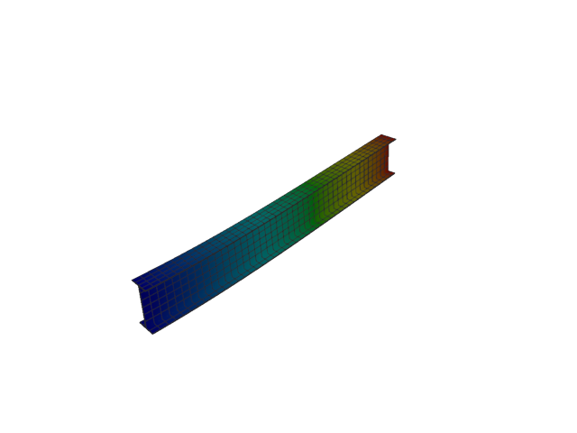
Figure 120: Sesam — mode 3, 51.970 Hz
Solver | f [Hz] | Δf vs mean [%] | λ [rad²/s²] | Meff X [kg] | Meff Y [kg] | Meff Z [kg] | Γ X | Γ Y | Γ Z
Abaqus | 51.998 | +0.03 | 106740 | 5.15e-27 | 9.66e-26 | 121.97 | 7.18e-14 | 3.11e-13 | 11.044
Sesam | 51.970 | -0.03 | 106628 | 6.42e-26 | 7.11e-25 | 122.03 | -2.53e-13 | -8.43e-13 | 11.047

Mode 4
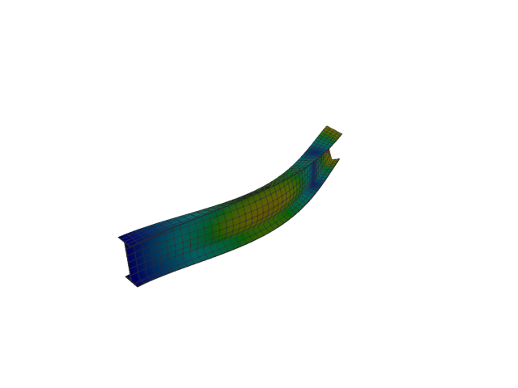
Figure 121: Abaqus — mode 4, 75.149 Hz
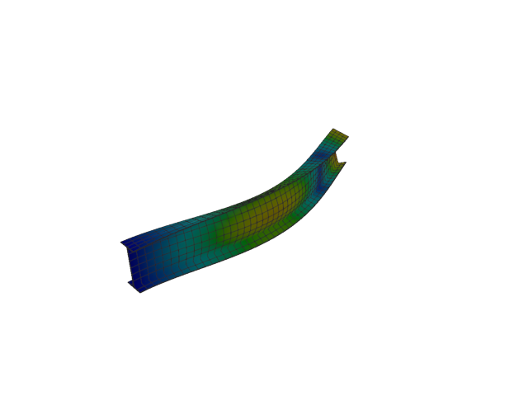
Figure 122: Sesam — mode 4, 75.125 Hz
Solver | f [Hz] | Δf vs mean [%] | λ [rad²/s²] | Meff X [kg] | Meff Y [kg] | Meff Z [kg] | Γ X | Γ Y | Γ Z
Abaqus | 75.149 | +0.02 | 222949 | 1.40e-27 | 36.85 | 6.29e-24 | -3.75e-14 | -6.071 | 2.51e-12
Sesam | 75.125 | -0.02 | 222804 | 2.91e-28 | 36.86 | 2.56e-24 | -1.70e-14 | -6.071 | 1.60e-12

Mode 5
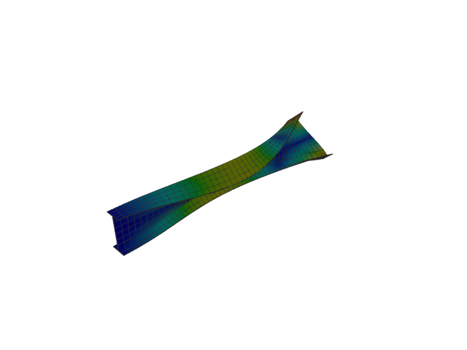
Figure 123: Abaqus — mode 5, 95.920 Hz
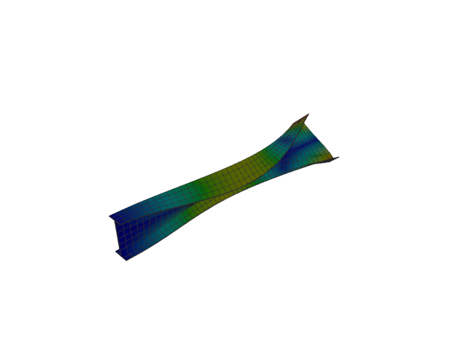
Figure 124: Sesam — mode 5, 95.889 Hz
Solver | f [Hz] | Δf vs mean [%] | λ [rad²/s²] | Meff X [kg] | Meff Y [kg] | Meff Z [kg] | Γ X | Γ Y | Γ Z
Abaqus | 95.920 | +0.02 | 363224 | 7.50e-27 | 2.54e-21 | 8.04e-25 | -8.66e-14 | -5.04e-11 | -8.97e-13
Sesam | 95.889 | -0.02 | 362989 | 1.39e-26 | 1.97e-21 | 1.90e-24 | 1.18e-13 | 4.44e-11 | -1.38e-12

Mode 6
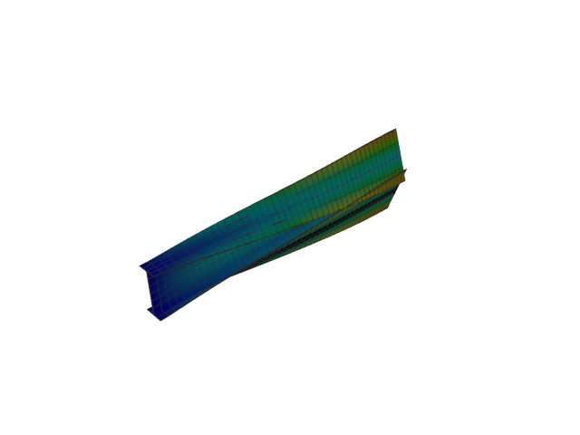
Figure 125: Abaqus — mode 6, 125.001 Hz
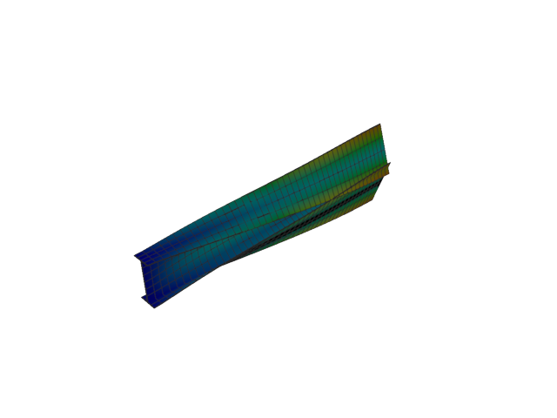
Figure 126: Sesam — mode 6, 124.987 Hz
Solver | f [Hz] | Δf vs mean [%] | λ [rad²/s²] | Meff X [kg] | Meff Y [kg] | Meff Z [kg] | Γ X | Γ Y | Γ Z
Abaqus | 125.000 | +0.01 | 616856 | 5.44e-26 | 0.02 | 4.78e-23 | -2.33e-13 | -0.137 | 6.92e-12
Sesam | 124.987 | -0.01 | 616722 | 1.29e-26 | 0.02 | 6.86e-24 | -1.13e-13 | -0.137 | 2.62e-12

Mode 7
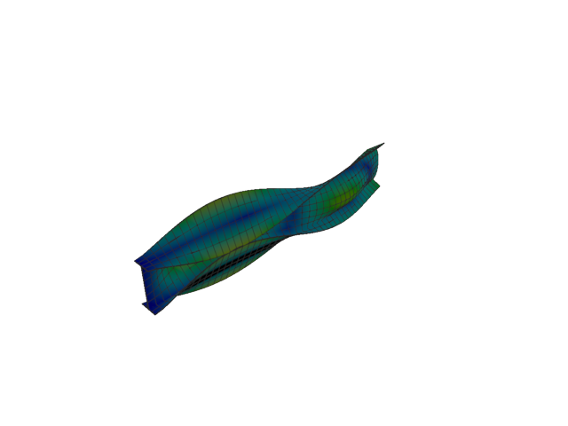
Figure 127: Abaqus — mode 7, 142.325 Hz
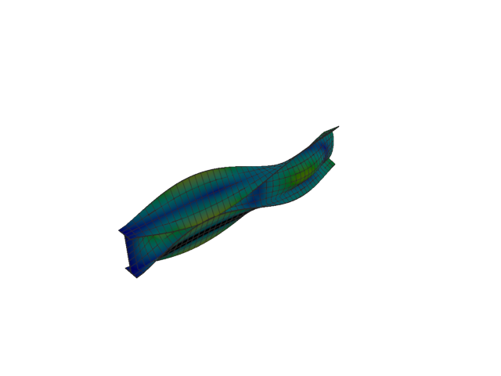
Figure 128: Sesam — mode 7, 142.234 Hz
Solver | f [Hz] | Δf vs mean [%] | λ [rad²/s²] | Meff X [kg] | Meff Y [kg] | Meff Z [kg] | Γ X | Γ Y | Γ Z
Abaqus | 142.320 | +0.03 | 799690 | 2.49e-27 | 3.45 | 4.42e-24 | -4.99e-14 | 1.858 | -2.10e-12
Sesam | 142.234 | -0.03 | 798665 | 6.03e-28 | 3.45 | 4.89e-25 | 2.46e-14 | 1.859 | -6.99e-13

Mode 8
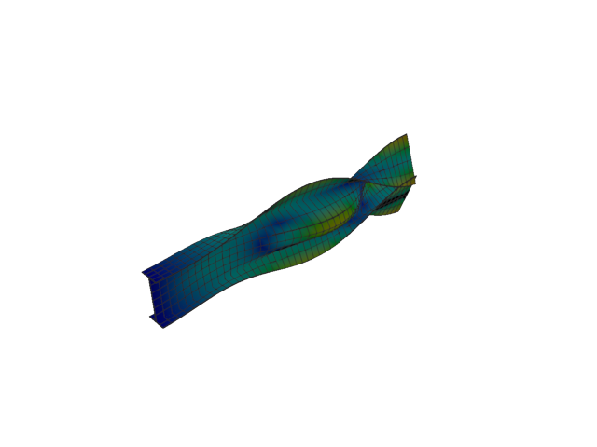
Figure 129: Abaqus — mode 8, 165.849 Hz
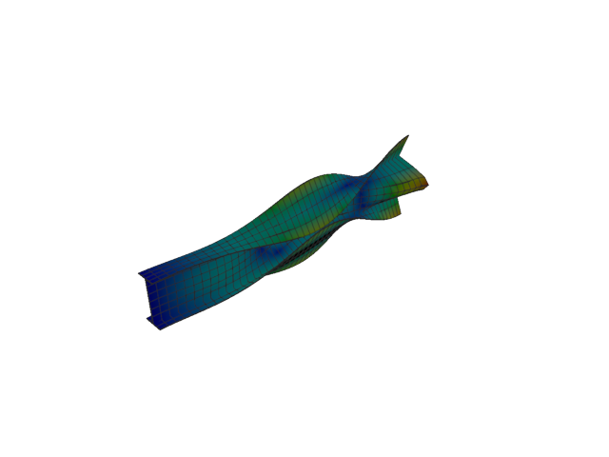
Figure 130: Sesam — mode 8, 165.718 Hz
Solver | f [Hz] | Δf vs mean [%] | λ [rad²/s²] | Meff X [kg] | Meff Y [kg] | Meff Z [kg] | Γ X | Γ Y | Γ Z
Abaqus | 165.850 | +0.04 | 1.08589e+06 | 2.43e-27 | 5.53 | 1.06e-23 | -4.93e-14 | 2.351 | 3.25e-12
Sesam | 165.718 | -0.04 | 1.08418e+06 | 4.51e-28 | 5.52 | 2.31e-24 | -2.12e-14 | -2.350 | -1.52e-12

Mode 9
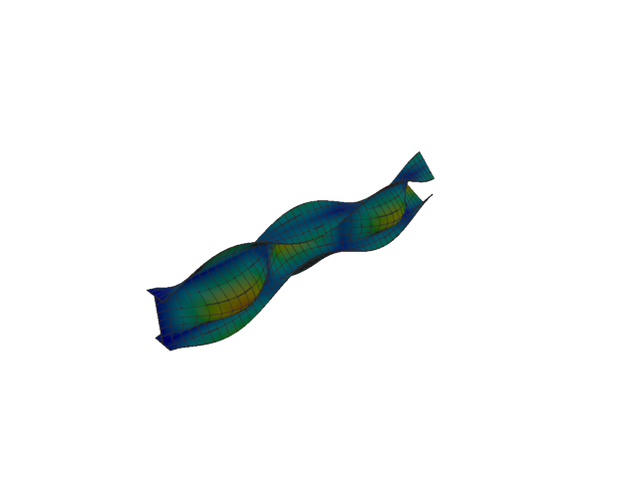
Figure 131: Abaqus — mode 9, 192.184 Hz
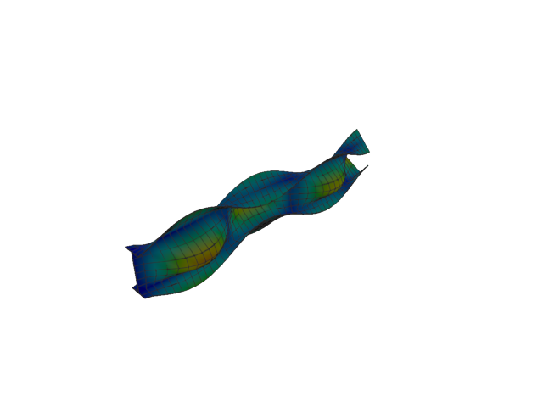
Figure 132: Sesam — mode 9, 191.999 Hz
Solver | f [Hz] | Δf vs mean [%] | λ [rad²/s²] | Meff X [kg] | Meff Y [kg] | Meff Z [kg] | Γ X | Γ Y | Γ Z
Abaqus | 192.180 | +0.05 | 1.45812e+06 | 1.15e-27 | 0.65 | 1.20e-25 | -3.40e-14 | -0.808 | 3.47e-13
Sesam | 191.999 | -0.05 | 1.45531e+06 | 3.95e-28 | 0.65 | 4.22e-27 | 1.99e-14 | -0.809 | 6.50e-14

Mode 10
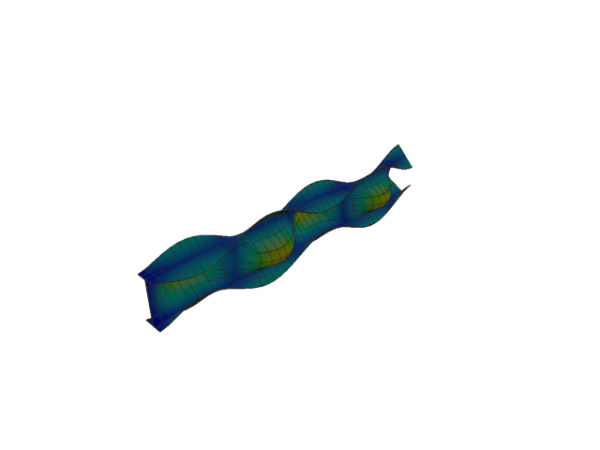
Figure 133: Abaqus — mode 10, 232.867 Hz
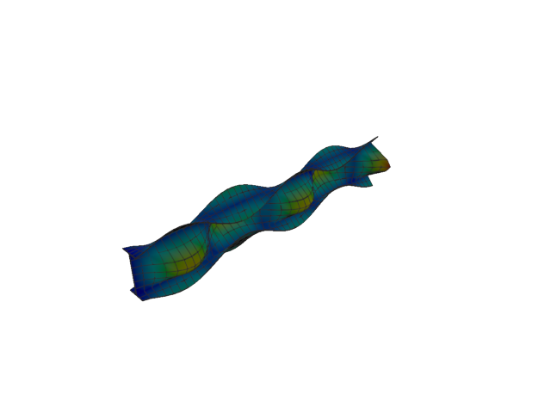
Figure 134: Sesam — mode 10, 232.626 Hz
Solver | f [Hz] | Δf vs mean [%] | λ [rad²/s²] | Meff X [kg] | Meff Y [kg] | Meff Z [kg] | Γ X | Γ Y | Γ Z
Abaqus | 232.870 | +0.05 | 2.14079e+06 | 4.88e-26 | 1.37 | 1.33e-23 | -2.21e-13 | 1.170 | -3.65e-12
Sesam | 232.626 | -0.05 | 2.13637e+06 | 1.30e-26 | 1.37 | 2.70e-25 | -1.14e-13 | -1.171 | -5.20e-13

Mode 11
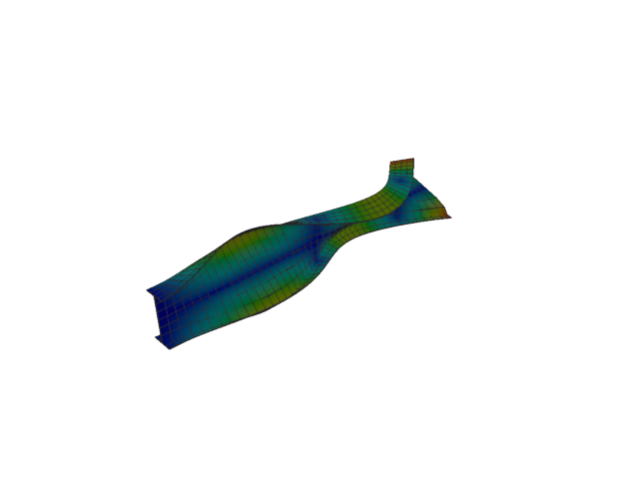
Figure 135: Abaqus — mode 11, 250.173 Hz
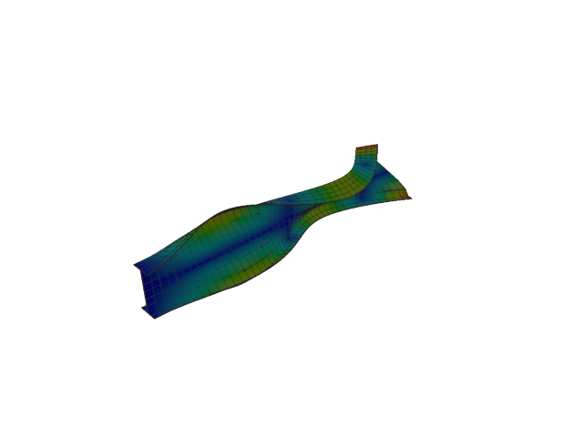
Figure 136: Sesam — mode 11, 250.095 Hz
Solver | f [Hz] | Δf vs mean [%] | λ [rad²/s²] | Meff X [kg] | Meff Y [kg] | Meff Z [kg] | Γ X | Γ Y | Γ Z
Abaqus | 250.170 | +0.01 | 2.47082e+06 | 3.28e-21 | 3.98e-19 | 6.25e-19 | 5.72e-11 | 6.31e-10 | -7.90e-10
Sesam | 250.095 | -0.01 | 2.46928e+06 | 1.10e-19 | 3.85e-22 | 2.18e-21 | -3.32e-10 | -1.96e-11 | 4.67e-11

Shell, 2nd order, QUAD, reduced integration

Mode 1
Figure 137: Abaqus — mode 1, 12.758 Hz
Solver | f [Hz] | λ [rad²/s²] | Meff X [kg] | Meff Y [kg] | Meff Z [kg] | Γ X | Γ Y | Γ Z
Abaqus | 12.758 | 6426.1 | 1.23e-25 | 119.92 | 9.18e-25 | 3.51e-13 | 10.951 | 9.58e-13

Mode 2
Figure 138: Abaqus — mode 2, 19.486 Hz
Solver | f [Hz] | λ [rad²/s²] | Meff X [kg] | Meff Y [kg] | Meff Z [kg] | Γ X | Γ Y | Γ Z
Abaqus | 19.486 | 14990 | 1.04e-26 | 4.65e-20 | 2.40e-23 | 1.02e-13 | 2.16e-10 | 4.90e-12

Mode 3
Figure 139: Abaqus — mode 3, 51.998 Hz
Solver | f [Hz] | λ [rad²/s²] | Meff X [kg] | Meff Y [kg] | Meff Z [kg] | Γ X | Γ Y | Γ Z
Abaqus | 51.998 | 106740 | 5.15e-27 | 9.66e-26 | 121.97 | 7.18e-14 | 3.11e-13 | 11.044

Mode 4
Figure 140: Abaqus — mode 4, 75.149 Hz
Solver | f [Hz] | λ [rad²/s²] | Meff X [kg] | Meff Y [kg] | Meff Z [kg] | Γ X | Γ Y | Γ Z
Abaqus | 75.149 | 222949 | 1.40e-27 | 36.85 | 6.29e-24 | -3.75e-14 | -6.071 | 2.51e-12

Mode 5
Figure 141: Abaqus — mode 5, 95.920 Hz
Solver | f [Hz] | λ [rad²/s²] | Meff X [kg] | Meff Y [kg] | Meff Z [kg] | Γ X | Γ Y | Γ Z
Abaqus | 95.920 | 363224 | 7.50e-27 | 2.54e-21 | 8.04e-25 | -8.66e-14 | -5.04e-11 | -8.97e-13

Mode 6
Figure 142: Abaqus — mode 6, 125.001 Hz
Solver | f [Hz] | λ [rad²/s²] | Meff X [kg] | Meff Y [kg] | Meff Z [kg] | Γ X | Γ Y | Γ Z
Abaqus | 125.000 | 616856 | 5.44e-26 | 0.02 | 4.78e-23 | -2.33e-13 | -0.137 | 6.92e-12

Mode 7
Figure 143: Abaqus — mode 7, 142.325 Hz
Solver | f [Hz] | λ [rad²/s²] | Meff X [kg] | Meff Y [kg] | Meff Z [kg] | Γ X | Γ Y | Γ Z
Abaqus | 142.320 | 799690 | 2.49e-27 | 3.45 | 4.42e-24 | -4.99e-14 | 1.858 | -2.10e-12

Mode 8
Figure 144: Abaqus — mode 8, 165.849 Hz
Solver | f [Hz] | λ [rad²/s²] | Meff X [kg] | Meff Y [kg] | Meff Z [kg] | Γ X | Γ Y | Γ Z
Abaqus | 165.850 | 1.08589e+06 | 2.43e-27 | 5.53 | 1.06e-23 | -4.93e-14 | 2.351 | 3.25e-12

Mode 9
Figure 145: Abaqus — mode 9, 192.184 Hz
Solver | f [Hz] | λ [rad²/s²] | Meff X [kg] | Meff Y [kg] | Meff Z [kg] | Γ X | Γ Y | Γ Z
Abaqus | 192.180 | 1.45812e+06 | 1.15e-27 | 0.65 | 1.20e-25 | -3.40e-14 | -0.808 | 3.47e-13

Mode 10
Figure 146: Abaqus — mode 10, 232.867 Hz
Solver | f [Hz] | λ [rad²/s²] | Meff X [kg] | Meff Y [kg] | Meff Z [kg] | Γ X | Γ Y | Γ Z
Abaqus | 232.870 | 2.14079e+06 | 4.88e-26 | 1.37 | 1.33e-23 | -2.21e-13 | 1.170 | -3.65e-12

Mode 11
Figure 147: Abaqus — mode 11, 250.173 Hz
Solver | f [Hz] | λ [rad²/s²] | Meff X [kg] | Meff Y [kg] | Meff Z [kg] | Γ X | Γ Y | Γ Z
Abaqus | 250.170 | 2.47082e+06 | 3.28e-21 | 3.98e-19 | 6.25e-19 | 5.72e-11 | 6.31e-10 | -7.90e-10

Solid, 1st order, TET

Mode 1
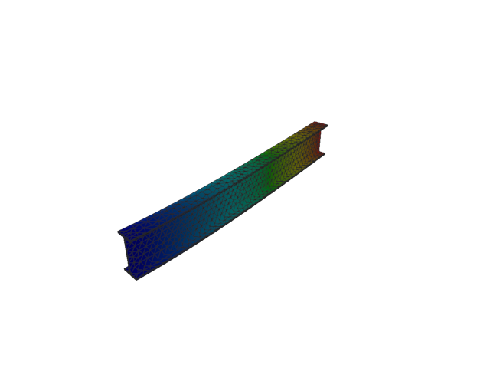
Figure 148: Abaqus — mode 1, 15.790 Hz
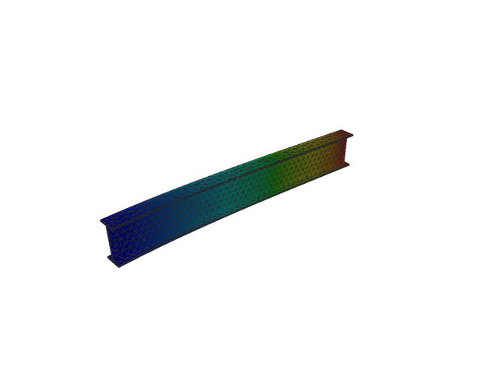
Figure 149: Sesam — mode 1, 15.793 Hz
Solver | f [Hz] | Δf vs mean [%] | λ [rad²/s²] | Meff X [kg] | Meff Y [kg] | Meff Z [kg] | Γ X | Γ Y | Γ Z
Abaqus | 15.790 | -0.01 | 9842.9 | 2.50e-14 | 117.47 | 2.82e-04 | 1.58e-07 | 10.838 | -0.017
Sesam | 15.793 | +0.01 | 9846.92 | 5.82e-13 | 117.52 | 2.82e-04 | 7.63e-07 | -10.841 | 0.017

Mode 2
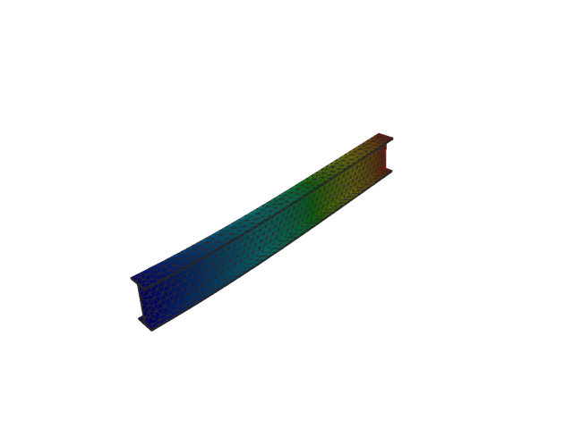
Figure 150: Abaqus — mode 2, 51.532 Hz
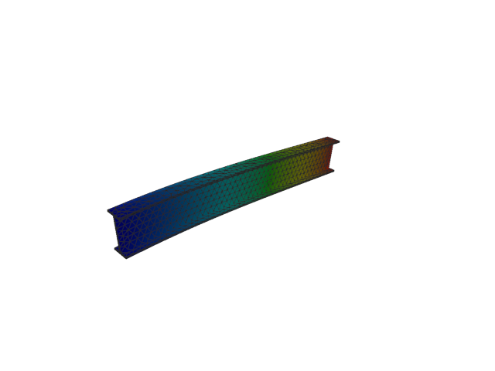
Figure 151: Sesam — mode 2, 51.542 Hz
Solver | f [Hz] | Δf vs mean [%] | λ [rad²/s²] | Meff X [kg] | Meff Y [kg] | Meff Z [kg] | Γ X | Γ Y | Γ Z
Abaqus | 51.532 | -0.01 | 104836 | 1.44e-08 | 7.90e-04 | 118.25 | 1.20e-04 | 0.028 | 10.874
Sesam | 51.542 | +0.01 | 104877 | 1.53e-08 | 7.86e-04 | 118.29 | -1.24e-04 | -0.028 | -10.876

Mode 3
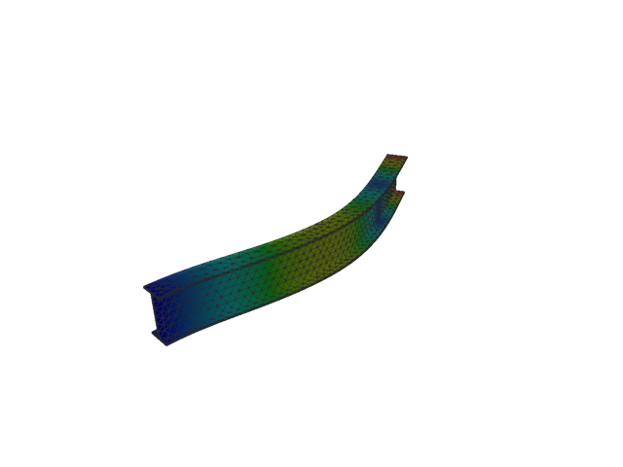
Figure 152: Abaqus — mode 3, 97.588 Hz
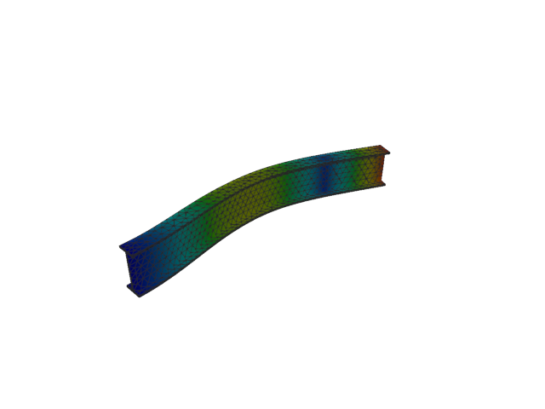
Figure 153: Sesam — mode 3, 97.731 Hz
Solver | f [Hz] | Δf vs mean [%] | λ [rad²/s²] | Meff X [kg] | Meff Y [kg] | Meff Z [kg] | Γ X | Γ Y | Γ Z
Abaqus | 97.588 | -0.07 | 375967 | 4.61e-08 | 34.91 | 3.71e-04 | -2.15e-04 | -5.909 | 0.019
Sesam | 97.731 | +0.07 | 377075 | 4.30e-08 | 34.94 | 3.65e-04 | 2.07e-04 | 5.911 | -0.019

Mode 4
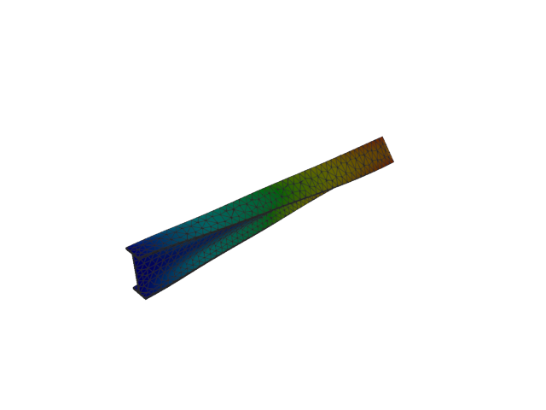
Figure 154: Abaqus — mode 4, 104.803 Hz
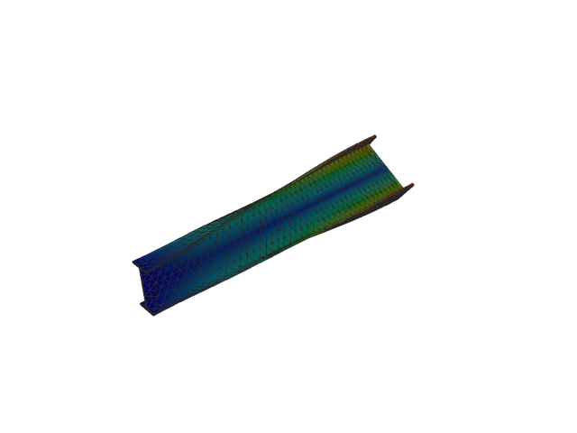
Figure 155: Sesam — mode 4, 105.691 Hz
Solver | f [Hz] | Δf vs mean [%] | λ [rad²/s²] | Meff X [kg] | Meff Y [kg] | Meff Z [kg] | Γ X | Γ Y | Γ Z
Abaqus | 104.800 | -0.42 | 433617 | 6.83e-06 | 0.01 | 1.07e-05 | 0.003 | -0.075 | 0.003
Sesam | 105.691 | +0.42 | 440993 | 6.99e-06 | 4.82e-03 | 1.08e-05 | -0.003 | 0.069 | -0.003

Mode 5
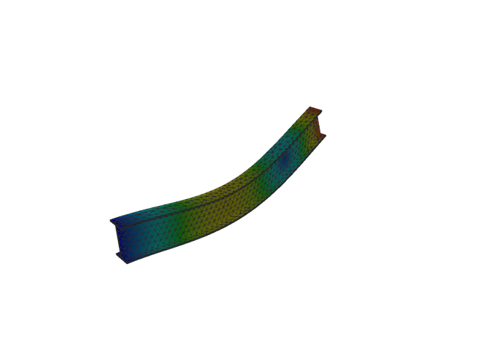
Figure 156: Abaqus — mode 5, 260.590 Hz
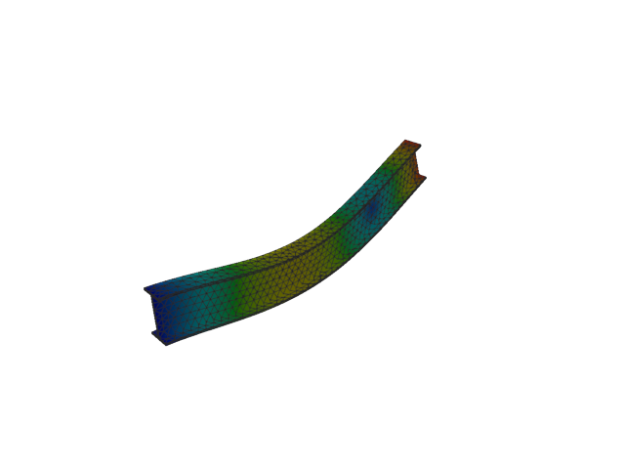
Figure 157: Sesam — mode 5, 260.887 Hz
Solver | f [Hz] | Δf vs mean [%] | λ [rad²/s²] | Meff X [kg] | Meff Y [kg] | Meff Z [kg] | Γ X | Γ Y | Γ Z
Abaqus | 260.590 | -0.06 | 2.68086e+06 | 3.30e-07 | 0.02 | 39.75 | -0.001 | 0.132 | -6.305
Sesam | 260.887 | +0.06 | 2.68699e+06 | 3.61e-07 | 0.01 | 39.76 | -0.001 | 0.122 | -6.305

Mode 6
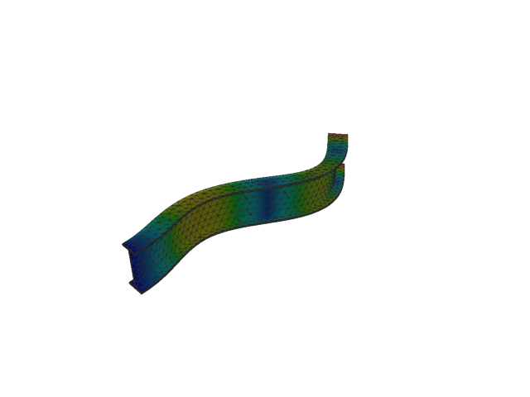
Figure 158: Abaqus — mode 6, 266.263 Hz
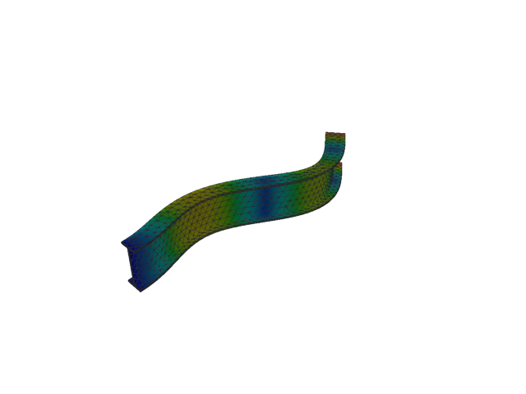
Figure 159: Sesam — mode 6, 267.131 Hz
Solver | f [Hz] | Δf vs mean [%] | λ [rad²/s²] | Meff X [kg] | Meff Y [kg] | Meff Z [kg] | Γ X | Γ Y | Γ Z
Abaqus | 266.260 | -0.16 | 2.79886e+06 | 1.72e-08 | 13.24 | 0.05 | 1.31e-04 | 3.638 | 0.226
Sesam | 267.131 | +0.16 | 2.81714e+06 | 1.49e-08 | 13.26 | 0.04 | 1.22e-04 | 3.642 | 0.207

Mode 7
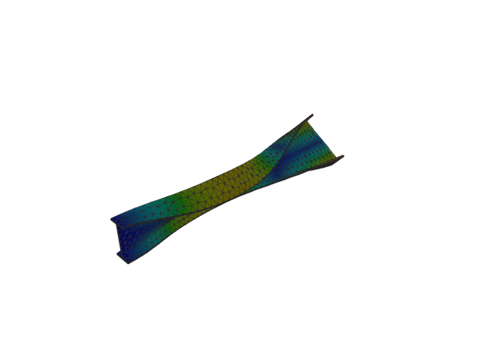
Figure 160: Abaqus — mode 7, 285.051 Hz
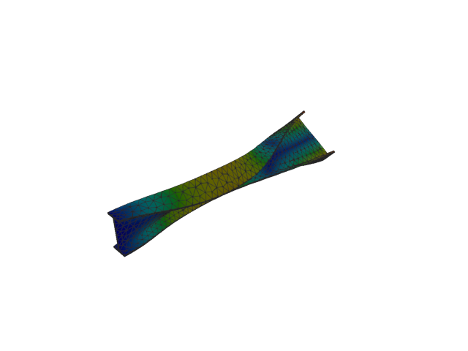
Figure 161: Sesam — mode 7, 287.461 Hz
Solver | f [Hz] | Δf vs mean [%] | λ [rad²/s²] | Meff X [kg] | Meff Y [kg] | Meff Z [kg] | Γ X | Γ Y | Γ Z
Abaqus | 285.050 | -0.42 | 3.20779e+06 | 1.44e-07 | 9.28e-04 | 1.25e-03 | 3.79e-04 | 0.030 | -0.035
Sesam | 287.461 | +0.42 | 3.26225e+06 | 1.26e-07 | 7.47e-04 | 1.07e-03 | 3.54e-04 | 0.027 | -0.033

Mode 8
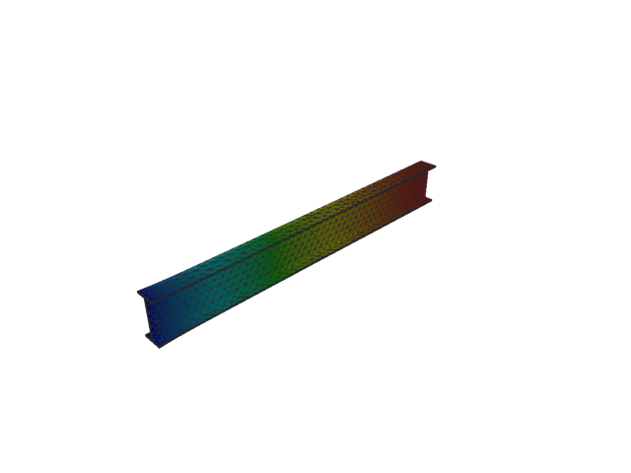
Figure 162: Abaqus — mode 8, 432.310 Hz
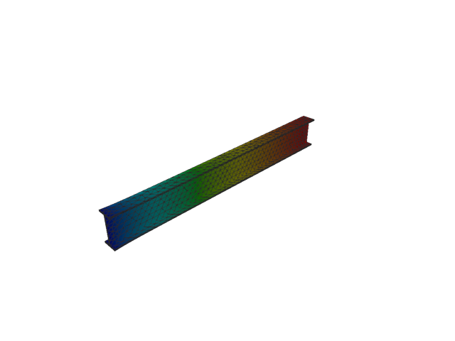
Figure 163: Sesam — mode 8, 432.347 Hz
Solver | f [Hz] | Δf vs mean [%] | λ [rad²/s²] | Meff X [kg] | Meff Y [kg] | Meff Z [kg] | Γ X | Γ Y | Γ Z
Abaqus | 432.310 | -4.31e-03 | 7.37819e+06 | 153.38 | 2.06e-06 | 3.31e-08 | 12.385 | -0.001 | 1.82e-04
Sesam | 432.347 | 4.31e-03 | 7.37947e+06 | 153.37 | 1.91e-06 | 2.88e-08 | 12.384 | -0.001 | 1.70e-04

Mode 9
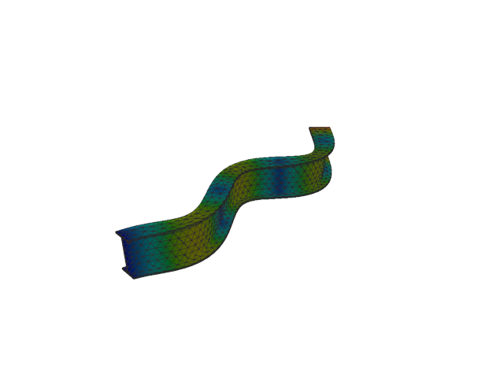
Figure 164: Abaqus — mode 9, 500.864 Hz
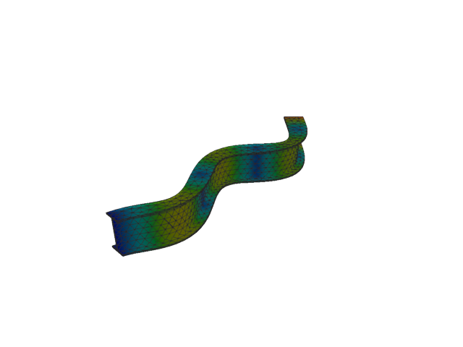
Figure 165: Sesam — mode 9, 503.862 Hz
Solver | f [Hz] | Δf vs mean [%] | λ [rad²/s²] | Meff X [kg] | Meff Y [kg] | Meff Z [kg] | Γ X | Γ Y | Γ Z
Abaqus | 500.860 | -0.30 | 9.90373e+06 | 3.39e-05 | 6.33 | 4.73e-05 | -0.006 | -2.515 | 0.007
Sesam | 503.862 | +0.30 | 1.00226e+07 | 3.01e-05 | 6.34 | 4.92e-05 | -0.005 | -2.518 | 0.007

Mode 10
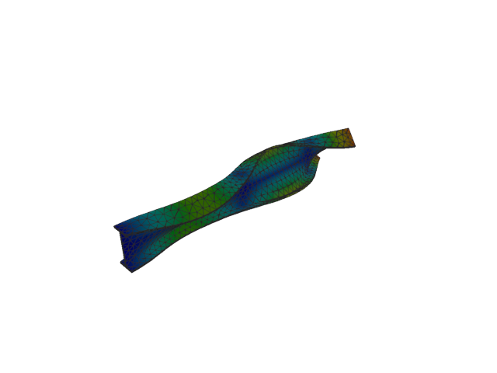
Figure 166: Abaqus — mode 10, 534.263 Hz
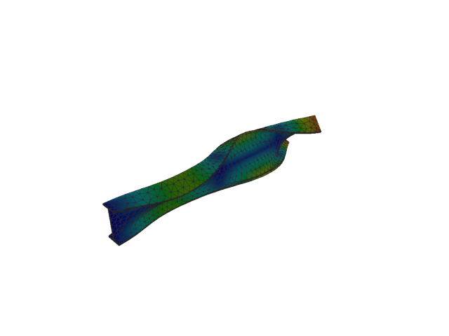
Figure 167: Sesam — mode 10, 539.506 Hz
Solver | f [Hz] | Δf vs mean [%] | λ [rad²/s²] | Meff X [kg] | Meff Y [kg] | Meff Z [kg] | Γ X | Γ Y | Γ Z
Abaqus | 534.260 | -0.49 | 1.12686e+07 | 2.60e-04 | 2.77e-04 | 6.63e-06 | -0.016 | -0.017 | 0.003
Sesam | 539.506 | +0.49 | 1.14909e+07 | 2.36e-04 | 2.31e-04 | 6.55e-06 | -0.015 | -0.015 | 0.003

Mode 11
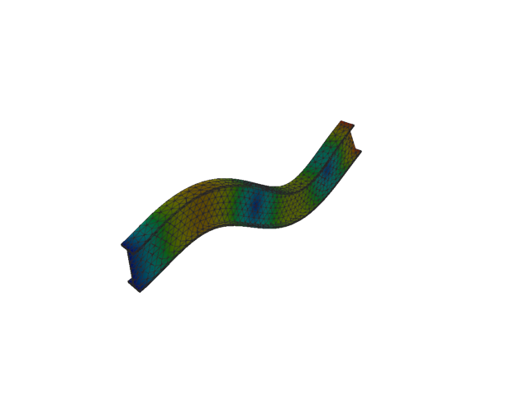
Figure 168: Abaqus — mode 11, 596.780 Hz
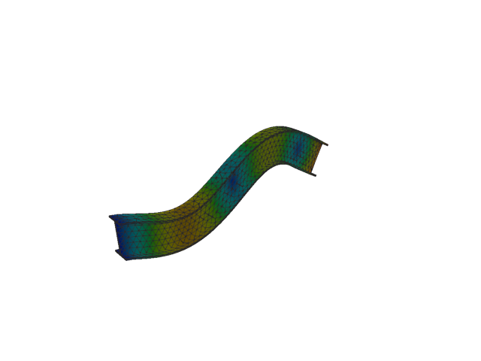
Figure 169: Sesam — mode 11, 598.200 Hz
Solver | f [Hz] | Δf vs mean [%] | λ [rad²/s²] | Meff X [kg] | Meff Y [kg] | Meff Z [kg] | Γ X | Γ Y | Γ Z
Abaqus | 596.780 | -0.12 | 1.40601e+07 | 4.55e-07 | 1.33e-07 | 12.80 | -0.001 | -3.65e-04 | 3.578
Sesam | 598.200 | +0.12 | 1.41271e+07 | 4.36e-07 | 3.62e-08 | 12.80 | 0.001 | 1.90e-04 | -3.578

Solid, 1st order, HEX

Mode 1
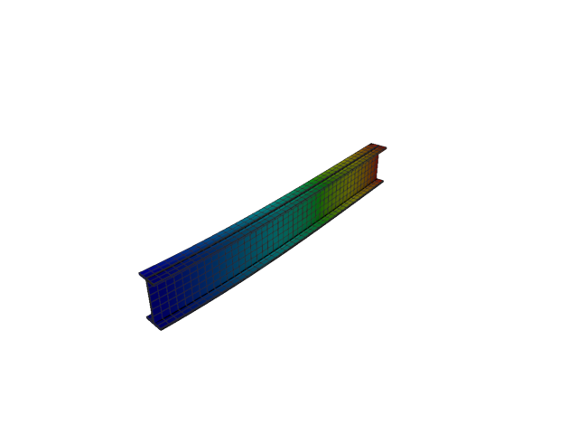
Figure 170: Abaqus — mode 1, 13.435 Hz
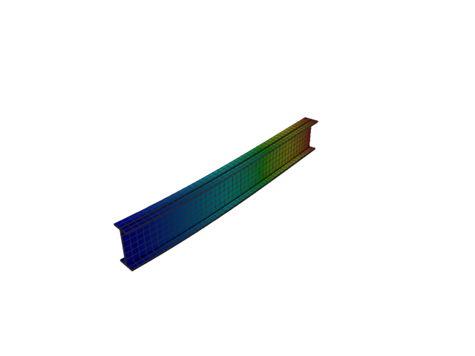
Figure 171: Sesam — mode 1, 12.977 Hz
Solver | f [Hz] | Δf vs mean [%] | λ [rad²/s²] | Meff X [kg] | Meff Y [kg] | Meff Z [kg] | Γ X | Γ Y | Γ Z
Abaqus | 13.435 | +1.74 | 7125.8 | 4.92e-29 | 116.39 | 5.47e-23 | -7.01e-15 | 10.788 | -7.39e-12
Sesam | 12.977 | -1.74 | 6647.9 | 8.06e-25 | 116.43 | 1.16e-20 | -8.98e-13 | 10.790 | 1.08e-10

Mode 2
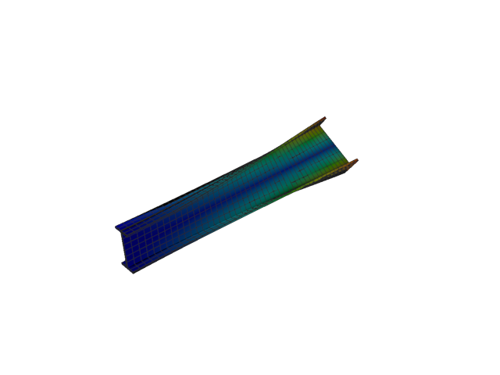
Figure 172: Abaqus — mode 2, 20.731 Hz
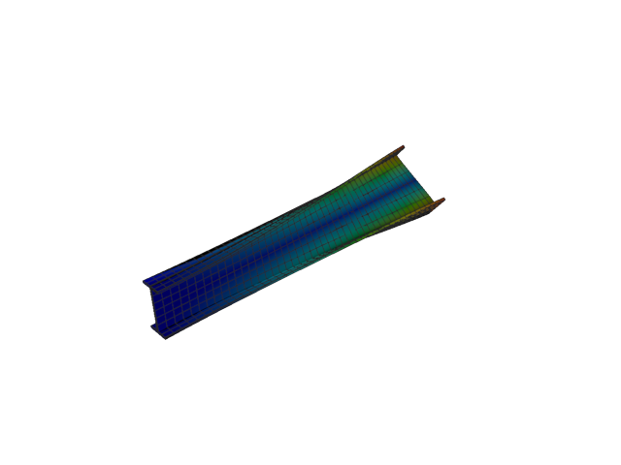
Figure 173: Sesam — mode 2, 20.302 Hz
Solver | f [Hz] | Δf vs mean [%] | λ [rad²/s²] | Meff X [kg] | Meff Y [kg] | Meff Z [kg] | Γ X | Γ Y | Γ Z
Abaqus | 20.731 | +1.05 | 16967 | 7.03e-26 | 1.48e-18 | 2.87e-22 | 2.65e-13 | 1.22e-09 | -1.69e-11
Sesam | 20.302 | -1.05 | 16271.1 | 2.93e-27 | 2.21e-19 | 3.64e-20 | -5.41e-14 | -4.70e-10 | 1.91e-10

Mode 3
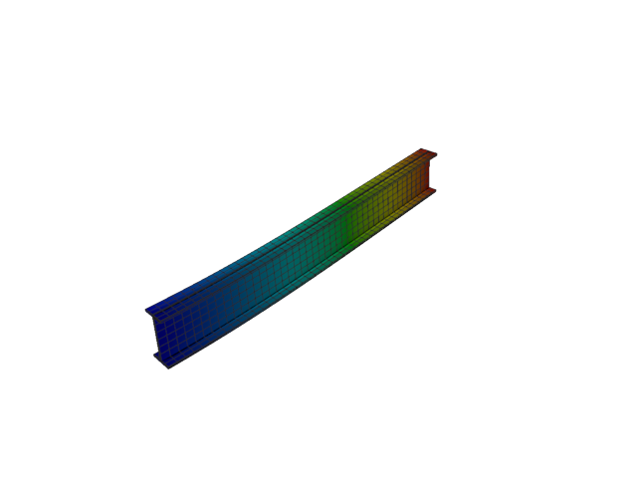
Figure 174: Abaqus — mode 3, 50.678 Hz
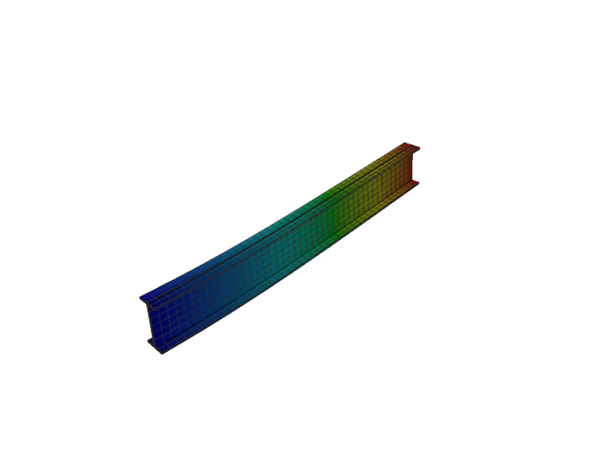
Figure 175: Sesam — mode 3, 50.618 Hz
Solver | f [Hz] | Δf vs mean [%] | λ [rad²/s²] | Meff X [kg] | Meff Y [kg] | Meff Z [kg] | Γ X | Γ Y | Γ Z
Abaqus | 50.678 | +0.06 | 101392 | 1.09e-25 | 2.57e-22 | 118.20 | -3.30e-13 | 1.60e-11 | 10.872
Sesam | 50.618 | -0.06 | 101151 | 1.08e-24 | 8.70e-21 | 118.29 | -1.04e-12 | -9.33e-11 | 10.876

Mode 4
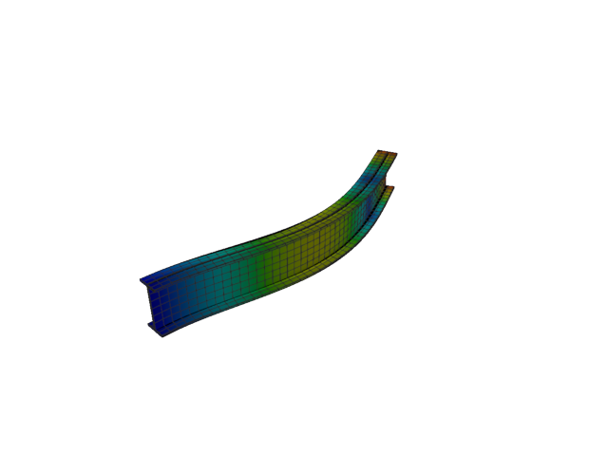
Figure 176: Abaqus — mode 4, 82.799 Hz
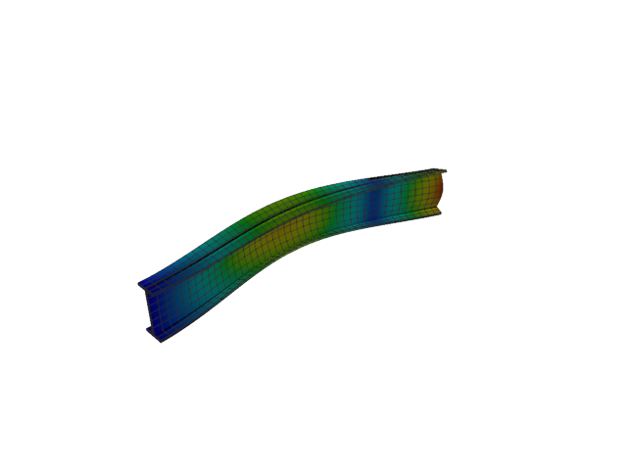
Figure 177: Sesam — mode 4, 77.392 Hz
Solver | f [Hz] | Δf vs mean [%] | λ [rad²/s²] | Meff X [kg] | Meff Y [kg] | Meff Z [kg] | Γ X | Γ Y | Γ Z
Abaqus | 82.799 | +3.38 | 270652 | 7.52e-26 | 36.02 | 2.70e-22 | -2.74e-13 | -6.002 | 1.64e-11
Sesam | 77.392 | -3.38 | 236458 | 6.94e-26 | 35.94 | 6.82e-22 | -2.63e-13 | 5.995 | -2.61e-11

Mode 5
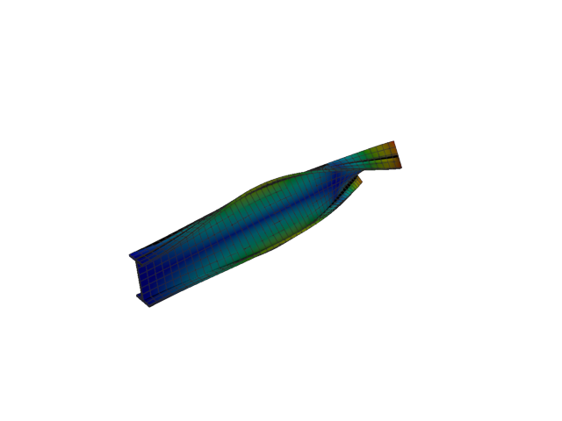
Figure 178: Abaqus — mode 5, 100.195 Hz
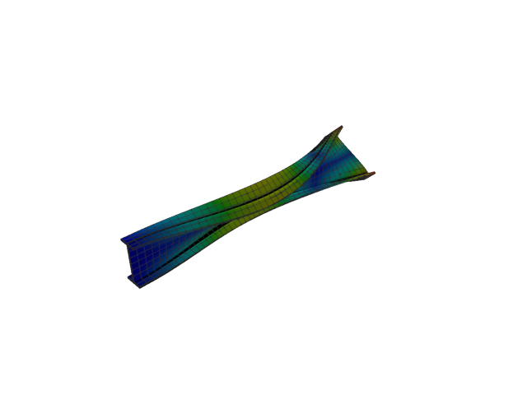
Figure 179: Sesam — mode 5, 98.119 Hz
Solver | f [Hz] | Δf vs mean [%] | λ [rad²/s²] | Meff X [kg] | Meff Y [kg] | Meff Z [kg] | Γ X | Γ Y | Γ Z
Abaqus | 100.190 | +1.04 | 396325 | 4.10e-26 | 6.87e-21 | 7.52e-23 | 2.03e-13 | -8.29e-11 | 8.67e-12
Sesam | 98.119 | -1.04 | 380068 | 1.62e-25 | 2.53e-21 | 7.29e-23 | 4.03e-13 | -5.03e-11 | -8.54e-12

Mode 6
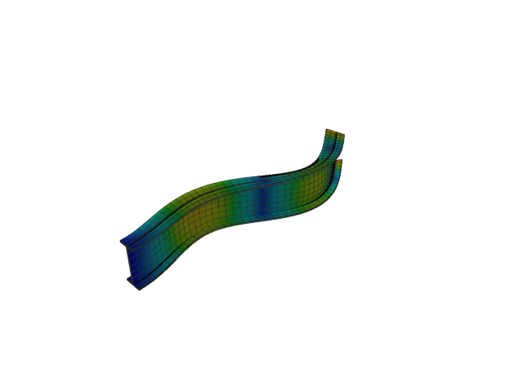
Figure 180: Abaqus — mode 6, 223.139 Hz
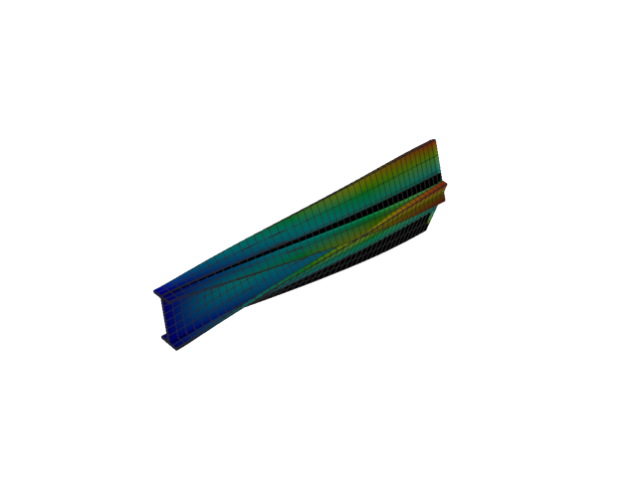
Figure 181: Sesam — mode 6, 133.016 Hz
Solver | f [Hz] | Δf vs mean [%] | λ [rad²/s²] | Meff X [kg] | Meff Y [kg] | Meff Z [kg] | Γ X | Γ Y | Γ Z
Abaqus | 223.140 | +25.30 | 1.96567e+06 | 2.33e-25 | 12.40 | 1.64e-23 | -4.83e-13 | 3.522 | 4.05e-12
Sesam | 133.016 | -25.30 | 698501 | 3.07e-26 | 0.01 | 1.44e-20 | -1.75e-13 | -0.114 | 1.20e-10

Mode 7
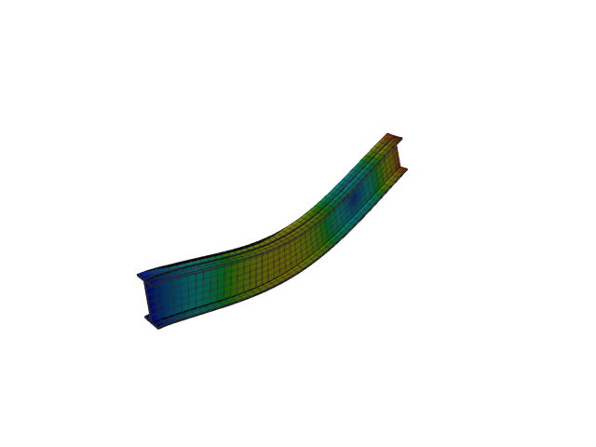
Figure 182: Abaqus — mode 7, 254.984 Hz
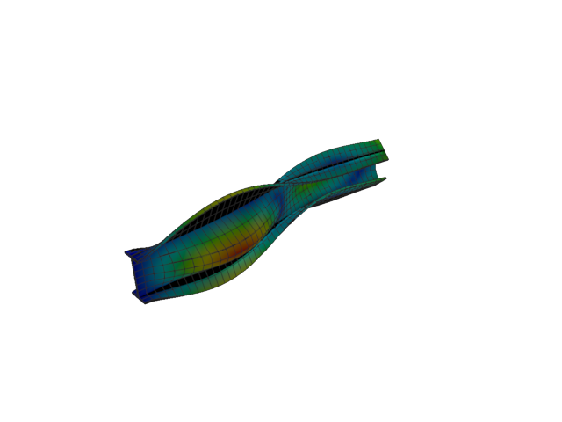
Figure 183: Sesam — mode 7, 153.833 Hz
Solver | f [Hz] | Δf vs mean [%] | λ [rad²/s²] | Meff X [kg] | Meff Y [kg] | Meff Z [kg] | Γ X | Γ Y | Γ Z
Abaqus | 254.980 | +24.74 | 2.56676e+06 | 2.24e-25 | 2.85e-24 | 40.01 | -4.74e-13 | 1.69e-12 | -6.326
Sesam | 153.833 | -24.74 | 934235 | 3.75e-25 | 3.20 | 1.37e-21 | -6.13e-13 | -1.788 | 3.70e-11

Mode 8
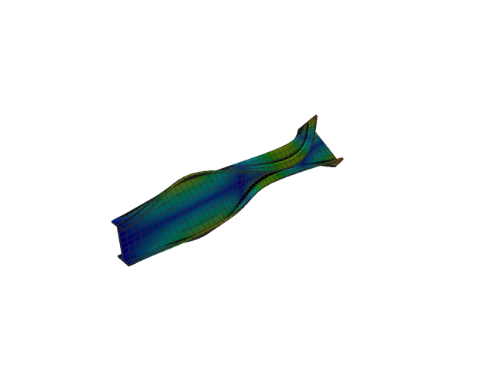
Figure 184: Abaqus — mode 8, 260.095 Hz
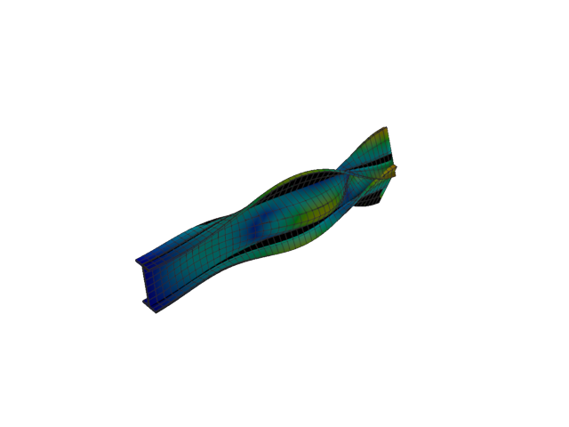
Figure 185: Sesam — mode 8, 178.565 Hz
Solver | f [Hz] | Δf vs mean [%] | λ [rad²/s²] | Meff X [kg] | Meff Y [kg] | Meff Z [kg] | Γ X | Γ Y | Γ Z
Abaqus | 260.100 | +18.59 | 2.6707e+06 | 2.66e-26 | 6.24e-23 | 3.82e-21 | -1.63e-13 | 7.90e-12 | 6.18e-11
Sesam | 178.565 | -18.59 | 1.25879e+06 | 3.19e-27 | 5.71 | 3.11e-21 | -5.65e-14 | 2.390 | 5.58e-11

Mode 9
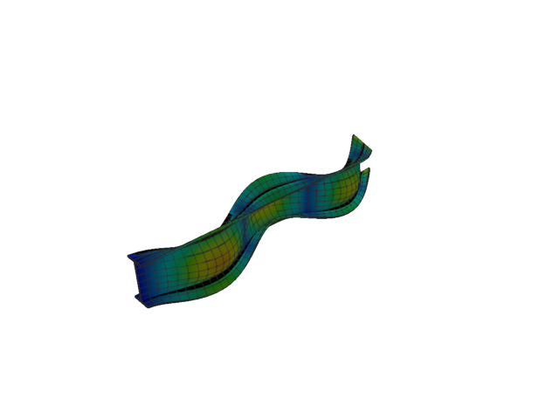
Figure 186: Abaqus — mode 9, 396.567 Hz
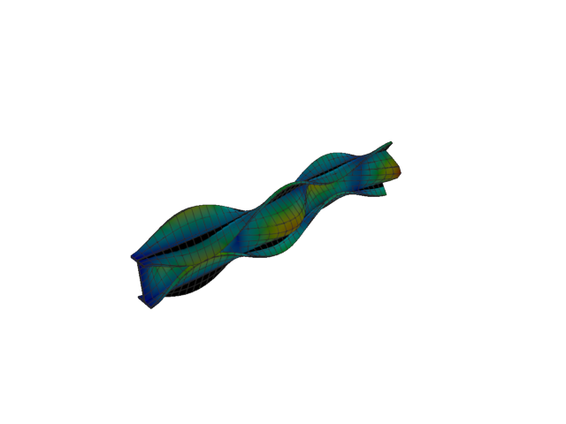
Figure 187: Sesam — mode 9, 214.689 Hz
Solver | f [Hz] | Δf vs mean [%] | λ [rad²/s²] | Meff X [kg] | Meff Y [kg] | Meff Z [kg] | Γ X | Γ Y | Γ Z
Abaqus | 396.570 | +29.76 | 6.20858e+06 | 2.52e-22 | 5.69 | 2.13e-23 | 1.59e-11 | -2.385 | 4.61e-12
Sesam | 214.689 | -29.76 | 1.81962e+06 | 5.15e-26 | 0.44 | 2.62e-22 | -2.27e-13 | 0.662 | -1.62e-11

Mode 10
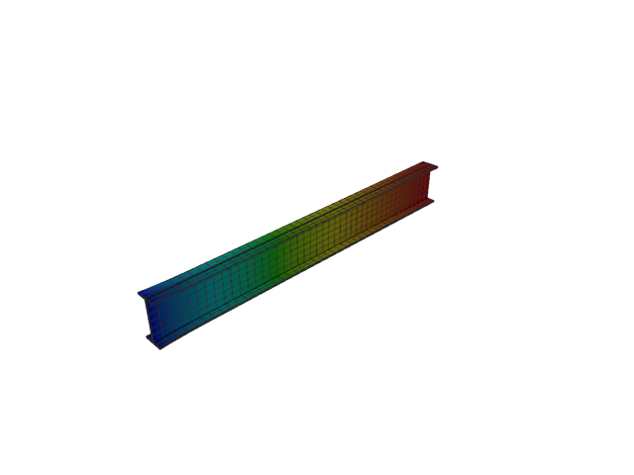
Figure 188: Abaqus — mode 10, 431.802 Hz
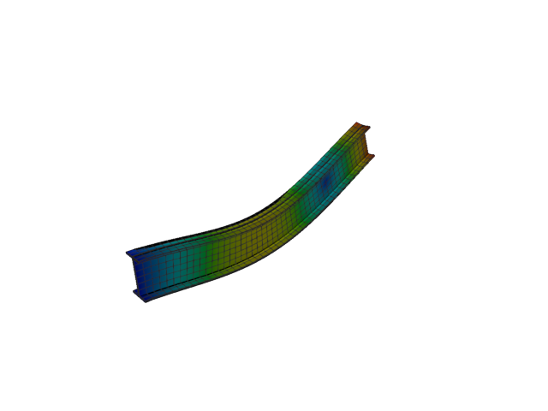
Figure 189: Sesam — mode 10, 253.463 Hz
Solver | f [Hz] | Δf vs mean [%] | λ [rad²/s²] | Meff X [kg] | Meff Y [kg] | Meff Z [kg] | Γ X | Γ Y | Γ Z
Abaqus | 431.800 | +26.02 | 7.36085e+06 | 153.54 | 1.07e-21 | 9.26e-21 | 12.391 | 3.27e-11 | -9.62e-11
Sesam | 253.463 | -26.02 | 2.53623e+06 | 1.48e-19 | 5.14e-20 | 40.27 | -3.84e-10 | 2.27e-10 | -6.346

Mode 11
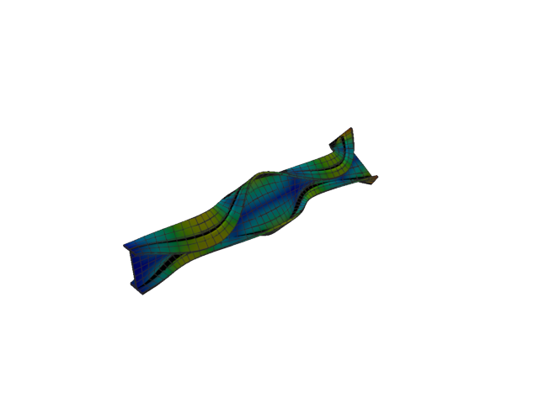
Figure 190: Abaqus — mode 11, 486.965 Hz
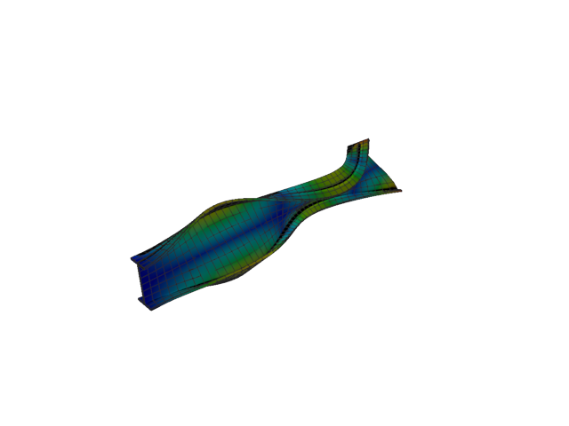
Figure 191: Sesam — mode 11, 256.050 Hz
Solver | f [Hz] | Δf vs mean [%] | λ [rad²/s²] | Meff X [kg] | Meff Y [kg] | Meff Z [kg] | Γ X | Γ Y | Γ Z
Abaqus | 486.960 | +31.08 | 9.3617e+06 | 1.09e-16 | 2.28e-18 | 1.17e-18 | 1.04e-08 | 1.51e-09 | 1.08e-09
Sesam | 256.050 | -31.08 | 2.58827e+06 | 4.64e-20 | 1.35e-20 | 4.71e-23 | 2.15e-10 | -1.16e-10 | -6.86e-12

Solid, 1st order, HEX, reduced integration

Mode 1
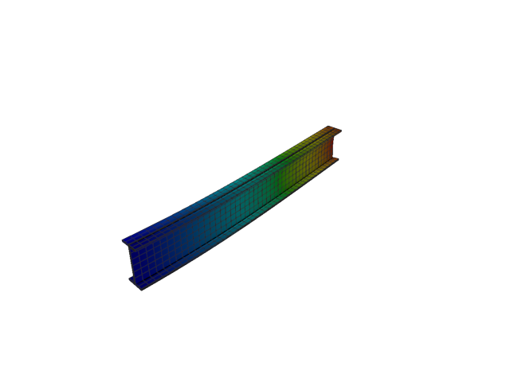
Figure 192: Abaqus — mode 1, 12.514 Hz
Solver | f [Hz] | λ [rad²/s²] | Meff X [kg] | Meff Y [kg] | Meff Z [kg] | Γ X | Γ Y | Γ Z
Abaqus | 12.514 | 6182 | 1.92e-26 | 116.92 | 5.56e-23 | 1.39e-13 | 10.813 | -7.45e-12

Mode 2
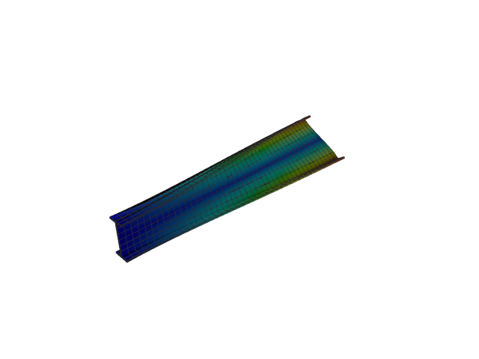
Figure 193: Abaqus — mode 2, 34.157 Hz
Solver | f [Hz] | λ [rad²/s²] | Meff X [kg] | Meff Y [kg] | Meff Z [kg] | Γ X | Γ Y | Γ Z
Abaqus | 34.157 | 46060 | 4.54e-27 | 1.11e-19 | 8.80e-22 | 6.74e-14 | 3.33e-10 | -2.97e-11

Mode 3
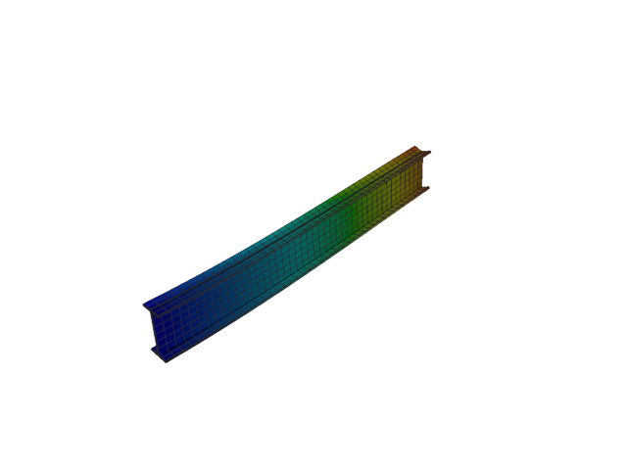
Figure 194: Abaqus — mode 3, 49.598 Hz
Solver | f [Hz] | λ [rad²/s²] | Meff X [kg] | Meff Y [kg] | Meff Z [kg] | Γ X | Γ Y | Γ Z
Abaqus | 49.598 | 97114 | 1.57e-26 | 1.07e-20 | 118.97 | -1.25e-13 | 1.03e-10 | 10.907

Mode 4
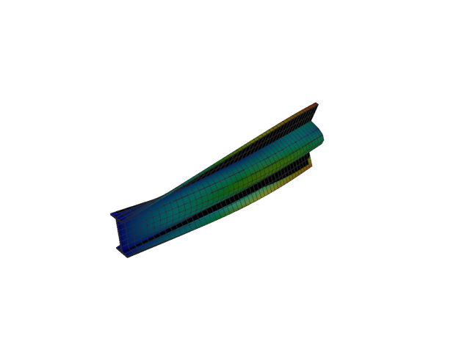
Figure 195: Abaqus — mode 4, 55.271 Hz
Solver | f [Hz] | λ [rad²/s²] | Meff X [kg] | Meff Y [kg] | Meff Z [kg] | Γ X | Γ Y | Γ Z
Abaqus | 55.271 | 120602 | 1.14e-25 | 2.12 | 1.05e-18 | -3.37e-13 | -1.456 | 1.02e-09

Mode 5
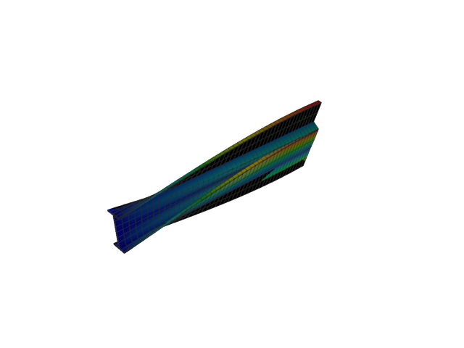
Figure 196: Abaqus — mode 5, 64.305 Hz
Solver | f [Hz] | λ [rad²/s²] | Meff X [kg] | Meff Y [kg] | Meff Z [kg] | Γ X | Γ Y | Γ Z
Abaqus | 64.305 | 163249 | 1.13e-26 | 8.64e-20 | 1.24e-20 | -1.06e-13 | -2.94e-10 | 1.11e-10

Mode 6
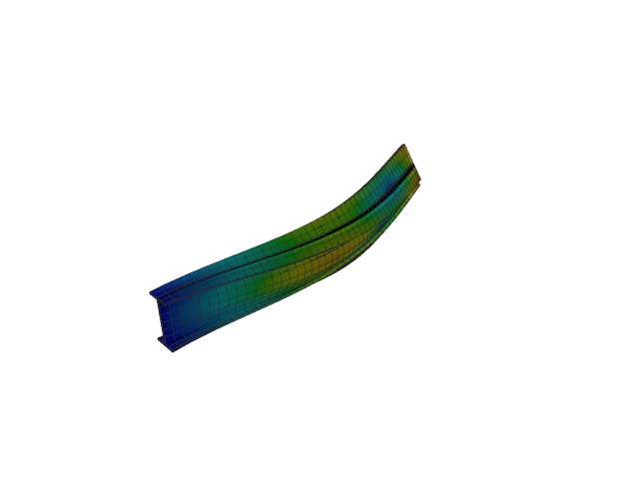
Figure 197: Abaqus — mode 6, 74.866 Hz
Solver | f [Hz] | λ [rad²/s²] | Meff X [kg] | Meff Y [kg] | Meff Z [kg] | Γ X | Γ Y | Γ Z
Abaqus | 74.866 | 221271 | 1.12e-26 | 31.40 | 1.02e-20 | 1.06e-13 | -5.603 | -1.01e-10

Mode 7
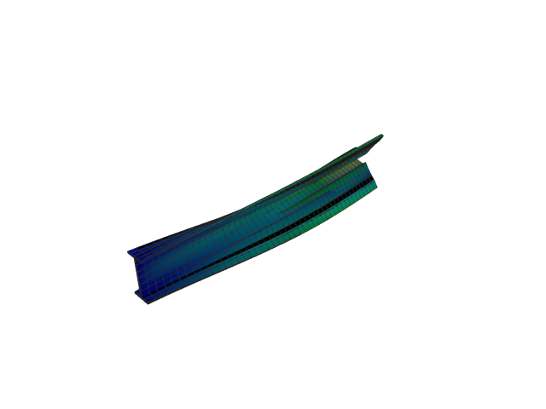
Figure 198: Abaqus — mode 7, 90.033 Hz
Solver | f [Hz] | λ [rad²/s²] | Meff X [kg] | Meff Y [kg] | Meff Z [kg] | Γ X | Γ Y | Γ Z
Abaqus | 90.033 | 320010 | 1.17e-28 | 2.79 | 5.27e-21 | -1.08e-14 | -1.671 | 7.26e-11

Mode 8
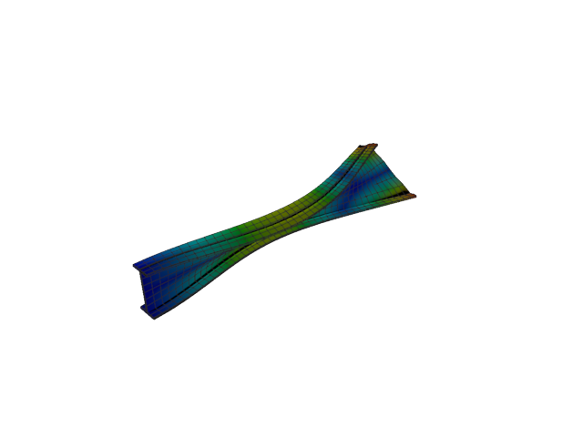
Figure 199: Abaqus — mode 8, 124.578 Hz
Solver | f [Hz] | λ [rad²/s²] | Meff X [kg] | Meff Y [kg] | Meff Z [kg] | Γ X | Γ Y | Γ Z
Abaqus | 124.580 | 612693 | 3.87e-24 | 3.38e-21 | 2.90e-24 | -1.97e-12 | -5.82e-11 | -1.70e-12

Mode 9
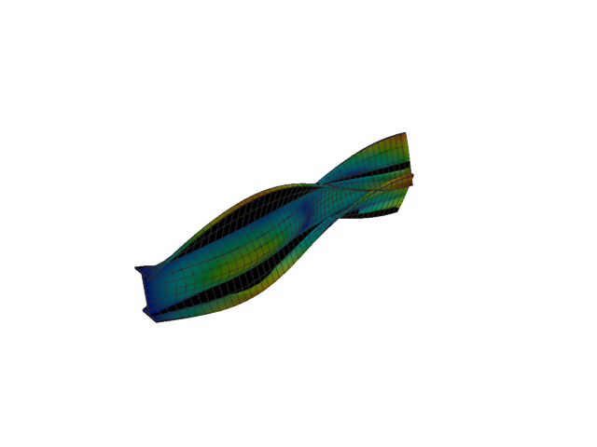
Figure 200: Abaqus — mode 9, 155.992 Hz
Solver | f [Hz] | λ [rad²/s²] | Meff X [kg] | Meff Y [kg] | Meff Z [kg] | Γ X | Γ Y | Γ Z
Abaqus | 155.990 | 960645 | 7.43e-21 | 1.12 | 2.07e-20 | -8.62e-11 | -1.056 | -1.44e-10

Mode 10
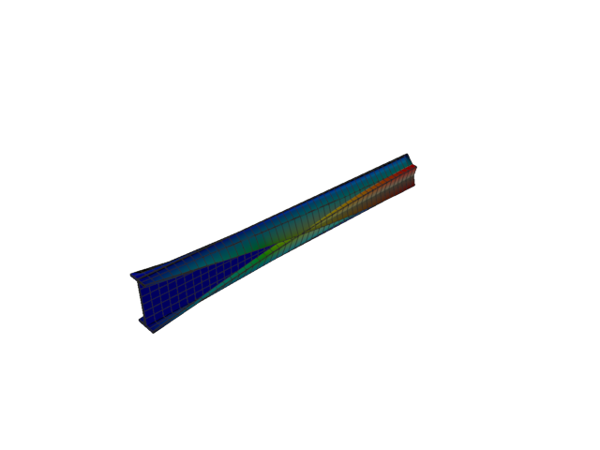
Figure 201: Abaqus — mode 10, 159.952 Hz
Solver | f [Hz] | λ [rad²/s²] | Meff X [kg] | Meff Y [kg] | Meff Z [kg] | Γ X | Γ Y | Γ Z
Abaqus | 159.950 | 1.01004e+06 | 3.65e-04 | 8.80e-19 | 3.04e-19 | 0.019 | -9.38e-10 | 5.51e-10

Mode 11
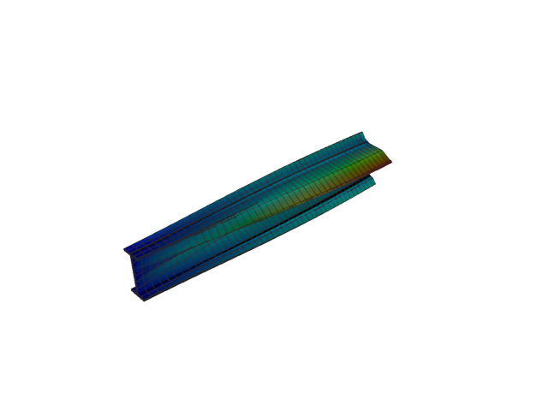
Figure 202: Abaqus — mode 11, 162.557 Hz
Solver | f [Hz] | λ [rad²/s²] | Meff X [kg] | Meff Y [kg] | Meff Z [kg] | Γ X | Γ Y | Γ Z
Abaqus | 162.560 | 1.04321e+06 | 4.88e-19 | 1.57e-19 | 3.29e-20 | -6.98e-10 | 3.96e-10 | -1.81e-10

Solid, 2nd order, TET

Mode 1
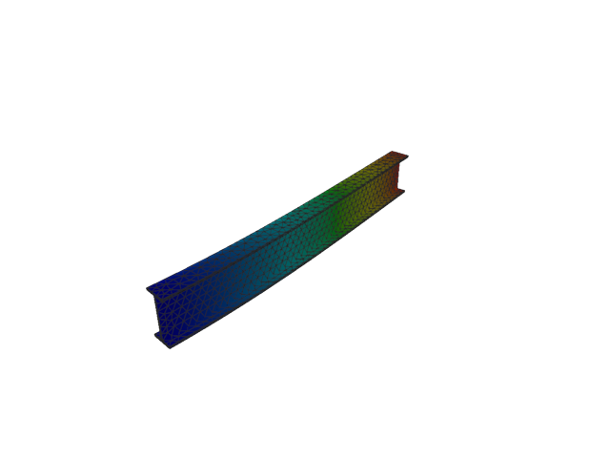
Figure 203: Abaqus — mode 1, 12.954 Hz
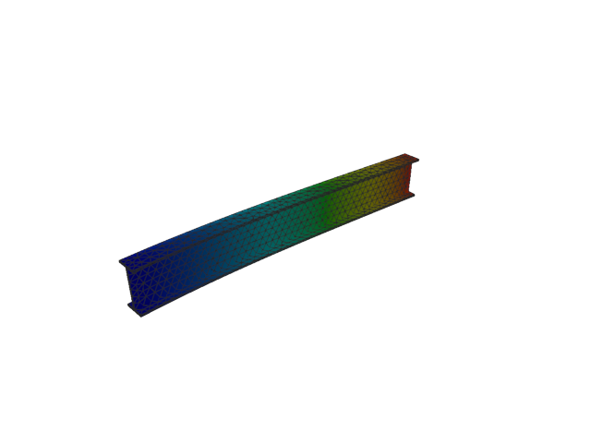
Figure 204: Sesam — mode 1, 12.954 Hz
Solver | f [Hz] | Δf vs mean [%] | λ [rad²/s²] | Meff X [kg] | Meff Y [kg] | Meff Z [kg] | Γ X | Γ Y | Γ Z
Abaqus | 12.954 | 1.00e-03 | 6624.5 | 3.65e-13 | 116.51 | 2.81e-11 | 6.04e-07 | 10.794 | 5.30e-06
Sesam | 12.954 | -1.00e-03 | 6624.46 | 3.01e-13 | 116.51 | 2.70e-11 | -5.49e-07 | -10.794 | -5.20e-06

Mode 2
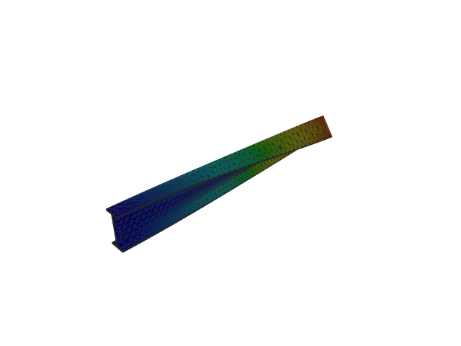
Figure 205: Abaqus — mode 2, 20.294 Hz
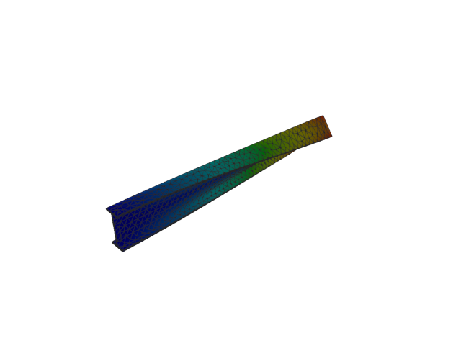
Figure 206: Sesam — mode 2, 20.294 Hz
Solver | f [Hz] | Δf vs mean [%] | λ [rad²/s²] | Meff X [kg] | Meff Y [kg] | Meff Z [kg] | Γ X | Γ Y | Γ Z
Abaqus | 20.294 | -1.13e-03 | 16260 | 8.19e-12 | 5.86e-08 | 1.99e-09 | 2.86e-06 | -2.42e-04 | 4.47e-05
Sesam | 20.294 | 1.13e-03 | 16259.8 | 8.59e-12 | 5.86e-08 | 1.98e-09 | 2.93e-06 | -2.42e-04 | 4.45e-05

Mode 3
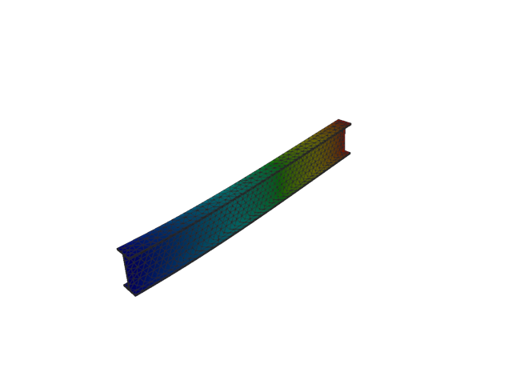
Figure 207: Abaqus — mode 3, 50.540 Hz
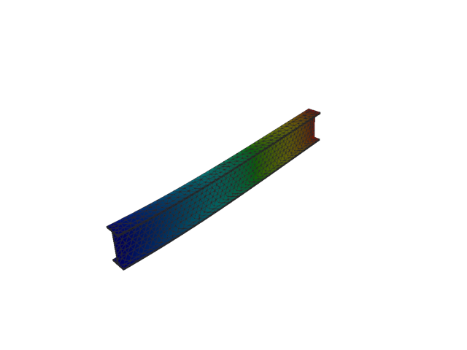
Figure 208: Sesam — mode 3, 50.540 Hz
Solver | f [Hz] | Δf vs mean [%] | λ [rad²/s²] | Meff X [kg] | Meff Y [kg] | Meff Z [kg] | Γ X | Γ Y | Γ Z
Abaqus | 50.540 | -4.95e-05 | 100840 | 3.09e-10 | 1.03e-08 | 118.35 | 1.76e-05 | -1.01e-04 | 10.879
Sesam | 50.540 | 4.95e-05 | 100840 | 3.10e-10 | 1.03e-08 | 118.35 | 1.76e-05 | -1.01e-04 | 10.879

Mode 4
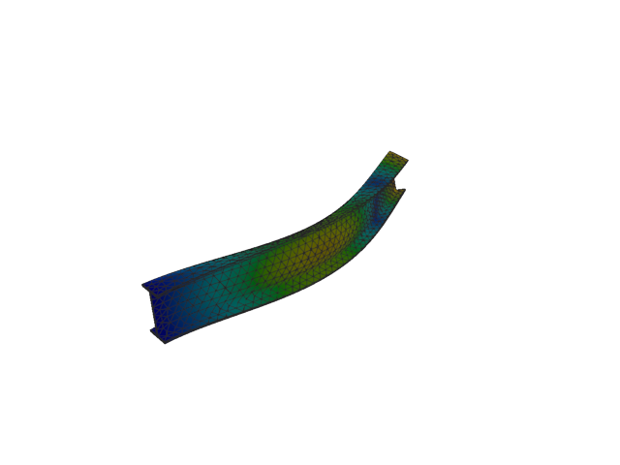
Figure 209: Abaqus — mode 4, 77.128 Hz
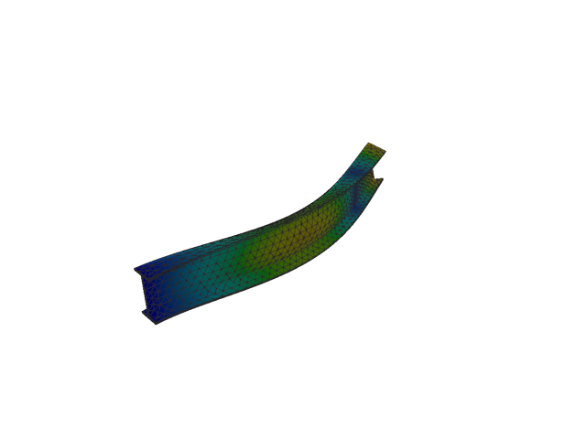
Figure 210: Sesam — mode 4, 77.128 Hz
Solver | f [Hz] | Δf vs mean [%] | λ [rad²/s²] | Meff X [kg] | Meff Y [kg] | Meff Z [kg] | Γ X | Γ Y | Γ Z
Abaqus | 77.128 | 1.43e-04 | 234845 | 6.40e-12 | 35.97 | 1.94e-09 | 2.53e-06 | -5.997 | -4.41e-05
Sesam | 77.128 | -1.43e-04 | 234845 | 1.04e-11 | 35.97 | 1.89e-09 | 3.22e-06 | -5.997 | -4.35e-05

Mode 5
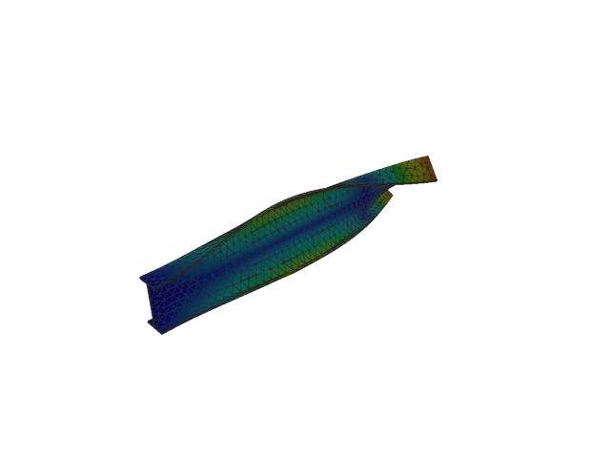
Figure 211: Abaqus — mode 5, 97.830 Hz
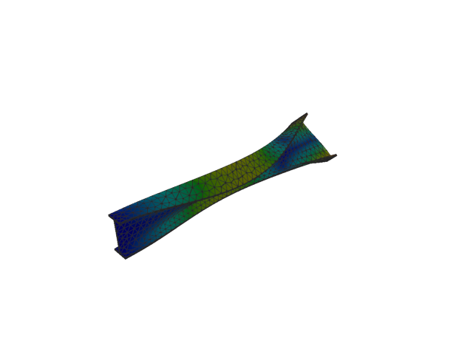
Figure 212: Sesam — mode 5, 97.830 Hz
Solver | f [Hz] | Δf vs mean [%] | λ [rad²/s²] | Meff X [kg] | Meff Y [kg] | Meff Z [kg] | Γ X | Γ Y | Γ Z
Abaqus | 97.830 | 2.10e-04 | 377834 | 1.93e-10 | 3.14e-07 | 6.49e-09 | -1.39e-05 | -0.001 | 8.06e-05
Sesam | 97.830 | -2.10e-04 | 377833 | 1.99e-10 | 3.14e-07 | 6.59e-09 | 1.41e-05 | 0.001 | -8.12e-05

Mode 6
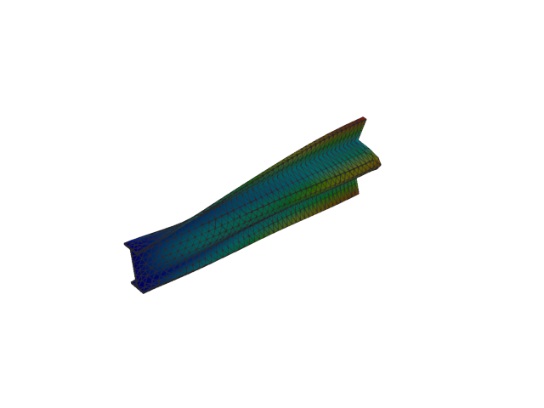
Figure 213: Abaqus — mode 6, 132.482 Hz
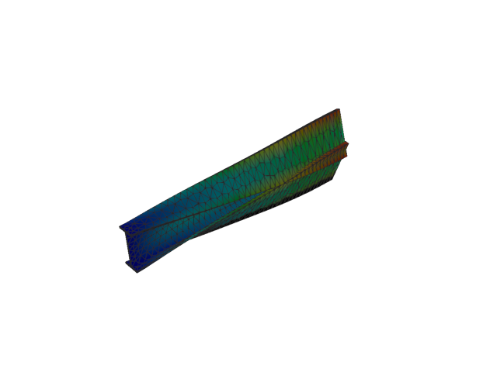
Figure 214: Sesam — mode 6, 132.478 Hz
Solver | f [Hz] | Δf vs mean [%] | λ [rad²/s²] | Meff X [kg] | Meff Y [kg] | Meff Z [kg] | Γ X | Γ Y | Γ Z
Abaqus | 132.480 | 6.04e-04 | 692901 | 1.05e-09 | 0.01 | 2.04e-09 | 3.23e-05 | 0.119 | -4.51e-05
Sesam | 132.478 | -6.04e-04 | 692867 | 1.14e-09 | 0.01 | 2.04e-09 | -3.38e-05 | -0.119 | 4.52e-05

Mode 7
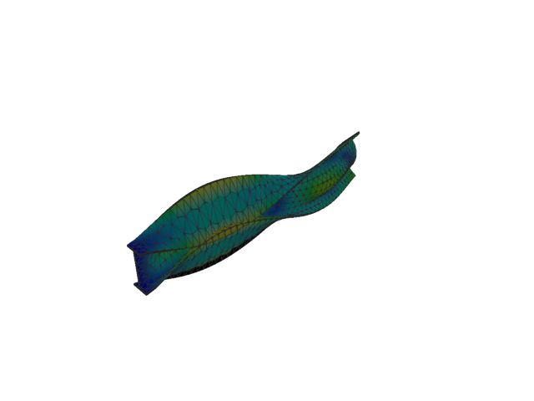
Figure 215: Abaqus — mode 7, 153.634 Hz
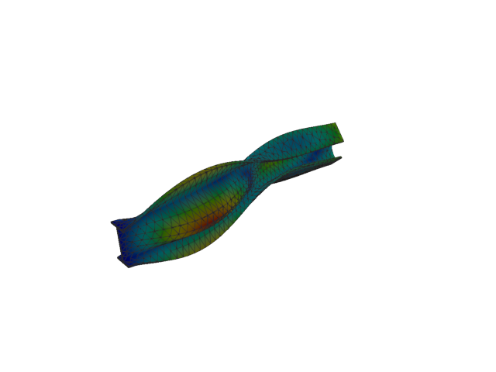
Figure 216: Sesam — mode 7, 153.631 Hz
Solver | f [Hz] | Δf vs mean [%] | λ [rad²/s²] | Meff X [kg] | Meff Y [kg] | Meff Z [kg] | Γ X | Γ Y | Γ Z
Abaqus | 153.630 | -4.56e-04 | 931828 | 1.43e-08 | 3.12 | 2.11e-09 | -1.19e-04 | 1.768 | -4.59e-05
Sesam | 153.631 | 4.56e-04 | 931794 | 1.56e-08 | 3.12 | 2.15e-09 | 1.25e-04 | -1.768 | 4.63e-05

Mode 8
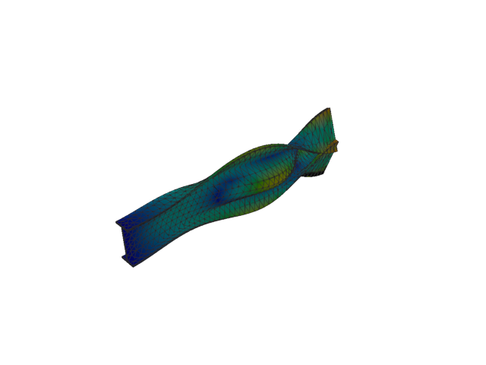
Figure 217: Abaqus — mode 8, 178.118 Hz
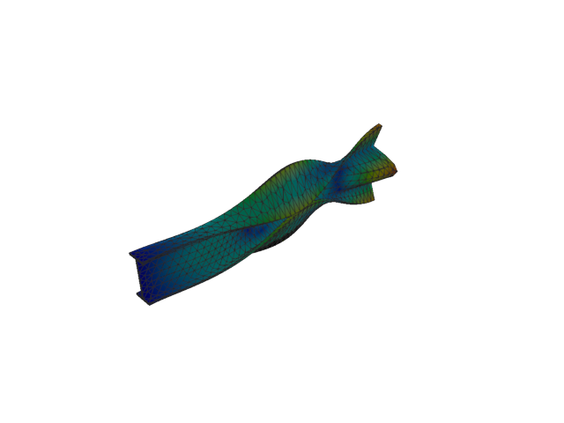
Figure 218: Sesam — mode 8, 178.114 Hz
Solver | f [Hz] | Δf vs mean [%] | λ [rad²/s²] | Meff X [kg] | Meff Y [kg] | Meff Z [kg] | Γ X | Γ Y | Γ Z
Abaqus | 178.120 | 1.74e-03 | 1.2525e+06 | 2.65e-10 | 5.79 | 5.99e-10 | -1.63e-05 | 2.405 | -2.45e-05
Sesam | 178.114 | -1.74e-03 | 1.25243e+06 | 3.03e-10 | 5.79 | 6.40e-10 | 1.74e-05 | -2.406 | 2.53e-05

Mode 9
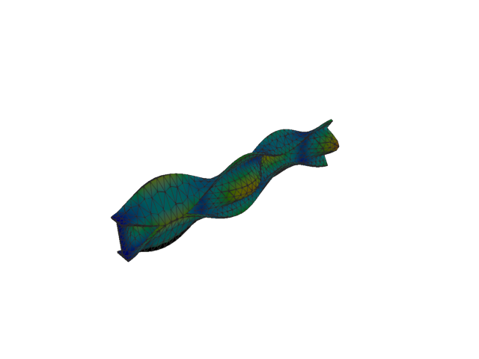
Figure 219: Abaqus — mode 9, 215.822 Hz
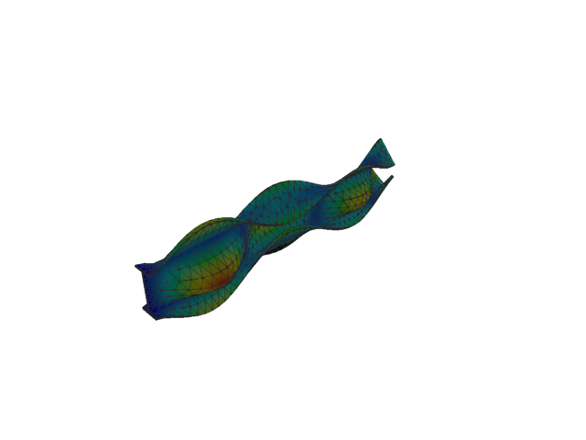
Figure 220: Sesam — mode 9, 215.815 Hz
Solver | f [Hz] | Δf vs mean [%] | λ [rad²/s²] | Meff X [kg] | Meff Y [kg] | Meff Z [kg] | Γ X | Γ Y | Γ Z
Abaqus | 215.820 | 1.20e-03 | 1.83887e+06 | 8.48e-08 | 0.60 | 8.50e-08 | -2.91e-04 | 0.774 | 2.91e-04
Sesam | 215.815 | -1.20e-03 | 1.83875e+06 | 9.03e-08 | 0.60 | 8.47e-08 | 3.00e-04 | -0.774 | -2.91e-04

Mode 10
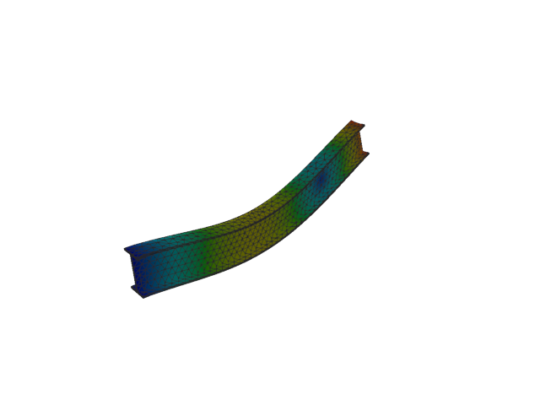
Figure 221: Abaqus — mode 10, 253.203 Hz
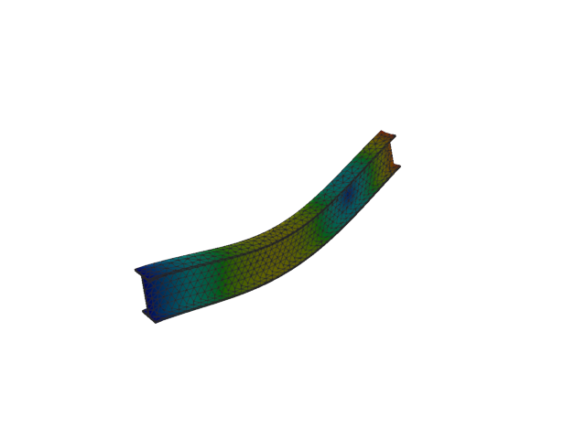
Figure 222: Sesam — mode 10, 253.203 Hz
Solver | f [Hz] | Δf vs mean [%] | λ [rad²/s²] | Meff X [kg] | Meff Y [kg] | Meff Z [kg] | Γ X | Γ Y | Γ Z
Abaqus | 253.200 | -5.73e-04 | 2.53103e+06 | 8.86e-09 | 1.97e-08 | 40.25 | -9.41e-05 | 1.40e-04 | -6.344
Sesam | 253.203 | 5.73e-04 | 2.53103e+06 | 9.13e-09 | 1.99e-08 | 40.25 | -9.56e-05 | 1.41e-04 | -6.344

Mode 11
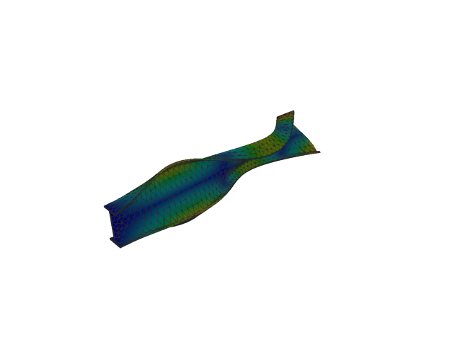
Figure 223: Abaqus — mode 11, 254.466 Hz
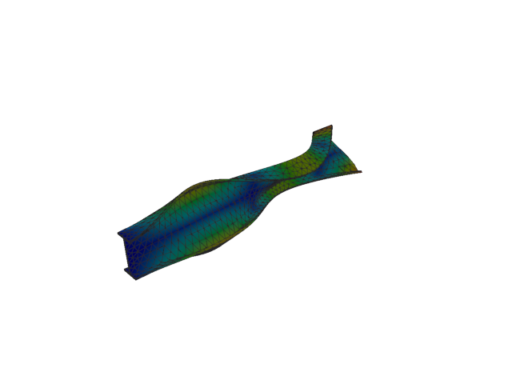
Figure 224: Sesam — mode 11, 254.466 Hz
Solver | f [Hz] | Δf vs mean [%] | λ [rad²/s²] | Meff X [kg] | Meff Y [kg] | Meff Z [kg] | Γ X | Γ Y | Γ Z
Abaqus | 254.470 | 8.65e-04 | 2.55635e+06 | 1.63e-09 | 6.96e-07 | 4.16e-05 | -4.04e-05 | -0.001 | -0.006
Sesam | 254.466 | -8.65e-04 | 2.55634e+06 | 1.66e-09 | 6.95e-07 | 4.17e-05 | -4.07e-05 | -0.001 | -0.006

Solid, 2nd order, HEX

Mode 1
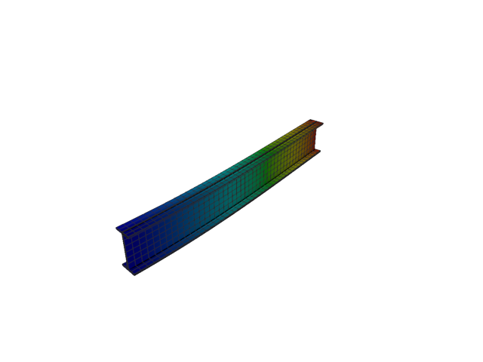
Figure 225: Abaqus — mode 1, 12.955 Hz
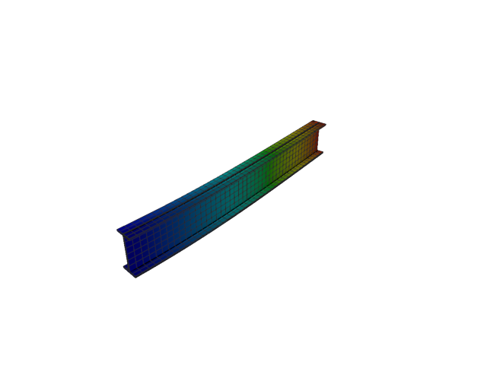
Figure 226: Sesam — mode 1, 12.954 Hz
Solver | f [Hz] | Δf vs mean [%] | λ [rad²/s²] | Meff X [kg] | Meff Y [kg] | Meff Z [kg] | Γ X | Γ Y | Γ Z
Abaqus | 12.955 | 3.32e-03 | 6625.8 | 3.08e-24 | 116.50 | 5.64e-20 | 1.76e-12 | 10.794 | 2.37e-10
Sesam | 12.954 | -3.32e-03 | 6624.86 | 3.50e-24 | 116.51 | 1.44e-22 | 1.87e-12 | 10.794 | 1.20e-11

Mode 2
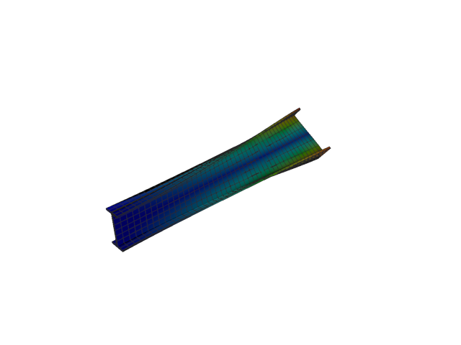
Figure 227: Abaqus — mode 2, 20.150 Hz
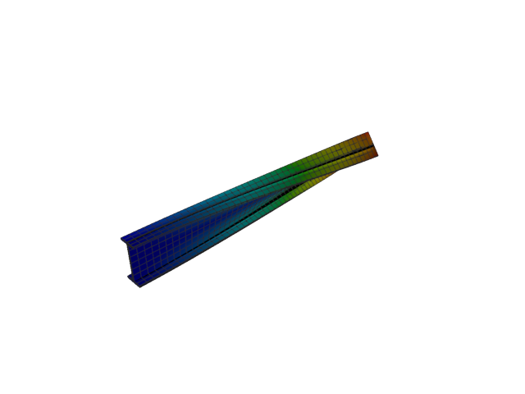
Figure 228: Sesam — mode 2, 20.044 Hz
Solver | f [Hz] | Δf vs mean [%] | λ [rad²/s²] | Meff X [kg] | Meff Y [kg] | Meff Z [kg] | Γ X | Γ Y | Γ Z
Abaqus | 20.150 | +0.26 | 16030 | 2.26e-25 | 4.71e-16 | 2.32e-18 | -4.76e-13 | 2.17e-08 | 1.52e-09
Sesam | 20.044 | -0.26 | 15861.7 | 2.99e-24 | 4.86e-15 | 1.02e-18 | 1.73e-12 | -6.97e-08 | 1.01e-09

Mode 3
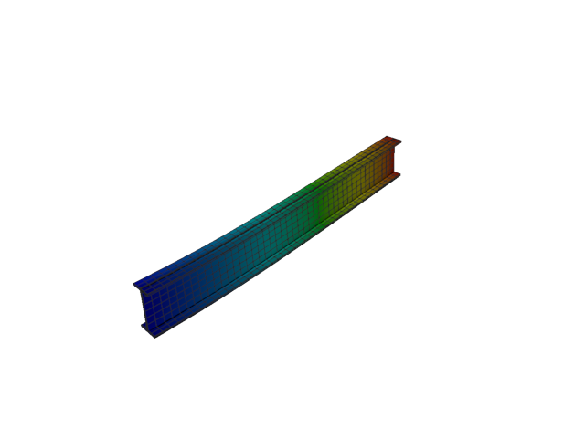
Figure 229: Abaqus — mode 3, 50.541 Hz
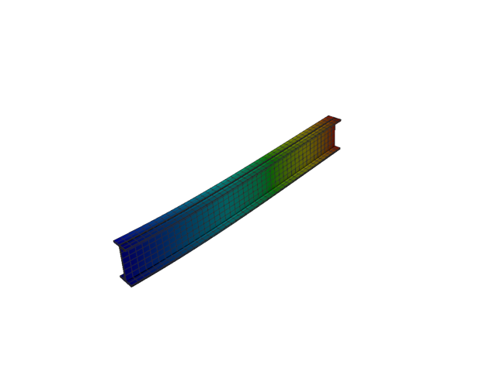
Figure 230: Sesam — mode 3, 50.534 Hz
Solver | f [Hz] | Δf vs mean [%] | λ [rad²/s²] | Meff X [kg] | Meff Y [kg] | Meff Z [kg] | Γ X | Γ Y | Γ Z
Abaqus | 50.541 | +0.01 | 100844 | 1.71e-23 | 8.62e-20 | 118.36 | -4.13e-12 | -2.94e-10 | 10.879
Sesam | 50.534 | -0.01 | 100816 | 4.30e-24 | 5.72e-22 | 118.37 | 2.07e-12 | 2.39e-11 | 10.880

Mode 4
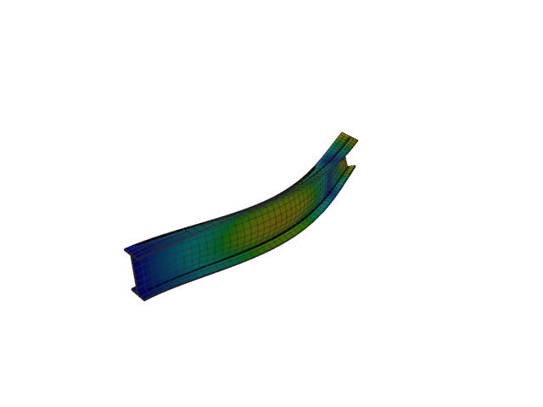
Figure 231: Abaqus — mode 4, 76.890 Hz
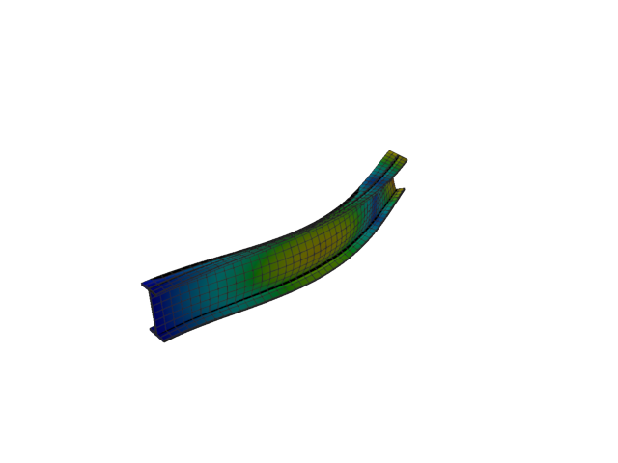
Figure 232: Sesam — mode 4, 76.747 Hz
Solver | f [Hz] | Δf vs mean [%] | λ [rad²/s²] | Meff X [kg] | Meff Y [kg] | Meff Z [kg] | Γ X | Γ Y | Γ Z
Abaqus | 76.890 | +0.09 | 233401 | 9.37e-28 | 35.91 | 1.14e-20 | -3.06e-14 | -5.993 | -1.07e-10
Sesam | 76.747 | -0.09 | 232530 | 1.68e-24 | 35.89 | 3.76e-21 | -1.29e-12 | -5.991 | 6.13e-11

Mode 5
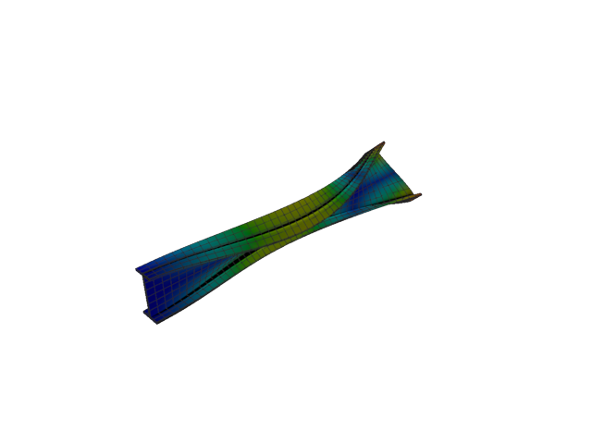
Figure 233: Abaqus — mode 5, 97.594 Hz
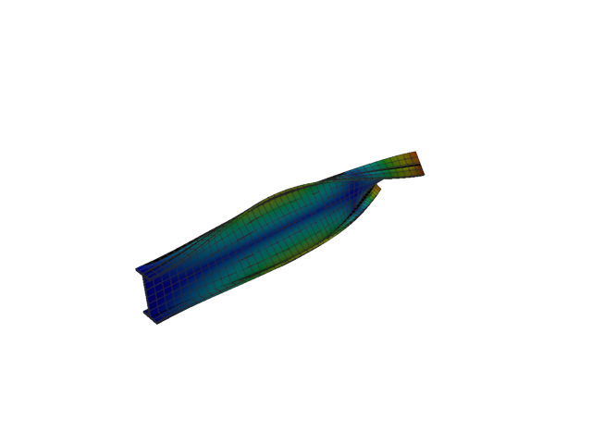
Figure 234: Sesam — mode 5, 97.472 Hz
Solver | f [Hz] | Δf vs mean [%] | λ [rad²/s²] | Meff X [kg] | Meff Y [kg] | Meff Z [kg] | Γ X | Γ Y | Γ Z
Abaqus | 97.594 | +0.06 | 376015 | 1.21e-24 | 3.12e-19 | 1.62e-21 | 1.10e-12 | -5.59e-10 | -4.02e-11
Sesam | 97.472 | -0.06 | 375078 | 8.04e-25 | 3.55e-18 | 2.80e-21 | -8.97e-13 | 1.88e-09 | -5.29e-11

Mode 6
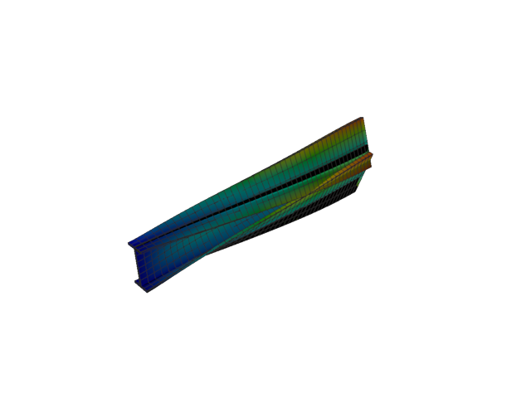
Figure 235: Abaqus — mode 6, 131.365 Hz
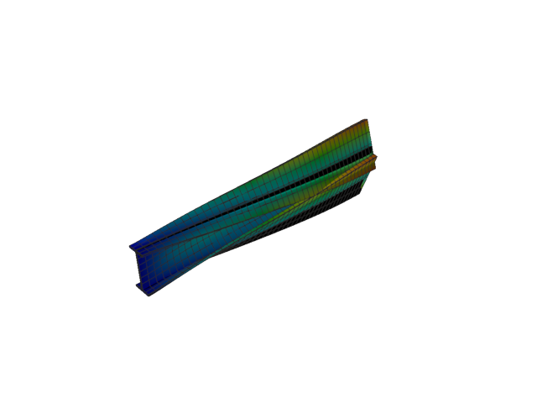
Figure 236: Sesam — mode 6, 130.865 Hz
Solver | f [Hz] | Δf vs mean [%] | λ [rad²/s²] | Meff X [kg] | Meff Y [kg] | Meff Z [kg] | Γ X | Γ Y | Γ Z
Abaqus | 131.370 | +0.19 | 681273 | 2.05e-24 | 0.01 | 1.33e-19 | 1.43e-12 | -0.103 | -3.65e-10
Sesam | 130.865 | -0.19 | 676090 | 1.00e-25 | 0.01 | 9.22e-22 | 3.16e-13 | -0.096 | 3.04e-11

Mode 7
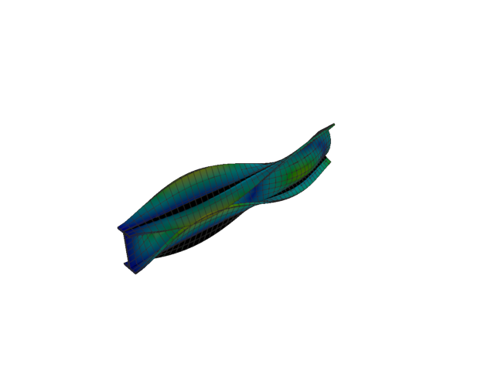
Figure 237: Abaqus — mode 7, 149.958 Hz
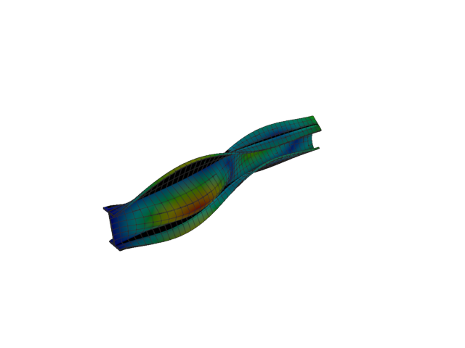
Figure 238: Sesam — mode 7, 148.496 Hz
Solver | f [Hz] | Δf vs mean [%] | λ [rad²/s²] | Meff X [kg] | Meff Y [kg] | Meff Z [kg] | Γ X | Γ Y | Γ Z
Abaqus | 149.960 | +0.49 | 887766 | 2.76e-24 | 3.31 | 8.83e-21 | 1.66e-12 | 1.818 | 9.40e-11
Sesam | 148.496 | -0.49 | 870539 | 3.33e-25 | 3.38 | 1.39e-22 | 5.77e-13 | -1.839 | -1.18e-11

Mode 8
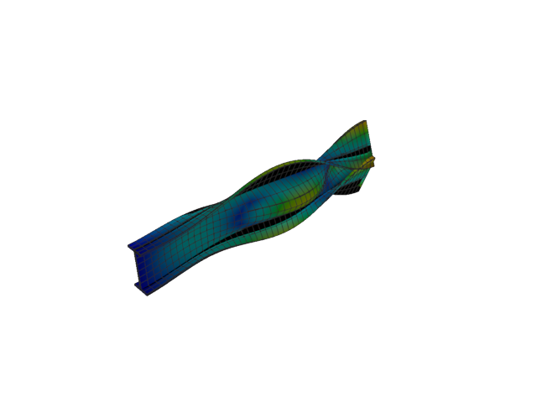
Figure 239: Abaqus — mode 8, 173.925 Hz
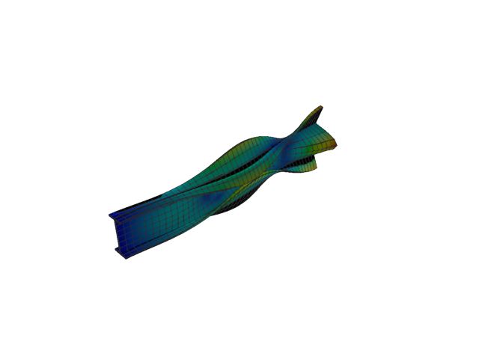
Figure 240: Sesam — mode 8, 172.243 Hz
Solver | f [Hz] | Δf vs mean [%] | λ [rad²/s²] | Meff X [kg] | Meff Y [kg] | Meff Z [kg] | Γ X | Γ Y | Γ Z
Abaqus | 173.920 | +0.48 | 1.19422e+06 | 4.36e-26 | 5.42 | 1.76e-20 | 2.09e-13 | 2.328 | -1.33e-10
Sesam | 172.243 | -0.48 | 1.17124e+06 | 8.12e-26 | 5.31 | 3.08e-22 | 2.85e-13 | -2.305 | -1.76e-11

Mode 9
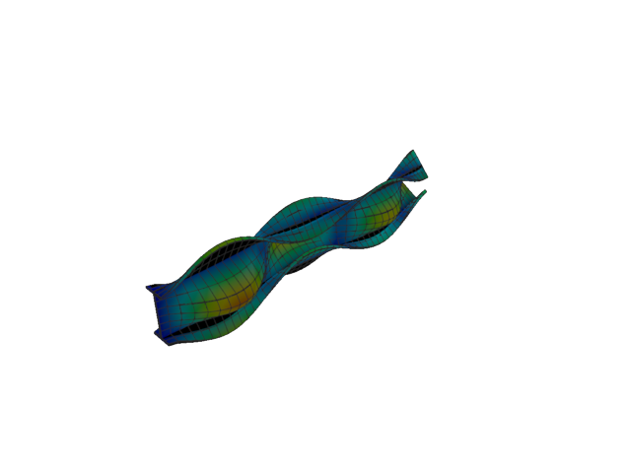
Figure 241: Abaqus — mode 9, 205.292 Hz
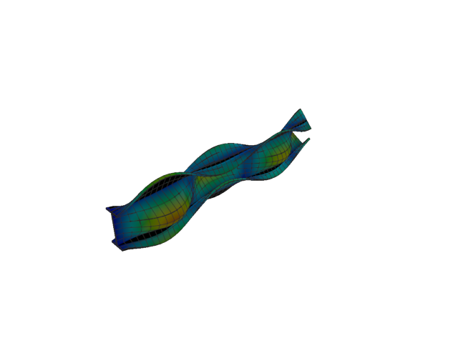
Figure 242: Sesam — mode 9, 201.904 Hz
Solver | f [Hz] | Δf vs mean [%] | λ [rad²/s²] | Meff X [kg] | Meff Y [kg] | Meff Z [kg] | Γ X | Γ Y | Γ Z
Abaqus | 205.290 | +0.83 | 1.66381e+06 | 4.78e-27 | 0.52 | 2.91e-22 | 6.91e-14 | -0.719 | 1.71e-11
Sesam | 201.904 | -0.83 | 1.60935e+06 | 1.55e-24 | 0.56 | 1.71e-22 | -1.25e-12 | -0.746 | 1.31e-11

Mode 10
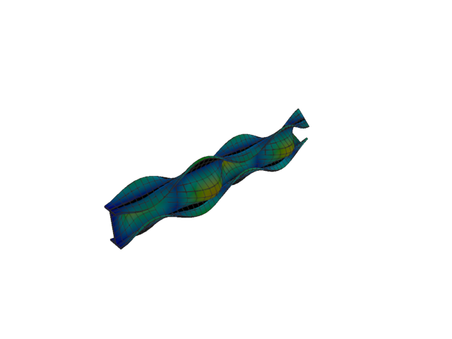
Figure 243: Abaqus — mode 10, 251.347 Hz
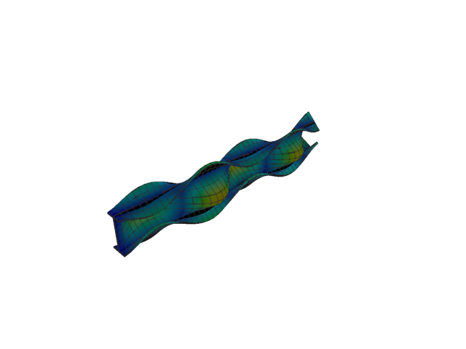
Figure 244: Sesam — mode 10, 246.353 Hz
Solver | f [Hz] | Δf vs mean [%] | λ [rad²/s²] | Meff X [kg] | Meff Y [kg] | Meff Z [kg] | Γ X | Γ Y | Γ Z
Abaqus | 251.350 | +1.00 | 2.49407e+06 | 1.08e-21 | 1.60 | 3.13e-19 | 3.29e-11 | 1.267 | -5.59e-10
Sesam | 246.353 | -1.00 | 2.39594e+06 | 1.32e-18 | 1.47 | 6.50e-19 | -1.15e-09 | 1.211 | 8.06e-10

Mode 11
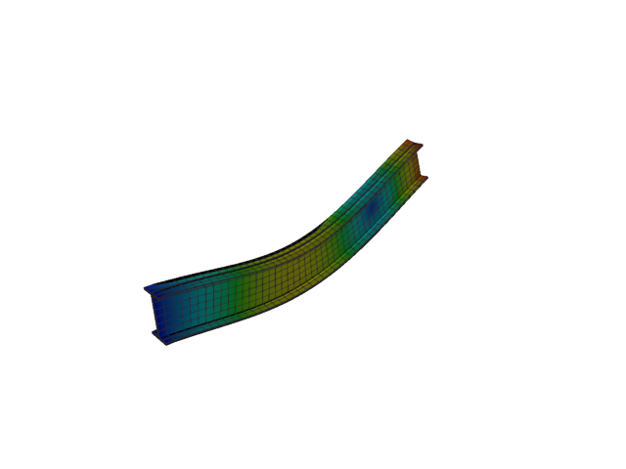
Figure 245: Abaqus — mode 11, 252.917 Hz
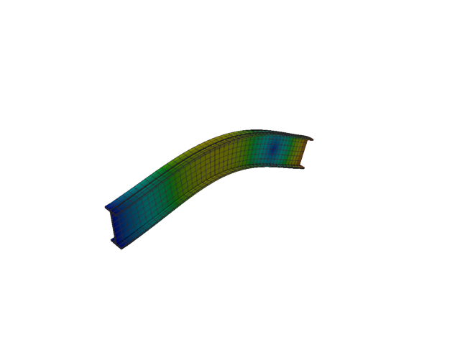
Figure 246: Sesam — mode 11, 252.742 Hz
Solver | f [Hz] | Δf vs mean [%] | λ [rad²/s²] | Meff X [kg] | Meff Y [kg] | Meff Z [kg] | Γ X | Γ Y | Γ Z
Abaqus | 252.920 | +0.04 | 2.52532e+06 | 4.22e-22 | 4.70e-20 | 40.25 | 2.05e-11 | 2.17e-10 | -6.344
Sesam | 252.742 | -0.04 | 2.52182e+06 | 2.26e-15 | 2.80e-16 | 40.28 | -4.75e-08 | 1.67e-08 | 6.346

Solid, 2nd order, HEX, reduced integration

Mode 1
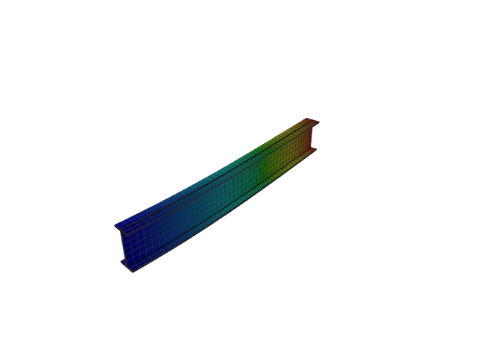
Figure 247: Abaqus — mode 1, 12.943 Hz
Solver | f [Hz] | λ [rad²/s²] | Meff X [kg] | Meff Y [kg] | Meff Z [kg] | Γ X | Γ Y | Γ Z
Abaqus | 12.943 | 6613.2 | 5.11e-26 | 116.56 | 2.93e-20 | -2.26e-13 | 10.796 | 1.71e-10

Mode 2
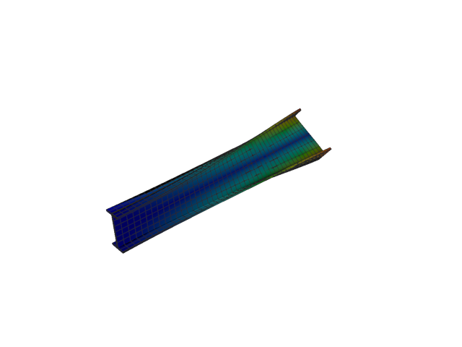
Figure 248: Abaqus — mode 2, 20.029 Hz
Solver | f [Hz] | λ [rad²/s²] | Meff X [kg] | Meff Y [kg] | Meff Z [kg] | Γ X | Γ Y | Γ Z
Abaqus | 20.029 | 15837 | 2.00e-26 | 8.47e-16 | 7.79e-20 | -1.41e-13 | 2.91e-08 | -2.79e-10

Mode 3
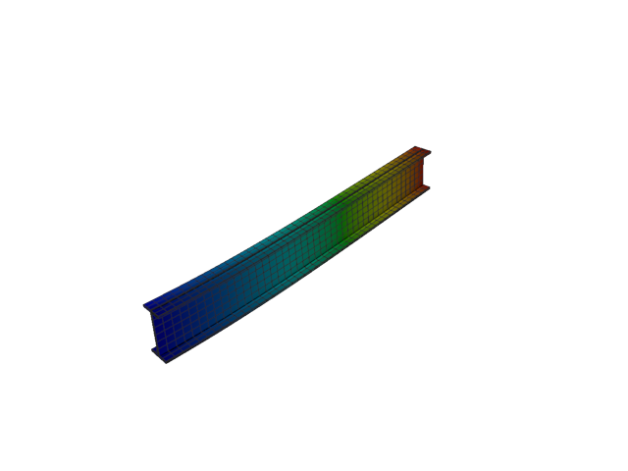
Figure 249: Abaqus — mode 3, 50.498 Hz
Solver | f [Hz] | λ [rad²/s²] | Meff X [kg] | Meff Y [kg] | Meff Z [kg] | Γ X | Γ Y | Γ Z
Abaqus | 50.498 | 100671 | 1.64e-24 | 3.78e-20 | 118.41 | -1.28e-12 | -1.94e-10 | 10.882

Mode 4
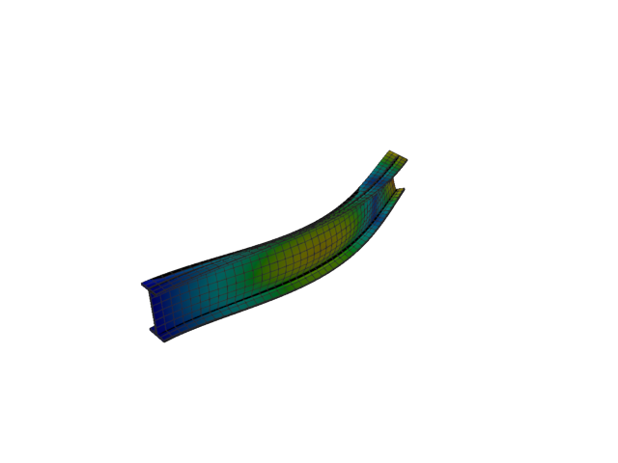
Figure 250: Abaqus — mode 4, 76.687 Hz
Solver | f [Hz] | λ [rad²/s²] | Meff X [kg] | Meff Y [kg] | Meff Z [kg] | Γ X | Γ Y | Γ Z
Abaqus | 76.687 | 232171 | 2.11e-25 | 35.90 | 8.07e-22 | -4.60e-13 | -5.992 | -2.84e-11

Mode 5
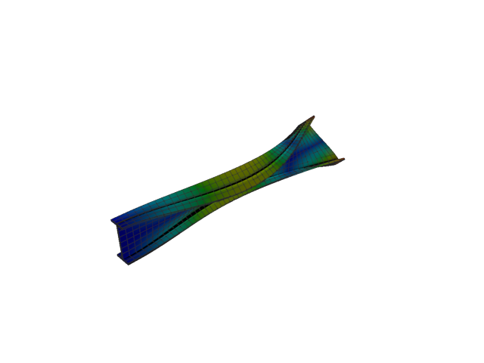
Figure 251: Abaqus — mode 5, 97.391 Hz
Solver | f [Hz] | λ [rad²/s²] | Meff X [kg] | Meff Y [kg] | Meff Z [kg] | Γ X | Γ Y | Γ Z
Abaqus | 97.391 | 374455 | 1.68e-25 | 8.25e-19 | 2.52e-24 | 4.10e-13 | -9.08e-10 | -1.59e-12

Mode 6
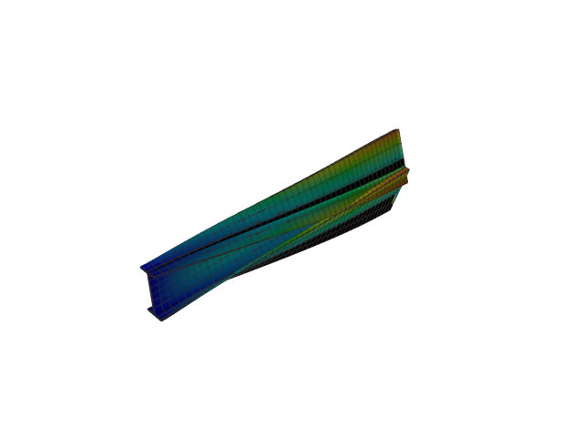
Figure 252: Abaqus — mode 6, 130.809 Hz
Solver | f [Hz] | λ [rad²/s²] | Meff X [kg] | Meff Y [kg] | Meff Z [kg] | Γ X | Γ Y | Γ Z
Abaqus | 130.810 | 675515 | 5.64e-26 | 0.01 | 6.07e-21 | -2.37e-13 | -0.097 | 7.79e-11

Mode 7
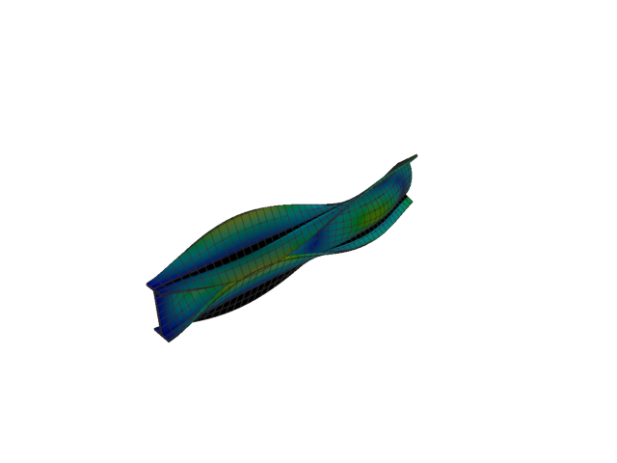
Figure 253: Abaqus — mode 7, 148.474 Hz
Solver | f [Hz] | λ [rad²/s²] | Meff X [kg] | Meff Y [kg] | Meff Z [kg] | Γ X | Γ Y | Γ Z
Abaqus | 148.470 | 870287 | 1.93e-24 | 3.39 | 2.12e-22 | -1.39e-12 | 1.840 | -1.46e-11

Mode 8
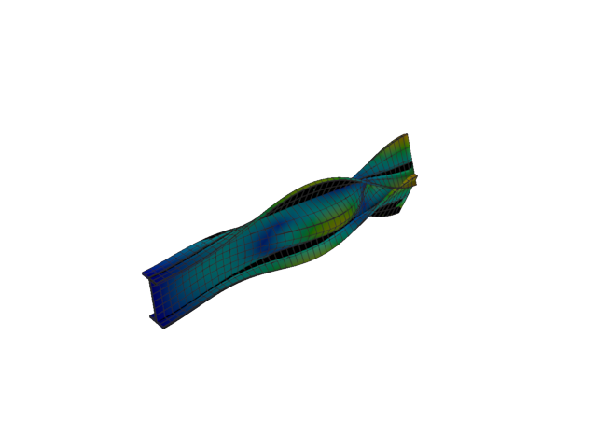
Figure 254: Abaqus — mode 8, 172.171 Hz
Solver | f [Hz] | λ [rad²/s²] | Meff X [kg] | Meff Y [kg] | Meff Z [kg] | Γ X | Γ Y | Γ Z
Abaqus | 172.170 | 1.17026e+06 | 1.27e-25 | 5.31 | 9.73e-21 | 3.57e-13 | 2.304 | 9.86e-11

Mode 9
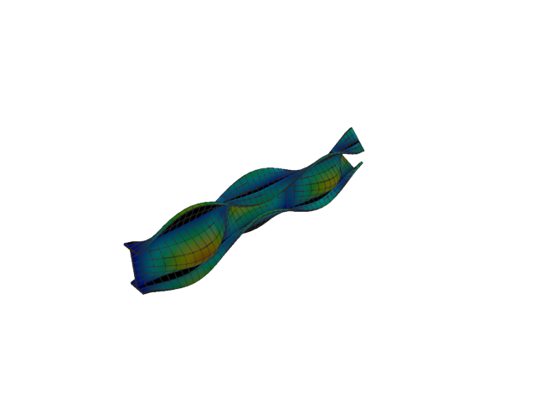
Figure 255: Abaqus — mode 9, 201.839 Hz
Solver | f [Hz] | λ [rad²/s²] | Meff X [kg] | Meff Y [kg] | Meff Z [kg] | Γ X | Γ Y | Γ Z
Abaqus | 201.840 | 1.60831e+06 | 9.86e-25 | 0.56 | 1.17e-21 | -9.93e-13 | -0.747 | 3.42e-11

Mode 10
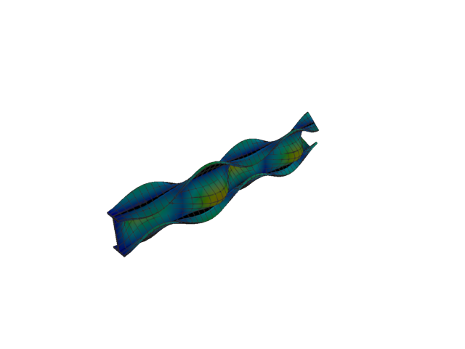
Figure 256: Abaqus — mode 10, 246.165 Hz
Solver | f [Hz] | λ [rad²/s²] | Meff X [kg] | Meff Y [kg] | Meff Z [kg] | Γ X | Γ Y | Γ Z
Abaqus | 246.170 | 2.39228e+06 | 3.32e-21 | 1.47 | 1.28e-24 | 5.76e-11 | 1.212 | -1.13e-12

Mode 11
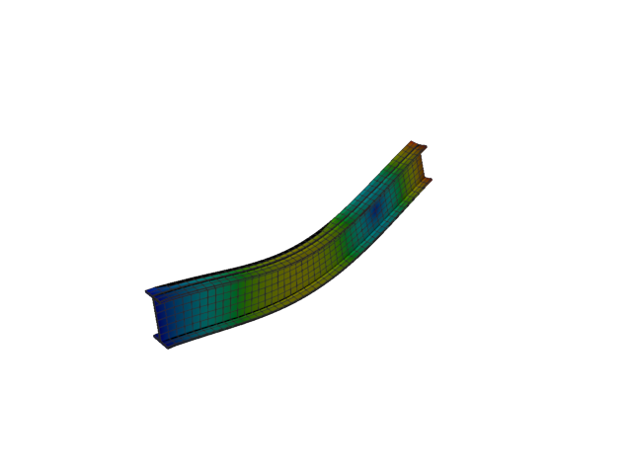
Figure 257: Abaqus — mode 11, 252.573 Hz
Solver | f [Hz] | λ [rad²/s²] | Meff X [kg] | Meff Y [kg] | Meff Z [kg] | Γ X | Γ Y | Γ Z
Abaqus | 252.570 | 2.51846e+06 | 4.57e-21 | 2.25e-19 | 40.26 | 6.76e-11 | 4.75e-10 | -6.345

Plate eigenvalue analysis
The plain and the stiffened strip, at the eigen case’s 0.0625 m seed.

Shell, 1st order, plain

Mode 1
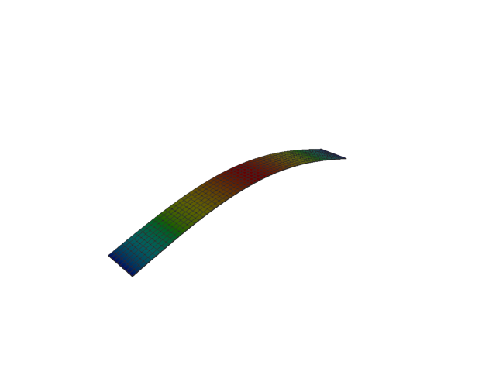
Figure 258: Abaqus — mode 1, 1.537 Hz
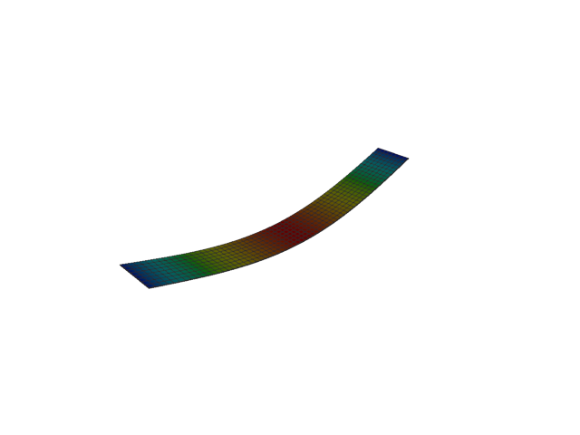
Figure 259: Sesam — mode 1, 1.537 Hz
Solver | f [Hz] | Δf vs closed form [%] | λ [rad²/s²] | Meff X [kg] | Meff Y [kg] | Meff Z [kg] | Γ X | Γ Y | Γ Z
Abaqus | 1.537 | +0.03 | 93.269 | 6.40e-31 | 3.03e-35 | 127.26 | -8.00e-16 | 5.50e-18 | 11.281
Sesam | 1.537 | -4.98e-06 | 93.2152 | 2.62e-40 | 5.38e-45 | 127.17 | -1.62e-20 | 7.33e-23 | -11.277
Closed form | 1.537

Mode 2
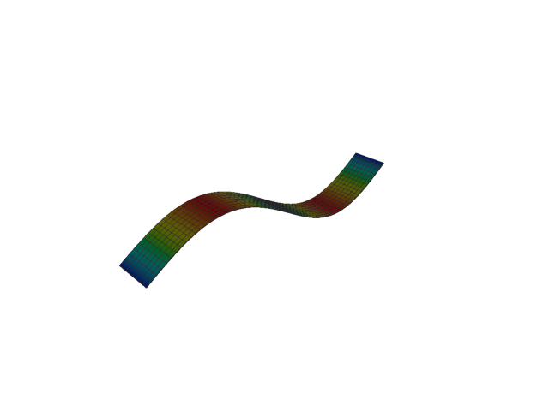
Figure 260: Abaqus — mode 2, 6.154 Hz
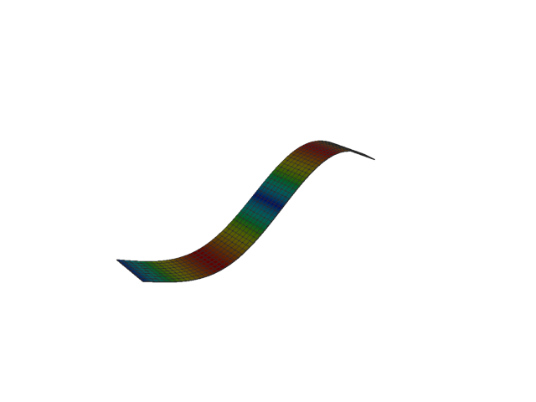
Figure 261: Sesam — mode 2, 6.146 Hz
Solver | f [Hz] | Δf vs closed form [%] | λ [rad²/s²] | Meff X [kg] | Meff Y [kg] | Meff Z [kg] | Γ X | Γ Y | Γ Z
Abaqus | 6.154 | +0.12 | 1494.9 | 5.42e-31 | 1.34e-33 | 5.32e-21 | 7.36e-16 | -3.66e-17 | 7.29e-11
Sesam | 6.146 | 1.13e-05 | 1491.44 | 2.17e-34 | 3.37e-39 | 9.71e-23 | -1.47e-17 | 5.81e-20 | -9.85e-12
Closed form | 6.146

Mode 3
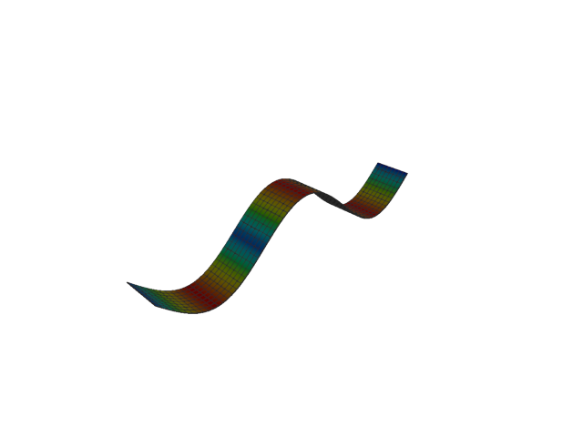
Figure 262: Abaqus — mode 3, 13.866 Hz
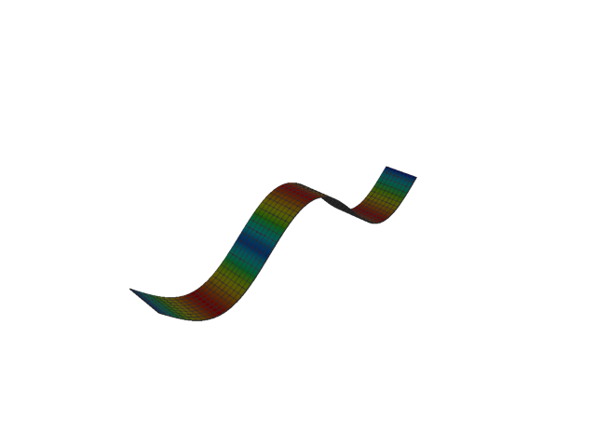
Figure 263: Sesam — mode 3, 13.829 Hz
Solver | f [Hz] | Δf vs closed form [%] | λ [rad²/s²] | Meff X [kg] | Meff Y [kg] | Meff Z [kg] | Γ X | Γ Y | Γ Z
Abaqus | 13.866 | +0.26 | 7589.9 | 4.43e-30 | 5.80e-32 | 14.14 | 2.10e-15 | -2.41e-16 | -3.760
Sesam | 13.829 | 6.01e-05 | 7550.43 | 2.14e-34 | 3.80e-39 | 14.05 | -1.46e-17 | 6.17e-20 | -3.748
Closed form | 13.829

Mode 4
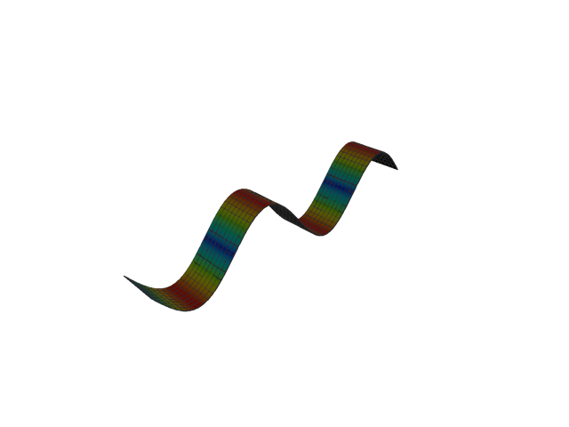
Figure 264: Abaqus — mode 4, 24.700 Hz
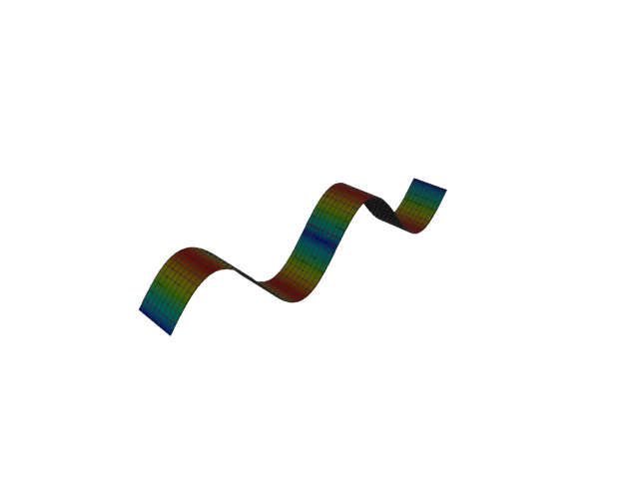
Figure 265: Sesam — mode 4, 24.586 Hz
Solver | f [Hz] | Δf vs closed form [%] | λ [rad²/s²] | Meff X [kg] | Meff Y [kg] | Meff Z [kg] | Γ X | Γ Y | Γ Z
Abaqus | 24.700 | +0.46 | 24086 | 1.04e-28 | 7.36e-32 | 1.83e-23 | -1.02e-14 | 2.71e-16 | 4.27e-12
Sesam | 24.586 | 1.01e-04 | 23863.1 | 1.77e-33 | 1.52e-36 | 1.13e-23 | 4.21e-17 | 1.23e-18 | 3.36e-12
Closed form | 24.586

Mode 5
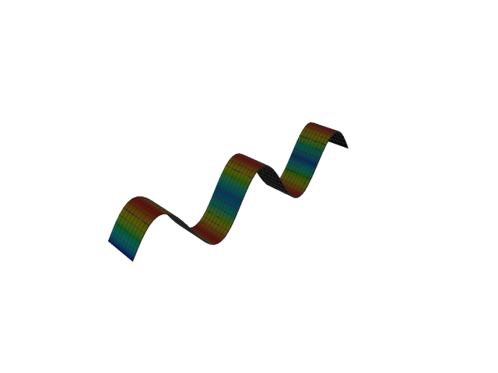
Figure 266: Abaqus — mode 5, 38.695 Hz
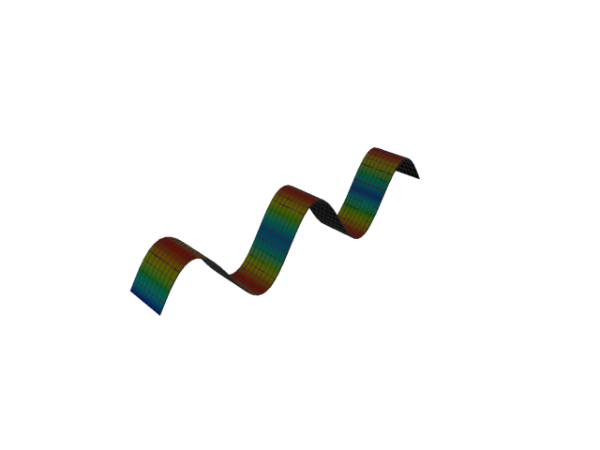
Figure 267: Sesam — mode 5, 38.415 Hz
Solver | f [Hz] | Δf vs closed form [%] | λ [rad²/s²] | Meff X [kg] | Meff Y [kg] | Meff Z [kg] | Γ X | Γ Y | Γ Z
Abaqus | 38.695 | +0.73 | 59111 | 1.02e-28 | 1.84e-30 | 5.09 | 1.01e-14 | -1.36e-15 | 2.256
Sesam | 38.415 | 2.42e-04 | 58259.8 | 1.78e-26 | 3.30e-27 | 5.00 | 1.33e-13 | 5.75e-14 | 2.236
Closed form | 38.415

Mode 6
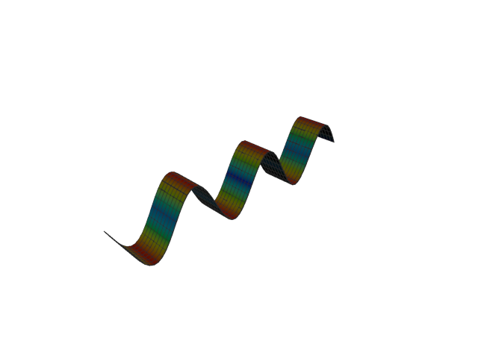
Figure 268: Abaqus — mode 6, 55.900 Hz
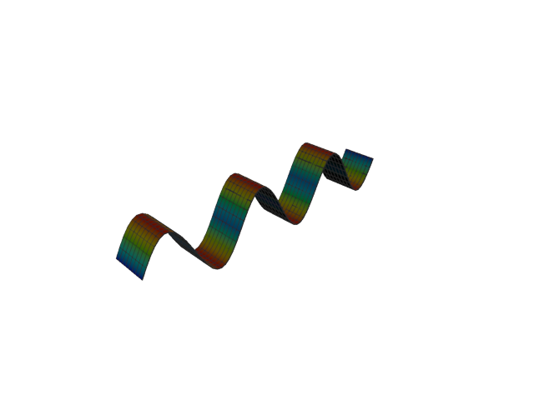
Figure 269: Sesam — mode 6, 55.318 Hz
Solver | f [Hz] | Δf vs closed form [%] | λ [rad²/s²] | Meff X [kg] | Meff Y [kg] | Meff Z [kg] | Γ X | Γ Y | Γ Z
Abaqus | 55.900 | +1.05 | 123361 | 4.94e-20 | 7.80e-26 | 3.09e-20 | -2.22e-10 | -2.79e-13 | -1.76e-10
Sesam | 55.318 | 5.30e-04 | 120808 | 1.43e-17 | 2.77e-18 | 6.63e-16 | 3.78e-09 | 1.66e-09 | -2.58e-08
Closed form | 55.318

Shell, 1st order, stiffened

Mode 1
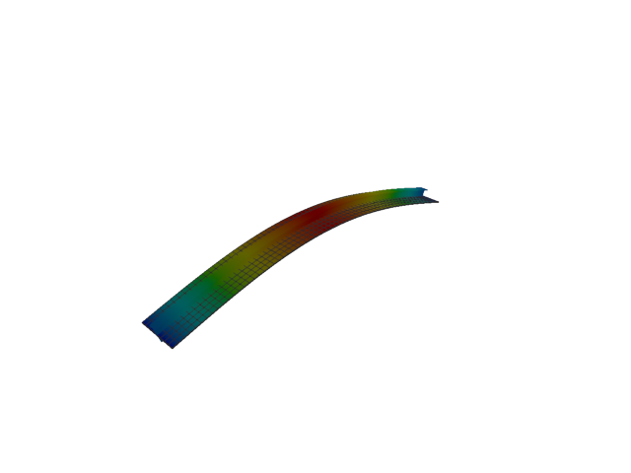
Figure 270: Abaqus — mode 1, 21.242 Hz
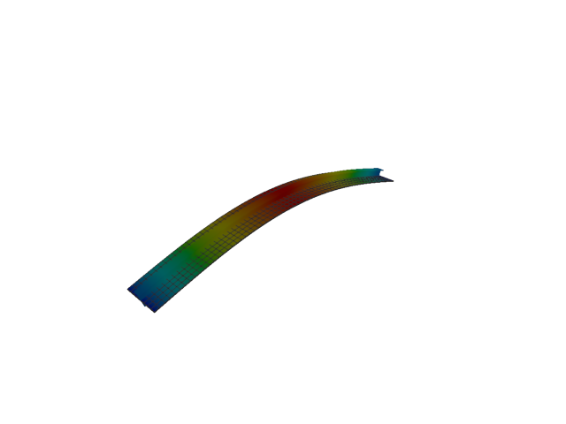
Figure 271: Sesam — mode 1, 18.917 Hz
Solver | f [Hz] | Δf vs mean [%] | λ [rad²/s²] | Meff X [kg] | Meff Y [kg] | Meff Z [kg] | Γ X | Γ Y | Γ Z
Abaqus | 21.242 | +5.79 | 17813 | 0.05 | 9.45e-26 | 195.80 | -0.214 | -3.07e-13 | 13.993
Sesam | 18.917 | -5.79 | 14127.2 | 2.29e-32 | 2.10e-37 | 195.94 | -1.51e-16 | -4.58e-19 | 13.998

Mode 2
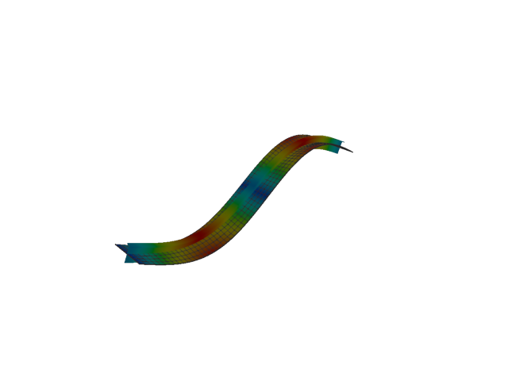
Figure 272: Abaqus — mode 2, 80.469 Hz
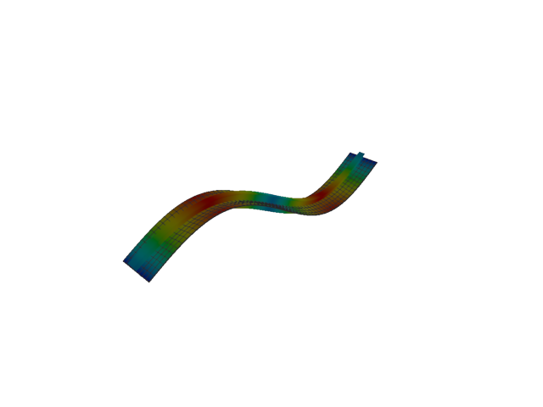
Figure 273: Sesam — mode 2, 70.063 Hz
Solver | f [Hz] | Δf vs mean [%] | λ [rad²/s²] | Meff X [kg] | Meff Y [kg] | Meff Z [kg] | Γ X | Γ Y | Γ Z
Abaqus | 80.469 | +6.91 | 255632 | 0.16 | 1.91e-25 | 3.42e-05 | 0.403 | 4.37e-13 | 0.006
Sesam | 70.063 | -6.91 | 193794 | 4.69e-34 | 9.89e-36 | 8.76e-26 | 2.17e-17 | 3.14e-18 | 2.96e-13

Mode 3
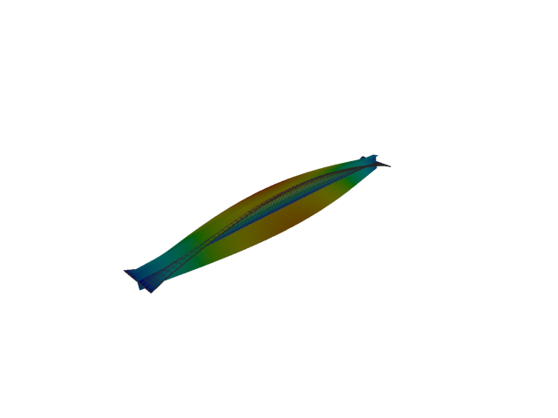
Figure 274: Abaqus — mode 3, 93.088 Hz
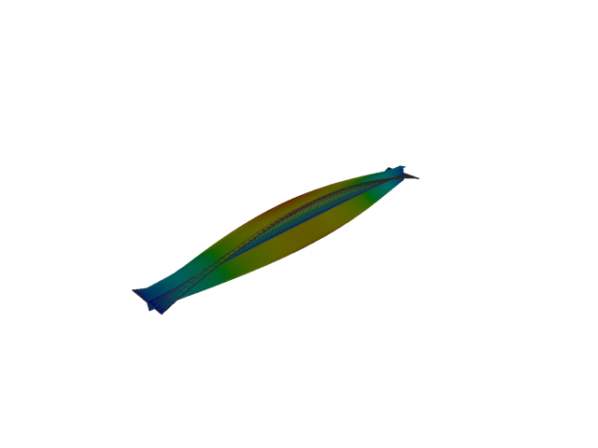
Figure 275: Sesam — mode 3, 92.575 Hz
Solver | f [Hz] | Δf vs mean [%] | λ [rad²/s²] | Meff X [kg] | Meff Y [kg] | Meff Z [kg] | Γ X | Γ Y | Γ Z
Abaqus | 93.088 | +0.28 | 342097 | 2.75e-24 | 3.95 | 1.03e-23 | 1.66e-12 | 1.988 | 3.22e-12
Sesam | 92.575 | -0.28 | 338332 | 5.73e-33 | 2.02e-07 | 3.30e-28 | -7.57e-17 | 4.49e-04 | 1.82e-14

Mode 4
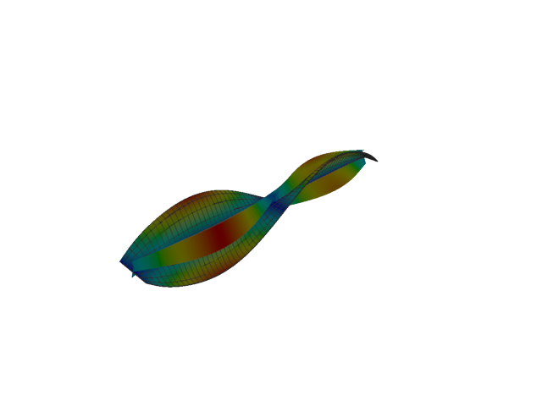
Figure 276: Abaqus — mode 4, 106.618 Hz
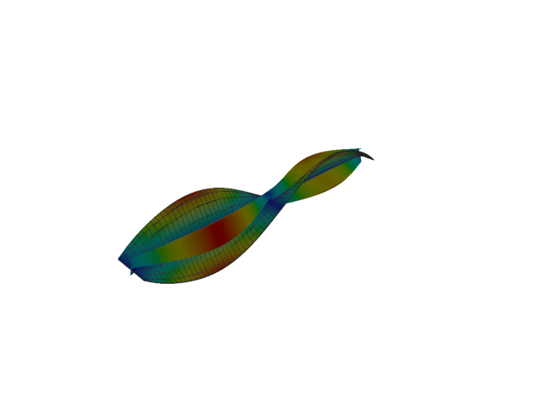
Figure 277: Sesam — mode 4, 100.998 Hz
Solver | f [Hz] | Δf vs mean [%] | λ [rad²/s²] | Meff X [kg] | Meff Y [kg] | Meff Z [kg] | Γ X | Γ Y | Γ Z
Abaqus | 106.620 | +2.71 | 448765 | 1.14e-22 | 2.35e-08 | 5.91e-22 | 1.07e-11 | 1.53e-04 | -2.43e-11
Sesam | 100.998 | -2.71 | 402700 | 1.38e-29 | 1.02e-09 | 1.26e-26 | -3.71e-15 | 3.19e-05 | 1.12e-13

Mode 5
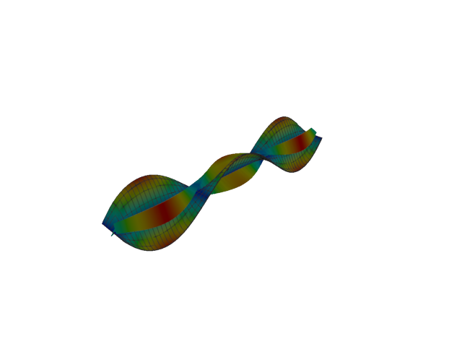
Figure 278: Abaqus — mode 5, 128.504 Hz
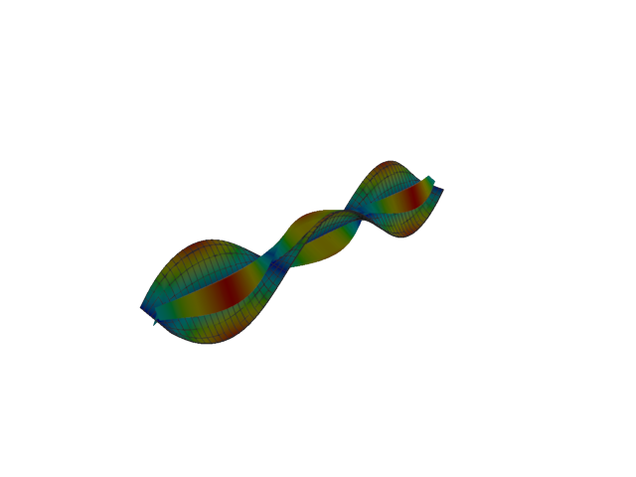
Figure 279: Sesam — mode 5, 115.222 Hz
Solver | f [Hz] | Δf vs mean [%] | λ [rad²/s²] | Meff X [kg] | Meff Y [kg] | Meff Z [kg] | Γ X | Γ Y | Γ Z
Abaqus | 128.500 | +5.45 | 651919 | 5.66e-20 | 0.39 | 1.44e-19 | 2.38e-10 | -0.624 | 3.79e-10
Sesam | 115.222 | -5.45 | 524118 | 4.47e-23 | 4.62e-07 | 1.89e-22 | -6.69e-12 | -0.001 | 1.37e-11

Mode 6
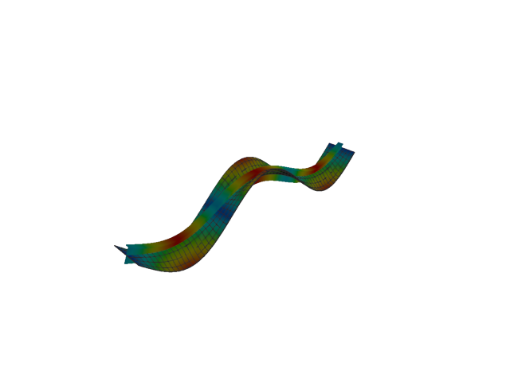
Figure 280: Abaqus — mode 6, 155.525 Hz
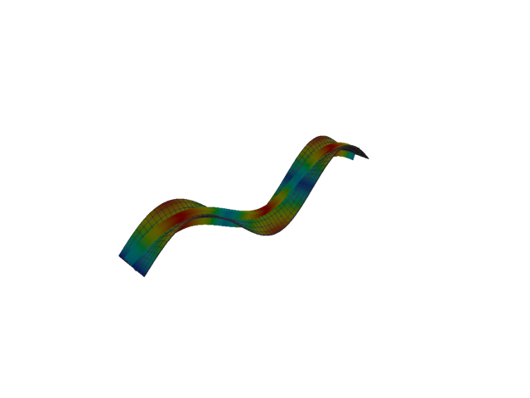
Figure 281: Sesam — mode 6, 134.344 Hz
Solver | f [Hz] | Δf vs mean [%] | λ [rad²/s²] | Meff X [kg] | Meff Y [kg] | Meff Z [kg] | Γ X | Γ Y | Γ Z
Abaqus | 155.520 | +7.31 | 954899 | 0.26 | 3.11e-16 | 20.18 | 0.507 | 1.76e-08 | -4.492
Sesam | 134.344 | -7.31 | 712516 | 3.13e-16 | 2.60e-18 | 20.78 | -1.77e-08 | 1.61e-09 | 4.558

Plate static analysis
The deflected strip under 1 kPa, plain and stiffened, at the same 0.0625 m seed. The other seeds deform into the same shape; their convergence is in the summary table.

Shell, 1st order, plain, seed 0.0625 m
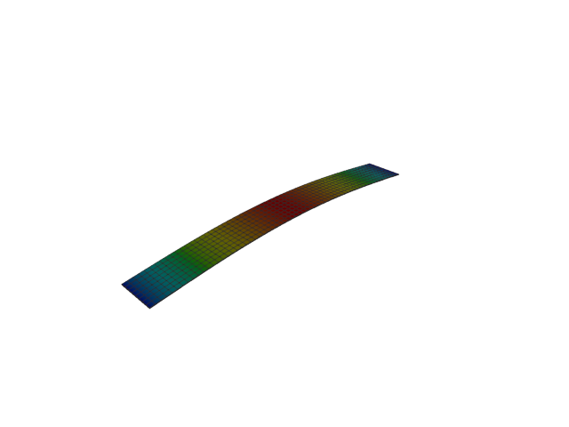
Figure 282: Abaqus — displacement
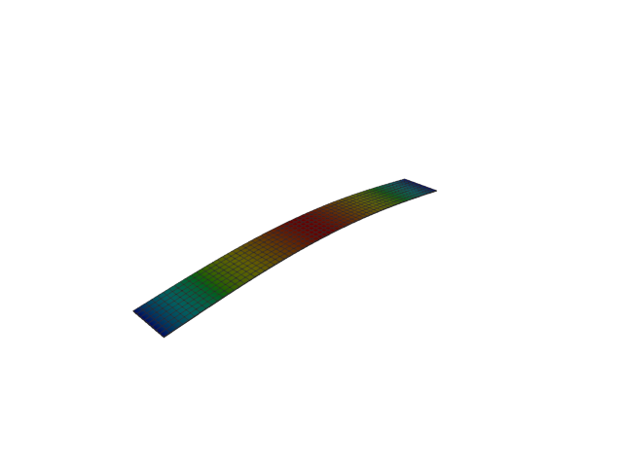
Figure 283: Sesam — displacement
Solver | Mid-span u_z [mm] | Δ vs closed form [%] | Peak u_z [mm] | Peak u_x [mm] | Peak u_y [mm]
Abaqus | 173.2686 | -0.04 | 173.2686 | 5.59e-17 | 4.12e-29
Sesam | 173.2995 | -0.02 | 173.2995 | 0.0000 | 0.0000
Closed form | 173.3333

Shell, 1st order, stiffened, seed 0.0625 m
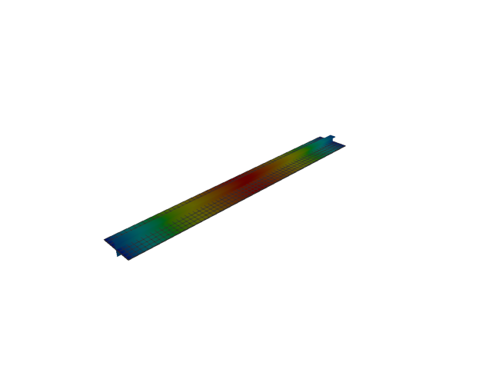
Figure 284: Abaqus — displacement
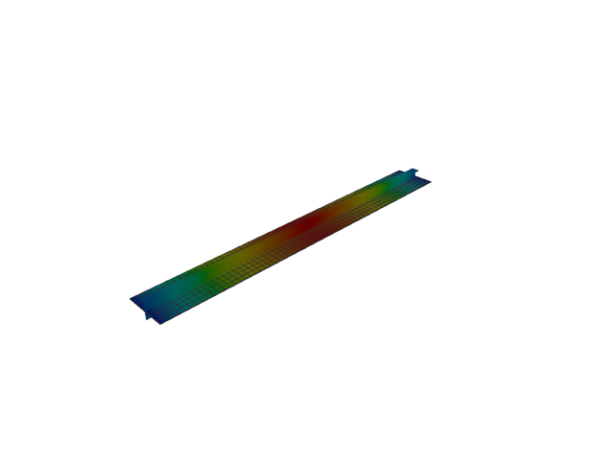
Figure 285: Sesam — displacement
Solver | Mid-span u_z [mm] | Δ vs mean [%] | Peak u_z [mm] | Peak u_x [mm] | Peak u_y [mm]
Abaqus | 0.5855 | -11.59 | 0.5934 | 0.0118 | 2.12e-05
Sesam | 0.7390 | +11.59 | 0.7474 | 1.25e-17 | 2.34e-17

