**DISCUSSION FORUM**

**DESIGN DOCUMENT**

*SET Software Organization*

**TABLE OF CONTENTS**

**1. Use Case Diagram**

**2. Class Diagram**

**3. Sequence Diagrams**

**3.1 Sign up sequence diagram**

**3.2 Sort displayed posts sequence diagram**

**3.3 Login / logout sequence diagram**

**3.4 Create new post sequence diagram**

**3.5 Edit post sequence diagram**

**3.6 Post new comment sequence diagram**

**3.7 Edit comment sequence diagram**

**3.8 Edit profile sequence diagram**

**3.9 Delete members’ comments sequence diagram**

**3.10 Delete members’ posts sequence diagram**

**1. Use Case Diagram**

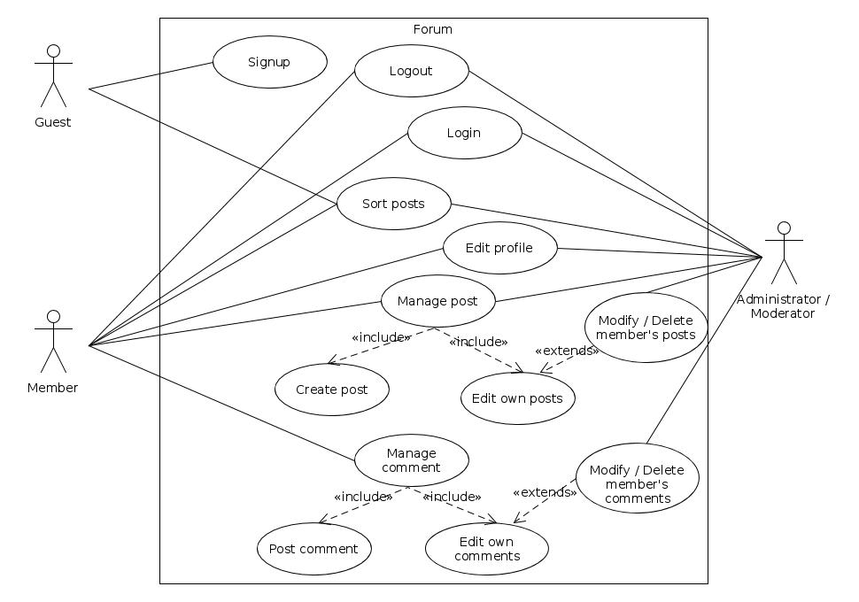

**2. Class Diagram**

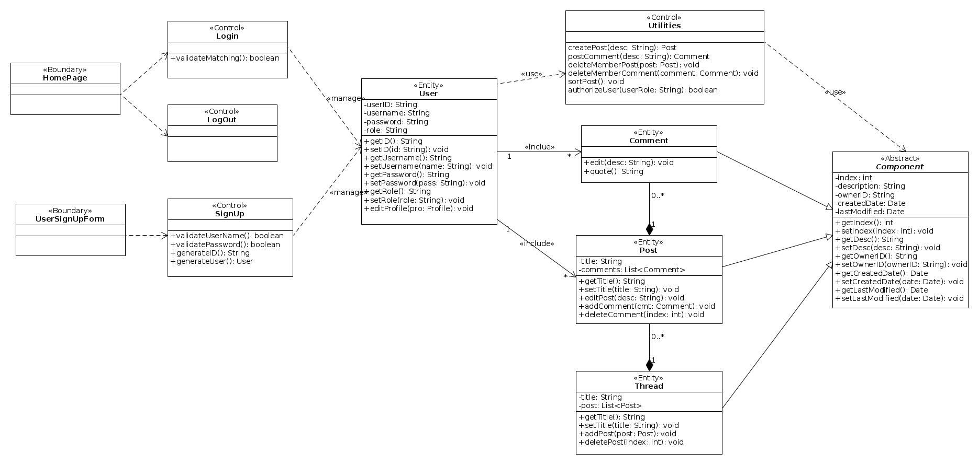

**3. Sequence Diagrams**

**3.1 Sign up sequence diagram**

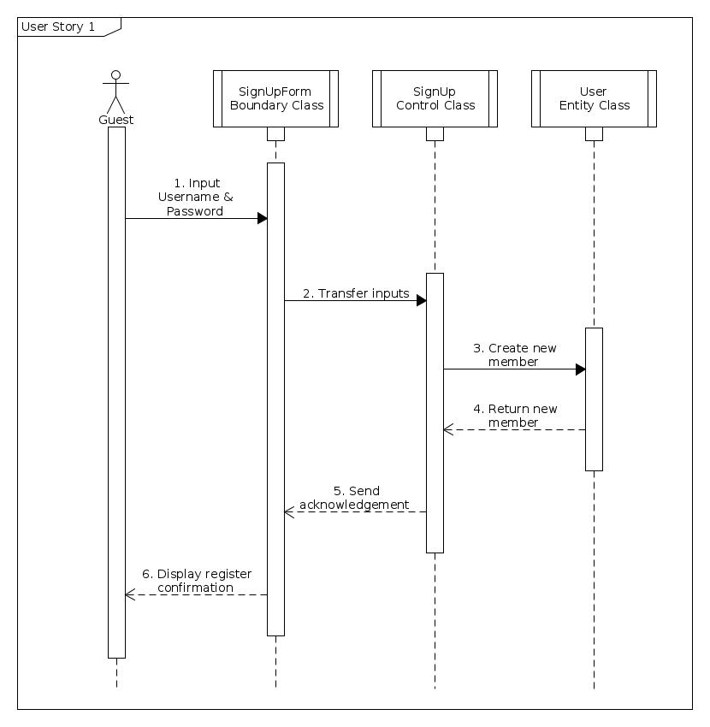

**3.2 Sort displayed posts sequence diagram**

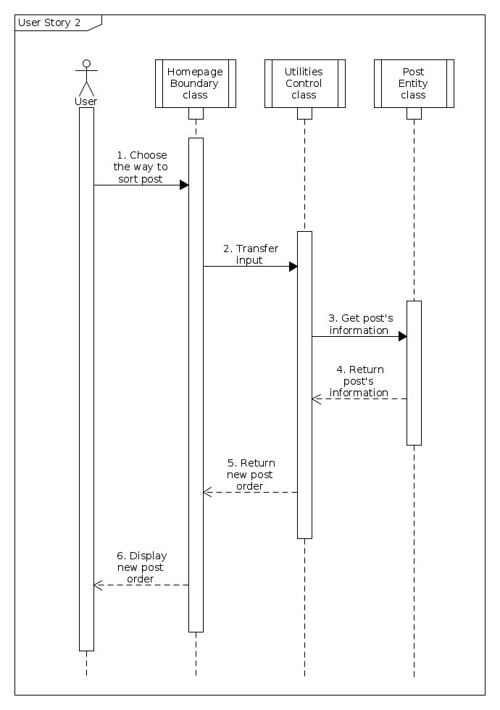

**3.3 Login / logout sequence diagram**

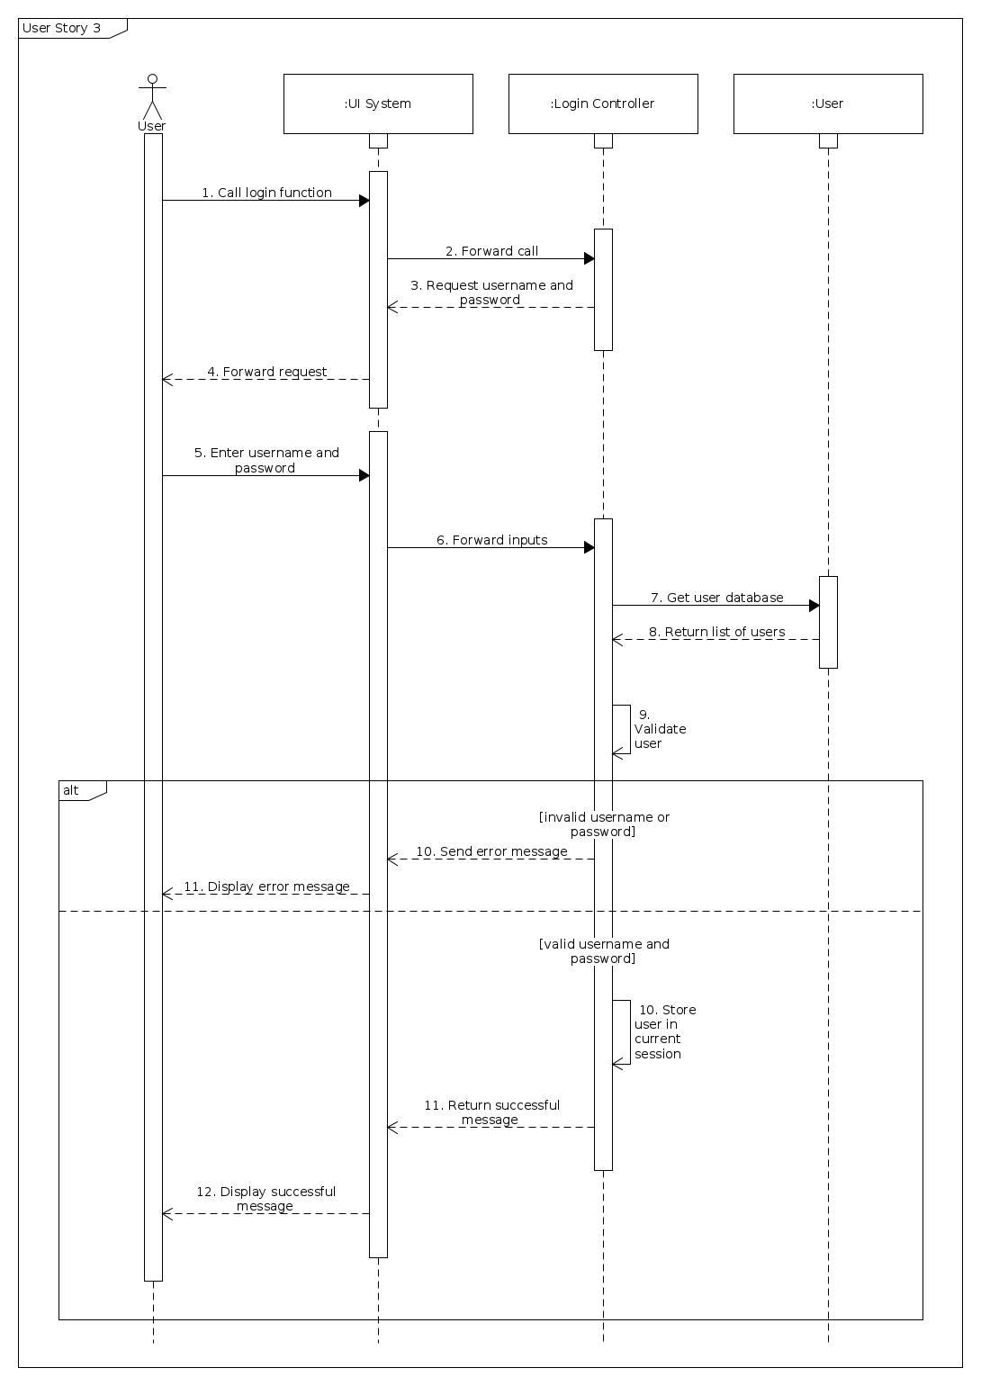

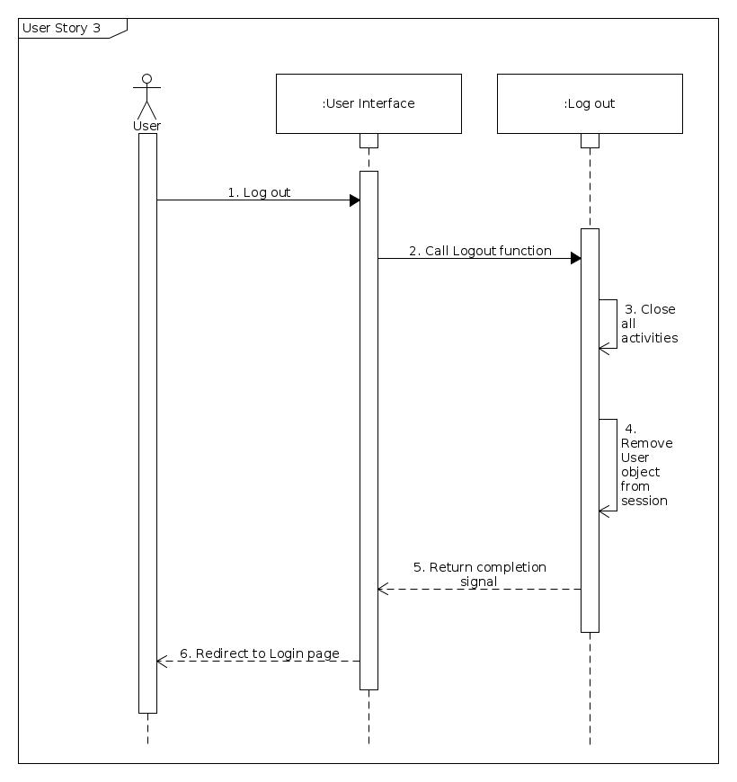

**3.4 Create new post sequence diagram**

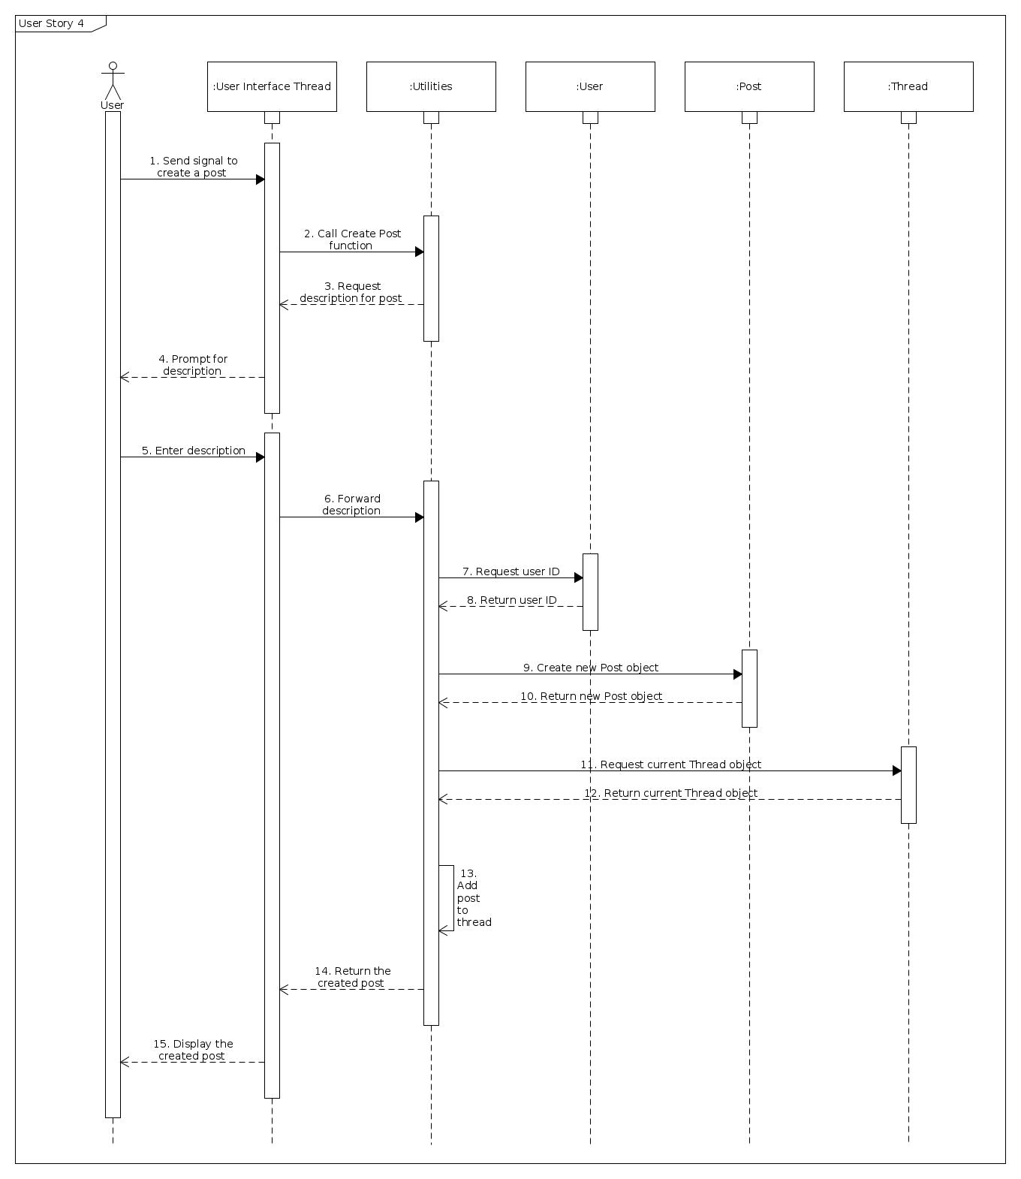

**3.5 Edit post sequence diagram**

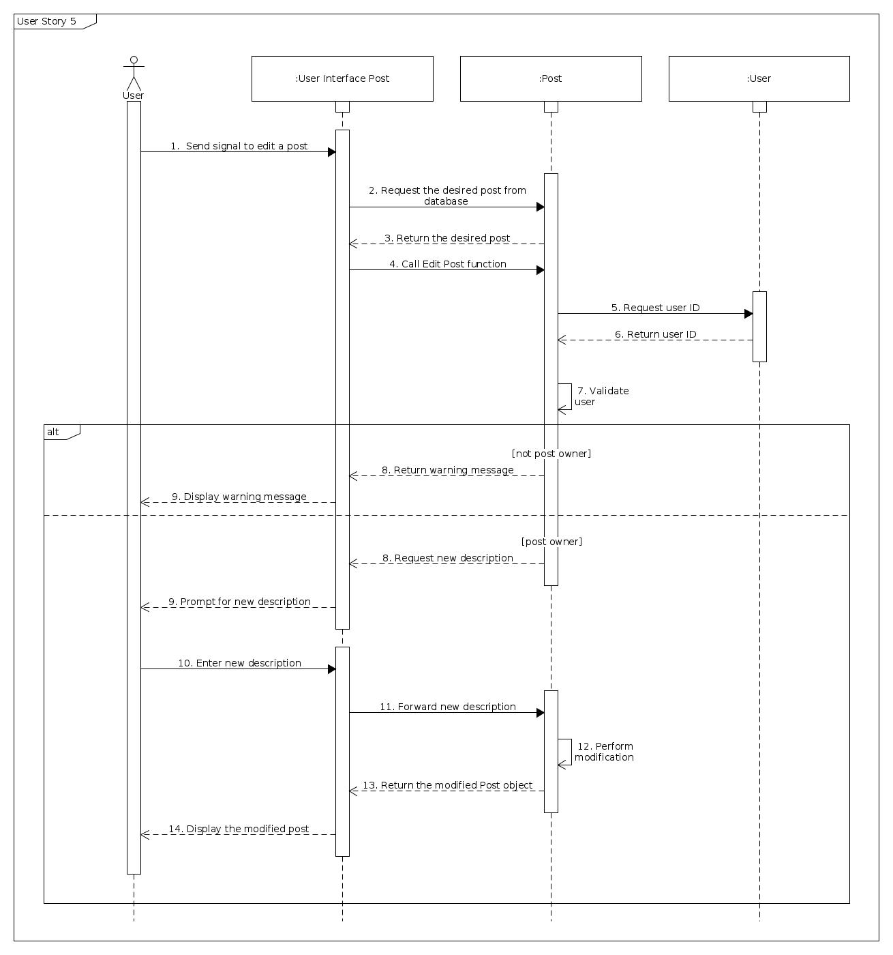

**3.6 Post new comment sequence diagram**

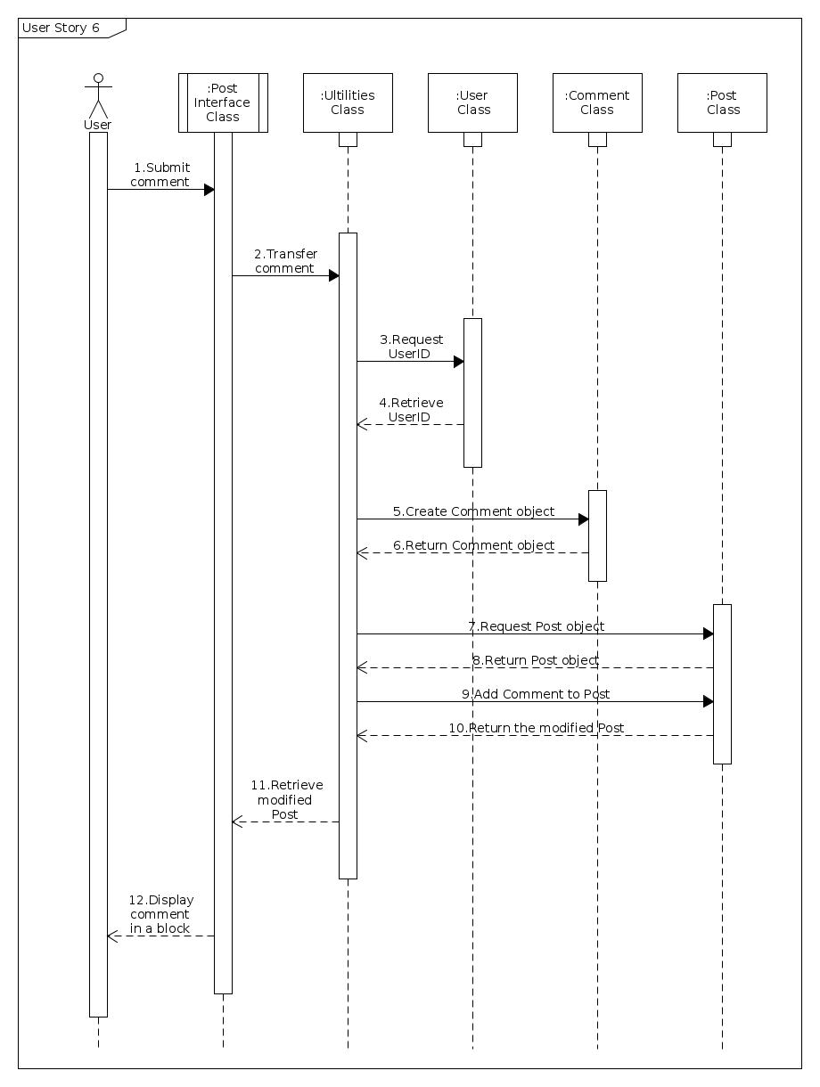

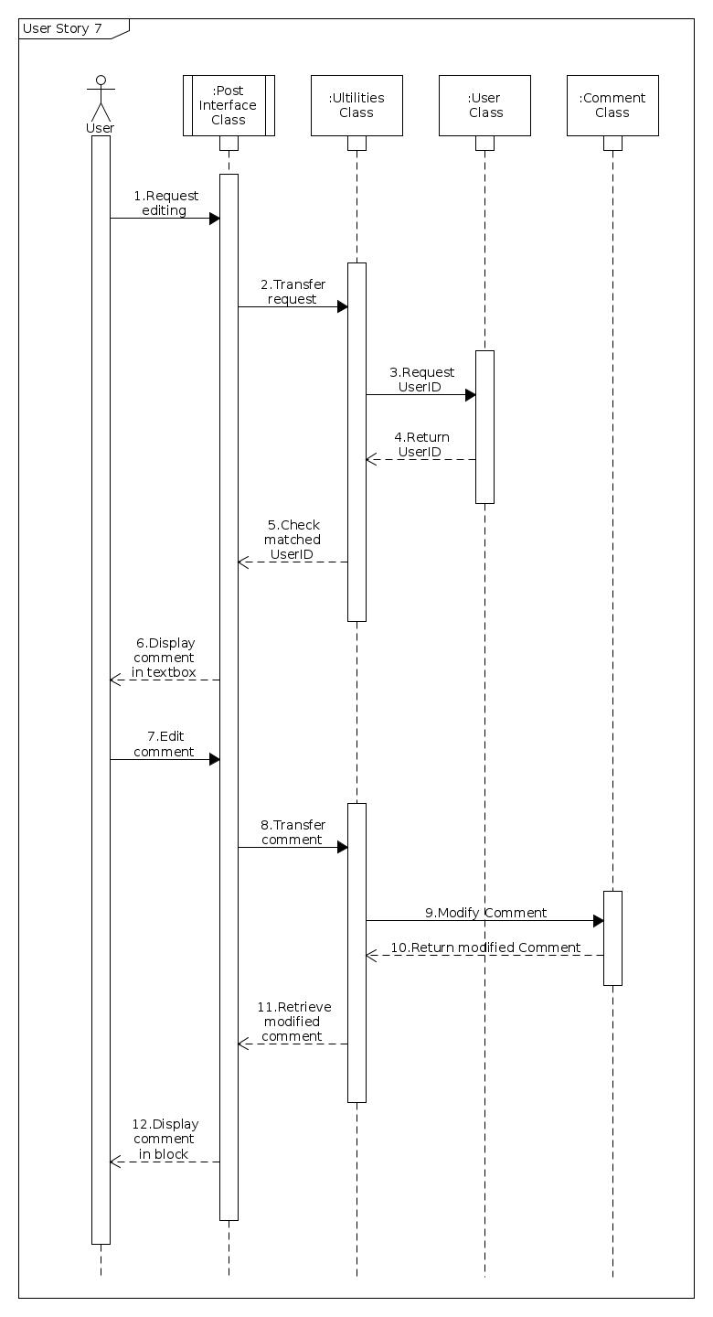**3.7 Edit comment sequence diagram**

**3.8 Edit profile sequence diagram**

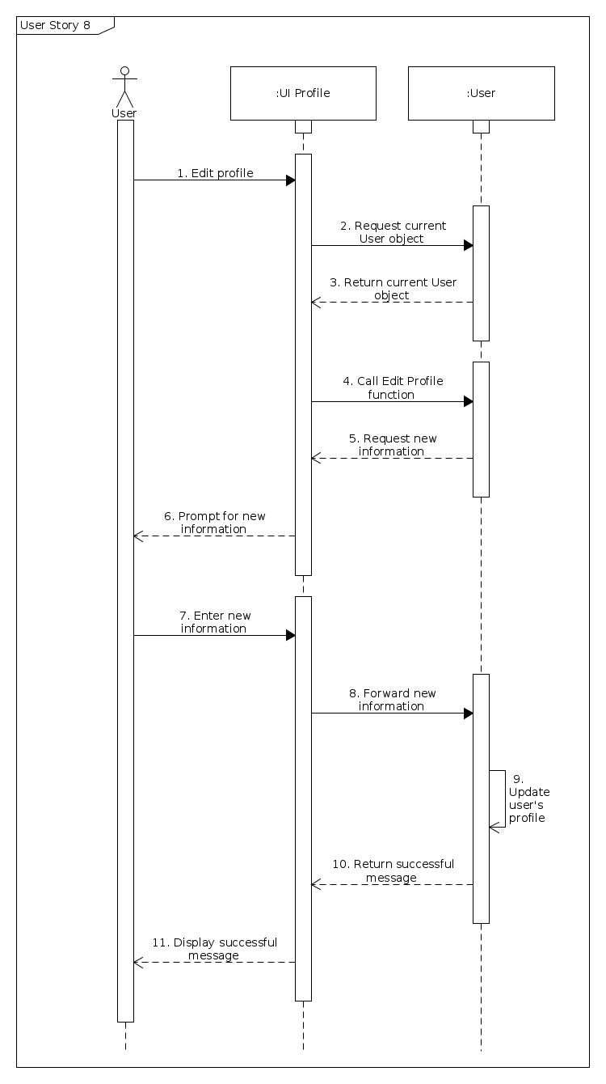

**3.9 Delete members’ comments sequence diagram**

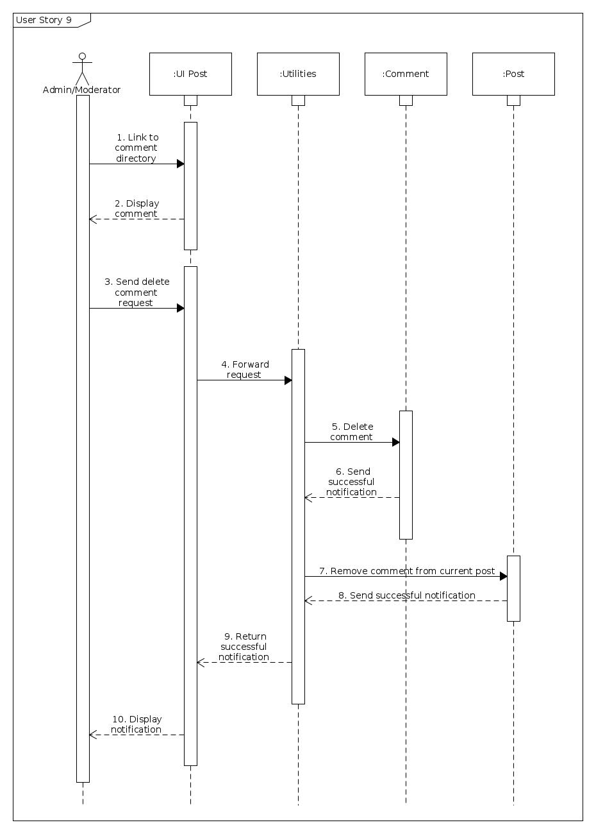

**3.10 Delete members’ posts sequence diagram**

