**DISCUSSION FORUM**

**DESIGN DOCUMENT**

*SET Software Organization*

**TABLE OF CONTENTS**

**1. System Architecture**

**2. Use Case Diagram**

**3. Class Diagram**

**4. Sequence Diagrams**

**4.1 Sign up sequence diagram**

**4.2 Sort displayed posts sequence diagram**

**4.3 Login / logout sequence diagram**

**4.4 Create new post sequence diagram**

**4.5 Edit post sequence diagram**

**4.6 Post new comment sequence diagram**

**4.7 Edit comment sequence diagram**

**4.8 Edit profile sequence diagram**

**4.9 Delete members’ comments sequence diagram**

**4.10 Delete members’ posts sequence diagram**

**1. System Architecture**

The MVC (Model – View – Controller) pattern is applied as the main system architecture for our project, an Online Discussion Forum.

The *View component* provides the user interface elements for different applications of the system. This component makes use of the Model to display the desired information and the Controller to display processed data corresponding to specific user events. There are three kinds of interfaces:

1. **Main Interface**: display the forum’s homepage with all the theads and corresponding posts listed in a specific order.
2. **User Management Interface**: display the GUIs for all functions relating to user management services.
3. **Discussion Mangement Interface**: display the GUIs for all functions relating to discussion services.

The *Model component* contains the main data models used in the system. There are two kinds of models:

1. **DBConnection Model:** used to provide a database connection.
2. **Entity Model:** represent basic entities existed in the system.

The *Controller component* includes all of the main functions and services deployed in the final system. This component tries to process and update the Model according to the corresponding user events, and return the results to the View component to display.

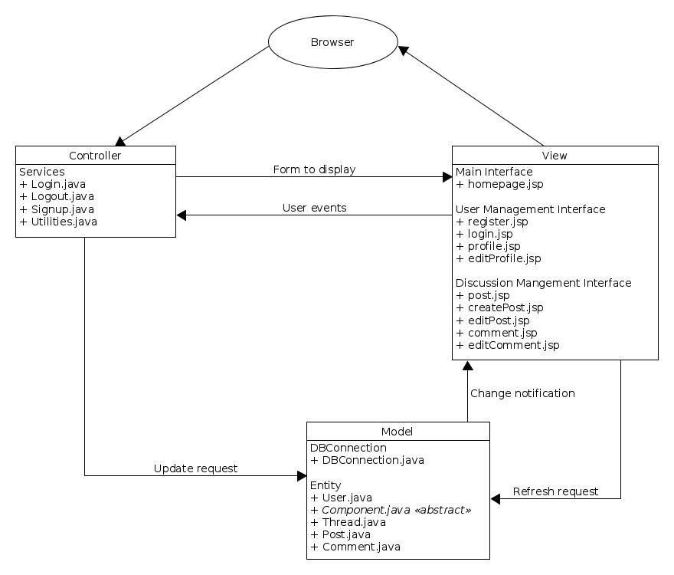

**2. Use Case Diagram**

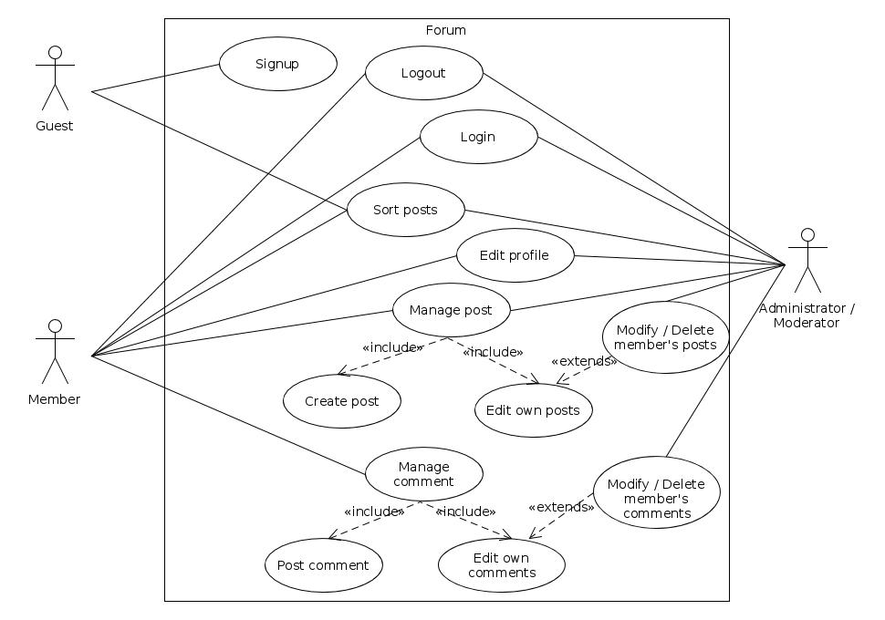

**3. Class Diagram**

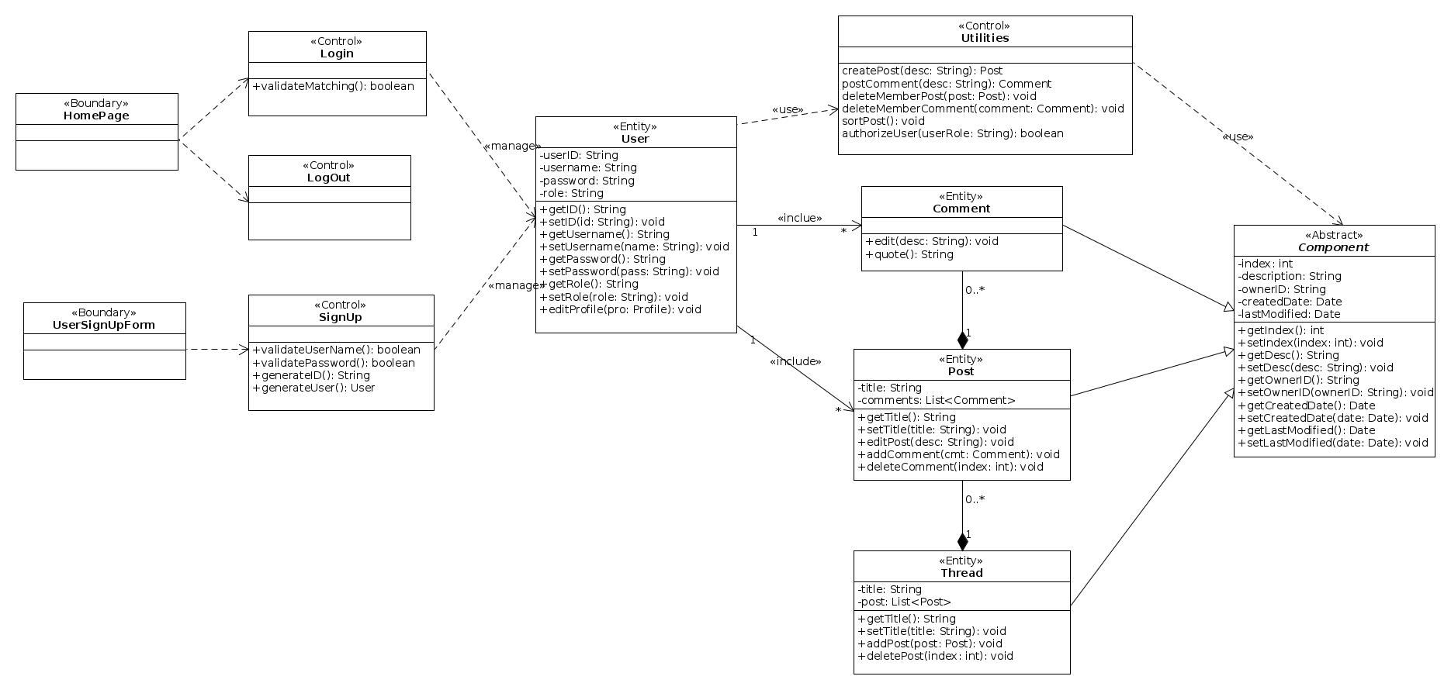

**4. Sequence Diagrams**

**4.1 Sign up sequence diagram**

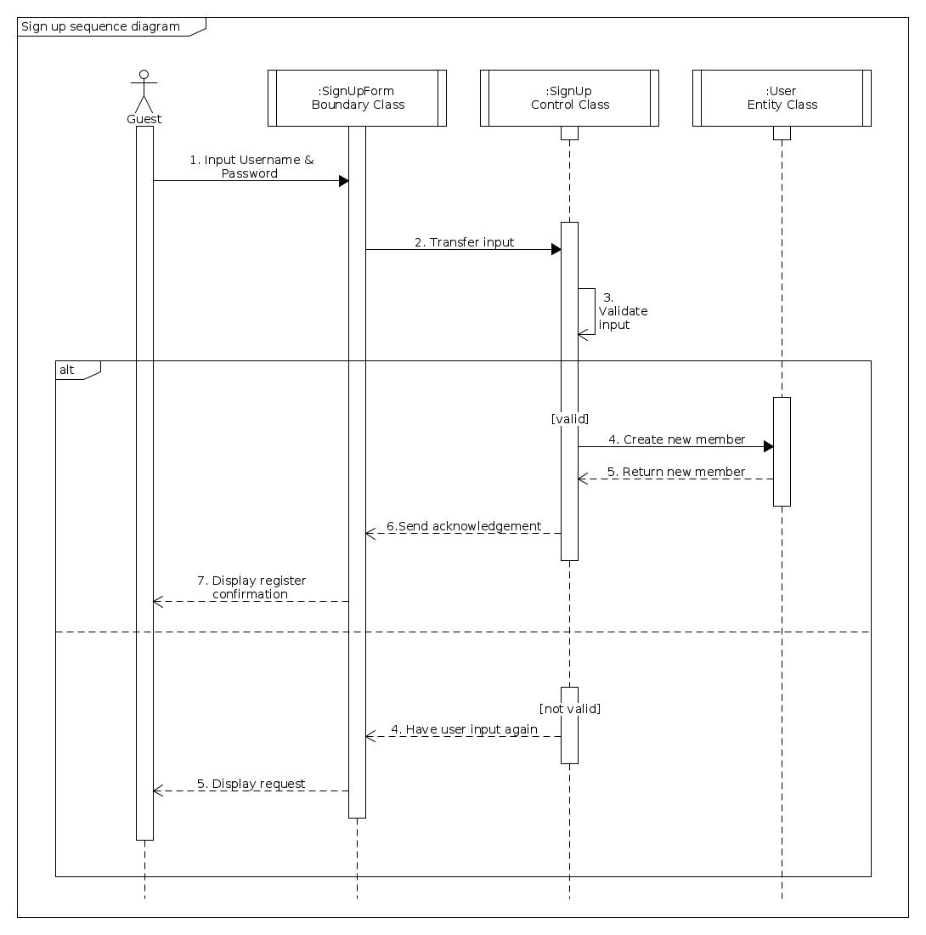

**4.2 Sort displayed posts sequence diagram**

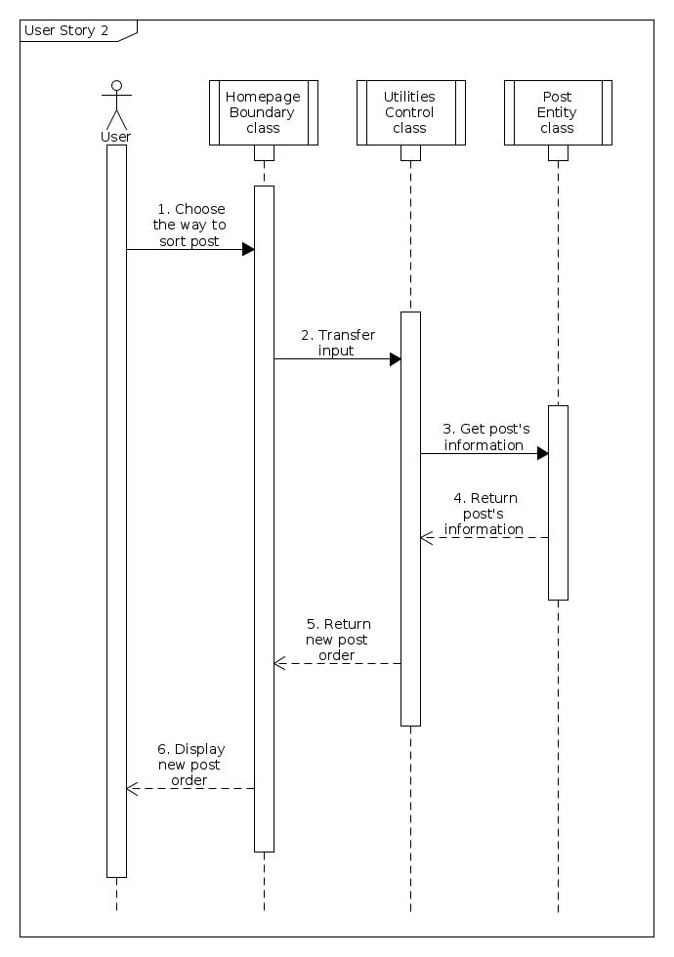

**4.3 Login / logout sequence diagram**

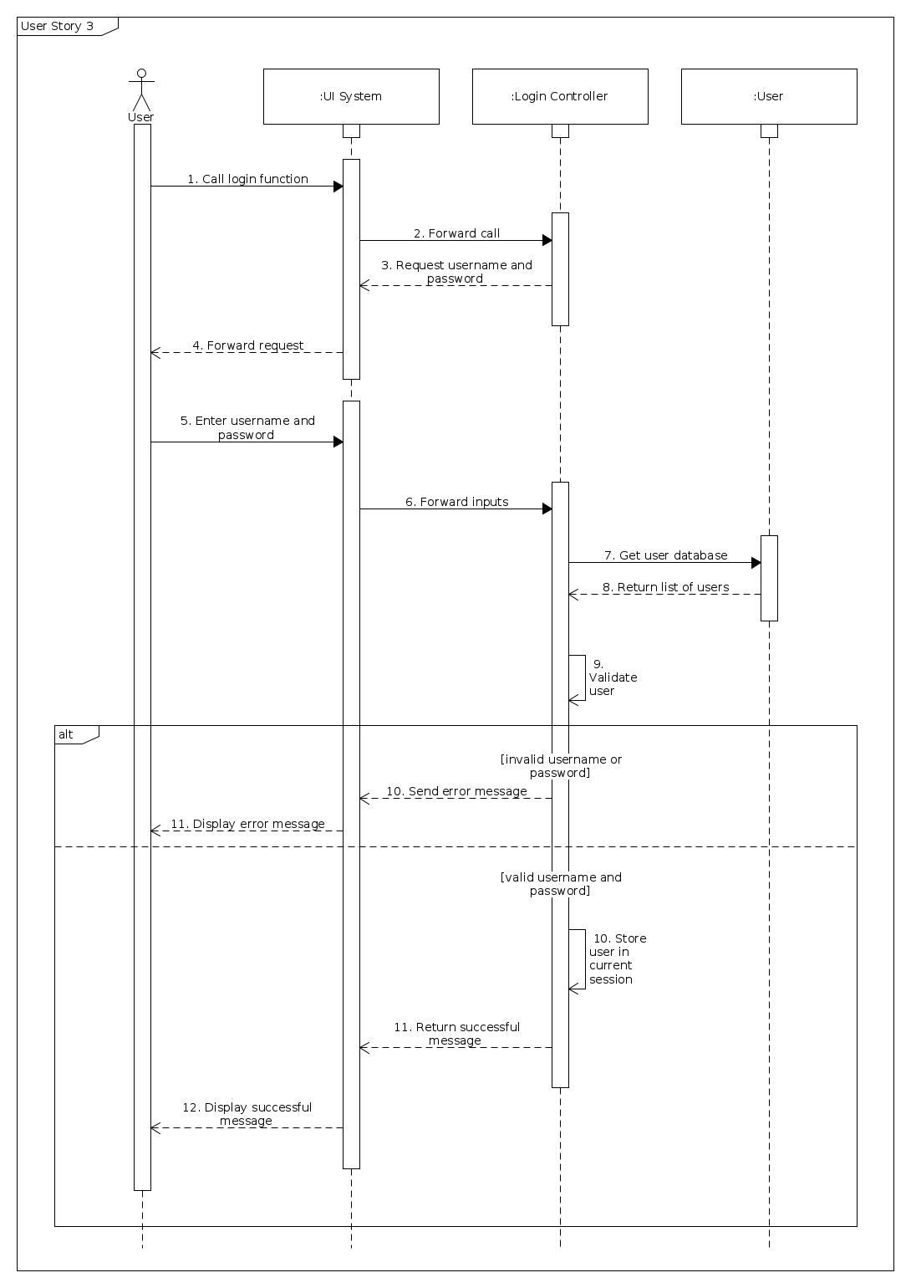

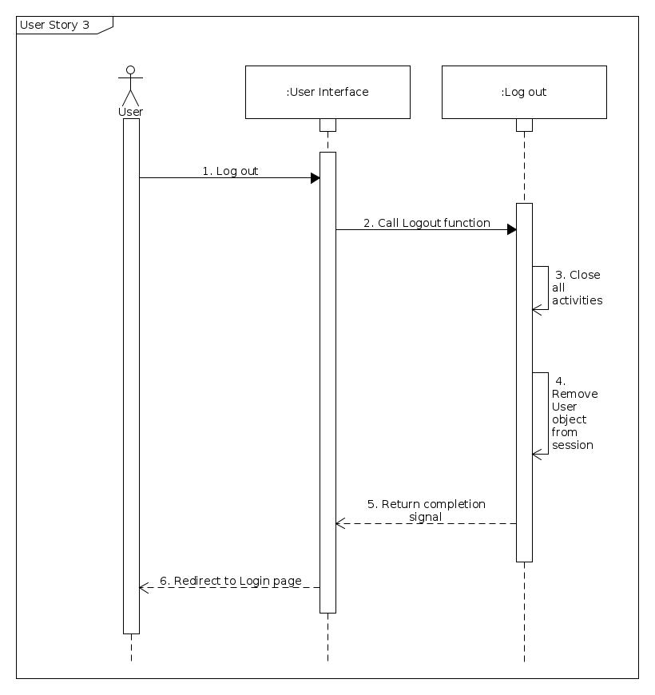

**4.4 Create new post sequence diagram**

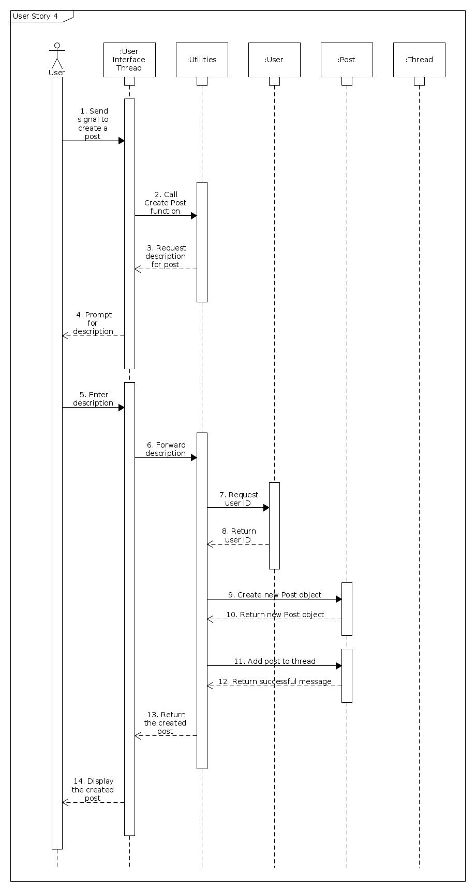

**4.5 Edit post sequence diagram**

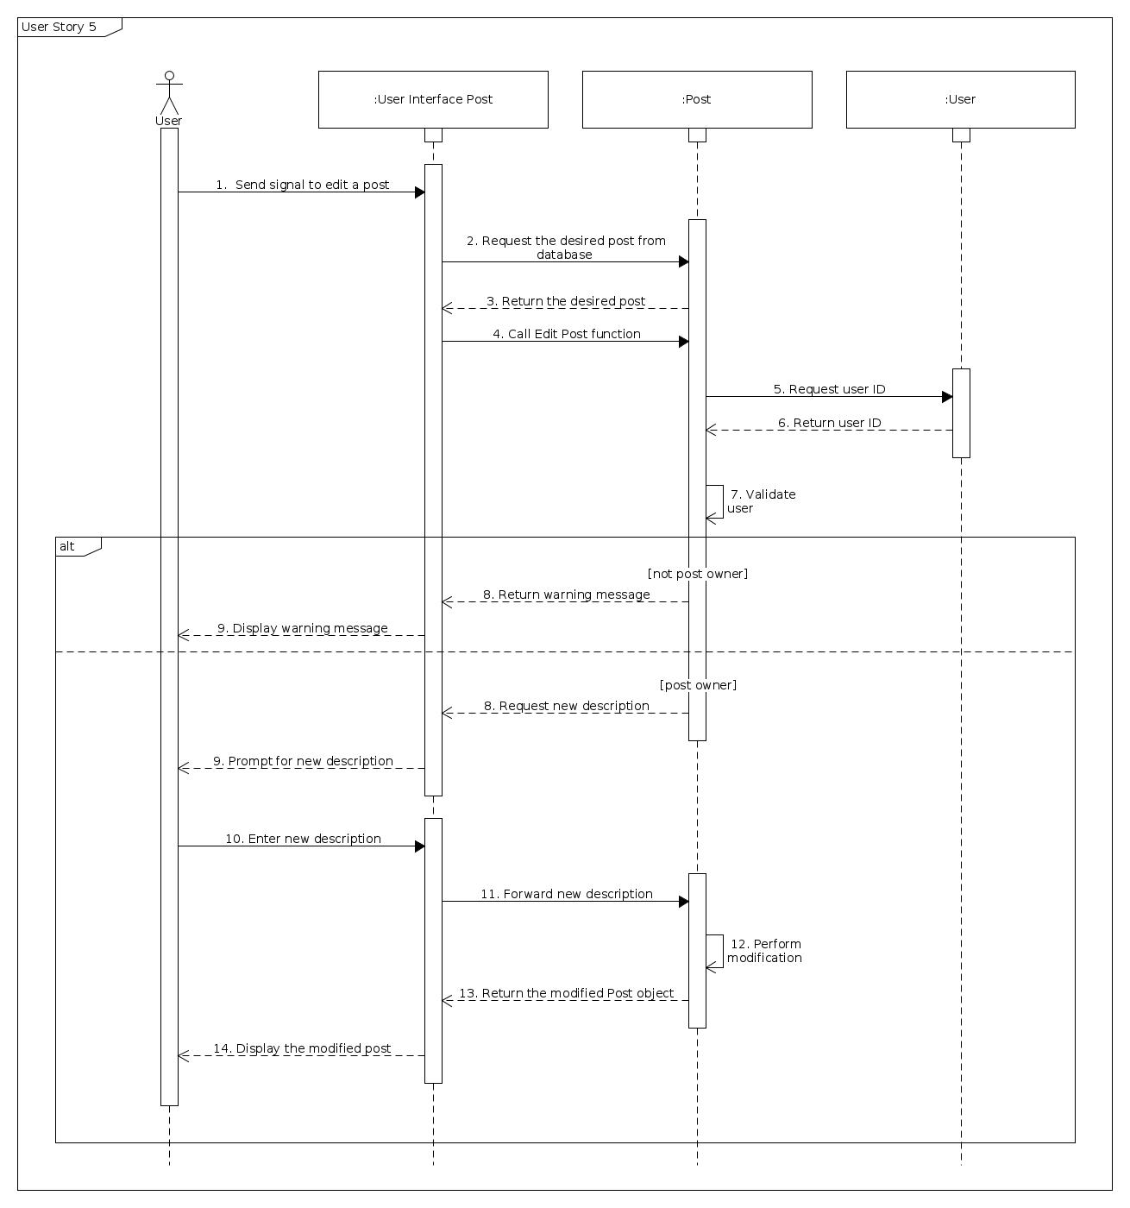

**4.6 Post new comment sequence diagram**

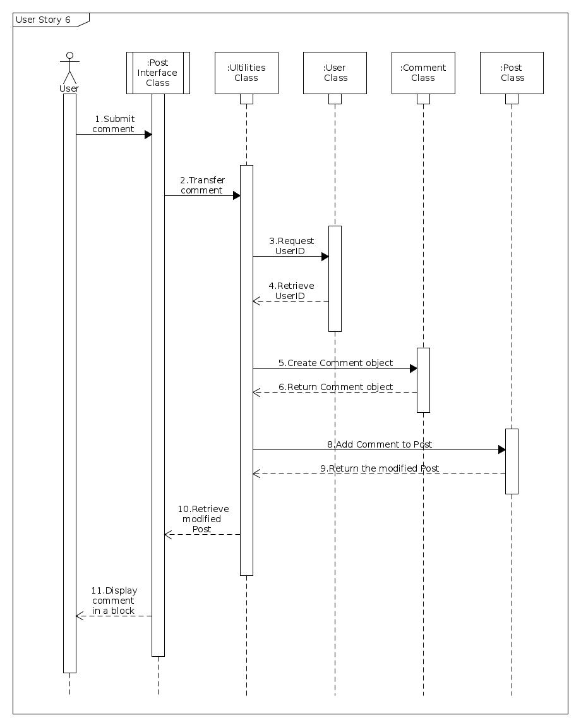

**4.7 Edit comment sequence diagram**

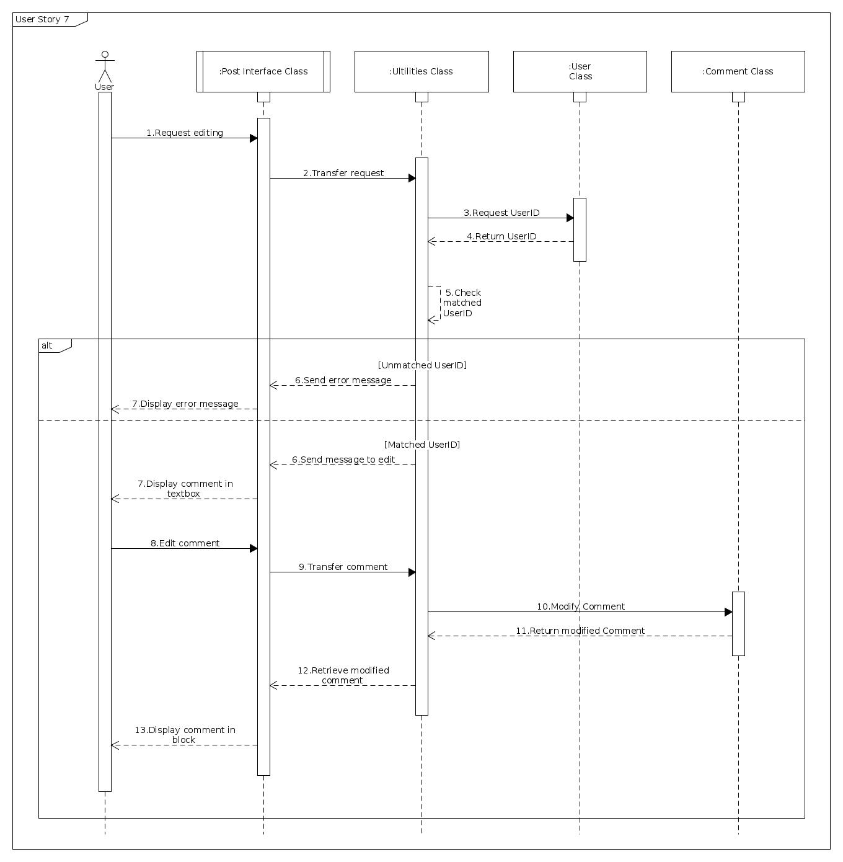

**4.8 Edit profile sequence diagram**

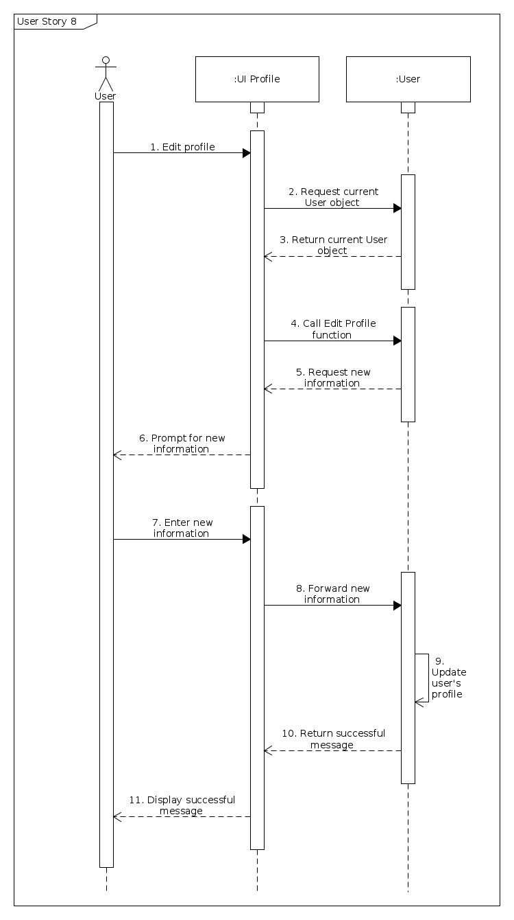

**4.9 Delete members’ comments sequence diagram**

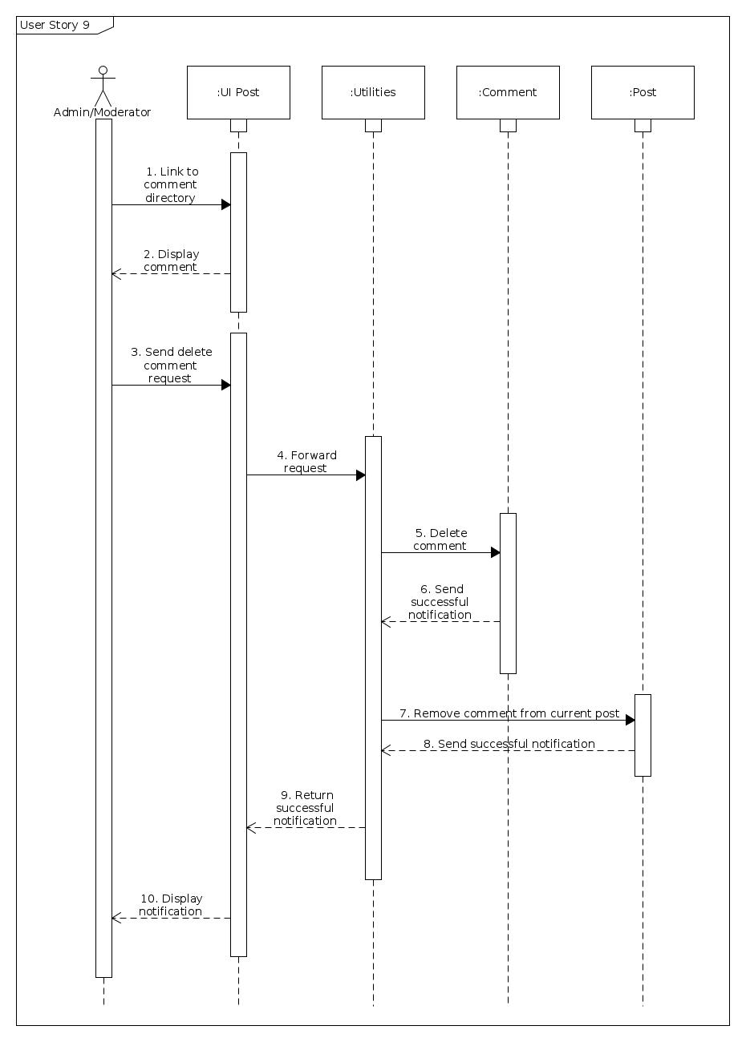

**4.10 Delete members’ posts sequence diagram**

