Online Retail Application:

Project Plan

|  |  |
| --- | --- |
| Lê Quang Minh Anh | ITITIU14004 |
| Nguyễn Xuân Anh | ITITIU14114 |
| Phạm Lê Trung | ITITIU14102 |
| Mai Thanh Bình | ITITIU12029 |
| Đỗ Quốc Toàn | ITITIU12022 |

# Table of Contents

|  |  |  |
| --- | --- | --- |
| 1. Overview ______________________________________________  1.1 About Us _________________________________________  1.2 Motivation _______________________________________  1.3 Dependencies and Constraints _____________________  2. Goals and Scope _______________________________________  2.1. Project Goals ____________________________________  2.2. Project Scope ____________________________________  2.2.1. Included __________________________________  2.2.2. Excluded __________________________________  3. Organization __________________________________________  4. Resource Requirements _________________________________  4.1. Hardware Resource ________________________________  4.2. Software Resource ________________________________  4.3. Human Resource ___________________________________  5. Schedule ______________________________________________  5.1. Work Breakdown Structure _________________________  5.2. Schedule and Milestones __________________________  5.3. Development Process ______________________________  5.4. Development Environment __________________________  5.5. Measurement Program ______________________________  6. Risk Management _______________________________________  7. Delivery Plan _________________________________________  8. Security ______________________________________________  8.1. Impacts __________________________________________  8.2. Vulnerabilities __________________________________  9. Abbreviations and Definitions _________________________  10. References ___________________________________________  11. Product and Sprint Backlogs __________________________  12. Member’s contribution ________________________________ | | page #  page #  page #  page #  page #  page #  page #  page #  page #  page #  page #  page #  page #  page #  page #  page #  page #  page #  page #  page #  page #  page #  page #  page #  page #  page #  page #  page #  page # |

# 1. Overview

This section describes a management summary which will include basic information and introduction of the company and project and will review the motivation for the product, its dependencies and constraints for delivery.

## 1.1 About Us

Dank Softwares is a company specializing in software development. We focus on development in web applications and web frameworks, looking to high standards in design, functionality, and performance. Our customers range from small and medium enterprises, development partners and mobile game companies.

|  |  |
| --- | --- |
| **Company Name:** | Dank Softwares |
| **Team Name:** | Dank Web Application |
| **Business:** | Design and Develop Web Applications |
| **Customer:** | Dank Gates |
| **Office:** | 345 Spear Street, San Francisco, CA 94105 |
| **Email:** | webapp@danksoftwares.com |
| **Phone:** | 573-4510471 |

## 1.2 Motivation

With a larger appreciation for web applications and logistic-free purchasing, there is a larger demand and need for competition in the PC game distribution market. With big companies such as Steam holding large client platforms for game licensing sales, customers have created the demand for the selling of PC games on a less constrictive platform that is easily accessible to everyone. The delivery of game product licenses and the ability to repackage those products standalone was in the interest of both our customer and the company.

Both selection of products and its process of order are required to be simplified for user purchase which demands a web application to be functionally designed for the general customer. Having experience in game mobile game designs, enterprise application softwares, and large projects, our company has decided that the creation of the new web application for online sale of games can be made professionally and quickly.

## 1.3 Dependencies and Constraints

The web application for sale of licensed games fills a niche, but growing demand and requirement for competing sale platforms. Our customers will consist of gamers purchasing PC games for entertainment, viewers and editors for our news article, and review parties for products. The project will deliver a platform for game sale of product licenses and product file transfer with general web features including checkouts, wishlists, and buyer session with history of products purchased. Our constraints include:

|  |  |
| --- | --- |
| **1. Time:** | Final date of product construction and the project will be on April 22nd, 2016. The project will be finished within five weeks. This will require design and development time will be finished before week 6 and the final week will include general polish and a stable framework for updates. |
| **2. Budget:** | The team and project will require a budget. The budget is separated into three parts:   * **Hardware Resources:** $2,500 * **Software Resources:** $1,300 * **Human Resources:** $6,200 (2 months)   Total estimated cost: $10,000 |

Detailed descriptions for all costs in section 4 (page #) under Resource Requirements.

# 2. Goals and Scope

## 2.1. Project Goals

**Functional:**

1. Create a functional and user-friendly web application
2. Meet all general requirements of a online product sale web application (buyer session, transaction history, checkout, wishlist, deals, etc...)
3. Create components for updating products and editorial content
4. Manage database contents and optimize backend for speed and security
5. Create measuring tools for web analytics such as traffic and product sales

**Business:**

1. Time to market for all function development should be under five weeks
2. Priority for sales and capital for the company and the product owner require minimizing costs for both parties
3. Encourage smart growth with consideration of current market profile and its relevance to project road map

Create and manage productive meetings with the team and other departments

**Quality:**

1. Website should functional on a design level; general design and layout should be simple and clear before dependency on development
2. Sale advertisement should be clear, concise, and attractive for customers
3. Quality analysis process should include involvement of the customer
4. Module and component programming with framework and refactoring should be coded clearly as to not require documentation

**Organizational:**

1. Create safe and quick practices for design and programming to ensure competence and proficiency development for our employees
2. Spare time left or made during the project will be used for optimization and/or creating new methods and applications for currently defined use case functions
3. Web application should be immediately usable for the product owner after domain claim

## 2.2. Project Scope

In order to avoid future shifts in the level of ambition and maintain consistent practice in the organization, this area of the project will (and will not) deliver the following:

### 2.2.1 Included

The project will include:

* Shopping cart
* Checkout
* Product Database
* Online Payment Processing and E-Commerce
* Traffic/Customer reports
* Promotional tools for products
* Content Management System
* Search Engine and Optimization
* Comment and Review Section
* Budget of the Project

Deadline of the Project

### 2.2.2 Excluded

The project will exclude (at the current moment):

* Site marketing
* Ad network management
* Online support (live chat)
* Other elements not discussed in the project

# 3. Organization

Our organization consists of five members. Each of us have separate responsibilities and working roles for the project. Contact information and email address for each member are provided below. If you would like to ask any question regarding the particulars of the project and/or information about the company, feel free to contact any one of us.

|  |  |  |  |
| --- | --- | --- | --- |
| Member Name | Role | Contact | Email Address |
| Nguyễn Xuân Anh | Scrum Manager | +84943470894 | tom81094@gmail.com |
| Lê Quang Minh Anh | Programmer |  | lequangminhanh96@gmail.com |
| Phạm Lê Trung | Programmer | +841285799350 | trunglepham1202@gmail.com |
| Mai Thanh Bình | Designer |  | maithanhbinh.iu@gmail.com |
| Đỗ Quốc Toàn | Tester |  | toan.do0612b@gmail.com |

# 4. Resource Requirements

Resource requirements for the project are divided into three sections: hardware and software requirements, along with organizational roles sectioned in human resources.

## 4.1. Hardware Requirements

|  |  |  |  |  |
| --- | --- | --- | --- | --- |
| Name | Quantity | Purpose | Date Needed | Price |
| Lenovo ThinkServer TD350 | 1 | Data Server | March 28th 2016 | $2280 |
| Lenovo Ultraslim Plus Wireless Keyboard and Mouse | 1 | Data Management Input | March 28th 2016 | $60 |
| LCD LG 24” 24MP47HQ (any LCD/LED monitor) | 1 | Data Management Input | March 28th 2016 | $160 |
|  |  |  |  | $2500 |

## 

## 

## 4.2. Software Requirements

|  |  |  |  |  |
| --- | --- | --- | --- | --- |
| Name | Quantity | Purpose | Date Needed | Price |
| Jetbrains PHPStorm IDE Organizational License | 5 | IDE Platform | March 28th 2016 | $200 |
| Adobe (Photoshop) + Stock Organizational License | 1 | Data Management Input | March 28th 2016 | $750 |
| Sublime Text Commercial | 5 | Data Management Input | March 28th 2016 | $350 |
|  |  |  |  | $1300 |

## 

## 4.3. Human Resources

|  |  |  |  |  |
| --- | --- | --- | --- | --- |
| Name | Position | Skillset | Time | Salary |
| Nguyễn Xuân Anh | Team Leader | Leader, Manager, and Programmer | Full | $700 |
| Lê Quang Minh Anh | Software Engineer | Programmer and Server Designer | Full | $600 |
| Phạm Lê Trung | Software Engineer | Programmer and Function Designer | Full | $600 |
| Đỗ Quốc Toàn | Software Test Engineer | Programmer and Test Case Designer | Full | $600 |
| Mai Thanh Bình | Software Designer | Main Designer and Programmer | Full | $600 |
|  |  |  |  | $3100 |

## 

# 5. Schedule

This section will show an overview of our project work structure and the general schedule outline of the project.

## 5.1. Work Breakdown Structure



Each branch represents the priority functions that needs to be created and completed by our development team. These functions serve as the front cover of our product. Each priority will divided into sections for specification, implementation, integration and testing.









## 5.2. Schedule and Milestones

The tasks of each sprint for every user story in the Scrum development process is summarized here:

**User Story:** Allow user to view product layout (info) through categories

Tasks S M T W T F S S

|  |  |  |  |  |  |  |  |  |
| --- | --- | --- | --- | --- | --- | --- | --- | --- |
| Design website (header, footer, menu, side bar) |  |  |  |  |  |  |  |  |
| Define use case and requirements for product display |  |  |  |  |  |  |  |  |
| Define entities and relationship of products (organize) |  |  |  |  |  |  |  |  |
| Design product view (overview) |  |  |  |  |  |  |  |  |
| Code and test website design |  |  |  |  |  |  |  |  |
| Code and test product view (overview) |  |  |  |  |  |  |  |  |
|  |  |  |  |  |  |  |  |  |
| Design product view interface (individual) |  |  |  |  |  |  |  |  |
| Find and insert product assets into database |  |  |  |  |  |  |  |  |
| Code product view interface (individual) |  |  |  |  |  |  |  |  |
| Test product view interface with associated assets |  |  |  |  |  |  |  |  |
|  |  |  |  |  |  |  |  |  |
| Design individual product description page |  |  |  |  |  |  |  |  |
| Code individual product description page |  |  |  |  |  |  |  |  |
| Integrate product assets to product description pages respectively |  |  |  |  |  |  |  |  |
| Test product description page with assets |  |  |  |  |  |  |  |  |
| Merge to and test website |  |  |  |  |  |  |  |  |

**User Story:** Allow a buyer to search and select products

Tasks S M T W T F S S

|  |  |  |  |  |  |  |  |  |
| --- | --- | --- | --- | --- | --- | --- | --- | --- |
| Design search interface / interaction |  |  |  |  |  |  |  |  |
| Code algorithm for search |  |  |  |  |  |  |  |  |
| Test search |  |  |  |  |  |  |  |  |
| Merge to and test website |  |  |  |  |  |  |  |  |

**User Story:** Allow a user to login:

Tasks S M T W T F S S

|  |  |  |  |  |  |  |  |  |
| --- | --- | --- | --- | --- | --- | --- | --- | --- |
| Define use case and requirements for login |  |  |  |  |  |  |  |  |
| Design and code login function |  |  |  |  |  |  |  |  |
| Design registration |  |  |  |  |  |  |  |  |
| Design user info interface |  |  |  |  |  |  |  |  |
| Code the connection to database |  |  |  |  |  |  |  |  |
| Test database connection |  |  |  |  |  |  |  |  |
| Merge to and test website |  |  |  |  |  |  |  |  |

**User Story:** Allow a user to checkout:

Tasks S M T W T F S S

|  |  |  |  |  |  |  |  |  |
| --- | --- | --- | --- | --- | --- | --- | --- | --- |
| Define use case and requirements for checkout |  |  |  |  |  |  |  |  |
| Design shopping cart interface |  |  |  |  |  |  |  |  |
| Design checkout interface and procedure pages |  |  |  |  |  |  |  |  |
| Code shopping cart and checkout interface |  |  |  |  |  |  |  |  |
| Code session for buying transaction |  |  |  |  |  |  |  |  |
| Test shopping cart and checkout |  |  |  |  |  |  |  |  |
| Test buying session(s) |  |  |  |  |  |  |  |  |
| Merge to and test website |  |  |  |  |  |  |  |  |

**User Story:** Allow an authorized user to control item inputs and user information

Tasks S M T W T F S S

|  |  |  |  |  |  |  |  |  |
| --- | --- | --- | --- | --- | --- | --- | --- | --- |
| Design general skeleton for CMS |  |  |  |  |  |  |  |  |
| Code inputs for product view with images |  |  |  |  |  |  |  |  |
| Code inputs for article creation for news |  |  |  |  |  |  |  |  |
| Code user admin control |  |  |  |  |  |  |  |  |
| Test product article |  |  |  |  |  |  |  |  |
| Test user admin control |  |  |  |  |  |  |  |  |
| Merge to and test website |  |  |  |  |  |  |  |  |

**User Story:** Allow an authorized user to view web traffic and product sales

Tasks S M T W T F S S

|  |  |  |  |  |  |  |  |  |
| --- | --- | --- | --- | --- | --- | --- | --- | --- |
| Design layout for web and product analytics |  |  |  |  |  |  |  |  |
| Code inputs and history database for products and view sessions |  |  |  |  |  |  |  |  |
| Test web analytics |  |  |  |  |  |  |  |  |
| Merge to and test website |  |  |  |  |  |  |  |  |

## 

## 

## 5.3. Development Process

Our team has chosen to adopt an agile method of development for our project. We will be using Scrum for our team’s general productivity model to facilitate in the delivery speed of the product.

Our requirement details are expected to change across the design and development period as the project depends on developing each functional part separately then integrating it holistically.

Each iteration will contain functionalities useful for our product owner as well as optimization standards as expected by the company, allowing users to interact with a convenient and functional user interface.

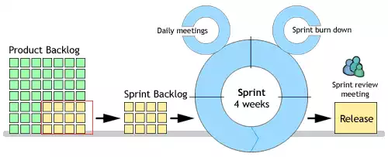

## 5.4. Development Environment

Our project will create a web application product to be used for online sale of third-party products and will therefore incorporate programming languages and frameworks under the model of MVC:

1. **HTML -** to develop the outline and structure of the webpage
2. **CSS -** to add styles and design color frames for the website
3. **Javascript/HTML5 -** to create animations and functional scripts
4. **PHP -** to create a coded structured connection to the database
5. **Servlet -** to manipulate data to create dynamic webpages
6. **MySQL -** to store the database and code structure data



1. **Model:** data structure of the system stored in the database
2. **View:** general user interface
3. **Controller:** logics and algorithms used to develop dynamic components of the website

The team will also use external web applications to organize ideas, functions, and measure performance and competence of the team as a whole:

1. **Trello -** a column (card) structured task organizer
2. **Workflowy -** an outlining web application
3. **Google Drive -** a file manager and document creation web application primarily usable for documentation and collaboration

## 

## 

## 5.5. Measurement Program

Performance and speed is our top non-functional and organizational requirement and thus we will use Chrome and Firefox’s developer performance measure modules and built-in console. We will perform local responsive tests through this module and test with various mobile devices.

For external reliability, we will host temporary domains with many services and rely on data and performance statistics given by <http://www.webpagetest.org/>. For external responsive tests, we will use <http://responsivetest.net/>.

If needed, we will use PHPUnit to develop test cases and code to time and check the reliability and functionality of our development components. However, we will take in consideration of possible limitations of page cache distribution to avoid security risks while compromising page load performance.

# 6. Risk Management

This section is to describe the procedure to be used for managing risks in the project. The procedure shall specify who is responsible for risk management, when risk situation is regularly considered, and which roles risks are communicated to.

The Project Manager will hold the responsibility of recommending mitigation and contingency measures for risks. The Risk Management Plan will be updated monthly or on event and communicated to all affected stakeholders by the Project Manager and the risk status is reported to the line management in the monthly Project Report.

The project will follow three indicators for risk:

1. Project Risks
2. Product Risks
3. Business Risks

List of Type of Risk level – Risk impact level on our team’s project plan:

1. Green – Solutions will be achieved in 2 working days or less
2. Orange – Solutions will be achieved 5 working days or less
3. Red - Solution must be achieved as soon as possible (within max 2 working weeks or less) or project will be cancelled until further notice.

**Project Risks:**

|  |  |  |
| --- | --- | --- |
| **Risk Factors** | **Risk Impact** | **Mitigations and Contingencies** |
| Team lack of cooperation or weak participation | Progress for the project will be slowed down as a result of unreliable work | Manage working environments to encourage cooperation and delegate tasks of higher priority to more capable members. |
| Team meetings cannot be organized | Conflicts in product backlogs preventing effective management and work done | Use smaller mediums (live chat) to hold meetings and backlogs should be emailed and updated to everyone involved |
| Sudden change in team member | Project will be delayed due to lack of expertise and workforce | Team members will be replaced immediately after confirmation or tasks will be delegated to other members |
| Time for assigned tasks go beyond the deadline | Project will be delayed | Timeline should be reviewed and tasks will be re-delegated to all members accordingly |
| Faulty hardware or data loss due to complications | Project will be delayed until solution is found | Backup images should be performed hourly, daily, and weekly for redundancy protection |

**Product Risks:**

|  |  |  |
| --- | --- | --- |
| **Risk Factors** | **Risk Impact** | **Mitigations and Contingencies** |
| Team’s lacking knowledge and skills in software or required programming framework | Progress for the project will be slowed down as a result of unreliable work | Proceed with online training and make sure programming architecture is developed beforehand |
| Product owner or client-user is not familiar in working with the project due to lack of documentation | Client-user cannot participate or communicate fully in the development phase of the project | Team should create small areas of documentation for their work and Project Manager shall explain the generals of the project |
| Incompatible among system/software version, requirements, design and programming framework between team members | Project will be delayed heavily due to incompatible software | General frameworks can be moved to different servlets and database coding frameworks. Functions for certain components must be ported to respective programming languages immediately |
| Program accumulates unexpected bugs | Project will be delayed as the product will not run correctly | Test cases must be developed to identify inconsistencies in development patterns |
| Database and/or main function instability | Project will be delayed indefinitely until solution is found | Main functions should be outlined and fixed along with database issues. Test cases and procedures are needed |

**Business Risks:**

|  |  |  |
| --- | --- | --- |
| **Risk Factors** | **Risk Impact** | **Mitigations and Contingencies** |
| Client-user does not willingly participate in the product’s development | Requirements will be unchangeable after a certain phase in development | Project Manager should encourage client-user involvement or include possible representative |
| Client inconsistencies in needs and requirements | Team will not be able to clearly identify requirements | Project Manager shall question for further information for requirements. If still not specified, development will continue with a standard approach to the product |
| Project is running over budget | Project will not continue without a budget | Safety margins for the budget must be specified beforehand |
| Client-user demands a completely new requirement that influences the environment and development flow of the product | Project will be delayed indefinitely until solution is found | Risks of change should be avoided; if issue still stands, reuse current framework and adapt to other programming structures immediately |

# 7. Delivery Plan

This section contains all deliverables from the project and the receivers of the deliverables. Delivery date will be specified in week sections reflective of project start:

|  |  |  |  |  |  |  |  |  |  |  |  |  |  |  |  |  |  |  |  |  |  |
| --- | --- | --- | --- | --- | --- | --- | --- | --- | --- | --- | --- | --- | --- | --- | --- | --- | --- | --- | --- | --- | --- |
| Functionality | Week 1 | | | | | | | Week 2 | | | | | | | Week 3 | | | | | | |
| Product view | W | W | W | W | W | W | W | **D** |  |  |  |  |  |  |  |  |  |  |  |  |  |
| Search |  |  |  |  |  |  |  | W | W | W | W | W | W | **D** |  |  |  |  |  |  |  |
| Login |  |  |  |  |  |  |  | W | W | W | W | W | W | **D** |  |  |  |  |  |  |  |
| Checkout |  |  |  |  |  |  |  |  |  |  |  |  |  |  | W | W | W | W | W | W | **D** |

Main functions of the project will be prioritized first. Analytics and administrative management will be handled in the following weeks:

|  |  |  |  |  |  |  |  |  |  |  |  |  |  |  |
| --- | --- | --- | --- | --- | --- | --- | --- | --- | --- | --- | --- | --- | --- | --- |
| Functionality | Week 4 | | | | | | | Week 5 | | | | | | |
| CMS | W | W | W | W | W | W | **D** |  |  |  |  |  |  |  |
| Web Analysis |  |  |  |  |  |  |  | W | W | W | W | W | W | **D** |

# 8. Security

## 8.1. Impacts

* Financial loss as a consequence if fraud or litigation
* Traffic to the website will reduce dramatically as a result of vulnerabilities
* Criminal charges and product suspension if found to be in breach of the Data Protection or Computer Misuse Acts, or other regulation on E-Commerce
* Loss of market share to any list of possible security issues
* Brand tarnishing that will indirectly influence stakeholder trading power and assets

## 

## 

## 

## 8.2. Vulnerabilities

|  |  |  |  |
| --- | --- | --- | --- |
| Vulnerabilities | Description | Examples | Solutions |
| SQL Injection | Injection is used by attackers to steal, edit data from online businesses. As a result, a malicious user can inject SQL statements through the website and into the database to have them executed. This means he or she can retrieve all the data stored in the database such as customer information, credit card details, social security numbers and credential to access private areas of the portal, such as the administrator portal. | Attackers will make use of the website URL to gain access or manipulate the website database. Here the attackers might want to know the number of columns of a table, they will insert a rogue code to test the column from 1 to n. If for the nth test there is an error message like “no such column...” the attackers will know right away that there would be n-1 columns inside the table. | -Wrap all SQL queries with prepared statements, along with parameters.  -Add stored procedures so that none of the tables should ever need to be exposed directly to outside applications. - Escape user input before putting it in a query  -Data submitted by form should always be set to ‘POST’ method. |
| Broken authentication | Application functions related to authentication and session management are often not implemented correctly, allowing attackers to compromise passwords, keys, or session tokens. | When customer forgets the password to the website, they will want to retrieve theirs by clicking on *Forgot password* option and surprisingly their email is exposed in the website’s message. | -Messages from the website should be generic, not specific E.g. : “An email has been sent to your registered email address. “  -Ensure a minimum of eight characters, containing uppercase letters and numbers to protect customers’ information more effectively. |
| Cross Site Scripting (XSS) | Cross site scripting is when an attacker tries to pass in JavaScript or other scripting code into a web form to attempt to run malicious code for visitors of your site. | When a visitor fill in the form and submit to the web server. They accidentally send the malicious code along with it. It will redirect the visitor to the clone website which looks similar to the original one. Here they will be asked to enter sensitive information such as their authentication details for that website, or credit card number or social security number. | -Check the submitted form for special characters such as html code  -filter input parameters for special characters.  -filter output based on input parameters for special characters. |

## 

## 

# 9. Abbreviations and Definitions

|  |  |
| --- | --- |
| Word | Definition |
| Web | An online network for finding information on the Internet |
| Hardware | Machinery and parts of a computer system |
| Software | Programs used to operate the computer |
| Search Engine | A function engine used to search or find information on the web |
| MySQL | An SQL structured system used to manage databases |
|  |  |
| Scrum Manager | Project manager of an agile method called Scrum |
| Specification | A detailed description of how something is designed or made |
| ERD | An entity relationship diagram to show relationships inside a database |
| Transaction | Business trade between people regarding the sales of goods or services |
| Use case | Methodology in system analysis to clarify and organize system requirements |
| Agile | A group of software development methods |
| SCRUM | An iterative and incremental agile development method |

# 10. References

TBM

Catherine Taibi, 2015. Al Roker Says The Harsh Winter Is Result Of Climate Change. The Huffington Post. Available at: http://social.huffingtonpost.com/2015/02/25/al-roker-climate-change-storms_n_6746786.html [Accessed April 25, 2015].

EVNCPC, 2011. National strategy on climate change. Socialist Republic of Vietnam Government Portal. Available at: http://chinhphu.vn/portal/page/portal/English/strategies/strategiesdetails%3FcategoryId%3D30%26articleId%3D10051283 [Accessed April 25, 2015].

Fears, D., 2013. IPCC report says humans almost certainly cause global warming. The Washington Post. Available at: http://www.washingtonpost.com/national/health-science/ipcc-says-humans-cause-global-warming/2013/09/27/aae32880-275d-11e3-b3e9-d97fb087acd6_story.html [Accessed April 25, 2015].

Oreskes, N., 2004. BEYOND THE IVORY TOWER: The Scientific Consensus on Climate Change. Science, 306(5702), pp.1686–1686. Available at: http://www.sciencemag.org/cgi/doi/10.1126/science.1103618 [Accessed April 25, 2015].

# 11. Product and Sprint Backlog

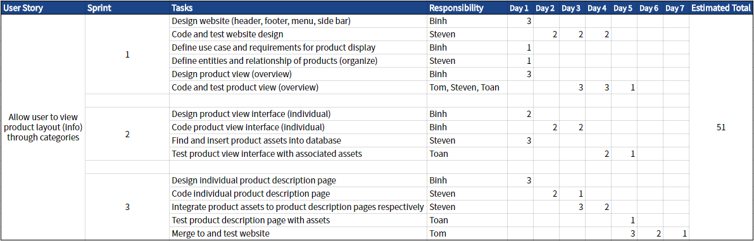

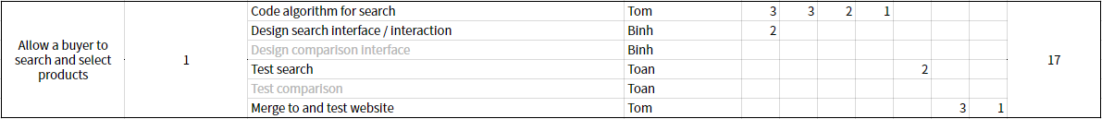

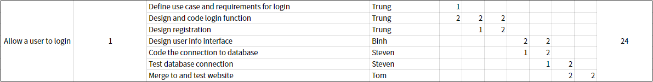

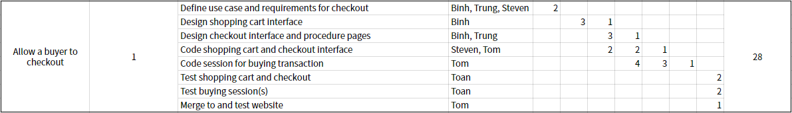

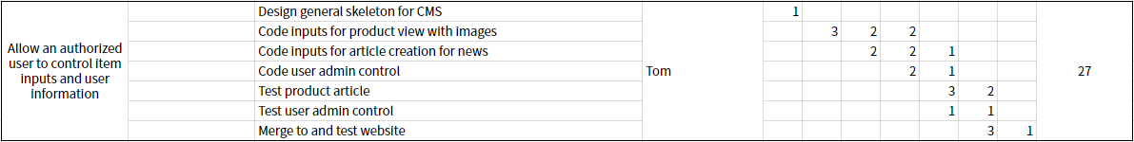



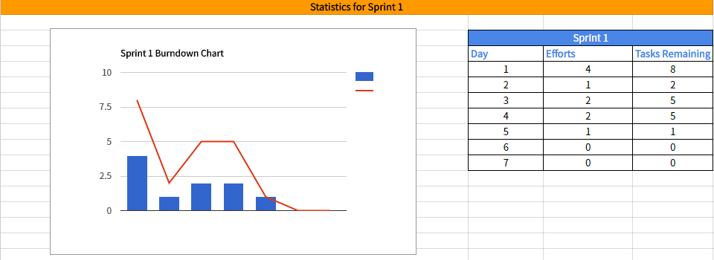

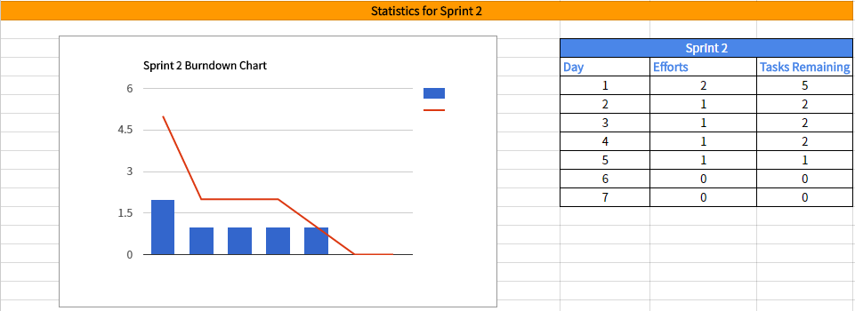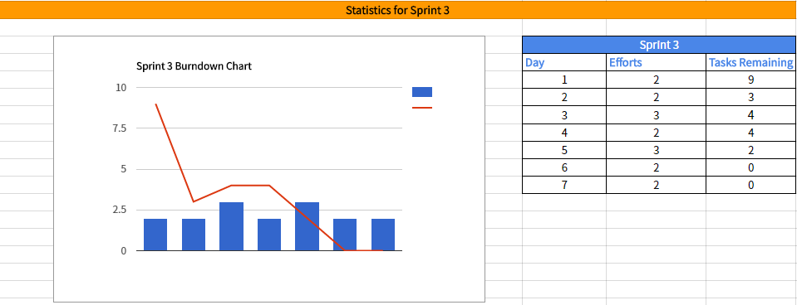

# 

# 

# 12. Member’s Contributions