Lab_Assignment_3.1
2303A51476
Batch-27
Question 1:
Prompt : Write a zero-shot prompt (without providing any examples) to generate a Python function that checks whether a given number is a palindrome.
Code:
def is_palindrome(num):
# Convert the number to string
str_num = str(num)

# Check if the string is the same forwards and backwards
return str_num == str_num[::-1]
# Test the function
number = int(input("Enter a number: "))
if is_palindrome(number):
print(f"{number} is a palindrome.")
else:
print(f"{number} is not a palindrome.")

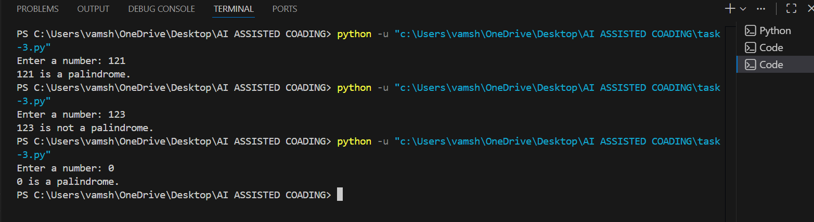
Question 2:
Prompt: Write a one-shot prompt by providing one input-output example and ask the AI to generate a Python function to compute the factorial of a given number.
Code:
def factorial(n):
if n == 0 or n == 1:
return 1
else:
return n * factorial(n - 1)
# Test the function
number = int(input("Enter a number to compute its factorial: "))
result = factorial(number)
print(f"The factorial of {number} is {result}.")
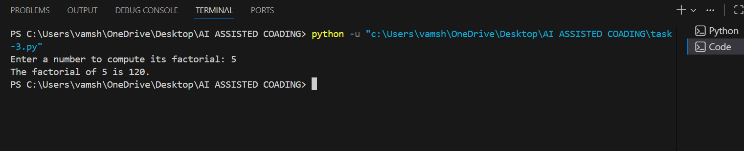
Question 3:
Prompt: Few-Shot Prompting (Armstrong Number Check)
Code:
def is_armstrong_number(num):
# Convert the number to string to easily iterate over digits
str_num = str(num)
num_digits = len(str_num)

# Calculate the sum of the cubes of each digit
sum_of_cubes = sum(int(digit) ** num_digits for digit in str_num)

# Check if the sum of cubes is equal to the original number
return sum_of_cubes == num
# Test the function
number = int(input("Enter a number: "))
if is_armstrong_number(number):
print(f"{number} is an Armstrong number.")
else:
print(f"{number} is not an Armstrong number.")
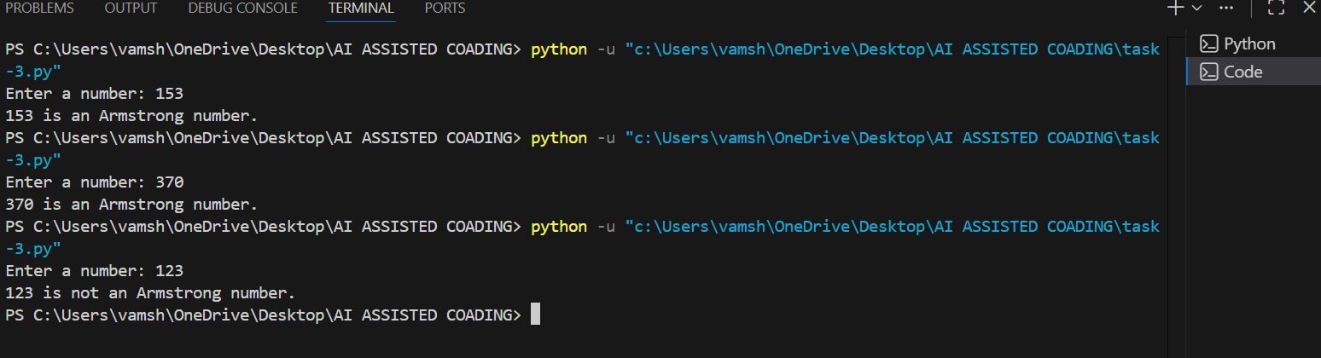
Question 4:
#prompt:Design a context-managed prompt with clear instructions and constraints to generate an optimized Python program that classifies a number as prime, composite, or neither.
#code:
def classify_number(num):
if num <= 1:
return "neither prime nor composite"
for i in range(2, int(num**0.5) + 1):
if num % i == 0:
return "composite"
return "prime"
# Test the function
number = int(input("Enter a number to classify: "))
classification = classify_number(number)
print(f"{number} is {classification}.")
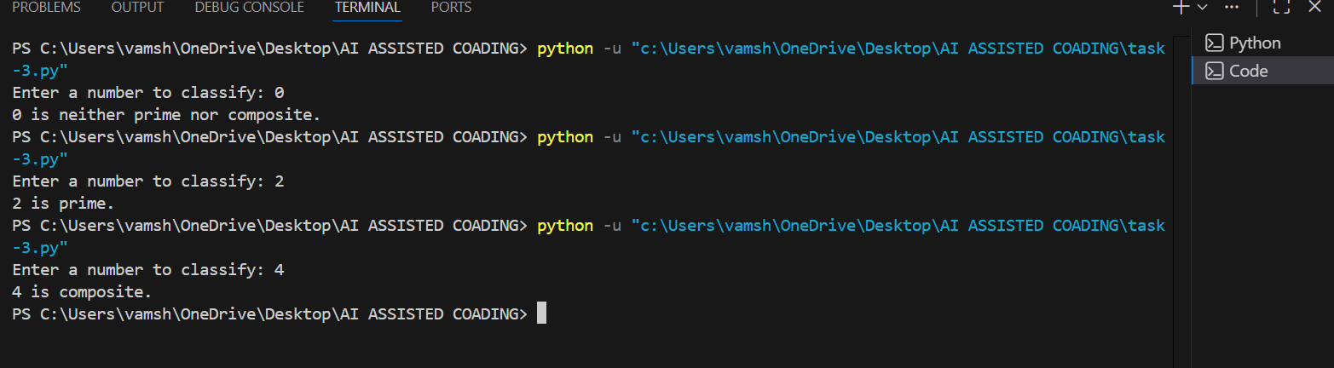
Question 5:
Prompt:Write a zero-shot prompt (without providing any examples) to generate a Python function that checks whether a given number is a perfect number
Code:
def is_perfect_number(num):
if num < 1:
return False

# Calculate the sum of divisors
sum_of_divisors = sum(i for i in range(1, num) if num % i == 0)

# Check if the sum of divisors is equal to the original number
return sum_of_divisors == num
# Test the function
number = int(input("Enter a number: "))
if is_perfect_number(number):
print(f"{number} is a perfect number.")
else:
print(f"{number} is not a perfect number.")
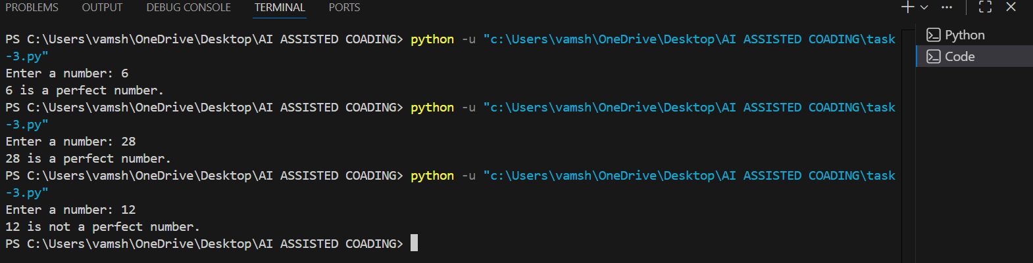
Question 6:
#prompt:Write a few-shot prompt by providing multiple input-output examples to guide the AI in generating a Python program that determines whether a given number is even or odd, including proper input validation
Code:
def is_even_or_odd(num):
if not isinstance(num, int):
return "Invalid input. Please enter an integer."

if num % 2 == 0:
return f"{num} is even."
else:
return f"{num} is odd."
# Test the function
try:
number = int(input("Enter a number to check if it's even or odd: "))
result = is_even_or_odd(number)
print(result)
except ValueError:
print("Invalid input. Please enter a valid integer.")
