Lab 7.3 K.Kranthi
2303A51476
Batch-27

Task 1: Fixing Syntax Errors

Scenario
You are reviewing a Python program where a basic function definition contains a syntax error.
Requirements:
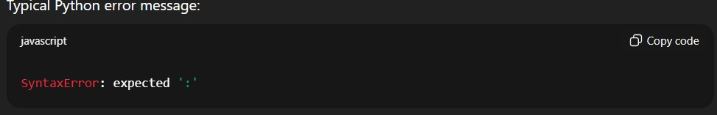

Output
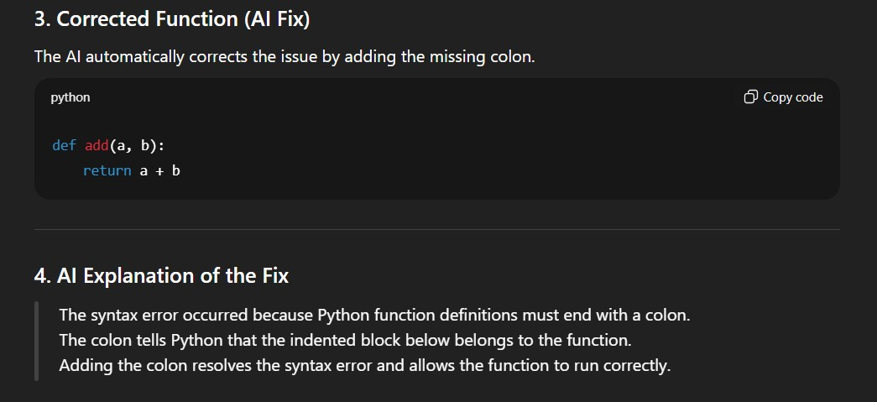

Task 2: Debugging Logic Errors in Loops
Scenario
You are debugging a loop that runs infinitely due to a logical mistake.

Requirements
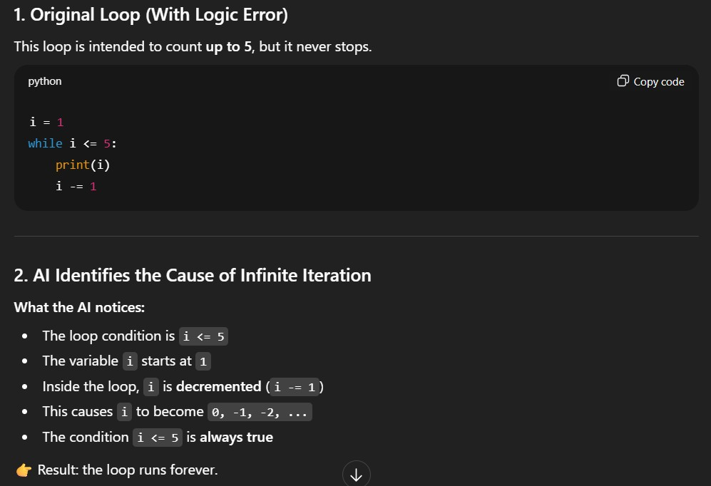

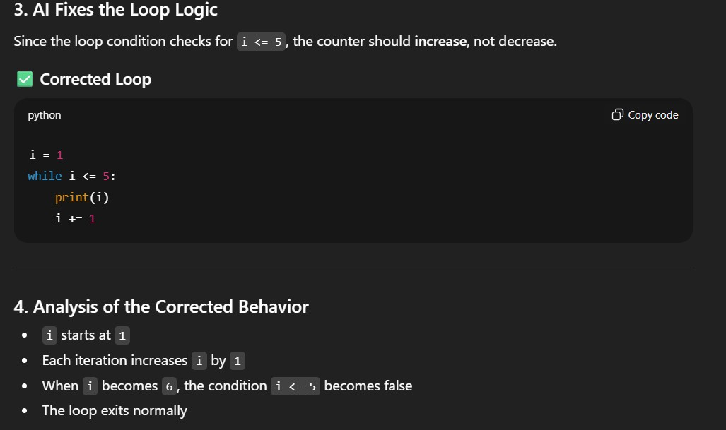

Output
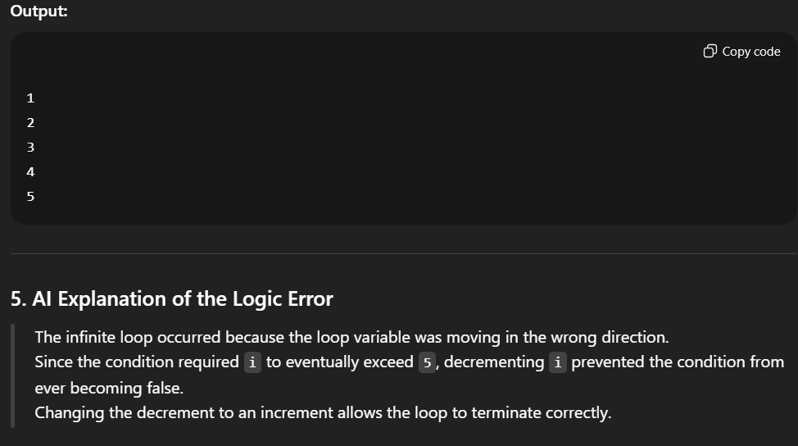

Task 3: Handling Runtime Errors (Division by Zero)

Scenario
A Python function crashes during execution due to a division by zero error. Requriments
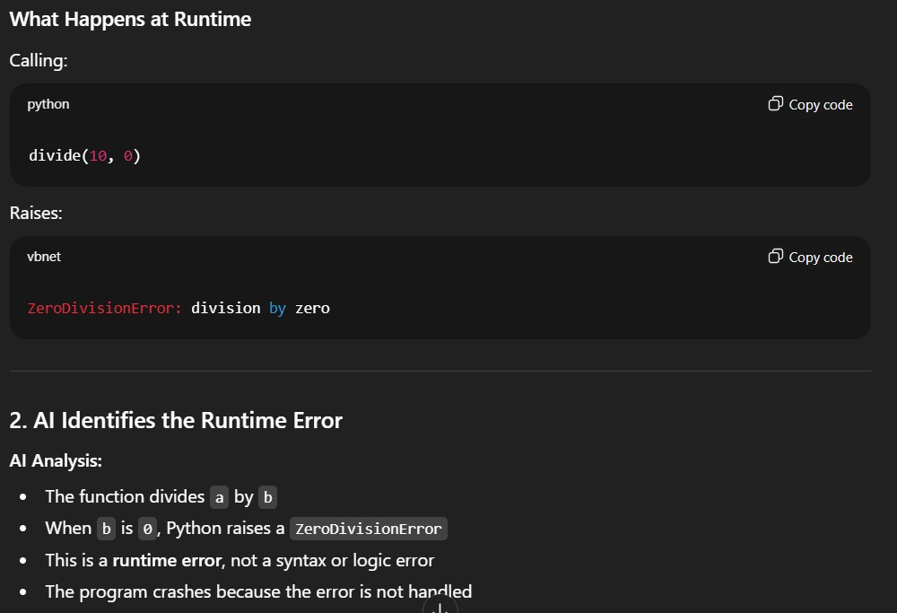
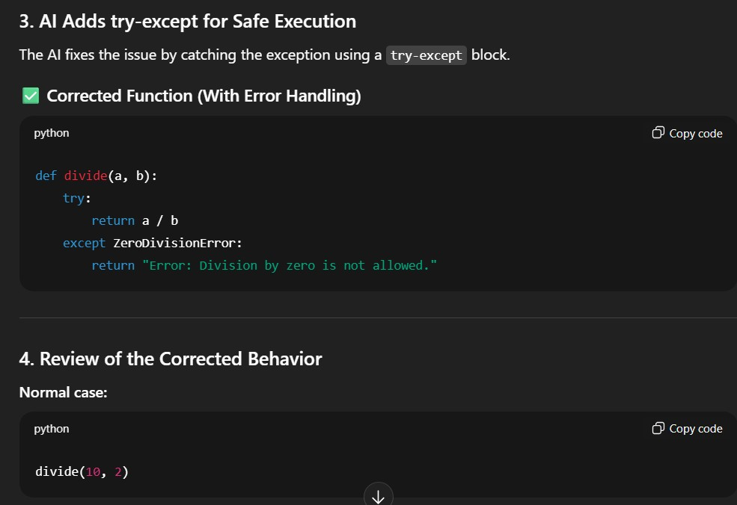
Output:
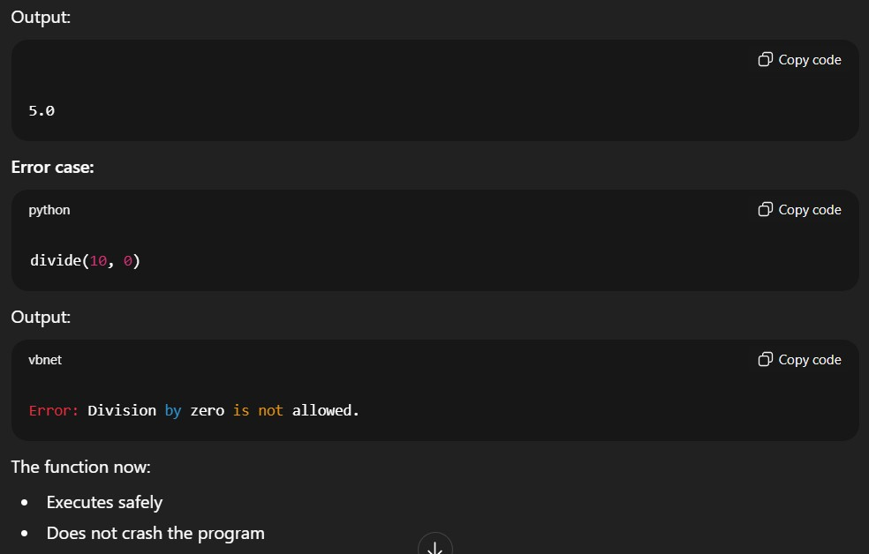

Task 4: Debugging Class Definition Errors

Scenario
You are given a faulty Python class where the constructor is incorrectly defined.
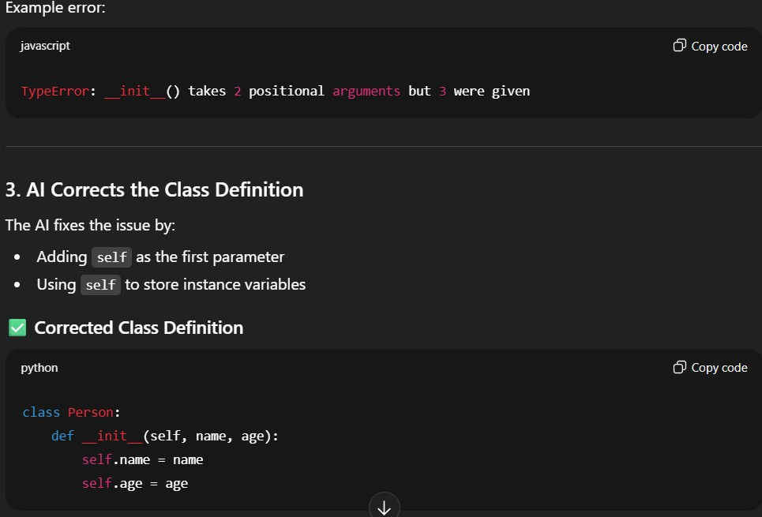

Output
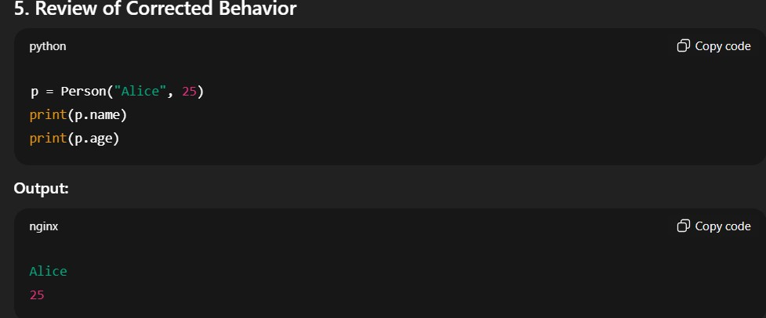

Task 5: Resolving Index Errors in Lists

Scenario
A program crashes when accessing an invalid index in a list.
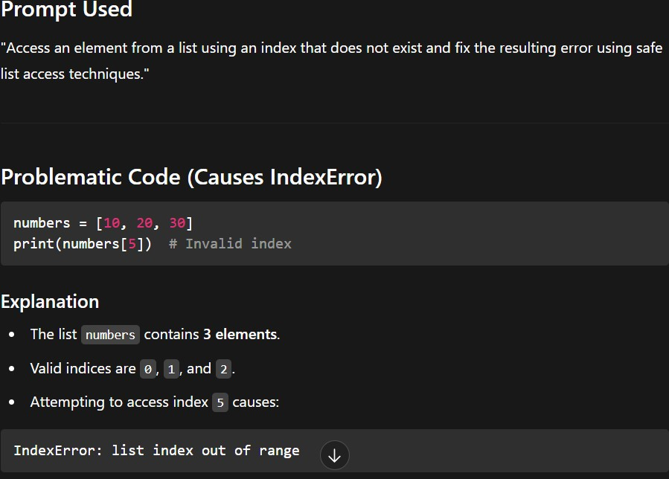

Output
