**McAfee DLP Policies (TATA ELXSI)**

1. DLP Monitoring:- Confidential data monitoring thorugh Oulook mail Client

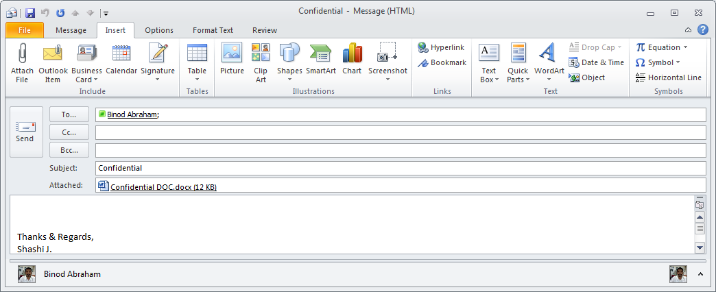

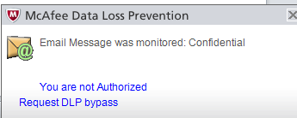

1. DLP Monitoring:- Confidential data upload through One Drive.

Compatible only with Internet Explorer

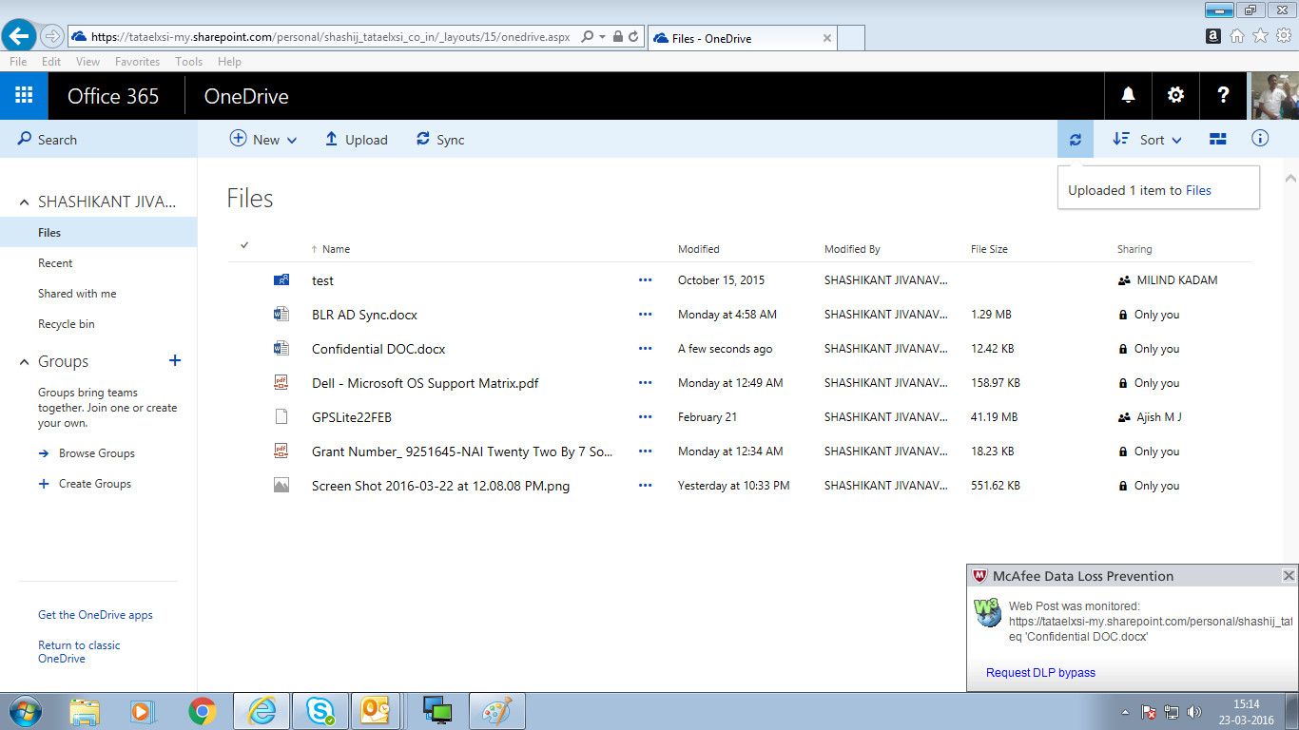

1. DLP Monitoring:- Confidential data monitoring through print.

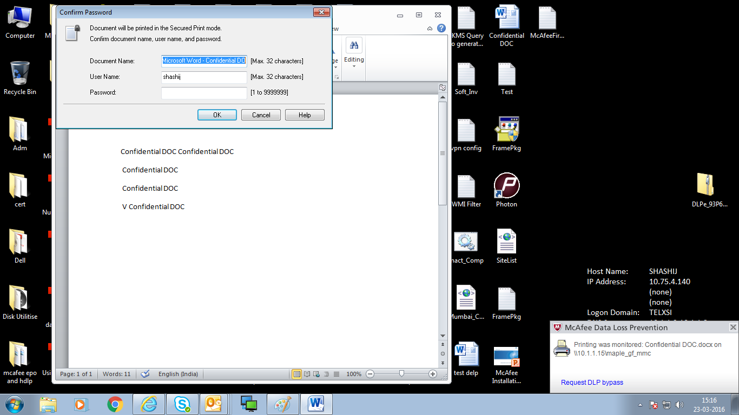

1. DLP Monitoring:- USB Data copy monitoing

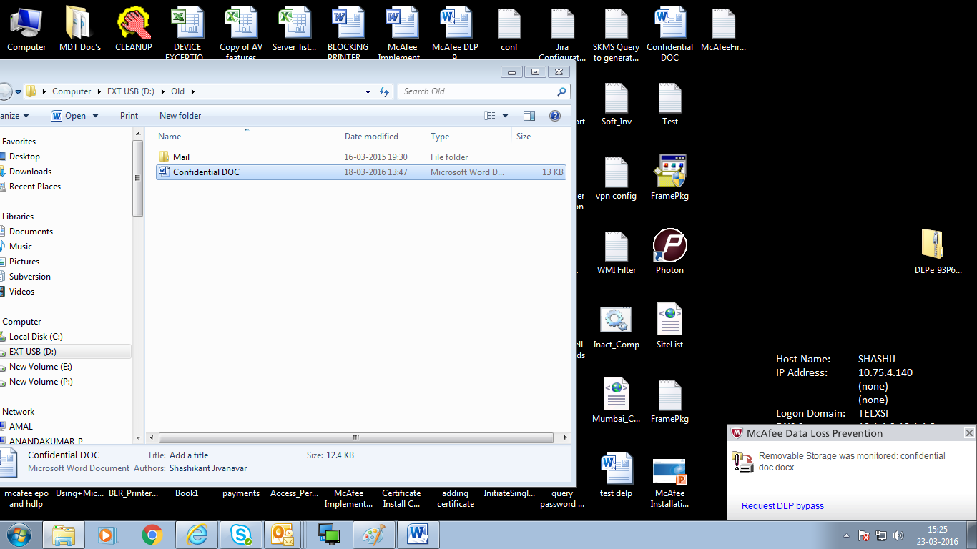

1. DLP Monitoring:- Print screen with Confidential word.



Pending :-

1. DLP Monitoing:- Instant Messaging attachment monitoring (Lync)
2. Clipboard