For learning rate = 0.01 changing number of steps:

steps-2:

Step 1: Minibatch Loss: 0.423010

Step 100: Minibatch Loss: 0.412647

Step 200: Minibatch Loss: 0.186102

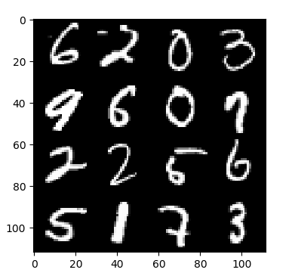

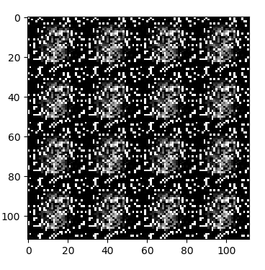

Steps-5:

Step 1: Minibatch Loss: 0.447734

Step 100: Minibatch Loss: 0.432156

Step 200: Minibatch Loss: 0.204547

Step 300: Minibatch Loss: 0.180096

Step 400: Minibatch Loss: 0.171112

Step 500: Minibatch Loss: 0.168490

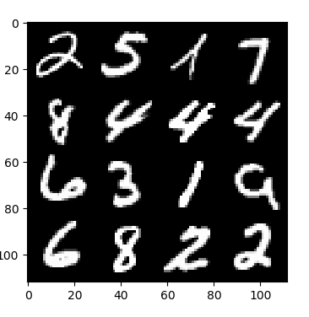

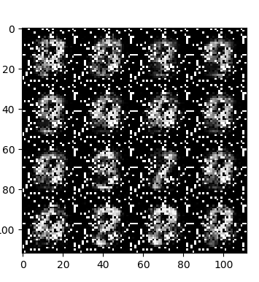

Steps:9:

Step 1: Minibatch Loss: 0.467684

Step 100: Minibatch Loss: 0.454508

Step 200: Minibatch Loss: 0.222230

Step 300: Minibatch Loss: 0.190635

Step 400: Minibatch Loss: 0.183878

Step 500: Minibatch Loss: 0.178599

Step 600: Minibatch Loss: 0.172714

Step 700: Minibatch Loss: 0.165396

Step 800: Minibatch Loss: 0.162164

Step 900: Minibatch Loss: 0.154698

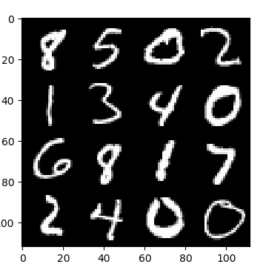

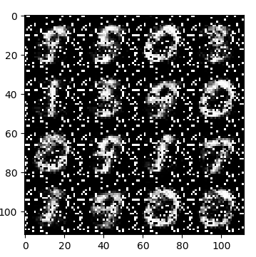

Num of steps: 15:

Step 1: Minibatch Loss: 0.422723

Step 100: Minibatch Loss: 0.407734

Step 200: Minibatch Loss: 0.192411

Step 300: Minibatch Loss: 0.177106

Step 400: Minibatch Loss: 0.163770

Step 500: Minibatch Loss: 0.150834

Step 600: Minibatch Loss: 0.143320

Step 700: Minibatch Loss: 0.141111

Step 800: Minibatch Loss: 0.136728

Step 900: Minibatch Loss: 0.131435

Step 1000: Minibatch Loss: 0.129512

Step 1100: Minibatch Loss: 0.124474

Step 1200: Minibatch Loss: 0.124007

Step 1300: Minibatch Loss: 0.119322

Step 1400: Minibatch Loss: 0.119067

Step 1500: Minibatch Loss: 0.117222

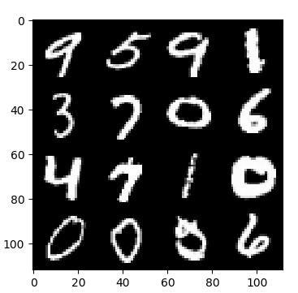

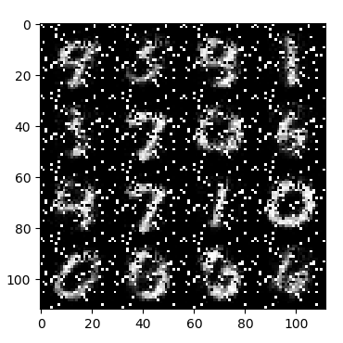

for 5 steps with learning rate 0.01

results:

Step 1: Minibatch Loss: 0.450839

Step 100: Minibatch Loss: 0.436870

Step 200: Minibatch Loss: 0.198692

Step 300: Minibatch Loss: 0.173210

Step 400: Minibatch Loss: 0.163189

Step 500: Minibatch Loss: 0.154679

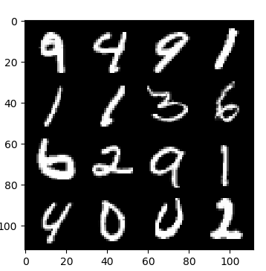

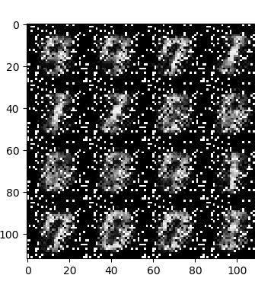

learning rate 0.05

Step 1: Minibatch Loss: 0.429340

Step 100: Minibatch Loss: 0.372388

Step 200: Minibatch Loss: 0.225028

Step 300: Minibatch Loss: 0.164728

Step 400: Minibatch Loss: 0.107674

Step 500: Minibatch Loss: 0.080614

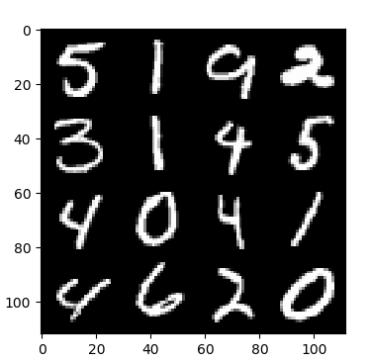

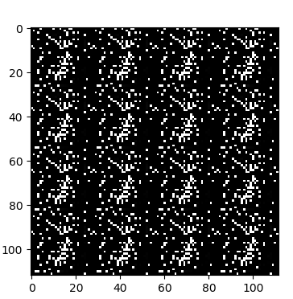

learning rate - 0.1

Step 1: Minibatch Loss: 0.454659

Step 100: Minibatch Loss: 0.350425

Step 200: Minibatch Loss: 0.219628

Step 300: Minibatch Loss: 0.188297

Step 400: Minibatch Loss: 0.186016

Step 500: Minibatch Loss: 0.180679

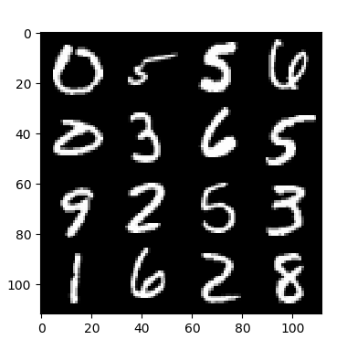

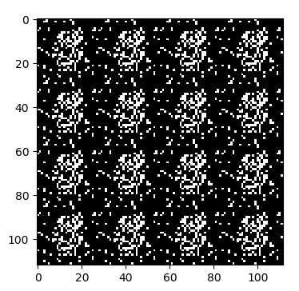

RMSPropOptimizer:

Step 1: Minibatch Loss: 0.444352

Step 100: Minibatch Loss: 0.432114

Step 200: Minibatch Loss: 0.208035

Step 300: Minibatch Loss: 0.187332

Step 400: Minibatch Loss: 0.177831

Step 500: Minibatch Loss: 0.173134

GradientDescentOptimizer:

Step 1: Minibatch Loss: 0.435565

Step 100: Minibatch Loss: 0.435668

Step 200: Minibatch Loss: 0.435845

Step 300: Minibatch Loss: 0.436104

Step 400: Minibatch Loss: 0.435635

Step 500: Minibatch Loss: 0.435013

AdamOptimizer

Step 1: Minibatch Loss: 0.456801

Step 100: Minibatch Loss: 0.099064

Step 200: Minibatch Loss: 0.087359

Step 300: Minibatch Loss: 0.083783

Step 400: Minibatch Loss: 0.079294

Step 500: Minibatch Loss: 0.077005

AdagradOptimizer

Step 1: Minibatch Loss: 0.440274

Step 100: Minibatch Loss: 0.437543

Step 200: Minibatch Loss: 0.436614

Step 300: Minibatch Loss: 0.435125

Step 400: Minibatch Loss: 0.433872

Step 500: Minibatch Loss: 0.432535

Number of steps5 and learning rate 0.01:

Without adding hidden encoder:

Step 1: Minibatch Loss: 0.440358

Step 100: Minibatch Loss: 0.423837

Step 200: Minibatch Loss: 0.195880

Step 300: Minibatch Loss: 0.176150

Step 400: Minibatch Loss: 0.168485

Step 500: Minibatch Loss: 0.156705

With adding hidden layer

Step 1: Minibatch Loss: 0.451070

Step 100: Minibatch Loss: 0.431343

Step 200: Minibatch Loss: 0.233014

Step 300: Minibatch Loss: 0.188876

Step 400: Minibatch Loss: 0.178080

Step 500: Minibatch Loss: 0.172289