.**NET Framework Learnings**

Date:20th November,2024

.Net Framework:-

CLR: Common language Runtime (Garbage Collector)

FCL: Framework class library

C# source code 🡪 Compile 🡪Assembly File(MSIL,Metadata) 🡪 JIT 🡪 CPU Native Code

C# .Net Syntaxes:-

1.variable declaration : variable is a name given to memory locations

Syntax:-

<data_type> <variable_name>;

Ex:-

Int a;

Int a,b;

2.Methods

Difference between method and function?

Syntaxtically both are same but functions are independent and methods are dependent.

Syntax:-

<return_data_type><method_name>(paramlist)

{

//statements

}

1.returnable methods

Ex:

Int sum(int x, int y){

Return x+y;

}

2. non returnable method

Ex:

void swap(int x,int y)

{

//statements;

}

3. control statements

1.simple if, else if , else….if ladder ;-

Syntax:-

If(condition1)

[statements 1];

Else if(condition2)

[statements 2];

Else

[next statements];

4. nested if:-

Syntax:-

If(condition 1)

{

If(condition 2)

{

//statements;

}

else

//statements

}

Else

//next statements

5. while and do-while are also same as java

6. class : it is a logical construction data members and member methods into single unit .

Syntax :-

class <class_name>

{

//statements

}

7. object:

It is a runtime entity of a class

It is instance variable of type class

It is physical existence of a class.

It contains both data and code of a class

We can create any number of objects belonging to the class

Syntax:-

<class_name> <object_name> = new <class_name>();

Ex:-

Sample obj = new Sample();

8. syntax of c#.net application

Class<class1>

{

Variables

` Constants

Constructors

Destructors

Methods

Properties

Event Procedures

}

Class<class2>

{

Static void Main(string[]args)

{

//statements;

}

}

Class<class3>

{

}

* Here Main method will accept an array of string arguments
* void it indicates that Main method it won’t return any value.
* Static it indicates with out creating an object of a class we can access the Main method.

9. output statement:-

System.Console.WriteLine();

🡪WriteLine() is a method which is defined in the Class

🡪Console is a class which is defined in the namespace System

10. input statements:-

System.Console.ReadLine();

🡪ReadLine() is a method which is defined in the Class

🡪Console is a class which is defined in the namespace System

using System;

Console.WriteLine();

Console.ReadLine();

Version related to .Net

Inheritence

1. Single inheriatance
2. Multi level inheritance
3. Multiple inheritance
4. Heirarchichal inheritance
5. Hybrid inheritance

Supported by C# and Java

1. Single inheritance
2. Multi level inheritance
3. Hierarchical inheritance

ASP .NET

ASP.NET(Active Server Pages) 🡪Web application

ASP.Net with MVC 🡪Architectural

ASP.NET WebAPI 🡪RESTFull services

Web Server(IIS):-

Windows servers and professional operating systems

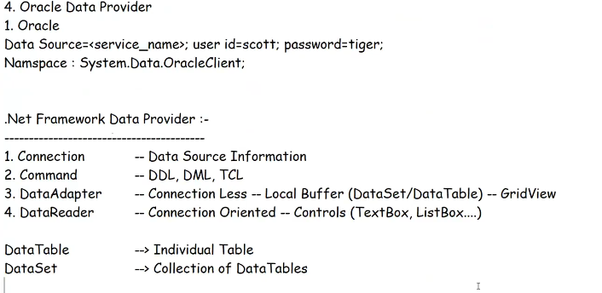

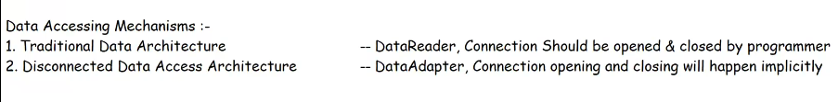

Model:-

