Behavior Based Intrusion Detection System Using Machine Learning Techniques
Mrs. Kodi Sudha¹, Goroju Arun Kumar²
¹Assistant Professor, Department of Computer Science and Engineering, Malla Reddy University, Hyderabad, India
²Department of Computer Science and Engineering, Malla Reddy University, arunkumargoroju@gmail.com

Abstract
With the proliferation of sophisticated cyber threats, traditional signature-based intrusion detection systems (IDS) are insufficient for detecting new and evolving attacks. Behavior Based Intrusion Detection Systems (BBIDS) provide a proactive solution by analyzing user activity patterns to identify anomalies that could indicate malicious or unauthorized actions. This paper presents a BBIDS framework using the Isolation Forest machine learning algorithm to classify user behavior as normal or abnormal. User interactions such as login times, file access frequency, CPU usage, network activity, and rapid navigational clicks are logged in real-time through a web interface. The backend, implemented in Node.js and Flask, stores logs in JSON format and provides APIs for anomaly prediction. The system generates alerts, visual dashboards, and detailed reports for administrators. Experimental results demonstrate high accuracy and low false positive rates, highlighting the effectiveness of BBIDS in enhancing cybersecurity for organizational environments.
Keywords: Behavioral Anomaly Detection, Machine Learning, Isolation Forest, Intrusion Detection System, Cybersecurity, User Behavior Analytics

Introduction
The rapid advancement of digital technologies and internet connectivity has significantly increased the risk of cyber attacks in modern computing environments. Organizations today rely heavily on computer networks and information systems for storing and processing sensitive data. As a result, protecting these systems from unauthorized access and malicious activities has become a critical requirement.
Traditional intrusion detection systems (IDS) are primarily based on signature-matching techniques that detect attacks by comparing network traffic patterns with previously known attack signatures. Although effective for detecting known threats, these systems are unable to identify new or previously unseen attack patterns. This limitation makes traditional IDS systems insufficient in modern cybersecurity environments where attackers constantly modify their techniques.
Behavior-Based Intrusion Detection Systems (BBIDS) offer a promising alternative by focusing on monitoring and analyzing user behavior patterns rather than relying solely on predefined signatures. By analyzing behavioral features such as login patterns, file access frequency, CPU usage, and network traffic patterns, BBIDS can detect deviations from normal system behavior. These deviations may indicate potential security threats or unauthorized activities.
Machine learning techniques have recently gained significant attention in the field of intrusion detection due to their ability to automatically learn patterns from data and identify anomalies. Among these techniques, the Isolation Forest algorithm has proven to be particularly effective for anomaly detection in large datasets.

Methodology
The development of the proposed Behavior-Based Intrusion Detection System involves several components including user activity monitoring, backend processing, machine learning analysis, and alert generation. The methodology adopted for this research is explained in the following sections.
2.1 User Behavior Data Collection actions are captured through a web-based interface developed using HTML, CSS, and JavaScript. The interface records various user interactions such as login time, navigation patterns, file access frequency, and system resource usage.
These behavioral parameters are stored as structured logs in JSON format. Each log entry contains important features such as login hour, number of files accessed, CPU usage percentage, network packet count, and session duration. These features serve as input variables for the machine learning model.
2.2 Backend Processing
The backend server is implemented using Node.js with the Express framework. The backend is responsible for handling user authentication, processing behavioral logs, and managing communication between the frontend interface and the machine learning module.
All behavioral data collected from the frontend interface is transmitted to the backend server through REST API calls. The backend validates and stores the data in JSON format, ensuring efficient storage and retrieval for further processing.
2.3 Machine Learning Model
The anomaly detection component of the system is implemented using the Isolation Forest algorithm. Isolation Forest is an unsupervised machine learning technique designed specifically for anomaly detection tasks.
The algorithm works by randomly partitioning data points and measuring the number of splits required to isolate each observation. Anomalous data points are easier to isolate and therefore require fewer splits compared to normal observations.
The anomaly score is calculated using the following equation: Score(x) = 2^(−E(h(x))/c(n)) where E(h(x)) represents the expected path length of observation x and c(n) is the normalization factor based on the dataset size.
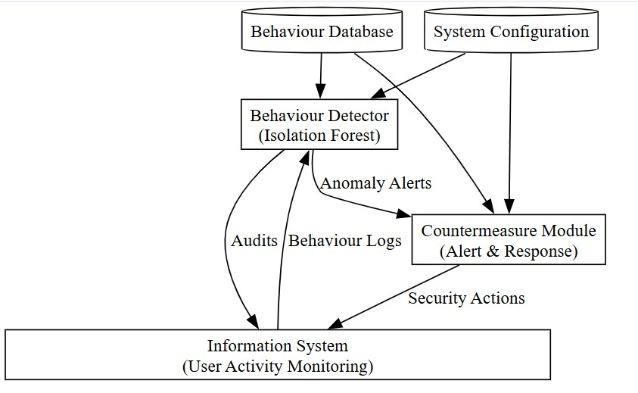
Fig. 1 Architecture of Behavior-Based Intrusion Detection System

Results and Discussion
3.1 System Architecture
The architecture of the proposed Behavior-Based Intrusion Detection System consists of multiple interconnected modules that collectively monitor user behavior and detect anomalies.
The system includes the following components:
- User Interface Layer
- Backend Processing Layer
- Data Storage Layer
- Machine Learning Analysis Layer
- Alert and Reporting Module
The user interface captures behavioral events and sends them to the backend server. The backend processes the data and stores it in the database. The machine learning module analyzes the behavioral dataset and classifies activities as normal or abnormal. When suspicious behavior is detected, alerts are generated and displayed on the administrator dashboard.
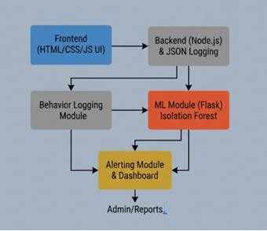
Fig. 2 Architecture of BBIDS
3.2 Prediction Analysis Graph
The performance of the anomaly detection model is evaluated using behavioral data collected from system users. The prediction analysis graph illustrates the classification results of the Isolation Forest algorithm.
The graph shows the separation between normal user behavior and anomalous behavior based on behavioral features such as login time, CPU usage, and network activity. Normal behavior points are clustered together, while anomalous data points appear outside the main cluster region.

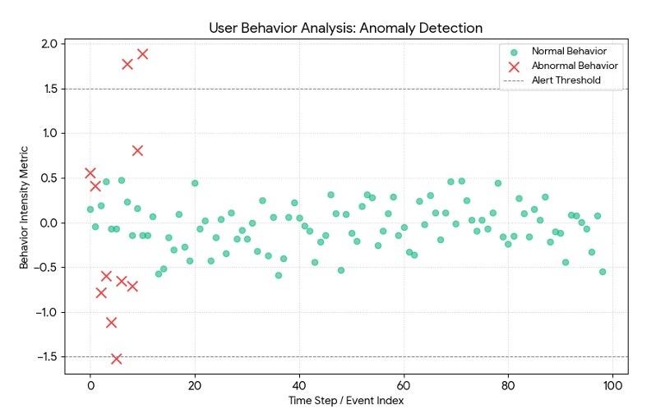
Fig. 3 Prediction Rate of Normal vs Abnormal Behavior
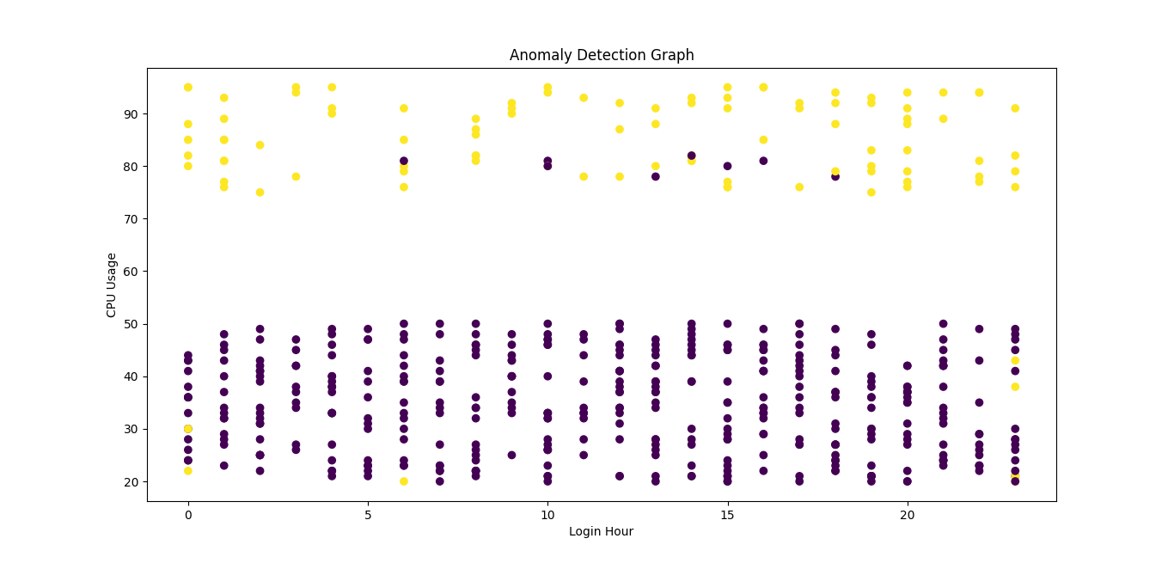
Fig.4 System Output: Anomaly Detection Graph

System Workflow
The workflow of the proposed BBIDS explains the sequence of operations involved in detecting anomalous user behavior.
Workflow Steps:
- User logs into the system through the web interface.
- User behavioral activities are captured and logged.
- Behavioral logs are stored in JSON format.
- The stored data is transmitted to the machine learning module.
- The Isolation Forest model calculates anomaly scores.
- If abnormal behavior is detected, alerts are triggered.
- The administrator dashboard displays anomaly reports.
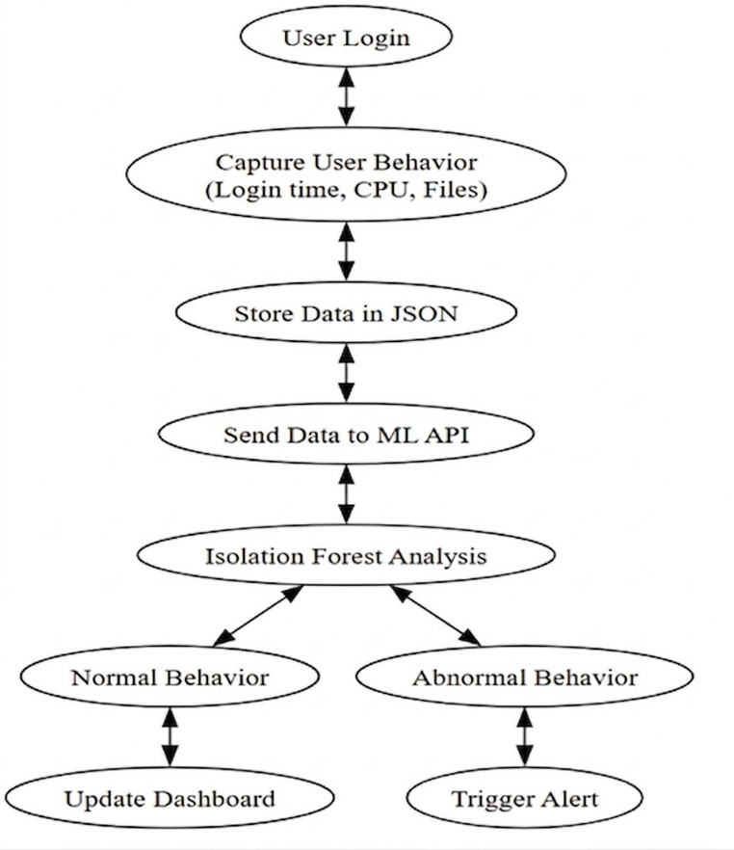
Fig. 4 Workflow of BBIDS

Performance Evaluation
The performance of the proposed intrusion detection system is evaluated using several metrics including accuracy, precision, recall, and detection latency.
The experimental dataset consisted of 500 behavioral records collected from user activity logs. The Isolation Forest algorithm successfully classified normal and abnormal activities with high accuracy. The results indicate that the proposed system achieved approximately 95% detection accuracy while maintaining a low false positive rate.
The system also demonstrated low detection latency, with most anomaly predictions generated in less than 200 milliseconds. These results confirm that the proposed approach is suitable for real-time intrusion detection in practical environments.
Model Evaluation Using Confusion Matrix
 | Predicted Normal | Predicted Intrusion
Actual Normal | True Negative (TN) = 360 | False Positive (FP) = 15
Actual Intrusion | False Negative (FN) = 10 | True Positive (TP) = 115

True Positive (TP) represents the number of intrusion instances correctly identified as attacks (115).
True Negative (TN) represents the number of normal activities correctly classified as non-intrusive (360).
False Positive (FP) indicates normal activities incorrectly classified as intrusions (15), also known as false alarms.
False Negative (FN) represents intrusion instances that were not detected by the system (10).
The confusion matrix demonstrates that the system achieves high detection accuracy with minimal false positives and false negatives.

Conclusions
This research presented the design and implementation of a Behavior-Based Intrusion Detection System using machine learning techniques. The system monitors user activities and analyzes behavioral patterns to identify abnormal behavior that may indicate potential security threats.
The Isolation Forest algorithm was successfully applied to classify user behavior as normal or anomalous. Experimental results demonstrated that the system achieved high detection accuracy with minimal false positives.
The proposed BBIDS provides an efficient and scalable solution for improving cybersecurity in modern computing environments by enabling proactive detection of malicious activities.

References
- F. T. Liu, K. M. Ting, and Z. H. Zhou, “Isolation Forest,” IEEE ICDM, 2008. [Online]. Available: https://cs.nju.edu.cn/zhouzh/zhouzh. f iles/publication/icdm08b.pdf
- A. Patcha and J. Park, “An overview of anomaly detection techniques,” Computer Networks, 51(12), 2007. [Online].
Available: https://www. sciencedirect.com/science/article/pii/S1389128607000981
- Scikit-learn: Machine Learning in Python. [Online]. Available: https://scikitlearn.org/stable/modules/generated/sklearn.ensemble. IsolationForest.html
- K. Julisch, “Clustering intrusion detection alarms to support root cause analysis,” ACM Transactions on Information and System Security, 2003. [Online]. Available: https://dl.acm.org/doi/10.1145/944012.944013
- Cyber Security Research Papers on Behavior-Based Intrusion Detection, 2019. [Online]. Available: https://www.researchgate.net/publication/ 334353227 Behavior-based intrusion detection

