Socket Programming 3: ICMP Pinger

**Identifying Lab Environment**
The below screenshot depicts my lab environment used for the lab work. I am using MacOS with Python version 3.9.11.
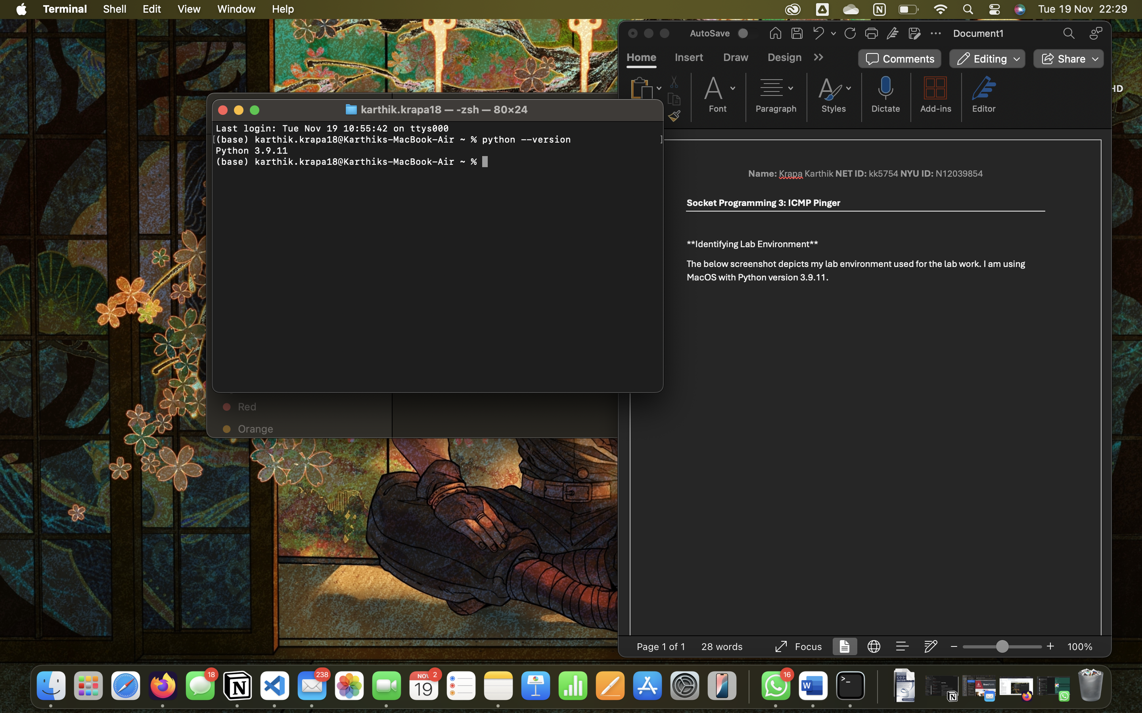

- ICMP Pinger Lab: Client Code Completed with commented lines for explanation of code.
client.py
- from socket import *
- import os
- import sys
- import struct
- import time
- import select

- ICMP_ECHO_REQUEST = 8 # ICMP Type
- IP_HEADER_SIZE = 20 #Standard size

- def checksum(string):
- csum = 0 #initialize checksum
- countTo = (len(string) // 2) * 2
- count = 0
- while count < countTo:
- thisVal = (string[count + 1]) * 256 + (string[count])
- csum += thisVal
- csum &= 0xffffffff #Keeping checksum within 32 bytes
- count += 2
- if countTo < len(string):
- csum += (string[len(string) - 1])
- csum &= 0xffffffff
- csum = (csum >> 16) + (csum & 0xffff)
- csum = csum + (csum >> 16)
- answer = ~csum
- answer = answer & 0xffff
- answer = answer >> 8 | (answer << 8 & 0xff00)
- return answer

- def receiveOnePing(mySocket, ID, timeout, destAddr):
- timeLeft = timeout #setting timeout value
- while True:
- startedSelect = time.time() #start time
- whatReady = select.select([mySocket], [], [], timeLeft) #incoming data
- howLongInSelect = (time.time() - startedSelect) #time spent
- if whatReady[0]==[]: # Timeout
- return (None, None)
- timeReceived = time.time() #packet received time
- recPacket, addr = mySocket.recvfrom(1024) #receive packet and sender's address

- #Extract ICMP header fields from the received packet
- #fill in start
- icmpHeader = recPacket[IP_HEADER_SIZE:IP_HEADER_SIZE + 8]
- icmpType, icmpCode, checksum, packetID, sequence = struct.unpack("bbHHh", icmpHeader)
- if packetID == ID:
- #Extract the data payload
- data = recPacket[IP_HEADER_SIZE + 8:]
- sendTimestamp = struct.unpack("d", data)[0]
- return ((timeReceived - sendTimestamp) * 1000, #RTT in ms
- (icmpType, icmpCode, checksum, packetID, sequence, sendTimestamp))
- #fill in end
- timeLeft -= howLongInSelect
- if timeLeft <= 0:
- return (None, None)

- def sendOnePing(mySocket, destAddr, ID):
- # Header is type (8), code (8), checksum (16), id (16), sequence (16)
- myChecksum = 0
- # Create dummy header with 0 checksum
- header = struct.pack("bbHHh", ICMP_ECHO_REQUEST, 0, myChecksum, ID, 1)
- data = struct.pack("d", time.time())
- # Calculate checksum on header + data
- myChecksum = checksum(header + data)
- # Put checksum into the header
- if sys.platform == 'darwin':
- myChecksum = htons(myChecksum) & 0xffff # Convert for MacOS
- else:
- myChecksum = htons(myChecksum)
- header = struct.pack("bbHHh", ICMP_ECHO_REQUEST, 0, myChecksum, ID, 1)
- packet = header + data
- mySocket.sendto(packet, (destAddr, 1)) # Destination must be tuple
- return time.time() # Return send time to calculate RTT later

- def doOnePing(destAddr, timeout):
- icmp = getprotobyname("icmp")
- mySocket = socket(AF_INET, SOCK_RAW, icmp)
- myID = os.getpid() & 0xFFFF # Get process ID for unique identifier
- sendOnePing(mySocket, destAddr, myID)
- result = receiveOnePing(mySocket, myID, timeout, destAddr)
- mySocket.close()
- return result

- def ping(host, timeout=1):
- dest = gethostbyname(host)
- resps = []
- print("Pinging " + dest + " using Python:")
- print("")
- for i in range(5): # Send 5 pings
- result = doOnePing(dest, timeout)
- resps.append(result)
- time.sleep(1)
- print(resps)
- return resps

- if __name__ == '__main__':
- ping("google.com")

checksum: Computes a checksum for error checking.
sendOnePing: Constructs and sends an ICMP Echo Request.
receiveOnePing: Receives an ICMP Echo Reply and extracts details.
doOnePing: Combines sending and receiving logic for a single ping.
ping: Sends multiple pings and displays the results.

Extra Credit 1
from socket import *
import os
import sys
import struct
import time
import select

ICMP_ECHO_REQUEST = 8 # ICMP Type
IP_HEADER_SIZE = 20

def checksum(data):
csum = 0
countTo = (len(data) // 2) * 2
count = 0
while count < countTo:
thisVal = (data[count + 1]) * 256 + (data[count])
csum += thisVal
csum &= 0xffffffff
count += 2
if countTo < len(data):
csum += (data[len(data) - 1])
csum &= 0xffffffff
csum = (csum >> 16) + (csum & 0xffff)
csum = csum + (csum >> 16)
answer = ~csum
answer = answer & 0xffff
answer = answer >> 8 | (answer << 8 & 0xff00)
return answer

def receive_one_ping(mySocket, ID, timeout, dest_addr):
timeLeft = timeout
while True:
startedSelect = time.time()
whatReady = select.select([mySocket], [], [], timeLeft)
howLongInSelect = (time.time() - startedSelect)
if whatReady[0]==[]: # Timeout
return (None, None)
timeReceived = time.time()
recPacket, addr = mySocket.recvfrom(1024)

# Extract ICMP header fields from the received packet
icmpHeader = recPacket[IP_HEADER_SIZE:IP_HEADER_SIZE + 8]
icmpType, icmpCode, checksum, packetID, sequence = struct.unpack("bbHHh", icmpHeader)
if packetID == ID:
# Extract the data payload
data = recPacket[IP_HEADER_SIZE + 8:]
sendTimestamp = struct.unpack("d", data)[0]
return ((timeReceived - sendTimestamp) * 1000, # RTT in ms
(icmpType, icmpCode, checksum, packetID, sequence, sendTimestamp))

timeLeft -= howLongInSelect
if timeLeft <= 0:
return (None, None)

def send_one_ping(sock, dest_addr, ID):
checksum_val = 0
header = struct.pack("bbHHh", ICMP_ECHO_REQUEST, 0, checksum_val, ID, 1)
data = struct.pack("d", time.time())
checksum_val = checksum(header + data)
checksum_val = htons(checksum_val)
header = struct.pack("bbHHh", ICMP_ECHO_REQUEST, 0, checksum_val, ID, 1)
packet = header + data
sock.sendto(packet, (dest_addr, 1))
return time.time()

def do_one_ping(dest_addr, timeout):
icmp = getprotobyname("icmp")
sock = socket(AF_INET, SOCK_RAW, icmp)
ID = os.getpid() & 0xFFFF
send_one_ping(sock, dest_addr, ID)
result = receive_one_ping(sock, ID, timeout, dest_addr)
sock.close()
return result

def ping(host, timeout=1):
dest = gethostbyname(host)
print(f"Pinging {dest} using Python:")
min_rtt, max_rtt, total_rtt, total_received = float('inf'), 0, 0, 0

for i in range(5):
rtt, _ = do_one_ping(dest, timeout)
if rtt:
min_rtt = min(min_rtt, rtt)
max_rtt = max(max_rtt, rtt)
total_rtt+=rtt
total_received += 1
time.sleep(1)

packet_loss = (5 - total_received) / 5 * 100
print("\n--- PING STATISTICS ---")
print(f"Packets Sent: 5, Packets Received: {total_received}, Packet Loss: {packet_loss:.1f}%")
if total_received > 0:
print(f"RTT (ms): min={min_rtt:.2f}ms, avg={(total_rtt/total_received):.2f}ms, max={max_rtt:.2f}ms")

if __name__ == "__main__":
ping("google.com")

Extra Credit 2:
from socket import *
import os
import sys
import struct
import time
import select

ICMP_ECHO_REQUEST = 8 # ICMP Type
IP_HEADER_SIZE = 20

ICMP_ERROR_TYPES = {
3: "Destination Unreachable",
5: "Redirect",
11: "Time Exceeded",
12: "Parameter Problem",
4: "Source Quench",
}

ICMP_ERROR_CODES = {
3: {
0: "Net Unreachable",
1: "Host Unreachable",
2: "Protocol Unreachable",
3: "Port Unreachable",
4: "Fragmentation Needed and Don't Fragment was Set",
5: "Source Route Failed",
6: "Destination Network Unknown",
7: "Destination Host Unknown",
8: "Source Host Isolated",
9: "Communication with Destination Network is Administratively Prohibited",
10: "Communication with Destination Host is Administratively Prohibited",
11: "Destination Network Unreachable for Type of Service",
12: "Destination Host Unreachable for Type of Service",
13: "Communication Administratively Prohibited",
14: "Host Precedence Violation",
15: "Precedence cutoff in effect",
},
4: {0: "No Code"},
5: {
0: "Redirect Datagram for the Network (or subnet)",
1: "Redirect Datagram for the Host",
2: "Redirect Datagram for the Type of Service and Network",
3: "Redirect Datagram for the Type of Service and Host",
},
11: {0: "Time to Live exceeded in Transit", 1: "Fragment Reassembly Time Exceeded"},
12: {0: "Pointer indicates the error", 1: "Missing a Required Option", 2: "Bad Length"},
}

def parse_icmp_error(icmp_type, icmp_code):
error_type = ICMP_ERROR_TYPES.get(icmp_type, None)
if error_type is None:
return "no error"
error_msg = ICMP_ERROR_CODES.get(icmp_type, {}).get(icmp_code, None)
if error_msg is None:
return "invalid error code"
return f"error type: {error_type} | error message: {error_msg}"

def checksum(data):
csum = 0
countTo = (len(data) // 2) * 2
count = 0
while count < countTo:
thisVal = (data[count + 1]) * 256 + (data[count])
csum += thisVal
csum &= 0xffffffff
count += 2
if countTo < len(data):
csum += (data[len(data) - 1])
csum &= 0xffffffff
csum = (csum >> 16) + (csum & 0xffff)
csum = csum + (csum >> 16)
answer = ~csum
answer = answer & 0xffff
answer = answer >> 8 | (answer << 8 & 0xff00)
return answer

def receive_one_ping(mySocket, ID, timeout, dest_addr):
timeLeft = timeout
while True:
startedSelect = time.time()
whatReady = select.select([mySocket], [], [], timeLeft)
howLongInSelect = (time.time() - startedSelect)
if whatReady[0]==[]: # Timeout
return (None, None)
timeReceived = time.time()
recPacket, addr = mySocket.recvfrom(1024)

# Extract ICMP header fields from the received packet
icmpHeader = recPacket[IP_HEADER_SIZE:IP_HEADER_SIZE + 8]
icmpType, icmpCode, checksum, packetID, sequence = struct.unpack("bbHHh", icmpHeader)
parse_result = parse_icmp_error(icmpType,icmpCode)
print(f"Parsing icmp type and code: {parse_result}")
if packetID == ID:
# Extract the data payload
data = recPacket[IP_HEADER_SIZE + 8:]
sendTimestamp = struct.unpack("d", data)[0]
return ((timeReceived - sendTimestamp) * 1000, # RTT in ms
(icmpType, icmpCode, checksum, packetID, sequence, sendTimestamp))

timeLeft -= howLongInSelect
if timeLeft <= 0:
return (None, None)

def send_one_ping(sock, dest_addr, ID):
checksum_val = 0
header = struct.pack("bbHHh", ICMP_ECHO_REQUEST, 0, checksum_val, ID, 1)
data = struct.pack("d", time.time())
checksum_val = checksum(header + data)
checksum_val = htons(checksum_val)
header = struct.pack("bbHHh", ICMP_ECHO_REQUEST, 0, checksum_val, ID, 1)
packet = header + data
sock.sendto(packet, (dest_addr, 1))
return time.time()

def do_one_ping(dest_addr, timeout):
icmp = getprotobyname("icmp")
sock = socket(AF_INET, SOCK_RAW, icmp)
ID = os.getpid() & 0xFFFF
send_one_ping(sock, dest_addr, ID)
result = receive_one_ping(sock, ID, timeout, dest_addr)
sock.close()
return result

def ping(host, timeout=1):
dest = gethostbyname(host)
print(f"Pinging {dest} using Python:")
min_rtt, max_rtt, total_rtt, total_received = float('inf'), 0, 0, 0

for i in range(5):
rtt, _ = do_one_ping(dest, timeout)
if rtt:
min_rtt = min(min_rtt, rtt)
max_rtt = max(max_rtt, rtt)
total_rtt+=rtt
total_received += 1
time.sleep(1)

packet_loss = (5 - total_received) / 5 * 100
print("\n--- PING STATISTICS ---")
print(f"Packets Sent: 5, Packets Received: {total_received}, Packet Loss: {packet_loss:.1f}%")
if total_received > 0:
print(f"RTT (ms): min={min_rtt:.2f}ms, avg={(total_rtt/total_received):.2f}ms, max={max_rtt:.2f}ms")

if __name__ == "__main__":
ping("google.com")

