Problem C?. MICE

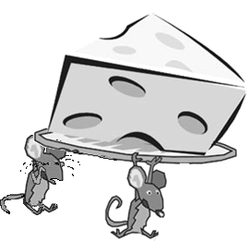
Mice are located in one line. Between them there are pieces of cheese. All mice can move one after another only to the left or only to the right and no mouse gets ahead of another mouse. For all mice there are 2 variants:
- Each mouse eats only one piece of cheese – the first one it finds.
- Each mouse eats all the pieces of cheese that are on its way.
On one position there is maximum one mouse, but the pieces of cheese can be more.
Creare a program mice, which for the each of the two variants draws the minimum number of mice, that haven`t eaten not even one piece of cheese in the direction they are moving to.

Input:
M –number of mice, 0<M<100000
m₁ m₂ … m_{M} – position of each mouse
N – number of the pieces of cheese, 0<N<100000
s₁ s₂ … s_{N} - the positions of the pieces of cheese
Output:
Р₁ В₁ -On the first line there are the answers of variant (A) – symbol P₁ and number B₁, separated by one space, where Р₁ is the direction of movement of the mice and B₁ – the minimum number of mice, that will stay hungry
Р₂ В₂ - On the second line are the answers of variant (B) – symbol P₂ and
number B₂, separated by one space , where Р₂ and B₂ have the same meanings like Р₁ and B₁.

The values of P₁ and P₂ are one of the symbols L, R or D, where:
L is to the left, R is to the right and D – the minimum number is the same when moving to the left or to the right.

Example 1 | Example 2
Input:  6  2 3 8 9 11 12  5  1 4 6 7 10  Output:  L 1  L 3 | Input:  4  1 2 3 5  5  2 2 3 3 4  Output:  D 1  L 1

Explanation: In 50% of the tests on one position there will be either one mouse or either one piece of cheese.

