Task. fractionS
Author: Teodosi Teodosiev

You know that when you use the computer for calculations with fractions, calculations are not always accurate, for example 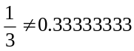. So we want to calculate the sum: 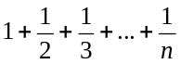 as simple irreducible fraction.
Write a program fractions, which input a positive integer n and displays the above sum as a mixed number – three positive integers representing the integer part, numerator and denominator of the sum.

Input
The program input a positive integer- n.
Output
The program output three positive integers, separated by a space, representing the integer part, numerator and denominator of the sum.

Restrictions
1<n <45

Examples

Input
2
Output
1 1 2
Input
4
Output
2 1 12

