Task B?. woodworms
Author: Zornica Dzhenkova

There is a barrier consisting of N tightly nailed wooden panels, each made of different material with different thickness. Two woodworms are placed on both sides. For each panel i (i = 1, ..., N), given is a time a_{i}, for which the first woodworm eats into the i-th pane and the time b_{i}, for which the second woodworm eats into the same i-th panel. Both woodworms start at the same time against each other moving in a straight line with a constant speed for the current panel. Obviously, on different arrangements of the panels, the time that is necessary for both woodworms to meet together will be different. Write a program woodworms, which finds such an arrangement of panels, so that the woodworms can eat into during the maximum time before they meet together.

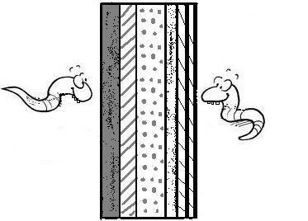  1. | 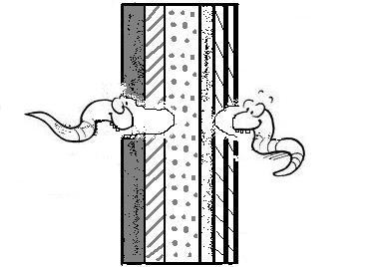  2.

Input
The first line of the standard input contains an integer N. Each of the next N lines contains two positive numbers a_{i} and b_{i}, separated by a space.
Output
On the standard output, your program has to display a number (integer or decimal fraction): the maximum time elapsed before the woodworms will meet together. This value should be with a precision better than 0.01.

Constraints:
1 ≤ N ≤ 256
a_{i} ≤ 1 000 000
b_{i} ≤ 1 000 000
In the tests, the times a_{i} and b_{i} are expressed as integers or as decimal fractions that contains up to six digits after the decimal point.
Example:
Input
4
1 2
1 2
0.5 1.5
7 3.5
Output
6.000

