PYTHON
PROGRAMMES
PROGRAMME 1
AIM
Write a python program that generate random number between 1 and 6(simulates a dice)
PYTHON CODE
import random
while True:
choice = input("Enter r to roll dice or press any other key to quit :")
if choice != 'r':
break
n = random.randint(1,6)
print("You rolled",n)
print('thanks for playing')
OUTPUT
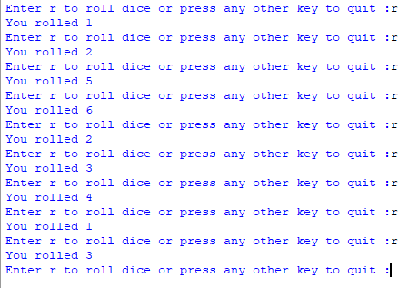

PROGRAMME 2
AIM
Program to compute the basic calculations performed in a calculator using function
PYTHON CODE
def calc(a,b):
add = a+b
sub = a-b
mul = a*b
div = a/b
return add,sub,mul,div
OUTPUT = calc(500,40)
print(OUTPUT)
print("the OUTPUT can be displayed as :")
for i in OUTPUT:
print(i)
OUTPUT
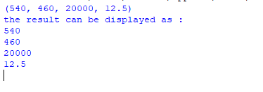
PROGRAMME 3
AIM
Write a program o find the maximum, minimum and mean value from the inputted list
PYTHON CODE
list1=[]
n=int(input("Enter the elements of elements in the list:"))
i=0
while i<n:
x=int(input("Enter the elements of the list:"))
list1.append(x)
i=i+1
print(list1)
maximum = max(list1)
minimum = min(list1)
mean=sum(list1)/len(list1)
print("maximum value is =",maximum)
print("minimum value is =",minimum)
print("mean value is =",mean)
OUTPUT

PROGRAMME 4
AIM
Read a text file line by line and count total number of having ‘H’ in it
FILE
PYTHON CODE
def countH():
f=open("greeting.txt",'r')
count=0
l=f.readlines()
for i in l:
if i[0]=='H':
count+=1
print("No.of lines are:",count)
f.close()
countH()
OUTPUT


PROGRAMME 5
AIM
Read a text file line by line and display each word seperated by a #
FILE
PYTHON CODE
def wordsseperated():
f=open("power.txt",'r')
lines=f.readlines()
for line in lines:
words=line.split()
for word in words:
print(word +"#",end='')
print()
wordsseperated()
OUTPUT

PROGRAMME 6
AIM
Read a text file and display the number of vowels/consonants/uppercase/lowercase characters.
FILE
PYTHON CODE
f = open("story.txt", 'r')
contents = f.read()
vowels = 0
consonants = 0
low_case = 0
upper_case = 0
for ch in contents:
if ch.isalpha():
# Count Vowels
if ch in 'aeiouAEIOU':
vowels = vowels + 1
if ch not in 'aeiouAEIOU':
consonants = consonants + 1
if ch.isupper():
upper_case = upper_case + 1

if ch.islower():
lower_case = lower_case + 1
f.close()
print("The total number of vowels: ", vowels)
print("The total number of consonants: ", consonants)
print("The total number of upper case: ", upper_case)
print("The total number of lower case: ", lower_case)
OUTPUT

PROGRAMME 7
AIM
Write a program to copy the content of a file to another file.
PYTHON CODE
import os
def filecopy(book, copybook):
f1 = open("book.txt", 'r')
f2 = open("copybook.txt", 'w')
line = f1.readline()
while line != '':
f2.write(line)
line = f1.readline()
f1.close()
f2.close()
def main():
filename1 = input('Enter the source file name:')
filename2 = input('Enter the destination file name:')
filecopy(filename1, filename2)
main()

OUTPUT
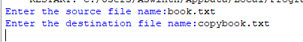

COPYBOOK
BOOK

PROGRAMME8
AIM
Write a program to input/append a record in the binary file “student.dat”
PYTHON CODE
import pickle
record = [ ]
while True:
roll_no = int(input('Enter student roll no:'))
name = input('Enter the student name:')
marks = int(input('Enter the marks obtained:'))
data = [roll_no, name, marks]
record.append(data)
choice = input('Wish to enter more records (Y/N)?:')
if choice.upper() == 'N':
break

f = open("student", "wb")
pickle.dump(record, f)
print("Record Added")
f.close()
OUTPUT

PROGRAMME 9
AIM
To search and display an employee’s details from a CSV file using their employee number
PYTHON CODE
import csv
flag = 0
f = open("EMP.csv",'r')
csvreader=csv.reader(f)
eno = int(input("Enter the eno to be searched for :"))
for row in csvreader:
if row[0]==str(eno):
print(row[1],row[2])
flag =1
if flag == 0:
print("Record not found")
f.close()

OUTPUT
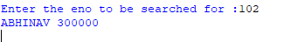
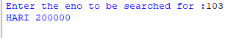
FILE
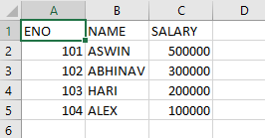

PROGRAMME 10
AIM
Write a program to read and count the contents of a CSV file.
PYTHON CODE
import csv
rec = 0
with open("test.csv", "r") as f:
csvreader = csv.reader(f)
for row in csvreader:
print(row)
rec += 1
print("No. of records:", rec)
FILE
OUTPUT

PROGRAMME 11
AIM
Write a python program to implement all basic operations of a stack.
PYTHON CODE
S = [ ]
c = 'Y'
while (c == 'Y'):
print('1. PUSH')
print('2. POP')
print('3. DISPLAY')
choice = int(input('Enter your choice:'))
if (choice == 1):
a = input('Enter an element:')
S.append(a)
elif (choice == 2):
if (S == [ ]):
print('Stack empty')
else:
print('Deleted element is', S.pop())
elif (choice == 3):
L = len(S)
for i in range(L - 1, -1, -1):
print(S[i])
else:
print('Wrong input')
c = input('Do you want to continue or not?')
OUTPUT

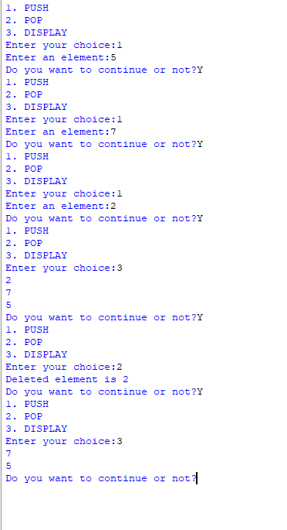
PROGRAMME 12
AIM
Write a program to create a stack called 'Employee' to perform the basic operations on stack using list. The list contains the two values - employee number and employee name.
PYTHON CODE
S = [ ]
c = 'Y'
while (c == 'Y'):
print('1. PUSH')
print('2. POP')
print('3. DISPLAY')
choice = int(input('Enter your choice:'))
if (choice == 1):
a = input('Enter an element:')
S.append(a)
elif (choice == 2):
if (S == [ ]):
print('Stack empty')
else:
print('Deleted element is', S.pop())
OUTPUT
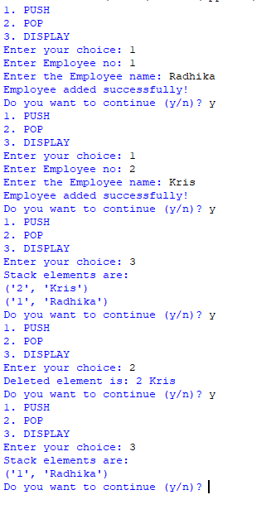

PROGRAMME 13
AIM
Write a program to find maximum ,minimum and average using stack.
PYTHON CODE
list1 = [ ]
n = int(input('enter the no. of elements in the list: '))
i = 0
while i< n:
x = int(input('enter the elements of list: '))
list1.append(x)
i = i + 1
print(list1)
maximum = max(list1)
minimum = min(list1)
mean = sum(list1) / len(list1)
print('maximum value is = ', maximum)
print('minimum value is = ', minimum)
print('average value is = ', mean)
OUTPUT
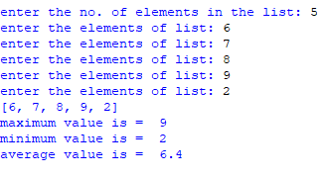

PROGRAMME 14
AIM
Write a user-defined function Createfile() to input data for a record and add to 'book.dat'. Also write a function Countrec(Author) in python which accepts the author’s name as a parameter and count and return number of books by the given author in the binary file 'book.dat'
PYTHON CODE
import pickle
def Createfile():
with open('book.dat', 'ab') as fobj:
bookno = input('input book number: ')
bookname = input('name: ')
author = input('author: ')
price = int(input('price: '))
rec = [bookno, bookname, author, price]
pickle.dump(rec, fobj)
def Countrec(author):
count = 0
try:
with open('book.dat', 'rb') as fobj:
while True:
rec = pickle.load(fobj)
if author == rec[2]:
count += 1
except EOFError:
pass
print("No. of books by", Author, "=", count)
OUTPUT
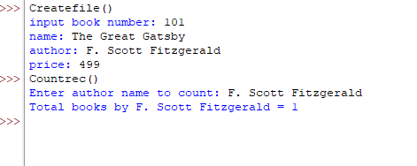

PROGRAMME 15
AIM
Write a program to display unique vowels present in the given word using stack
PYTHON CODE
vowels = ['a', 'e', 'i', 'o', 'u']
word = input('enter the word to search for vowels: ')
stack = []
for letter in word:
if letter in vowels:
if letter not in stack:
stack.append(letter)
print(stack)
print('the no. of different vowels present in', word, 'is', len(stack))
OUTPUT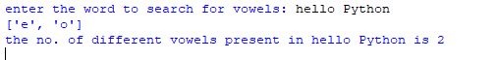

PROGRAMME 16
AIM
Write a program to find the maximum, minimum and mean value from the inputted list
PYTHON CODE
str1 = input('enter the string: ')
print(str1)
uppercase = 0
lowercase = 0
i = 0
while i<len(str1):
if str[i].islower():
lowercase = lowercase + 1
if str[i].isupper():
uppercase = uppercase + 1
i = i + 1
print('no. of uppercase letters in the string: ', uppercase)
print('no. of lowercase letters in the string: ', lowercase)

OUTPUT
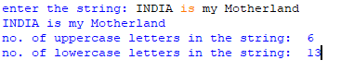

PROGRAMME 17
AIM
To create a new database database ‘employee11’ in mysql through python

PYTHON CODE
import mysql.connector
mydb=mysql.connector.connect(host="localhost",user='root',password='1234')
mycursor=mydb.cursor()
mycursor.execute('create database employee11')
mydb.commit
OUTPUT
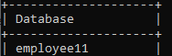

PROGRAMME 18
AIM
To create table emp11 inside the database ‘employee’ in mysql through python
PYTHON CODE
import mysql.connector
mydb = mysql.connector.connect(
host='localhost',
user='root',
password='1234')
mycursor = mydb.cursor()
mycursor.execute('USE employee11')
mycursor.execute('CREATE TABLE emp11 (empno INT, ename VARCHAR(20), salary INT)')
mydb.commit()
mycursor.close()
mydb.close()
OUTPUT
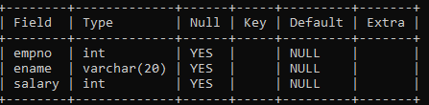
PROGRAMME 19
AIM
To insert records into the table emp11 using python interface.

PYTHON CODE
import mysql.connector
mydb=mysql.connector.connect(host="localhost",user='root',password='1234')
mycursor=mydb.cursor()
mycursor.execute('use employee11')
mycursor.execute("insert into emp11 values(1,'atlas corrigan',1000000)")
mycursor.execute("insert into emp11 values(2,'lilly bloom',50000)")
mycursor.execute("insert into emp11 values(3,'ryle leincard',10000000)")
mydb.commit()
print('yes')
OUTPUT
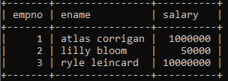
PROGRAMME 20
AIM
To update employee11 record using python connectivity.
PYTHON CODE
import mysql.connector
mydb = mysql.connector.connect(
host='localhost',
user='root',
password='1234'
)
mycursor = mydb.cursor()
mycursor.execute('USE employee11')
query='update emp11 set salary = salary+1000 where empno =2'
mycursor.execute(query)
mydb.commit()
OUTPUT
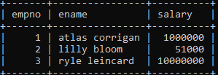

PROGRAMME 21
AIM
To delete the record of employee11 table using python connectivity
PYTHON CODE
import mysql.connector
mydb = mysql.connector.connect(
host='localhost',
user='root',
password='1234'
)
mycursor = mydb.cursor()
mycursor.execute('USE employee11')
mycursor.execute('delete from emp11 where empno=3')
mydb.commit()
OUTPUT
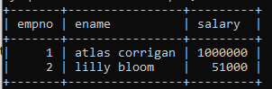

SQL
PROGRAMS

SET COMMANDS(SET-1)
Create a table Customer using the following data
Accno | Custname | Loanamount | Installment | Intrate | Startdate | Interest
1 | Druv Sharma | 800000 | 36 | 12 | 2012-07-09 | 1200
2 | MahandraSingh | 300000 | 48 | 10 | 2014-08-20 | 1800
3 | Shivika R | 500000 | 36 | NULL | 2015-04-10 | 1600
4 | Aaura B | 200000 | 60 | 10 | 2017-10-25 | 2250
5 | Aakrithi S | 600000 | 36 | 10.5 | 2019-02-18 | 4500

SQL STATEMENT
CREATE TABLE CUSTOMER(Accno INT(2)PRIMARY KEY,Custname VARCHAR(20),Loanamount INT(10),Installment INT(3),Intrate VARCHAR(8),StartdateDATE,Interest INT(5));
INSERT INTO CUSTOMER VALUES(1,"Druv Sharma",800000,36,12,'2012-07-09',1200);
INSERT INTO CUSTOMER VALUES(2,"Mahandra Singh",300000,48,10,'2014-08-20',1800);
INSERT INTO CUSTOMER VALUES(3,"Shivika R",500000,36,NULL,'2015-04-10',1600);
INSERT INTO CUSTOMER VALUES(4,"Aaura B",200000,60,10,'2017-10-25',2250);
INSERT INTO CUSTOMER VALUES(5,"Aakrithi S",600000,36,10.5,'2019-02-18',4500);

OUTPUT
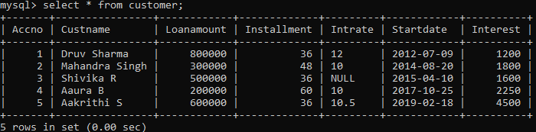

SET COMMANDS(SET-2)
Consider the table customer and execute the following SQL queries:
Accno | Custname | Loanamount | Installment | Intrate | Startdate | Interest
1 | Druv Sharma | 800000 | 36 | 12 | 2012-07-09 | 1200
2 | MahandraSingh | 300000 | 48 | 10 | 2014-08-20 | 1800
3 | Shivika R | 500000 | 36 | NULL | 2015-04-10 | 1600
4 | Aaura B | 200000 | 60 | 10 | 2017-10-25 | 2250
5 | Aakrithi S | 600000 | 36 | 10.5 | 2019-02-18 | 4500
1.To arrange and display all the records of table customer
QUERY
SELECT*FROM CUSTOMER;
OUTPUT
2.To increase the interest by 10% of interest for loan amount greater than 400000
QUERY
UPDATE CUSTOMER SET interest=interest+(interest*10)/100 WHERE LOANAMOUNT>400000;
OUTPUT
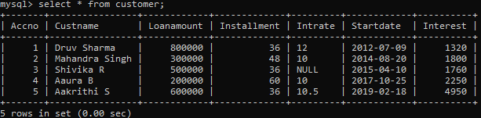

2.To add a new column DUE_DATE with NULL values
QUERY
ALTER TABLE CUSTOMER ADD DUE_DATE Date;
OUTPUT
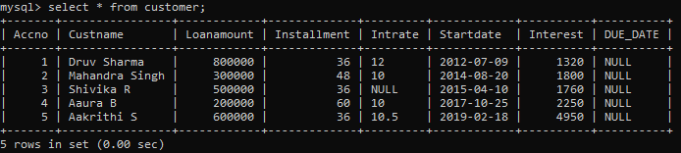
4.To display the customer name ends with “a”
QUERY
SELECT * FROM CUSTOMER WHERE Custnamelike"%a";
OUTPUT
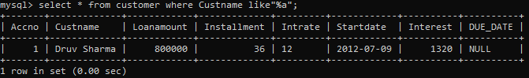
5.To delete the record of whose account number is 4
QUERY
DELETE FROM CUSTOMER WHERE Accno=4;
OUTPUT
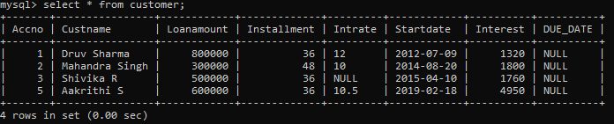

SOL COMMANDS(SET-3)
Consider the table employee and execute the following SQL queries
E_ID | E_NAME | E_SALARY | E_AGE | E_GENDER | E_DEPT
1 | JOY | 95000 | 24 | M | OPERATIONS
2 | SAM | 80000 | 30 | M | SUPPORT
3 | ELSA | 110000 | 22 | F | ANALYTICS
4 | TOM | 73000 | 23 | M | OPERATIONS
5 | JERRY | 125000 | 21 | M | SALES
6 | LISA | 100000 | 25 | F | ANALYTICS
1.To display the name of the employee from operations department
QUERY
SELECT E_ID FROM EMPLOYEE WHERE E_DEPT="OPERATIONS";
OUTPUT
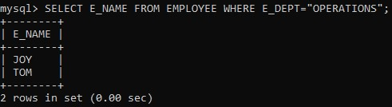
2.TODISPLAY THE E_NAME,E_SALARY FROM EMPLOYEES WHOSE AGE IS LESS THAN 30.
QUERY
SELECT E_NAME,E_SALARY FROM EMPLOYEE WHERE E_GENDER="F"AND E_AGE<30;
OUTPUT
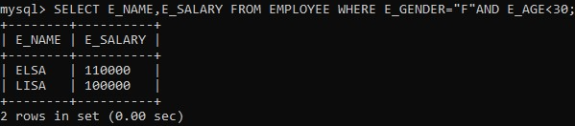

3.Display the average salary of female employees
QUERY
SELECT AVG(E_SALARY) FROM EMPLOYEE WHERE E_GENDER ='F';
OUTPUT
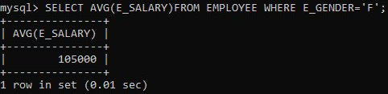
4.To delete from employee WHERE E_ID=6
QUERY
DELETE FROM EMPLOYEE WHERE E_ID=6;
OUTPUT
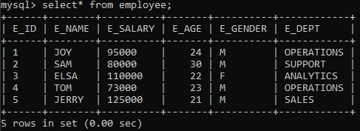
5.TO CHANGE THE DEPARTMENT OF EMPLOYEE TO SALES WHOSE E_ID IS 4
QUERY
UPDATE EMPLOYEE SET E_DEPT="SALES" WHERE E_ID=4;
OUTPUT
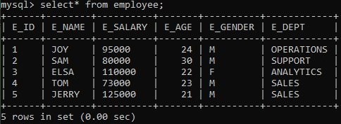

SQL COMMANDS(SET-4)
1.To create table car
Mysql> create table car(Vcode varchar(5),Vehicle_name varchar(10),Make char(10),color char(10),capacity integer(2),charges integer(4));
2.To create a table customer
mysql> create table customer(C_codeinteger,C_name varchar(15),Vcode integer);
3.To show table car
mysql> select* from car;
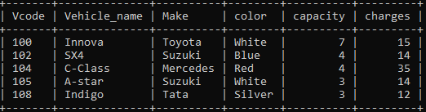
4.To show table customer
mysql> select* from customer;
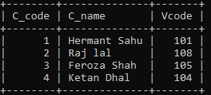
5.To display names of all the white coloured vehicles.
mysql> select vehicle_name from car where color='white';
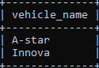
6.To display name of vehicle, make and capacity of vehicles in ascending order of their seating capacity
mysql> select Vehicle_name,make,capacity from car order by capacity;
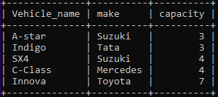
7.To display highest charges at which vehicles can be hired form car.
mysql> select max(charges) from car;

8.To display the customer name and corresponding name of the vehicle hired by them.
mysql> select C_name,Vehicle_name car from customer,car where customer.vcode=car.vcode;
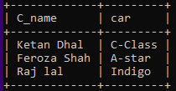
9,To display the seating capacity and charges of vehicles whose name ends with ‘a’
mysql> select capacity,charges from car where make like'%a';
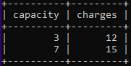

SQLCOMMANDS(SET-5)
1. To create a table ITEM.
mysql> create table ITEM (i_ID varchar(10),ItemName varchar(20),Manufacturer char(10),Price integer(10));
2. To create a table CUSTOMERS.
mysql> create table CUSTOMERS (C_ID integer(10),CustomerName varchar(20),City char(10),I_ID VARCHAR(10));
3. To show table ITEM.
mysql> select*from ITEM;
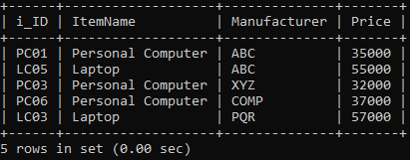
4.To show table CUSTOMERS.
mysql> select*from CUSTOMERS;
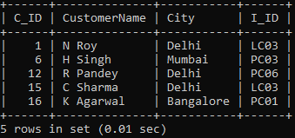
5.To display the details of those Customers whose City is Delhi.
mysql> select * from CUSTOMERS where City = 'Delhi';
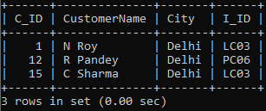

6. To display the details of ITEM whose Price is in the range of 35000 to 55000.
mysql>select from ITEM where Price between 35000 and 55000;
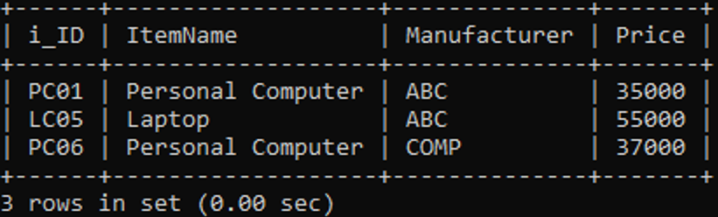
7.To display the CustomerName, City from table CUSTOMERS and ItemName and Price from table ITEM.
mysql>SELECT CustomerName, City, ItemName, Price from CUSTOMERS, ITEM where CUSTOMERS.I_ID=ITEM.I_ID;
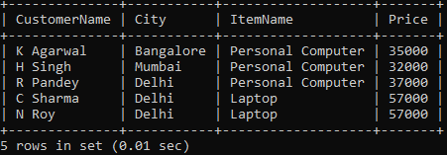
8. To arrange the whole table ITEM in the order of Price.
mysql>select*from ITEM order by Price;
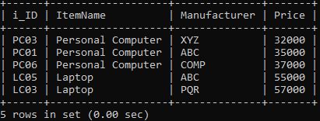
9.To increase the Price of all Items by 1000 in the table ITEM.
mysql>update ITEM set Price = Price + 1000;
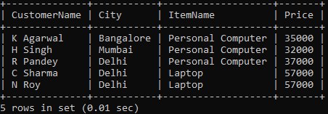

SQL COMMANDS(SET-6)
1.To create a table Books.
mysql> create table Books(Book_Id varchar(10),Book_Name varchar(20),Author_Name char(20),Publishers char(15),Price integer(10),Type char(10),Qty integer(5);
2. To create a table Issued.
mysql> create table Issued(Book_Id varchar(10),Quantity_Issued integer(5));
3. To show table Books.
mysql> select*from Books;
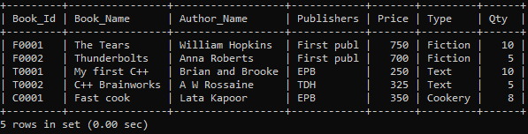
4. To show table Issued.
mysql> select*from Issued;
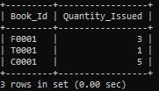
5. To show Book_name, Author_name and Price of Books of EPB Publishers.
mysql> select Book_Name, Author_Name, Price from Books where Publishers = 'EPB';
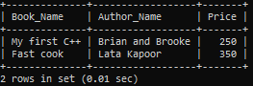

6. To list the names from books of Fiction type.
mysql> select Book_Name from Books where Type = 'Fiction';
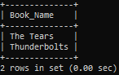
7.To display the names and price of the Books in descending order of their price.
mysql> select Book_Name, Price from Books order by Price desc;
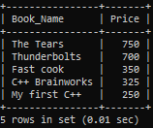
8.To display the Book_Id, Book_Name and Quantity_Issued for all books which have been issued.
mysql> select Books.Book_ID, Books.Book_Name, Issued.Quantity_Issued from Books join Issued on Books.Book_ID = Issued.Book_ID;
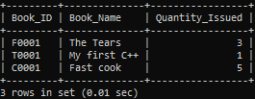
9.To increase the price of all books of First Publishers by 50.
mysql> update Books set Price = Price + 50 where Publishers = 'First Publ';
