SIGNALCHECK
Multi-Agent AI News Assistant
Project Epic • Features • User Stories • Workflow • Team Allocation

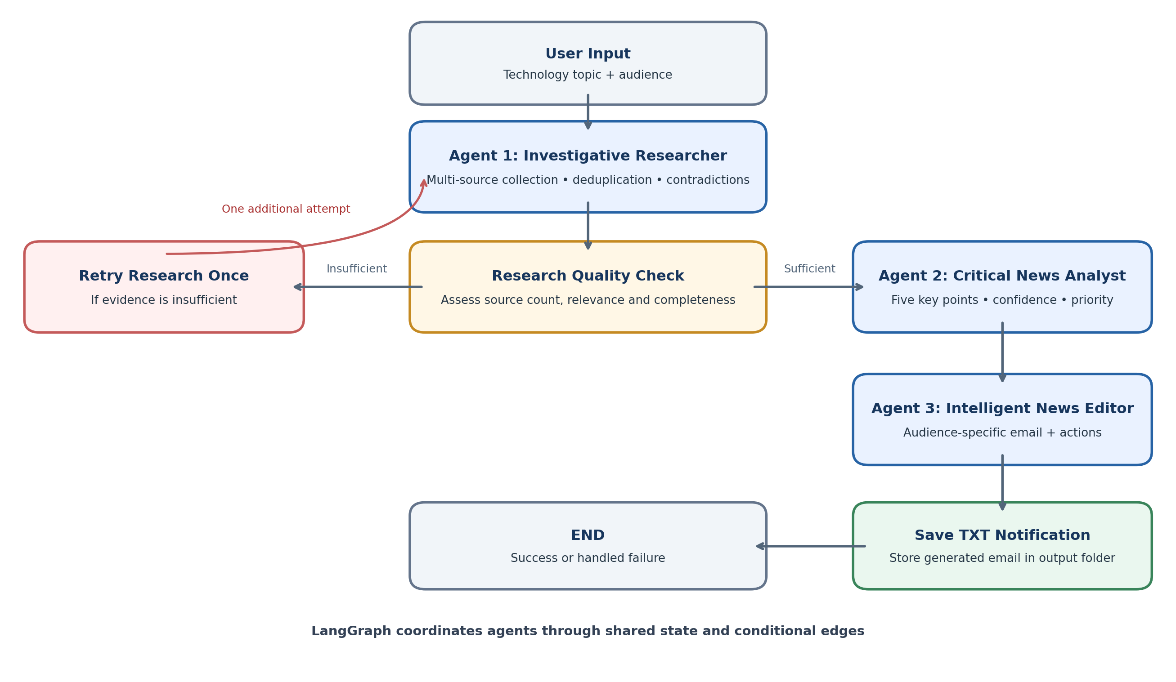
Prepared from the supplied project requirements

1. Epic
EPIC-01 | High Priority

SignalCheck – Multi-Agent AI News Assistant
As an organization, we want to build an intelligent multi-agent AI News Assistant using LangChain and LangGraph that researches the latest technology developments from multiple web sources, identifies conflicting information, evaluates news credibility, generates a five-point summary with confidence and priority indicators, and prepares audience-specific professional email notifications.
The system should use three specialized AI agents coordinated through LangGraph, including a conditional research-quality validation mechanism that triggers a limited research retry when the collected information is insufficient.

Business value
- Reduce the time employees spend researching technology news.
- Improve awareness of important technology developments.
- Distinguish verified information from conflicting or uncertain claims.
- Deliver relevant information to different employee groups.
- Provide reliable, actionable and source-backed news notifications.

2. Feature Breakdown
Feature ID | Feature Name | Description
F01 | Investigative News Research | Collect and validate technology news from multiple sources.
F02 | Research Quality Validation | Evaluate research completeness and trigger conditional retry.
F03 | Critical News Analysis | Generate five key points and analyze contradictions, confidence and priority.
F04 | Intelligent Email Notification | Generate audience-specific employee email notifications.
F05 | LangGraph Workflow Orchestration | Coordinate the three agents using shared state and conditional edges.
F06 | Notification Storage & Error Handling | Save email notifications and handle workflow errors.

3. User Stories and Acceptance Criteria

F01 – Investigative News Research

US01 – Topic input
As an employee, I want to enter a technology topic so that I can receive the latest developments.
Acceptance criteria
- User can enter a technology topic.
- Empty input is rejected.
- Research starts after valid input.

US02 – Multi-source news collection
As an employee, I want the Research Agent to collect information from multiple web sources so that I can get a broader understanding of a development.
Acceptance criteria
- Search multiple relevant sources.
- Extract article titles, descriptions, publication dates and URLs.
- Remove duplicate articles.
- Pass research findings to the next workflow stage.

US03 – Contradiction identification
As an employee, I want conflicting information between sources to be identified so that I am not misled by inconsistent reporting.
Acceptance criteria
- Compare claims across collected sources.
- Identify supporting and conflicting information.
- Preserve the source references for each claim.
- Mark unresolved information as uncertain rather than presenting it as fact.

F02 – Research Quality Validation

US04 – Research quality check
As an employee, I want research findings to be evaluated before summarization so that insufficient information does not produce misleading reports.
Acceptance criteria
- Evaluate source count, relevance and information completeness.
- Continue when research meets the defined quality threshold.
- Trigger another research attempt when information is insufficient.
- Limit retries to one additional attempt.
- Return an understandable error if sufficient information remains unavailable.

F03 – Critical News Analysis

US05 – Five-point news summary
As an employee, I want a concise summary of five important developments so that I can understand the latest news quickly.
Acceptance criteria
- Generate five key points when sufficient information is available.
- Avoid repeating the same development.
- Include relevant source links.
- Maintain the original meaning of the research.

US06 – Confidence and priority analysis
As an employee, I want each important development to have confidence and priority indicators so that I can understand its reliability and importance.
Acceptance criteria
- Separate confirmed, developing and disputed claims.
- Generate an explainable confidence assessment.
- Calculate priority using recency, impact, corroboration and relevance.
- Identify information that remains unknown.

F04 – Intelligent Email Notification

US07 – Audience-specific notification
As an employee, I want notifications relevant to my department so that I receive information applicable to my work.
Acceptance criteria
- Support Engineering, Cybersecurity, Management and All Employees.
- Adapt the business implications to the selected audience.
- Retain the same underlying research findings.
- Include five key points and source links.

US08 – Actionable email generation
As an employee, I want a professional email containing recommended actions so that I understand what to monitor or consider next.
Acceptance criteria
- Generate a professional subject and email body.
- Include important findings and priority.
- Include confidence and uncertainty information.
- Include recommended actions.
- Include relevant source links.

F05 – LangGraph Workflow Orchestration

US09 – Multi-agent coordination
As a developer, I want LangGraph to coordinate three agents so that information passes through the complete workflow automatically.
Acceptance criteria
- Implement three separate agent modules.
- Define shared workflow state.
- Execute Research → Quality Check → Summarizer → Notifier.
- Implement conditional edges for research retry.
- End execution after successful notification or handled failure.

F06 – Notification Storage & Error Handling

US10 – Save notification
As an employee, I want the generated email saved to a text file so that I can access it later.
Acceptance criteria
- Save email content in a .txt file.
- Store generated reports in the output directory.
- Display the saved file location.
- Handle file-writing errors.

US11 – Workflow error handling
As a developer, I want the application to handle failures gracefully so that one failed stage does not cause an uncontrolled application crash.
Acceptance criteria
- Handle web search failures.
- Handle missing research.
- Handle LLM/API errors.
- Handle research retry limits.
- Provide meaningful error messages.

4. LangGraph Workflow
The workflow below represents the sequence implemented by the user stories and features.

Workflow stages
- User enters a technology topic and selects an audience.
- Agent 1 – Investigative Researcher collects information from multiple sources, removes duplicates and identifies contradictions.
- Research Quality Check evaluates source count, relevance and completeness. If evidence is insufficient, research is retried once.
- Agent 2 – Critical News Analyst generates five key points and assesses confidence and priority.
- Agent 3 – Intelligent News Editor prepares an audience-specific professional email with recommended actions.
- The notification is saved as a TXT file. The workflow ends after successful notification or a handled failure.
LangGraph coordinates the agents through shared state and conditional edges.

5. Task Allocation – Team of 3
Task ID | Task | Assigned Member
T01 | Project setup and dependencies | Member 1
T02 | Tavily integration | Member 1
T03 | Multi-source research | Member 1
T04 | Duplicate detection | Member 1
T05 | Contradiction identification | Member 1
T06 | Research quality validation logic | Member 1
T07 | Five-point summarization | Member 2
T08 | Fact and claim classification | Member 2
T09 | Confidence assessment | Member 2
T10 | Priority calculation | Member 2
T11 | Business impact analysis | Member 2
T12 | Audience-specific email generation | Member 3
T13 | Recommended actions | Member 3
T14 | TXT notification storage | Member 3
T15 | LangGraph shared state and orchestration | Member 3
T16 | Conditional retry integration | Member 3
T17 | End-to-end testing | All 3
T18 | README and documentation | All 3

Task allocation overview
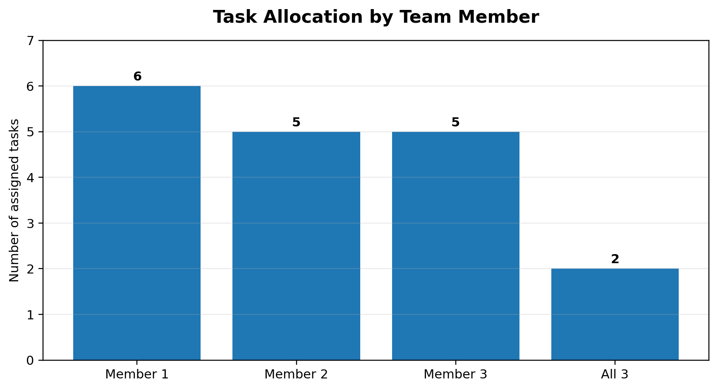
The chart counts the explicitly assigned tasks: Member 1 = 6, Member 2 = 5, Member 3 = 5, and shared team tasks = 2.

6. Definition of Done
The Epic can be considered complete when:
- All three agents are implemented separately.
- Multi-source research is functional.
- Contradictory information is identified and presented with supporting sources.
- Research quality validation and limited retry work.
- Five-point summarization works.
- Confidence and priority assessments are generated.
- Audience-specific email notifications are generated.
- Notifications are saved to text files.
- LangGraph coordinates the complete workflow.
- Error handling and end-to-end testing are completed.
- README and architecture documentation are available.

