Kratik Mehta

PGp-DSBA  Feb 2022

SMDM Project Bussiness Report

Table of Contents

List of Figures 4

List of Tables 5

Problem 1 6

Executive Summary 6

Sample of the Wholesale Customers Dataset 6

Checking the types of variables in the dataset. 6

Checking the distributions of the continuous variables. 6

1.1 Use methods of descriptive statistics to summarize data. Which Region and which Channel spent the most? Which Region and which Channel spent the least? 7

Descriptive Statistics of the Wholesale Customers Dataset 7

Region wise Total Annual Spending’s for the items 8

Channel wise Total Annual Spending’s for the items 8

1.2 There are 6 different varieties of items that are considered. Describe and comment/explain all the varieties across Region and Channel? Provide a detailed justification for your answer. 9

Region wise Average spending for different variety of Items. 9

Region wise Coefficient of Variation of spending for different variety of Items. 9

Channel wise Average spending’s for different variety of Items. 9

Channel wise Coefficient of Variation of spending’s for different variety of Items. 10

1.3 On the basis of a descriptive measure of variability, which item shows the most inconsistent behaviour? Which items show the least inconsistent behaviour? 10

1.4 Are there any outliers in the data? Back up your answer with a suitable plot/technique with the help of detailed comments. 10

1.5 On the basis of your analysis, what are your recommendations for the business? How can your analysis help the business to solve its problem? Answer from the business perspective 11

Problem 2 11

Executive Summary 11

Sample of the Survey Dataset 12

Checking the types of variables in the dataset. 12

2.1. For this data, construct the following contingency tables (Keep Gender as row variable) 12

2.1.1. Gender and Major 12

2.1.2. Gender and Grad Intention 13

2.1.3. Gender and Employment 13

2.1.4. Gender and Computer 13

2.2. Assume that the sample is representative of the population of CMSU. Based on the data, answer the following question: 13

2.2.1. What is the probability that a randomly selected CMSU student will be male? 13

2.2.2. What is the probability that a randomly selected CMSU student will be female? 13

2.3. Assume that the sample is representative of the population of CMSU. Based on the data, answer the following question: 13

2.3.1. Find the conditional probability of different majors among the male students in CMSU. 13

2.3.2. Find the conditional probability of different majors among the female students in CMSU. 14

2.4. Assume that the sample is a representative of the population of CMSU. Based on the data, answer the following question: 14

2.4.1. Find the probability that a randomly chosen student is a male and intends to graduate. 14

2.4.2 Find the probability that a randomly selected student is a female and does NOT have a laptop. 14

2.5. Assume that the sample is representative of the population of CMSU. Based on the data, answer the following question: 14

2.5.1. Find the probability that a randomly chosen student is a male or has full-time employment? 14

2.5.2. Find the conditional probability that given a female student is randomly chosen, she is majoring in international business or management. 15

2.6. Construct a contingency table of Gender and Intent to Graduate at 2 levels (Yes/No). The Undecided students are not considered now and the table is a 2x2 table. Do you think the graduate intention and being female are independent events? 15

2.7. Note that there are four numerical (continuous) variables in the data set, GPA, Salary, Spending, and Text Messages. Answer the following questions based on the data 15

2.7.1. If a student is chosen randomly, what is the probability that his/her GPA is less than 3? 15

2.7.2. Find the conditional probability that a randomly selected male earns 50 or more. Find the conditional probability that a randomly selected female earns 50 or more. 16

2.8. Note that there are four numerical (continuous) variables in the data set, GPA, Salary, Spending, and Text Messages. For each of them comment whether they follow a normal distribution. Write a note summarizing your conclusions. 16

Distribution of GPA 16

Distribution of Salary 17

Distribution of Spending 17

Distribution of Text Messages 18

Conclusion 18

Problem 3 19

Executive Summary 19

Sample of the A & B Shingles Dataset 19

Checking the types of variables in the dataset. 19

Checking the distribution of both variables in the Shingles dataset. 19

3.1 Do you think there is evidence that mean moisture contents in both types of shingles are within the permissible limits? State your conclusions clearly showing all steps. 20

Stating the Null and Alternative Hypothesis for both A and B shingles. 20

Deciding on the Type of Test to use. 20

Deciding on the Significance Level. 20

Hypothesis test for A shingles 20

Hypothesis test for B shingles 21

Conclusion 21

3.2 Do you think that the population mean for shingles A and B are equal? Form the hypothesis and conduct the test of the hypothesis. What assumption do you need to check before the test for equality of means is performed? 21

Stating the Null and Alternative Hypothesis 21

Deciding on the Type of Test to use. 21

Assumptions to check for Two-sample t-test 21

Deciding on the Significance Level. 21

Hypothesis Test 21

Conclusion 21

# List of Figures

Figure 1: Distributions of the continuous variables in Wholesale Dataset 7

Figure 2: Region wise Total Annual Spending’s 8

Figure 3: Channel wise Total Annual Spending’s 8

Figure 4: Item wise Box plots for Wholesale Dataset 11

Figure 5: Distribution of Continuous Variables in Survey Dataset 16

Figure 6: QQ-Plot for GPA 17

Figure 7: QQ-Plot for Salary 17

Figure 8: QQ-Plot for Spending 18

Figure 9: QQ-Plot for Text Messages 18

Figure 10: Distribution of Variables in Shingles Dataset 20

# List of Tables

Table 1: Wholesale Customers Dataset Sample 6

Table 2: Descriptive Statistics of the Wholesale Customers Dataset 7

Table 3: Region wise Total Annual Spendings for the items 8

Table 4: Channel wise Total Annual Spendings for the items 8

Table 5: Region wise Average spendings for different variety of Items 9

Table 6: Region wise Coefficient of Variation of spendings for different variety of Items 9

Table 7: Channel wise Average spendings for different variety of Items 9

Table 8: Channel wise Coefficient of Variation of spendings for different variety of Items 10

Table 9: Survey Dataset Sample 12

Table 10: Contingency Table for Gender and Major 12

Table 11: Contingency Table for Gender and Grad Intention 13

Table 12: Contingency Table for Gender and Employment 13

Table 13: Contingency Table for Gender and Computer 13

Table 14: Contingency table for Gender and Intent to Graduate at 2 levels 15

Table 15: A & B Shingles Dataset Sample 19

# Problem 1

## Executive Summary

A wholesale distributor operating in different regions of Portugal has information on annual spending of several items in their stores across different regions and channels. The data consists of 440 large retailers’ annual spending on 6 different varieties of products in 3 different regions (Lisbon, Oporto, Other) and across different sales channel (Hotel, Retail). In this problem statement, we will perform some basic exploratory data analysis on the annual spending’s of different items across different regions and channels.

## Sample of the Wholesale Customers Dataset

|  |  |  |  |  |  |  |  |  |  |
| --- | --- | --- | --- | --- | --- | --- | --- | --- | --- |
|  | Buyer/Spender | Channel | Region | Fresh | Milk | Grocery | Frozen | Detergents_Paper | Delicatessen |
| 0 | 1 | Retail | Other | 12669 | 9656 | 7561 | 214 | 2674 | 1338 |
| 1 | 2 | Retail | Other | 7057 | 9810 | 9568 | 1762 | 3293 | 1776 |
| 2 | 3 | Retail | Other | 6353 | 8808 | 7684 | 2405 | 3516 | 7844 |
| 3 | 4 | Hotel | Other | 13265 | 1196 | 4221 | 6404 | 507 | 1788 |
| 4 | 5 | Retail | Other | 22615 | 5410 | 7198 | 3915 | 1777 | 5185 |

*Table 1: Wholesale Customers Dataset Sample*

## Checking the types of variables in the dataset.

<class 'pandas.core.frame.DataFrame'>

RangeIndex: 440 entries, 0 to 439

Data columns (total 9 columns):

# Column Non-Null Count Dtype

--- ------ -------------- -----

0 Buyer/Spender 440 non-null int64

1 Channel 440 non-null object

2 Region 440 non-null object

3 Fresh 440 non-null int64

4 Milk 440 non-null int64

5 Grocery 440 non-null int64

6 Frozen 440 non-null int64

7 Detergents_Paper 440 non-null int64

8 Delicatessen 440 non-null int64

dtypes: int64(7), object(2)

memory usage: 31.1+ KB

From the above output we can see that:

* There are 440 observations of different buyers in the data.
* There are 9 variables, out of which, 7 are of integer type and 2 are of object(categorical) type.
* Out of the 7 integer type variables, **Buyer/Spender** is *discrete numerical variable* while the others are *continuous numerical variables*.
* The dataset does not have any missing values.

## Checking the distributions of the continuous variables.

From the below plot, it can be seen that the data for the continuous variables is not normally distributed.

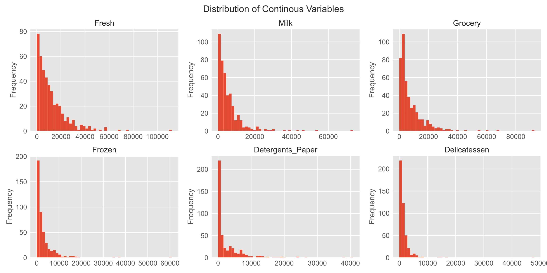Figure 1: Distributions of the continuous variables in Wholesale Dataset

## 1.1 Use methods of descriptive statistics to summarize data. Which Region and which Channel spent the most? Which Region and which Channel spent the least?

### Descriptive Statistics of the Wholesale Customers Dataset

Descriptive Statistics tells us a brief summary of the dataset. It can include the 5-point summary for the numerical variables and frequency distribution of categorical variables.

|  |  |  |  |  |  |  |  |  |  |  |  |
| --- | --- | --- | --- | --- | --- | --- | --- | --- | --- | --- | --- |
|  | count | unique | top | freq | mean | std | min | 25% | 50% | 75% | max |
| Buyer/Spender | 440.0 | NaN | NaN | NaN | 220.5 | 127.161315 | 1.0 | 110.75 | 220.5 | 330.25 | 440.0 |
| Channel | 440 | 2 | Hotel | 298 | NaN | NaN | NaN | NaN | NaN | NaN | NaN |
| Region | 440 | 3 | Other | 316 | NaN | NaN | NaN | NaN | NaN | NaN | NaN |
| Fresh | 440.0 | NaN | NaN | NaN | 12000.297727 | 12647.328865 | 3.0 | 3127.75 | 8504.0 | 16933.75 | 112151.0 |
| Milk | 440.0 | NaN | NaN | NaN | 5796.265909 | 7380.377175 | 55.0 | 1533.0 | 3627.0 | 7190.25 | 73498.0 |
| Grocery | 440.0 | NaN | NaN | NaN | 7951.277273 | 9503.162829 | 3.0 | 2153.0 | 4755.5 | 10655.75 | 92780.0 |
| Frozen | 440.0 | NaN | NaN | NaN | 3071.931818 | 4854.673333 | 25.0 | 742.25 | 1526.0 | 3554.25 | 60869.0 |
| Detergents_Paper | 440.0 | NaN | NaN | NaN | 2881.493182 | 4767.854448 | 3.0 | 256.75 | 816.5 | 3922.0 | 40827.0 |
| Delicatessen | 440.0 | NaN | NaN | NaN | 1524.870455 | 2820.105937 | 3.0 | 408.25 | 965.5 | 1820.25 | 47943.0 |

*Table 2: Descriptive Statistics of the Wholesale Customers Dataset*

From the above output we can see that:

* The **Channel** variable has 2 unique values, with *Hotel* being the most frequent, occurring 298 times.
* The **Region** variable has 3 unique values, with *Other* being the most frequent, occurring 316 times.
* The **Fresh** items have the highest average annual spending in the dataset.
* The maximum annual spending values of all the items are quite high. These values might be outliers.
* The standard deviations of the annual spending are also large. This indicates that the data is spread over a big range.

NaN shows that the values cannot be calculated for that particular variable. Like we cannot calculate mean for a categorical variable. And in a same way unique value cannot be calculated for a numerical variable.

### Region wise Total Annual Spending’s for the items

|  |  |
| --- | --- |
|  | Total_Spendings |
| Region |  |
| Oporto | 1555088 |
| Lisbon | 2386813 |
| Other | 10677599 |

*Table 3: Region wise Total Annual Spending’s for the items*

Figure 2: Region wise Total Annual Spending’s

After calculating the Region wise Total Spending’s, we found that:

* The buyers spent the *least* in the *Oporto* region.
* The buyers spent the *most* in the *Other* regions.

### Channel wise Total Annual Spending’s for the items

|  |  |
| --- | --- |
|  | Total_Spendings |
| Channel |  |
| Retail | 6619931 |
| Hotel | 7999569 |

*Table 4: Channel wise Total Annual Spending’s for the items*

Figure 3: Channel wise Total Annual Spending’s

After calculating the Channel wise Total Spending’s, we found that:

* The buyers spent the *least* in the *Retail* channels.
* The buyers spent the *most* in the *Hotel* channels.

## 1.2 There are 6 different varieties of items that are considered. Describe and comment/explain all the varieties across Region and Channel? Provide a detailed justification for your answer.

### Region wise Average spending for different variety of Items.

|  |  |  |  |  |  |  |
| --- | --- | --- | --- | --- | --- | --- |
|  | Fresh | Milk | Grocery | Frozen | Detergents_Paper | Delicatessen |
| Region |  |  |  |  |  |  |
| Lisbon | 11101.727273 | 5486.415584 | 7403.077922 | 3000.337662 | 2651.116883 | 1354.896104 |
| Oporto | 9887.680851 | 5088.170213 | 9218.595745 | 4045.361702 | 3687.468085 | 1159.702128 |
| Other | 12533.471519 | 5977.085443 | 7896.363924 | 2944.594937 | 2817.753165 | 1620.601266 |

*Table 5: Region wise Average spending for different variety of Items*

### Region wise Coefficient of Variation of spending for different variety of Items.

Coefficient of Variations is a measure of relative dispersion around the mean. It is used to compare variables with different ranges and units of measurements.

|  |  |  |  |  |  |  |
| --- | --- | --- | --- | --- | --- | --- |
|  | Fresh | Milk | Grocery | Frozen | Detergents_Paper | Delicatessen |
| Region |  |  |  |  |  |  |
| Lisbon | 1.041049 | 1.039815 | 1.147670 | 1.030599 | 1.587430 | 0.993008 |
| Oporto | 0.848318 | 1.145076 | 1.176182 | 2.262291 | 1.766718 | 0.906043 |
| Other | 1.068277 | 1.327648 | 1.207808 | 1.446761 | 1.630040 | 1.994680 |

*Table 6: Region wise Coefficient of Variation of spending for different variety of Items*

From the above tables we can conclude that:

* For all the Regions in Portugal: -
  + Highest Averages spending’s are for *Fresh* items.
  + Lowest Averages spending’s are for *Delicatessen* items. This means that people spend less on expensive food stores.
  + In general, spending’s for all the items are largely spread out around the mean.
* In Lisbon: -
  + The spending’s for **Detergents_Paper** is highly spread out about its mean in comparison to other items. This could mean that the actual spending’s for **Detergents_Paper** are away from its mean and near the extreme values.
* In Oporto: -
  + The spending’s for **Frozen** items is highly spread out about its mean in comparison to other items. This could mean that the actual spending’s for **Frozen** are away from its mean and near the extreme values.
* In Other regions: -
  + The spending’s for **Delicatessen** is highly spread out about its mean in comparison to other items. This could mean that the actual spending’s for **Delicatessen** are away from its mean and near the extreme values.

### Channel wise Average spending’s for different variety of Items.

|  |  |  |  |  |  |  |
| --- | --- | --- | --- | --- | --- | --- |
|  | Fresh | Milk | Grocery | Frozen | Detergents_Paper | Delicatessen |
| Channel |  |  |  |  |  |  |
| Hotel | 13475.560403 | 3451.724832 | 3962.137584 | 3748.251678 | 790.560403 | 1415.956376 |
| Retail | 8904.323944 | 10716.500000 | 16322.852113 | 1652.612676 | 7269.507042 | 1753.436620 |

*Table 7: Channel wise Average spending’s for different variety of Items*

### Channel wise Coefficient of Variation of spending’s for different variety of Items.

|  |  |  |  |  |  |  |
| --- | --- | --- | --- | --- | --- | --- |
|  | Fresh | Milk | Grocery | Frozen | Detergents_Paper | Delicatessen |
| Channel |  |  |  |  |  |  |
| Hotel | 1.026428 | 1.260867 | 0.894849 | 1.505745 | 1.396596 | 2.222828 |
| Retail | 1.009365 | 0.903246 | 0.751543 | 1.096932 | 0.865408 | 1.114267 |

*Table 8: Channel wise Coefficient of Variation of spending’s for different variety of Items*

From the above tables we can conclude that:

* For all the Channels in Portugal: -
  + In general, spending’s for all the items are largely spread out around the mean.
* For Hotels in Portugal: -
  + Highest Averages spending’s are for *Fresh* items.
  + Lowest Averages spending’s are for *Detergents_Paper*.
  + The spending’s for **Delicatessen** is highly spread out about its mean in comparison to other items. This could mean that most of the values are less than the mean while only few are more than the mean.
* For Retail outlets in Portugal: -
  + Highest Averages spending’s are for *Grocery* items.
  + Lowest Averages spending’s are for *Frozen* items.
  + The spending’s for **Delicatessen** items is highly spread out about its mean in comparison to other items. This could mean that most of the values are less than the mean while only few are more than the mean.

## 1.3 On the basis of a descriptive measure of variability, which item shows the most inconsistent behaviour? Which items show the least inconsistent behaviour?

Using the Coefficient of Variation (CV) as a measure of variability, as the means of all the items are highly different.

Fresh 1.053918

Milk 1.273299

Grocery 1.195174

Frozen 1.580332

Detergents_Paper 1.654647

Delicatessen 1.849407

dtype: float64

From the above table we can see that:

* *Delicatessen* items show the most inconsistent behaviour as its CV is very high.
* *Fresh* items show the least inconsistent behaviour as its CV is very low.

## 1.4 Are there any outliers in the data? Back up your answer with a suitable plot/technique with the help of detailed comments.

Box Plot is a very effective visualization to detect outliers. It also shows the five point summary of the variables, which helps us to identify the distribution of the variables.

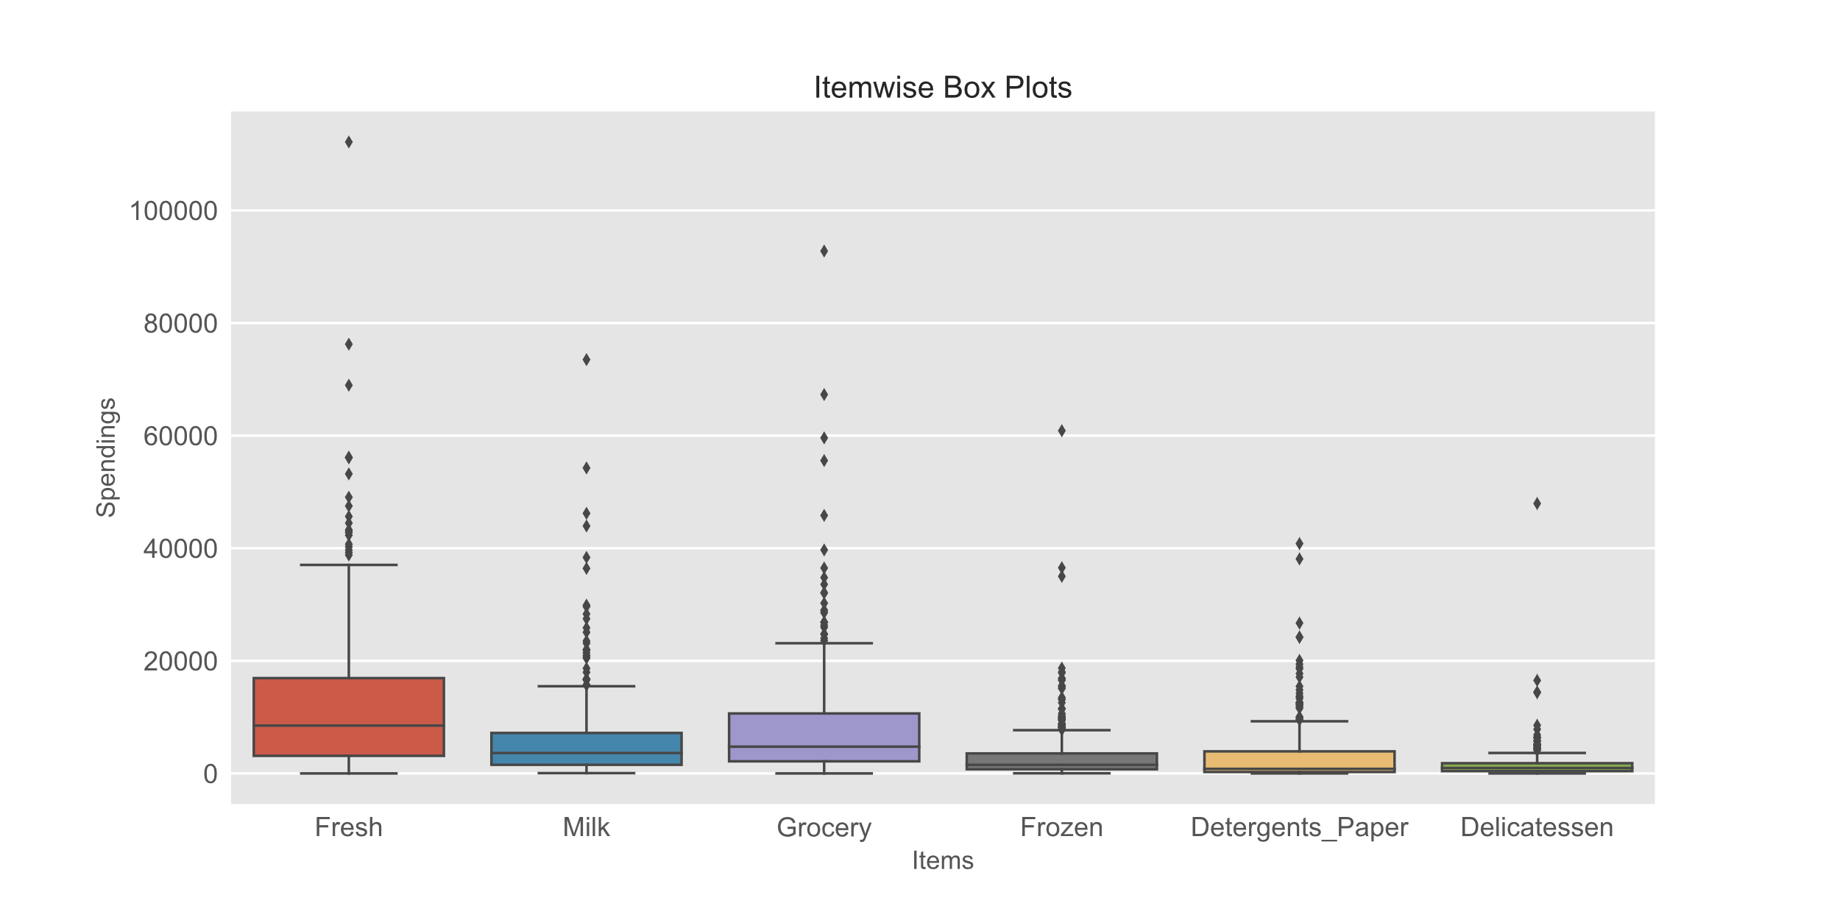

Figure 4: Item wise Box plots for Wholesale Dataset

From the above box plot we can see that the spending’s for all the items in the dataset have outliers. The plot also confirms that the spending’s are Positively skewed as the spread of data above the median is more than spread of data below the median. These outliers can be buyers who buy in large quantities at once or buyers who buy expensive items.

## 1.5 On the basis of your analysis, what are your recommendations for the business? How can your analysis help the business to solve its problem? Answer from the business perspective

* From the above histograms we can see that, most of the buyers spend less for all items. So, the wholesaler can keep more stock of reasonable items as compared to expensive items to meet demand expectations.
* **Fresh** items are the most popular items bought by the customers. Keeping higher stock of the items might help increase sales and meet demands.
* **Delicatessen** items are the least bought items. Reducing the stock of these items will help decrease inventory costs.
* **Oporto** region has the lowest annual spending’s. Increasing the stock of **Fresh** and **Grocery** items in this region might help increase sales.
* In **Lisbon** region, **Detergent_Paper** and **Delicatessen** items have the lowest sales. Reducing their stocks will help decrease inventory.
* The **Other** regions combined have the highest sales. Increasing the customer base and keeping the prices reasonable can help increase sales and profit in this regions.
* For **Hotel** channels, providing offers on **Detergent_Paper** and **Delicatessen** can help increase sales of these items. Also keeping high stocks of **Fresh** items will help meet demand expectations.
* For **Retail** channels, providing offers on **Frozen** and **Delicatessen** can help increase sales of these items. Also keeping high stocks of **Milk** and **Grocery** items will help meet demand expectations.

# Problem 2

## Executive Summary

The Student News Service at Clear Mountain State University (CMSU) has decided to gather data about the undergraduate students that attend CMSU. CMSU creates and distributes a survey of 14 questions and receives responses from 62 undergraduates (stored in the Survey data set). In this problem statement, we will find various probabilities of different attributes of the students in the data set.

## Sample of the Survey Dataset

|  |  |  |  |  |  |  |  |  |  |  |  |  |  |  |
| --- | --- | --- | --- | --- | --- | --- | --- | --- | --- | --- | --- | --- | --- | --- |
|  | ID | Gender | Age | Class | Major | Grad Intention | GPA | Employment | Salary | Social Networking | Satisfaction | Spending | Computer | Text Messages |
| 0 | 1 | Female | 20 | Junior | Other | Yes | 2.9 | Full-Time | 50.0 | 1 | 3 | 350 | Laptop | 200 |
| 1 | 2 | Male | 23 | Senior | Management | Yes | 3.6 | Part-Time | 25.0 | 1 | 4 | 360 | Laptop | 50 |
| 2 | 3 | Male | 21 | Junior | Other | Yes | 2.5 | Part-Time | 45.0 | 2 | 4 | 600 | Laptop | 200 |
| 3 | 4 | Male | 21 | Junior | CIS | Yes | 2.5 | Full-Time | 40.0 | 4 | 6 | 600 | Laptop | 250 |
| 4 | 5 | Male | 23 | Senior | Other | Undecided | 2.8 | Unemployed | 40.0 | 2 | 4 | 500 | Laptop | 100 |

*Table 9: Survey Dataset Sample*

## Checking the types of variables in the dataset.

<class 'pandas.core.frame.DataFrame'>

RangeIndex: 62 entries, 0 to 61

Data columns (total 14 columns):

# Column Non-Null Count Dtype

--- ------ -------------- -----

0 ID 62 non-null int64

1 Gender 62 non-null object

2 Age 62 non-null int64

3 Class 62 non-null object

4 Major 62 non-null object

5 Grad Intention 62 non-null object

6 GPA 62 non-null float64

7 Employment 62 non-null object

8 Salary 62 non-null float64

9 Social Networking 62 non-null int64

10 Satisfaction 62 non-null int64

11 Spending 62 non-null int64

12 Computer 62 non-null object

13 Text Messages 62 non-null int64

dtypes: float64(2), int64(6), object(6)

memory usage: 6.9+ KB

From the above output we can see that:

* There are 62 observations from different students in the data.
* There are 14 variables, out of which, 6 are of integer type, 2 are of float type and 6 are of object(categorical) type.
* The dataset does not have any missing values.

## 2.1. For this data, construct the following contingency tables (Keep Gender as row variable)

### 2.1.1. Gender and Major

|  |  |  |  |  |  |  |  |  |  |
| --- | --- | --- | --- | --- | --- | --- | --- | --- | --- |
| Major | Accounting | CIS | Economics/Finance | International Business | Management | Other | Retailing/Marketing | Undecided | Total |
| Gender |  |  |  |  |  |  |  |  |  |
| Female | 3 | 3 | 7 | 4 | 4 | 3 | 9 | 0 | 33 |
| Male | 4 | 1 | 4 | 2 | 6 | 4 | 5 | 3 | 29 |
| Total | 7 | 4 | 11 | 6 | 10 | 7 | 14 | 3 | 62 |

*Table 10: Contingency Table for Gender and Major*

### 2.1.2. Gender and Grad Intention

|  |  |  |  |  |
| --- | --- | --- | --- | --- |
| Grad Intention | No | Undecided | Yes | Total |
| Gender |  |  |  |  |
| Female | 9 | 13 | 11 | 33 |
| Male | 3 | 9 | 17 | 29 |
| Total | 12 | 22 | 28 | 62 |

*Table 11: Contingency Table for Gender and Grad Intention*

### 2.1.3. Gender and Employment

|  |  |  |  |  |
| --- | --- | --- | --- | --- |
| Employment | Full-Time | Part-Time | Unemployed | Total |
| Gender |  |  |  |  |
| Female | 3 | 24 | 6 | 33 |
| Male | 7 | 19 | 3 | 29 |
| Total | 10 | 43 | 9 | 62 |

*Table 12: Contingency Table for Gender and Employment*

### 2.1.4. Gender and Computer

|  |  |  |  |  |
| --- | --- | --- | --- | --- |
| Computer | Desktop | Laptop | Tablet | Total |
| Gender |  |  |  |  |
| Female | 2 | 29 | 2 | 33 |
| Male | 3 | 26 | 0 | 29 |
| Total | 5 | 55 | 2 | 62 |

*Table 13: Contingency Table for Gender and Computer*

## 2.2. Assume that the sample is representative of the population of CMSU. Based on the data, answer the following question:

### 2.2.1. What is the probability that a randomly selected CMSU student will be male?

Out of the total 62 students, 29 students are male. Therefore,

Hence the probability that a randomly selected CMSU student will be male is 0.468.

### 2.2.2. What is the probability that a randomly selected CMSU student will be female?

Out of the total 62 students, 33 students are female. Therefore,

Hence the probability that a randomly selected CMSU student will be female is 0.532.

## 2.3. Assume that the sample is representative of the population of CMSU. Based on the data, answer the following question:

### 2.3.1. Find the conditional probability of different majors among the male students in CMSU.

Conditional probability that a Male student has an Accounting major is 0.138.

Conditional probability that a Male student has a CIS major is 0.034.

Conditional probability that a Male student has an Economics/Finance major is 0.138.

Conditional probability that a Male student has an International Business major is 0.069.

Conditional probability that a Male student has a Management major is 0.207.

Conditional probability that a Male student has Other major is 0.138.

Conditional probability that a Male student has a Retailing/Marketing major is 0.172.

Conditional probability that a Male student has an Undecided major is 0.103.

### 2.3.2. Find the conditional probability of different majors among the female students in CMSU.

Conditional probability that a Female student has an Accounting major is 0.091.

Conditional probability that a Female student has a CIS major is 0.091.

Conditional probability that a Female student has an Economics/Finance major is 0.212.

Conditional probability that a Female student has an International Business major is 0.121.

Conditional probability that a Female student has a Management major is 0.121.

Conditional probability that a Female student has Other major is 0.091.

Conditional probability that a Female student has a Retailing/Marketing major is 0.273.

Conditional probability that a Female student has an Undecided major is 0.0.

## 2.4. Assume that the sample is a representative of the population of CMSU. Based on the data, answer the following question:

### 2.4.1. Find the probability that a randomly chosen student is a male and intends to graduate.

Out of the 62 students, 17 students are male who intends to graduate. Therefore,

Hence the probability that a randomly chosen student is a male and intends to graduate is 0.274.

### 2.4.2 Find the probability that a randomly selected student is a female and does NOT have a laptop.

Out of the 62 students, 4 students are female who do not have a laptop. Therefore,

Hence the probability that a randomly chosen student is a female and does NOT have a laptop is 0.065.

## 2.5. Assume that the sample is representative of the population of CMSU. Based on the data, answer the following question:

### 2.5.1. Find the probability that a randomly chosen student is a male or has full-time employment?

Out of the 62 students, 29 are male, 10 have full time jobs, and 7 are both male and have full time jobs.

Hence the probability that a randomly chosen student is a male or has full-time employment is 0.516.

### 2.5.2. Find the conditional probability that given a female student is randomly chosen, she is majoring in international business or management.

Out of the 33 female students, 4 are majoring in International Business and 4 are majoring in Management. Therefore for mutually exclusive events:

Hence the conditional probability that given a female student is randomly chosen, she is majoring in international business or management is 0.242.

## 2.6. Construct a contingency table of Gender and Intent to Graduate at 2 levels (Yes/No). The Undecided students are not considered now and the table is a 2x2 table. Do you think the graduate intention and being female are independent events?

|  |  |  |  |
| --- | --- | --- | --- |
| Grad Intention | No | Yes | Total |
| Gender |  |  |  |
| Female | 9 | 11 | 20 |
| Male | 3 | 17 | 20 |
| Total | 12 | 28 | 40 |

*Table 14: Contingency table for Gender and Intent to Graduate at 2 levels*

Out of the 40 students, 20 are female, 28 intent to graduate, and 11 are both female and intent to graduate. Therefor for independent events:

Hence using the above-mentioned formula, we find that the graduate intention and being female are not independent events.

## 2.7. Note that there are four numerical (continuous) variables in the data set, GPA, Salary, Spending, and Text Messages. Answer the following questions based on the data

### 2.7.1. If a student is chosen randomly, what is the probability that his/her GPA is less than 3?

Out of the 62 students, 17 students have GPA less than 3.

Hence if a student is chosen randomly, the probability that his/her GPA is less than 3 is 0.274.

### 2.7.2. Find the conditional probability that a randomly selected male earns 50 or more. Find the conditional probability that a randomly selected female earns 50 or more.

Out of the 29 male students, 14 students have salaries more than or equal to 50.

Hence the conditional probability that a randomly selected male earns 50 or more is 0.483.

Out of the 33 female students, 18 students have salaries more than or equal to 50.

Hence the conditional probability that a randomly selected female earns 50 or more is 0.545.

## 2.8. Note that there are four numerical (continuous) variables in the data set, GPA, Salary, Spending, and Text Messages. For each of them comment whether they follow a normal distribution. Write a note summarizing your conclusions.

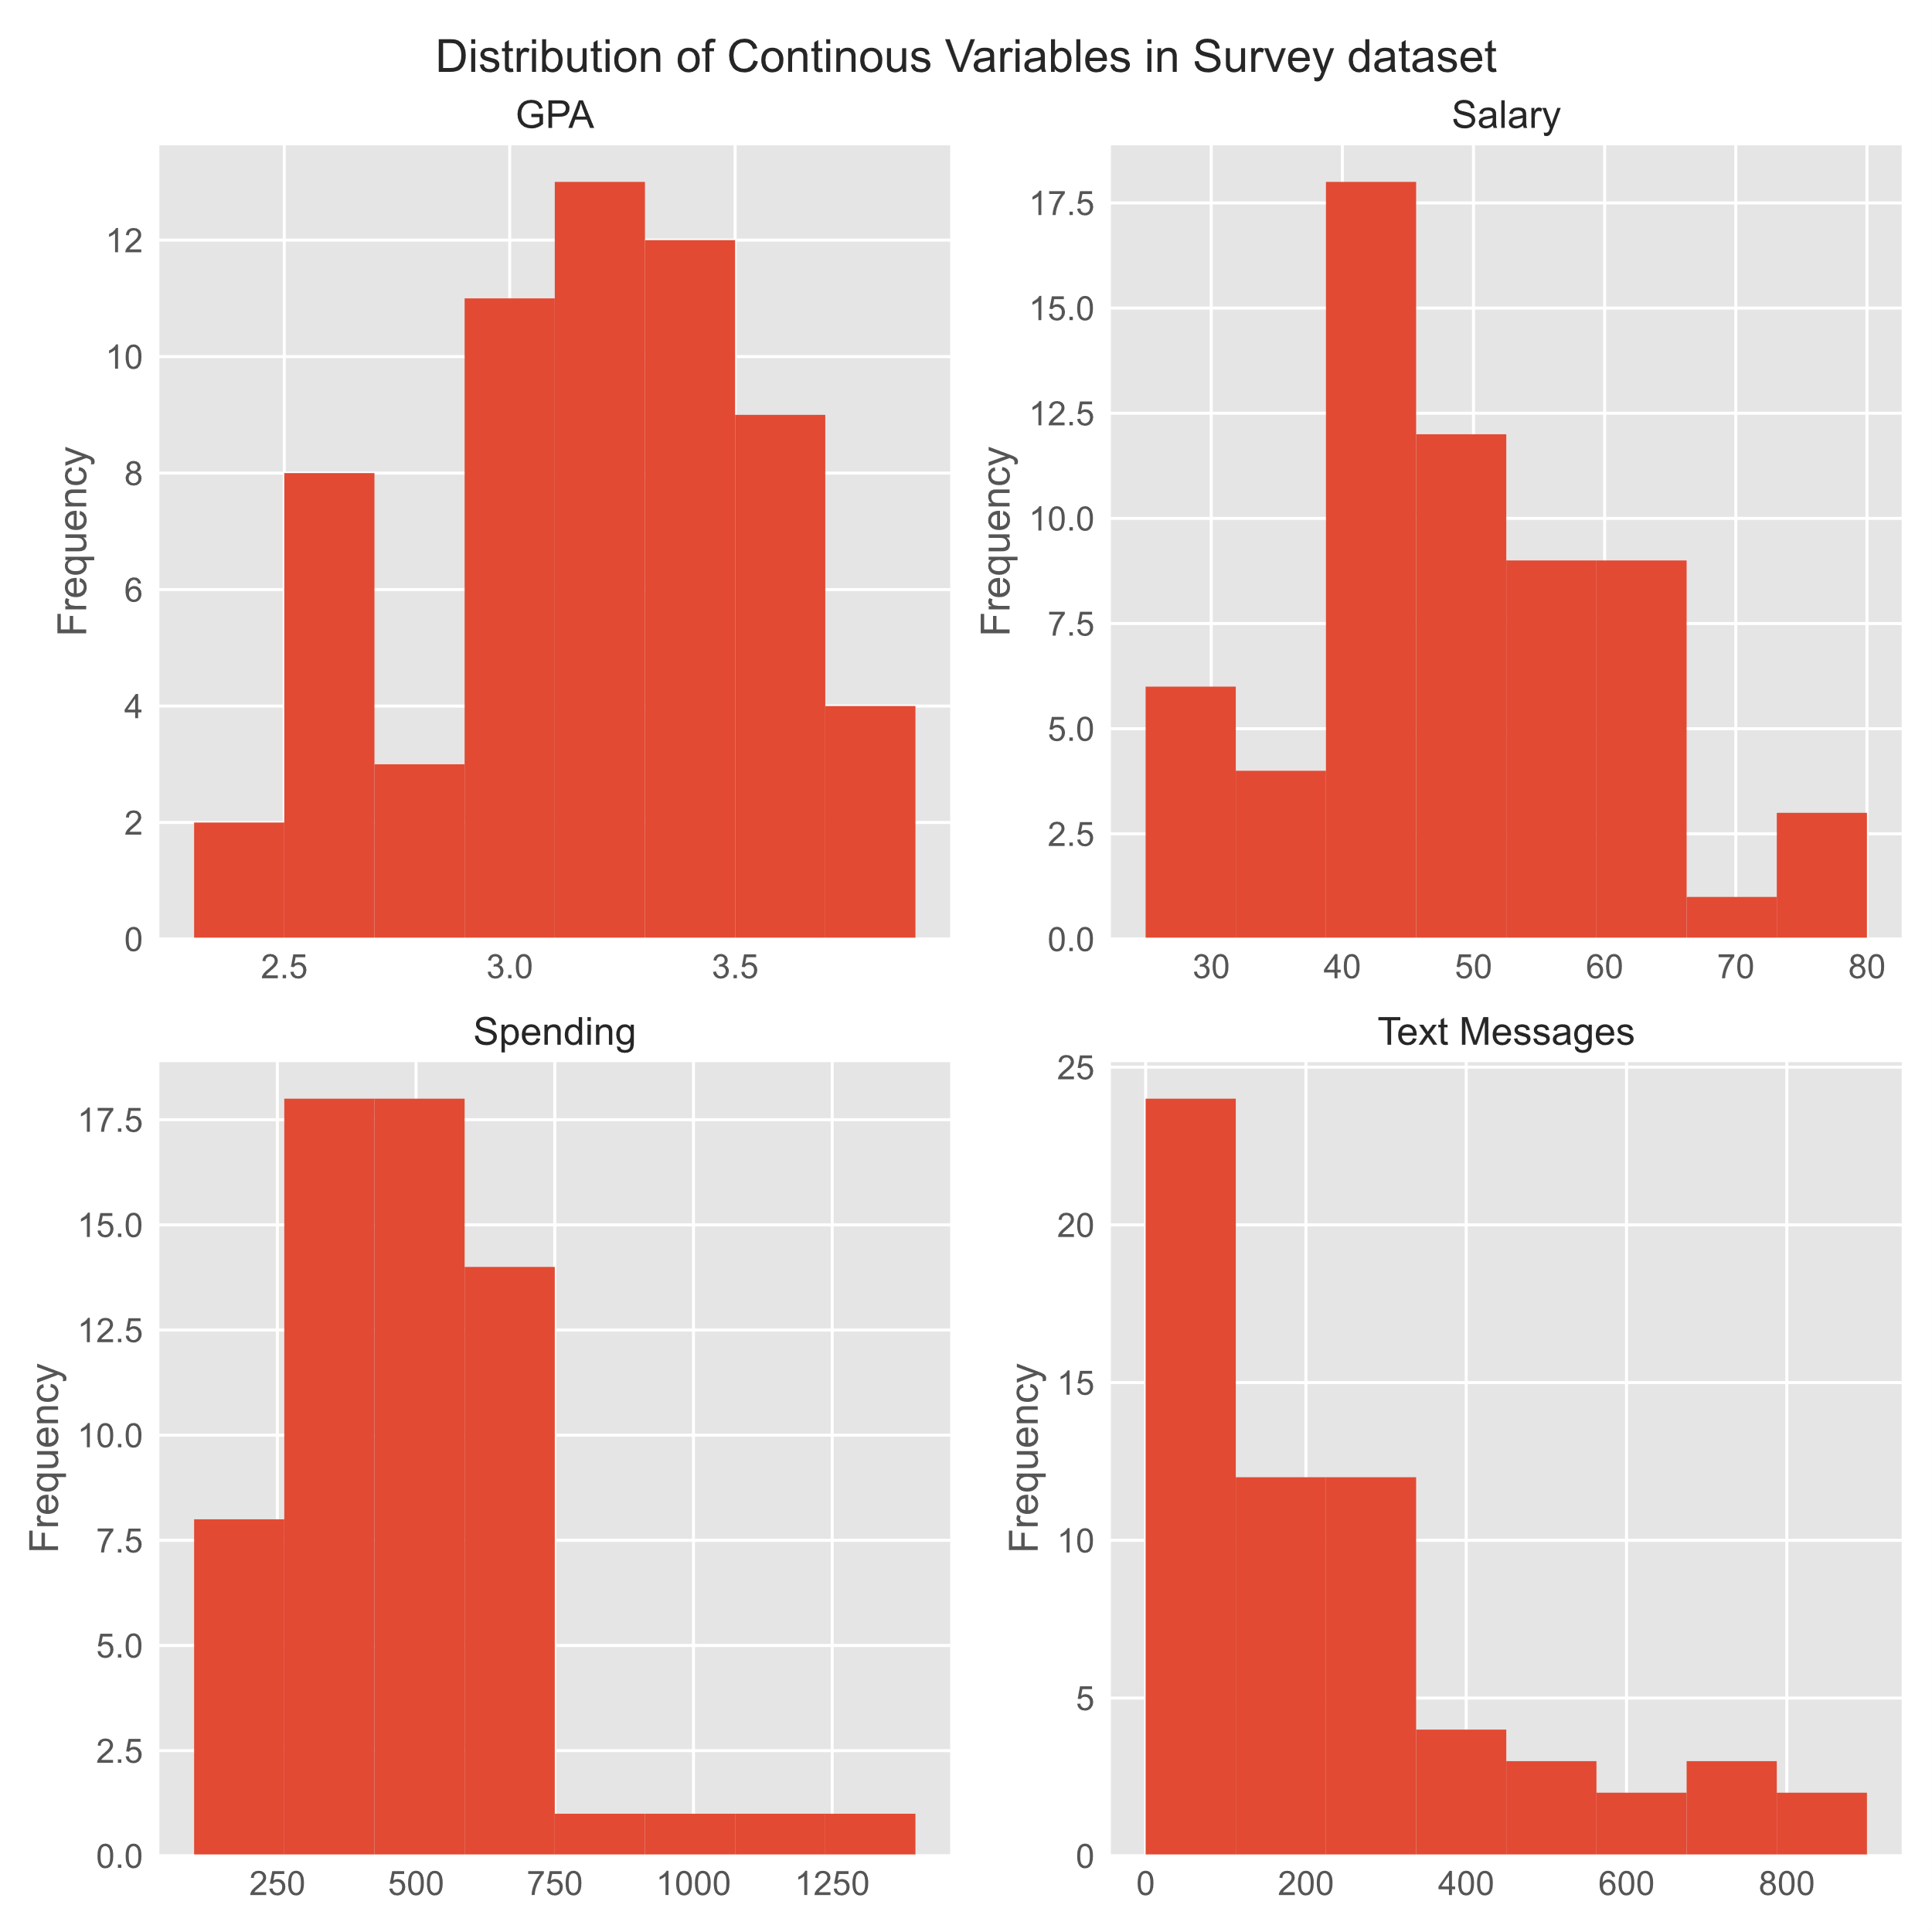

Figure 5: Distribution of Continuous Variables in Survey Dataset

Theoretically the mean, median and mode of a normal distribution are equal.

### Distribution of GPA

For the GPA variable:

Mean = 3.1

Median = 3.2

Mode = [3.0, 3.1, 3.4]

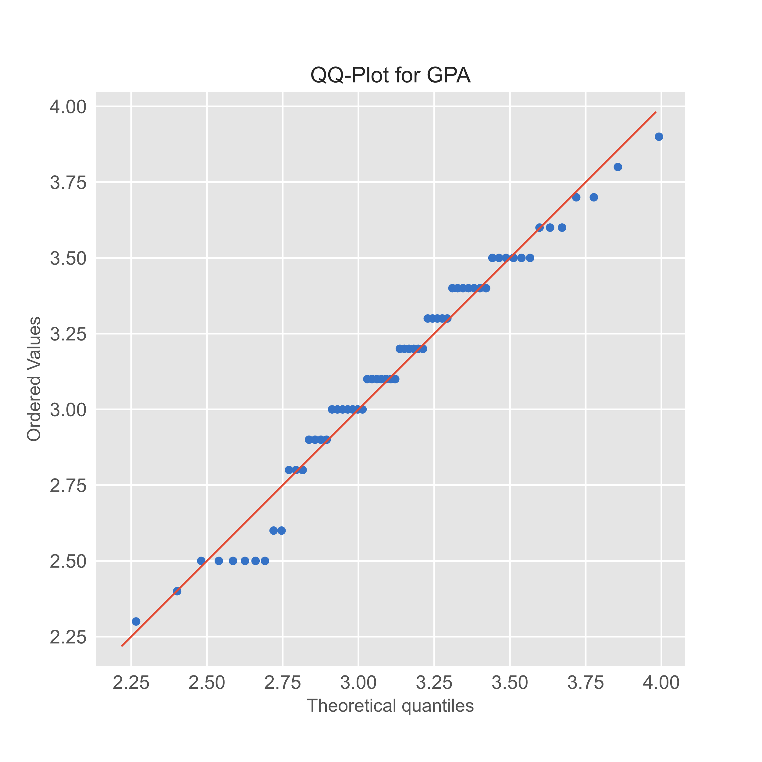

Figure 6: QQ-Plot for GPA

From the above outputs we can conclude that the GPA variable in the Survey dataset approximately follows a normal distribution. This can also be verified from the histogram in Figure 5.

### Distribution of Salary

For the Salary variable:

Mean = 48.5

Median = 50.0

Mode = 40.0

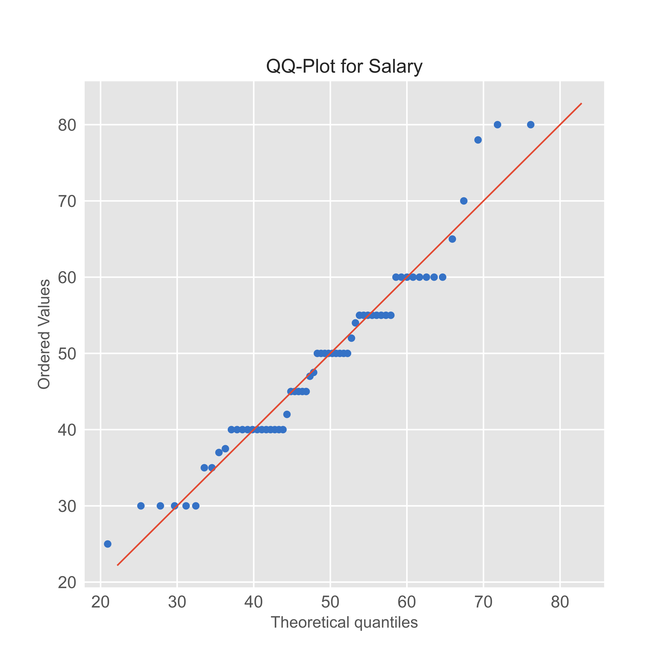

Figure 7: QQ-Plot for Salary

The mean, median and mode of Salary are very different from each other but its QQ-Plot is close to the straight line. Hence the Salary variable approximately follows a normal distribution. This can also be verified from the histogram in Figure 5.

### Distribution of Spending

For the Spending variable:

Mean = 482.0

Median = 500.0

Mode = 500

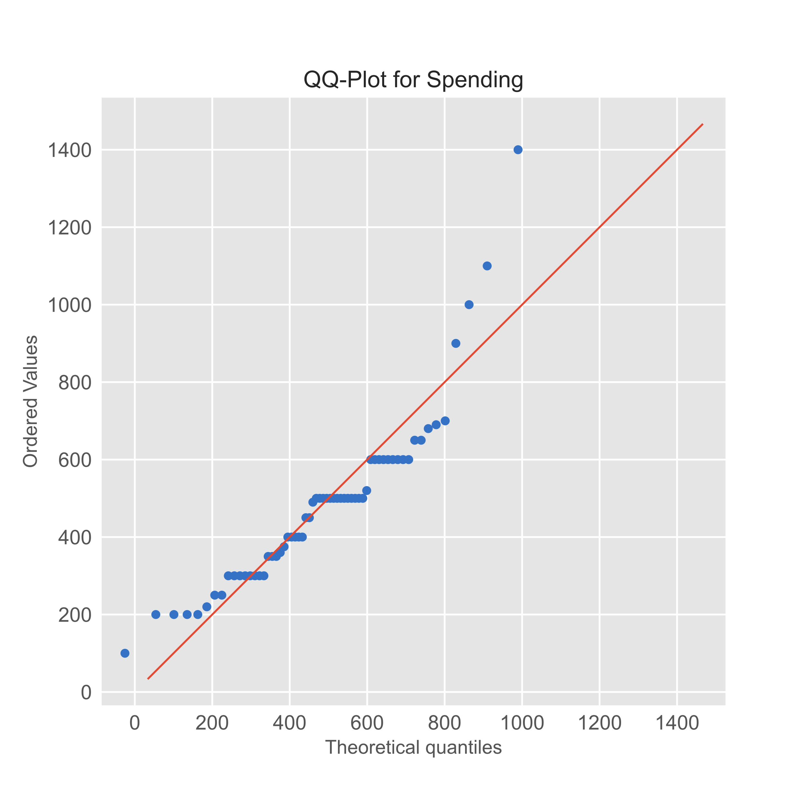

Figure 8: QQ-Plot for Spending

Even though the mean, median and mode of Spending are close to each other, its QQ-Plot varies a lot from the straight line. Hence the Spending variable does not follow a normal distribution. This can also be verified from the histogram in Figure 5.

### Distribution of Text Messages

For the Text Messages variable:

Mean = 246.2

Median = 200.0

Mode = 300

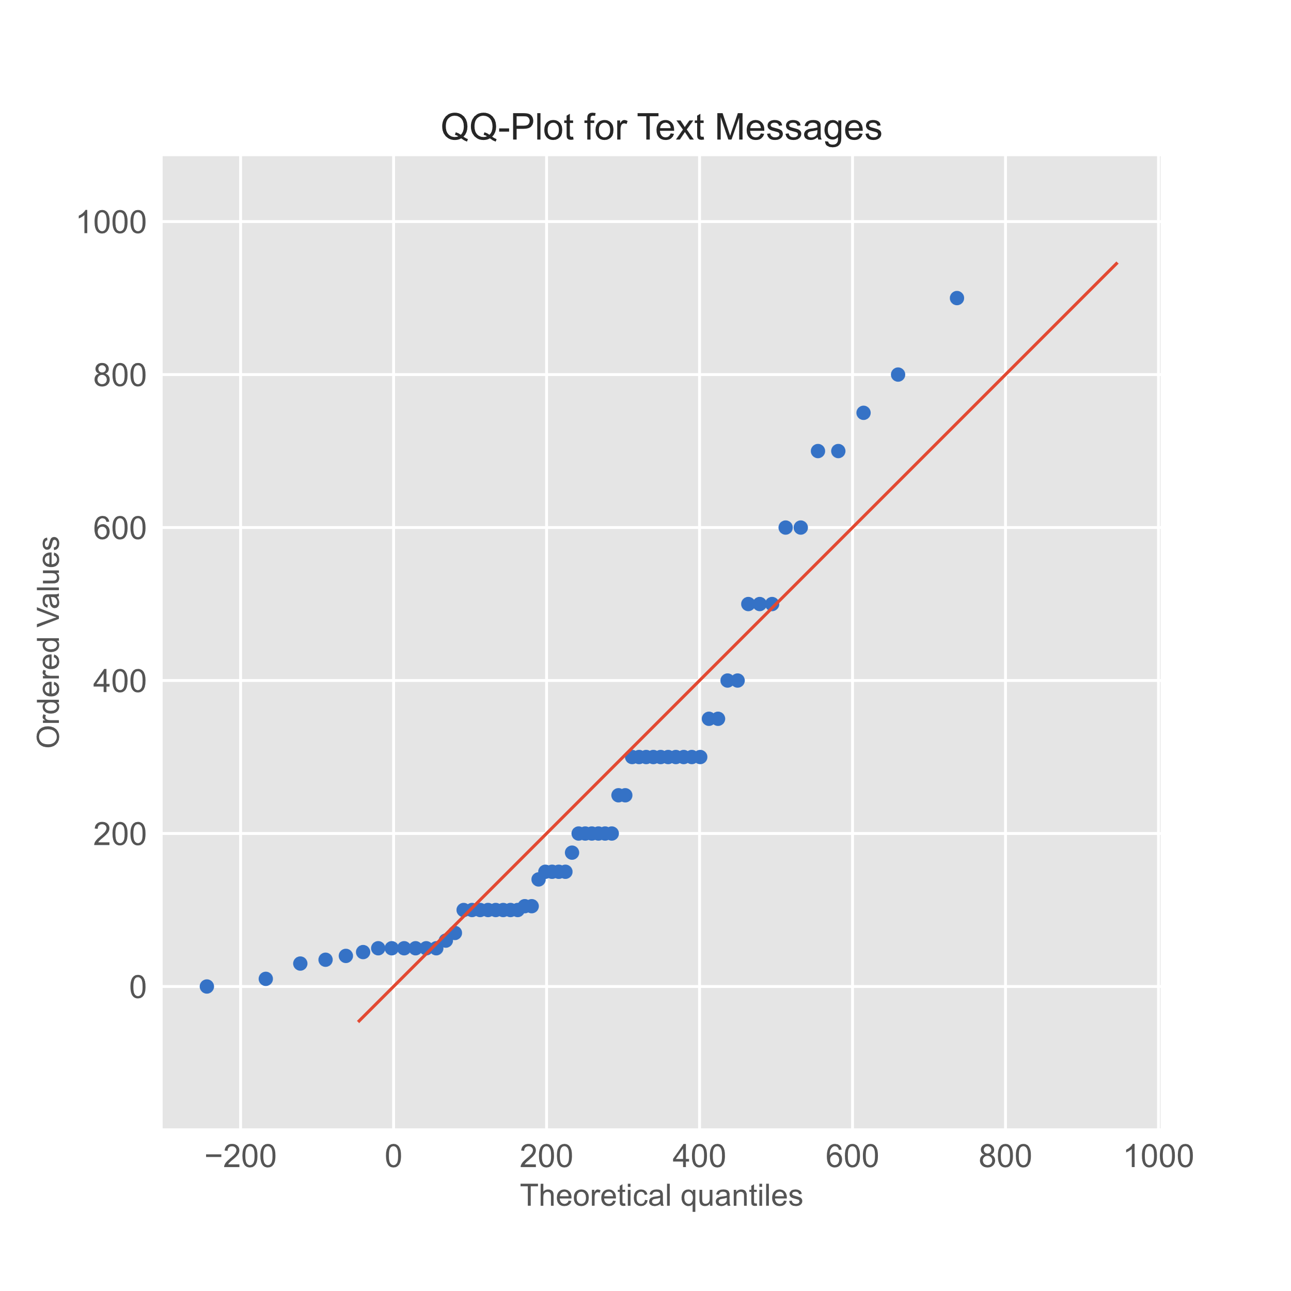

Figure 9: QQ-Plot for Text Messages

As the mean, median and mode of Text Messages variable are very different from each other and its QQ-Plot is not close to the straight line, the Text Messages variable does not follow a normal distribution. This can also be verified from the histogram in Figure 5.

### Conclusion

1. The variables GPA and Salary approximately follow a normal distribution.
2. The variables Spending and Text Messages does not follow a normal distribution.

# Problem 3

## Executive Summary

An important quality characteristic used by the manufacturers of ABC asphalt shingles is the amount of moisture the shingles contain when they are packaged. Customers may feel that they have purchased a product lacking in quality if they find moisture and wet shingles inside the packaging. In some cases, excessive moisture can cause the granules attached to the shingles for texture and colouring purposes to fall off the shingles resulting in appearance problems. To monitor the amount of moisture present, the company conducts moisture tests. A shingle is weighed and then dried. The shingle is then reweighed, and based on the amount of moisture taken out of the product, the pounds of moisture per 100 square feet are calculated. The company would like to show that the mean moisture content is less than 0.35 pounds per 100 square feet.

The file (A & B shingles.csv) includes 36 measurements (in pounds per 100 square feet) for A shingles and 31 for B shingles. In this problem statement, we will test some hypothesis regarding the moisture content of the A and B shingles using appropriate test statistic.

## Sample of the A & B Shingles Dataset

|  |  |  |
| --- | --- | --- |
|  | A | B |
| 0 | 0.44 | 0.14 |
| 1 | 0.61 | 0.15 |
| 2 | 0.47 | 0.31 |
| 3 | 0.30 | 0.16 |
| 4 | 0.15 | 0.37 |

*Table 15: A & B Shingles Dataset Sample*

## Checking the types of variables in the dataset.

<class 'pandas.core.frame.DataFrame'>

RangeIndex: 36 entries, 0 to 35

Data columns (total 2 columns):

# Column Non-Null Count Dtype

--- ------ -------------- -----

0 A 36 non-null float64

1 B 31 non-null float64

dtypes: float64(2)

memory usage: 704.0 bytes

* As mentioned in the problem statement, we can confirm that A shingles column has 36 measurements and B shingles column has 31 measurements.
* Both the columns are float type variables.
* Column B has 5 null values, which is expected from the problem statement.

## Checking the distribution of both variables in the Shingles dataset.

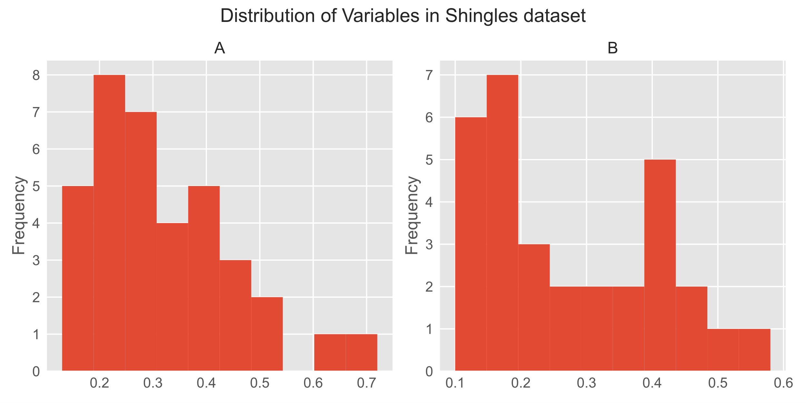

Figure 10: Distribution of Variables in Shingles Dataset

From the above histograms we can see that the measurements for both A and B shingles are not normally distributed.

## 3.1 Do you think there is evidence that mean moisture contents in both types of shingles are within the permissible limits? State your conclusions clearly showing all steps.

### Stating the Null and Alternative Hypothesis for both A and B shingles.

The company's current status is that the mean moisture content is less than 0.35 pounds per 100 square feet. If there is enough evidence against this claim, then the company will have to take preventive actions.  
Hence the Null and Alternative Hypothesis for both A and B shingles are:

### Deciding on the Type of Test to use.

Here we have to check whether the moisture content in both shingles is within permissible limits. Also, the population parameters are not provided. Assuming that the samples are randomly selected, independent and their population follows a normal distribution, we are going to use the One-sample t-test for both the shingles separately. From the Alternative Hypothesis we can conclude that this is a right tailed t-test.

### Deciding on the Significance Level.

As the significance level is not mentioned, here we consider it to be 5%. Hence,

### Hypothesis test for A shingles

t_statistic = -1.4735046253382782 and p_value = 0.9252236685509249

As the , we fail to reject the Null Hypothesis. In other words, we do not have enough evidence to reject the claim that the moisture content is less than 0.35 pounds per 100 square feet for the A shingles.

### Hypothesis test for B shingles

t_statistic = -3.1003313069986995 and p_value = 0.9979095225996808

As the , we fail to reject the Null Hypothesis. In other words, we do not have enough evidence to reject the claim that the moisture content is less than 0.35 pounds per 100 square feet for the B shingles.

### Conclusion

We have enough evidence to conclude that the moisture content is less than 0.35 pounds per 100 square feet for both A and B shingles.

## 3.2 Do you think that the population mean for shingles A and B are equal? Form the hypothesis and conduct the test of the hypothesis. What assumption do you need to check before the test for equality of means is performed?

### Stating the Null and Alternative Hypothesis

Here we have to check whether the mean moisture content is equal for both A and B shingles.  
Hence the Null and Alternative Hypothesis are:

### Deciding on the Type of Test to use.

The population parameters are not provided. Assuming that the samples are randomly selected, independent and their population follows a normal distribution, we are going to use the Two-sample independent t-test for both the shingles. This is a two-tailed t-test.

### Assumptions to check for Two-sample t-test

To perform a 2-sample t-test, we assume that the sample variance of both the samples are equal.

The ratio of the variance of both samples is 0.9773231765154546.

As the ratio is close to 1.0, we can proceed with the 2-sample t-test.

### Deciding on the Significance Level.

As the significance level is not mentioned, here we consider it to be 5%. Hence,

### Hypothesis Test

t_statistic = 1.2896282719661123 and p_value = 0.2017496571835306

### Conclusion

As the , we fail to reject the Null Hypothesis. In other words, we have enough evidence to conclude that the mean moisture content of both A and B shingles are equal to each other.