JAVA

Project Plan

Wanfōru

E-commerce Website

Group Members:

1. Vaibhav Vijay Singh:U101116FCS268(S6)
2. Purandhar Chilukuru:U101116FCS272(S4)
3. Mohit Kumar:U101116FCS250(S3)
4. Vaishnavi Kattekola:U101116FCS270(S3)
5. Shivashish Prasad:U101116FCS272(S5)

**Database**

**Tables**

1. **Cart Table**

Attributes:

1. Cart item id - primary key
2. Price
3. Product name
4. Product Id
5. Quantity
6. Status
7. Username - foreign key references username in user table

**2. Category**

Attributes:

1. Category Id - primary key
2. Category description
3. Category name

**3.Orderdetails**

Attributes:

1. Order id - primary key
2. Order date
3. Payment mode
4. Total purchase
5. Username - foreign key references username in user table

**4. Products**

Attributes:

1. Product id - primary key
2. Category id - foreign key references category id in category table
3. Code
4. Description
5. Price
6. Product category
7. Product name
8. Stock
9. Supplier Id - foreign key references category id in supplier id in supplier

**5. Supplier**

Attributes:

1. Supplier id - primary key
2. Dealer name
3. Dealer Address
4. Dealer Description

**6. User**

Attributes:

1. User id - primary key
2. Email
3. Name
4. Password
5. Phone no
6. Role
7. Enable

**Entity-Relation Diagram** :

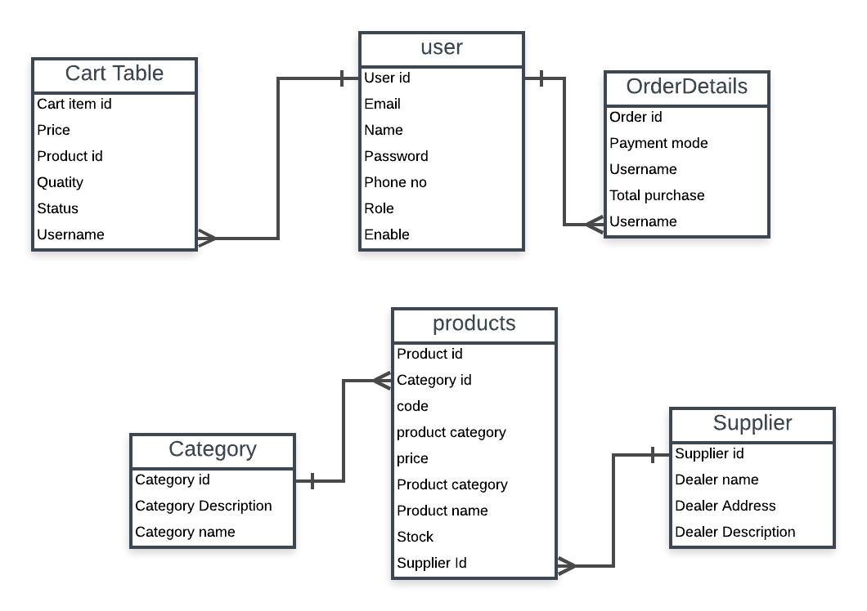

**Features:**

1. User and admin login:Users have the feature to register themselves with the site and login from next time.User and admin login is done through same page.
2. Adding,deleting,updating products:These privileges are available only to the admin but not the users.
3. Adding suppliers
4. Adding categories
5. View products and add to cart feature:These features are available to both users and admin.
6. Checkouts
7. Store order details

**Technologies used :**

1. XML
2. Servlet
3. JSP
4. Bootstrap
5. HTML,CSS,JAVASCRIPT
6. Hibernate, Spring MVC,Apache Maven
7. H2
8. Spring Security.

**Division Of modules**

1. Vaibhav Vijay Singh: Product and User modules
2. Purandhar Chilukuru: Category Module
3. Mohit Kumar: Cart Module
4. Vaishnavi Kattekola: Supplier Module
5. Shivashish Prasad: Registration module

**Hours on Modules**

1. Product : 3.5 hours
2. User modules: 5 hours
3. Category Module: 5 hours
4. Cart Module: 6 hours
5. Supplier Module: 3.5 hours
6. Registration module: 4 hours

**Roles of Developers**

Vaibhav Vijay Singh: Front-end and Back-end

Purandhar Chilukuru: Front-end and Back-end

Mohit Kumar:Front-end and Back-end

Vaishnavi Kattekola: Back-end and Product Selection

Shivashish Prasad:Back-end ,Product Selection,Content Writing