# CODING METRICS of Chat Bot

**Date:12/11/2018**

**Prepared By:**

Mohit Kumar(U101116FCS250)

Purandhar Chilukuru(U101116FCS272)

Vaishnavi Kattekola(U101116FCS270)

Vaibhav Singh(U101116FCS268)

Sarthak Tripathi(U101116FCS110)

# **Metrics Tools Used** -

### DashBot

You can easily integrate botmetric to analyze your chatbot performance .since we are using google’s dialog flow the following steps need to be followed:

1.Install dashbot via npm

npm install --save dashbot

2.Include Dashbot

const dashbot = require('dashbot')(process.env.DASHBOT_API_KEY).google;

3.Pass the dashbot after creating dialogflow object

const DialogflowApp = require('actions-on-google').DialogflowApp;  
  
app.post('/', (request, response) => {  
 const assistant = new DialogflowApp({request: request, response: response});  
 dashbot.configHandler(assistant);  
 ...  
}

1. **Conversational Analytics**

**Message Funnels:**

Message and Interaction Funnels enable you to see where your chatbot or skill may be breaking down as well as opportunities for new use cases to support. Simply select any message or interaction in or out from your bot or skill and see what happened before and after, and continue to traverse the flows in either direction.

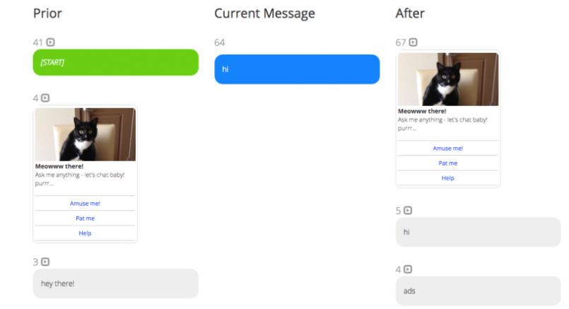

## 

**2. User Behaviour:**

**a.Top Messages, Utterances, Interactions, and Intents**

The most common messages, utterances, and Intents into or out from the chatbot .

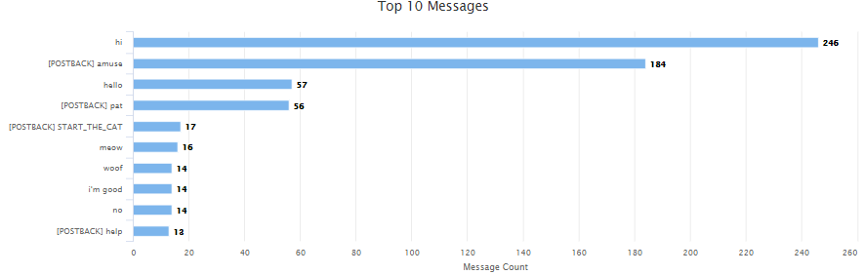

**b.Top Exit Messages**

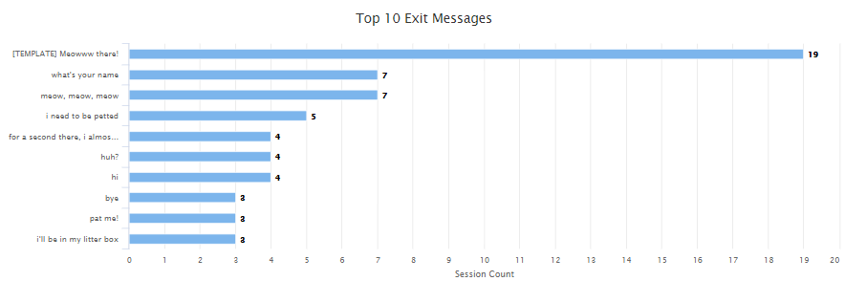

**3. Retention Rate:**

The retention rate of the company website is provided below:

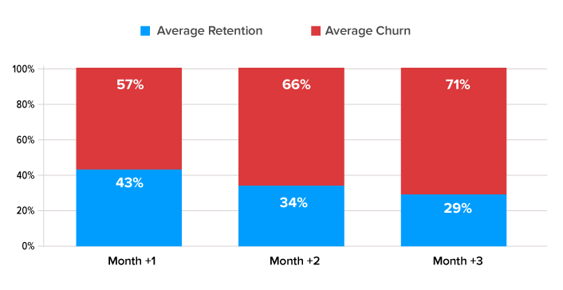

The retention rate of the company chat bot is provided below:

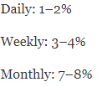

**4. Goal Completion Rate**

Goal Completion Rate= # of Web Visitors / # of Goals Completed

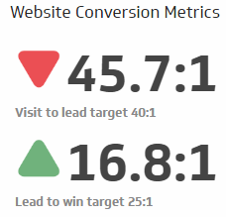

**5. Natural Language Processing score:**

A document with positive emotion would have the value greater than 0 and up to 1.The chat bot’s response are mostly positive,so the value is greater than 0.For example:

