Lab 3 - Implementation of a MIPS like processor

Design and implement (in Verilog) a Datapath and control unit for a single-cycle MIPS-like processor (including instruction memory) which has two classes of instructions. The two classes of instructions along with the example usage and instruction decoding to be used are as below

- Immediate Type
Example: li r1, constant loads immediate signed value specified in the instruction to the register R1
Constant
Rdst
Opcode

6-bit Opcode 5-bit destination 21-bit

- Register Type (R-type)
Example: add r1, r2, r3 adds the contents of registers r2 and r3. The result of addition is written in to the register r1
Function
Shamt
Rsrc2
Rsrc1
Rdst
Opcode

6-bit Opcode 5-bit 5-bit 5-bit 5-bit 6-bit
Destination Source1 Source2 Shift Amount

Assume there are 32 32-bit general purpose registers indicated by r0, r1, r2…r31 and corresponding register numbers (00000), (00001)………..(11111).
Assume the Opcode for Immediate type and R-type instructions as below
Instruction Class | Opcode
Immediate type | 111111
Register Type | 000000
Additionally, R-type instructions have multiple variations defined by their function codes. The R-type instructions should include add, sub, AND, OR, srl (Shift right logical), sll (shift left logical). The different R-type instructions that the processor should support are tabulated below.

R-type Instruction | Example usage | Opcode | Rdst | Rsrc1 | Rsrc2 | shamt | Function
add | add r0, r1, r2 | 000000 | 00000 | 00001 | 00010 | 00000 | 100000
sub | sub r4, r5, r6 | 000000 | 00100 | 00101 | 00110 | 00000 | 100010
AND | and r8, r9, r10 | 000000 | 01000 | 01001 | 01010 | 00000 | 100100
OR | or r9, r8, r10 | 000000 | 01001 | 01000 | 01010 | 00000 | 100101
sll | sll r11, r6, 6 | 000000 | 01011 | 00110 | 00000* | 00110 | 000000
srl | srl r13, r9, 10 | 000000 | 01101 | 01001 | 00000* | 01010 | 000010
*Second source is not used for shift operations
The processor module should have only two inputs CLK and Reset. When Reset is activated the Processor starts executing instructions from the 0th location of instruction memory.
- Draw the block-level design of the processor (datapath + control unit) for the above specifications. (you can modify the design given in the class ppts and copy the image of the final design here)
Answer: 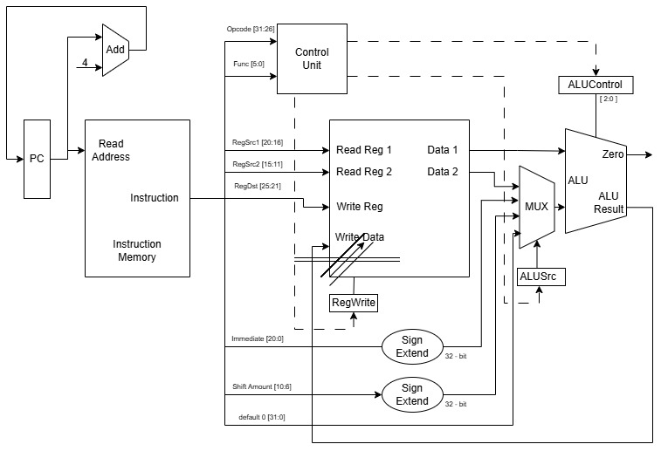

- List the different blocks that will be required for the implementation of the datapath of the above processor.

Answer: Instruction Fetch with Instruction Memory, Instruction Decoder or Control Unit, Register File, 4x1 MUX, ALU are the blocks that will be required for the implementation of the datapath of the above processor.

- Most of the datapath blocks that are listed above have already been implemented as part of previous labs. Implement the blocks which have not been implemented in the previous labs and copy the images of those Verilog codes here.

Answer: 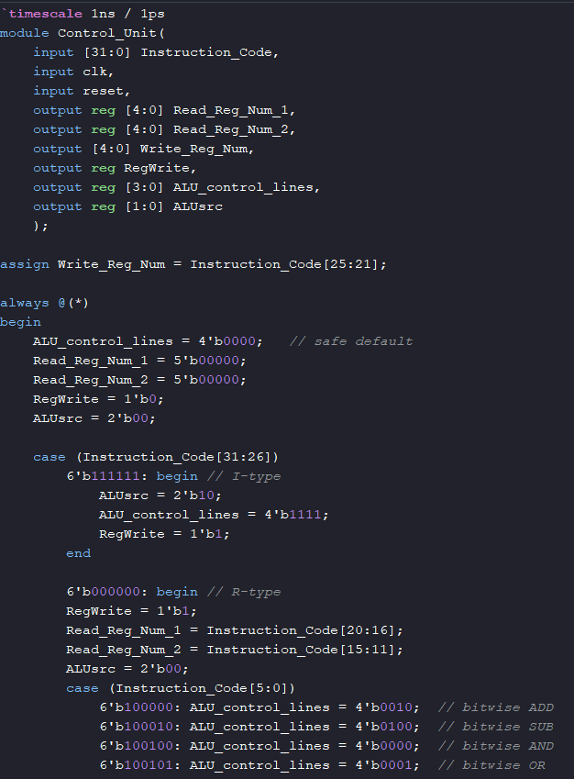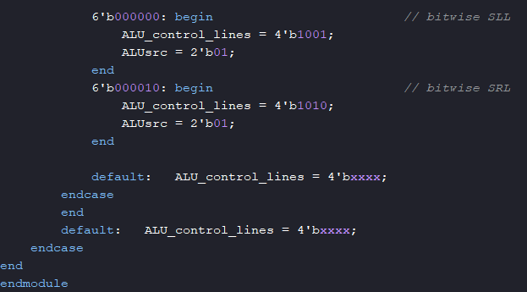
- Assume the Main control unit generates all the control signals. List different control signals that will be required for the above processor. Also, specify the value of the control signals for different instructions.

Answer:
Control Signal Name | Control Lines | RegWrite | ALUsrc
li r1, 8 | 1111 | 1 | 10
add r0, r1, r2 | 0010 | 1 | 00
sub r4, r5, r6 | 0100 | 1 | 00
and r8, r9, r10 | 0000 | 1 | 00
or r9, r8, r10 | 0001 | 1 | 00
sll r11, r6, 6 | 1001 | 1 | 01
srl r13, r9, 10 | 1010 | 1 | 01

- Implement the main control unit and copy the image of the Verilog code of the Main control unit here.

Answer: 
- Implement a complete processor in Verilog (using all the datapath blocks and main control unit as modules). Copy the image of the Verilog code of the processor here.

Answer: 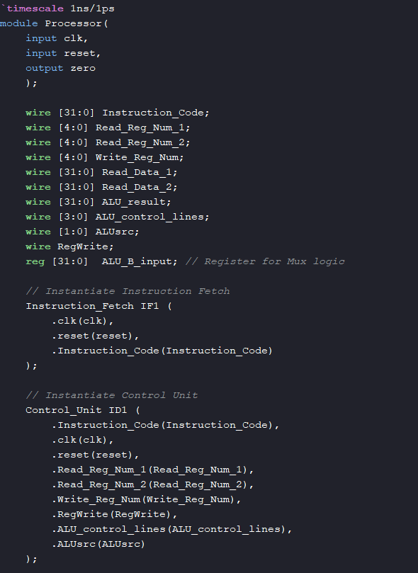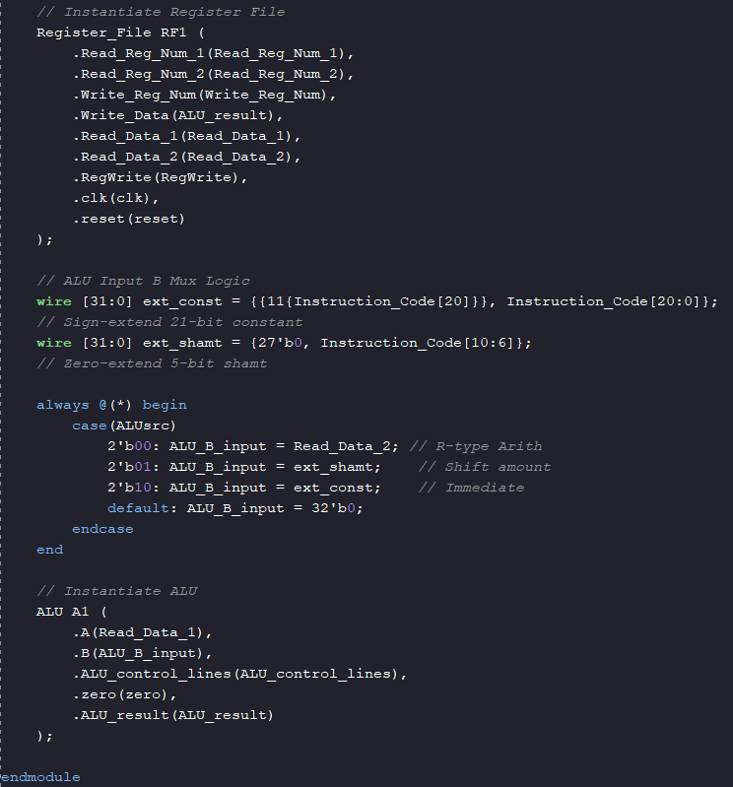
- Test the processor design by initializing the instruction memory with a set of instructions (at least 5 instructions). List below the instructions you have used to initialize the instruction memory. Verify if the register file is changing according to the instructions. (The register file contains unknowns, you can initialize the register file or you can load values into the register file using li instruction specified earlier).

Answer: 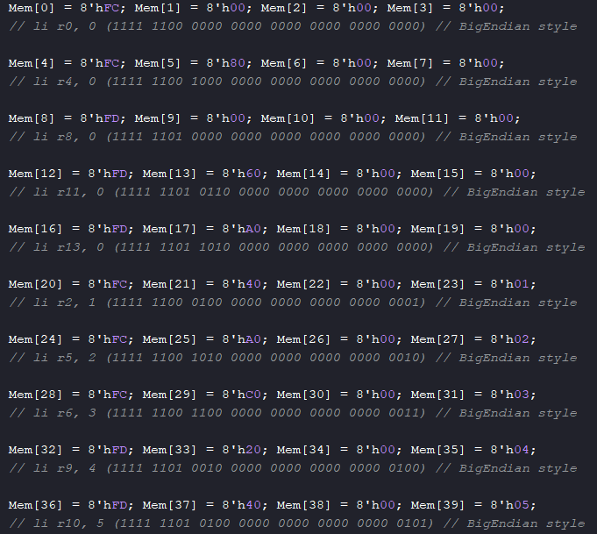
- Once design, test, and verification are

Copy verified Register file waveform here:
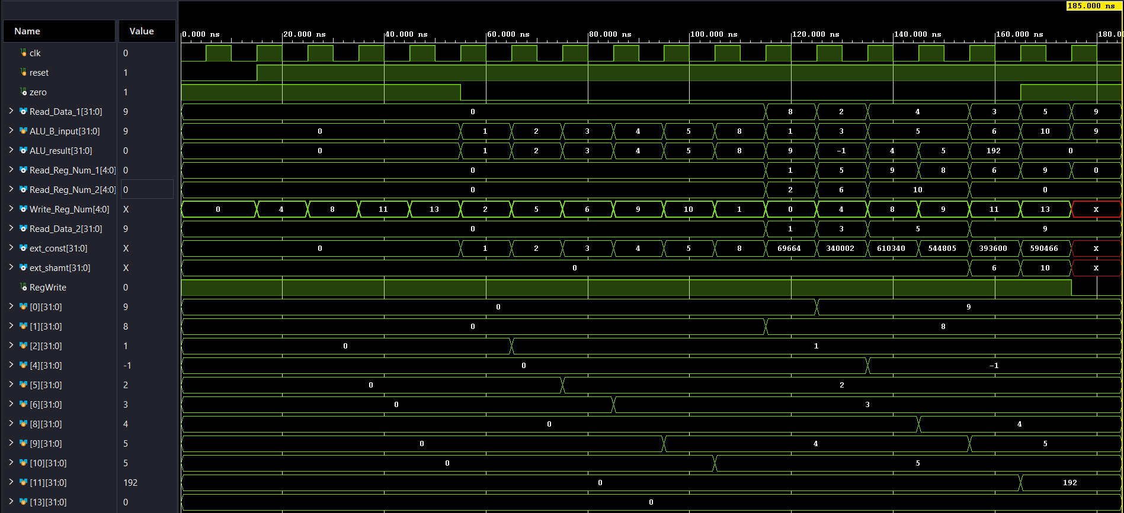
- Synthesise the processor designed and copy the RTL generated below

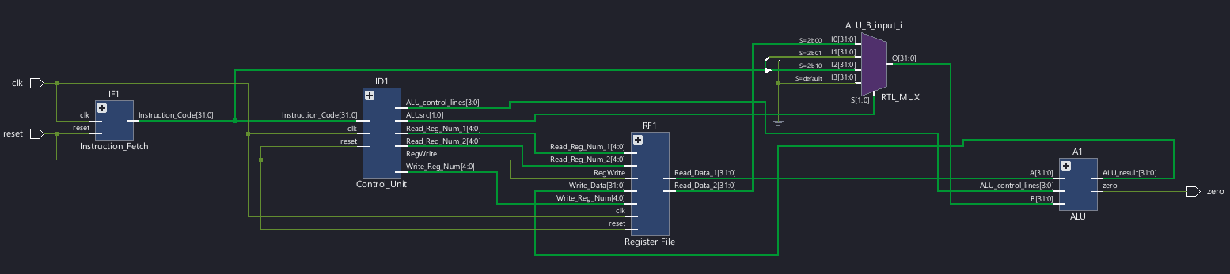

Please note: If you are not able to upload before the deadline, don’t email me. All such emails will be ignored. Upload the sheet well in advance to avoid unexpected delays.

