Lab 4 - Implementation of a Simple Pipelined Processor

Implement pipelined datapath (shown in the figure below) of a processor in Verilog. This processor supports data transfer (mov) instructions only. The processor has Reset, CLK as inputs and no outputs. The processor has an instruction fetch unit, register file, and write back unit. The processor also contains two pipelined registers IF/ID and ID/WB. When reset is activated the PC is initialized to 0, and the instruction memory and register file get loaded by predefined values. When the instruction unit starts fetching the first instruction the pipeline registers contain unknown values. When the second instruction is being fetched in the IF unit, the IF/ID registers will hold the instruction code for the first instruction. When the third instruction is being fetched by the IF unit, the IF/ID register contains the instruction code of the second instruction, and the ID/WB register contains information (destination address and data) related to the first instruction.
The instruction and the 8-bit instruction format are shown below:
Mov DestinationReg, SourceReg
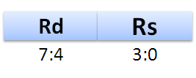
Assume the register file contains 16 registers (R0-R15) each register can hold 8-bit data. The register file does not require a clock or any other control signals except for those shown in the figure. On reset assume that the instruction memory gets initialized with three instructions.
Mov Ry, Rx
Mov Rx, Rz
Mov Rz, Ry
Where xyz are related to the last 3 digits of your ID No.
If ID number: 20XXXXXX123G, then x =1,y=2, z=3

If your ID number contains ‘0’ in the last two digits then consider ‘0’ as ‘10’. For example, If ID number: 20XXXXXX103H, then x =1,y=10, z=3

If two of the digits of your ID number are the same, then take one of the digits as it is and replace the other digit with a value between 11-15. For example, If ID number: 20XXXXXX155H, then x=1, Y=5, z= 11,

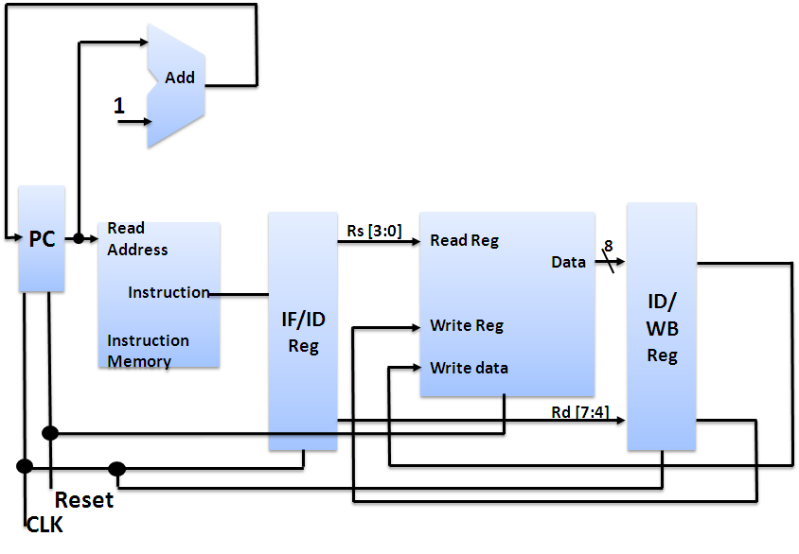
P.T.O
____________________________________________________________________________________
Name: Manan Agarwal ID No: 2022B5A30129G

- Implement the Instruction Fetch block. Copy the image of the Verilog code of the Instruction fetch block here

Answer: 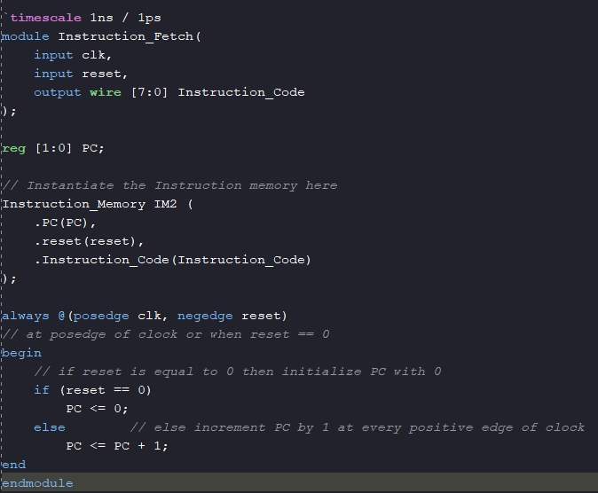
- Implement the Register File and copy the image of the Verilog code of the Register file unit here.

Answer: 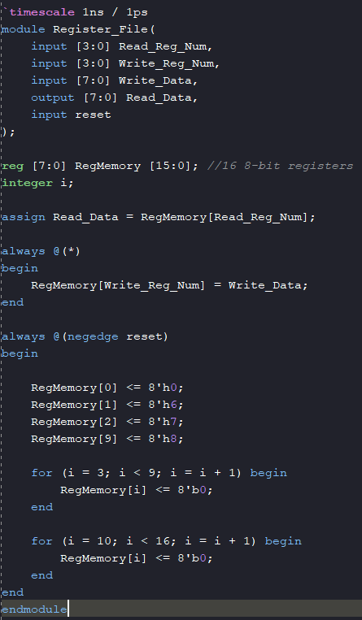

- Implement complete processor in Verilog (using all the datapath blocks). Copy the image of the Verilog code of the processor here.

Answer:
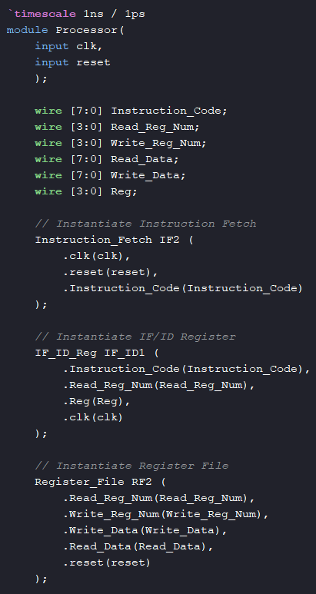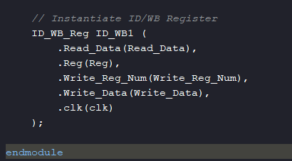
- Test the processor design by initializing the instruction memory with a set of instructions (mentioned earlier) and register file with a set of values. List below the data you have filled your registers with.

Answer: R0: 0 R1: 6 R2: 7 R3: 0 R4: 0 R5: 0 R6: 0 R7: 0 R8: 0 R9: 8 R10: 0 R11: 0 R12: 0 R13: 0 R14: 0 R15: 0
- Verify if the register file is getting updated according to the set of instructions (mentioned earlier).
Copy verified Register file waveform here (show only the Registers that get updated, CLK, RESET): 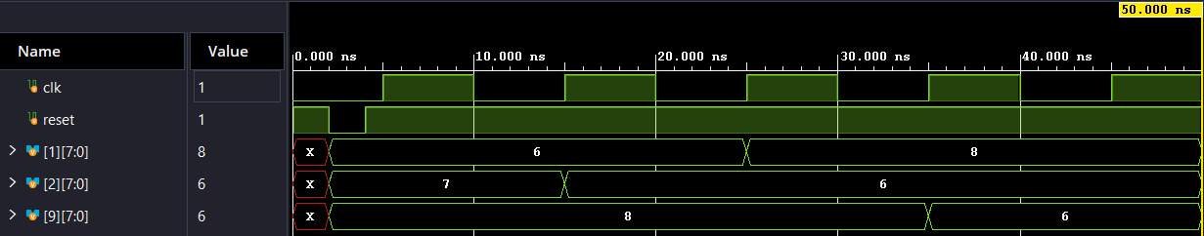
- Suppose the set of instructions to be executed are
Mov Rx, Ry
Mov Rz, Rx
Will there be any hazards in this processor?
Answer Yes or No: No.
Give detailed reasoning for your answer here: There shouldn’t be any hazards in this processor, including Data and Control Hazards. There won’t be any control hazards in this processor, as the processor is capable of executing only 1 type of instruction, i.e. mov instruction. The processor won’t have any data hazards either, as the processor is only a 3 staged pipelined processor, consisting of Instruction Fetch, Instruction Decode and Write Back stages only. The above instruction is supposed to have a RAW (Read After Write) dependency, but due to the design of this processor there won’t be any hazards. In the 1st clock cycle, the 1st instruction will be fetched, and the IF/ID pipeline registers will have rx and ry as rd and rs respectively, and they will read the data from ry accordingly which will be available to the input of ID/WB pipeline register. In the 2nd clock cycle, the 2nd instruction will be fetched, and the IF/ID pipeline registers will have rz and rx as rd and rs respectively, while the ID/WB pipeline registers will have data of ry, address of rx, and will write value of ry to rx towards to start of the clock cycle, while the data being read from the rx will be towards the end of the clock cycle, and hence it will contain the data that was loaded into it from ry. In the 3rd clock cycle, the data of rx (which now contains data of ry), will be loaded into rz.
- Synthesise the processor designed and copy the RTL generated below

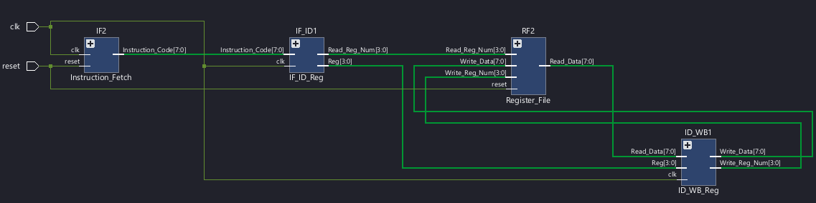

Please note: If you are not able to upload before the deadline, don’t email me. All such emails will be ignored. Upload the sheet well in advance to avoid unexpected delays.

