Lab 2: Implementation of Register File and Partial Datapath

A register file is one of the important components of the MIPS data path. It can read two registers and write into one register. The MIPS register file contains a total of 32 32-bit registers. Hence 5-bits are used to specify the register numbers that are to be read or written.

Register Read: The register file always outputs the contents of the register corresponding to read register numbers specified. Reading a register is not dependent on any other signals.
Register Write: Register writes are controlled by a control signal RegWrite. Additionally, the register file has a clock signal. The write should happen if the RegWrite signal is made 1 and if there is a positive edge of the clock.

32
32
32
5
5
5
Write Data
RegWrite
Read Register number 1

Read Data 2
Read Data 1
Write Register
Read Register number 2

Clock

Exercise 2.1 Implement MIPS register file with above specifications using Behavioral modeling. Test the Register file using Testbench.

Hint: Registers are similar to memory. So 32 32-bit registers are like 32 memory locations with 32 bits each.
Syntax to read from memory is:
RegData = RegMemory[RegAddress]; (if used inside always block)
assign RegData = RegMemory[RegAddress]; (if used outside always block)
Where RegData is the data read from the address location specified by RegAddress.

Syntax to write into memory location is:
RegMemory[RegAddress] = NewData; (if used inside always block), where NewData is written into the RegMemory to address the location specified by RegAddress. Since we define RegMemory as Reg type, the above assignment is not done outside always block.

You can use the module definition shown below for the register file. Please note that the following is just the module definition which specifies input, and output ports. You have to describe the behavior of the Register file to make the design complete. Also if any of the outputs are to be assigned inside the always block then you have to additionally define those outputs as reg.

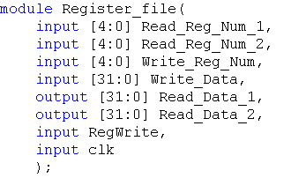
//Add reset as one more input to initialize the register file with some default values
//Define 32, 32 bit RegMemory here
// your behavioral design comes here

Testbench:
You can test your Register file with the following test pattern. (The below code comes after the instantiation of the test module). The test bench contains three initial blocks one for the generation of signals to check writing in to register 0 (when Register_Num is 00000) and register 1(Register_Num is 00001), Second initial block to read register 0 and register 1 and register 2. The third initial block is used to generate the clock. If you have reset as input, you have to add one more initial block where the reset (active low) is low for some time initially and then changed to 1.

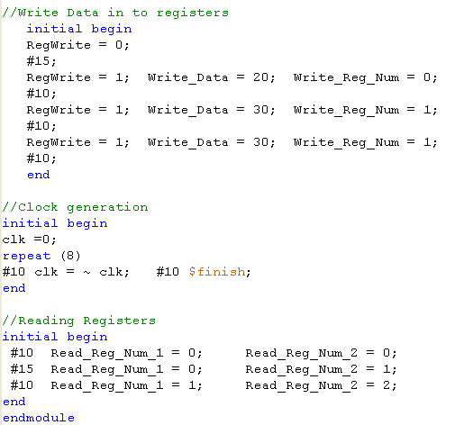
For easy viewing of the testbench waveforms, you can change the view in simulation window to decimal/Hexadecimal mode. Right click on all the input output signals select Radix and then click on signed decimal/Hexadecimal.

Additional Information:

For verifying the design you might have to monitor the internal signals which could be defined as wires or Reg. In the above Register file design RegMemory will be defined as reg and is neither input nor output. The steps for adding internal signal (in this case RegMemory) into the wave form window is shown below.

- To check the internal signals of a module (e.g. Register File), Click on the corresponding module in the Vivado Simulation window (after you run the test bench) and then right click Add to Wave window.
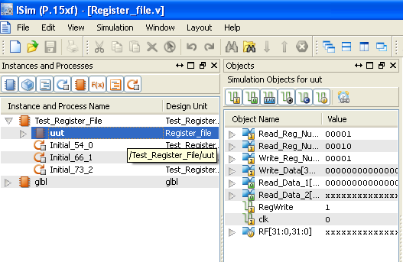

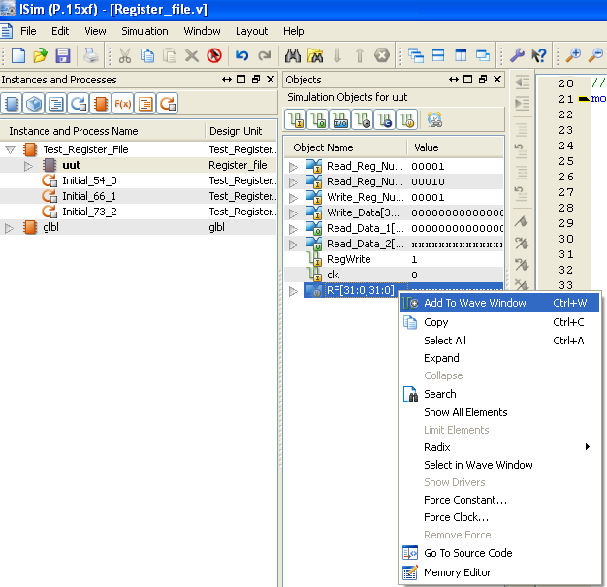

- Then Click on Re-launch Icon. Click ‘No’ when prompted to save the waveform. This will run the testbench with the newly added internal signal.
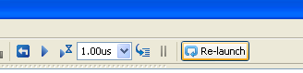

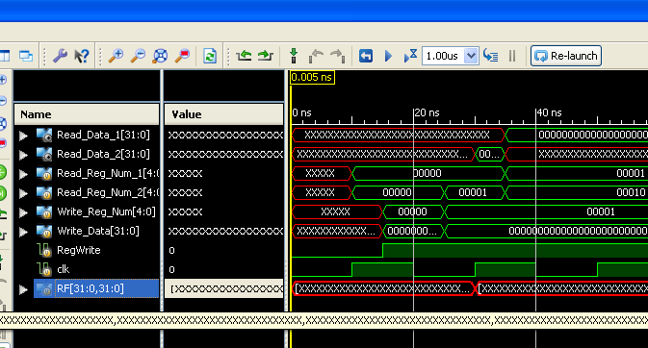

- Did you get any errors during the check syntax of the design file or when simulating the testbench? If yes then, how did you solve the error?
Answer: No errors were encountered during the check syntax of the design file, however while simulating the testbench, the register file doesn’t work as intended as the Write_Data and Write_Reg_Num are changing at arbitrary times, as the RegWrite is not aligned to the clock edge when the clock is toggling every 10ns causing incorrect data to be read by Read_Data_1 and Read_Data_2.
The error was fixed by changing the clock toggling time from 10ns to 5ns, as this aligns the clock edge and hence enables the data to be read correctly by Read_Data_1 and Read_Data_2 as the Write_Data is now able to write data into the registers at correct time intervals.
- Copy the image of the final working code of the register file here.
Answer: 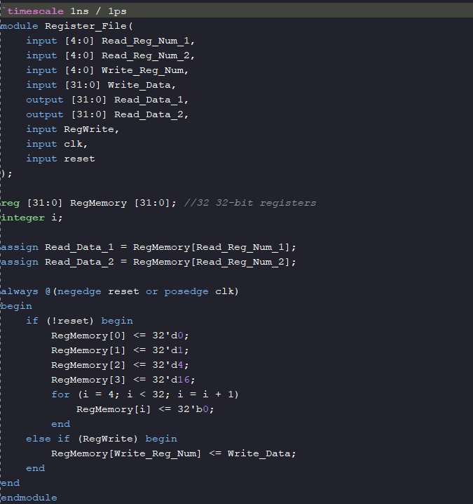

- What changes will you make to the Register_File module if you want to give an option for preloading the register file with some default values?
Answer: We will add an always block with reset condition or add the reset condition in the existing always block and initialize the registers there, first 4 registers are given the value 0, 1, 4, 16, while the others are followed by 0.
- Modify the Register_File module by including a reset signal as input. Add an always block to your register file. This always block checks for reset signal and initializes the register memory (RegMemory) with some default values?
Answer: 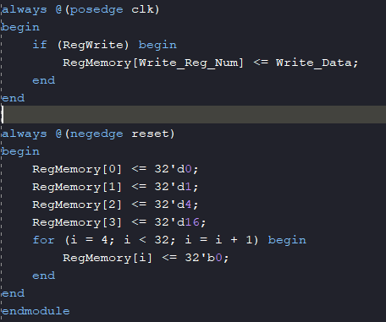

- Copy the image of the waveform window that is generated for the given Testbench? Waveforms should be in decimal/ hexadecimal view.
Answer: With clock toggling every 10ns:
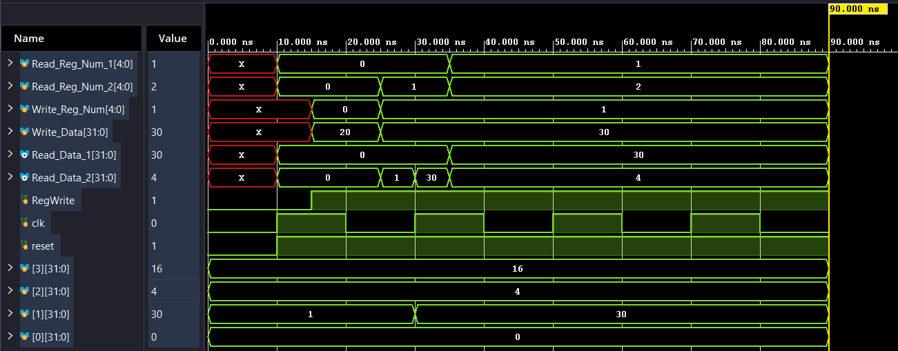
With clock toggling every 5ns:
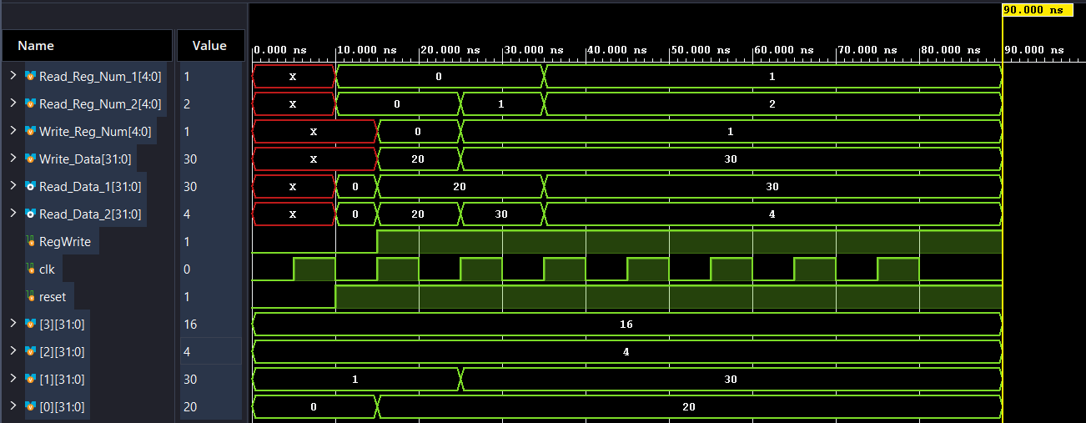

Exercise 2.2 Implement partial Datapath of a MIPS like processor (Shown below). This Datapath has Read_Register_number 1, Read Register_number_2, Write_Register, ALU Control lines (ALU Operation) bits, Clk, Reset, and RegWrite as inputs. This Datapath has only one output i.e. Zero. To implement this Datapath first create another module called Datapath. Instantiate (similar to calling a function) the Register_file module and ALU Module (Reuse the ALU which was implemented in Lab 1) in the Datapath module. Make internal connections as per the Datapath given. (e.g. ReadData1 is connected to the first input of ALU). Please note that all intermediate signals should be defined as wire with appropriate bit widths.

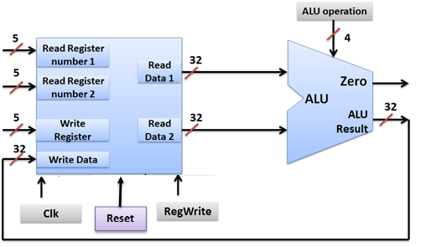

- Copy the image of the Verilog code of the above Datapath.
Answer: 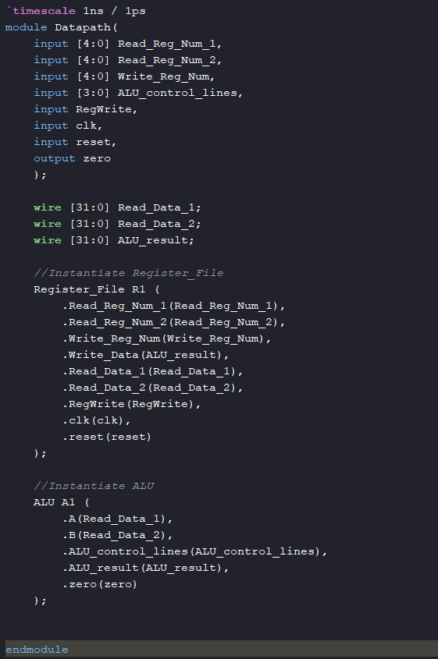
- Write an appropriate test bench to test the above data path. Copy the test bench below (Hint: You should supply new register numbers after the positive edge of Clk or before the positive edge of Clk to avoid confusion)
Answer: 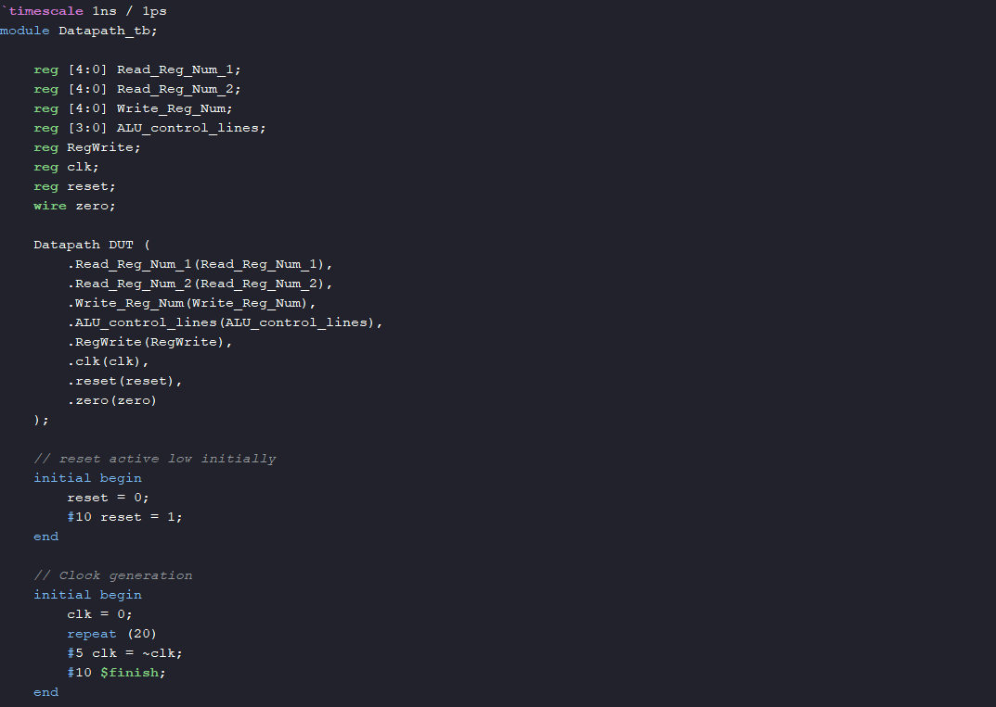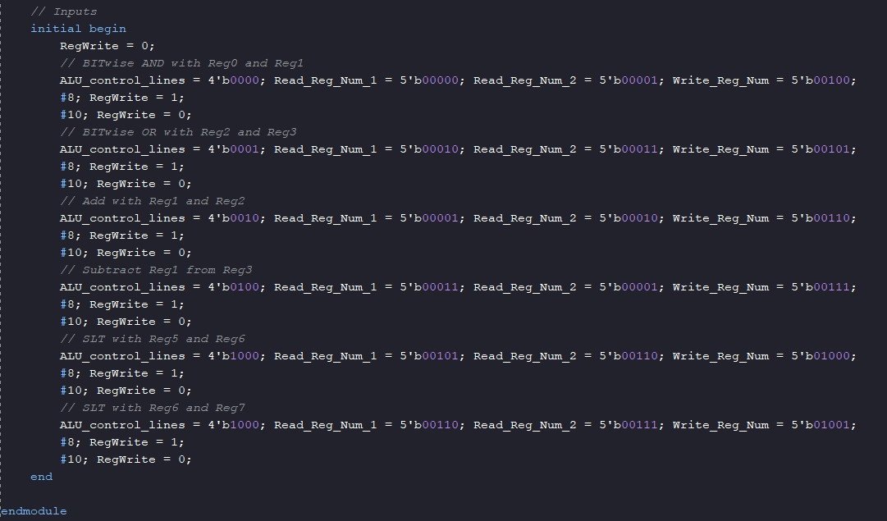
- Simulate the above test bench and paste the waveforms below.

Answer: 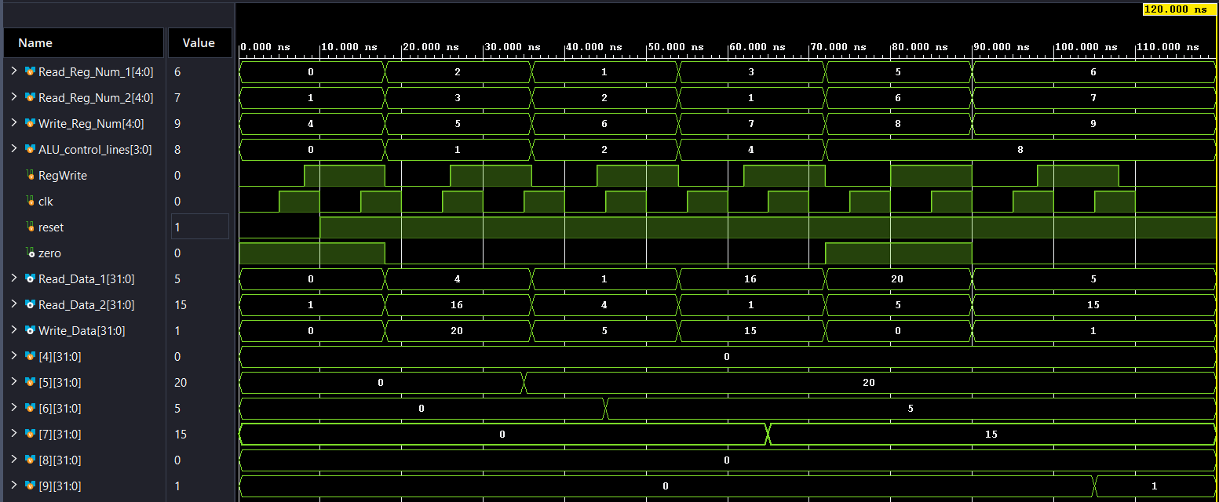
- List the concepts you learned from this experiment (Conclusions/Observations)

Answer: Writing a detailed testbench such that it covers all functionalities of the register file and ALU, and also thinking of edge cases that might lead to wrong output. Understanding, implementing, debugging and verifying testbench inputs and outputs through simulation waveforms.
Exercise 2.3 Now Synthesise the above partial Datapath using the Xilinx Vivado

- Copy the RTL generated below

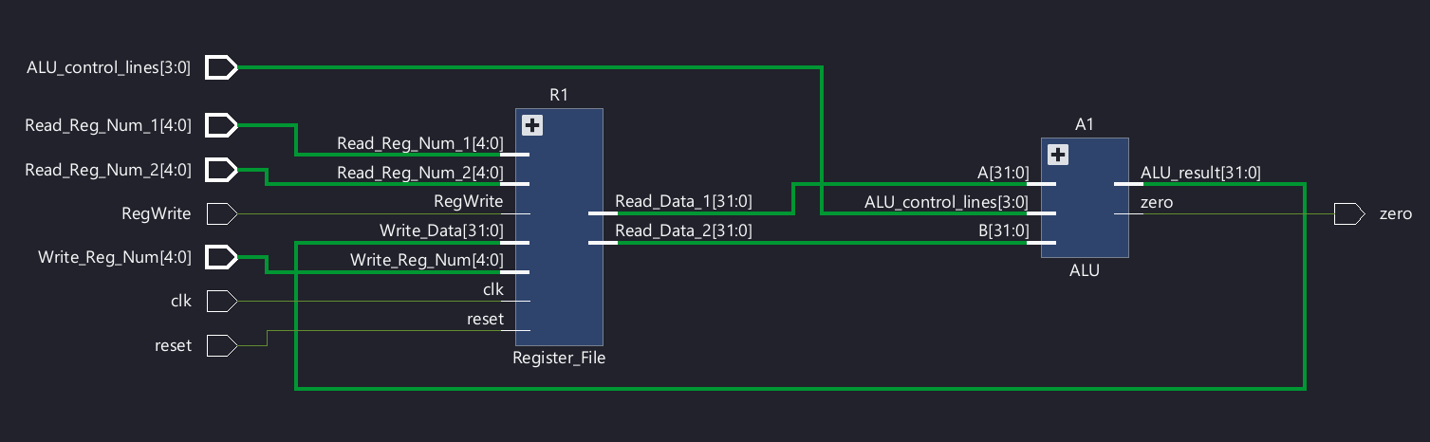

- Note the observations from the RTL generated

The RTL shows the complete Datapath of the Register File and the ALU, with the Register File having 32 32-bit registers in memory, reset, clock, 2 read inputs to access 2 32-bit registers, 2 outputs to output the contents of the selected registers to the ALU. The ALU has a 4-bit control line which decides the type of operation and outputs the data combinationally back to the Register File, which writes to the specified register, based on the RegWrite and Write_Data signals.
Please note: If you are not able to upload before the deadline, don’t email me. All such emails will be ignored. Upload the sheet well in advance to avoid unexpected delays.

