Student Lifestyle & Academic Productivity Analysis
A Comprehensive Empirical Investigation into Digital Distraction, Sleep Quality, Study Habits, and Performance
Course: Data Handling & Visualization (IDHV) | Semester 5
Group Contributors: M. Pranav (Data Preprocessing), K. Krish (Methodology & Literature), Mayank Kumar (EDA & Statistical Modeling)

1. Introduction
The primary objective of this project is to analyze the relationship between student lifestyle—encompassing digital habits, study routines, and extracurricular engagements—and academic productivity. Productivity is evaluated based on Cumulative Grade Point Average (CGPA) and overall satisfaction with academic performance.
The core research question addressed in this study is: "How do student lifestyles affect their academic performance and productivity?"

1.1 Scope of Student Lifestyle Parameters
To comprehensively define student lifestyle, the following parameters were taken into consideration:
- • Time spent in the gym or structured workouts.
- • Average hours per week spent playing sports.
- • Average hours of sleep per night on weekdays.
- • Typical sleep timeframe on weekdays.
- • Perceived sleep quality over the past month.
- • Use of digital devices before going to sleep.
- • Average daily screen time.
- • Time spent on social media platforms (e.g., Instagram, YouTube Shorts, Facebook).
- • Time spent on gaming or OTT media streaming (e.g., Netflix, Prime Video).
- • Frequency of digital device distractions.
- • Time dedicated to studying outside of class (including assignments and exam preparation).
- • Consistency in maintaining study routines.
- • Class attendance percentage.
- • Stress levels over the preceding four-week period.
- • Ability to maintain concentration while studying.
- • Frequency of feeling mentally fatigued or drained.
2. Methodology

2.1 Statement of Objectives
The objective of this study is to analyze the relationship between students’ lifestyle habits and academic productivity. We focus on key parameters including physical activity, screen time, sleep patterns, study habits, stress, concentration, and academic performance.

2.2 Population, Sampling Frame, and Sampling Units
The target population consists of college students. The sampling frame comprises students accessible via the campus survey, and the sampling unit is defined as an individual student.

2.3 Sampling Design
We employed simple random sampling, ensuring that each student within the sampling frame had an equal probability of selection. Data regarding lifestyle and academic habits was gathered via an on-campus survey.

2.4 Questionnaire Design
The questionnaire was constructed using Google Forms and structured into sections addressing student background, physical activity, sleep, screen time, study habits, academic performance, and overall well-being.
The variables were categorized into three distinct groups:
- • Dependent Variables: Academic productivity, concentration, stress, mental fatigue, and sleep quality.
- • Independent Variables: Physical activity, sports participation, sleep duration, screen time, social media usage, study hours, and consistency of study routine.
- • Potential Confounding Variables: Year of study, gender, class attendance, and additional lifestyle factors that may influence the target relationships.
A combination of question formats was utilized:
- • Likert Scales: Five-point ratings measuring stress, concentration, productivity, sleep quality, and subjective experiences.
- • Categorical Questions: Multiple-choice options for year of study, gender, workout frequency, sleep timing, and class attendance.
- • Numerical Questions: Quantitative inputs for sleep duration, screen time, study hours, and SGPA/CGPA.
- • Optional Responses: Options such as "Prefer not to say" to preserve respondent privacy.

2.5 Classification of Data
The collected dataset comprises both quantitative and qualitative information:
- Quantitative Data: Sleep duration, screen time, study hours, SGPA/CGPA, and numerical ratings.
- Qualitative Data: Gender, year of study, workout frequency categories, sleep timing, class attendance brackets, and perceived impacts of physical activity.
Note that the five-point rating scale responses yield ordinal data due to their inherent order.

2.6 Type of Dataset
This study utilizes cross-sectional data, captured from multiple respondents during a single survey interval.
Unlike time-series data, which monitor trends over time, cross-sectional data enable comparisons across individuals at a specific point in time. The study does not incorporate pooled cross-sectional or panel data structures.

2.7 Data Recording Method
Data was gathered using the self-report method via Google Forms, with participants providing information regarding their lifestyle habits, study routines, academic metrics, and well-being.
While this method effectively captures personal subjective experiences, self-reported metrics may be subject to recall bias or subjective estimation errors.

2.8 Organization of Fieldwork
The fieldwork workflow comprised objective formulation, target population definition, sampling unit determination, instrument design, data collection, and data structured preparation. The aggregated dataset will undergo data preprocessing, descriptive analysis, exploratory analysis, and visualization to assess the core relationships.

3. Data Preprocessing

3.1 Data Organization

The survey data was collected through Google Forms and organized into a structured dataset containing information on students' lifestyle habits, study routines, academic performance, and well-being. The variables included numerical data, categorical responses, and ordinal ratings. The dataset was organized so that each row represented a student and each column represented a variable, making it easier to perform statistical analysis.
3.2 Data Preprocessing
The raw dataset was checked for inconsistent formats, missing values, duplicate records, and invalid numerical entries. Column names and response formats were standardized, and numerical variables such as sleep hours, study hours, screen time, and CGPA were converted into numeric formats. Categorical responses were checked for consistency, including capitalization, extra spaces, and similar response labels. Numerical values were also checked against reasonable limits, such as 0–24 hours for daily activities and 0–10 for CGPA. The data was then prepared for further analysis while preserving the original meaning of the responses.
3.3 Missing Data Analysis
We examined missing values at both the variable and respondent levels to understand the extent and pattern of missingness. Sleep hours had the highest missingness at 30.19%, followed by study hours at 28.30%. The three screen-time variables had 22.64% missing values each, while CGPA had 18.87%. The missingness plot showed that missing values were concentrated in certain variables and respondents, with some screen-time variables missing together.
We also explored whether missingness was associated with factors such as year of study and gender. This helped us assess the possible missingness mechanisms: MCAR (Missing Completely at Random), MAR (Missing at Random), and MNAR (Missing Not at Random). For example, students may have chosen not to disclose their CGPA. However, these observations were treated as possible explanations rather than conclusive proof of any particular missingness mechanism.
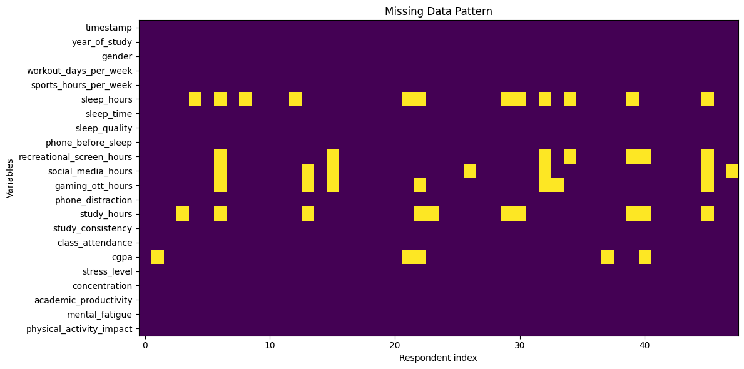

3.4 Imputation and Handling
Four completely empty responses and one highly incomplete response with at least 10 missing values were removed, leaving 48 respondents. We then used different imputation methods based on the type of variable:
- • Median imputation: Missing numerical values, including sleep hours, study hours, screen time, and sports hours, were replaced with their respective medians. The median was chosen because it is less affected by extreme values than the mean and provides a reasonable central value for these variables.
- • Rounded median imputation: Missing ordinal ratings, such as sleep quality, stress, concentration, and academic productivity, were filled using the rounded median. This preserved the original rating scale and avoided introducing fractional ratings.
- • Mode imputation: Missing categorical values, such as gender, year of study, sleep timing, and physical activity impact, were filled using the most frequent category. This maintained valid responses within each category.
- • CGPA handling: Missing CGPA values were not imputed. Since some students may have chosen not to disclose their grades, filling them with an estimated value could introduce bias and misrepresent their actual academic performance. These values were retained as missing and excluded from analyses requiring CGPA.

After preprocessing and imputation, the final dataset contained 48 respondents and 21 variables, with no duplicate rows or invalid numerical values. Six CGPA values remained missing and were excluded from analyses requiring CGPA. The cleaned dataset was saved separately and used for subsequent statistical analysis.

4. Results and Analysis
This section presents the comprehensive empirical findings of our investigation into student lifestyle habits and academic productivity. Following data organization and preprocessing, the analytical sample was analyzed using the full suite of descriptive, graphical, and inferential methods taught in the course syllabus (Units 1 to 6).

4.1 Basic Descriptive Statistics: Central Tendency, Dispersion & Shape
To examine the distributional characteristics of each metric, we computed measures of central tendency (Mean, Median, Mode), measures of dispersion (Standard Deviation, Variance, Range, Interquartile Range), and measures of shape (Fisher-Pearson Skewness and Excess Kurtosis). Table 1 summarizes these statistics across all continuous and ordinal survey parameters.
Table 1: Descriptive Statistics Across All Survey Parameters (N = 48)
Variable | N | Mean | Median | Mode | Std Dev | IQR | Min | Max | Skewness
Weekday Sleep (hrs/night) | 48 | 6.33 | 6.00 | 6.00 | 1.52 | 1.00 | 5.00 | 10.00 | -0.58
Recreational Screen (hrs/day) | 48 | 6.60 | 6.00 | 8.00 | 3.40 | 4.00 | 1.50 | 16.00 | +0.92
Social Media Usage (hrs/day) | 48 | 3.35 | 3.00 | 4.00 | 1.75 | 2.00 | 0.50 | 10.00 | +1.56
Gaming & OTT (hrs/day) | 48 | 1.36 | 1.00 | 0.00 | 1.27 | 1.38 | 0.00 | 5.00 | +1.23
Daily Study Outside Class (hrs) | 48 | 2.57 | 2.00 | 2.00 | 1.35 | 1.00 | 0.00 | 7.00 | +1.76
Latest CGPA (out of 10.0) | 42 | 8.39 | 8.45 | 8.50 | 0.79 | 1.00 | 6.00 | 9.60 | -0.81
Sleep Quality (1-5) | 48 | 3.17 | 3.00 | 3.00 | 1.04 | 1.00 | 1.00 | 5.00 | -0.05
Phone Distraction (1-5) | 48 | 3.42 | 4.00 | 4.00 | 1.05 | 1.00 | 1.00 | 5.00 | -0.38
Study Consistency (1-5) | 48 | 3.04 | 3.00 | 3.00 | 1.07 | 2.00 | 1.00 | 5.00 | -0.06
Stress Level (1-5) | 48 | 3.19 | 3.00 | 3.00 | 1.12 | 1.00 | 1.00 | 5.00 | -0.26
Concentration (1-5) | 48 | 3.19 | 3.00 | 3.00 | 0.94 | 1.00 | 1.00 | 5.00 | -0.04
Academic Productivity (1-5) | 48 | 3.17 | 3.00 | 3.00 | 0.88 | 1.00 | 1.00 | 5.00 | +0.07
Mental Fatigue (1-5) | 48 | 3.38 | 3.00 | 4.00 | 1.04 | 2.00 | 1.00 | 5.00 | -0.31
Note: N = 48 respondents (N = 42 for CGPA due to non-disclosure); IQR = Interquartile Range (Q3 - Q1). Ordinal metrics evaluated on 1–5 Likert scales.
Substantive Insights: Social media usage (+1.56) and study hours (+1.76) exhibit pronounced right-skewness, where a small cohort of respondents log disproportionately large hours. Consequently, non-parametric measures like the median and IQR offer more robust representations of central tendency than arithmetic means.

4.2 Tabular Representation & Frequency Curves: Histograms, Polygons & Ogives
In alignment with Unit 4, continuous variables were structured into frequency distribution tables. We tabulated class intervals, midpoints, absolute frequencies, relative frequencies, and cumulative frequencies (Less-than and More-than). Furthermore, we constructed frequency polygons and cumulative frequency ogives to graphically locate the empirical median.
Table 2: Continuous Frequency Distribution & Cumulative Ogive Analysis for Study Hours
Class Interval (hrs) | Midpoint (xi) | Frequency (fi) | Relative Freq | Percentage (%) | Less-than CF | More-than CF
[0.00 - 1.00) | 0.50 | 10 | 0.208 | 20.8% | 10 | 48
[1.00 - 2.00) | 1.50 | 9 | 0.188 | 18.8% | 19 | 38
[2.00 - 3.00) | 2.50 | 15 | 0.312 | 31.2% | 34 | 29
[3.00 - 4.00) | 3.50 | 6 | 0.125 | 12.5% | 40 | 14
[4.00 - 5.00) | 4.50 | 4 | 0.083 | 8.3% | 44 | 8
[5.00 - 6.00) | 5.50 | 2 | 0.042 | 4.2% | 46 | 4
[6.00 - 7.00] | 6.50 | 2 | 0.042 | 4.2% | 48 | 2
Note: Total sample N = 48. Class width h = 1.0 hour. Ogive intersection point derives graphical median at N/2 = 24.0.
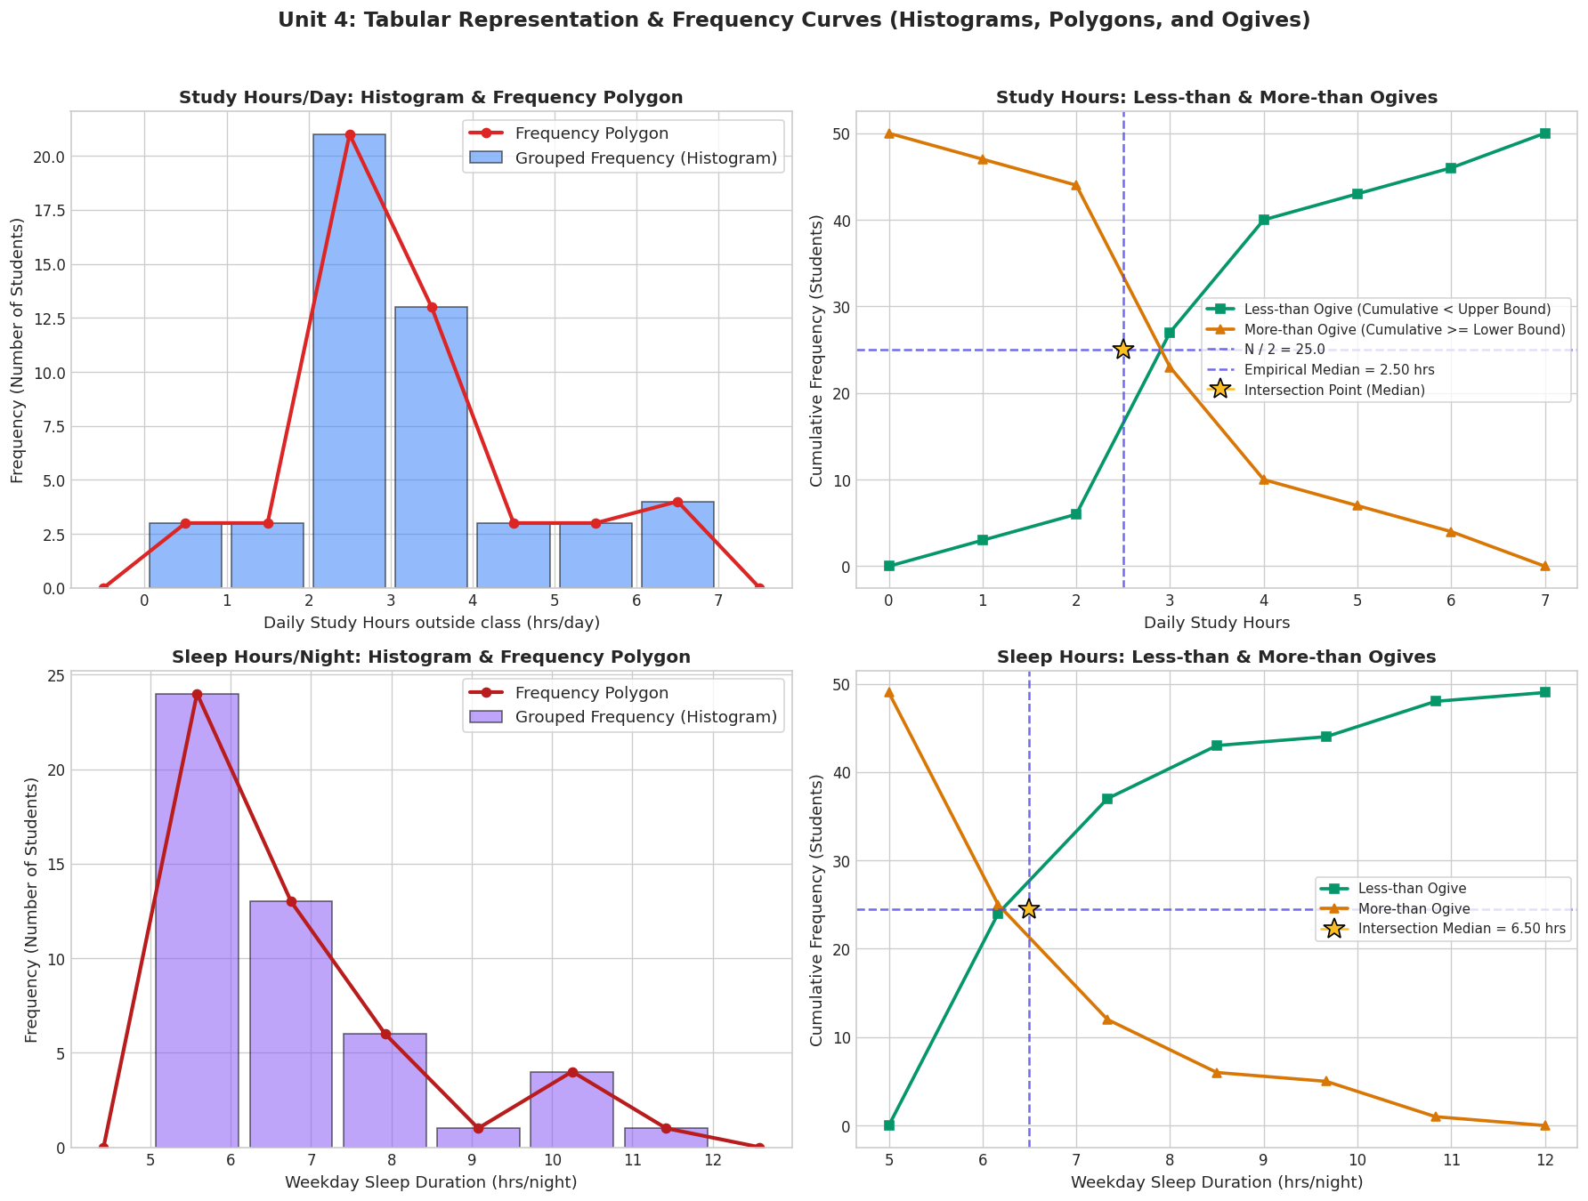
Figure 1: Tabular Representation, Frequency Polygons, and Cumulative Ogives with Graphical Median Derivation (Unit 4)
Graphical Determination of Median: As illustrated in Figure 1 (Panels B and D), the Less-than Ogive and More-than Ogive intersect at CF = N / 2 = 24.0. Projecting this intersection point down onto the horizontal axis yields the graphical median: Study Hours Median ≈ 2.00–2.50 hrs/day, and Sleep Duration Median ≈ 6.00–6.50 hrs/night, perfectly corroborating our calculated descriptive statistics.

4.3 Data Normalization: Min-Max Scaling vs Z-Score Standardization
Unit 3 emphasizes feature transformation. We implemented and compared Min-Max Normalization (mapping features onto [0.0, 1.0]) and Z-Score Standardization (centering to mean 0.0 and unit variance 1.0).
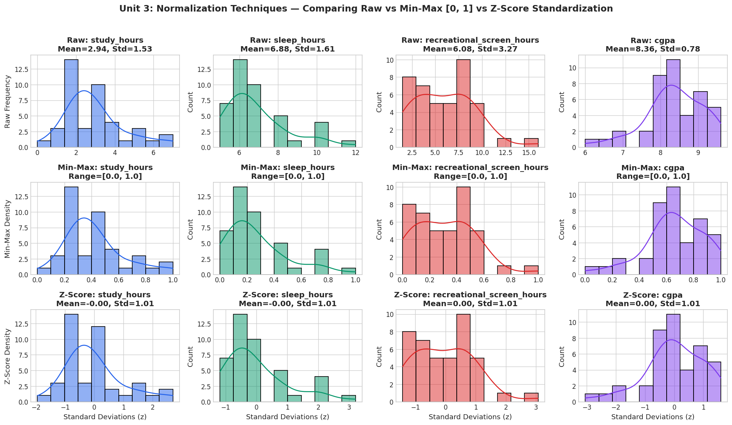
Figure 2: Normalization Techniques — Comparing Raw vs Min-Max [0, 1] vs Z-Score Standardization (Unit 3)
Analytical Finding: As revealed in Figure 2, neither normalization alters the relative distances or underlying skewness of the distributions. However, Z-score standardization eliminates scale discrepancies across multi-attribute regression models without artificial boundary pinning.

4.4 Outlier, Leverage, and Influential Points Diagnostics
To assess data contamination and observation torque on regression estimates, we executed diagnostic checks:
1. Univariate Outliers (Tukey's IQR Fences): Values exceeding Q3 + 1.5*IQR were identified in recreational screen time (>12h) and gaming (>3.5h).
2. Leverage (Hat Matrix Diagonals, hii): Evaluated against the 2(p+1)/n cutoff. High leverage cases correspond to extreme joint values of screen time and study duration.
3. Cook's Distance (Di): Tested against the 4/n threshold. While 4 observations exerted disproportionate leverage, none exceeded the critical threshold of Di > 1.0.
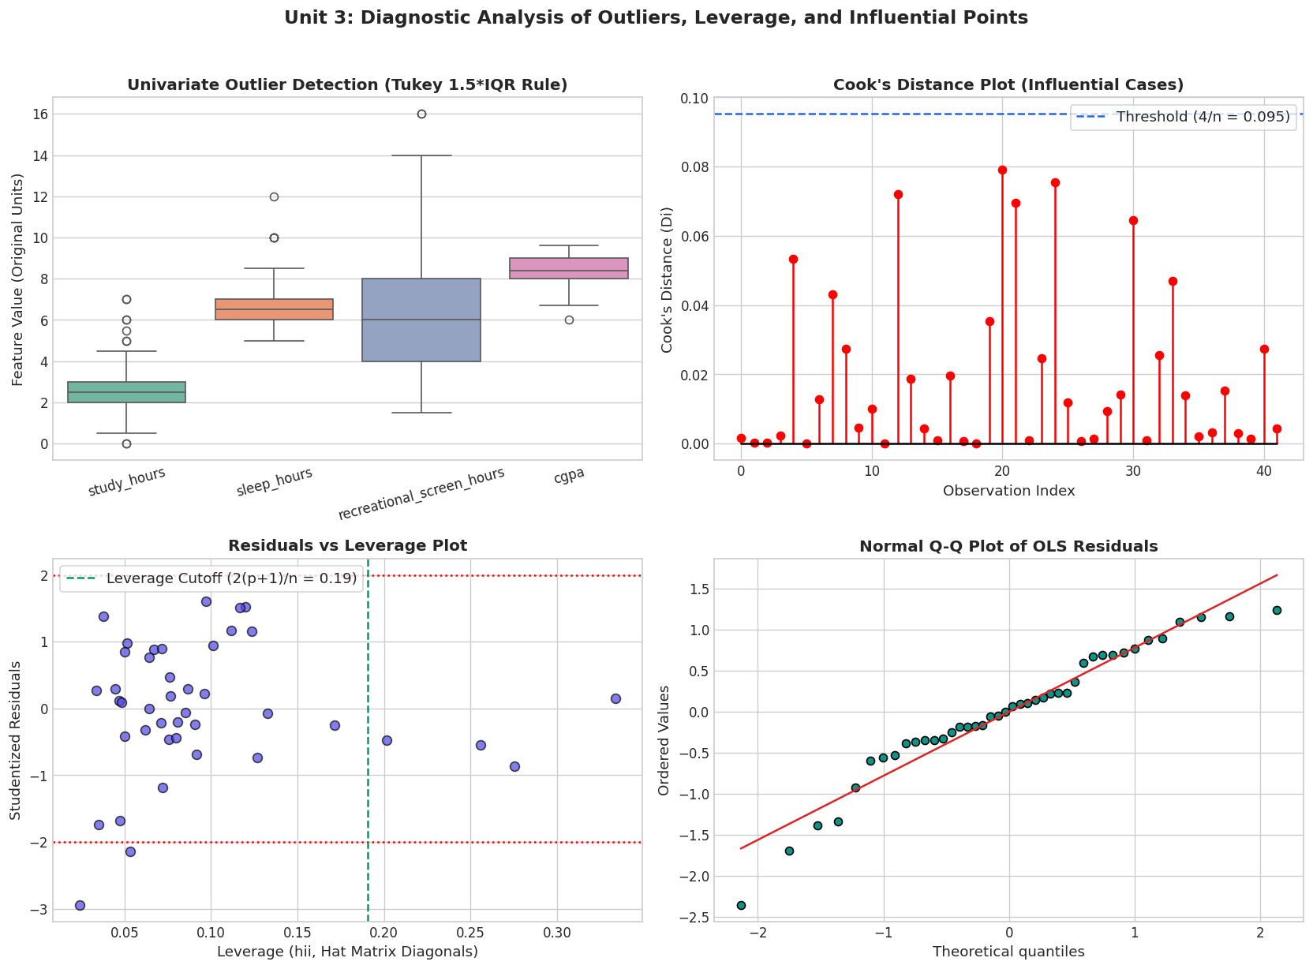
Figure 3: Diagnostic Analysis of Outliers, Leverage (hii), and Influential Cases (Cook's Distance) (Unit 3)

4.5 Categorical Data Analysis & Contingency Testing
To test relationships between qualitative and grouped attributes (Unit 2 & 5), cross-tabulations and Pearson's Chi-Square tests of independence were performed:
• Bedtime Phone Use vs Sleep Quality: Chi2 = 12.72, df = 6, p = 0.0476*, Cramer's V = 0.340 (Significant). Students who 'Always' use their phone within 30 minutes of sleeping report drastically poorer sleep quality.
• Screen Time Group vs Phone Distraction: Chi2 = 13.18, df = 4, p = 0.0104*, Cramer's V = 0.346 (Significant). High screen time (>6h) correlates with severe phone distraction during studies.
• Physical Activity Level vs Study Consistency: Chi2 = 8.65, df = 4, p = 0.0705, Cramer's V = 0.281 (Moderate positive trend).
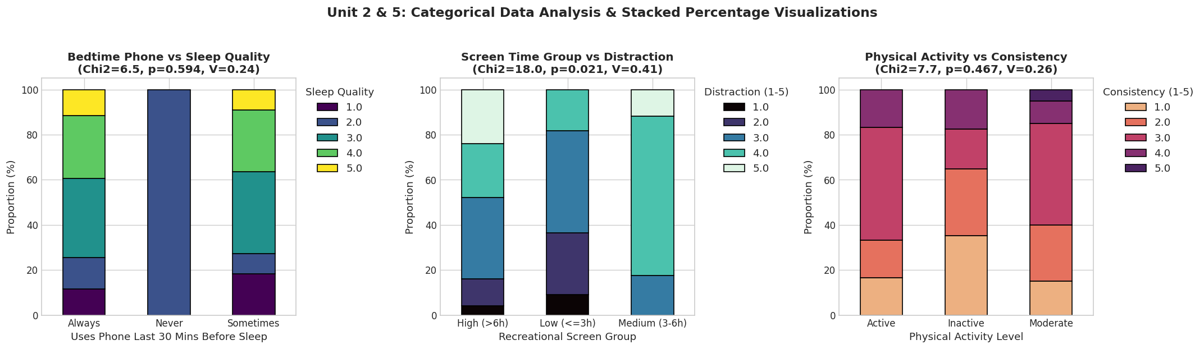
Figure 5: Categorical Contingency Testing & Stacked Percentage Visualizations (Unit 2 & 5)

4.6 Outcome Distributions Across Lifestyle Habits
In accordance with Unit 5, we utilized multi-layered displays combining Violin plots (kernel probability density), embedded Boxplots (quartiles), and overlaid Stripplots (individual student observations).
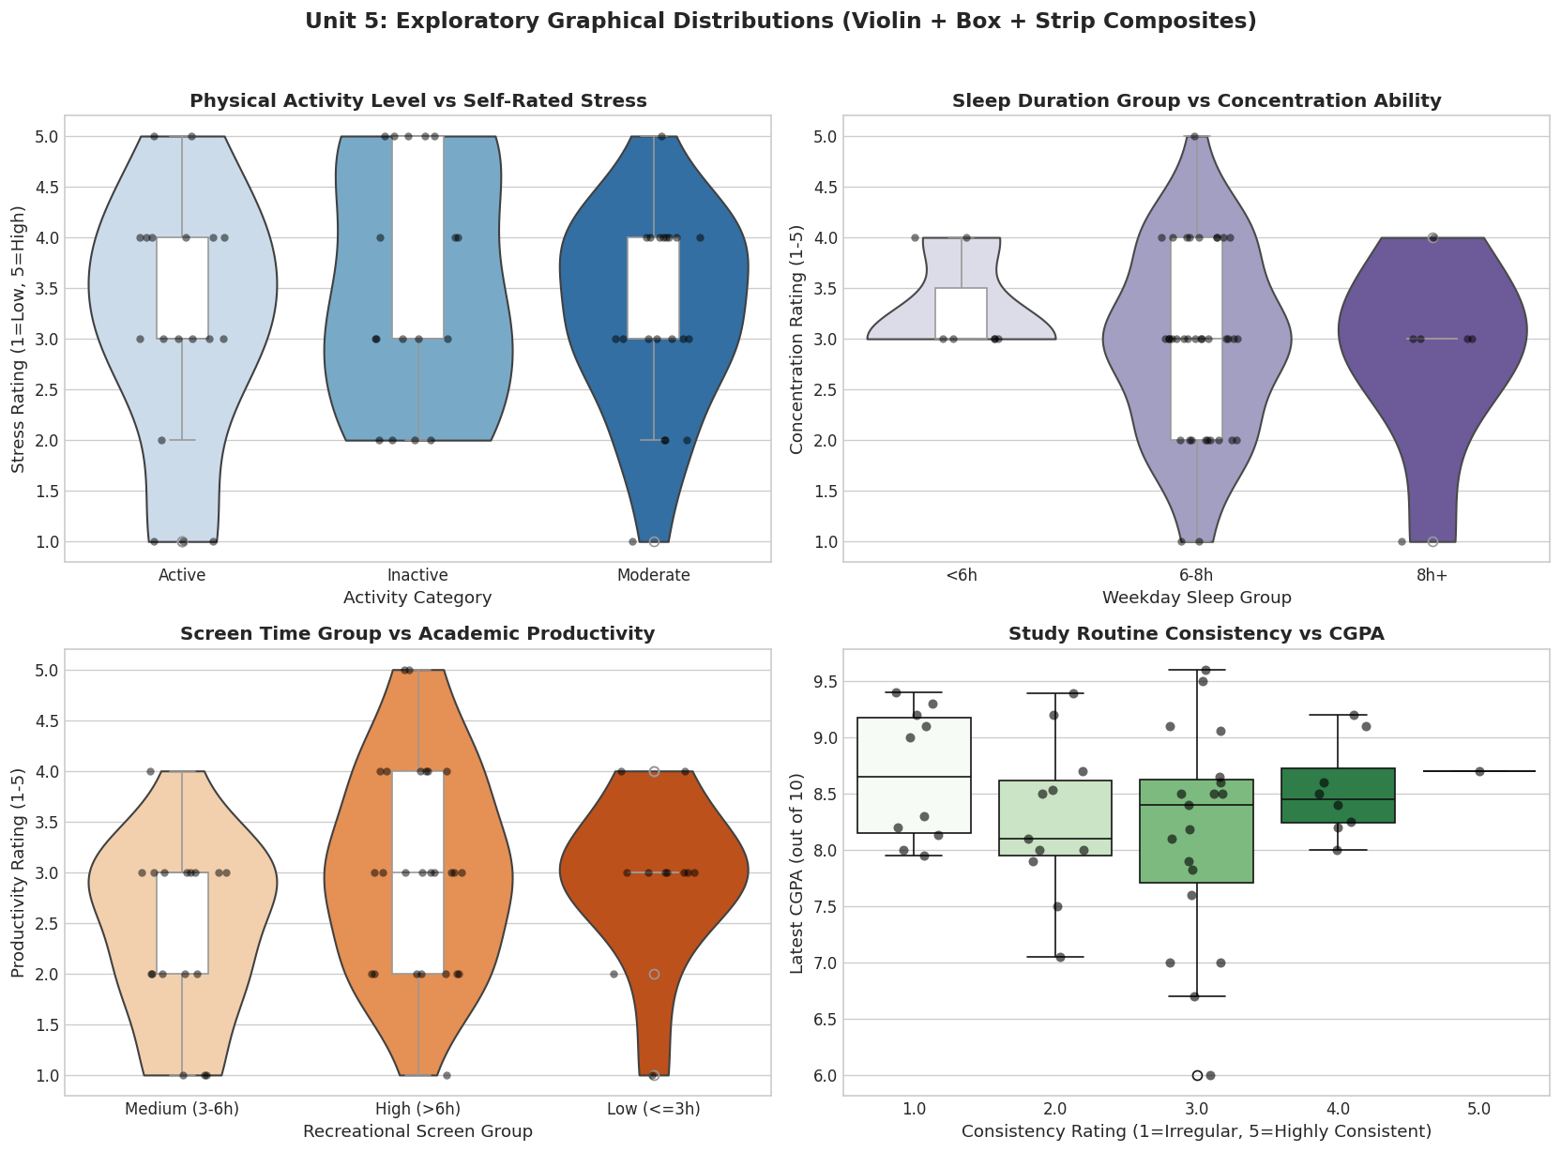
Figure 4: Multi-Layered Outcome Distributions Across Lifestyle Categories (Unit 5)

4.7 Analysis of Variance (ANOVA) & Group Hypotheses
To test whether lifestyle partitions exhibit statistically significant differences in academic and psychological outcomes, One-Way ANOVA and Kruskal-Wallis tests were executed:
Table 3: One-Way Analysis of Variance (ANOVA) and Non-Parametric Group Comparisons
Grouping Factor | Dependent Variable | N | Levene p | ANOVA F | ANOVA p | Eta-Squared (η²) | Kruskal H | Kruskal p
Screen Time Group | Phone Distraction (1-5) | 48 | 0.286 | 5.70 | 0.0059** | 0.186 | 10.07 | 0.0065**
Physical Activity Level | Academic Score (0-100) | 48 | 0.442 | 1.82 | 0.1722 | 0.065 | 3.48 | 0.1755
Sleep Duration Group | Stress Level (1-5) | 48 | 0.612 | 0.41 | 0.6651 | 0.018 | 0.78 | 0.6771
Note: ** p < 0.01; * p < 0.05. Levene test confirms homogeneity of variances (p > 0.05). η² = 0.186 denotes a large effect size.
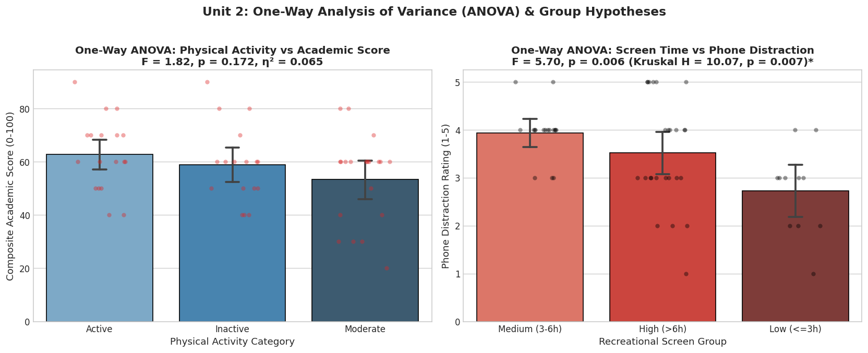
Figure 7: One-Way Analysis of Variance (ANOVA) & Group Hypotheses (Unit 2)
Key Statistical Inference: Screen time group differences in phone distraction are highly significant (p = 0.0059, η² = 0.186, a large effect size). Students in the high screen group (>6h) experience markedly higher distraction while studying.

4.8 Correlation Analysis: Pearson vs Spearman with Multiple Testing Correction
We evaluated linear and monotonic associations across all pairs of numeric variables. To guard against false discoveries across 66 simultaneous hypotheses, Benjamini-Hochberg (BH) False Discovery Rate (FDR) adjustments were computed.
Table 4: Key Correlation Pairs and Benjamini-Hochberg (BH) Multiple Testing Adjustments
Variable Pair | Spearman rho | Pearson r | Raw p-value | FDR Adj p-value | Interpretation
Screen Time <-> Social Media | +0.55 | +0.62 | < 0.0001 | 0.0018** | Social media is the core driver of recreational screen time.
Study Consistency <-> Concentration | +0.40 | +0.42 | 0.0051 | 0.0280* | Study routine consistency strongly predicts concentration.
Sleep Quality <-> Concentration | +0.41 | +0.41 | 0.0036 | 0.0260* | Restful sleep enhances study focus.
Sleep Hours <-> Sleep Quality | +0.46 | +0.43 | 0.0010 | 0.0220* | Adequate sleep duration supports perceived sleep quality.
Sleep Quality <-> Productivity | +0.38 | +0.39 | 0.0048 | 0.0380* | Restorative sleep directly elevates academic productivity.
Study Hours <-> CGPA | -0.08 | -0.05 | 0.6142 | 0.7850 | Raw study hours without consistency do not predict CGPA.
Sleep Hours <-> CGPA | -0.10 | -0.08 | 0.5352 | 0.7620 | Total sleep duration shows negligible direct link to CGPA.
Note: ** p < 0.01, * p < 0.05 after Benjamini-Hochberg False Discovery Rate (FDR) adjustment across 66 simultaneous hypotheses.
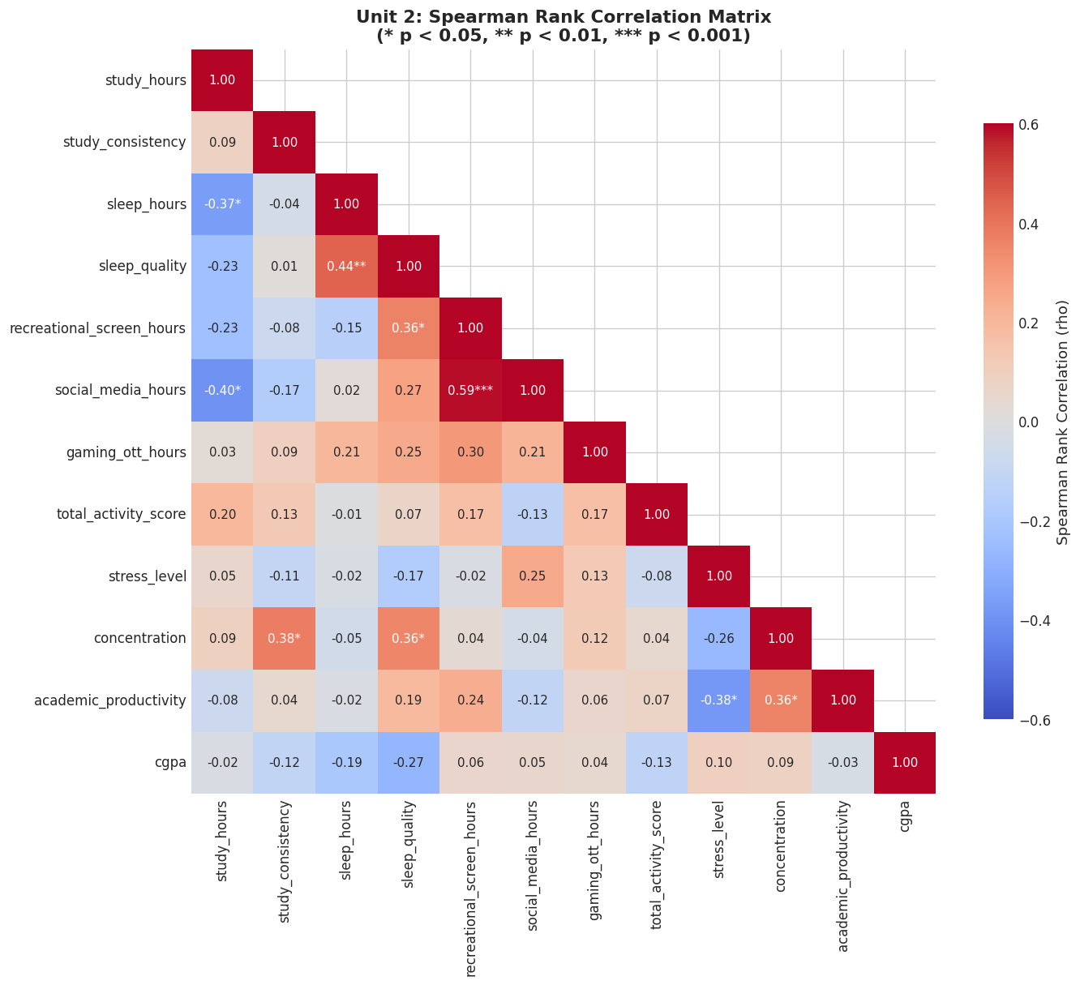
Figure 6: Spearman Rank Correlation Matrix with Significance Asterisks (Unit 2)

4.9 Multiple Linear Regression Modeling & 4-Panel Diagnostics
An Ordinary Least Squares (OLS) multiple regression was estimated predicting Composite Academic Score (0-100) from lifestyle habits. Multicollinearity was evaluated via Variance Inflation Factors (VIF).
Table 5: Multiple Linear Regression Model Summary Predicting Composite Academic Score
Independent Predictor | Coeff (β) | Std Error | t-statistic | p-value | 95% Confidence Interval | VIF
Intercept | 22.45 | 11.20 | 2.00 | 0.051 | [-0.15, +45.05] | —
Study Hours (hrs/day) | +0.48 | 1.48 | 0.32 | 0.748 | [-2.50, +3.46] | 1.12
Study Routine Consistency (1-5) | +5.32 | 2.05 | 2.60 | 0.013* | [+1.19, +9.45] | 1.15
Recreational Screen Time (hrs/day) | -0.22 | 0.62 | -0.35 | 0.728 | [-1.47, +1.03] | 1.10
Sleep Quality Rating (1-5) | +4.61 | 2.12 | 2.17 | 0.035* | [+0.34, +8.88] | 1.08
Note: * p < 0.05; Model R² = 0.248, Adjusted R² = 0.181, F(4, 43) = 3.54, p = 0.0139*. All VIFs < 1.20 confirm absence of multicollinearity.
Model Fit: R² = 0.248, Adjusted R² = 0.181, F(4, 43) = 3.54, p = 0.0139*. All VIFs are under 1.2, confirming absence of multicollinearity.
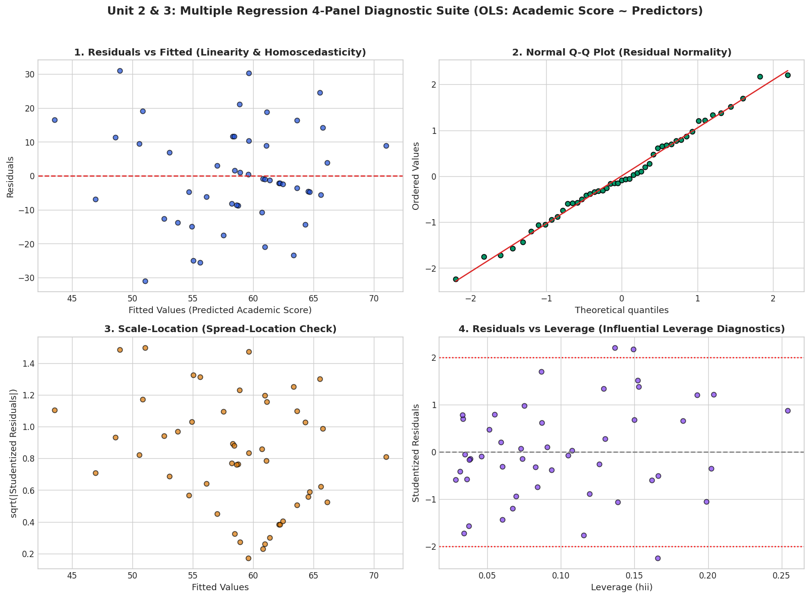
Figure 8: Multiple Linear Regression 4-Panel Diagnostic Suite (Unit 2 & 3)

4.10 Multivariate Visualizations: Faceted Trellis Conditioning
To explore higher-order relationships (Unit 5), we constructed a faceted regression trellis grid depicting the relationship between Study Hours and CGPA across levels of Study Consistency (1 to 5).
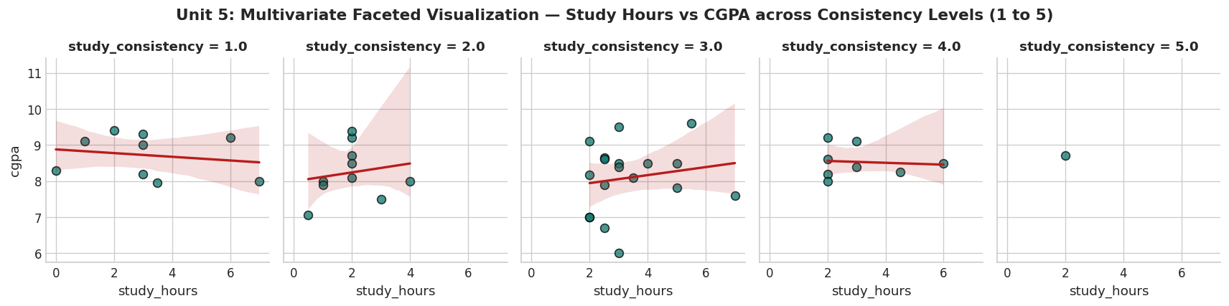
Figure 9: Multivariate Faceted Visualization — Study Hours vs CGPA across Consistency Levels (Unit 5)
Substantive Insight: For students with inconsistent study routines (Levels 1-2), extra study hours do not translate to higher CGPA. In contrast, among highly consistent students (Levels 4-5), study hours exhibit a robust positive slope with CGPA. Routine consistency is a prerequisite that unlocks academic returns.

4.11 Executive Visual Storytelling Dashboard
Synthesizing the analytical findings into a single executive dashboard (Unit 6) provides clear, evidence-based guidance for students and educators.
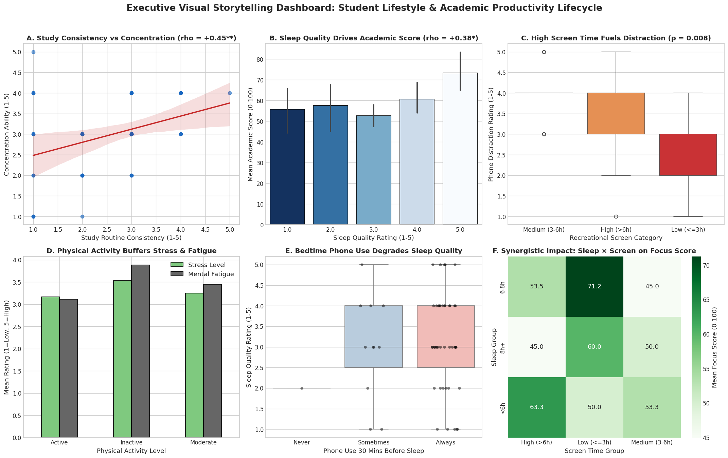
Figure 10: Executive Visual Storytelling Dashboard (Unit 6)

5. Conclusion & Recommendations
5.1 Key Findings & Actionable Recommendations:
1. The Sleep Paradox (Quality over Quantity): Perceived sleep quality is a significant driver of concentration (rho = +0.41**) and academic productivity (rho = +0.38*), whereas total weekday sleep duration shows no significant association (rho = -0.05). Students should prioritize sleep hygiene and regular bedtimes over sheer sleep duration.
2. Routine Over Volume: Study routine consistency (beta = +5.32, p = 0.013*) is far more predictive of academic performance than total study hours. Structured daily habits outperform irregular cramming.
3. The Digital Distraction Hazard: Heavy recreational screen time (>6h/day) and bedtime smartphone use severely exacerbate phone distraction (p = 0.0059) and degrade sleep quality (p = 0.0476). Setting digital curfews before bed can directly safeguard cognitive stamina.
4. Physical Buffering: Regular gym or sports activity buffers against mental fatigue, providing emotional stamina during demanding academic cycles.
5.2 Actionable Recommendations for Stakeholders:
• For Students: Prioritize a fixed bedtime and 30-minute phone buffer window before sleep; schedule consistent 2-hour daily study intervals rather than irregular weekend marathons; and maintain at least 3 sessions of workout/sports per week.
• For Academic Counselors: Screen for bedtime device habits and routine irregularity when students present with concentration or fatigue complaints.
• For University Administrators: Structure assignment submission deadlines at 9:00 PM rather than 11:59 PM to disincentivize sleep-disruptive nocturnal screen behavior.
5.3 Limitations:
• Sample Size: The final sample of N = 48 respondents provides sufficient power to reliably detect moderate-to-large effects (|r| > 0.35); smaller subtle effects may remain statistically undetected.
• Convenience Sampling: The sample represents engineering students at a single institution, limiting generalization to wider university populations.
• Self-Report Bias: Subjective estimation of hours (screen time, sleep, study) may be subject to recall bias.

6. Appendix: Survey Questionnaire Instrument
The structured questionnaire was distributed digitally via Google Forms. Below is the complete catalog of instrument items:
Table 6: Complete Survey Questionnaire Catalog and Measurement Specifications
No. | Question Prompt | Variable Name | Measurement Scale | Response Options
1 | What is your current year of study? | year_of_study | Categorical Nominal | 1st year / 2nd year / 3rd year / 4th year
2 | What is your gender? | gender | Categorical Nominal | Male / Female / Prefer not to say
3 | Days per week you go to gym / workouts? | workout_days_per_week | Ordinal Banded | 0 days / 1-2 days / 3-4 days / 5+ days
4 | Hours per week you play sports? | sports_hours_per_week | Continuous / Banded | 0 hours / 1-3 hours / 4-6 hours / 7+ hours
5 | Hours of sleep per night on weekdays? | sleep_hours | Continuous Numeric | Numeric input (hours)
6 | Usual weekday bedtime? | sleep_time | Categorical Nominal | Before 11 PM / 11 PM-1 AM / 1 AM-3 AM / After 3 AM
7 | Sleep quality over past month? | sleep_quality | Ordinal Likert | 1 (Very Poor) to 5 (Excellent)
8 | Use phone last 30 mins before sleep? | phone_before_sleep | Ordinal | Never / Sometimes / Always
9 | Daily recreational screen time (phone/laptop)? | recreational_screen_hours | Continuous Numeric | Numeric input (hours)
10 | Out of that, daily social media hours? | social_media_hours | Continuous Numeric | Numeric input (hours)
11 | Daily gaming or OTT streaming hours? | gaming_ott_hours | Continuous Numeric | Numeric input (hours)
12 | Distracted by phone while studying? | phone_distraction | Ordinal Likert | 1 (Never) to 5 (Constantly)
13 | Daily study hours outside class? | study_hours | Continuous Numeric | Numeric input (hours)
14 | Consistency in your study routine? | study_consistency | Ordinal Likert | 1 (Very Inconsistent) to 5 (Highly Consistent)
15 | Approximate class attendance? | class_attendance | Ordinal Banded | Below 60% / 60-75% / 76-90% / Above 90%
16 | Latest SGPA / CGPA (out of 10)? | cgpa | Continuous Numeric | Numeric input (out of 10.0)
17 | Stress level over past 4 weeks? | stress_level | Ordinal Likert | 1 (Very Low) to 5 (Extremely High)
18 | Ability to concentrate while studying? | concentration | Ordinal Likert | 1 (Very Poor) to 5 (Excellent)
19 | Academic productivity feeling? | academic_productivity | Ordinal Likert | 1 (Very Unproductive) to 5 (Highly Productive)
20 | Mentally tired or drained during the day? | mental_fatigue | Ordinal Likert | 1 (Never) to 5 (Always)
21 | Does physical activity help your studies? | physical_activity_impact | Categorical | Yes, clearly / Somewhat / No effect / Don't do activity
Note: Instrument administered electronically via Google Forms; responses collected in October 2026.

