1.

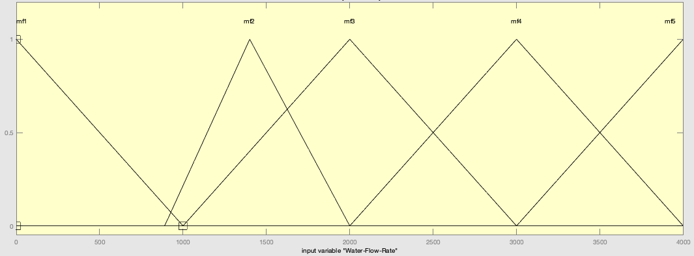

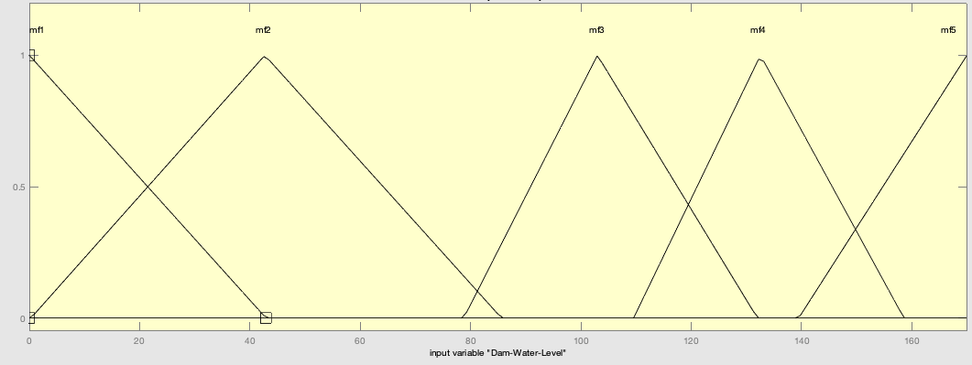

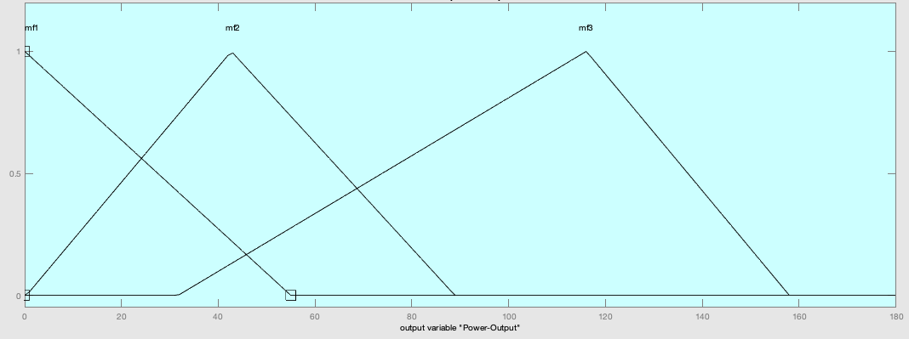

2.

|  |  |  |  |  |  |  |
| --- | --- | --- | --- | --- | --- | --- |
| **AND** | | Dam Water Level (Y) | | | | |
| very low | low | medium | high | very high |
| Water Flow Rate (X) | very weak | low | Low | low | low | average |
| weak | low | low | low | low | average |
| average | low | low | low | average | high |
| strong | average | average | average | high | high |
| very strong | average | average | average | high | 0 |

3.

4.

5.