3. Final Suitability Analysis
The final part of the project focused on identifying the areas that remained suitable for wind farm development after all exclusion zones had been created. The two main input layers for this analysis were Landnutzung and Total_Exclusion_Area.
First, the Landnutzung layer was processed using Fix Geometries, as some polygons contained invalid geometries. Only the two land-use classes allowed by the assignment, Ackerland and Gruenland, were then selected using Extract by Expression with: "typ" IN ('Ackerland', 'Gruenland')
The selected polygons were clipped to the Frame boundary so that only land within the study area was retained. The resulting layer was then dissolved without using a dissolve field. This removed internal boundaries between adjacent Ackerland and Gruenland polygons and allowed continuous areas to be treated as one candidate area. Next, the Difference tool was used to subtract Total_Exclusion_Area from the eligible land. This removed all areas affected by the road, railway, power-line, water, forest, biotope and settlement restrictions. Because the Difference result could contain multipart geometries, Multipart to Singleparts was applied so that each continuous candidate area could be evaluated separately. This resulted in 129 candidate polygons. The area of each polygon was then calculated in hectares using the Field Calculator and stored in the field area_ha with:
$area / 10000
Since the project CRS uses metres, this converts the polygon area from square metres to hectares. Finally, only areas meeting the minimum size requirement of 18 ha were retained. This was done using Extract by Expression with:
$area >= 180000
The final result consisted of 4 suitable areas with a combined area of approximately 90.93 ha. The smallest area was approximately 18.50 ha, the largest approximately 29.96 ha, and the mean area was approximately 22.73 ha.
To better understand the contribution of the two eligible land-use classes, Ackerland and Gruenland were also analysed separately after applying Total_Exclusion_Area. In total, 118 Ackerland patches remained, covering approximately 537.72 ha, with the largest continuous patch measuring about 29.96 ha. For Gruenland, 22 patches remained with a total area of approximately 33.46 ha, while the largest patch measured only about 11.25 ha. Therefore, no individual Gruenland patch reached the minimum requirement of 18 ha.
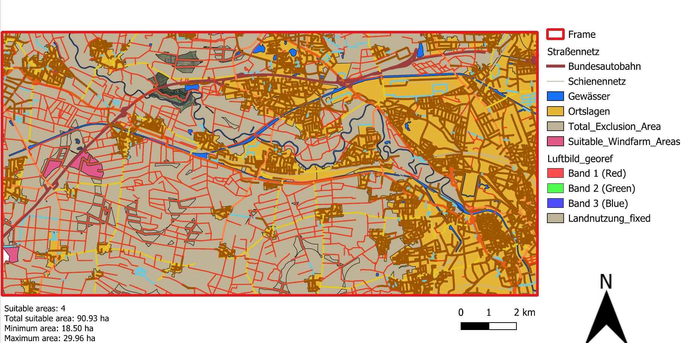
Picture 1: Suitable Areas for Wind Turbine Development in the Study Area West of Hanover
The map presents the final result of the suitability analysis for wind farm development in the study area west of Hanover. The pink polygons (Suitable_Windfarm_Areas) represent the areas remaining after all exclusion criteria and the minimum-area requirement were applied. The analysis identified four suitable areas with a combined area of approximately 90.93 ha. The individual areas range from approximately 18.50 ha to 29.96 ha. Therefore, all retained areas satisfy the minimum requirement of 18 ha, which corresponds to the assumed space requirement for a wind farm containing at least three wind turbines. Spatially, the suitable areas are concentrated mainly in the western and south-western parts of the study area. Very few or no suitable areas remain in the central and eastern parts. This pattern can be explained by the high density of settlements, transport infrastructure, water bodies and other protected features, whose buffer zones overlap considerably and exclude large parts of the study area. Although some land remains outside the individual exclusion zones, only areas belonging to the permitted land-use classes and forming a continuous area of at least 18 ha were retained in the final result. This further reduced the number of possible locations. Overall, the map shows that the protection and safety-distance criteria, particularly the large setback from settlement areas, have a strong influence on both the distribution and the total extent of land potentially available for wind farm development.

