Module 1

The website in its current form is a very basic hello work page. The CSS page is disabled with a comment. It features a home page and a link to module 1. Module 1 links back to the home page. The way I will have it set up is for each module to feature its own website, with subpages. The main modules will be accessed from the top, and pages within each module will be accessed from the left-hand bar. There will be a center column of core content for each page and a right-hand bar with supporting content.

<http://krausladenshome.centralus.cloudapp.azure.com/> …… Index

<http://krausladenshome.centralus.cloudapp.azure.com/module1/one.html> ...... Module 1

Azure

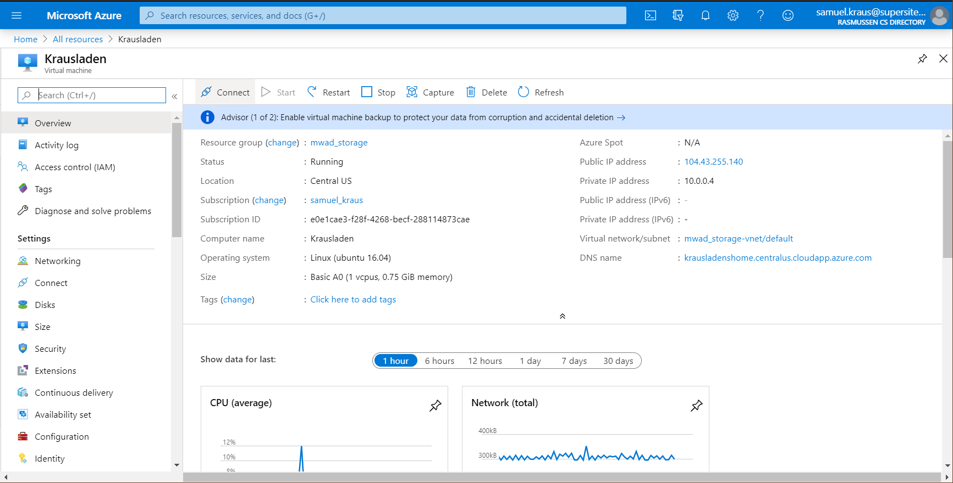

Bitnami Tunnel

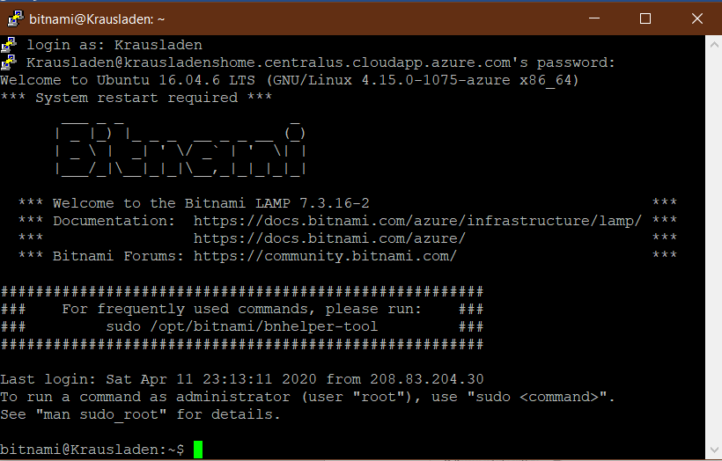

phpMyAdmin with adventureworks & updated privileges

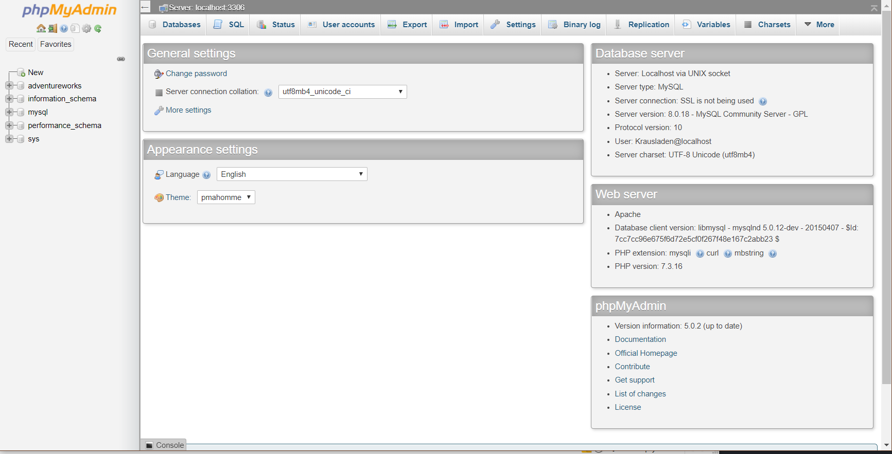

FileZilla

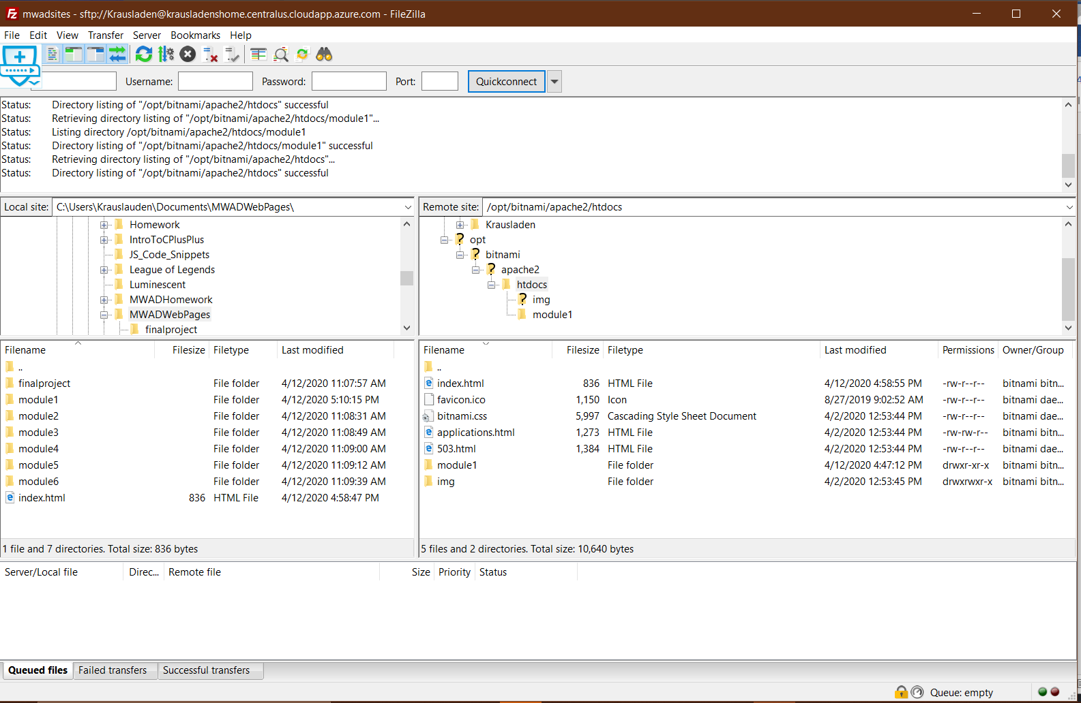

GitHub: <https://github.com/Krausladen/hello-world>

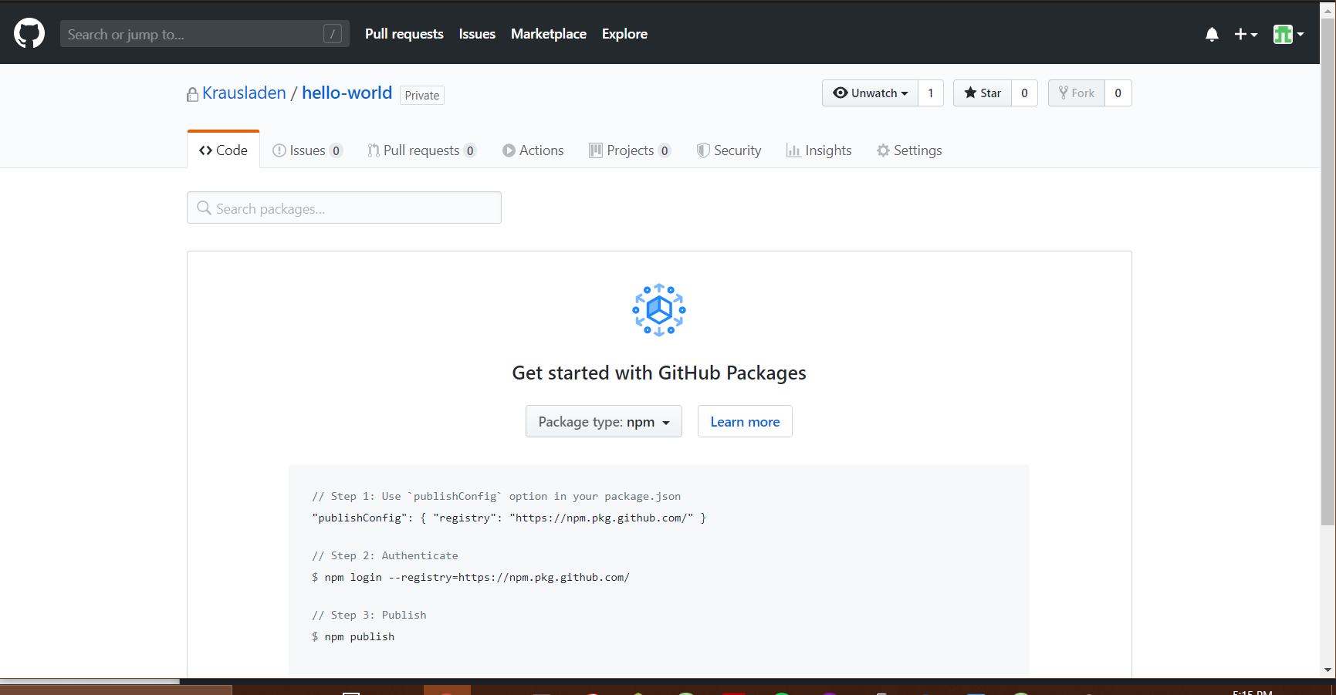

Atom Class Project Folder

