For module two, I decided to build a backbone site to use for hosting assignments for the rest of the class. Each module has its own page now. Each modules home page will be updated as we go along with the class. Module 3’s home page will link into a separate module 3 website, and branch off, while linking back into this host site. The design layout for module 2 is to make it responsive to the screen that is being used. The site does not seem to lose any content between browser or phone, and seems to be legible across all devices.

<http://krausladenshome.centralus.cloudapp.azure.com/index.html> //My index page

<http://krausladenshome.centralus.cloudapp.azure.com/module2/two.html> //module 2 home

GitHub Repository

<https://github.com/Krausladen/MWAD_ClassFolder/settings>

Desktop Orientation:

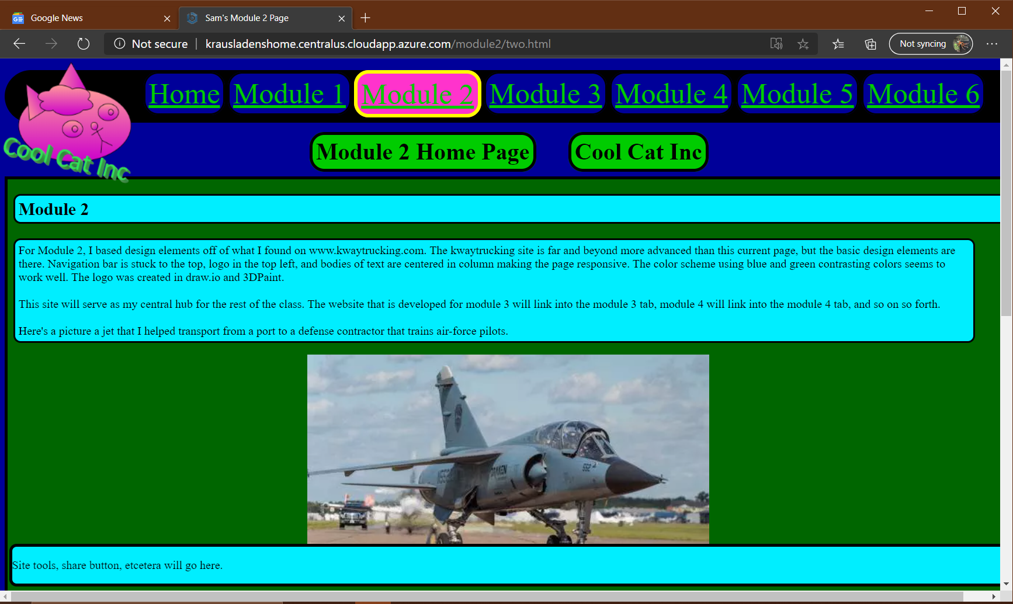

Mobile Phone Orientation:

