Here are a few screenshots demonstrating navigation through the website.

Desktop wide ->Home page:

<http://krausladenshome.centralus.cloudapp.azure.com/module4/blog/index.html>

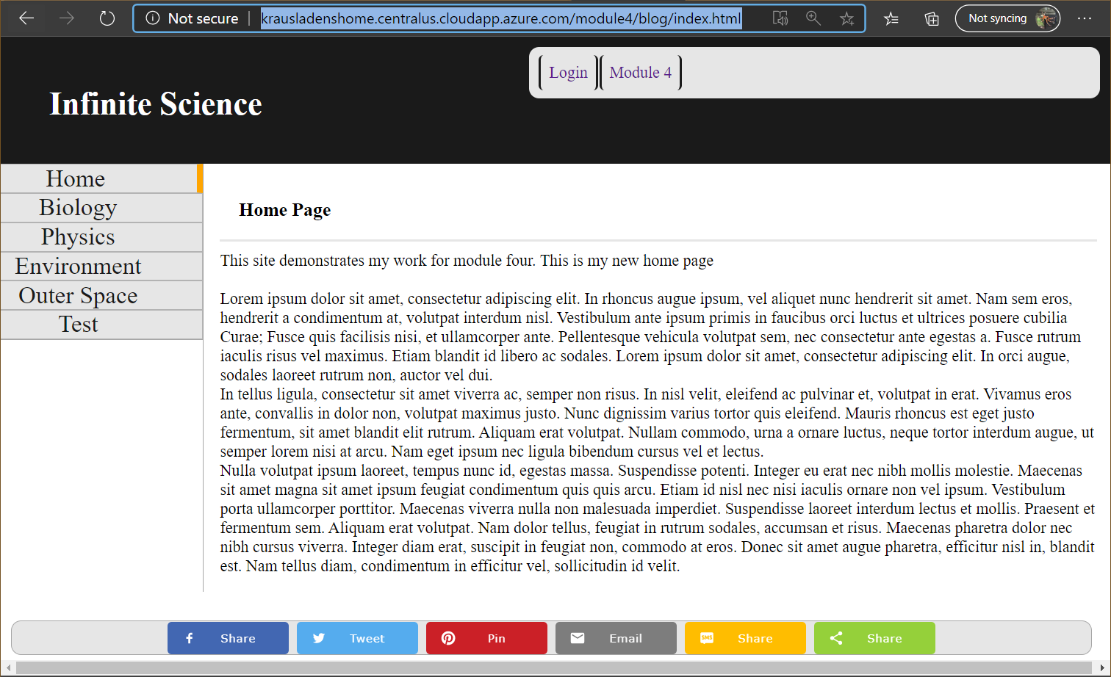

Desktop Skinny -> Biology:

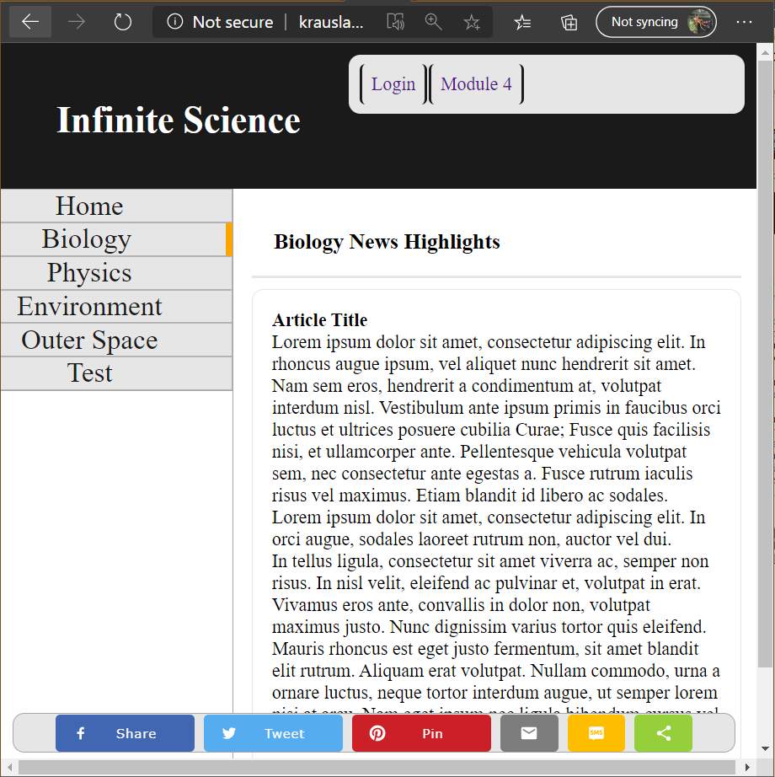

MotoG4 -> Physics

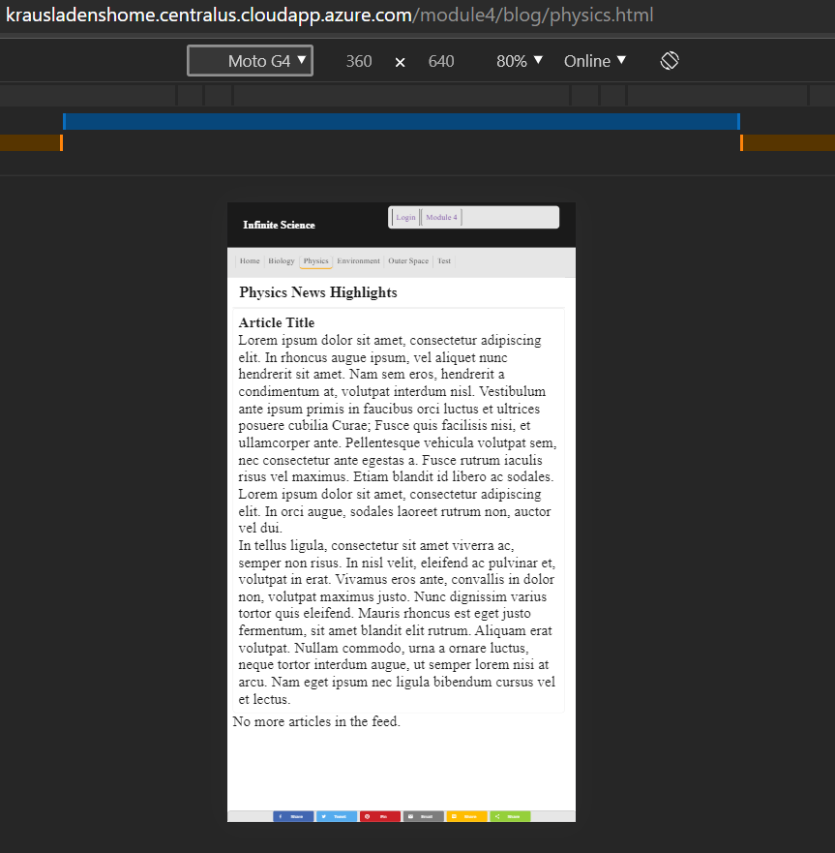

iPhone X -> Environment

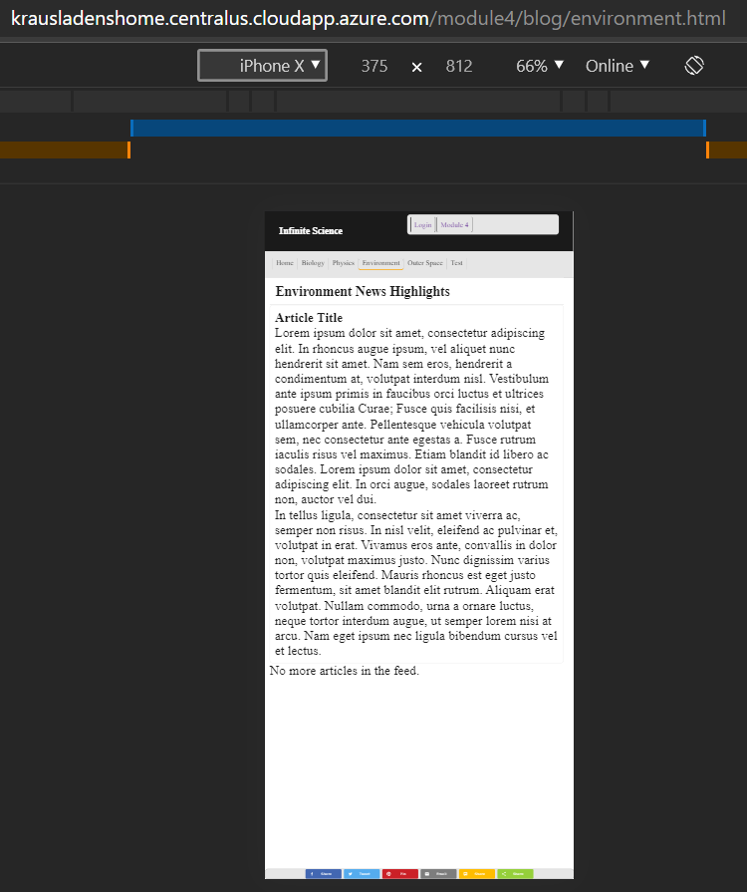

iPad -> Outerspace

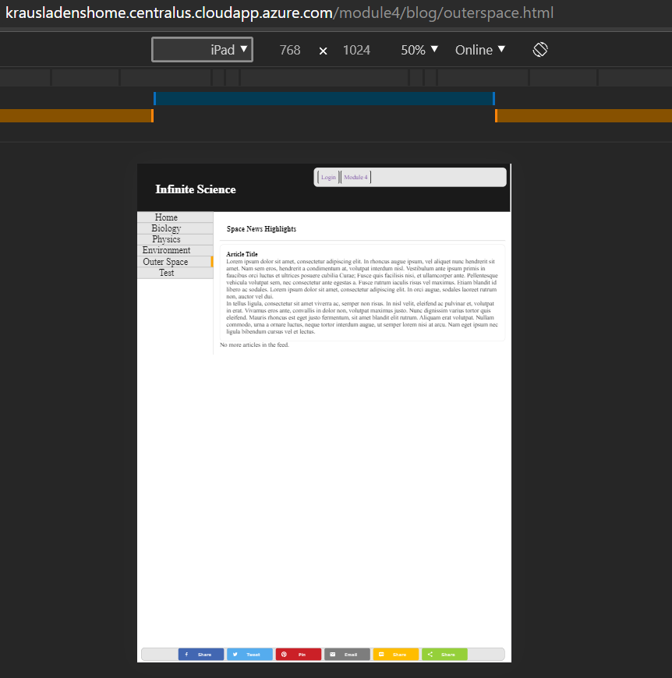

iPad -> Log in / create page

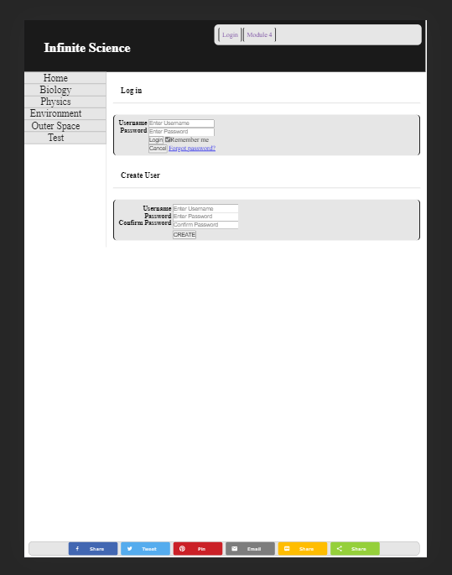

Desktop wide -> Log in / create page

