Module 4 Website:

<http://krausladenshome.centralus.cloudapp.azure.com/module4/blog/index.html>

No more messing around. This site is set up to mimic a news site for science subjects. I’d like to develop a user creation and log in feature and present them with containerized articles into an RSS feed.

The same set up can then be used for a few other idea’s I have floating around. The site is almost entirely responsive between mobile and desktop platforms with a breakpoint set at 700px device width. The CSS file is maybe my best one so far. One thing I had trouble with was the log in page for mobile, I may have to gut what I have going on there entirely and restructure the entire page for mobile.

Github: <https://github.com/Krausladen/MWAD_ClassFolder/>

Php files on the server for this page are currently empty, but those seem to be the next step for a page like this. If I can learn how to turn it into an RSS feed and write about science breakthroughs and speculate science topics for a living, I’m happy with that.

I had to use a site mapper other than Visio. For some reason, I was not able to access Visio in the link that was provided, which was fine. I used other resources available and made it work.

This is a site map from: <http://visualsitemapper.com/>

It is a nice visual for seeing how the pages are clustered. The purple dots are my module four site.

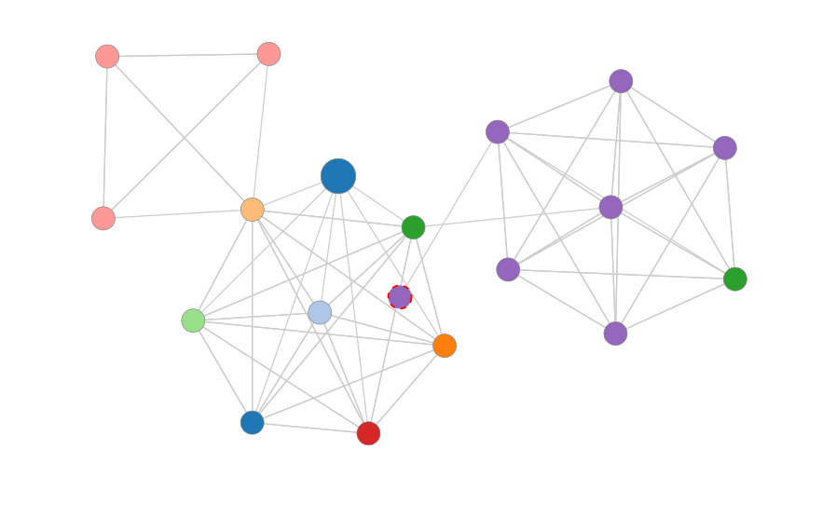

This site map was provided by <https://dynomapper.com/>

It has just as many fields as visual site mapper, but allows you to look at individual clusters. For the purposes of this assignment, I highlighted my module four website site.

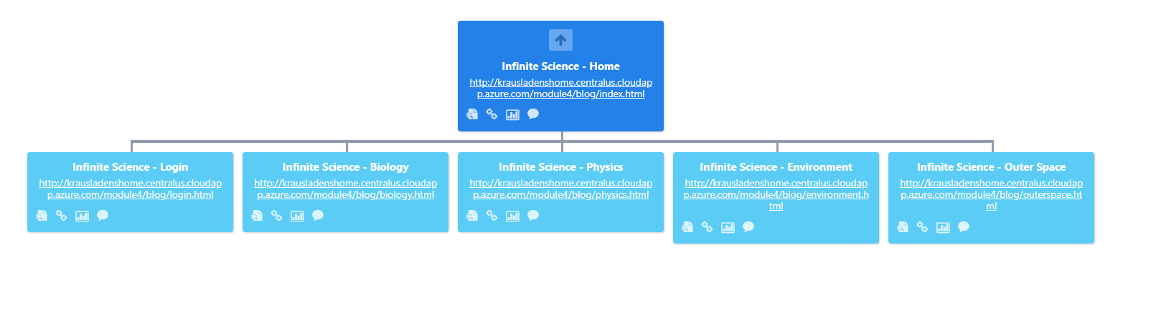

Verified ownership to Google

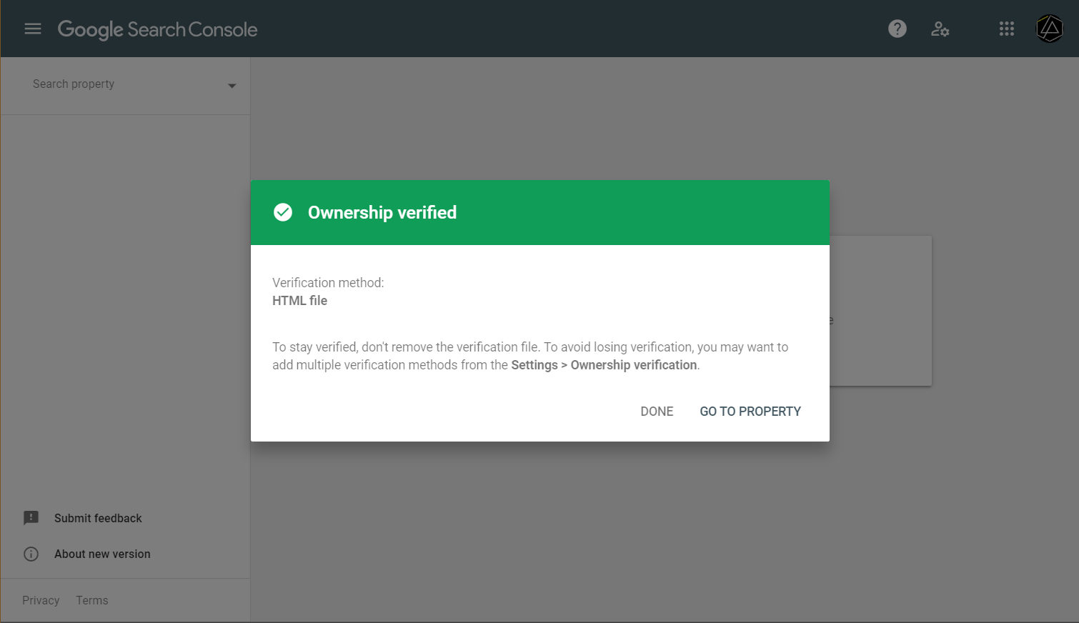

Site map uploaded to google.

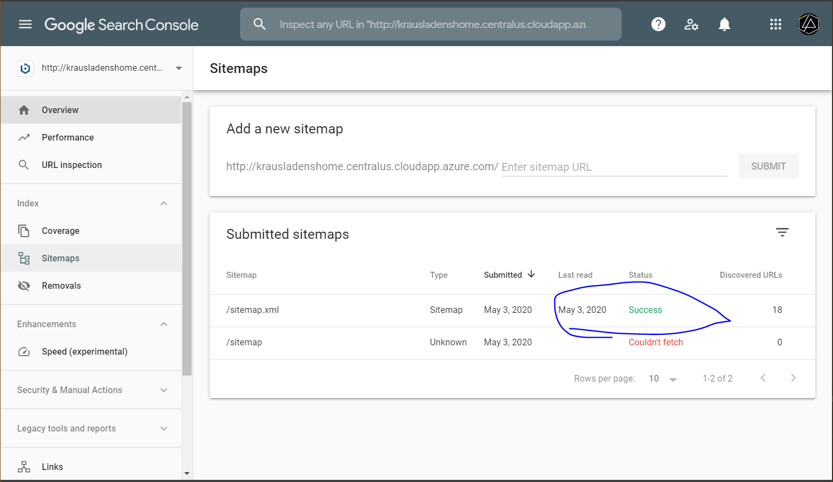

Takes up to a day to see anything else according to Google.